YOLOv7-Based Image Classification for Early Detection of Basal Stem Rot Disease in Oil Palm Plants
Mohammad Jamil Asfihani^{a)}, Merinda Lestandy^{b)}, Amirul Faruq^{c)}, and Lailis Syafa’ah^{d)}
Department of Electrical Engineering, Universitas Muhammadiyah Malang, Malang, Indonesia

^{b)} Corresponding author: merindalestandy@umm.ac.id
^{a)} mohammadjamilasfihani@webmail.umm.ac.id
^{c)} faruq@umm.ac.id
^{d)} lailis@umm.ac.id
Abstract. Basal stem rot (BSR) disease poses a serious threat to oil palm plantations, and effective detection methods are urgently needed. This study investigates the use of an advanced image classification model based on the YOLOv7 architecture to detect BSR in oil palm plants. The model was trained on a dataset of oil palm images and evaluated using key performance metrics, including F1 score, precision, recall, and Precision-Recall (PR) curves. The results indicate strong model performance, with an F1 score of 0.896, demonstrating a balance between precision and recall. The model shows high precision, minimizing false positives and ensuring that healthy plants are not misclassified as diseased. Additionally, its high recall values suggest effective identification of most infected plants, reducing the chance of missing disease cases. The PR curve further validates the model's robustness, particularly in handling imbalanced datasets. Near-perfect area under the curve (AUC) values highlight its ability to maintain high precision even at lower recall levels. In conclusion, the YOLOv7-based model shows significant promise for early detection of BSR disease in oil palms. Its accuracy and reliability could help mitigate disease spread, reduce economic losses, and support sustainable palm oil production.
Keywords: YOLOv7, Oil palm, Basal stem rot, UAV image

INTRODUCTION
Oil palm is one type of plant that is suitable for growing in the tropical climate of Southeast Asia, especially in Indonesia [1]. Palm oil production is a very large global industry worth 65.73 billion USD in 2015 and is expected to reach 92.84% by 2025, with major palm oil exporting countries such as Malaysia and Indonesia producing 85% of world demand [2] [3]. However, oil palm trees are susceptible to diseases such as Ganoderma boninense (G. boninense)[4], and there is no efficient method to treat the infection without excessive use of chemicals, damage to the product, and resulting in decreased palm oil production per unit area [5]. The underlying causes of this disease can vary and can be related to soil conditions (i.e. temperature and shade) as described in[6], abnormal weather changes, or even climate change[7].
One of the major diseases that affect the health of oil palm plants is basal stem rot (BSR), a fungal disease and early detection of G. boninense infection. According to the survey, BSR disease has caused economic losses in Indonesia of around 50-350 million USD per year, while in Malaysia the economic loss is estimated to reach USD 365 million per year [2]. The problem becomes more serious when BSR disease is a highly contagious disease and is easily spread from plant to plant through direct contact [2]. Currently, there is no effective treatment that can be done to cure oil palm trees [2].
Therefore, collecting very accurate data on the distribution and health status of oil palm trees in a plantation area is very important for efficient disease control management and agricultural yield modeling. Examination of BSR disease in oil palm trees by humans is very difficult, especially in the early stages of infection. In addition, oil palm plantation areas are usually large and the distribution of oil palm trees is wide. Therefore, the process of monitoring the health status and distribution of oil palm trees by implementing field-based inspections can be very challenging and requires a large investment of time and effort.
Over the past few years, various remote sensing technologies such as satellite imaging and UAVs have been widely applied in the agricultural sector. This is used because, first, their ability to cover a large area, and second, they provide higher spatial resolution of images at a reasonable cost. In addition, However, monitoring and detecting early symptoms of BSR disease in oil palm trees from UAV imagery is still a complex and difficult challenge. First, the visual characteristics of oil palm trees infected with early stages of BSR disease are very similar to healthy oil palm trees, resulting in poor classification performance. Second, certain oil palm plantation areas are very dense and the boundaries of oil palm plantations overlap. Therefore, detecting the early stages of BSR disease infection in each oil palm tree is a big challenge to produce good quality.
Current technological advances make it possible for object detection techniques to be used to improve quality improvement performance. This study aims to develop a model that can detect oil palm images to detect BSR disease. Object detection techniques that can be implemented include Artificial Intelligence (AI) with deep learning methods. This study classifies oil palm images to detect BSR disease through computer vision using the deep learning method with the YOLOv7 architecture. YOLO is a network used to detect objects while YOLOv7 is part of deep learning and is a one-stage detection algorithm that performs object location detection and object classification in one stage [8] [9]. In addition, this algorithm was chosen because it has the advantage of the fastest detection speed reaching 140 frames/second. The file size of the YOLOv7 target detection network model weight is also small, almost 90% smaller than YOLOv4 [10] [11] . So that the image detection process can be carried out efficiently. This study aims to improve the early detection of BSR disease in oil palm trees, utilizing deep learning techniques with the YOLOv7 architecture.

METHODS
This study uses a deep learning method with YOLOv7 architecture to classify BSR disease in oil palm plants. The research stages are divided into 3 processes, namely data collection, data pre-processing, and data processing. As seen in FIGURE 1, the data collection system is in the form of images of oil palm plants via UAV. Then the data pre-processing process is carried out with split data training/testing, auto orient, and resizing to obtain an output of 1612 train sets, 461 valid sets, and 230 test sets that are ready to be processed. Data that is ready to be processed will be data processed using the YOLOv7 architecture. The output is in the form of a classification of BSR disease, namely healthy and unhealthy.

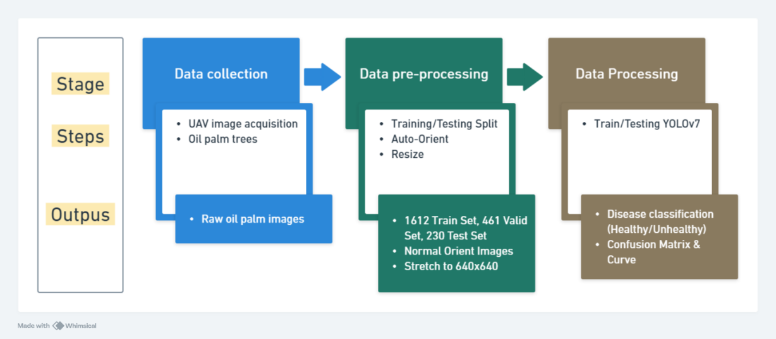
FIGURE 1. Research Method

DATA COLLECTION
The data source was obtained from the website https://kaggle.com. The dataset was obtained by taking pictures of oil palm trees from the top of the research location using a UAV. The images were taken with a UAV at a height of 500m and a speed of 15-20 m/s with a resolution of 1024 x 1024 pixels. A sample dataset with labeled images is shown in TABLE 1 [5].

TABLE 1. Examples of aerial view images annotated by experts along with their respective descriptions [5].
Sample Dataset | Classification | Description
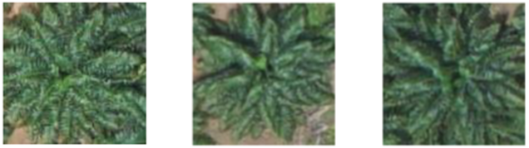 | Healthy | A healthy open canopy displays lush green color and dense foliage.
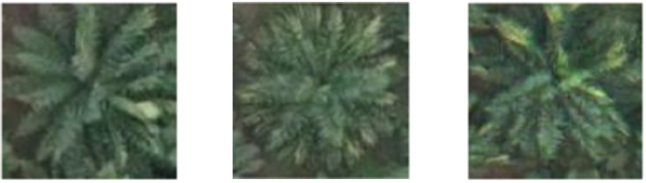 | BSR disease-infected (unhealthy) | A subtle green color with a hint of yellow is visible on the leaves.
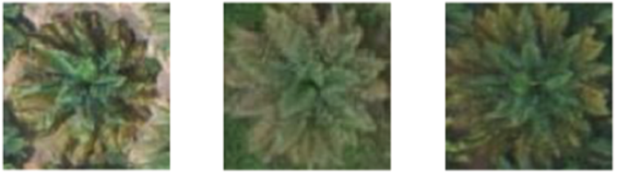 | BSR disease-infected (unhealthy) | A higher intensity of yellow spots is seen.
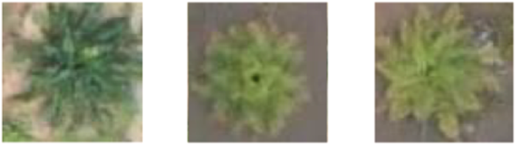 | BSR disease-infected (unhealthy) | The canopy wilts and the canopy dimensions shrink.
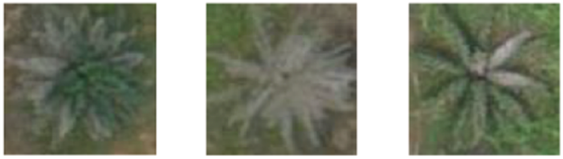 | BSR disease-infected (unhealthy) | Trees that have lost their vitality usually show a grayish hue and a wilted canopy.

Next, each image will be given a label and bounding box in the form of a "Healthy" and "Unhealthy" label. Furthermore, the training process stage aims to create weight data or prediction data through the training process. The last is the implementation process, namely testing palm oil image data.

DATA PREPROCESSING
Data preprocessing is the process of preparing data to be processed using machine learning or deep learning. Before going to the processing stage, the raw data will be processed first [12]. Preprocessing consists of automatic orientation, image resizing, and labeling. The data taken previously was still in raw form, amounting to 2303 images, so it was necessary to split or separate the data using the Roboflow service (https://roboflow.com) as shown in FIGURE 2.

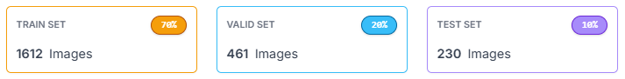
FIGURE 2. Dataset sharing process

FIGURE 2 shows the number of Train Set compositions of 1612 images (70%), Valid Set of 461 (20%) images, and 230 (10%) for Test Set, with this total data is 2303 images which is the same as the previous raw data which is also 2303 images. This process is used to determine the level of detection or model that will be generated in YOLOv7 later. After the data is split, Auto-Orient is then carried out to ensure that non-portrait data becomes a portrait, in this case where the image is oriented by 90 ° or even 180 ° will be normalized to portrait or 0 ° and then the image size will also be changed equally to 640x640 in pixel units. Then the last step in data pre-processing is to annotate or label each image in each data set such as FIGURES 3, 4, and 5.

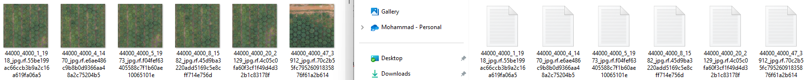
FIGURE 3. Train set and data annotations (labels)

FIGURE 4. Valid set and data annotations (labels)

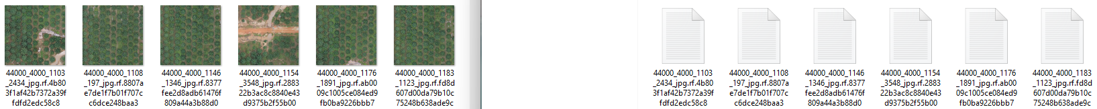
FIGURE 5. Test set and data annotations (labels)

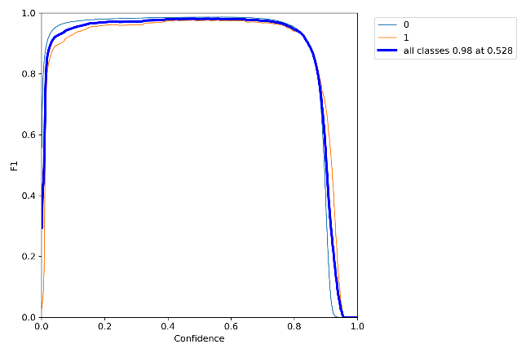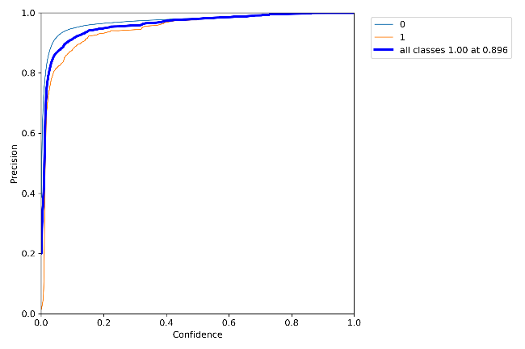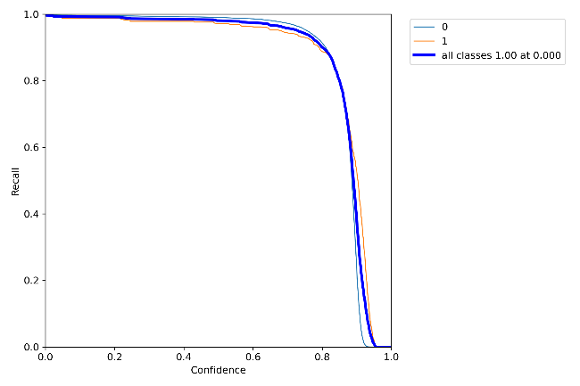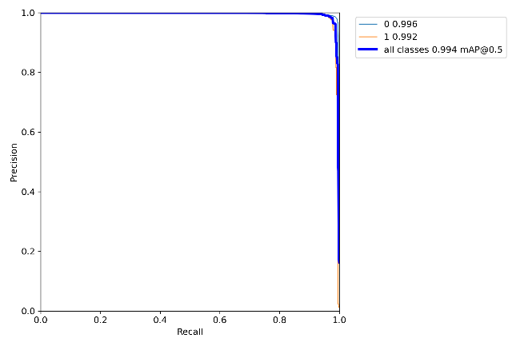
FIGURE 6. Curve or result curve from initial training and validation

DATA PROCESSING
The proposed method is based on YOLOv7. YOLOv7 has better advantages in faster speed and higher accuracy. It introduces re-parameterized modules to reduce parameters and improve inference speed [13].YOLOv7, created by Chien-Yao Wang, Alexey Bochkovskiy, and Hong-Yuan Mark Liao [14], represents the latest advancement in the YOLO series. This model outperforms all current real-time object detectors in both speed and accuracy, operating at an impressive range of 5 to 120 FPS. YOLOv7 combines the best elements of the YOLO framework, resulting in a highly advanced object detection model [15].
The process begins with a backbone network that analyzes an input image, extracting information at multiple scales. An optional neck component can be added to further enhance contextual data. The detection heads then predict bounding boxes, class probabilities, and object-specific features using the feature maps generated by the neck or backbone. The final output is refined through post-processing methods, such as non-maximum suppression, to remove redundant detections. This step ensures that only the most confident bounding boxes, along with their corresponding class labels and confidence scores, are retained. YOLOv7 combines the fundamental principles of YOLO with carefully considered design improvements, resulting in a model that provides fast and accurate object detection [16].

RESULTS AND DISCUSSION
After the preprocessing stage is carried out, the next step is to train the data for the YOLOv7 model.
In the initial setting step, the results obtained were only in the form of a confusion matrix and several curves as displayed in FIGURE 6.
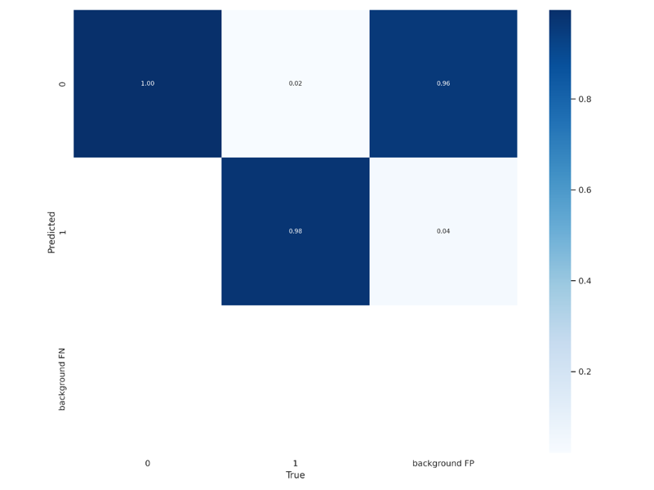
FIGURE 7. Confusion matrix results from initial model testing.

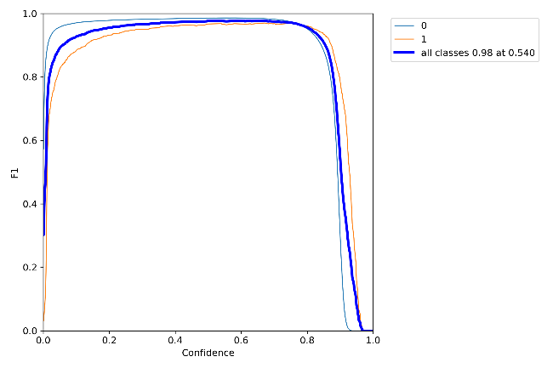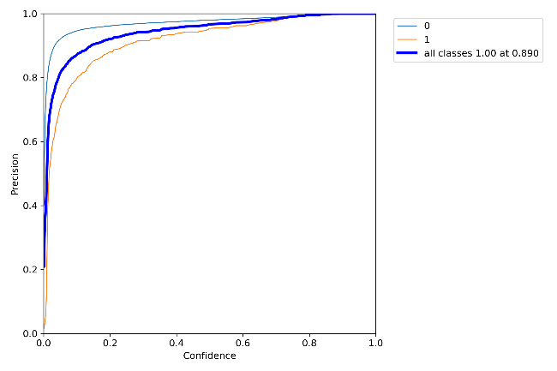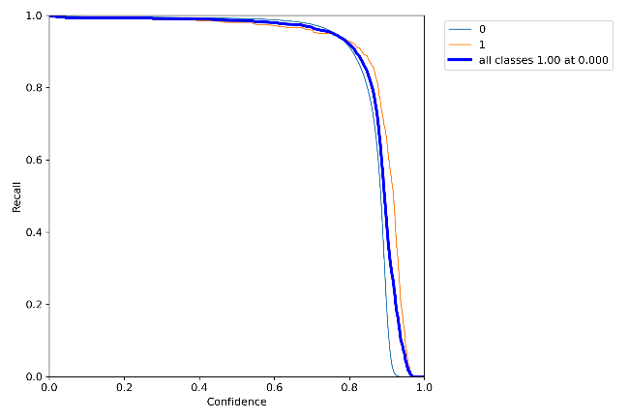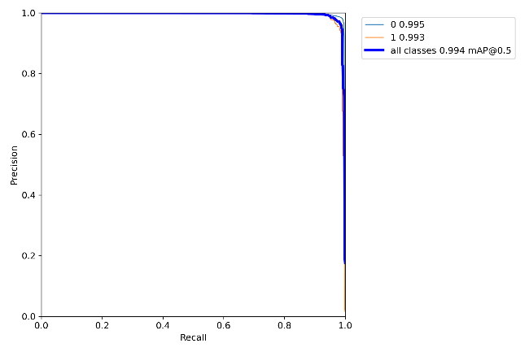
Figure 8. Curve from the initial model testing results

FIGURE 7 collectively provide a comprehensive analysis of a binary classification model's performance across different metrics and thresholds for training phase. The first plot illustrates the relationship between the F1 score and confidence, showing that the model's performance peaks around a confidence level of 0.5 to 0.6, where it achieves a near-optimal balance between precision and recall, before slightly declining as confidence increases further. The second plot focuses on the precision versus confidence, highlighting that precision improves as the model becomes more confident, with perfect precision achieved at a confidence level of 0.896, suggesting this threshold may be optimal when precision is critical. The third plot, a precision-recall (PR) curve, demonstrates the model's effectiveness across different recall thresholds, with precision remaining high for both classes. The model exhibits a high mean Average Precision (mAP) of 0.994, indicating strong performance even in scenarios where the balance between precision and recall is crucial. Together, these plots indicate that the model is highly effective, achieving near-perfect precision and recall across various thresholds, making it a robust choice for applications where both metrics are important.

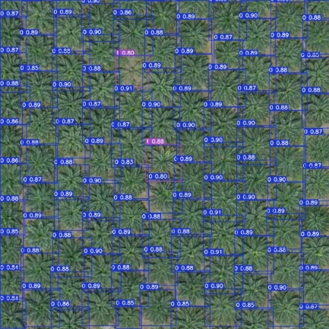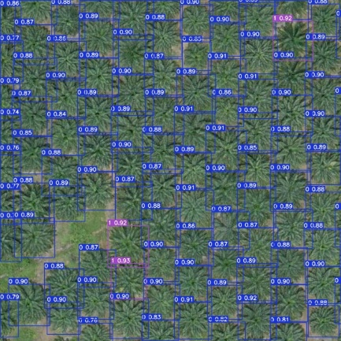

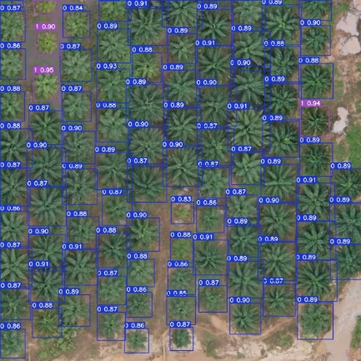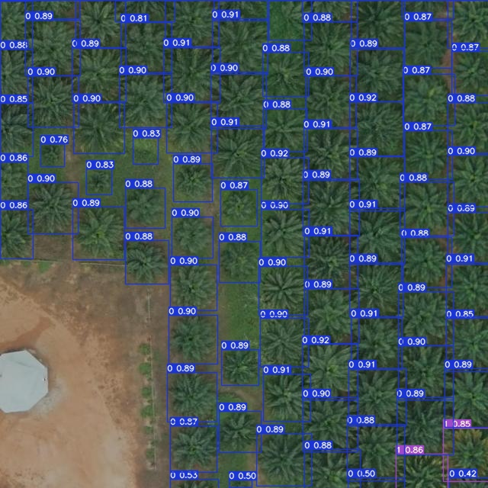
FIGURE 9. Results of the initial detection of each object in the bounding box.

In the final testing phase, FIGURE 8 displays four performance evaluation plots for a classification model: F1 vs. Confidence, Precision vs. Confidence, Recall vs. Confidence, and Precision vs. Recall (PR curve). Each plot compares the performance metrics for two classes (0 and 1) and the overall average across all classes. The plots indicate high performance with metrics near 1, suggesting the model is well-calibrated with strong precision, recall, and F1 scores across varying confidence thresholds, as reflected in the high area under the curve (AUC) values. These plots help visualize and assess the model’s classification efficacy.
The initial detection results of YOLOv7 can provide bounding boxes (healthy blue and unhealthy red) for each object of the oil palm image as shown in FIGURE 9.

CONCLUSIONS
This study demonstrates the effectiveness of the YOLOv7 model in classifying images for the early detection of Basal Rot Disease in oil palm plants. The model's performance is visualized through several key plots: F1 vs. Confidence, Precision vs. Confidence, Recall vs. Confidence, and the Precision-Recall (PR) curve. Each of these plots shows metrics for two classes, likely representing healthy and diseased plants, as well as an overall metric across all classes. The F1 score plot reveals that the model maintains a high balance between precision and recall across a wide range of confidence thresholds. This indicates that the model is both accurate in its positive predictions and comprehensive in detecting actual positive cases of the disease. Similarly, the precision and recall plots suggest that the model achieves near-perfect precision and recall, indicating very few false positives and false negatives, respectively.
The Precision-Recall curve, which is particularly important in scenarios with imbalanced datasets, shows that the model performs consistently well across varying recall levels, maintaining high precision. The area under these curves (AUC), with values close to 1, further confirms the model's exceptional performance. Overall, these results suggest that the YOLOv7 model is highly reliable for detecting Basal Rot Disease in oil palm plants. Its ability to maintain high accuracy across different metrics makes it an invaluable tool for early disease detection, potentially leading to more timely and effective disease management in agricultural settings. This can help mitigate the spread of the disease, reduce crop losses, and support sustainable palm oil production.

Acknowledgments
The research team would like to express their gratitude and appreciation to the Faculty of Engineering, Universitas Muhammadiyah Malang, for their support in the implementation of this work through the Engineering Study and Engineering Center scheme, Pusat Kajian dan Rekayasa Teknik-UMM (PUSKAREKATEK 2024).

References
1. Corley, R.H.V. and P.B.H. Tinker, The oil palm. 2015: John Wiley & Sons.
2. Siddiqui, Y., et al., Current strategies and perspectives in detection and control of basal stem rot of oil palm. Saudi Journal of Biological Sciences, 2021. 28(5): p. 2840-2849.
3. Xu, Y., et al., Recent expansion of oil palm plantations into carbon-rich forests. Nature Sustainability, 2022. 5(7): p. 574-577.
4. Jazuli, N.A., et al. A Review of Factors Affecting Ganoderma Basal Stem Rot Disease Progress in Oil Palm. Plants, 2022. 11, DOI: 10.3390/plants11192462.
5. Win Kent, O., et al., Early symptom detection of basal stem rot disease in oil palm trees using a deep learning approach on UAV images. Computers and Electronics in Agriculture, 2023. 213: p. 108192.
6. Lo, M.L., et al., Comparison of Ganoderma boninense Isolate’s Aggressiveness Using Infected Oil Palm Seedlings. Journal of Microbiology, 2023. 61(4): p. 449-459.
7. Darlan, N.H., et al., Recent Evaluation of Rising Temperature and Oil Palm Extension to Higher Elevation in North Sumatra (evaluasi Terkini Kenaikan Suhu Dan Perluasan Tanaman Kelapa Sawit Ke Dataran Tinggi Di Sumatera Utara). Agromet, 2009. 23(2): p. 112-122.
8. Nugraha, Y.P.P. and E.P. Wibowo, Deteksi Cacat pada Sekrup Berbasis Citra Menggunakan YOLOv5. Jurnal Ilmiah Komputasi, 2024. 23(1): p. 59-66.
9. Prasetiadi, A., et al., YOLOv5 and U-Net-based Character Detection for Nusantara Script. Jurnal Online Informatika, 2023. 8(2): p. 232-241.
10. Ashar, M.H. and D. Suarna, Implementasi Algoritma YOLOv5 dalam Mendeteksi Penggunaan Masker Pada Kantor Biro Umum Gubernur Sulawesi Barat. KLIK: Kajian Ilmiah Informatika dan Komputer, 2022. 3(3): p. 298-302.
11. Hidayah, M.N., F. Sthevanie, and K.N. Ramadhani, Deteksi Penggunaan Masker Pada Citra Menggunakan YOLOv5 Dengan CNN. eProceedings of Engineering, 2023. 10(5).
12. Dhimas, T., Hazriani, and A. Abdul Latief, Image Preprocessing Approaches Toward Better Learning Performance with CNN. Jurnal RESTI (Rekayasa Sistem dan Teknologi Informasi), 2024. 8(1).
13. Cen, J., et al., An improved ship classification method based on YOLOv7 model with attention mechanism. Wireless Communications and Mobile Computing, 2023. 2023(1): p. 7196323.
14. Wang, C.-Y., A. Bochkovskiy, and H.-Y.M. Liao. YOLOv7: Trainable bag-of-freebies sets new state-of-the-art for real-time object detectors. in Proceedings of the IEEE/CVF conference on computer vision and pattern recognition. 2023.
15. Gillani, I.S., et al., Yolov5, yolo-x, yolo-r, yolov7 performance comparison: A survey. Artificial Intelligence and Fuzzy Logic System, 2022: p. 17-28.
16. Shi, H., et al., CPA-YOLOv7: Contextual and pyramid attention-based improvement of YOLOv7 for drones scene target detection. Journal of Visual Communication and Image Representation, 2023. 97: p. 103965.

