Simplified PSO-based MPPT for PV-based DC Microgrid
Haneef Nouval Alannibras Humaidi^{1,a)}, Alfina Fatma Damayanti^{1,b)}, Dieta Wahyu Asry Ningtias^{2,c)}, Ilham Pakaya^{1,d)}, and Diding Suhardi^{1,e)}
¹ Electrical Engineering Department, University of Muhammadiyah Malang, Malang, Indonesia
² Electrical Technology, Politeknik Enjinering Indorama, Purwakarta, Indonesia
^{d)} Corresponding author: ilham@umm.ac.id
^{a)} haneefnouval@umm.ac.id
^{b)} alfinafatma@webmail.umm.ac.id
^{c)} dieta@pei.ac.id
^{e)} diding@umm.ac.id
Abstract. Efforts to address the energy crisis and climate change encourage the use of renewable energy sources, especially solar energy which has great potential. In Indonesia, the potential of solar energy reaches 9,100 TWh/day. Photovoltaic (PV) is an attractive solution with direct conversion of sunlight into electricity. However, there remains the challenge of managing the intermittent nature of renewable energy. Maximum Power Point Tracking (MPPT) is used to maximize the power from solar PV panels. This research focuses on the Simplified PSO (SPSO) algorithm that accelerates the convergence of MPPT. The algorithm used is simplified from its basic equation by eliminating the variable best position of the particle, because adding this variable to the original PSO has no strong reason, unless the problem being optimized is very non-linear and multimodal... The results show SPSO is able to achieve convergence faster than the complex PSO method. However, a decrease in accuracy is a consequence of algorithm simplification. Nevertheless, SPSO is still very valuable in situations that require fast response to changes. This research provides insight into the use of SPSO in MPP optimization in PV. In future research, it is important to strike a balance between speed and accuracy in MPPT algorithm development.
Keywords: Maximum Power Point Tracking (MPPT), Simplified PSO (SPSO), DC Microgrid, Photovoltaic (PV)

INTRODUCTION
The energy crisis and the negative impacts of climate change have created global pressure to find sustainable solutions to meet energy needs. One answer that is increasingly recognized and widely adopted is the utilization of renewable energy sources. Amidst the various options available, solar energy dominates the attention due to its enormous potential, in Indonesia alone, the potential of solar energy is 9,100 TWh/day [1]. Efforts to convert solar energy into a reliable energy source have triggered various innovations in renewable energy technology.
In an effort to optimize the potential of solar energy, various methods have been pursued. One of them is the utilization of solar heat to rotate turbine generators. Although effective, this approach has limitations in terms of efficiency and wider applicability. As an alternative solution, photovoltaic (PV) technology is emerging as a promising option. By utilizing semiconductors that are directly exposed to photons, PV technology is able to convert sunlight into electrical energy directly. This enables more efficient and faster conversion of solar energy into electrical energy.
In order to achieve 100% electrification, many countries, including Indonesia, have developed the microgrid concept, which is different from the conventional main grid. Instead of being centralized like a conventional main grid, the microgrid concept puts forward a distributed or decentralized concept. In this system, electrical energy is generally generated and directly distributed without going through the transmission network, this concept is also known as DER (Distributed Energy Resources). This approach reduces dependence on long-distance transmission networks and creates a more adaptive energy system that is responsive to local needs, making it very suitable for areas that are difficult to reach by the main grid.
The development of microgrid systems does not mean that these systems run without obstacles. Voltage stability and continuity of power supply for consumers are aspects that are of great concern to researchers. Renewable energy sources that generally have intermittent properties, namely availability that cannot be ascertained in each unit of time, make customers disadvantaged if not managed properly. One of the efforts in overcoming this intermittent nature is to maximize the output power of these renewable energy sources. In this case, PV as a means of converting solar energy into electrical energy, can be maximized by using MPPT (Maximum Power Point Tracker). MPPT is a method used to optimize the output power of PV solar panels by ensuring that the current and voltage generated are at the maximum working point on the P-V (Power-Voltage) characteristic curve of the PV module. The shape of the P-V characteristic curve for each PV is also affected by the intensity of solar irradiation received by the PV, as shown in FIGURE 1.

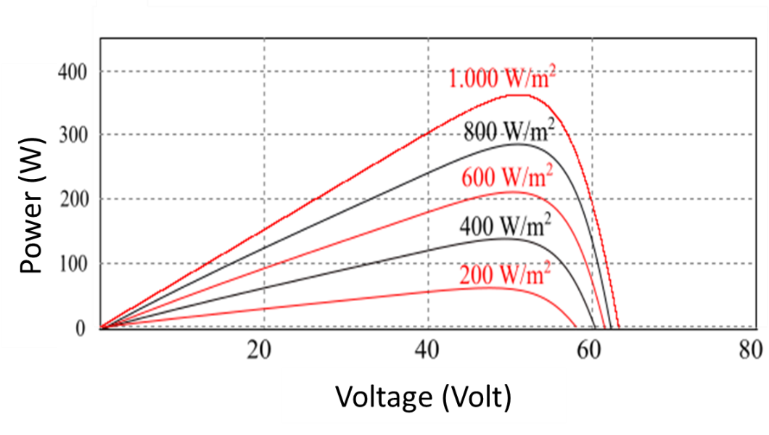
FIGURE 1. Characteristic P-V curve of PV and its effect on solar irradiation intensity (in indonesian version)

A number of studies have focused on developing MPPT to ensure that solar PV panels operate at their highest efficiency. In various existing literatures, various basic algorithms to algorithms that apply artificial intelligence have been applied to MPPT. [2-4] used the P&O (Perturb and Observe) algorithm which is a basic algorithm in MPPT. [5] developed the P&O algorithm developed with the addition of variations in the MPP tracking step size. A comparison between the P&O and IC (Incremental Conductance) algorithms has been presented by [6]. The research highlighted the advantages and disadvantages of each method in achieving the maximum working point under various environmental conditions and sunlight intensity.
Besides basic optimization algorithms, a number of studies have implemented metaheuristic optimization algorithms. [7] applied GA (Genetic Algorithm) algorithm in MPPT and compared it with the basic algorithm. compared the performance between GA and PSO (Particle Swarm Optimization) algorithms. This comparison helps illustrate the efficiency of both algorithms in optimizing the output power of solar PV panels.
More specifically, a number of studies have applied PSO as one of the metaheuristic optimization algorithms in MPPT. PSO itself has gained wide recognition as a robust method in MPP tracking. This algorithm is inspired by the behavior of animal groups in searching for food sources. The original PSO was applied to MPPT by [8, 9]. While [10] applied a modified PSO to MPPT. [11, 12] used the MPSO (Modified Particle Swarm Optimization) algorithm applied to the Boost Converter. [8, 13] applied MPSO implemented on Buck Converter. Furthermore, [14] developed an adaptive PSO-based MPPT. [15] applied DPSO (Deterministic Particle Swarm Optimization) to provide simplification to the PSO algorithm by eliminating random values and acceleration coefficients. [16] provided a combination of PSO and basic algorithms by using IC for reinitialization.
From the previously mentioned research, PSO-based MPPT and other metaheuristic optimization algorithms can achieve convergent point with high accuracy, but with longer time than conventional optimization algorithms. Therefore, this study proposes a PSO-based metaheuristic optimization algorithm-based MPPT with simplification so that the convergent point can be achieved faster but with little exclusion of the efficiency value of MPPT.
.

METHODS

PV SYSTEM MODELING
PV cells are the smallest component of a PV system. PV cells assembled into a single unit are referred to as PV modules or solar panels. Several PV modules assembled in series are referred to as a PV string and several PV strings assembled in parallel are referred to as a PV array. The equivalent circuit of a PV module is shown in FIGURE 2.
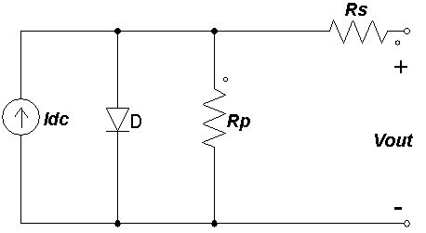
FIGURE 2. PV Equivalent circuit

The mathematical formulas for PV cells are shown in equations (1) and (2).
$I=I_{sc}-I_{o}\left(e^{\frac{q\left(V+IR_{s}\right)}{kT}}-1\right)-(\frac{V+IR_{s}}{Rp})$ (1)
$V_{oc}=\left(\frac{kT}{q}\right)ln⁡(\frac{I_{sc}}{I_{o}}+1)$ (2)

where :
I : Cell current (A), Isc : Cell short-circuit current (A),
Io : Reverse saturation current (A), V : Cell voltage (V),
Voc : Cell open-circuit voltage (V), T : module temperature (K),
k : Boltzman constant, q : Electron charge (C),
Rp : Parallel resistance, Rs : Series resistance.

TABLE 1 shows the specifications of the PV modules used along with the specifications of the PV array consisting of 2 PV strings and each PV string consisting of 3 PV modules. The data is obtained from the datasheet which is a calculation under STC (standard test condition) conditions where the value of solar irradiation intensity is 1,000 W/m2 and at a temperature of 25º.
TABLE 1. PV Specifications
Characteristics | Value in PV module units | Value on PV array
Maximum power (Pmax) | 60 W | 360 W
Current at Pmax (Imp) | 3,5 A | 7 A
Voltage at Pmax (Vmp) | 17,1 V | 51,3 V
Short-circuit current (Isc) | 3,8 A | 7,6 A
Open-circuit voltage (Voc) | 21,1 V | 63,3 V

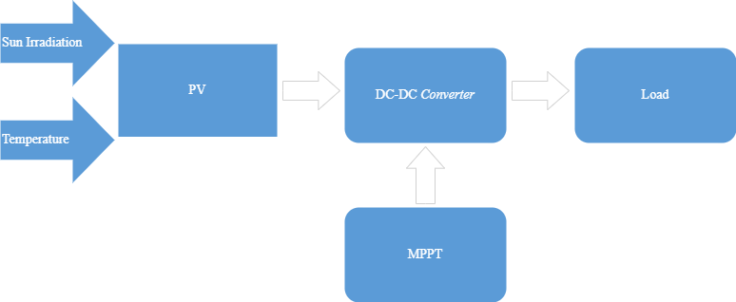
FIGURE 3. PV System Diagram

FIGURE 3 is a diagram of the PV system used in this research where MPPT will be implemented in the form of PWM (Pulse Width Modulation) to control the DC-DC converter. As among the existing types of DC-DC Converter, Buck Converter is chosen in this research due to the simplicity aspect of this type of converter so that the research is expected to be more focused on the developed algorithm. The Buck Converter circuit is shown in FIGURE 4.
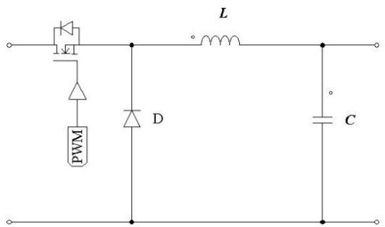
FIGURE 4. Buck Converter circuit

MPPT BASED ON SIMPLIFIED PSO
PSO is a metaheuristic optimization algorithm inspired by nature, specifically from the collection of birds in search of food. An important aspect of PSO is the presence of a collection of individuals, commonly referred to as particles [17]. Each particle has a velocity and position component that changes at each iteration. The changes that occur can be due to the exchange of information between particles and the ability of each particle to evaluate itself. In addition, the particle with the best position will also affect other particles, as well as its speed. Commonly known PSO equations are as stated in (3) and (4).
$v_{i}^{k+1}={ωv}_{i}^{k}+c_{1}r_{1}\left(p_{best,i}-x_{i}^{k}\right)+c_{2}r_{2}\left(g_{best}-x_{i}^{k}\right)$ (3)

$x_{i}^{k+1}=x_{i}^{k}+v_{i}^{k+1}$ (4)
Where:
Vi : velocity of particle i,
xi : position of particle i,
k : iteration;
ω : inertia,
Pbest,i : the best position of particle i,
G best : global best positioning,
r1 , r 2 : random variable, 0 - 1,
c1 , c 2 : cognitive and social coefficients.

This research uses SPSO (Simplified Particle Swarm Optimization) which is a PSO algorithm that is simplified from its initial equation. SPSO is adapted from research [18] which states that the use of Pbest in the original PSO does not have a strong reason, unless the optimized problem is very non-linear and multimodal. So [18] proposed a simplified PSO concept into equations (5) and (6). The flow chart of the SPSO algorithm is shown in FIGURE 5.

$x_{i}^{k+1}={(1-β)x}_{i}^{k}+βg_{best}$ (5)
$β=β_{min}+\frac{k}{k_{max}}(β_{max}-β_{min})$ (6)
Where:
xi : position of particle i,
k : iteration to
k : maximum iteration
G best : the global best position of all particles,
$β$ : variation factor
$β_{min}$ : minimum variation factor
$β_{max}$ : maximum variation factor
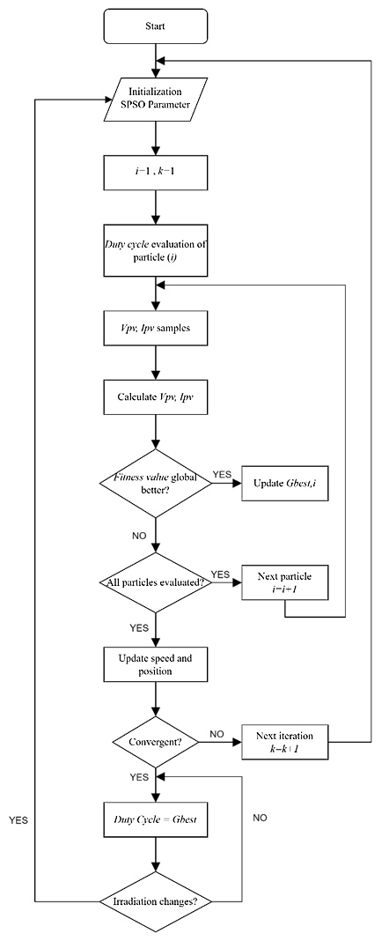
FIGURE 5. Simplified PSO Flowchart

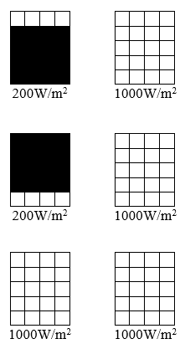
FIGURE 6. Partial shading pattern

The irradiation pattern applied in this study is 80% shading on 2 solar panels as shown in FIGURE 6. This pattern was determined because the PV system with this shading can produce a P-V characteristic curve with 2 peaks as shown in FIGURE 7. With 2 contrasting peaks, this system can provide a complete picture of the algorithm's performance.
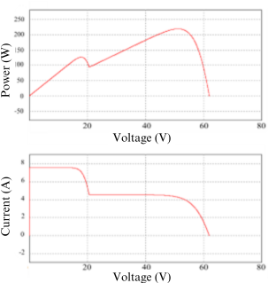
MPP Target (GMPP)
LMPP
FIGURE 7. P-V characteristic curve with 2 peaks

RESULTS AND DISCUSSION
This study focuses on evaluating the performance of the proposed Maximum Power Point (MPP) tracking algorithm. To provide a comparative analysis, performance data from tracking methods such as Perturb and Observe (P&O) and Modified Particle Swarm Optimization (MPSO), as reported in [13], are used as references. The results shown in TABLE 2 indicate that the Simplified Particle Swarm Optimization (SPSO) method managed to achieve faster convergence, with SPSO converging in 0.059 seconds, compared to the MPSO method, which took 0.108 seconds. FIGURE 8 illustrates the MPPT tracking process for each method, providing a clear comparison of their performance.
This faster convergence of SPSO highlights its significant potential for real-world applications, particularly in systems that require rapid responses to optimize generated power, such as in solar energy systems. However, although the SPSO method demonstrates a faster convergence rate compared to the metaheuristic-based MPSO method, this improvement in speed comes at the expense of accuracy in Maximum Power Point Tracking (MPPT). The simplification applied to the basic PSO algorithm in SPSO enables faster convergence but reduces the precision in identifying the maximum power point.In practical applications, this trade-off between speed and accuracy must be carefully considered. While systems that prioritize quick response times may benefit from the SPSO method, systems that require high precision in maximum power tracking might be better suited for more accurate methods, such as MPSO or further developments of the PSO algorithm. One approach to improving the accuracy of PSO-based methods is to develop algorithms that focus on a more meticulous and detailed tracking process. This can be achieved by adding variables that allow PSO to explore every possible solution point more thoroughly.
One such approach, as suggested in [19], involves incorporating a constriction factor into the PSO algorithm. The addition of a constriction factor aims to reduce the velocity of particles within the PSO algorithm, enabling it to search for solutions more carefully and thoroughly. As a result, the accuracy of MPPT can be improved. However, it should be noted that this increase in accuracy usually comes at the cost of a longer tracking process. In other words, the algorithm will require more time to achieve convergence, particularly under conditions of high variability, such as those commonly encountered in photovoltaic systems where light intensity and ambient temperature can change rapidly. Overall, further development of PSO algorithms to improve accuracy requires a balanced approach between convergence speed and tracking precision, which will depend heavily on the specific needs of the application.
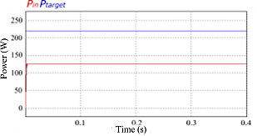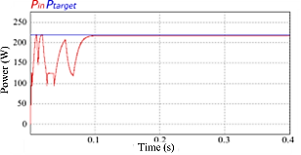
- (b)
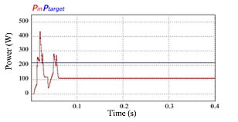
(c)
FIGURE 8. MPP tracking process based on each method (a) P&O (b) MPSO (c) SPSO

TABLE 2. Comparison of MPPT tracking results based on each method
 | Target | P&O | MPSO | SPSO
P_{in} | 219,24 W | 127,05 W | 217,29 W | 111,91 W
Accuracy | 100% | 57,95% | 99,11% | 51,04%
Convergence speed | - | 0,006 s | 0,108 s | 0,059 s

CONCLUSIONS
The research conducted in this context aims to present an alternative in the form of a metaheuristic optimization algorithm capable of accelerating the MPP tracking process in PV systems. The proposed SPSO method is a simplification of the basic PSO algorithm by eliminating the influence of Pbest on particles during the MPP tracking process. In the tests conducted, the SPSO method was shown to converge faster than the MPSO method, which is a variant of PSO that has been modified for higher complexity. However, as a consequence of this acceleration, there is a much lower accuracy value. Further development of the SPSO method could focus on improving accuracy without sacrificing convergence speed. Therefore, this research paves the way for further exploration into the development of MPPT algorithms that can strike an optimal balance between these two aspects.

REFERENCES
1. Reinders, A., H. Veldhuis, and A. Susandi. Development of grid-connected PV systems for remote electrification in Indonesia. IEEE.
2. Apriliyanto, W., F.D. Wijaya, and E. Firmansyah. Performance of microgrid with photovoltaic, synchronous generator and induction generator power sources. IEEE.
3. Femia, N., et al. Optimizing sampling rate of P&O MPPT technique. IEEE.
4. Femia, N., et al., Optimization of perturb and observe maximum power point tracking method. IEEE transactions on power electronics, 2005. 20(4): p. 963-973.
5. Jusoh, A.B., O.J.E.I. Mohammed, and T. Sutikno, Variable step size Perturb and observe MPPT for PV solar applications. TELKOMNIKA (Telecommunication Computing Electronics and Control), 2015. 13(1): p. 1-12.
6. Firmansyah, E. and S. Suharyanto, Variable Step Size P&O MPPT Algorithm on 250 W Interleaved Flyback Converter. IJITEE (International Journal of Information Technology and Electrical Engineering), 2018. 1(4): p. 132-138.
7. Megantoro, P., F.D. Wijaya, and E. Firmansyah. Analyze and optimization of genetic algorithm implemented on maximum power point tracking technique for PV system. IEEE.
8. Khairi, M.N.S., et al. MPPT design using PSO technique for photovoltaic system. IEEE.
9. Liu, G., et al. A MPPT algorithm based on PSO for PV array under partially shaded condition. IEEE.
10. Ishaque, K., et al., An improved particle swarm optimization (PSO)–based MPPT for PV with reduced steady-state oscillation. IEEE transactions on Power Electronics, 2012. 27(8): p. 3627-3638.
11. Murdianto, F.D., et al. Modeling and simulation of MPPT Sepic-boost using modified particle swarm optimization (MPSO)-FLC under dynamic partial shading condition in DC microgrid system. IEEE.
12. Khazain, M.A., et al. Boost converter of maximum power point tracking (MPPT) using particle swarm optimization (PSO) method. IEEE.
13. Humaidi, H.N.A., M.I.B. Setyonegoro, and S. Sarjiya, Performance of MPSO-MPPT on PV-Based DC Microgrid in Partial Shading Conditions. IJITEE (International Journal of Information Technology and Electrical Engineering). 5(4): p. 152-158.
14. Eltamaly, A.M., et al., Photovoltaic maximum power point tracking under dynamic partial shading changes by novel adaptive particle swarm optimization strategy. Transactions of the Institute of Measurement and Control, 2020. 42(1): p. 104-115.
15. Ishaque, K. and Z. Salam, A deterministic particle swarm optimization maximum power point tracker for photovoltaic system under partial shading condition. IEEE transactions on industrial electronics, 2012. 60(8): p. 3195-3206.
16. Mirbagheri, S.Z., M. Aldeen, and S. Saha. A PSO-based MPPT re-initialised by incremental conductance method for a standalone PV system. IEEE.
17. Eberhart, R. and J. Kennedy. A new optimizer using particle swarm theory. Ieee.
18. Rajendran, S. and H. Srinivasan, Simplified accelerated particle swarm optimisation algorithm for efficient maximum power point tracking in partially shaded photovoltaic systems. IET Renewable Power Generation, 2016. 10(9): p. 1340-1347.
19. Pervez, I., et al. An improved maximum power point tracking (MPPT) of a partially shaded solar PV system using PSO with constriction factor (PSO-CF). Springer.

