Combination of Plant System in LFC with PID Control Hybrid FPA-PSO Optimization
Fajri Alfitrah Baharudin Ahmad^{a)}, Ermanu Azizul Hakim^{b)}, Zulfatman^{c)}, and Haneef Nouval Alannibras Humaidi^{d)}
Electrical Engineering Department, University of Muhammadiyah Malang, Malang, Indonesia

^{d)} Corresponding author: haneefnouval@umm.ac.id
^{a)} fajrialfitrah15@webmail.umm.ac.id
^{b)} ermanu@umm.ac.id
^{c)} zulfatman@umm.ac.id
Abstract. Frequency stability in the power system will be disturbed due to Small Load Perturbance (SLP). Frequency changes can be controlled by the governor using Load Frequency Control (LFC). LFC, which is combined with several plants, has stability problems despite control and optimization. This problem can be overcome by adding energy storage devices (ESDs). One type of ESD is SMES which helps to overcome disturbance problems that affect frequency stability. In this research, a combination of renewable energy source (RES) power plant in the form of wind power plant and diesel power plant and added ESDs in the form of SMES and given hybrid PID control FPA-PSO optimization for better stability solutions. This plant combination has been successfully developed and simulated. Based on the simulation results of two plants used, namely diesel power plants and wind power plants, it can be concluded that the addition of SMES with FPA-PSO optimization in PID control, can overcome overshoot and undershoot and faster settling time than without the addition of SMES.
Keywords: Load Frequency Control; PID; FPA; PSO; FPA-PSO

INTRODUCTION
One of the power system problems is controlling the frequency area [1]. This needs to be done so that the distributed energy does not experience a significant decrease [2]. The provision of control algorithms is intended to handle the problem of frequency decline and provide a stable frequency with little oscillation [1]. The frequency drop and frequency stability will be disturbed due to the Small Load Perturbance (SLP) [3]. Frequency changes can be controlled by the governor using Load Frequency Control (LFC) [2]. In addition to LFC, research that has been done before, combines voltage control using Automatic Voltage Regulator (AVR) and frequency control using Load Frequency Control (LFC) [4-7] and combined with several power plants.
LFC combined with several plants, has stability problems despite PID control and has been optimized by HGA-PSO, AEFA, GWO, BSA, DE, and PSO. [5] But this problem can be reduced by giving Communication Time Delays (CTD). This CTD block is placed before entering the PID control. The other solution offered is using different control and tie-line addition as power sharing in multi area LFC [4]. Multi-area LFC and plant combination of LFC system have been done in several researches. In addition to the combined plant, other researchers added AVR as well as each control on LFC and AVR and even added optimization with various methods. [5] Conventional controls that have been used in several studies include PI [8, 9], PID [10, 11]/PIDD [12].
Previous research [5], used a multi-area LFC with the first area containing a thermal plant system with a reheat turbine then combined with two power plants including a hydro plant system and a gas plant system. Then the second area uses diesel plant system, wind plant system and solar PV plant system. In the paper, adding redox flow batteries (RFBs) and Interline power flow controller (IPFC) with tie-lines. The control used is PID control with hybrid optimization mainly differential evolution - artificial electric field (DE-AEFA). The next research [1] was conducted by adding several energy storage devices (ESDs) including RFBs, superconducting magnetic energy storage (SMES) and ultra capacitors (UCs). The controls used are PID and fuzzy logic which are optimized using a hybridized approach of the artificial electric field algorithm (HAEFA).
Furthermore, there is research [7] on multi-area LFC that uses renewable energy sources (RES) from solar PV and wind turbines. The first area uses solar PV and the second area uses wind turbines. Paper on the research, using CTD in its application. The control used is FOPI-PIDD which is optimized using Dandelion Optimizer (DO). There is another research [13] that uses RES that has multiple areas using solar PV and wind turbines. The control used is intellegent fractional-order integral (iFOI) with grey wolf optimization (GWO). The above two studies did not use ESD at all.
Based on the above studies, LFC can be combined with several plants and can be controlled using various controls and can be performed using various optimizations. However, the few studies found have not used ESD even though they have used RES. Therefore, in this study, it is proposed to use multi-area LFC with RES and use one type of ESD, namely SMES. The first area uses diesel power plant and the second area uses RES type wind power system using conventional PID control with hybrid optimization using flower pollination algorithm-particle swarm optimization (FPA-PSO).

METHODS
LFC or Automatic Generation Control (AGC) are terms that point in the same direction. The concept of frequency control in generation is closely related between the power generated and the power consumed. Excess power in a synchronous generator will cause acceleration and rotational speed to increase so that it will cause the frequency deviation value to be positive. And vice versa. If the power consumed increases, it can cause the frequency deviation to become negative and decrease. Setting the rotational speed of the synchronous generator needs to be considered so that it does not experience over-speed or under-speed. This setting can be done through several control areas on the LFC [14]. Frequency control has three control areas. The first control area is the primary control area. The second control area is the secondary control area and the last is the tertiary control area. If the LFC circuit uses more than one area, then the power change towards the tie-lines is also always maintained. While the tertiary control area is an area that is directly maintained by the mechanic or electrician on duty [15].
As a result, it is required to be maximized in distributing energy over long distances quickly and powerfully. In maximizing electricity sources, there are options that can be used even in remote areas. The option is to maximize renewable energy that has a microgrid concept [14]. The microgrid concept, allows users to control more than when using electricity providers managed by the company. In this research, the plants used are diesel power plants and wind power plants.
Diesel is the main driver in electricity production due to several advantages. The thermal brake efficiency of diesel's internal combustion chamber is quite high. Even the largest diesel engines can reach 50%. The 50% figure is not the peak efficiency of diesel engines. Instead, it can reach a range of 40%-110% . On the other hand, considering the earth has limited resources, where the need for energy supply is increasing, there is a need for renewable energy such as wind turbines. The way to use wind as energy is to convert kinetic energy into electricity. Given that wind energy is quite abundant, cheap and widespread throughout the earth and pollution-free [16].
The method carried out in this study is suggested as illustrated in the block diagram below to answer the problem formulation listed in the previous chapter.
In FIGURE 1 two PID controls are used with one control for each area and hybrid optimization using FPA-PSO is performed. Diesel plant is the first area and wind plant is the second area. Each area uses SMES in order to help minimize the frequency delta by providing frequency delta input as depicted in FIGURE 6. The load given is a step signal placed on the SLD. The diesel plant and wind plant are modeled into mathematics in the form of transfer function blocks and will be discussed further in this chapter. Likewise, the power system, SMES and AC tie line are modeled into transfer function blocks. The gain blocks are alpha, beta, and R.

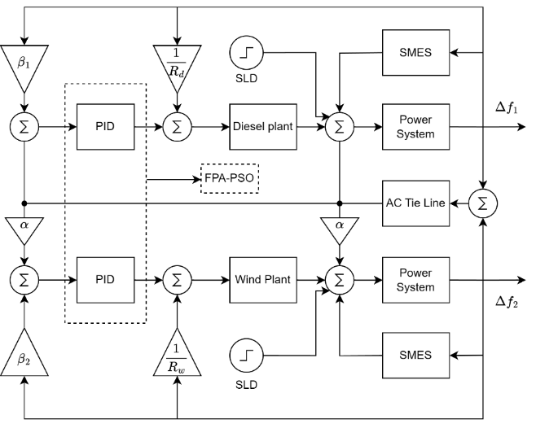
FIGURE 1. Multi Area LFC Block Diagram

DIESEL PLANT
The model of the governor and turbine system in the diesel plant consists of one gain constant and four times constants. The gain constant is placed in the numerator of the transfer function while one time constant is placed in the numerator and the remaining three are placed in the denominator of the transfer function.
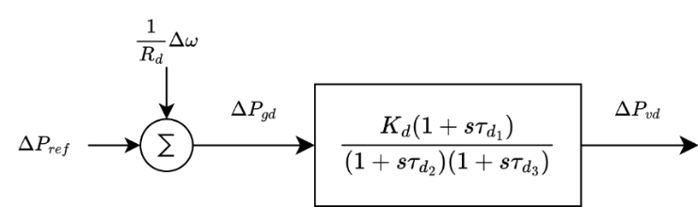
FIGURE 2. Governor Diesel Plant

Diesel governor constant $K_{d}$= 16.5 while $τ_{d1}, τ_{d2}, τ_{d3}$ = 1, 2, 0.025. the value is obtained from paper [5]. As for the turbine section, it is described as follows.
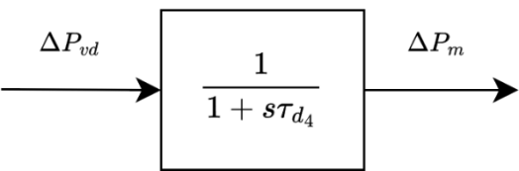
FIGURE 3. Turbin Diesel Plant

After going through the governor with input to where is the injection pump as input from the diesel turbine plant and produces which is the mechanical power output to change the size of the injection pump sprayed and modeled as in FIGURE 2 and FIGURE 3. There is one parameter time constant = 3.

WIND PLANT
The wind plant model has two gain constants and two times constants. The two gain constants are placed in the numerator while the two times constants are placed in the numerator and denumerator respectively. The wind plant consists of a hydraulic pitch actuator and a data fit pitch response. The hydraulic pitch actuator has one gain constant and two times constants (FIGURE 4). While the data fit pitch response has one gain constant and no time constant.
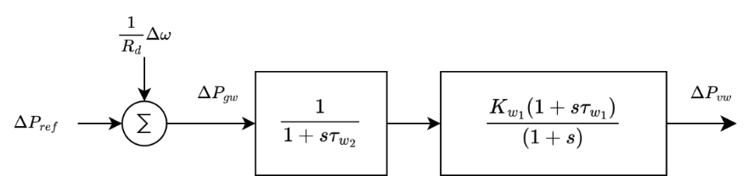
FIGURE 4. Hydraulic Pitch Actuator

The constants $τ_{ω1},τ_{ω2}, K_{ω1}$are 0.6, 0.041 and 1.25 respectively. Next is the pitch response fit data which is depicted as following FIGURE 5.

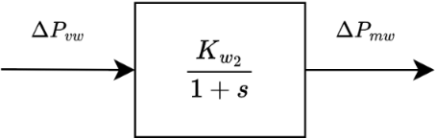
FIGURE 5. Data Fit Pitch Response

The pitch response data fit constant $K_{ω2}$ value is 1.4. These two transfer functions are modeled to protect the rotor from high speed and to maintain a stable output. The parameter values used in the wind plant are from paper [5].

SUPERCONDUCTING MAGNETIC ENERGY STORAGE (SMES)
SMES are used in power systems and are connected to superconducting coils on the ac power grid. The SMES inductor winding ${(E}_{d})$ is controlled through an input signal and energized then stored and released. As for references that use input signals other than frequency errors but are given input through control signals. The following FIGURE 6 is a block diagram of the SMES.

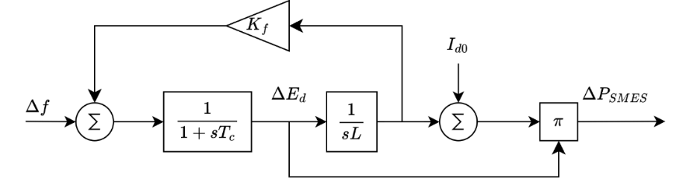
FIGURE 6. SMES Modelling

The value of the constant $K_{f}$ is 0.001 while, and $T_{c}$, $L$ dan $I_{d0}$ are 0.003, 3, and 20K, respectively. All values used are from paper [14]. In this study, the SMSES input is taken from the frequency error or delta frequency obtained from the power system. The power system model is described as follows.

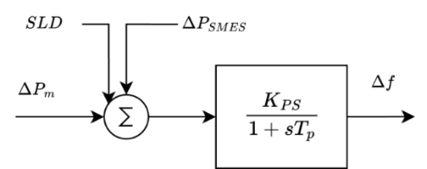
FIGURE 7. Power System

There is one power system in each area as depicted in the block diagram of FIGURE 1. In FIGURE 7, the power system can be used in the first area and the second area. The gain constant parameter $K_{PS}$ is 120 and is 20. This value is taken from paper [15].

FPA-PSO Hybrid Optimization
The FPA algorithm is a metaheuristic computing algorithm taken from the metaphor of a flower on a plant. Flowers are used to accommodate reproductive organs in which plant reproductive cells such as pollen and ovules can then produce seeds containing plants [17]. The PSO algorithm is a swarm-based optimization technique consisting of insects, farm animals, birds and fish. Each of these animal herds helps each other to find food and each one of the animal groups always looks for patterns based on the experience gained from other animal groups [18, 19].
The search for PID values with FPA-PSO optimization starts from FPA first until then the final value of FPA, will be used for initialization in PSO. This initialization will help PSO continue the search for the optimal PID value because it is assisted by FPA. This strategy is very helpful to find the optimal PID value. Although the process is quite time consuming (depending on the specifications of the laptop or desktop used), it is not a problem in this study. The following FIGURE 8 is the flowchart of FPA-PSO.

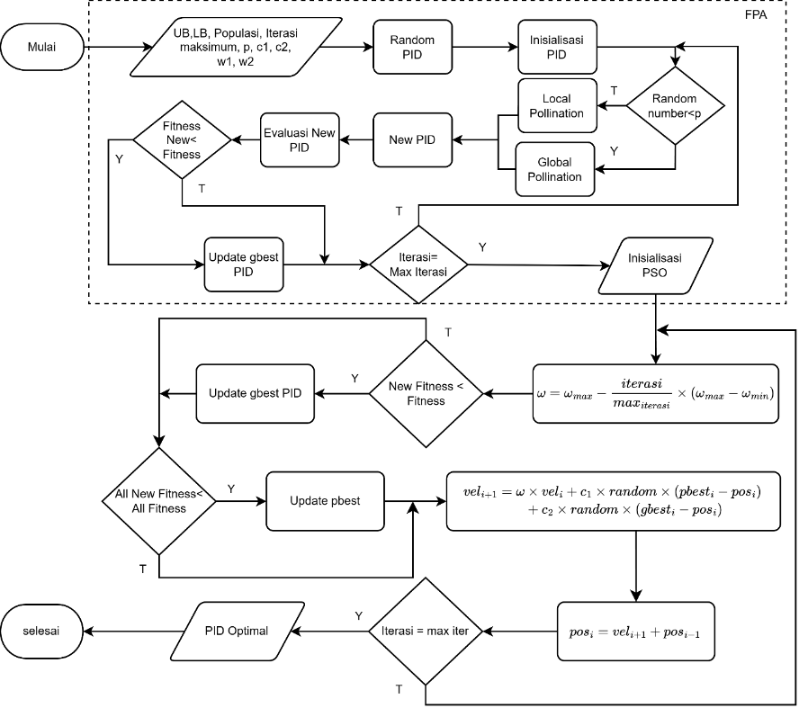
FIGURE 8. Diagram Alir FPA-PSO (in indonesian version)

The top section marked with a rectangular dashed line is FPA optimization while the unmarked line is PSO. FPA optimization uses local pollination and global pollination to find the optimal PID value. PSO uses a mathematical equation called velocity to find the optimal PID value candidate. One of the inputs from PSO and FPA is UB and LB, which are the upper bound and lower bound or the upper limit and lower limit of the PID value that cannot be less or more than the specified one. There is no specific way to determine UB and LB so it can be freely determined. This optimization process must have an objective function to assess how good the PID value is sought and given to the multi-area LFC system.

 | $$OF=ITSE+OS+E_{ss}+ t_{s}$$ | (1)

The objective function uses the mathematical equation (1) to find the optimal PID value. OS is overshoot, $E_{ss}$ is steady state error and is $t_{s}$ settling time.

RESULTS AND DISCUSSION
The results of PID control performance optimized using FPA, PSO and FPA-PSO combined (hybrid) are discussed in this section. In the previous section, it has been discussed how to perform hybrid optimization based on the FPA-PSO flowchart. The results of FPA and PSO will also be given separately and at the end of this sub-section, a comparison will be given regarding the results of FPA, PSO and FPA-PSO on PID control applied to diesel and wind power plans.

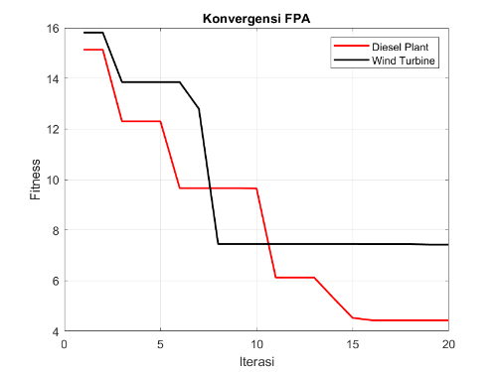 | 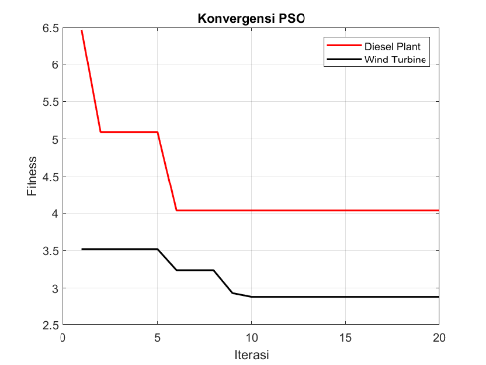 | 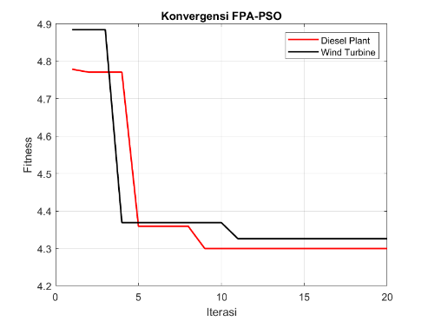
(a) | (b) | (c)
FIGURE 9. Convergence Charts (a)FPA (b)PSO (c)FPA-PSO (in indonesian version)

In the optimization of FPA-PSO diesel power plant, fitness decreased three times and twice for wind turbine. The value of the convergence graph shows how much progress will be optimized to reach the minimum value. It is not necessarily that the combined optimization will surpass the results of a single optimization algorithm. FIGURE 9 (a) above is evidence of a greater fitness value than FIGURE 9 (b) of the PSO algorithm. The result of FIGURE 9 (b) is able to surpass the result of FIGURE 9 (c). There is nothing wrong with this phenomenon. But even though the fitness value is still below PSO, at least the delta frequency waveform result of FPA-PSO is not worse than the PSO result. The following are the PID value results from several optimizations. it can be seen in TABLE 1.

TABLE 1. PID Optimization Diesel Power Plant
Optimization | P | I | D | Fitness
FPA | -2 | -1.300240866 | -1.514084316 | 4.435128587
PSO | -2 | -0.181857428 | -0.651022795 | 4.035295999
FPA-PSO | -1.592532315 | -0.678647168 | -1.884285692 | 4.299609421
Wind Power Plant
Optimization | P | I | D | Fitness
FPA | -1.272510385 | -0.682473335 | -0.791337141 | 7.426914535
PSO | -2 | -1.483456584 | -1.888012711 | 2.8847201
FPA-PSO | -2 | -1.145146109 | -1.943553406 | 4.325863226

If the optimized PID values are put into PID control, the waveform results will be different. Although the fitness value of PSO optimization is smaller than other methods, it does not hurt to look at the resulting graph.
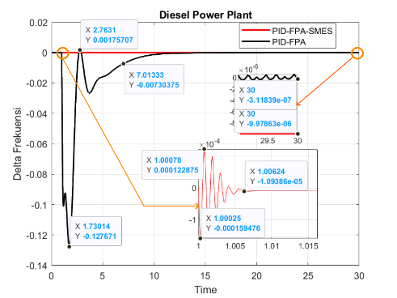 | 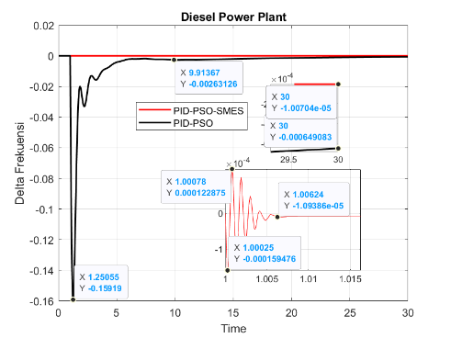 | 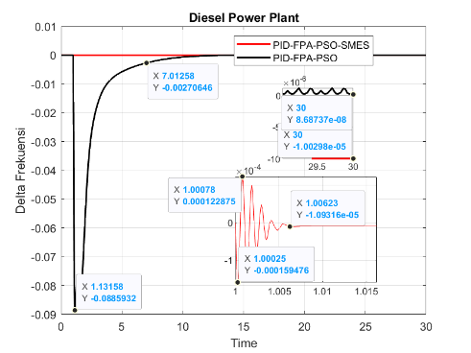
(a) | (b) | (c)
FIGURE 10. Diesel Optimasi (a)FPA (b)PSO (c)FPA-PSO (in indonesian version)

The maximum overshoot and maximum undershoot values using SMES have the same large value in each optimization algorithm FPA, PSO and FPA-PSO. Whereas, the PID value is different from the given one. PID has little effect on SMES for overshoot and undershoot parameters. Although it has no effect on overshoot and undershoot, in the end the steady state error can be different starting from FPA, PSO and FPA-PSO. The system without SMES, has oscillating wave values like FIGURE 10. But there is no significant problem because the oscillations are very small. The undershoot value is faster and smaller compared to the FPA and PSO algorithms as discussed in the previous section. When using FPA-PSO there is no overshoot at all like when using the PSO algorithm. After experiencing undershoot there is no oscillation shown in FIGURE 10 (a) and FIGURE 10 (b). Unlike FIGURE 10 (a) and FIGURE 10 (b) which oscillate first before going to the settling time. The wind turbine power plant can be seen as follows.

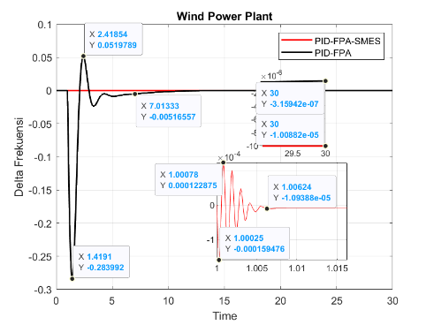 | 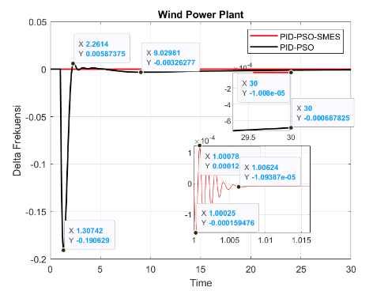 | 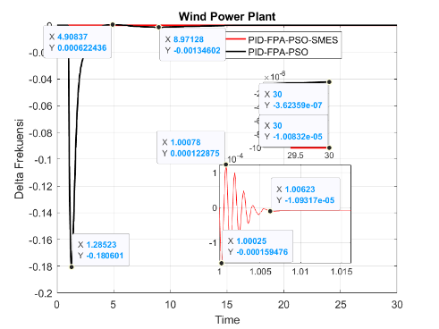
(a) | (b) | (c)
FIGURE 11. Wind Optimasi (a)FPA (b)PSO (c)FPA-PSO (in indonesian version)

Some disadvantages of the FPA-PSO results lie in the overshoot value and overshoot time when compared to using the PSO algorithm. Apart from that, the transient response of the FPA-PSO wind power plant algorithm is superior to the previous two algorithms. In seeing the value of the transient response parameters of each method and each plant with the given method, it can be seen in the following TABLE 2.

TABLE 2. Transient Response Diesel Power Plant PID
Comparison |  | FPA | PSO | FPA-PSO
Undershoot | Waktu | 1.730136928 | 1.2505545 | 1.131575258
Undershoot | Nilai | -0.127670765 | -0.159189512 | -0.088593172
Overshoot | Waktu | 2.418540826 | - | -
Overshoot | Nilai | -0.022494817 | - | -
Settling time | Waktu | 7.013327529 | 9.029806887 | 8.971280725
Settling time | Nilai | -0.007303753 | -0.002298089 | -0.001140074
Error steady state | Waktu | 30 | 30 | 30
Error steady state | Nilai | -3.11839E-07 | -0.000649083 | 8.68737E-08
Total Score |  | 1 | 2 | 6

In TABLE 2 shows the number given yellow color means superior to the comparison. There is an exception to the score calculation at the steady state error time. Because the steady state error is taken from the last time of simulation which is 30 seconds. The reason why 30 seconds and not 50 seconds or so on is because 30 seconds is certain the system will be steady state seen from the average settling time at 8.3 seconds.

TABLE 3. Transient Response Diesel Power Plant PID-SMES
Comparison |  | FPA | PSO | FPA-PSO
Undershoot | Time | 1.00024722 | 1.00024722 | 1.00024722
Undershoot | Value | -0.000159476 | -0.000159476 | -0.000159476
Overshoot | Time | 1.000784951 | 1.000784951 | 1.000784951
Overshoot | Value | 0.000122875 | 0.000122875 | 0.000122875
Settling time | Time | 1.006236584 | 1.006236528 | 1.006231117
Settling time | Value | -1.09386E-05 | -1.09386E-05 | -1.09316E-05
Error steady state | Time | 30 | 30 | 30
Error steady state | Value | -9.97863E-06 | -1.00704E-05 | -1.00298E-05
Total Score |  | 4 | 4 | 7

In TABLE 3 shows the difference in the score of the scores using SMES is very small and does not look much different. Even some values have exactly the same value. PID control with different values does not have a big effect on SMES. This happens because SMES behaves like a system injector into the generator. So it can change the value directly.
TABLE 4. Transient Response Wind Power Plant PID
Comparison |  |  | PSO | FPA-PSO
Undershoot | Time | 1.419098512 | 1.307419352 | 1.285230807
Undershoot | Value | -0.283991653 | -0.190629027 | -0.180600863
Overshoot | Time | 2.418540826 | 2.261396659 | 4.908373752
Overshoot | Value | 0.051978935 | 0.005873749 | 0.000622436
Settling time | Time | 7.013327529 | 9.029806887 | 8.971280725
Settling time | Value | -0.005165571 | -0.003262771 | -0.001346025
Error steady state | Time | 30 | 30 | 30
Error steady state | Value | -3.15942E-07 | -0.000687825 | -3.62359E-07
Total Score |  |  | 0 | 4

In TABLE 4 shows When using a diesel power plant, the PID control successfully suppresses overshoot without generating it. It is different when using a wind power plant. All three methods with two algorithms were unable to suppress overshoot. But it does not matter even if it is unable to suppress overshoot. The overshoot value is very minimal and there is no need to doubt that it will interfere with the starting performance of the system.
TABLE 5. Transient Response Wind Power Plant PID-SME
Comparison |  |  | PSO | FPA-PSO
Undershoot | Time | 1.00024722 | 1.00024722 | 1.00024722
Undershoot | Value | -0.000159476 | -0.000159476 | -0.000159476
Overshoot | Time | 1.000784951 | 1.000784951 | 1.000784951
Overshoot | Value | 0.000122875 | 0.000122875 | 0.000122875
Settling time | Time | 1.006236584 | 1.006236528 | 1.006231117
Settling time | Value | -1.09388E-05 | -1.09387E-05 | -1.09317E-05
Error steady state | Time | 30 | 30 | 30
Error steady state | Value | -1.00882E-05 | -1.008E-05 | -1.00832E-05
Total Score |  |  | 5 | 6

In TABLE 5 The comparative values of transient response in wind power plants are also many similarities. As is the case with diesel power plants. Some other manuscripts [20-22] mentioned that, the use of SMES transient response results are always superior to the model without SMES. From the manuscripts that have been listed, there are those that combine SMES with UPFC and have even better transient response.

CONCLUSIONS
The combination of plant system in LFC with PID control hybrid FPA-PSO optimization has been successfully developed and simulated. Based on the simulation results of two plants used, namely diesel and wind power plants, it can be concluded that the use of PID without SMES and with SMES can each be used separately or combined. If using PID without SMES, then the best result is PID when FPA-PSO optimization is performed. Although the fitness value of FPA-PSO is higher than PSO optimization, the transient response parameter of FPA-PSO is better. When using PID and SMES, the best result is the optimization of FPA-PSO.

References
1. Kalyan, C.H.N.S., et al., Comparative performance assessment of different energy storage devices in combined LFC and AVR analysis of multi-area power system. Energies, 2022. 15(2): p. 629.
2. Rajbongshi, R. and L.C. Saikia, Combined control of voltage and frequency of multi‐area multisource system incorporating solar thermal power plant using LSA optimised classical controllers. IET Generation, Transmission & Distribution, 2017. 11(10): p. 2489-2498.
3. Prakash, A. and S.K. Parida. Combined frequency and voltage stabilization of thermal-thermal system with UPFC and RFB. IEEE.
4. Ramoji, S.K. and L.C. Saikia, Utilization of electric vehicles in combined voltage‐frequency control of multi‐area thermal‐combined cycle gas turbine system using two degree of freedom tilt‐integral‐derivative controller. Energy Storage, 2021. 3(4): p. e234.
5. Kalyan, C.H.N.S. and G.S. Rao, Impact of communication time delays on combined LFC and AVR of a multi-area hybrid system with IPFC-RFBs coordinated control strategy. Protection and Control of Modern Power Systems, 2021. 6(1): p. 1-20.
6. Sahani, A.K., et al., Firefly optimization based control strategies for combined load frequency control and automatic voltage regulation for two-area interconnected power system. International Journal on Electrical Engineering and Informatics, 2019. 11(4): p. 747-758.
7. Alharbi, M., et al., Innovative AVR-LFC design for a multi-area power system using hybrid fractional-order PI and PIDD2 controllers based on dandelion optimizer. Mathematics, 2023. 11(6): p. 1387.
8. Mohanty, B. and P.K. Hota, A hybrid chemical reaction-particle swarm optimisation technique for automatic generation control. Journal of Electrical Systems and Information Technology, 2018. 5(2): p. 229-244.
9. Yousri, D., T.S. Babu, and A. Fathy, Recent methodology based Harris Hawks optimizer for designing load frequency control incorporated in multi-interconnected renewable energy plants. Sustainable Energy, Grids and Networks, 2020. 22: p. 100352.
10. Guha, D., P.K. Roy, and S. Banerjee, Load frequency control of interconnected power system using grey wolf optimization. Swarm and Evolutionary computation, 2016. 27: p. 97-115.
11. Madasu, S.D., M.L.S.S. Kumar, and A.K. Singh, A flower pollination algorithm based automatic generation control of interconnected power system. Ain Shams Engineering Journal, 2018. 9(4): p. 1215-1224.
12. Suresh, C.V. PIDD controller for AGC of nonlinear system with PEV integration and AC-DC links. IEEE.
13. Zaid, S.A., et al., A new intelligent fractional-order load frequency control for interconnected modern power systems with virtual inertia control. Fractal and Fractional, 2023. 7(1): p. 62.
14. Dehghanpour, K. and S. Afsharnia, Electrical demand side contribution to frequency control in power systems: a review on technical aspects. Renewable and Sustainable Energy Reviews, 2015. 41: p. 1267-1276.
15. Alhelou, H.H., et al., Challenges and opportunities of load frequency control in conventional, modern and future smart power systems: a comprehensive review. Energies, 2018. 11(10): p. 2497.
16. Rediske, G., et al., Wind power plant site selection: A systematic review. Renewable and Sustainable Energy Reviews, 2021. 148: p. 111293.
17. Abdel-Basset, M. and L.A. Shawky, Flower pollination algorithm: a comprehensive review. Artificial Intelligence Review, 2019. 52: p. 2533-2557.
18. Wang, D., D. Tan, and L. Liu, Particle swarm optimization algorithm: an overview. Soft computing, 2018. 22(2): p. 387-408.
19. Juneja, M. and S.K. Nagar. Particle swarm optimization algorithm and its parameters: A review. IEEE.
20. Mishra, D.K., D. Złotecka, and L. Li, Significance of SMES devices for power system frequency regulation scheme considering distributed energy resources in a deregulated environment. Energies, 2022. 15(5): p. 1766.
21. Alghamdi, S., et al., First-of-its-kind frequency enhancement methodology based on an optimized combination of FLC and TFOIDFF controllers evaluated on EVs, SMES, and UPFC-integrated smart grid. Fractal and Fractional, 2023. 7(11): p. 807.
22. Kumar, N., et al., Application of fractional order-PID control scheme in automatic generation control of a deregulated power system in the presence of SMES unit. Mathematics, 2022. 10(3): p. 521.

