Implementation of Three Wheeled Omnidirectional Kinematics on Soccer Robot
Aditya Nugraha Putra^{a)}, Novendra Setyawan^{b)}, and Nur Alif Mardiyah^{c)}
Department of Electrical Engineering, University of Muhammadiyah Malang, Malang, Indonesia

^{b)} Corresponding author: novendra@umm.ac.id
^{a)} aditya113@webmail.umm.ac.id
^{c)} nuralif@umm.ac.id
Abstract. Three-wheeled omnidirectional soccer robots are increasingly significant in robotics for sports competitions. Understanding their kinematic behavior is essential for achieving effective movement on the field, as their unique omnidirectional wheels allow for highly adaptable and precise motions. This configuration, with each wheel able to rotate independently, enables the robot to move in any direction without needing to adjust its body orientation. This research investigates the kinematic model specific to these robots, detailing the mathematical relationships between wheel speeds and the robot’s linear and angular movements. Furthermore, it examines practical applications of this model in robot control, discussing control methods that improve stability and responsiveness during gameplay. The results provide useful insights into designing and advancing three-wheeled omnidirectional soccer robots and underscore their potential to enhance performance and strategy in competitions.
Keywords: Robot, Indonesian Robot Contest, Omnidirectional, Kinematic, Control

INTRODUCTION
The advancement of soccer robots has emerged as a prominent research focus in recent years, particularly for events like the Indonesian Robot Contest. Various configurations have been tested, with one of the most successful approaches involving the implementation of omnidirectional wheel [1]. This setup enables the robot to attain exceptional flexibility and maneuverability in various directions, which is essential for competitive effectiveness. This study focuses on developing a soccer robot with a three-wheeled omnidirectional configuration, specifically engineered to boost competitive performance. The robot features three omni wheels arranged at 120-degree angles from one another [2]. This setup enables the robot to execute lateral, forward, backward, and rotational maneuvers with impressive speed and precision [3].
The robot's design relies on a microcontroller functioning as the central control unit. This microcontroller connects different sensors and actuators required for accurately managing the robot's movements [4]. Tailored control algorithms are implemented to synchronize the robot’s actions, allowing each movement to be carried out with precision.
This study seeks to enhance the robot's competitive performance while also promoting the development of advanced, practical robotics technology in the field of soccer robotics.

METHODS

SYSTEM FLOW DIAGRAM
The developed robot is designed to move flexibly in multiple directions, such as sideways, forward, backward, and diagonally, along with combinations of these directions. It is also able to kick the ball with both force and accuracy and can receive and dribble the ball effectively. FIGURE 1 shows the flow diagram of the soccer robot system, which is equipped with a three-wheeled omnidirectional motor setup. Each motor operates with a specific RPM, which is controlled through kinematics. An encoder measures the RPM, offering feedback for the PID controller. The diagram further illustrates the kinematic calculations for determining the robot's position, utilizing angle parameters and odometry.
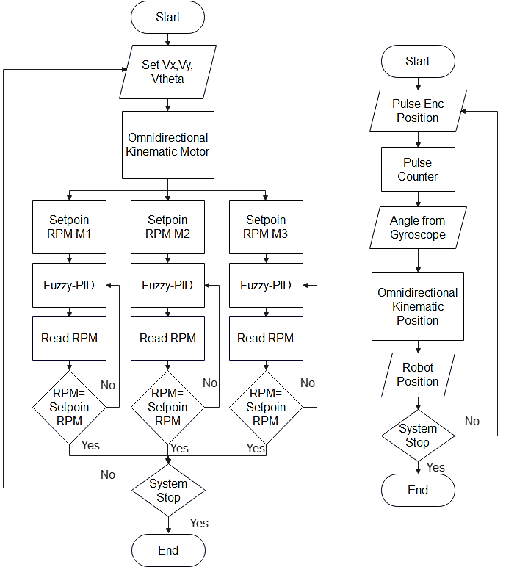
FIGURE 1. System flow diagram

RESULTS AND DISCUSSION
In kinematics testing, the success criteria include the software's capability to set the motor speed based on kinematic calculations accurately. The testing procedure involves inputting the movement direction and speed toward the target direction, monitoring each motor's speed, observing the robot's motion, and recording the distance the robot travels from its starting point. The outcomes are presented in TABLE 1.

TABLE 1. Motor direction and speed
Coordinate Setpoint (X,Y) | Motor 1 Direction | Motor 1 Speed (RPM) | Motor 2 Direction | Motor 2 Speed (RPM) | Motor 3 Direction | Motor 3 Speed (RPM)
0,100 | CW | 81.84 | - | 0 | CCW | 81.84
100,0 | CW | 52.08 | CCW | 96.72 | CW | 52.08
0,-100 | CCW | 81.84 | - | 0 | CW | 81.84
-100,0 | CCW | 52.08 | CW | 96.72 | CCW | 52.08
100,100 | CW | 141.36 | CCW | 96.72 | CCW | 37.2
100,-100 | CCW | 37.2 | CCW | 96.72 | CW | 141.36
-100,100 | CW | 37.2 | CW | 96.72 | CCW | 141.36
-100,-100 | CCW | 141.36 | CW | 96.72 | CW | 37.2

This test assesses how closely the robot's movement matches the actual measured distance. The procedure involves moving the robot based on precise measurements and then comparing the actual distance it covers to the distance recorded by the robot, thereby determining the measurement error. According to the data, the maximum error recorded is 8%, indicating a movement accuracy of 92% for the robot. The detailed results are presented in TABLE 2.

TABLE 2. Robot movement measurement based on coordinates
Coordinate Setpoint (X,Y) | Position With Manual Measurement | Error
0,100 | 0,103 | 1.5%
100,0 | 109,0 | 4.5%
0,-100 | 0,-106 | 3%
-100,0 | -104,0 | 2%
100,100 | 109,107 | 8%
100,-100 | 103,-105 | 4%
-100,100 | -106,106 | 6%
-100,-100 | -107,-106 | 6.5%

In this experiment, the robot is directed to move across multiple coordinates, adjusting its speed according to predefined set points. The outcomes are presented in TABLES 3 and 4.

TABLE 3. Robot movement with more than 1 coordinate
Coordinate Setpoint 1 (X,Y,W) | Coordinate Setpoint 2 (X,Y,W) | Coordinate Setpoint 3 (X,Y,W) | Result
0,100,0 | 100,100,0 | 0,0,0 | Success
0,100,90 | 100,0,-90 | 100,100,30 | Success
100,100,0 | -100,100,30 | -100,-100,120 | Success
200,0,0 | 200,150,0 | 0,200,0 | Success
125,100,-90 | -125, 200,-90 | 0,0,0 | Success

TABLE 3 displays the outcomes of tests assessing the robot's ability to reach multiple setpoints in order. Each test involves three specific coordinate setpoints, designated as (X, Y, W), where X and Y denote the robot's position on a plane, and W signifies its orientation. The first column identifies the initial setpoint where the robot begins. Following this, the robot is directed to reach the second setpoint, as indicated in the second column, and then to proceed to the third setpoint, as shown in the third column. The "Result" column verifies if the robot successfully arrived at each setpoint in the correct sequence. The results in the table indicate that the robot consistently navigated through each specified setpoint across all tests, showcasing dependable performance in reaching multiple coordinates.

TABLE 4. Change in robot speed while moves
Coordinate Setpoint 1 (X,Y,W) | Speed Setpoint | Coordinate Setpoint 2 (X,Y,W) | Speed Setpoint | Result
0,200,0 | 50 | 200,200,0 | 150 | Success
200,0,0 | 100 | 200,200,0 | 50 | Success
0,50, 90 | 200 | 100,100,90 | 100 | Success
250,30,-90 | 225 | 0,0,0 | 100 | Success
50,350,0 | 50 | 200,-350,90 | 225 | Success

TABLE 4 presents an overview of the robot's ability to adjust speed between two distinct coordinate targets. In each trial, the robot starts at an initial setpoint, noted in the first column as (X, Y, W), where X and Y denote position and W represents orientation. The second column provides the designated speed setpoint for this initial movement. Once the robot reaches this initial target, it moves toward a second setpoint, with updated coordinates and speed setpoints detailed in the third and fourth columns, respectively. The "Result" column reports if the robot effectively altered its speed and completed the transition between setpoints. Overall, the table indicates that the robot consistently succeeded in adapting its speed and navigating between the designated coordinates, demonstrating reliable control over movement and speed adjustments.

CONCLUSIONS
The study led to the creation of a soccer-playing robot with a three-wheeled omnidirectional kinematic design. The results indicate that the robot's kinematic functionality was successfully implemented. A primary finding is that the robot’s movements correspond closely to the designated coordinates, showing only minor positioning errors after movement. Additionally, the robot can reach high speeds while maintaining a positioning accuracy of 92%.

Acknowledgments
The author expresses appreciation to Icon-TINE Call for Papers for hosting the Seminar 2024 event. Gratitude is also extended to Universitas Muhammadiyah Malang for its support of the ZhafaruL team and for providing financial assistance toward the development of the wheeled soccer robot.

References
1. Kurniawan, G.W., N. Setyawan, and E.A. Hakim, PID Trajectory Tracking Control 4 Omni-Wheel Robot. SinarFe7, 2019. 2(1): p. 345-350.
2. Yunardi, R.T., et al., Holonomic Implementation of Three Wheels Omnidirectional Mobile Robot Using DC Motors. Journal of Robotics and Control (JRC), 2021. 2(2): p. 65-71.
3. Wibowo, I.K., et al. Penentuan Posisi Robot Menggunakan Odometry Omniwheel. in The Indonesian Symposium on Robot Soccer Competition 2018. 2018. Surabaya, Indonesia: Politeknik Elektronika Negeri Surabaya (PENS).
4. Syeichu, M.M., P.W. Rusimamto, and I.G.P.A. Buditjahjanto, Desain Sistem Pengaturan Kecepatan Motor Dc Pada Prototipe Elevator Menggunakan Hybrid Fuzzy-Pid Controller. Jurnal Teknik Elektro, 2021. 10(2): p. 405-4012.

