Optimization Automatic Voltage Regulator and Load Frequency Control using Model Predictive Control Tunning Particle Swarm Optimization
Rohmayanti Rohmayanti^{a)}, Zulfatman Zulfatman^{b)}, and Ilham Pakaya^{c)}
Department of Electrical Engineering, Universitas Muhammadiyah Malang, Malang, Indonesia

^{c)} Corresponding Author: ilham@umm.ac.id
^{a)} rohmayanti098@gmail.com
^{b)} zulfatman@umm.ac.id
Abstract. This research aims to design AVR and LFC with MPC-PSO method that can maintain the stability of voltage and frequency output system. As well as optimizing the AVR and LFC models using the MPC-PSO method designed to optimally stimulate voltage and frequency using Matlab simulink. Optimization using PSO is done as many as 20 populations and 50 iterations. The results of MPC-PSO and MPC-init are different at the time speed only on the LFC plant, as well as what happens on the AVR plant. Following the details of the step response of LFC and AVR, the base frequency and base voltage values are set to 50 Hz and 20 kV, respectively. Based on the base frequency and base voltage values, the undershoot value is 49.9926 Hz. While the overshoot values are 50.00187 Hz and 50.0000159 Hz for frequency steady state. In AVR, there are only two step response analysis, namely overshoot and steady state. The overshoot value of MPC-PSO is higher than the initialization value of 24.38 kV and for steady state it is 19.8 kV. Although MPC-PSO has a higher overshoot, the steady state time is faster than the initialized MPC. Although MPC can perform control with two plants, suggestions for further development should use one MPC for one plant for optimal results. If you want to do MPC optimization, it is better to use a device that has higher specifications so that the use of time is more efficient.
Keywords: Model Predictive Control, PSO, Automatic Voltage Regulator, Load Frequency Control, Geothermal

INTRODUCTION
A geothermal power plant is a type of power plant that uses steam heat from within the Earth as its primary energy source to drive turbines. Given Indonesia's geographical conditions, there is significant geothermal potential that can be optimally utilized. Geothermal power plants have several advantages over other primary energy sources, one of which is that they are clean and environmentally friendly. Geothermal energy is considered a renewable energy source because the process of exploration and heat processing generates far less heat than the geothermal energy itself. The carbon dioxide (CO2) emissions produced by geothermal power plants are currently approximately 122 kg CO2 per megawatt-hour (MW·h) of electricity. Compared to coal-fired power plants, the emissions from geothermal power plants are much lower, about one-eighth of the emissions from coal-fired power plants [1]. However, geothermal power plants also have negative environmental impacts that must be minimized, including air pollution, water pollution, noise pollution, and land subsidence.
In practice, Automatic Voltage Regulator (AVR) and Load Frequency Control (LFC) systems are expected to provide a quick response to stabilize voltage and frequency during load changes. However, some AVR and LFC systems still exhibit relatively high discrepancies in terms of undershoot, overshoot, settling time, and steady-state performance. These discrepancies arise because some systems primarily focus on improving response under load conditions without considering the variability in system performance. Ideally, AVR and LFC systems should be able to learn from both poor and optimal responses, comparing these conditions to achieve the best optimization. This approach ensures that AVR and LFC systems can effectively stabilize voltage and frequency, fulfilling their intended function for power supply to the public.
To address this issue, the author proposes using a mathematical model known as Model Predictive Control (MPC). According to a study published in the journal titled “Improved Model Predictive Load Frequency Control of Interconnected Power System with Synchronized Automatic Generation Control Loops” [1], research was conducted on the transient response of AVR and LFC systems, comparing those without MPC to those with MPC. The results demonstrated a reduction in response time by 23.21% and 20.83% with the use of MPC. These findings suggest that the MPC model can effectively predict the factors influencing AVR and LFC responses [2].
To further enhance this model, the author also suggests integrating artificial intelligence, specifically Particle Swarm Optimization (PSO). This integration aims to analyze and improve poor AVR and LFC responses, thereby minimizing poor voltage and frequency responses and achieving better, more stable, and robust system outputs [3]. Several studies have shown that various AVR and LFC designs equipped with artificial intelligence have successfully reduced poor performance responses. From several parameter indices used in these studies, it can be concluded that AVR and LFC systems equipped with artificial intelligence can automatically adjust to the load requirements of AVR and LFC devices. Therefore, based on this research, the author intends to optimize AVR and LFC systems using Model Predictive Control tuned with PSO [4]. This optimization aims to ensure that AVR and LFC systems perform as intended, achieving average performance with relatively shorter response times. Additionally, it enhances the robustness of the system against load changes, allowing for improved voltage and frequency output compared to previous systems [5].

METHODS

Research Methodology
To ensure that the research can be conducted in alignment with the title "Optimization of Automatic Voltage Regulator and Load Frequency Control using Model Predictive Control (MPC) Tuning with Particle Swarm Optimization (PSO)," the following steps are outlined: problem identification, literature review, data collection, system modeling, system design, and system testing, as shown in FIGURE 1.
FIGURE 1 shows the flowchart for the research phases to be conducted. The first step in this research is to identify the problems that form the basis of the study background. Following the problem identification, a literature review will be conducted to understand what needs to be done and to recognize the weaknesses of each reference collected, whether from books or journals. The next phase involves data collection, where data from previous studies will be used as a reference for this research, including various parameters related to AVR and LFC. Once the AVR and LFC parameters are collected, the next step is to gather data on PSO algorithm parameters. After collecting all necessary parameters, the research will proceed to integrate AVR and LFC with the MPC-PSO combination using Simulink in MATLAB. The testing phase will involve simulating AVR and LFC under open-loop control conditions [6]. Following this, simulations will be conducted with closed-loop control based on MPC-PSO. The expectation is to observe significant differences in response improvements between open-loop and closed-loop control in the AVR and LFC systems. Finally, the time response results, including rise time, settling time, and maximum overshoot, will be analyzed to draw conclusions from the research [7].

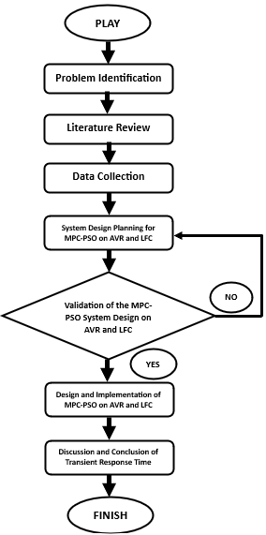
FIGURE 1. Flowchart of Research Phases

Literature Review
In this literature review, information and references are collected to support the research process. The sources used include books, journals, and theses related to AVR and LFC.

Data Collection
The following data presents the parameters for the combination of AVR and LFC systems, In TABLE 1: AVR and LFC Parameter Combination and TABLE 2 PSO algorithm Parameters.
TABLE 1. AVR and LFC Parameter Combination
Parameters | Value
Governor induction time (TG) response | 0.2s
Induction turbine response time (TT) | 0.5s
Inertia Constant (H) | 10s
ΔPd | 0.1 p.u
Induction Exciter Gain (Ke) | 1
Induction Exciter Response Time (Te) | 0.1s
Induction Amplifier Gain (Ka) | 1.0
Induction Amplifier Response Time (Ta) | 0.4s
Induction generator regulator amplifier (Kg | 1
Induction generator response time (Tg) | 1.4s
Induction sensor regulator amplifier (Ks) | 1
Induction sensor response time (Ts) | 0.5s
R | 60 Hz/p.u
D | 1.1 MW/Hz
TABLE 2. PSO Algorithm Parameters
Parameters | Value
Population Size | 50
Number of generations | 50
Weight (w) | 0.9
Cognitive coefficient (C1) | 2.0
Social coefficient (C2) | 2.0

System Modeling

AVR and LFC
Here is the system optimization design shown in the FIGURE 2.
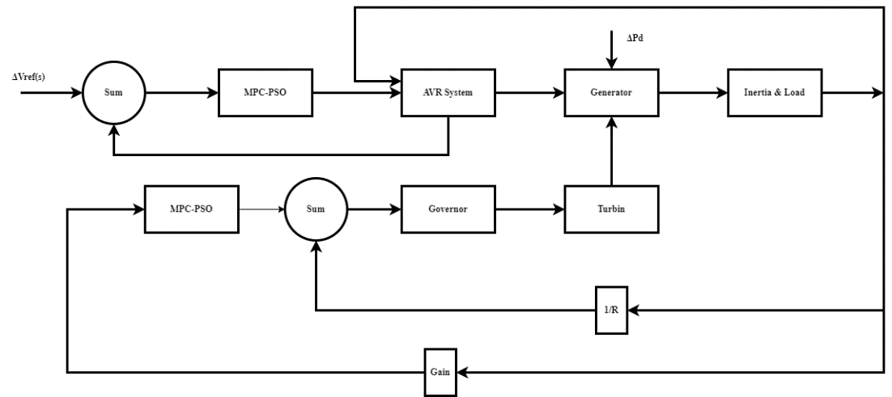
FIGURE 2. System Design for AVR & LFC Optimization with MPC-PSO

By referring to FIGURE 2, which illustrates the system design, it can be observed that the AVR and LFC are designed to stimulate voltage and frequency at the generator output. Generally, AVR and LFC serve as voltage and frequency controllers aimed at maintaining stable voltage and frequency outputs even with unpredictable load conditions, such as those in synchronous generators [8]. However, AVR and LFC still have weaknesses, as their response to load changes can be relatively slow in stabilizing voltage and frequency. Therefore, this research requires a specialized method to achieve optimal voltage and frequency control. The proposed method for this research is Model Predictive Control (MPC). In addition to MPC, Particle Swarm Optimization (PSO) will also be applied to optimize the control system. This combined approach aims to enhance the responsiveness and performance of the AVR and LFC systems, ensuring more effective stabilization of voltage and frequency.

MPC
Model Predictive Controller or commonly known as MPC is an effort to improve or optimize the response time of AVR and LFC. According to a journal published with the title "Improved model predictive load frequency control of interconnected power system with synchronized automatic generation control loops" [9], the journal showed a decrease of 29.68% and 22.77% in response time between AVR and LFC optimized with MPC compared to AVR and LFC without MPC optimization. From this reference, it can be seen that by implementing the MPC method into the AVR and LFC systems, it is expected to provide a more responsive response time in this study. Furthermore, the design of the MPC in this research will be presented as shown in the FIGURE 3.
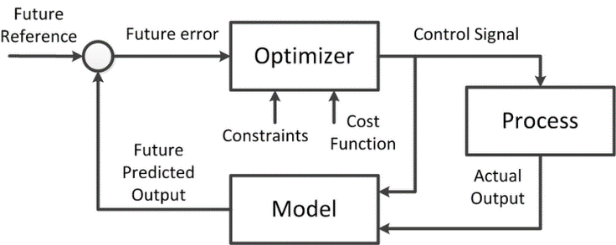
FIGURE 3. MPC System Design

In FIGURE 3, by providing a reference signal (ref) and a measurable disturbance signal (md), the actual conditions can be simulated to demonstrate how MPC works to improve the time response of AVR and LFC systems. The output from the MPC will continue to be calculated with the AVR and LFC system model to determine the difference between the reference output and the system output. This MPC model aims to minimize the time response issues as much as possible. To effectively utilize MPC, several key aspects need to be considered, as MPC involves two main components: the prediction part and the control part. In the prediction part, MPC is responsible for forecasting the future state of the system based on the previous distribution of AVR and LFC. In the control part, MPC determines the actions to be taken once the future predictions have been calculated [10].

PSO
Particle Swarm Optimization, or PSO, is a stochastic evolutionary computation technique based on the movement and intelligence of swarms. The PSO algorithm combines both the cognitive behavior and cooperation of each individual. It was developed to address nonlinear optimization problems with continuous variables. In the PSO algorithm, the fitness value is measured based on evaluations performed within one epoch. In this research, the PSO algorithm is designed to optimize the performance of the MPC. When the MPC predicts and controls the actions to be taken to improve the AVR and LFC system, the PSO algorithm will act as a validator to determine if the actions taken by the MPC actually improve the system's time response for AVR and LFC. Additionally, the PSO algorithm is responsible for remembering each process that has been executed, providing more valid references to the MPC system. FIGURE 4 represents the MPC-PSO design proposed in this research.

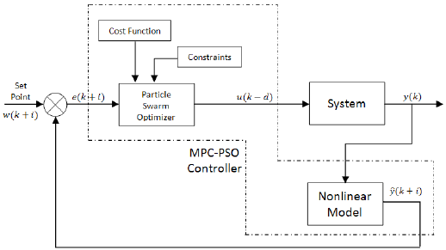
FIGURE 4. PSO System Design

To run the PSO algorithm, several parameters need to be considered, such as population size, weight, and acceleration factors.

Design of AVR-LFC Controller with MPC-PSO
In this system design, MATLAB Simulink 2022 is used to design an MPC-PSO control system for LFC and AVR. The results of this system will then be applied to a large-scale power system. The overall system design can be seen in FIGURE 5.
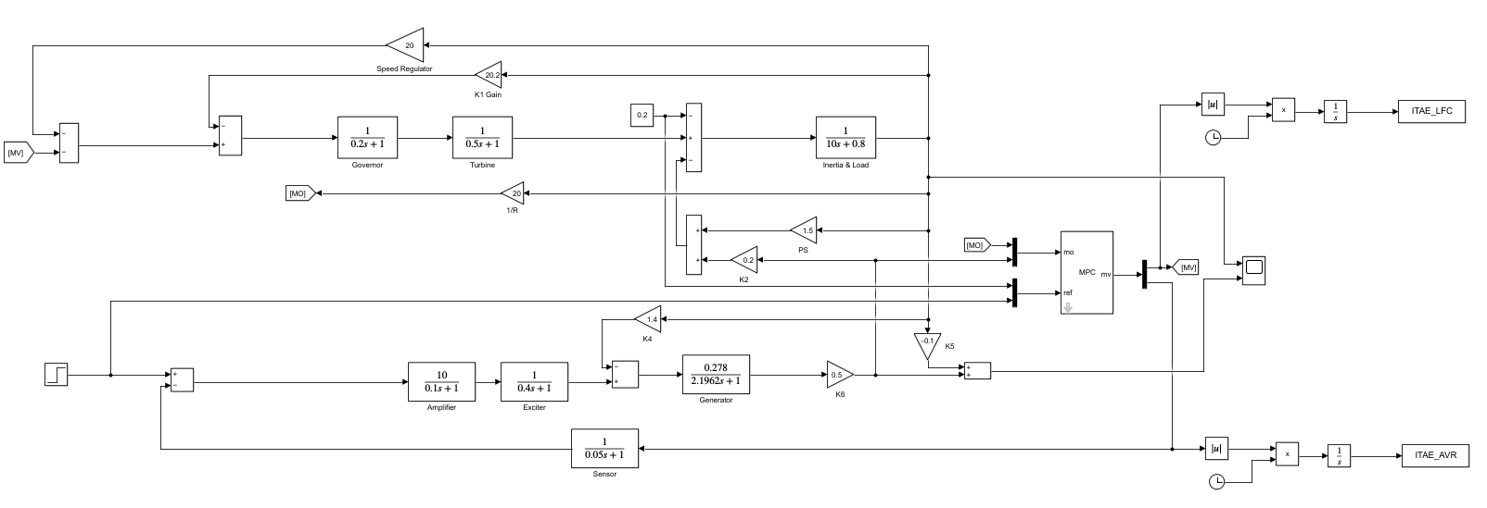
FIGURE 5. Design of AVR & LFC System with MPC-PSO

This research focuses on analyzing the stability of voltage and frequency output from a synchronous generator system that uses an MPC-PSO controller in the AVR and LFC systems. Several variables must be considered in the MPC system: measured variables, measured output, and reference. These three variables will affect the performance of the AVR and LFC systems. The measured variable will be used as the output parameter for the PSO, while the measured output will be used as the result of the AVR and LFC response, which the PSO will then use as the basis for maintaining the stability of the AVR & LFC system. This design aims to achieve optimal values for the AVR & LFC system and to maintain system robustness in frequency and voltage during highly fluctuating load changes. The controller will work to adjust the necessary inputs and maintain system stability.

RESULTS AND DISCUSSION
The parameters that can be adjusted in the MPC control within a single plant are not limited to the six parameters used in this study. Other parameters, such as the weights for constraint outputs (minimum and maximum), the weights for manipulated variables, and the weights for output variables, can also be adjusted. However, based on previous trials, altering these parameters can disrupt the output signals and potentially cause simulation errors due to mismatched values. Therefore, to avoid signal disruption and simulation errors, this study decided to use only six parameters. Optimization using PSO was performed with 20 populations and 50 iterations. The results showed that MPC-PSO and MPC-init differed only in terms of response time in the LFC plant, and similarly in the AVR plant. Ultimately, MPC-PSO was selected for use. The details of the step response for LFC and AVR are as follows: The base frequency and base voltage were set to 50 Hz and 20 kV, respectively. Based on these values, the undershoot was 49.9926 Hz, the overshoot was 50.00187 Hz, and the steady-state frequency was 50.0000159 Hz. For the AVR, the analysis was limited to overshoot and steady-state values. The overshoot for MPC-PSO was higher than the initialization value at 24.38 kV, while the steady-state value was 19.8 kV. Although the overshoot with MPC-PSO is higher, the steady-state time is faster compared to the MPC initialization.The reason why MPC-PSO may still not closely approach ideal conditions is due to the complexity of the MPC parameters and the use of a single MPC for both AVR and LFC plants. Ideally, separate MPC controls for each plant would allow for better optimization, though this would double the process and time required. Research using optimized MPC should ideally be conducted on high-specification equipment to achieve more optimal results.

Convolution Performance of MPC-PSO to AVR and LFC
Before entering the main PSO process, initialization or init, is needed to randomize the parameter values as many as the specified population. In this study, 20 randomized values were used, then from the randomized MPC parameter values by PSO, the fitness obtained from the average ITAE LFC and AVR will be issued. The following are the results of the PSO initialization used for MPC.
TABLE 3. PSO Initialization
Predict Horizon | Control Horizon | Time Sampling | LFC Weight | AVR Weight | ECR Weight | Fitness
16 | 1 | 0.0511739 | 0.070631714 | 0.000821194 | 1138.630939 | 0.45822944
10 | 2 | 0.053245577 | 0.146344477 | 0.000647746 | 5058.313358 | 0.436432885
15 | 2 | 0.053723464 | 0.037791003 | 0.000686775 | 2651.600402 | 0.433852122
14 | 3 | 0.053901137 | 0.016225154 | 0.000929386 | 7981.414107 | 0.426922702
15 | 2 | 0.052233919 | 0.061269894 | 0.000508509 | 5596.944078 | 0.432522852
18 | 3 | 0.053221591 | 0.075721877 | 0.00081158 | 5795.430299 | 0.427927432
14 | 4 | 0.054379714 | 0.110031269 | 0.000622475 | 6283.402341 | 0.427397617
12 | 2 | 0.052354617 | 0.046097632 | 0.000844309 | 2752.878606 | 0.433480592
12 | 2 | 0.051138321 | 0.087139737 | 0.000311102 | 9310.416779 | 0.428907731
14 | 2 | 0.054524405 | 0.195949676 | 0.00043887 | 2000.073011 | 0.444620583
13 | 2 | 0.05297448 | 0.05244235 | 0.000602843 | 7400.942024 | 0.430859159
12 | 1 | 0.051483379 | 0.06375566 | 0.000424167 | 5570.724562 | 0.447219829
11 | 2 | 0.054005073 | 0.005844056 | 0.000928854 | 7572.977766 | 0.428125817
15 | 3 | 0.051186418 | 0.091769766 | 0.000963089 | 5921.251469 | 0.427328837
15 | 2 | 0.052444489 | 0.124812018 | 0.000679136 | 4559.636941 | 0.434126674
14 | 4 | 0.050188694 | 0.177033602 | 0.000913287 | 8165.654862 | 0.426975852
11 | 2 | 0.051676784 | 0.13594559 | 0.000136553 | 7491.047487 | 0.433563288
11 | 3 | 0.05247087 | 0.155810345 | 0.000715037 | 9133.485045 | 0.428404492
19 | 2 | 0.053493729 | 0.039561965 | 3.05409E-05 | 7696.668343 | 0.4314462
15 | 2 | 0.054523611 | 0.12197333 | 0.000617666 | 8734.980751 | 0.432209474

There are six MPC parameters optimized by PSO, including predict horizon, control horizon, time sampling, LFC weight, AVR weight and ECR weight. Although there are more than six parameters in MPC, in this study only six parameters are given. The optimization of these six parameters is not decided directly during PSO optimization. But with trial and error testing of other parameters in MPC. For example, a trial was given on the parameter section of the minimum and maximum output variable constraint weight, the rating weight of the manipulate variable and the output variable weight. Some of the parameters mentioned can have their values ​​changed. However, based on the trials that have been tried, some of these parameters can damage the output signal. In addition, it can potentially cause simulation errors because the values ​​given are not appropriate. So, to avoid potential signal damage and simulation errors in this study, it was decided to use only six parameters according to TABLE 3 above. If initialization has been done, then it is necessary to choose the parameters with the minimum fitness value before entering the main process of PSO optimization. The initialization process is carried out as many times as the number of populations or swarms given. The speed of initialization can vary for each device used. The better the specifications of a device, the faster the initialization process is given. Likewise with the processing speed of PSO optimization which is the main process. However, speed is not everything and is not a problem for the research being conducted. The following graph of the initialization fitness value from TABLE 3 is shown in the FIGURE 6 below.

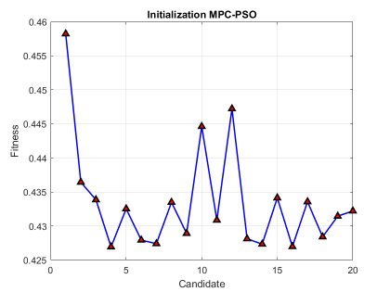
FIGURE 6 Fitness Initialization

The candidates in FIGURE 6 are random values ​​of six MPC parameters from the initialization used in PSO before entering the main process. Then the vertical axis is the fitness value obtained from the average value of ITAE LFC and AVR. In finding random values ​​or candidate values, here is the Eq. 1.

 | $$init={LB}_{i}+rand×({UB}_{i}-{LB}_{i})$$ | (1)

Where LB is the lower bound or lower limit while UB is the upper bound or upper limit. These two limits are determined so that the random value of the six parameters is not less than LB and not more than UB. While rand is a random value between 0 and 1. In FIGURE 6, the minimum fitness value is located on candidate number 16 with a fitness value of 0.426922702. So, the minimum initialization MPC parameter value of error can be seen in the TABLE 4 and TABLE 5.
TABLE 4. Best Initialization Values
MPC Parameters | Mark
PredictHorizon | 14
ControlHorizon | 3
TimeSampling | 0.053901137
LFC Weight | 0.016225154
AVR Weight | 0.000929386
ECR Weight | 7981.414107

TABLE 5. Initialization Step Response
step response | LFC |  | AVR
step response | time | mark | time | mark
undershoot | 1.243 s | -0.00737 | - | -
overshoot | 2.59 s | 0.00187 | 1.64 s | 1,101 pu.
steadystate | 13.4 s | 0.000016 | 11.05 s | 0.99 pu.

The parameter values ​​attached to TABLE 4 will control the frequency delta on the LFC and the voltage on the AVR. Based on the parameter values ​​given in TABLE 4, the results of the response graph given by the LFC and AVR can be seen. Then after the running process is carried out, a wave will appear and the fitness value will be compared to the fitness value of the next iteration. The following are the output values ​​of the LFC and AVR. If the base frequency is set at 50 Hz, the undershoot is 49.9926 Hz. This figure is obtained from the difference of 50-0.00737. In the overshoot, the frequency value is 50.00187 Hz and 50.000016 Hz for steady state. The AVR step response only has an overshoot and steady state of 1.101 pu and 0.99 pu. If the base voltage is set at 20 kV, the voltage overshoot reaches 22.020 kV and the steady state is at 19.8 kV.

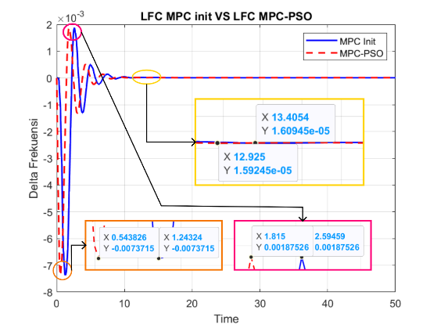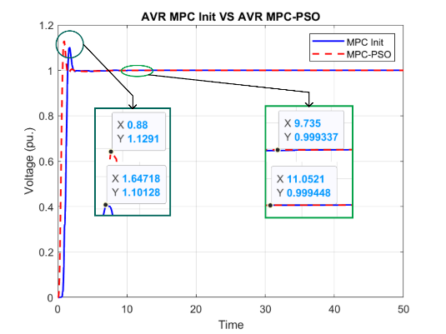
- (b)
FIGURE 7 (a). LFC MPC Init VS LFC MPC-PSO (b). AVR MPC Init VS LFC MPC-PSO

The representation between MPC init and MPC-PSO which are juxtaposed as in FIGURE 7 will make it easier to make a comparison between the two. The values ​​listed in the figure above are the same values ​​as the previous sub-chapter. The difference is clearly visible in the speed of undershoot, overshoot and steady state times. Although the MPC-PSO step response time obtained is faster, the undershoot and overshoot values ​​remain unchanged. In fact, PSO optimization has reached the optimal value and has not found a better candidate even though it has been run repeatedly. Another cause is because it uses one MPC control for two plants. Although MPC control can be used for more than one plant, it turns out that it can affect the waves of each plant. Given the complex MPC parameters and only using one MPC, some parameters cannot be separated in each plant but one parameter is used for two plants, namely AVR and LFC. If each plant uses MPC control separately, the optimization will take two processes and take twice as long. The next is a comparison of the response signals from the AVR [11].
The values listed in the image above are the same as the previous sub-chapter. In the AVR output wave or signal, the step response analysis performed is only two, namely overshoot and steady state. There is no undershoot like in AVR. There are disappointing results in the MPC-PSO overshoot value which is greater than the MPC init. Although larger, the overshoot rise time is faster than the MPC init. Likewise, what happens in the MPC-PSO steady state is faster than the MPC init. The reason why this happens is the same as the analysis in FIGURE 7 namely because the MPC parameters are complex and only use one MPC so that several parameters cannot be separated in each plant but one parameter is used by two plants, namely AVR and LFC. If each plant uses separate MPC control, the optimization will take place twice the process and twice as long. Research using optimized MPC should be carried out on devices that have high specifications to obtain more optimal results.

CONCLUSIONS
The research on Load Frequency Control (LFC) and Automatic Voltage Regulator (AVR) using Model Predictive Control (MPC) with Particle Swarm Optimization (PSO) has been successfully conducted and simulated. Based on the simulations carried out, it can be concluded that the parameters in the MPC control can be implemented using two plants, namely MPC and AVR. Moreover, there are many parameters in the MPC that can be optimized with PSO. However, in this study, only six parameters were optimized to avoid the potential of deteriorating the system response of LFC and AVR. With this research, it is hoped to refine or improve future studies. It is recommended to consider the following:
- Use alternative optimization algorithms such as Firefly Algorithm (FPA), Genetic Algorithm (GA), and Cuckoo Search (CS).
- Implement simpler controllers compared to MPC to support faster optimization processes and achieve optimal results.

References
1. Bertani, R. and I. Thain, Geothermal power generating plant CO2 emission survey. IGA news, 2002. 49: p. 1-3.
2. Chapman, S.J., Electric machinery and power system fundamentals. (No Title), 2002.
3. Kundur, P., Power system stability. Power system stability and control, 2007. 10: p. 7-1.
4. Putra, D.P., ANALISIS PRAKIRAAN KONSUMSI ENERGI LISTRIK TAHUN 2022-2026 MENGGUNAKAN LOGIKA FUZZY MAMDANI (Studi Kasus: PT PLN Kota Dumai). 2022.
5. Nikolaou, M., Model predictive controllers: A critical synthesis of theory and industrial needs. 2001.
6. Berberich, J., et al., Linear tracking MPC for nonlinear systems—Part I: The model-based case. IEEE Transactions on Automatic Control, 2022. 67(9): p. 4390-4405.
7. Patil, P.M. and S.K. Patil. Automatic voltage regulator. in International Conference on Emerging Trends in Information Technology and Engineering (ic-ETITE). 2020. IEEE.
8. Guha, D., P.K. Roy, and S. Banerjee, Load frequency control of interconnected power system using grey wolf optimization. Swarm and Evolutionary computation, 2016. 27: p. 97-115.
9. Alam, M.N., Particle swarm optimization: Algorithm and its codes in matlab. ResearchGate, 2016. 8(1): p. 10.
10. Eberhart, R. and J. Kennedy. A new optimizer using particle swarm theory. in Proceedings of the sixth international symposium on micro machine and human science. 1995. MHS'95: Ieee.
11. Ali, H.H., et al., Multi-verse optimizer for model predictive load frequency control of hybrid multi-interconnected plants comprising renewable energy. Ieee Access, 2020. 8: p. 114623-114642.

