Optimization of Recloser Placement to Improve Distribution Network Reliability Using Grey Wolf Optimizer (GWO)
Machmud Effendy^{1, a)} ,Ana Muslimah Faqih^{1, b)} , Nur Alif Mardiyah^{1, c)}
Author Affiliations
¹Electrical Engineering Department, Universitas Muhammadiyah Malang, Malang, Indonesia
Author Emails
^{a)} Corresponding author: machmud@umm.ac.id
^{b)}anamuslimahfaqih@webmail.umm.ac.id
^{c)}nuralif@umm.ac.id
Abstract. Repeated disturbances in the electrical distribution network significantly impact the reliability of the distribution system. Efforts to minimize the impacted area can be made by isolating the affected area using a safety device called a recloser. The objective of this paper is to improve the reliability of the electrical distribution system by installing reclosers in the distribution network. The study was conducted on the Galis feeder, which has two reclosers installed on lines 5 and 6. Based on 2024 data, both have a SAIDI reliability index of 18.929450 hours/year and a SAIFI of 6.29843203 interruptions/year. Recloser placement was optimized using the GWO algorithm to improve the distribution system reliability index. Tests were conducted to find the best positions for two and three reclosers. The test revealed that the best placement for two reclosers was on lines 46 and 90, with a SAIDI reliability index of 13.01 hours/year and a SAIFI of 7.52 interruptions/year. Meanwhile, the best placement for three reclosers was found to be on buses 38, 57, and 3, with a SAIDI reliability index of 12.46 hours/year and a SAIFI of 4.13 interruptions/year. Based on these SAIFI and SAIDI values, it can be concluded that the reliability of the distribution system optimized with the GWO algorithm is better than that of the system without optimization (the installed system).
Keywords: Recloser, Distribution Network, SAIDI, SAIFI, GWO

INTRODUCTION
The level of reliability of energy is very important. This is related to the continuity of customer power distribution (consumers). The reliability of the electric power system is the ability of the system to ensure good quality and adequate power supply. Some factors that affect the quality of electric power include tension stability, frequency, service continuity, and performance coefficient. From the various factors mentioned above, the sustainability of power services is the main problem of the electricity distribution. [1]. The level of reliability of the distribution system can be tested through calculation or analyzing the level of success in a certain period, then comparing it with the previous standard [2]. The electric power supply system through the distribution network should not have electrical disorders or at least failure must be maintained as short as possible.
One of the most important goals of distribution companies is to improve their reliability. Using automatic devices (reclosers and auto-sectionalizers) can reduce the number of outages during outages and repair time [3]. System Average Interruption Frequency Index (SAIFI) values are important parameters used to indicate the extent of failures or outages that result in customers not receiving electricity service.
Installing reclosers in a distribution system can improve the reliability of the system. Reclosers are safety devices in distribution systems that function to disconnect and connect areas affected by disturbances [4]. Many disturbances in distribution systems are temporary, so the use of reclosers is very effective in distribution networks.
Considering the complexity of the recloser placement problem, there are several previous references that can be studied. Comparing the results of the Binary Differential Evolution (BDE) algorithm with the Particle Swarm Optimization (PSO) algorithm [5], which was used to determine the optimal recloser placement, this study found that the BDE algorithm is more optimal than the PSO algorithm using five parameters (CENS, SAIDI, SAIFI, MAIFI and Objective Function) in determining the optimal recloser location. Genetic Algorithm (GA) [6] is used to determine the optimal placement and addition of reclosers on the Nguling feeder using the objective function parameters SAIDI, SAIFI, CADI, and ASAI. The best position results are obtained at buses 17 and 37, followed by the objective fitness value towards the convergence point. The evolutionary algorithm [7] has also been used to determine the optimal recloser placement using multi-objective (SAIDI/SAIFI, SAIDI/EENS and SAIFI/EENS). 10 optimal recloser placements were obtained and in this study a single solution cannot be considered optimal in recloser placement. Analysis of recloser placement on the Kentungan 05 feeder was used to determine the placement of reclosers in the section. The results showed that the optimal recloser placement was in section 2 which had the lowest SAIDI and SAIFI values compared to the other sections [8]. The author [9] also improved the reliability of the distribution system using the ABC algorithm. The results showed that the ABC algorithm could better improve the reliability of the distribution system compared to the PSO algorithm using the SAIDI, SAIFI, CAIDI and AENS parameters.
In this paper, the GWO algorithm is used to optimize recloser placement on the Galis feeder. The advantage of the GWO algorithm is its ability to explore various location combinations and simultaneously refine the best solution through an exploitation process. This is crucial to avoid getting stuck in local solutions, which often occurs in other optimization algorithms. GWO requires only a few parameters to tune (the number of wolves and iterations), making it more practical and easy to implement in electricity distribution system simulations.

METHODS
Research Design

The research design is illustrated by the flow diagram in the following figure:

Start

Collecting Data

Calculation of SAIFI and SAIDI values before optimization

Recloser placement optimization

Calculation of SAIFI and SAIDI values after recloser placement optimization

Conclusion

End

Figure 1. System Design Flow Diagram

Figure 1 shows a flowchart for system reliability assessment, which is determined based on the SAIDI and SAIFI indices, optimized using the GWO algorithm.

Data collection

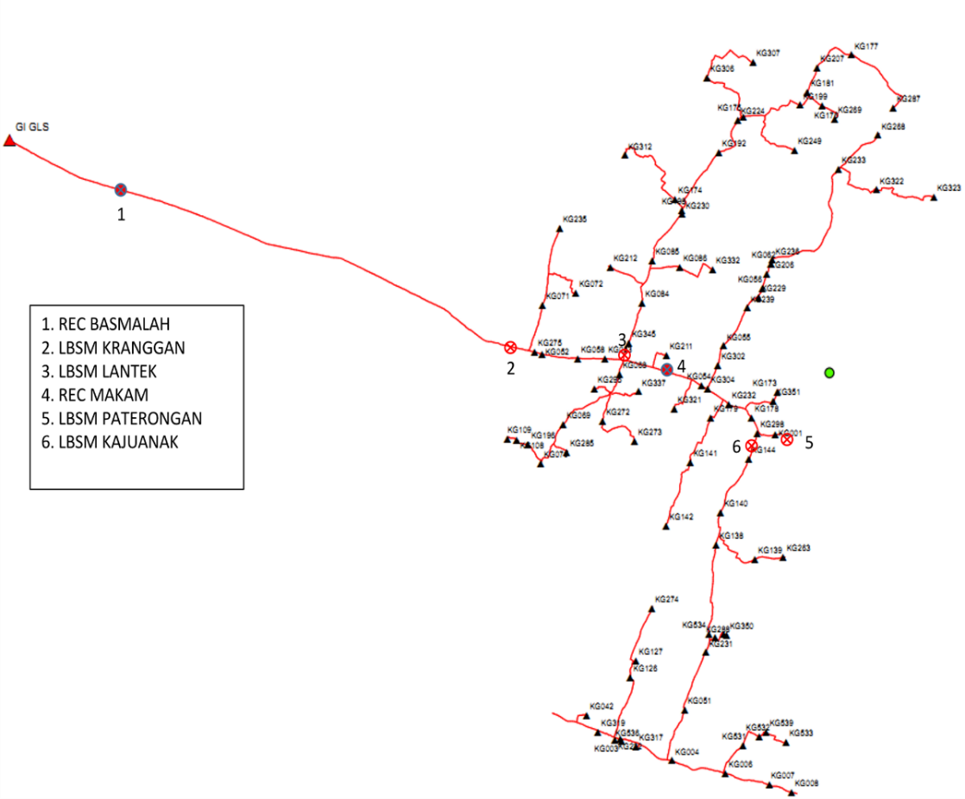
PT PLN (Persero) Customer Service Implementation Unit (UP3) Pamekasan, Madura is the location of the research. The data needed to support this research include a summary of disturbance data for 2024, a single-line diagram (Figure 2), the length of the Galis Pamekasan feeder line, the transformer power capacity, and the number of customers on the Galis Pamekasan feeder.
Figure 2. Single Line Diagram Data of the Galis Pamekasan Feeder

Data Analysis

After the required data has been collected, an initial reliability index is calculated for the Galis Pamekasan feeder system. The reliability of a distribution system is determined by several factors, such as the frequency of outages, the duration of outages, and the time required to restore the system after an outage [10].
SAIFI is an index that shows the average amount customers experience disruption for one year and SAIDI is an index that shows the average duration of outages for customers over a one-year period [3], the equation are written as follows.
$SAIFI=\frac{{}_{i}N_{i}}{N}$ (1)

$SAIDI=\frac{U_{i}N_{i}}{N}$ (2)
Where,
λ_{i} = Theverage failure rate at the load point
U_{i} = The average failure rate at point 𝑖.
N_{i} = Total customers at point-𝑖.
N = Total number of customers.
Next, the initial system conditions are calculated before recloser placement using the Section Technique.

Section Technique

The Section Technique evaluates the reliability of a distribution system based on equipment failures that affect system operation [11]. The Section Technique in this study uses data obtained from the research object. The equation for the average failure rate and the equation for the average duration of power outages per year are presented as follows:
${}_{i}=\sum_{i=k}{}$ (3)
$U_{i}=\sum_{i=k}{({}_{i}.r)}$ (4)

Optimization Using the Grey Wolf Optimizer (GWO) Algorithm

The Grey Wolf Optimizer is a nature-inspired metaheuristic optimization algorithm proposed by Seyedali Mirjalili in 2014. It mimics the leadership hierarchy and hunting behavior of grey wolves (Canis lupus) in nature to solve complex optimization problems. The flowchart of the GWO Algorithm can be seen in Figure 3.

Start

Entering data into systems and algorithms

Initialize the population

Evaluate the objective function values

Update λ, β, δ

Update the positions of all wolves

Maximum Iterations?
No

Yes
Optimal recloser position

End

Figure 3. GWO Algorithm Flowchart

Figure 3 shows the flow of the GWO algorithm, which will be explained as follows:
- Enter data such as 𝜆𝑖, 𝑈𝑖, value SAIDI and SAIFI.
- Create GWO algorithm parameters such as maximum iteration, population, and a value.
- The objective function used in this study is as follows: fx₁= SAIDI/SAIFI
- Compute the fitness (objective function value) for each wolf. Alpha (α): best solution so far, Beta (β): second-best, Delta (δ): third-best.
- Check if the current population has solutions better than the previous α, β, or δ
- Check whether the stopping condition is met. Common criteria: maximum number of iterations reached, Error threshold or fitness tolerance achieved.

RESULT AND DISCUSSION

The results of the optimization calculations for recloser placement in the Galis feeder distribution network have been completed using the GWO algorithm. The results of the optimization calculations include failure rate, power outage duration, SAIDI, and SAIFI. The detailed results of this study are described as follows.

Initial System Reliability Calculation Results Before Optimization

Initial system reliability calculations using Section Technique calculations by processing the Galis feeder data that has been obtained. This data will be processed using the equations described in equations 1 to 4 by multiplying the system failure rate and system repair time according to SPLN 59 of 1985[12]. The results of the calculation of the failure rate and the average annual duration of power outages can be seen in Table 1 below.

Table 1. Results of Calculation of Failure Rate and Duration
Average Annual Power Outages
No | Load Point | λ_{i} | U_{i}
1. | 56 | 1,0609 | 3,2289
2. | 20 | 1,0609 | 3,2289
3.  4.  5.  …  92 | 19  66  9  ….  92 | 1,0609  1,9427  1,9427  …..  7,0367 | 3,2289  5,8828  5,8828  ….  21,139

Table 1 shows that the calculated failure rate and average annual outage duration vary. These values depend on the components and number of customers on each bus. Meanwhile, the calculated SAIDI and SAIFI for the feeder can be seen in Table 2 below.
Table 2. Results Before Recloser Placement Optimization
SAIDI | SAIFI
18,929450 | 6,29843203

Recloser Placement Optimization Results Using the GWO Algorithm

The results of optimizing the placement of 2 and 3 reclosers using the GWO algorithm can be shown in Table 3 below.
Table 3. Recloser Placement Results Using the GWO Algorithm
SAIDI | SAIFI | Fitness | Recloser Position
13,01  12,46 | 7,52  4,13 | 15,29  15,29 | 46,90  38,57,3

Table 3 shows that the results of placing two reclosers using the GWO algorithm suggest recloser placement on lines 46 and 90. The system reliability values for the optimized Galis feeder are SAIDI of 13.01 hours/year, SAIFI of 7.52 times/year and fitness of 15,29. Meanwhile, when placing three reclosers, recloser placement is recommended on buses 38, 57, and 3. The resulting SAIDI value is 12.46 hours/year, SAIFI of 4.13 times/year and fitness of 15.29.
Calculation of system reliability after optimization using the GWO algorithm using Matlab R2018b software. The method for calculating system reliability after optimization is the same as calculating the initial system reliability, but this calculation includes the results of the recloser placement resulting from the optimization using the GWO algorithm. The results of the recloser placement optimization using the GWO algorithm indicate that the optimal recloser placement to improve distribution system reliability is located on lines 46 and 90, and when using three reclosers, it is located on lines 38, 57, and 3.

CONCLUSION

Optimization of recloser placement on the Galis feeder using the GWO algorithm has been successfully performed. Testing revealed that the optimal placement of two reclosers was achieved on lines 46 and 90. Meanwhile, for three reclosers, the optimal placement was on lines 38, 57, and 3. Based on the SAIFI and SAIDI index values obtained for the placement of two and three reclosers, as evidenced by the fitness values converging, it can be concluded that the reliability of the distribution system optimized with the GWO algorithm is better than that of the system without optimization (the installed system).

References
- Canizes B, Soares J, Ramos S, Chaves J, Vale Z, Forouzandeh Z. Optimal location of normally closed switches in medium voltage distribution networks. 2022 9th International Conference on Electrical and Electronics Engineering (ICEEE) 2022 s. 227–31. https://doi.org/10.1109/ICEEE55327.2022.9772604.
- Banerjee A, Chattopadhyay S, Gavrilas M, Grigoras G. Optimization and estimation of reliability indices and cost of Power Distribution System of an urban area by a noble fuzzy-hybrid algorithm. Applied Soft Computing 2021; 102: 107078. https://doi.org/10.1016/j.asoc.2021.107078.
- Costa MM, Bessani M, Batista LS. A Multiobjective and multicriteria approach for optimal placement of protective devices and switches in distribution networks. IEEE Transactions on Power Delivery 2022; 37(4): 2978–85. https://doi.org/10.1109/TPWRD.2021.3120968.
- Gastelbondo Mercado GA, Gonzalez Sanchez JW. Optimization of reclosers placement in distribution networks to improve service quality indices. IEEE Latin America Transactions 2022; 20(2): 241–9. https://doi.org/10.1109/TLA.2022.9661463.
- Neshadnaeini M.F., Hajivand M., Karimi R., Karimi M. Optimal Recloser Placement By Binary Differential Evolutionary Algorithm To Improve Reliability Of Distribution System. Internasional Journal of Information, Security and System Management. 2014; 3(2): 332-336.
- Duan L. Design of teaching mode classification system based on PSO algorithm. 2022 International Conference on Information System, Computing and Educational Technology (ICISCET) 2022 s. 79–82. https://doi.org/10.1109/ICISCET56785.2022.00028.
- Moskwa S., Koziel S., Siluszyc M., Galias Z. Multiobjective Optimization for Switch Allocation in Radial Power Distribution Grids. International Conference on Signals and Electronic System. Krakow, Poland. 2018: 1-4.
- Hani S., Santoso G., Wibowo R.D. Penempatan Recloser Sebagai Parameter Keandalan Sistem Proteksi pada Sistem Distribusi. Simposium Nasional RAPI XVIIII. Yogyakarta. 2019: 1-7.
- Dixit M., Kundu P., Jariwala H.R. Assessment of Distribution System Reliability using Artificial Bee Colony Algorithm. 2017 Second Int. Conf. on Electrical, Computer and Communication Technology (ICECCT). Coimbatore, India. 2017:1-6
- Dhole S, Mir M, Hasan KN, Farhan A, Yaghoobi J, Veselov A, i in. optimal recloser placement in power networks based on reliability and cost-benefit analysis. 2021 31st Australasian Universities Power Engineering Conference (AUPEC) 2021: https://doi.org/10.1109/AUPEC52110.2021.9597794.
- Varganova AV, Chizhikova ES, Makushin EV. Methodology for determining the optimal location of reclosers in distribution networks 6-10 kV. 2022 4th International Conference on Control Systems, Mathematical Modeling, Automation and Energy Efficiency (SUMMA) 2022:879–83. https://doi.org/10.1109/SUMMA57301.2022.9974037.
- PT. PLN (Persero). SPLN 59. Keandalan Pada Sistem Distribusi 20 kV dan 6 kV. 1981.

