Development of a Real-Time Monitoring Biodiesel Reactor Using IoT Technology
Ndaru Candra Sukmana^{1, a)}, Firdaus Agil Prasetyo^{1, b)}, Wahyu Kamal Setiawan^{2, c)}, and Ufafa Anggarini^{3, d)}
Author Affiliations
¹Department of Engineering Management, Universitas Internasional Semen Indonesia, Kompleks PT. Semen Indonesia (Persero) Tbk., Jln. Veteran, Gresik 61122, Indonesia
²Department of Agroindustrial Technology, Universitas Internasional Semen Indonesia, Kompleks PT. Semen Indonesia (Persero) Tbk., Jln. Veteran, Gresik 61122, Indonesia
³Department of Chemical Engineering, Universitas Internasional Semen Indonesia, Kompleks PT. Semen Indonesia (Persero) Tbk., Jln. Veteran, Gresik 61122, Indonesia

Author Emails
^{a)}ndaru.sukmana@uisi.ac.id
^{b)}firdaus.prasetyo21@student.uisi.ac.id
^{c)}wahyu.setiawan@uisi.ac.id
^{d)}ufafa.anggarini@uisi.ac.id
Abstract. The increasing demand for sustainable energy solutions has prompted the development of advanced technologies to optimize biodiesel production. In order to improve process automation and monitoring, this paper describes the design and implementation of an Internet of Things (IoT)-based control system for a biodiesel reactor. To manage temperature and mixing in real time, the system combines a NodeMCU ESP32 microcontroller with DS18B20 temperature sensors, a 12V DC motor with an L298N driver, and an SG90 servo motor. Esterification and transesterification operations were carried out in a glass reactor that was equipped with a condenser and an electric heater. The Blynk cloud platform is used by the IoT system to allow for smartphone-based remote monitoring and control, including live data display and manual parameter change. The results showed that the temperature sensors were accurate, the actuators were dependable, and the automatic shutdown feature in the event of overheating was effective. The system maintained steady functioning during the reaction process and accomplished a low latency data transfer.

Introduction
Biodiesel is a renewable energy source that offers a more sustainable and environmentally friendly alternative. Biodiesel is a promising substitute for conventional diesel fuel, as it can be used directly in diesel engines without modification.^{1–3} Biodiesel is defined as a diesel-engine fuel consisting of monoalkyl esters of long-chain fatty acids derived from vegetable oils or animal fats.⁴ It has considerable potential due to its low carbon emissions, renewable nature, and biodegradability.⁵ Biodiesel is commonly produced through esterification and transesterification processes, in which triglycerides are converted into fatty acid methyl esters. This reaction typically involves alcohols and the use of catalysts, yielding biodiesel and glycerin as by-products.^{6,7}
Despite these advances, conventional biodiesel production faces several challenges, such as long reaction times, high energy consumption, and inconsistent product quality.^{8,9} These limitations are mainly due to the lack of real-time monitoring and control over critical parameters such as temperature, mixing speed, and reaction time. In recent years, various types of biodiesel reactors have been developed to meet the increasing demand for renewable energy sources.^{10–12} These include batch reactors, continuous stirred-tank reactors, and tubular flow reactors, which are commonly used in both laboratory and industrial scales.^{7,13,14} Traditional biodiesel reactors primarily rely on mechanical stirring, fixed heating systems, and manual control of process parameters. While these systems have contributed to large-scale biodiesel production, they often face several limitations. One of the primary shortcomings is the lack of real-time monitoring and automation, which leads to inconsistency in product quality due to fluctuations in temperature and mixing speed.^{15–18} Moreover, existing designs often do not support adaptive control, limiting their efficiency in small-scale or decentralized production settings.
These challenges highlight the urgent need for a more cost-effective, adaptable, and smart biodiesel reactor design that integrates emerging technologies such as the Internet of Things to enable remote monitoring, real-time control, and data-driven optimization. The Internet of Things refers to a network of physical devices connected to the internet that can collect, transmit, and act upon data without human intervention.^{19–21} In the context of biodiesel production, IoT can facilitate continuous monitoring and precise control over reactor conditions, enhancing efficiency and consistency in product quality. Nevertheless, the implementation of IoT in biodiesel reactor systems remains limited. There is a pressing need for research and development of IoT-based biodiesel reactors that can optimize production efficiency. Therefore, this study aims to design an IoT-integrated biodiesel reactor capable of monitoring and controlling the production process in real-time to address the inefficiencies in conventional methods and ensure better product quality and operational sustainability.

METHODS
The reactor design was based on the requirements showed in Table 1. Accordingly, this reactor used 300 mL boiling flasks capable of withstanding thermal shocks and a vertical condenser for methanol recovery. The system integrates IoT sensors and actuators, DS18B20 temperature sensors used for reaction and condenser temperature monitoring. Actuators include a 12V DC motor for stirring, an SG90 servo for dimmer SCR 2000W (current supplied) control, and an electric heater for heating. The sensors and actuators are controlled via a NodeMCU ESP32 microcontroller, which serves as the interface to a cloud-based IoT platform (Blynk).

TABLE 1. Reactor requrements and components
Parameters | Requirements | Components
Reaction temperature  Condensor temperature  Stirrer speed  Heater  Control and monitoring system | 50-100 °C  20-40 °C  120-1200 rpm  50-200 °C  Long-range remote IoT | DS18B20 sensor  DS18B20 sensor  L298N + 12V DC motor  SCR2000W dimmer + servo + heater  ESP 32 + Blynk

Electronic schematics were designed using Fritzing software. Sensors and actuators were wired to the ESP32 for centralized control. Physical assembly of all components was completed, followed by integration of electronic and IoT systems. Components were installed as per the design layout and tested for functional connectivity. All signals were routed to the Blynk cloud platform for visualization. The firmware was developed using Arduino IDE. The code enabled reading sensors, controlling actuators, and sending data to Blynk. Remote control functionalities and notification systems were embedded. All components were tested individually and in full system mode. Sensors and actuators were verified for accuracy and tested for response, respectively. The IoT interface was tested for real-time monitoring and control.
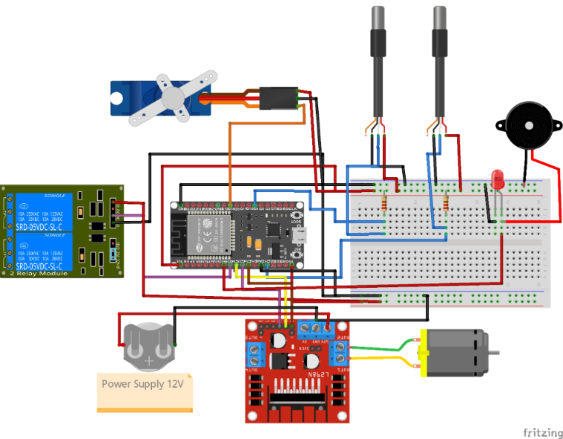
Figure 1. IoT System Electronic Circuit Schematic

Results and Discussion

Implementation of the IoT System on the Biodiesel Reactor
The implementation of the Internet of Things (IoT) system on the biodiesel reactor was carried out through a comprehensive process that included the design, assembly, and software-hardware integration of the system components. The main objective was to facilitate real-time monitoring and control of the biodiesel production process, either esterification or transesterification, by utilizing remote access through a Wi-Fi-enabled microcontroller (ESP32) and cloud platform (Blynk). The design concept combines embedded systems, sensor networks, and cloud computing to automate critical aspects of the process.
The concept of the Internet of Things (IoT) illustrated in Figure 2 demonstrates how the reactor device can be connected to the internet for remote monitoring and control. The process begins with an internet provider that connects the system to the cloud, where data is collected and processed. The ESP32 microcontroller serves as the control center, gathering data from the reactor and sending it to the cloud while also receiving commands to control the devices. A smartphone equipped with the Blynk application allows users to monitor the reactor's status in real time and make adjustments through an intuitive interface. This system reflects the efficiency of IoT in integrating hardware and software for improved automation and management. The implementation of IoT on the reactor, as shown in Figure 2, also highlights the importance of two-way communication between the reactor device and the smartphone user. Data from the reactor, such as reaction temperature and condenser temperature, is transferred to the microcontroller, which then uploads it to the cloud for analysis. Users can access this information via their smartphone and send commands back to the reactor through the same network. This enables more precise and responsive management, even from a distance.

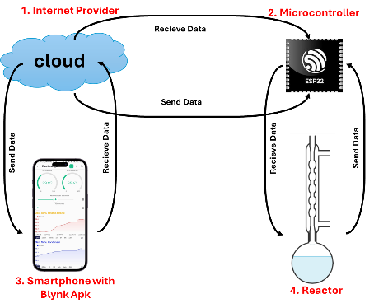
Figure 2. IoT Concept on the Reactor

This study used 300 mL boiling flasks that could handle sudden temperature changes, which are good for controlling esterification and transesterification reactions. The flasks could hold up to 250 mL of a mixture of oil, methanol, and catalyst. The reactor was made from a 300 mL borosilicate glass boiling flask that was made to resist heat stress and work between 50-70°C, a good temperature range for making biodiesel. The flask had a lid with openings for things like a magnetic stirrer, a condenser, and temperature sensors. A 55 cm tall glass condenser was connected to the reactor with a glass pipe, which helped to condense methanol vapors and keep them from going into the air. A 2000W electric heater under the flask provided heat for the reaction, making sure the temperature was consistent. The heat was controlled by a SCR2000W dimmer, which was carefully adjusted with a SG90 servo motor to precisely control the temperature.
The components were arranged in a specific way, as shown in Figure 1, to make the IoT system work as well as possible and to make the process run more efficiently. Two DS18B20 temperature sensors were used. One was placed inside the reaction flask and connected to GPIO4. The other was placed inside the condenser and connected to GPIO13. These sensors gave accurate temperature readings of both the liquid and vapor in real-time. The SG90 servo motor, which was connected to GPIO18, turned the dimmer knob to change how strong the heater was. A 12V DC motor was placed under the oil bath to power the magnetic stirrer inside. This motor was controlled by an L298N motor driver (IN1 = GPIO26, IN2 = GPIO27, ENA = GPIO14) and kept the reactants evenly mixed. The entire control system was run by the NodeMCU ESP32, which was wired to all the parts. It was programmed to automatically use a relay (GPIO12) to turn off the system if the temperature went above 80°C, as a safety feature.
Reactor components were mounted on a statif stand equipped with clamps to maintain stability and safety throughout operation. Figure 3 illustrates the physical assembly of the IoT-enabled biodiesel reactor, including the arrangement of the flask, heater, stirrer, condenser, and associated sensors. ESP32 served as the central controller and was programmed using Arduino IDE and libraries such as Blynk, DallasTemperature, and OneWire. The data from sensors was transmitted to the cloud, allowing users to monitor and interact with the system in real time through a smartphone interface. This setup significantly enhances the user’s control over the chemical process while reducing the risk of manual errors and safety hazards.

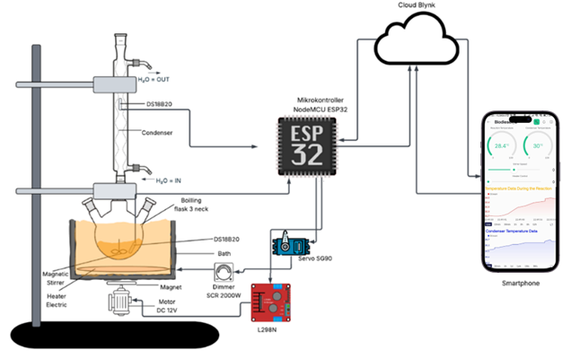
Figure 3. Physical assembly of the IoT-enabled biodiesel reactor

As shown in Figure 4, the graphical user interface of the Blynk platform on the smartphone includes two real-time gauges that display the temperatures of the reactor and the condenser, respectively. Additionally, two sliders are featured for manually adjusting the motor speed and heater intensity. The interface also presents two charts that allow users to review historical temperature data from both the reactor and the condenser. This visualization enhances user experience by offering comprehensive insights into the system’s performance and supports precise decision-making for process control.
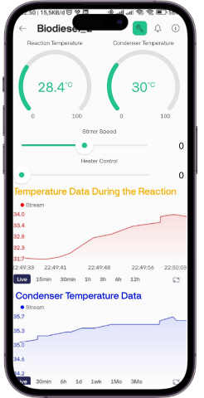
Figure 4. Graphical user interface of the Blynk platform

IoT Component Testing and System Performance Analysis
The performance of each component was tested separately first and then as part of an integrated system to begin the testing phase. Compared to a reference digital thermometer, the DS18B20 sensors displayed an average difference of ±0.2°C in temperature reading accuracy. This accuracy is crucial in biodiesel production since maintaining the right reaction temperature is important for maximizing productivity and minimizing byproducts such as soap. The SG90 servo motor responds quickly, making it perfect for controlling the heater's intensity with a dimmer switch. The electric heater connected through the dimmer enabled gradual and adjustable heating while effectively maintaining the desired temperature. The 12V DC motor, controlled by a L298N motor driver linked to the ESP32, provided a steady and adjustable stirring speed, which is vital for mixing oil, methanol, and catalyst effectively. The relay cut off the power supply when unsafe temperatures were reached, serving as an effective overheat safety feature. Additionally, the buzzer and LED indicators activate during overheating, ensuring real-time alerts for safe operation.
The integrated IoT setup showed high accuracy, responsiveness, and user-friendliness in overall system performance. The average time for data transfer between the ESP32 and the Blynk server was one second, which works well for biodiesel synthesis on a lab scale. Blynk's user interface was easy to navigate and used gauges and charts to display important parameters like reactor and condenser temperatures. The interface allowed users to control operations directly from a smartphone, enabling them to manually adjust the stirrer speed and reaction temperature. The system's ability to gather and process data in real-time greatly improved process transparency and safety. Features like automatic shutdown and alarm systems, triggered by set thresholds, improved the reliability and operational integrity of the reactor. The system's efficiency showed through precise sensor readings, stable temperature control, and adjustable stirring. The DS18B20 sensors maintained temperature monitoring with an accuracy of ±0.2°C. To verify the accuracy of the DS18B20 sensors, we conducted a validation test. We compared the sensor readings to those from a calibrated digital thermometer, collecting 43 data points within the temperature range of 35°C to 81°C. A regression analysis showed a strong linear relationship (R² ≈ 0.99). This level of accuracy shows that the DS18B20 is effective for real-time monitoring in biodiesel reactors. The servo-controlled heater allowed quick and precise adjustments to the heating element, while the DC motor ensured effective mixing for stable reaction conditions. Reliability was clear from the consistent response of actuators, low latency in data communication, and strong safety features. The relay cut the power supply during overheating, and visual and audio alarms provided immediate alerts. Additionally, the cloud-based interface removed the need for constant physical presence, allowing for better usability and remote access.

CONCLUSION

The IoT-based biodiesel reactor system using NodeMCU ESP32 was successfully designed and tested. It showed real-time monitoring and control of reaction temperature and stirring speed. The system allowed effective remote operation through Blynk and provided reliable overheating alerts.

Acknowledgments

This manuscript was prepared with the assistance of language editing powered by artificial intelligence (ChatGPT by OpenAI).

References
1. O. E. Ajala, F. Aberuagba, T. E. Odetoye, A. M. Ajala, ChemBioEng Rev. 2, 145–156 (2015).
2. S. A. Afolalu, O. O. Yusuf, A. A. Abioye, M. E. Emetere, S. O. Ongbali, O. D. Samuel, IOP Conf. Ser. Earth Environ. Sci. 665 (2021).
3. A. E. Atabani, A. S. Silitonga, I. A. Badruddin, T. M. I. Mahlia, H. H. Masjuki, S. Mekhilef, Renew. Sustain. Energy Rev. 16, 2070–2093 (2012).
4. M. Gotovuša, I. Pucko, M. Racar, F. Faraguna, Energies, 15, (2022).
5. M. Torkashvand, A. Hasan-Zadeh, A. Torkashvand, J. Mater. Environ. Sci, 13, 6012-630 (2022).
6. M. Salaheldeen, A. A. Mariod, M. K. Aroua, S. M. A. Rahman, M. E. M. Soudagar, I. M. R. Fattah, Catalysts, 11, 1–37 (2021).
7. C. Carlucci, Catalysts, 12, 717(2022).
8. A. G. Alsultan, N. Asikin-Mijan, Z. Ibrahim, R. Yunus, S. Z. Razali, N. Mansir, A. Islam, S. Seenivasagam, Y. H. Taufiq-Yap, Catalysts, 11, 1–36 (2021).
9. M. K. Pasha, L. Dai, D. Liu, M. Guo, W. Du, Biotechnol. Biofuels, 14, 1–23 (2021).
10. V. C. Akubude, K. F. Jaiyeoba, T. F. Oyewusi, E. C. Abbah, J. A. Oyedokun, V. C. Okafor, Biodiesel Technology and Applications, (Scrivener Publishing LLC, 2021) pp. 341–359.
11. O. Awogbemi, D. V. Von Kallon, Bioengineering, 9, 347 (2022).
12. M. A. G. Nasim, O. Khan, M. Parvez, B. K. Bhatt, Green Technol. Sustain. 1, 100033 (2023).

13. E. Santacesaria, R. Turco, M. Tortorelli, V. Russo, M. Di Serio, R. Tesser, Ind. Eng. Chem. Res. 51, 8777–8787 (2012).
14. N. F. Nasir, W. R. W. Daud, S. K. Kamarudin, Z. Yaakob, Int. J. Chem. Eng. 2014, 931264 (2014).
15. M. F. Elkady, A. Zaatout, O. Balbaa, J. Chem. 2015, 630168 (2015).

16. A. S. Peiter, P. V. S. Lins, L. Meili, J. I. Soletti, S. H. V. Carvalho, W. R. O. Pimentel, S. M. P. Meneghetti, J. King Saud Univ. -Sci. 32, 54–59 (2020).
17. K. Subramaniam, K. Y. Wong, K. H. Wong, C. T. Chong, J. H. Ng, Energies, 17, 1652 (2024).
18. D. Vujicic, D. Comic, A. Zarubica, R. Micic, G. Boskovic, Fuel, 89, 2054–2061 (2010).
19. O. Yakubu, O. Adjei, N. Babu, Int. J. Comput. Appl. 139, 33–39 (2016).
20. M. I. Ahmad, M. H. Mohd, R. Nordin, F. Mohamed, A. Abu-Samah, N. F. Abdullah, Sensors, 21, 1–29 (2021).
21. Y. Kondratenko, O. Kozlov, O. Korobko, A. Topalov, Commun. Comput. Inf. Sci. 826, 164–187 (2018).

