Design and Performance Evaluation of a Piezoelectric-Based Energy Harvesting Conblock with IoT-Enabled Monitoring System
Haneef Nouval Alannibras Humaidi^{a)}, Muhammad Irfan^{b)}, Muhammad Wildan N^{c)}, Muhammad Iqbal Al Munawwar^{d)}, Ustman Rizal Firmansyah B.S^{e)}

Electrical Engineering Department, Universitas Muhammadiyah Malang, Tlogomas Street 246, Malang, East Java, Indonesia.

^{a)} Corresponding author: haneefnouval@umm.ac.id
^{b)} irfan@umm.ac.id
^{c)} muhammadwildannurmawansyah@webmail.umm.ac.id
^{d)} iqbalalmunawwar@webmail.umm.ac.id
^{e)} fbinsyam@gmail.com
Abstract. This study presents the design, development, and testing of a smart conblock system embedded with piezoelectric sensors to harvest electrical energy from human footsteps. The harvested energy is stored in a lithium-ion 18650 battery and powers an IoT-based monitoring system. The system integrates piezoelectric elements, a rectifier circuit, a boost converter, and an Arduino Uno microcontroller with current and voltage sensors, a 16×2 LCD display, and an ESP8266 Wi-Fi module for real-time monitoring via Telegram. Experimental results demonstrate that increasing the number of piezoelectric sensors does not necessarily increase the output voltage. Instead, excessive sensors distribute the applied pressure, reducing energy conversion efficiency. The developed system demonstrates a practical micro-renewable energy solution with potential applications in public areas as an alternative power source.

INTRODUCTION
The accelerating pace of technological advancement, particularly in the domains of energy systems and electronic engineering, has intensified global demand for energy sources that are not only reliable and efficient but also sustainable and environmentally benign. Rapid urbanization, coupled with exponential growth in the global population and the proliferation of portable electronic devices, has placed unprecedented strain on conventional energy infrastructures, most of which remain heavily dependent on fossil fuels. This dependence exacerbates environmental degradation, contributes to greenhouse gas emissions, and raises concerns regarding the long-term security and resilience of the global energy supply. Consequently, the pursuit of alternative, renewable, and distributed energy solutions has emerged as a critical research priority in the 21st century.

Among the various approaches to renewable energy harvesting, the exploitation of mechanical energy from everyday human activities presents a particularly promising and underutilized opportunity. Activities such as walking, running, and even vehicular movement inherently generate mechanical forces that are typically dissipated as heat or vibrations in surrounding structures. Harnessing this latent energy and converting it into usable electrical power could provide a decentralized, on-demand, and environmentally sustainable energy source—especially for applications requiring low to moderate power levels.

A key enabling technology for such mechanical-to-electrical energy conversion is the piezoelectric effect, first discovered in 1880 by Pierre and Jacques Curie. The piezoelectric effect is characterized by a linear electromechanical coupling within certain crystalline materials, wherein mechanical deformation induces an electrical polarization (direct piezoelectric effect), and conversely, applied electrical fields produce mechanical strain (inverse piezoelectric effect). This property is a consequence of the asymmetric crystal lattice structure, which allows the redistribution of internal dipole moments under external mechanical or electrical excitation.

Piezoelectric materials can be broadly categorized into natural and synthetic classes. Natural piezoelectric materials, such as quartz (SiO₂), tourmaline, and Rochelle salt, exhibit intrinsic crystalline asymmetry that facilitates the effect. Synthetic materials, including barium titanate (BaTiO₃), lead zirconium titanate (PZT), and lead titanate (PbTiO₃), have been engineered to exhibit enhanced piezoelectric coefficients, thermal stability, and mechanical robustness, making them preferable for high-performance applications. These materials are widely employed in diverse technologies ranging from medical ultrasound transducers and precision actuators to vibration sensors and micro-energy harvesting systems.

Recent advancements in energy harvesting from piezoelectric floors have demonstrated the potential of integrating these materials into structural components such as floor tiles, road surfaces, and pedestrian pathways. By embedding piezoelectric transducers within these surfaces, it becomes possible to capture the mechanical pressure exerted by human footsteps or vehicular loads and convert it into electrical energy. This energy can be used immediately for low-power applications such as LED illumination or stored in batteries for later use. The approach offers a compelling balance between practicality, scalability, and sustainability.

The present research builds upon this foundation by developing a smart piezoelectric-based conblock capable of harvesting electrical energy from pedestrian traffic. The proposed system integrates piezoelectric transducers with power conditioning circuits—including rectifiers, boost converters, and lithium-ion battery storage—alongside an Internet of Things (IoT)-enabled monitoring system based on the ESP8266 wireless module. This allows real-time data acquisition, transmission, and visualization via the Telegram platform, enabling both performance tracking and public engagement with the technology.

Beyond its technical contributions, this work addresses broader urban sustainability challenges by proposing a dual-function infrastructure element that simultaneously serves as a physical surface for pedestrian traffic and a micro-scale renewable energy generator. Such systems, when deployed strategically in high-footfall public areas—such as university entrances, urban parks, transit stations, and residential walkways—could contribute to distributed renewable energy generation, support smart city initiatives, and foster public awareness of sustainable energy technologies.

By combining mechanical energy harvesting, efficient power electronics, and IoT-based monitoring, the proposed system represents a step toward practical, interactive, and educational implementations of renewable energy technologies in urban environments. This integration of functionality and sustainability positions the technology as a potential contributor to the broader energy transition and aligns with global objectives for carbon neutrality and environmental stewardship.

LITERATURE REVIEW
The piezoelectric effect has been extensively studied since its discovery by Pierre and Jacques Curie in 1880 [1], and its applications have diversified across numerous engineering and scientific disciplines. Early investigations into piezoelectric materials primarily focused on their electromechanical properties, leading to widespread adoption in sensing, actuation, and frequency control devices [2]. Over the past two decades, advancements in material science have significantly enhanced the piezoelectric coefficients of synthetic materials such as lead zirconium titanate (PZT) and barium titanate (BaTiO₃), enabling their integration into high-performance energy harvesting systems [3].

In the domain of mechanical-to-electrical energy conversion, numerous studies have explored the potential of piezoelectric transducers to capture ambient mechanical vibrations, structural deformations, and human-induced forces [4]. Research by Priya and Inman [5] demonstrated the feasibility of converting kinetic energy from environmental vibrations into electrical power sufficient to operate low-energy devices. Similarly, Beeby et al. [6] highlighted the viability of pedestrian-induced piezoelectric floors as a micro-energy source for powering lighting systems and wireless sensors. These works have established a foundation for deploying piezoelectric systems in urban environments, where mechanical input is abundant but often wasted.

Recent studies have specifically examined piezoelectric floor tile systems for public infrastructure. Li et al. [7] investigated the performance of multi-tile piezoelectric flooring under varying pedestrian traffic conditions, revealing that while energy output increases with applied force, excessive distribution of load across multiple tiles can reduce per-unit efficiency—a phenomenon attributed to mechanical load sharing among transducers. This finding underscores the importance of optimizing sensor arrangement and structural design to maximize energy harvesting efficiency.

Beyond energy harvesting, integration with Internet of Things (IoT) platforms has emerged as a critical advancement in piezoelectric-based systems. Several works [8][9] have demonstrated IoT-enabled energy harvesters that provide real-time monitoring of voltage, current, and stored energy levels, thus facilitating predictive maintenance, performance optimization, and user engagement. For example, Firoozabadi et al. [10] designed a smart floor monitoring network capable of transmitting usage data to remote dashboards, illustrating the synergy between energy harvesting and smart city applications.

In the context of urban renewable energy micro-systems, piezoelectric conblock implementations present unique opportunities. Unlike conventional rigid floor tiles, conblocks are widely deployed in outdoor pedestrian walkways, public parks, and campus entrances, making them suitable candidates for decentralized energy harvesting installations [11]. Prior implementations, such as those by Khalid et al. [12], have shown that embedding piezoelectric transducers in modular pavement blocks can generate enough power to illuminate LED pathways or charge small battery systems, thereby reducing reliance on grid-based electricity for low-power applications.

Collectively, these studies illustrate that piezoelectric technology, when integrated into pedestrian infrastructure, can serve as both a renewable energy source and a data acquisition platform for urban planning and sustainability initiatives. However, they also reveal persistent challenges—namely, efficiency losses due to load distribution, durability under high footfall, and cost-effectiveness in large-scale deployment. Addressing these limitations requires a holistic design approach encompassing material optimization, electrical conditioning circuits, energy storage strategies, and IoT-based system integration. The present work builds upon this body of research by proposing a smart piezoelectric-based conblock system designed to overcome some of these challenges through optimized sensor arrangement, efficient boost conversion, lithium-ion storage, and real-time performance monitoring via the ESP8266 IoT module.

METHODOLOGY
This study adopts a system engineering approach, encompassing design, and testing phases to develop a smart piezoelectric-based conblock capable of harvesting mechanical energy from human footsteps and converting it into usable electrical energy. The methodology integrates both hardware and software subsystems to enable real-time battery voltage monitoring locally and remotely via an IoT communication platform. The complete system architecture consists of three primary subsystems: the piezoelectric energy harvesting module, the energy rectification and storage unit, and the IoT-based monitoring and control system.

System Architecture
The overall system architecture is illustrated in Fig. 1. The first subsystem—the energy harvester—utilizes piezoelectric sensors to generate alternating current (AC) voltage when subjected to mechanical stress, such as human foot pressure. The generated AC voltage is rectified into direct current (DC) using a full-bridge rectifier composed of 1N4007 diodes, followed by smoothing through a 470 µF capacitor to reduce voltage ripple and transient spikes. Subsequently, the low-level DC voltage is boosted using an XL6009 DC–DC converter to meet the charging requirements of the lithium-ion storage battery (type 18650).
The harvested energy is stored in a high-capacity 18650 Li-ion battery, managed by a TP4056 charging module to ensure safe charging within the optimal voltage range (nominal 3.7 V). Stored energy is used to power both the system load and the monitoring subsystem.
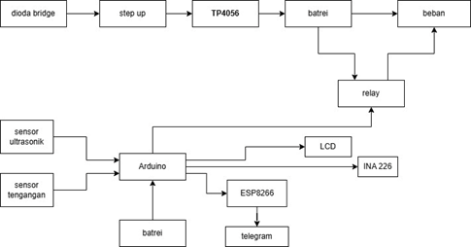

Piezoelectric Technology
Piezoelectric materials exhibit the ability to convert mechanical stress into electrical energy through the direct piezoelectric effect, caused by the displacement of internal charge centers in non-centrosymmetric crystal structures [5]. In this work, multiple piezoelectric discs are connected in a parallel configuration to increase the output current while maintaining manageable voltage levels. This configuration is advantageous for footstep energy harvesting, where the applied force is intermittent and variable.

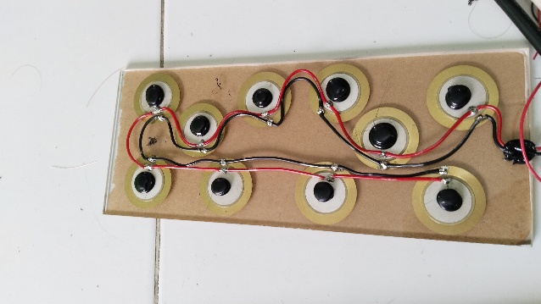

Energy Rectification and Storage
The rectification and storage subsystem consists of a full-bridge rectifier followed by a smoothing capacitor, enabling the conversion of the piezoelectric AC output into stable DC voltage. The TP4056 battery management module ensures controlled charging of the 18650 Li-ion cell, preventing overcharging and deep discharge, thereby enhancing battery lifespan [6]. The selected battery capacity (2000–3000 mAh) enables sustained operation of low-power loads such as LEDs, sensors, and microcontrollers, even during periods without mechanical input.

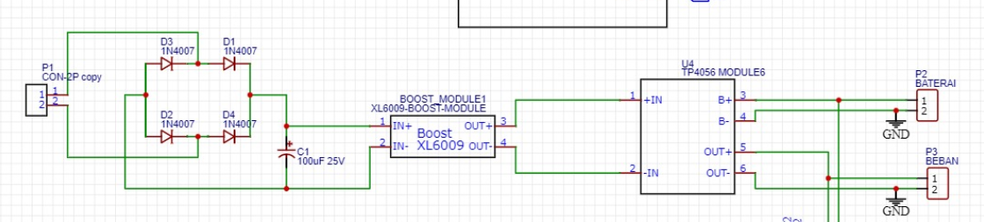

IoT-Based Monitoring System
The IoT monitoring subsystem continuously measures the battery voltage and load current using a DC voltage sensor and the INA226 current sensor. An Arduino Uno microcontroller serves as the central processing unit, acquiring data from the sensors, displaying it locally on a 16×2 LCD with I²C interface, and transmitting it remotely via the ESP8266 Wi-Fi module.
The ESP8266 communicates with a Telegram bot, enabling remote real-time access to battery status data upon request [7, 8, 9]. This dual-mode monitoring—local and remote—ensures that users can manage system performance and schedule maintenance proactively. A relay-based load control mechanism is implemented to switch the output load on or off based on predefined voltage thresholds programmed in the Arduino firmware.
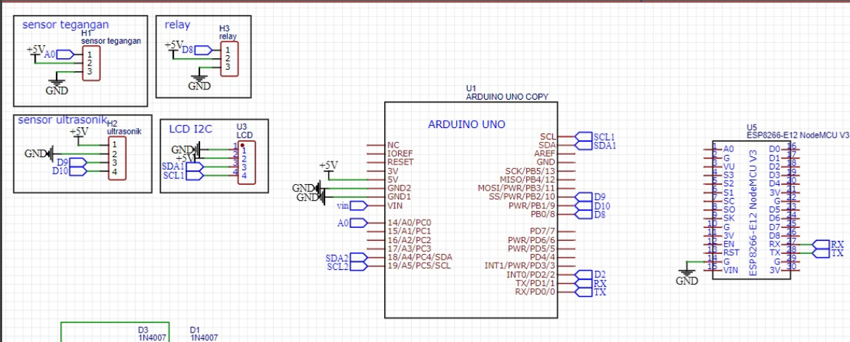

Summary of Operation
When mechanical force is applied to the piezoelectric tiles, electrical energy is generated, rectified, boosted, and stored in the battery. The monitoring system then provides immediate visual feedback through the LCD and sends remote alerts or updates through IoT connectivity. This integrated design ensures energy harvesting, storage, and monitoring functions operate seamlessly, offering a practical and sustainable micro-energy solution suitable for high-footfall public spaces.

RESULT AND DISCUSSION
Here The experimental evaluation of the piezoelectric energy harvesting system focused on understanding how the number of piezoelectric elements influences the output voltage when the applied load and number of impacts remain constant. The tests were carried out using a subject with a body mass of 95 kg, applying 20 foot impacts per trial to the piezoelectric tile assembly. The independent variable was the number of piezoelectric elements installed: 5, 10, and 20 units.

Table 1. summarizes the measured output voltage for each configuration.
Body Mass (kg) | Number of Piezoelectric Elements | Number of Footsteps | Output Voltage (V)
95 | 5 | 20 | 3.524
95 | 10 | 20 | 3.368
95 | 20 | 20 | 2.194

Table 1: Measured output voltage for different numbers of piezoelectric elements under constant load and number of impacts.

From Table 1, it is evident that increasing the number of piezoelectric elements did not lead to an increase in output voltage. The highest voltage, 3.524 V, was recorded with only five elements. When the number of elements was doubled to 10, a slight decrease in voltage to 3.368 V was observed. Further increasing the number to 20 elements caused a more pronounced drop in voltage to 2.194 V.

This counterintuitive result can be explained by mechanical load distribution. In a piezoelectric system, the electrical output is highly dependent on the amount of mechanical stress applied to each element. With a fixed total force from the user’s footstep, adding more elements distributes this force over a greater number of discs, reducing the stress experienced by each disc. Because the piezoelectric effect is proportional to mechanical strain, less strain per element directly translates into lower voltage generation.

Furthermore, the way the elements are electrically connected also contributes to the outcome. In a parallel connection, the current capacity increases, but the voltage tends to remain constant or decrease if the stress distribution is uneven or the load impedance is not well matched [11]. Conversely, a series connection would theoretically increase voltage, but it is more sensitive to inconsistencies in mechanical loading—if one element produces a lower voltage due to uneven pressure, it can limit the overall system output.

Another factor worth noting is the mechanical coupling between the footstep and the sensors. The placement of sensors, stiffness of the conblock material, and damping effects introduced by the mounting method all influence how the applied force is transferred to the piezoelectric discs. For example, if the tile flexes unevenly or absorbs part of the force before it reaches the sensors, the effective stress on each element will be reduced.

These results highlight a key engineering trade-off in designing piezoelectric harvesting systems: adding more elements can increase coverage area and total energy capacity under some conditions, but without proper force concentration and mechanical coupling, the per-element performance may decline. In the tested configuration, five elements provided the best voltage performance, suggesting that there may be an optimal balance between number of elements, their positioning, and the mechanical characteristics of the tile.

For practical implementation in public areas, such as pedestrian walkways, it is important to consider not only the electrical arrangement but also the human–system interaction. In real-world scenarios, variations in walking patterns, step force, and impact location could exacerbate the non-uniform stress distribution observed in controlled testing. Future improvements could involve mechanical force concentrators, optimized series–parallel electrical layouts, or adaptive load management to maximize harvested power under varying operational conditions.

CONCLUSION
This study demonstrated the design, implementation, and evaluation of a piezoelectric-based energy harvesting system integrated with an IoT-enabled monitoring platform. The system utilized piezoelectric sensors embedded within a concrete block to convert mechanical pressure from foot impacts into electrical energy, which was subsequently stored in a lithium-ion battery and monitored locally via an LCD display as well as remotely through Telegram bot communication.

Experimental results revealed that the number of piezoelectric elements significantly influenced the output voltage under constant load and number of impacts. Specifically, the configuration with five piezoelectric elements produced the highest voltage output (3.524 V), while increasing the number of elements to ten and twenty led to decreased voltages of 3.368 V and 2.194 V, respectively. This behavior was attributed to the distribution of mechanical force across multiple elements, reducing individual sensor strain and thus lowering voltage generation.

The findings emphasize that in piezoelectric energy harvesting systems, a higher number of elements does not necessarily translate into better electrical output. Instead, optimal system performance depends on careful consideration of mechanical force distribution, sensor configuration (series or parallel), and load matching.

In practical applications, such as pedestrian-powered energy harvesting in public spaces, these insights can guide design improvements to balance energy output, coverage area, and cost efficiency. Future work will focus on optimizing mechanical coupling, exploring hybrid series–parallel configurations, and testing the system under varied real-world load conditions to enhance performance and reliability.

References
- M. I. Mowaviq, A. Junaidi, and S. Purwanto, “Lantai Permanen Energi Listrik Menggunakan Piezoelektrik,” Energi & Kelistrikan, vol. 10, no. 2, pp. 112–118, 2018.
- [2] W. Hidayatullah, M. Syukri, and S. Syukriyadin, “Perancangan prototype penghasil energi listrik berbahan dasar piezoelectrik,” Jurnal Komputer, Informasi Teknologi, dan Elektro, vol. 1, no. 3, 2016.
- [3] Y. A. C. Wijaya, D. Zebua, D. P. Kolago, and Y. A. K. Utama, “PENGARUH LUAS PERMUKAAN PIEZOELECTRIC DISK TERHADAP TEKANAN DAN GETARAN DALAM MENGHASILKAN ENERGI LISTRIK,” Prosiding Sains Nasional dan Teknologi, vol. 1, no. 1, 2019.
- [4] P. Adam, D. Ronaldo, and N. Nugrahaningsih, “Rancang Bangun Kangkanung Elektrik Dengan Sensor Piezo Berbasis Mikrokontroler,” Jurnal Teknika: Jurnal Teoritis dan Terapan Bidang Keteknikan, vol. 6, no. 1, pp. 74–83, 2022.
- [5] D. Zebua, D. Kolago, Y. A. C. Wijaya, and Y. A. K. Utama, “Desain dan pembuatan pembangkit listrik tenaga air hujan menggunakan piezoelectric disk,” Jurnal Tecnoscienza, vol. 4, no. 1, pp. 79–94, 2019.
- [6] R. Artayuda, R. Candra, H. Rasjid, and Y. Chalri, “INFORMASI PENGISIAN BATERAI KENDARAAN SEPEDA MOTOR LISTRIK BERBASIS INTERNET OF THINGS (IOT),” JIKA (Jurnal Informatika), vol. 9, no. 2, pp. 184–191, 2025.
- [7] M. I. Mowaviq, A. Junaidi, and S. Purwanto, “Lantai permanen energi listrik menggunakan piezoelektrik,” Energi & Kelistrikan, vol. 10, no. 2, pp. 112–118, 2018.
- [8] R. Tullah, S. Sutarman, and A. H. Setyawan, “Sistem penyiraman tanaman otomatis berbasis mikrokontroler arduino uno pada toko tanaman hias yopi,” Jurnal Sisfotek Global, vol. 9, no. 1, 2019.
- [9] M. Royhan, “Pengukuran tegangan baterai mobil dengan Arduino Uno,” Jutis (Jurnal Teknik Informatika), vol. 6, no. 1, pp. 30–36, 2018.
- [10] M. A. Prasetyo and H. K. Wardana, “Rancang Bangun Monitoring Solar Tracking System Menggunakan Arduino dan Nodemcu Esp 8266 Berbasis IoT,” RESISTOR (Elektronika Kendali Telekomunikasi Tenaga Listrik Komputer), vol. 4, no. 2, pp. 163–168, 2021.
- [11] A. A. Hakim, “Perancangan Sistem Monitoring Tegangan Piezoelektrik Untuk Pengisian Baterai Berbasis Bluetooth,” 2020, JTEUNIBA.

