Development of a Dual-Axis Smart Solar Tracking System with IoT-Based Performance Monitoring for Enhanced Photovoltaic Efficiency
Muhammad Irfan^{1, a)}, Haneef Nouval Alannibras Humaidi ^{1, b)} , Anugerah Wahyu Muhammad^{1, c)} , Mohammad Jhorggi Arridho^{1, d)}
Author Affiliations
¹Electrical Engineering Department, Universitas Muhammadiyah Malang, Tlogomas Street 246, Malang, East Java, Indonesia.
Author Emails
^{a)} irfan@umm.ac.id
^{b)} Corresponding author: haneefnouval@umm.ac.id
^{c)} anugerahwm@webmail.umm.ac.id
^{d)} mohammadjhorggi@webmail.umm.ac.id
Abstract. Static photovoltaic (PV) panels exhibit optimal energy absorption only during limited time intervals, leading to reduced efficiency at other times due to changes in sunlight incidence angles. This study presents the design, development, and implementation of a two-axis smart solar tracker to improve solar energy conversion efficiency. The proposed system employs four light-dependent resistors (LDRs) for directional sensing, two servo motors for panel orientation, and a microcontroller as the control unit. The methodology encompasses mechanical design, control circuit design, and performance testing against a static PV panel under identical conditions. Experimental results demonstrate a significant improvement in energy capture with the two-axis tracking system compared to the static configuration, highlighting its potential as an effective solution for small- to medium-scale renewable energy applications.

INTRODUCTION
This The rapid growth of population and the accelerated pace of technological advancement have led to a significant increase in energy demand, particularly electricity consumption, in Indonesia. To date, this demand is still predominantly met by fossil energy sources such as petroleum, natural gas, and coal. Continued reliance on fossil fuels poses serious environmental risks, most notably the increase in carbon dioxide emissions, which contributes to global warming and climate change [1,2].

Among various renewable energy alternatives, solar energy stands out as a highly promising and environmentally friendly option. As a tropical country located along the equator, Indonesia benefits from high and relatively stable solar irradiance throughout the year, making it highly suitable for the deployment of photovoltaic (PV) power plants [2,3]. Beyond its environmental benefits, solar energy utilization represents a strategic step toward supporting the national transition to a sustainable and clean energy system [1].

A major limitation of conventional PV systems lies in their static configuration, in which panels are fixed at a certain tilt and azimuth angle. Without the ability to automatically follow the sun’s movement, the incident solar radiation received is often suboptimal, especially during early morning and late afternoon hours. This non-optimal alignment results in reduced energy absorption and lower electrical output [4,5].

To overcome this drawback, solar tracking systems have been developed to dynamically adjust PV panel orientation in accordance with the sun’s position throughout the day. By maintaining an optimal angle of incidence, these systems can significantly improve energy conversion efficiency [3,5]. Recent advancements in the Internet of Things (IoT) have further enhanced solar tracking systems by enabling remote monitoring and control, which is particularly advantageous for installations in remote or hard-to-access locations [3,6].

Solar trackers are generally classified into two categories based on their movement mechanisms: single-axis and dual-axis trackers. Single-axis systems rotate either in the horizontal (azimuth) or vertical (elevation) plane, while dual-axis systems adjust in both planes, allowing for more precise sun tracking over the course of the day and across seasons [4–6]. Several studies have demonstrated that dual-axis tracking can yield significantly higher energy output compared to single-axis and fixed systems [4].

This study focuses on the design and implementation of an IoT-based dual-axis solar tracking system aimed at optimizing solar energy utilization. The proposed system employs light-dependent resistors (LDRs) and a gyroscope sensor to detect the sun’s direction and panel orientation, while a microcontroller and wireless communication module enable automatic control and real-time data monitoring [3,5,7]. The contributions of this research are expected to provide a cost-effective solution for alternative energy adoption in Indonesia and to support the advancement of renewable energy technologies.

methodology

System Design
This research adopts an experimental approach by designing and developing a microcontroller-based dual-axis solar tracking system. The system is engineered to automatically adjust the orientation of the solar panel according to the light intensity detected from four different directions. The primary objective of this design is to ensure that the panel remains aligned with the direction of maximum sunlight throughout the day, thereby improving the efficiency of solar energy conversion.

The overall system architecture, illustrated in Figure 1, comprises four Light Dependent Resistors (LDRs) serving as light intensity sensors, two servo motors acting as actuators for horizontal and vertical movement, and a NodeMCU ESP8266 microcontroller functioning as the central processing and control unit.

Hardware Components
The main hardware components used in the proposed system are as follows:

Light Dependent Resistors (LDRs): Detect solar irradiance from four distinct directions (top, bottom, left, right).

INA219 Current Sensor: Measures current, voltage, and power output of the PV module.

ADS1115 Analog-to-Digital Converter (ADC): Provides higher resolution and accuracy compared to the built-in ADC of the microcontroller.

DS3218 Servo Motors: Control the horizontal (azimuth) and vertical (elevation) rotation of the PV panel.

NodeMCU ESP8266 Microcontroller: Serves as the main controller for data acquisition, decision-making, and actuator control.

Mini PV Panel: Serves as the primary energy source for testing the tracking performance.

SMT125 Battery Pack: Functions both as a power supply for the system and as an energy storage unit.

Solar Charge Controller (SCC): Regulates power flow from the PV panel to the battery.

LM2596 DC-DC Buck Converter: Steps down the battery voltage to safe operating levels (5 V or 3.3 V) for the microcontroller, servo motors, LDR sensors, and communication modules.

XH-M604 Digital Battery Charger Controller: Automatically controls battery charging and discharging.

Mechanical Frame: Constructed from PVC boards and lightweight steel plates, providing structural support and enabling two-axis motion of the panel.

Control Algorithm
The tracking mechanism operates by continuously comparing the light intensity values obtained from the four LDR sensors positioned at the panel’s edges (top, bottom, left, right). The microcontroller reads the sensor outputs, calculates the differences between opposing pairs, and determines the required movement direction.

Horizontal Adjustment: If the intensity difference between left and right exceeds a predefined threshold, the horizontal servo motor rotates the panel toward the brighter side.

Vertical Adjustment: If the difference between top and bottom exceeds the threshold, the vertical servo motor adjusts the tilt accordingly.

This process is executed in a continuous loop with a fixed sampling interval to ensure real-time alignment with the sun’s position. When the light intensity from all four sensors is below a minimum threshold (e.g., <50), the system enters a standby mode to conserve energy. The logical sequence of the control process is illustrated in the flowchart shown in Figure 2.

Testing Procedure
The performance evaluation was conducted by comparing the efficiency of a static PV panel with that of the proposed dual-axis tracking system. The tests were performed outdoors over several hours under clear-sky conditions.

The parameters measured during testing include:

Output Voltage (V) from the PV module.

Output Current (I) delivered by the PV module.

Power Output (P), calculated as P=V×I.

Data were recorded at one-hour intervals from morning until late afternoon. For each time interval, the energy conversion efficiency of both systems was calculated and compared to evaluate the improvement provided by the tracking mechanism.

RESULT AND DISCUSSION

Dual-Axis Tracking System Performance
The experimental evaluation compared the performance of a static solar panel and a dual-axis tracking system under clear weather conditions from 07:00 to 17:00 WIB. Voltage, current, and power output were measured in real time using the INA219 sensor, an ESP8266 microcontroller, and the Blynk monitoring platform.

As shown in Table 1, the dual-axis tracker consistently produced higher power output than the static panel during most of the day. The difference was particularly significant during early morning and late afternoon, when the angle of incidence of sunlight on the static panel deviated substantially from optimal alignment. At solar noon (12:00), both systems achieved their peak output, as the static panel happened to be closely aligned with the sun’s position.

Table 1. Comparison of Output Power between Static Panel and Dual-Axis Tracker
 | Static Panel |  |  | Using Solar Tracker
Time | Voltage (V) | Current (A) | Power (W) | Voltage (V) | Current (A) | Power (W)
07:00 | 4.2 | 0.08 | 0.33 | 12.1 | 0.10 | 1.21
08:00 | 6.5 | 0.15 | 0.97 | 12.2 | 0.20 | 2.44
09:00 | 9.0 | 0.22 | 1.98 | 12.1 | 0.32 | 3.87
10:00 | 10.5 | 0.30 | 3.15 | 12.3 | 0.45 | 5.53
11:00 | 11 | 0.40 | 4.4 | 12.3 | 0.52 | 6.39
12:00 | 12.4 | 0.56 | 6.94 | 12.4 | 0.56 | 6.94
13:00 | 11.3 | 0.40 | 4.52 | 12.2 | 0.53 | 6.46
14:00 | 10.7 | 0.32 | 3.42 | 12.0 | 0.30 | 3.40
15:00 | 9.5 | 0.27 | 2.56 | 12.1 | 0.24 | 2.90
16:00 | 7.8 | 0.18 | 1.40 | 12.1 | 0.22 | 2.66
17:00 | 6.0 | 0.10 | 0.6 | 12.0 | 0.12 | 1.44

On average, the dual-axis system demonstrated an energy gain of approximately 15–20% compared to the static configuration, with the most pronounced improvement occurring during the low solar elevation periods in the morning and afternoon.

Panel Orientation Tracking
In addition to electrical performance, the azimuth and elevation angles of the panel were recorded throughout the day (Table 2).

Table 2. Recorded Azimuth and Elevation Angles of the Tracking System
Time | Azimuth (°) | Elevation (°)
07.00 | 23 | 15
08.00 | 35 | 25
09.00 | 50 | 35
10.00 | 64 | 50
11.00 | 78 | 65
12.00 | 90 | 90
13.00 | 112 | 60
14.00 | 128 | 55
15.00 | 148 | 35
16.00 | 160 | 20
17.00 | 168 | 15
The azimuth angle reflects the horizontal rotation of the panel from east to west, while the elevation angle corresponds to the vertical tilt in response to the sun’s height in the sky. These recorded angles confirm that the tracking system maintained optimal panel orientation throughout the day, resulting in more consistent energy capture than the static panel.
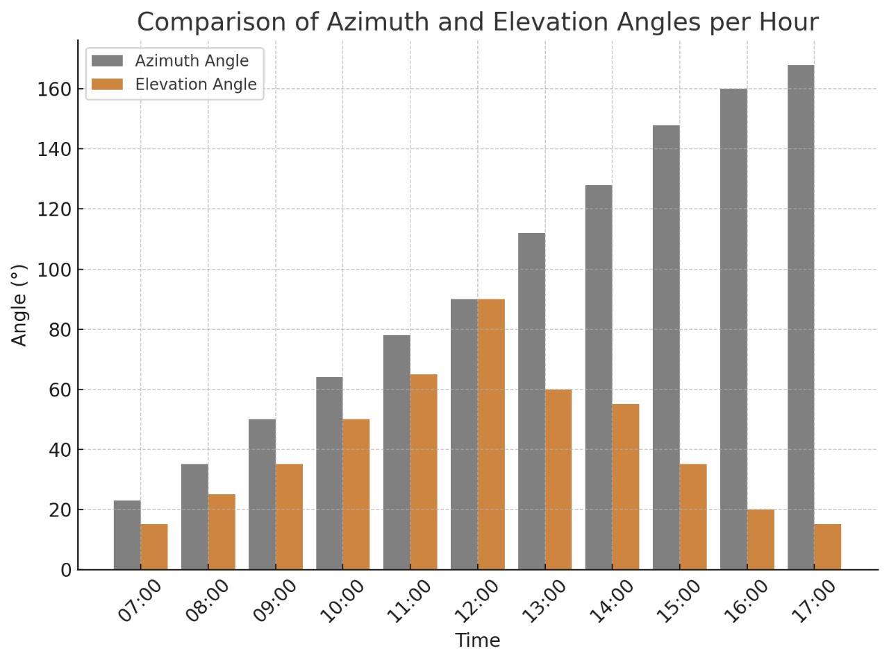

IoT-Based Real-Time Monitoring
The Blynk application provided remote, real-time monitoring of the system’s electrical output and battery status. The ESP8266 transmitted sensor readings via Wi-Fi to the Blynk server, which displayed them on a smartphone dashboard. Parameters monitored included PV voltage, current, power output, and battery charging status.

During the field test, the application displayed PV Voltage = 12.1 V, PV Current = 0.2 A, and PV Power = 2.9 W. This interface enabled operators to observe system performance trends, identify peak production periods, and detect anomalies such as sudden drops in output due to cloud cover or shading.

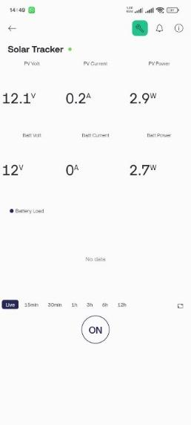

Role of the Solar Charge Controller (SCC)
A Solar Charge Controller (SCC) was integrated to regulate energy transfer from the PV panel to the SMT125 12V 5Ah battery. The SCC prevented overcharging, safeguarded against reverse current flow, and stabilized the charging voltage at around 12 V. During the test, the SCC maintained a steady output of 12.0 V, ensuring safe and efficient battery charging while prolonging battery lifespan.
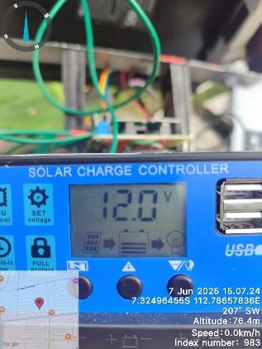

System Evaluation and Technical Challenges
The dual-axis tracking system proved effective in increasing solar energy capture and could operate autonomously with battery backup. However, several technical challenges were identified:

Energy consumption of the servo motors and ESP8266, which must be balanced against the additional energy harvested.

Dependence on internet connectivity for real-time IoT monitoring.

Reduced tracking effectiveness during overcast conditions or when shaded by surrounding objects.

Despite these challenges, the system exhibited stable and reliable performance, making it suitable for small- to medium-scale renewable energy applications, particularly in regions with high solar potential.

CONCLUSION
This study successfully designed, implemented, and evaluated a dual-axis smart solar tracking system aimed at improving the efficiency of photovoltaic (PV) energy conversion. The experimental results demonstrated that the proposed system consistently outperformed a static solar panel, achieving an average power gain of 15–20% under clear weather conditions. The improvement was most significant during early morning and late afternoon, when solar incidence angles deviate substantially from the static panel’s orientation.

The integration of a real-time IoT monitoring platform (Blynk) enabled continuous performance tracking and operational diagnostics, while the inclusion of a Solar Charge Controller ensured safe and efficient battery charging. The system maintained stable operation and optimal solar alignment throughout the test period, as confirmed by the recorded azimuth and elevation angle data.

Although certain challenges remain—such as energy consumption by tracking components, dependence on internet connectivity, and reduced performance under cloudy conditions—the dual-axis tracker offers a practical and reliable solution for small- to medium-scale renewable energy applications. This approach can contribute significantly to optimizing solar energy utilization, particularly in regions with high solar potential.

Future work may focus on implementing low-power actuators, developing offline tracking algorithms, and enhancing environmental adaptability to further improve system efficiency and scalability.

Acknowledgments
The authors would like to express their sincere gratitude to Universitas Muhammadiyah Malang and PT. Renus Global Indonesia for providing the facilities, resources, and continuous support throughout the design and testing phases of this research. Their guidance and encouragement were instrumental in ensuring the successful completion of this work.

The authors also wish to acknowledge the valuable technical assistance and contributions from fellow students, colleagues, and all individuals who directly or indirectly supported the execution of this study. Their collective efforts are deeply appreciated.

References
- M. Ali dan J. Windarta, “Pemanfaatan Energi Matahari Sebagai Energi Bersih yang Ramah Lingkungan,” Jurnal Energi Baru dan Terbarukan, vol. 1, no. 2, hlm. 68–77, Jul 2020, doi: 10.14710/jebt.2020.10059.
- A. Kharisma, S. Pinandita, dan A. E. Jayanti, “Literature Review: Kajian Potensi Energi Surya Alternatif Energi Listrik,” Jurnal Energi Baru dan Terbarukan, vol. 5, no. 2, hlm. 145–154, Jul 2024, doi: 10.14710/jebt.2024.23956.
- D. Saputra, M. Rafiq, N. R. Setyoningrum, dan H. Setiawan, “Prototipe Smart Solar Tracker System dengan Memanfaatkan Internet Of Things dan Monitoring Berbasis Android,” Digital Transformation Technology, vol. 4, no. 1, hlm. 540–549, Jul 2024, doi: 10.47709/digitech.v4i1.4375.
- O. Wendryanto dkk., “PENGEMBANGAN PENGGERAK SOLAR PANEL DUA SUMBU UNTUK MENINGKATKAN DAYA PADA SOLAR PANEL TIPE POLIKRISTAL,” 2017.
- M. Pardawantara dan F. Antony, “PERANCANGAN SISTEM SOLAR TRACKING DUAL AXIS UNTUK OPTIMASI PANEL SURYA MENGGUNAKAN SENSOR LDR DAN GYROSCOPE BERBASIS INTERNET OF THINGS (IOT).”
- B. A. Hamad, A. M. T. IBRAHEEM, dan A. G. ABDULLAH, “Design and practical implementation of dual-axis solar tracking system with smart monitoring system,” Przeglad Elektrotechniczny, vol. 96, no. 10, hlm. 151–155, 2020, doi: 10.15199/48.2020.10.28.
- A. A. Solikah dan B. Bramastia, “Systematic Literature Review : Kajian Potensi dan Pemanfaatan Sumber Daya Energi Baru dan Terbarukan Di Indonesia,” Jurnal Energi Baru dan Terbarukan, vol. 5, no. 1, hlm. 27–43, Mar 2024, doi: 10.14710/jebt.2024.21742.

