Design and Development of a pH and Salinity Control System for Vannamei Shrimp Ponds Using the Fuzzy PD Method

Zulfatman^{a)}, M. Chasrun Hasani^{b)}, Icwan Febriatno ^{c)}, Amrul Faruq ^{d)}

Department of Electrical Engineering, University of Muhammadiyah Malang, Jl. Raya Tlogomas No.246, Malang, Indonesia
ᵃ⁾Corresponding author: zulfatman@umm.ac.id

Abstract. Maintaining optimal water quality parameters, particularly pH and salinity, is essential for the growth, health, and productivity of Vannamei shrimp (Litopenaeus vannamei). This study presents the design and development of an automated control system for regulating pH and salinity in shrimp ponds using the Fuzzy Proportional-Derivative (Fuzzy PD) method. The system employs water quality sensors to continuously monitor real-time conditions, while the Fuzzy PD controller processes the sensor data to determine appropriate control actions. Actuators, including dosing pumps and water inlet/outlet mechanisms, are used to adjust water parameters to maintain them within optimal ranges. The proposed design emphasizes precision, adaptability to fluctuating environmental conditions, and user-friendly operation. Experimental tests demonstrate that the system effectively stabilizes pH and salinity levels, thereby supporting sustainable aquaculture practices and improving shrimp yield.

INTRODUCTION
Unmanned Aerial Vehicles (UAVs) have become a key technology in various industrial sectors, from precision agriculture to infrastructure surveillance. UAV operation relies heavily on Ground Control Station (GCS) software, which serves as the interface between the pilot and the vehicle. Currently, one of the most widely used open-source GCSs is QGroundControl.
While QGroundControl offers comprehensive features, several user studies and analyses have highlighted its drawbacks, including its dense and complex user interface (UI), which presents a steep learning curve for new users. This complexity potentially increases the risk of human error, which can impact mission safety and success. This gap between robust functionality and poor usability is the basis for this research. There is a need to develop a GCS system that is not only functional but also intuitive, in accordance with User-Centered Design principles.
Therefore, this study aims to design, build, and test a new GCS application called MotoGrid GCS. The main goal is to provide an efficient, safe and accessible UAV operations management solution for users of all skill levels, thereby minimizing operational risks and increasing mission effectiveness.

LITERATURE REVIEW

No-Fly Area Features
This module draws on modern airspace management principles and advanced geofencing technology to ensure compliance with drone regulations. Studies on the use of geofencing in geospatial applications demonstrate how virtual boundaries significantly impact drone user safety and privacy. DJI recently updated its geofencing system, aligning with FAA and EASA data from early 2024–2025, replacing rigid no-fly zones with revocable warning zones, emphasizing operator responsibility and adapting to aviation authority standards.
Dynamic geofencing technology is becoming more sophisticated through frameworks such as UTICN, which enables real-time airspace management for UAVs, including swarm coordination and intelligent connectivity. Furthermore, complex geofencing algorithms, such as the alpha shapes approach with Voronoi diagrams, have been tested since 2021 to improve the accuracy of virtual boundaries, particularly in urban environments.
Flight Data Storage and Documentation
In this study, the authors utilized a SQLite database to simplify the process of storing log data, which will later be displayed to administrators. SQLite itself is an embedded RDBMS database management system currently popular among developers, for both desktop and web-based applications. This system is used to store, organize, and manage data in file form, allowing for immediate use. Its functionality is similar to MySQL, which is often used for database management.
Furthermore, research presents a flow-time optimization model for real-time data stream processing in UAV networks for mobile edge computing, demonstrating the importance of a low-latency architecture to support rapid analysis and response. [16] One study introduced a mini-UAV telemetry-based solution for real-time flight data acquisition, highlighting the need for a reliable backend system for flight log storage.
Furthermore, the development of a spatio-temporal aggregation algorithm (ESTA) for UAV networks, which enables efficient querying, storage, and delivery of data in dynamic UAV topologies, is presented.

RESEARCH METHOD
This research uses a Software Engineering approach with a Research and Development (R&D) model. The adopted framework is the ADDIE (Analysis, Design, Development, Implementation, Evaluation) model due to its structured and measurable nature for software development.

Analysis
This stage aimed to identify the functional and non-functional requirements of the system. The methods applied included:

- Literature Study: Examining QGroundControl documentation, drone flight regulations from ICAO, EASA, FAA, and CASR (Indonesia), as well as standards related to usability and risk management.
- Observation: Observing existing UAV operation paths and geofencing systems, such as those in DJI and ArduPilot.
- Interviews: Speaking with UAV operators and field technicians to uncover real user needs

Design
This system was created as a set of interconnected features within MotoGrid GCS. The system structure consists of:

- Frontend: Utilizes QML (Qt Quick) to create a user interface and interactions that are easy to understand.
- Backend: Utilizes C++ to manage business logic, information management, and the processing of no-fly zone data in GeoJSON format.
- Visual Design: UML diagrams (Use Case, Activity, Class) were used to represent the system's workflow, while user interface mockups were created with Figma to provide an initial visual concept.

Development
The applied prototyping method supports rapid iteration based on user feedback. The process consists of rapid planning, development of a functional prototype, user assessment, and iterative refinement until the prototype meets all predetermined criteria. This development was carried out by cloning and modifying the QGroundControl source code.
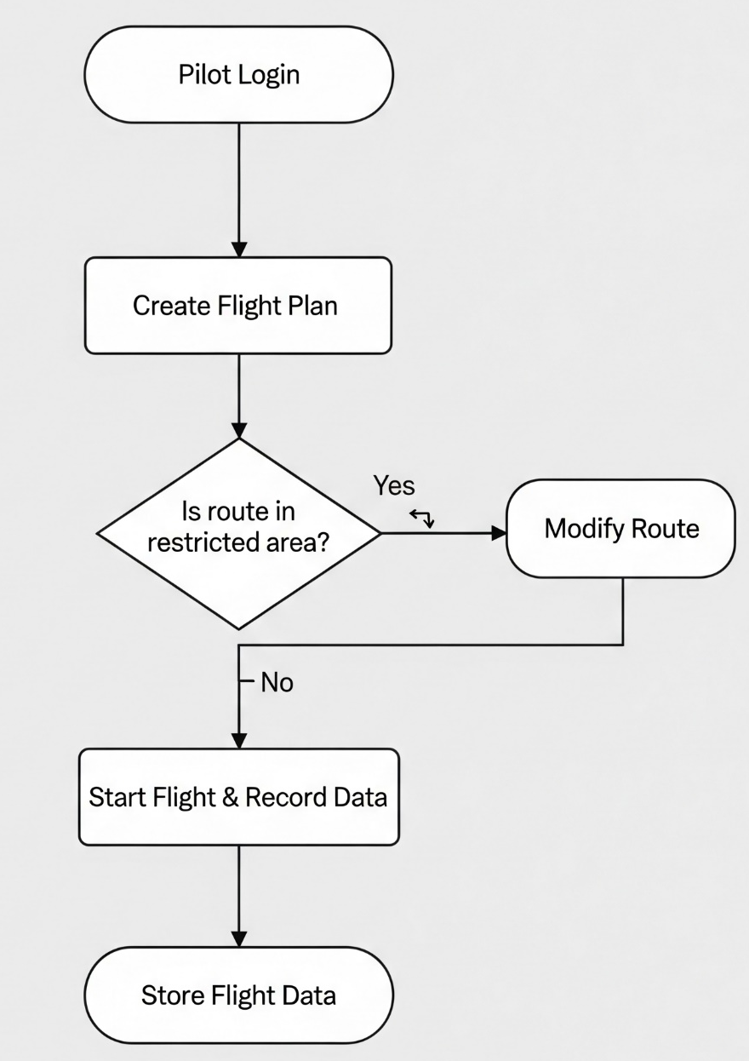
FIGURE 1. System Workflow Flowchart for MotoGrid GCS.

Implementation
The system was implemented in the following technical environment:

- Programming Languages: C++ and QML.
- Tools & Frameworks: Qt Creator, Qt 5.15, CMake, and Git.
- Development Environment: Windows 10 / Ubuntu 22.04.
- Simulation: Initial testing was conducted in a PX4 SITL (Software In The Loop) simulation environment to validate functionality before real-world trials.

Evaluation
Evaluation was conducted through two types of testing:

- Functional Testing: Ensuring that all features, such as the pre-flight checklist, No-Fly Zone warnings, and information logging, function correctly according to the established criteria without errors.
- Performance Testing: Evaluating quantitative figures such as system response time and data processing speed. Qualitative analysis was also performed based on user feedback on the ease of use and effectiveness of the existing features.

RESULTS AND DISCUSSION

Module Development Results
The results of this study indicate that the UAV (Unmanned Aerial Vehicle) operations management module designed with MotoGrid GCS has been successfully developed to meet the requirements of the Ground Control Station (GCS) system. The results can be seen in the following figure.

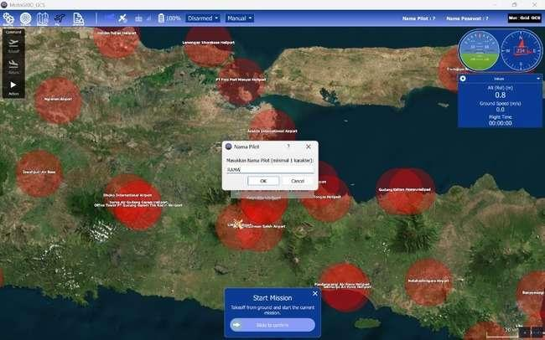
FIGURE 2. Display of the Prohibited Area Zone
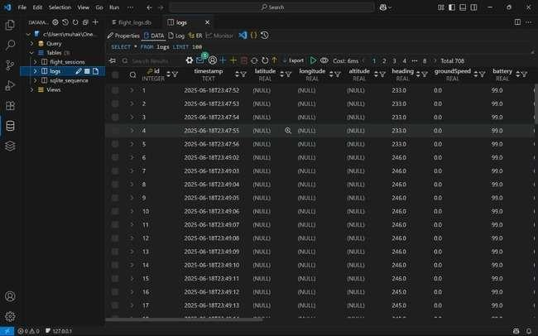
FIGURE 3. Flight History Database View

The following table summarizes the main components of the module and their functionality:
TABLE 1. Features and Functions of the MotoGrid GCS Application.
No | Feature Module | Main Function
1 | No-Fly Zone | Visual warning when UAV enters no-fly zone
2 | Mission Data Log | Recording and storing flight data

Discussion
Answering the Research Question (What)

This research successfully created a flexible module compatible with the MotoGrid GCS platform to effectively manage UAV operations. The results showed that the system could perform planning, monitoring, and reporting functions directly.

Interpretation of Results (Why)

This success is demonstrated by the modular strategy used in software development and the utilization of the MAVLink library, which has been proven to work with many automated control systems. Furthermore, the integration of open-source maps (such as Leaflet and Mapbox) allows the system to display maps and restricted areas with a high degree of accuracy.

Comparison with Previous Research

The results of this research corroborate the assertion proposed by Widodo et al. (2021), who argued that the level of flexibility of a GCS is determined by the openness of its communication protocols and its modular structure. However, this study adds to this knowledge by incorporating risk management aspects through the implementation of automatic marking of prohibited zones for flight, which has not been discussed in detail in previous research.

Scientific and Theoretical Contributions (What else)

Theoretically, this advancement adds value to the GCS management framework by incorporating airspace control elements, making it more suitable for UAV deployment in complex environments such as urban areas. This module can be used as a reference for the development of other open-source GCSs.

Theoretical and Implementation Implications
Theoretically, this module emphasizes that a GCS system should act not only as a flight controller but also as a device for overall mission management. The practical consequences of this research are:

- Assisting UAV operators in managing missions without requiring other systems.
- Applicable in various missions, such as surveillance, mapping, and logistics in restricted areas.

CONCLUSION
The MotoGrid GCS system was successfully developed with a flight logging feature equipped with metadata such as pilot identity and UAV ID, enabling more structured and easily traceable data documentation. The data logging feature in Sqlite (.db) format facilitates further analysis, reporting, and integration with other documentation systems. Functional testing showed that every system component runs according to specifications, including automatic data storage and data retrieval through the GUI. In terms of advantages, this system offers user-friendliness for novice operators, better data transparency, and flight history tracking capabilities. However, the system still has limitations, such as the lack of an integrated automatic cloud backup feature and minimal protection against operator metadata input errors.

ACKNOWLEDGMENTS
The authors would like to thank the University of Muhammadiyah Malang and PT Motodoro for the facilities provided for this research. We also express our gratitude to our colleagues for their constructive discussions and support throughout the research process.

REFERENCES
- A. Rezi and M. Allam, "Techniques in array processing by means of transformations, " in Control and Dynamic Systems, Vol. 69, Multidimensional Systems, C. T. Leondes, Ed. San Diego: Academic Press, 1995, pp. 133-180.
- W.K. Chen, Linear Networks and Systems. Belmont, CA: Wadsworth, 1993, pp. 123-135
- T. J. van Weert and R. K. Munro, Eds., Informatics and the Digital Society: Social, ethical and cognitive issues: IFIP TC3/WG3.1&3.2 Open Conf.e on Social, Ethical and Cognitive Issues of Informatics and ICT, July 22-26, 2002, Dortmund, Germany. Boston: Kluwer Academic, 2003.
- L. Bass, P. Clements, and R. Kazman, Software Architecture in Practice, 2nd ed. Reading, MA: Addison Wesley, 2003. [Online] Available: Safari e-book.
- M. W. Dixon, "Application of neural networks to solve the routing problem in communication networks," Ph.D. dissertation, Murdoch Univ., Murdoch, WA, Australia, 1999.
- Putri, D.D., Nama, G.F. and Sulistiono, W.E., 2022. Analisis Sentimen Kinerja Dewan Perwakilan Rakyat (DPR) Pada Twitter Menggunakan Metode Naive Bayes Classifier. Jurnal Informatika dan Teknik Elektro Terapan, 10(1).
- Anwaruddin Ridho Novianto & Septia Rani. (2022). Pengembangan Desain UI/UX Aplikasi Learning Management Syste
- Dwi Rizky Alamsyah, Mochzen Gito Resmi & Irsan Jaelani. (2023). A Design UI/UX E-Learning English Mobile Using User Centered Design (UCD) Method. Sinkron: Jurnal dan Penelitian Teknik Informatika, 7(4), 2434–2443.
- ISO. (2018; dikonfirmasi masih berlaku 2023). ISO 9241-11:2018 – Ergonomics of human-system interaction — Part 11: Usability: Definitions and concepts. International Organization for Standardization.
- Habibi, H., Rao, D. M. K. K. V., & Sanchez-Lopez, J. L. (2023). On SORA for High-Risk UAV Operations under New EU Regulations: Perspectives for Automated Approach. arXiv.
- Naji, H. R., & Ayati, A. (2023). Risk Management of Unmanned Aerial Vehicles. arXiv.
- Lee, S.-H., et al. (2023). How to Enhance Safety of Small Unmanned Aircraft Systems via Safety Management System (SMS). MDPI — Aviation.
- Luo, G., Li, J., Zhang, Q., et al. (2025). Toward Low-Altitude Airspace Management and UAV Operations: Requirements, Architecture and Enabling Technologies. arXiv.
- Vagal, V., Markantonakis, K., & Shepherd, C. (2021). A New Approach to Complex Dynamic Geofencing for Unmanned Aerial Vehicles. arXiv.
- A. N. Hadianti, A. F. Aufar, R. R. Aisyiyah, dan R. F. Putra, “Rancang Bangun Sistem Log Server Berbasis RSyslog dan MySQL untuk Monitoring Aktivitas Komputer Laboratorium,” ELECTRICIAN – Jurnal Rekayasa dan Teknologi Elektro, vol. 17, no. 2, pp. 152–156, Mei 2023..
- Xu, Z., Qiao, H., Liang, W., Xu, Z., Xia, Q., Zhou, P., Rana, O. F., & Xu, W. (2024). Flow-Time Minimization for Timely Data Stream Processing in UAV-Aided Mobile Edge Computing. ACM Transactions on Sensor Networks, 20(3).
- Konar, M., Özdemir, D., Erşen, M., & Fenerci, M. (2024). Acquisition of Flight Data from Mini Unmanned Aerial Systems. Journal of Aviation, 8(3), 221–228.
- Zhai, W., Li, X., Liu, L., Ding, Y., Lu, W., et al. (2023). ESTA: An Efficient Spatial-Temporal Range Aggregation Query Processing Algorithm for UAV Networks. arXiv preprint.

