Performance Analysis of a Photovoltaic Microinverter Based on Interleaved Flyback Converter with MPPT and Current Sharing Compensator
Khusnul Hidayat^{1, a)}, Machmud Effendy^{1, b)}, and Ermanu Azizul Hakim^{1, c)}
¹Department of Electrical Engineering, Universitas Muhammadiyah Malang, Indonesia
^{a)}Corresponding author: khusnulhidayat@umm.ac.id
^{b)}machmud@umm.ac.id
^{c)}ermanu@umm.ac.id
Abstract. This paper presents the design and simulation of a photovoltaic microinverter based on an interleaved flyback converter (IFC) topology for small-scale grid-connected applications. The proposed system integrates maximum power point tracking (MPPT), phase-locked loop (PLL) synchronization, feedforward compensation, and a current sharing compensator (CSC) to improve conversion efficiency, current quality, and channel current balance. The microinverter is designed to operate with a maximum PV power of 250 Wp, an input voltage range of 20–45 V, and a grid voltage of 196–253 Vrms at 49.5–50.5 Hz. MATLAB/Simulink simulations were conducted to evaluate the system performance. Without CSC, the two flyback inductors exhibited a current imbalance of approximately 12%, leading to uneven thermal loading. The implementation of CSC reduced the current sharing error to below 2%, improving load distribution and component reliability. The system achieved grid-synchronized operation with a unity power factor (0.999), total harmonic distortion (THD) of less than 3.6%, and an estimated conversion efficiency improvement of 1.2% compared to operation without CSC. The results confirm that the proposed IFC microinverter architecture, combined with the advanced control scheme, offers a compact, efficient, and reliable solution for residential and small-scale PV systems. Future research will focus on hardware prototyping and experimental validation to assess real-world performance and long-term reliability.
Keywords: Interleaved Flyback Converter, Photovoltaic Microinverter, Current Sharing Compensator, MPPT, Grid-Connected

INTRODUCTION
The global transition towards renewable energy has placed photovoltaic (PV) technology at the forefront of sustainable power generation. Among various PV system configurations, microinverter-based architectures have gained significant attention due to their ability to perform maximum power point tracking (MPPT) at the module level, thereby mitigating mismatch and shading losses, improving overall energy yield, and enhancing system reliability [1], [5], [9]. Microinverters are particularly advantageous in residential and small-scale PV applications because they offer modularity, ease of installation, and improved fault tolerance compared to centralized or string inverters [2], [13]. For low-to-medium power ratings, the flyback converter has emerged as a popular power stage choice owing to its galvanic isolation, high voltage gain capability, and relatively simple structure [3], [14]. The adoption of interleaved flyback converter (IFC) configurations further improves performance by reducing input and output current ripple, lowering peak current stress, and enhancing thermal distribution [4], [6]. These advantages make IFC-based microinverters an appealing solution for single-phase grid integration, especially in distributed generation scenarios.
Recent studies have advanced the design and control of PV microinverters through topology optimization, advanced modulation, and intelligent control strategies. Lodh et al. [2] proposed a novel control scheme for IFC-based microinverters to achieve high efficiency under varying load and irradiance conditions. Dong et al. [4] introduced a model-based current sharing approach for discontinuous conduction mode (DCM) IFC microinverters, enabling balanced current distribution between interleaved channels. Paul et al. [6] and Bhattacharya et al. [7] explored high-gain non-isolated topologies such as SEPIC–Ćuk and coupled inductor–Ćuk converters, reporting efficiency improvements but with increased design complexity. Xiao et al. [8] developed a dual-input microinverter with active power decoupling to suppress double-line frequency power oscillations, while Dutta et al. [9] optimized a GaN-based buck-derived active power decoupler to eliminate electrolytic capacitors. On the control side, recent works have combined MPPT algorithms, phase-locked loop (PLL) synchronization, and feedforward techniques to enhance power extraction, grid current quality, and system stability [11], [12], [15]. Kolantla [13] reviewed PV inverter topologies, emphasizing the importance of modularity, thermal management, and control adaptability. Mohammadi [14] proposed a simplified yet highly efficient flyback inverter control method that leverages the converter’s intrinsic dynamics, showing promising results in reducing control complexity while maintaining performance. However, most of these works either focus on hardware prototypes without extensive simulation analysis or investigate individual control techniques without integrating them into a unified system.
Although IFC-based microinverters have been widely studied, few works have comprehensively integrated P&O-based MPPT, PLL synchronization, feedforward control, and current sharing compensation (CSC) into a single control framework—particularly in a simulation-driven environment that enables exhaustive performance evaluation before hardware prototyping. Existing approaches often optimize either the power stage or control strategy in isolation, missing the synergistic benefits of an integrated design. Moreover, limited studies address the impact of combined control schemes on current balancing, dynamic response, and efficiency under varying irradiance and load conditions.
To address this gap, this paper presents a comprehensive MATLAB/Simulink simulation study of a grid-connected PV microinverter based on an interleaved flyback converter architecture with integrated MPPT, PLL synchronization, feedforward compensation, and CSC. The main contributions are as follows: 1) unified control design combining MPPT, PLL, feedforward, and CSC to improve conversion efficiency, grid current quality, and channel current balance, 2) detailed performance analysis under different operating conditions, including variations in irradiance, load, and grid parameters, and 3) demonstration of performance gains in efficiency, ripple reduction, and transient stability compared to conventional IFC control schemes.

METHODOLOGY
This section describes the proposed photovoltaic microinverter system design and its associated control architecture. The methodology is divided into two main parts. The first part, Microinverter Design, details the power stage configuration, key component specifications, and interleaved flyback converter topology considerations for achieving high voltage gain, reduced ripple, and improved thermal performance. The second part, Control System Design, presents the integration of maximum power point tracking (MPPT), phase-locked loop (PLL) synchronization, feedforward compensation, and current sharing control into a unified framework to ensure efficient energy extraction, stable grid synchronization, and balanced load sharing between converter channels.

Microinverter Design
The proposed system adopts a grid-connected photovoltaic microinverter architecture based on an interleaved flyback converter (IFC) followed by a low-frequency unfolding full-bridge stage, as illustrated in Fig. 1. This topology is selected for its modular structure, high voltage gain capability, galvanic isolation, and ability to reduce input/output current ripple through interleaving. The design targets a PV module rated at 250 Wp with an input voltage range of 20–45 V and a single-phase grid output of 220 Vrms at 50 Hz, as summarized in Table 1.
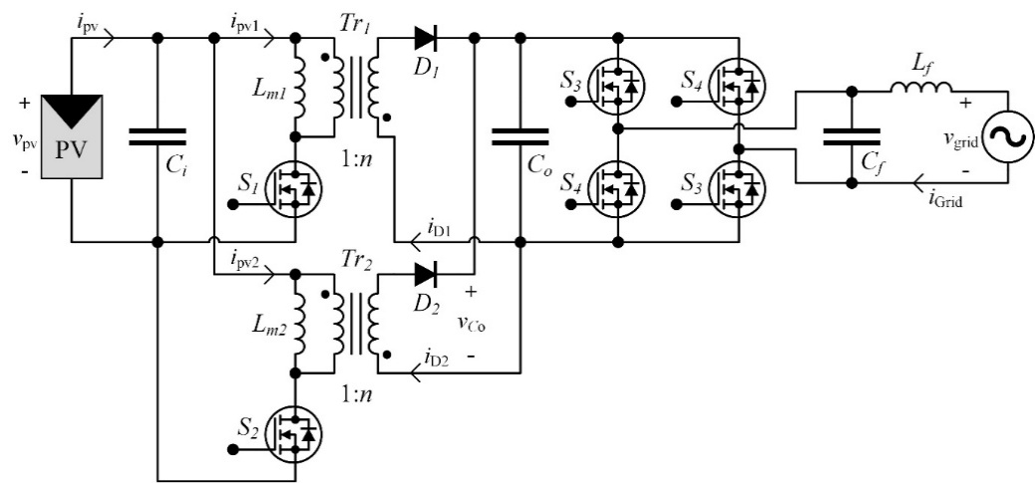
FIGURE 1. Proposed IFC Microinverter Design

The IFC stage consists of two identical flyback converter modules operating 180° out of phase. This interleaving configuration, whose current waveform is depicted in Fig. 3, significantly reduces peak current stress and ripple, thereby improving thermal performance and allowing for the use of smaller passive components. Each flyback module employs a high-frequency transformer to provide isolation and step-up conversion from the PV input to the DC-link. A current sharing compensator (CSC) is implemented to ensure balanced current distribution between the two flyback channels, minimizing uneven thermal stress and enhancing system reliability.
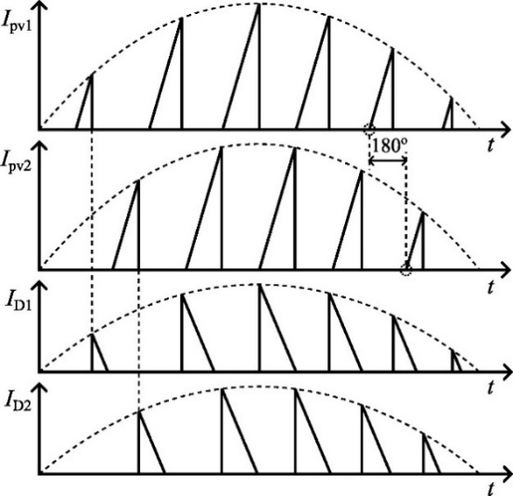
FIGURE 2. IFC Output Current Waveforms

The DC-link output of the IFC feeds a full-bridge unfolding inverter, which operates synchronously with the grid to inject sinusoidal current. Operating the unfolding stage at grid frequency reduces switching losses, while an output CL filter attenuates high-frequency harmonics to comply with grid interconnection standards (IEEE 1547 and IEC 61727).
TABLE 1. Microinverter Design Specifications
Symbol | Value and unit | Nomenclature
P_{max} | 250 W | Maximum PV Power
V_{in} | 20 – 45 V | Input Voltage
I_{in} | 10 A | Maximum Input Current
V | 196 – 253 Vrms | Grid Voltage
f | 49.5 – 50.5 Hz | Grid Frequency

The DC voltage gain of the flyback converter stage is expressed as:
(1)
where V_{co} is the DC-link voltage, V_{in} is the PV input voltage, n is the transformer turns ratio, and D is the duty cycle.
The ripple current reduction factor k_{r} for N interleaved phases is given by:
(2)
for N = 2, k_{r} ≈ 0.637, indicating ~36% ripple reduction compared to a single-phase design.
The magnetizing inductance L_{m} is determined from the desired peak-to-peak magnetizing current ΔI_{m} and switching period T_{sw}:
(3)
The filter inductance L_{f} for the output CL filter is calculated from:
(4)
where V_{ac} is the RMS grid voltage, f_{sw} is the switching frequency, and ΔI_{ac} is the allowable output ripple current.

Control System Design

CONCLUSION
This paper has presented the design and simulation of an interleaved flyback converter (IFC)-based photovoltaic microinverter with an integrated control strategy combining MPPT, PLL, feedforward compensation, and a current sharing compensator (CSC). Simulation results demonstrate that the CSC significantly improves current balancing between converter channels, reducing the current sharing error from approximately 12% to less than 2%, thereby enhancing thermal uniformity and component lifetime.
The proposed system achieves stable grid-synchronized operation with near-unity power factor (0.999), low total harmonic distortion (THD < 3.6%), and an estimated efficiency improvement of 1.2% compared to operation without CSC. The MPPT ensures optimal PV power extraction, while the feedforward compensation improves transient response during voltage and load changes.
Overall, the results confirm that the proposed IFC microinverter architecture and control strategy provide a promising solution for compact, efficient, and reliable small-scale grid-connected PV applications. Future work will focus on experimental validation and the implementation of advanced digital control algorithms to further improve dynamic performance and efficiency.

References
- F. Zhang et al., “A hybrid boost-flyback/flyback microinverter for photovoltaic applications,” IEEE Trans. Ind. Electron., vol. 67, no. 1, pp. 308–318, Jan. 2020.
- T. Lodh et al., “Novel Control Scheme for an Interleaved Flyback Converter Based Solar PV Microinverter to Achieve High Efficiency,” IEEE Trans. Ind. Appl., vol. 54, no. 4, pp. 3473–3482, Jul. 2018.
- H. A. Sher et al., “An Efficient and Cost-Effective Hybrid MPPT Method for a Photovoltaic Flyback Microinverter,” IEEE Trans. Sustain. Energy, vol. 9, no. 3, pp. 1137–1144, Jul. 2018.
- M. Dong et al., “Model-based current sharing approach for DCM interleaved flyback micro-inverter,” Energies, vol. 11, no. 7, 2018.
- J. Yuan et al., “An Overview of Photovoltaic Microinverters: Topology, Efficiency, and Reliability,” in CPE-POWERENG, Denmark, Oct. 2019.
- A. R. Paul et al., “A Novel SEPIC-Ćuk-Based High Gain Solar PV Microinverter for Grid Integration,” IEEE Trans. Ind. Electron., vol. 70, no. 12, pp. 12365–12375, Dec. 2023.
- A. Bhattacharya et al., “A Coupled Inductor Based Ćuk Microinverter for Single Phase Grid Connected PV Applications,” IEEE Trans. Ind. Appl., vol. 59, no. 1, pp. 981–993, Jan. 2023.
- C. Xiao et al., “A Novel Single-Phase Nonisolated Dual-Input Microinverter With Active Power Decoupling,” IEEE Trans. Power Electron., vol. 40, no. 3, pp. 4437–4448, 2025.
- W. Dutta et al., “Design Optimization of a Fully GaN-Based Buck-Derived Active Power Decoupler for a Single-Phase Electrolytic Capacitor-Less PV Microinverter,” IEEE J. Emerg. Sel. Top. Power Electron., vol. 12, no. 4, pp. 3986–4003, 2024.
- M. Effendy et al., “An Interleaved Isolated Flyback Converter with MPPT using Modified P&O Algorithm for Photovoltaic Generators,” Engineering, Technology and Applied Science Research, vol. 15, no. 3, pp. 22295–22300, Jun. 2025.
- D. S. Burbano-Benavides et al., “Design of an On-Grid Microinverter Control Technique for Managing Active and Reactive Power in a Microgrid,” Applied Sciences, vol. 11, no. 11, 2021.
- D. Rojas et al., “Review of Control Techniques in Microinverters,” Sensors, vol. 21, no. 19, 2021.
- D. Kolantla, “Critical review on various inverter topologies for PV system,” IET Renew. Power Gener., vol. 14, no. 8, pp. 1327–1338, 2020.
- S. Mohammadi, “A simple and highly efficient flyback inverter control strategy considering its intrinsic dynamic characteristics,” IET Power Electron., vol. 16, no. 2, pp. 197–208, 2023.
- S. Ritson and A. Elkhateb, “An Overview of Microinverter Design Characteristics and MPPT Control,” arXiv preprint, arXiv:2009.06055, 2020.

