Re-layout Laboratory Instruments Using HIRARC and Activity Relationship Chart Method in the Palm Oil Laboratory
Fransisca Dini Ariyanti^{a)} and Siti Rahmawati^{b)}
Industrial Engineering, Faculty of Engineering, Bina Nusantara University, Jakarta, Indonesia

^{a)} Corresponding author: dini.ariyanti@binus.ac.id
^{b)} siti.rahmawati002@binus.ac.id
Abstract. Laboratories are essential spaces for conducting various experiments and research activities. Occupational safety is the key to realizing work to achieve efficiency and productivity to provide benefits for companies in running a business. Through the use of the HIRARC (Hazard Identification, Risk Assessment, and Control) and ARC (Activity Relationship Chart) methods, this study intends to investigate how analysts perform analyses in the laboratory while adhering to occupational health and safety regulations and meeting productivity targets. Nine events were classified as high levels, four as low levels, six as extreme levels, and 19 as high levels after risks were identified and evaluated using the HIRARC method. The next step involved the author rearranging the analysis laboratory's instruments, specifically those for FFA (free fatty acids), water content, and contaminants, using the ARC method. This increased efficiency was first demonstrated by the following reduce in analysis time: FFA- 41%, water content - 25%, and impurities - 25%, secondly to reduce the distance traveled: namely FFA - 50%, water content - 17%, and impurities - 56%, and thirdly to reduce the total distance between lab instruments, namely FFA - 50%, water content - 6%, and impurities - 55%. Re-layout of laboratory instruments has reduced extreme risk and high-risk levels to low risk. It was concluded that there was an increase in the efficiency and productivity of analysts in carrying out every work process in the laboratory.
Keywords: Laboratory instruments, re-layout, HIRARC, ARC, safety.

INTRODUCTION
Laboratories are essential spaces for conducting various experiments and research activities.[1], [2], [3] Therefore, it is crucial to ensure that the laboratory layout is designed in a way that prioritizes safety and minimizes risks associated with hazardous chemicals and equipment. One of the key methods used in designing a safe laboratory layout is Hazard Identification Risk Assessment and Risk Control (HIRARC). This method involves identifying potential hazards, assessing the risks associated with these hazards, and implementing control measures to mitigate these risks.
Additionally, the Principle of Room Design Using Activity Relationship Chart plays a significant role in organizing the layout of a laboratory. By creating an ARC, the relationship between different activities and workstations could be visualized, allowing for efficient space utilization and the minimization of potential conflicts or hazards.
When designing a laboratory layout, it is essential to consider factors such as the proper placement of equipment, storage of hazardous materials, and the flow of personnel within the space. Adhering to best practices in laboratory layout design is essential for creating a safe and productive work environment for researchers and staff. [4] This research was conducted at PT.CTP a company that produces Crude Palm Oil and Palm Kernel in West Kalimantan province, Indonesia. Where the production system is continuous, with an hourly quality testing schedule. Quality Control Analysts carry out quality tests of finished products, to achieve standards and goals set by a company, in meeting customer requests. An accurate level of analysis is required, so it really requires a good laboratory layout and identification of hazards so that all work achieves targets while meeting the principles of occupational health and safety.
Research driving factors are, first throughout 2022 there were 3 incidents and 5 near misses at the laboratory. Second, the current work facilities do not have a layout that is appropriate to the stages in carrying out an analysis based on SOP, standard Operating Procedure, last, need to further improve the 5S + Safety concept (Sort, Set in Order, Shine, Standardize, Sustain, and Safety.) Therefore, the research aims are: first, Identify the hazards of the laboratory test work process using HIRARC. Second, proposed improvements to the laboratory work process and re-layout of the facilities using the ARC (Activity Relation Chart) method to improve occupational health and safety.

Literatur review

HIRARC
HIRARC is a systematic method for identifying and mitigating workplace hazards. It involves assessing risks, implementing control measures, and evaluating potential consequences. Risk assessment determines the likelihood and severity of potential hazards, ensuring acceptable control levels. [5],[6],[7] Risk control involves a hierarchy of control, which consists of several levels to prevent and control potential hazards. By prioritizing these hazards, risk control could be implemented to ensure the safety and effectiveness of processes, operations, and activities. [8]
The assessment in the risk assessment is likelihood (L) and severity (S) or consequence (C). Likelihood shows how likely the accident is to occur, while severity or consequence shows how severe the impact of the accident is. The value of likelihood and severity will be used to determine the risk rating or risk level. The following is a consequence table, likelihood table and risk matrix according to AS/NZS 4360:1999 standard. [9]

ARC
The Activity Relationship Chart visually represents the sequence of activities in a process, aiding in identifying relationships, determining critical paths, and efficiently allocating resources. It provides a basis for arranging interrelated activities and uses qualitative measures to assess facility relationships, enhancing the overall process. [10] ARC has several benefits of ARC, first, shows the relationship of one activity to another and the reason. Second, obtain a basis for the arrangement of the next area ARC uses qualitative measures to assess the relationship between facilities.

METHODS
The study focuses on the analysis process of fragile tools and hazardous chemicals in the PT. CTP Laboratory. Literature and field studies were conducted to gather data on the problems. Data collection involved field observations, interviews with analysts, and analyzing using the ARC and HIRARC methods. The data was then processed to determine layout design and safety.
a. Principle of room design in the Activity Relationship Chart (ARC) method, the process is carried out by analyzing the process carried out by the analyst when carrying out the analysis and providing a laboratory layout of proposals regarding planning in accordance with the applicable SOP, standard operating procedure at Palm oil company.
b. HIRARC (Hazard Identification Risk Assessment and Risk Control), the identification analysis process is carried out in the field to find out what hazards will occur, and the actions taken to control hazard risks in the analysis process in the Palm oil Laboratory.
The results were discussed in detail, and conclusions and suggestions were drawn to inform future research. The findings should be relevant to the research objectives and serve as a basis for improvement.
TABLE 1. Consequence criteria
Level | Criteria | Remarks
1 | Almost Certain | Happens almost everywhere
2 | Likely | Quite Possible in almost any situation
3 | Possible | Can occur in almost any situation
4 | Unlikely | Chance of happening are rare
5 | Rare | Only can occur under certain circumstances

TABLE 2. Risk "Probability" Level Standard AS/NZS 4360
Level | Criteria | Remarks
1 | Insignification | No injury, small financial loss
2 | Minor | First aid, Handling on the spot, and moderate financial losses
3 | Moderate | Require medical treatment, treatment on the spot with outside assistance, large financial losses
4 | Major | Serious injury, loss of production capability, handling outside the area without negative effects, large financial loss
5 | Catastrophic | Death, poisoning outside the area with disruptive effects, heavy financial loss

TABLE 3 shows the risk analysis matrix with H being high risk, E being extreme risk, M being moderate risk, and L being low risk. Meanwhile, risk control according to OHSAS 18001 provides more specific risk control guidelines for OHS hazards with the Elimination, Substitution, Engineering control, Administrative, Personal Protective Equipment (PPE) approaches [10] [11], [12]. The research flowchart is seen in FIGURE 1.

TABLE 3. Risk Matrix
Likelyhood | Consequence
Likelyhood | 1 | 2 | 3 | 4 | 5
5 | H | H | E | E | E
4 | M | H | H | E | E
3 | L | M | H | E | E
2 | L | L | M | H | E
1 | L | L | M | H | H

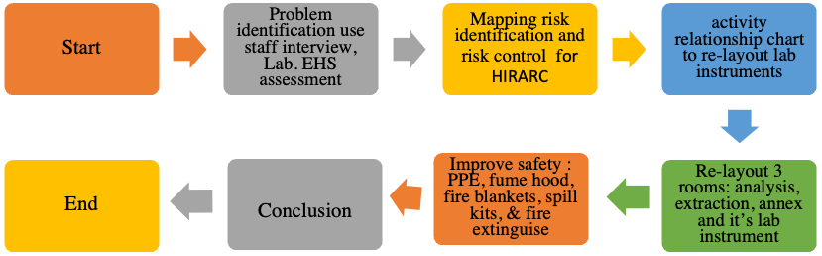
FIGURE 1. flow chart research

RESULTS AND DISCUSSION

DATA COLLECTION
Identification carried out at the Palm oil Laboratory by interviews and discussions, to the employment, assessment of the Laboratory activities with EHS (Environmental Health and Safety) staff. The following are the results of risk identification and risk control which are mapped into a table as presented in table 5 in the following attachment:
Table 5 (19 risks in two portrait pages)
Discussion results of risk identification in Table 5 there are identified 19 hazard risks, with the risk mapping shown in FIGURE 2. The number of hazards with low risk (L) is 4, high risk (H) is 9, and very high risk (E) is 6, The majority of hazards in each risk have a high-risk distribution, so it is necessary to make the laboratory a place that prioritizes safety and minimizes the risk of work accidents.
The activity relationship chart is a method used in layout planning to ensure the relationship between machines and work equipment used in a line after identification and assessment based on the HIRARC method. The reason table used to determine the degree of relationship between each component and other components must be created at the same time as filling in the ARC. Through observation and discussion with related parties in the organization, a table of reasons was obtained. FIGURE 3 is an ARC (Activity Relationship Chart) that has been created and implemented in the field.
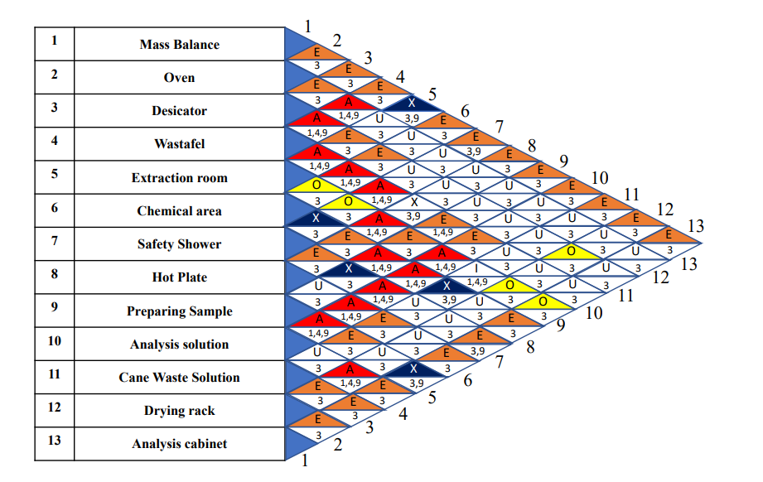

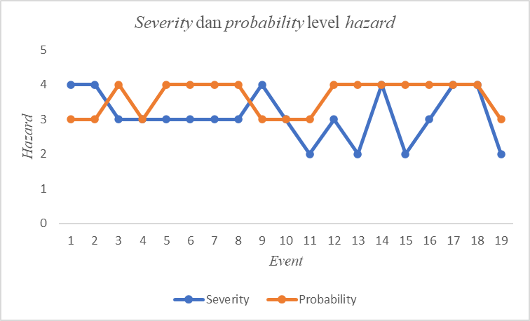

FIGURE 2. Risk mapping Result | FIGURE 3. ARC of 13 instruments in Palm oil Laboratory
Discussion of FIGURE 3, In accordance with the HIRARC method and the principles of room design utilizing the ARC method, an assessment is first conducted to identify potential hazards in conjunction with the configuration of the laboratory's equipment based on work steps on the analysis conducted by the analyst under the direction of the SOP (Standard Operational Procedure) to obtain comparative assessment data for the time being.

TABLE 4. Current Matrix
Analysis | Current
Analysis | Time (minute) | Footsteps (times) | Tool distance total (cm)
FFA Analysis | 17 | 6 | 42
Mouisture Analysis | 20 | 12 | 82
Impurities Analysis | 20 | 25 | 171

TABLE 5. Proposed Matrix
Analysis | Proposed
Analysis | Time (minute) | Footsteps (times) | Tool distance total (cm)
FFA Analysis | 10 | 3 | 21
Mouisture Analysis | 15 | 10 | 77
Impurities Analysis | 15 | 11 | 77

The recommendations made regarding the identification that have been carried out are shown in TABLE 5. TABLE 4 presents the current and proposed data along with the results of three analyses that were performed: moisture, contaminants, and FFA. An evaluation was conducted on four analysts, all of whom were male and had an average height of 160 cm. Under the current circumstances, conducting a FFA analysis takes 17 minutes, requires six steps from the analysts, and results in a total tool distance of 42 cm. After recommendations for layout and safety were made, an analysis time of 10 minutes, three steps, and a total tool distance of 21 cm was obtained. In addition, it is estimated that the current conditions will require 170 minutes and 12 steps to complete the moisture analysis, with a total distance between the tools in the analysis being 82 cm. After making a proposal in the layout, the analysis time will be 165 minutes and 10 steps, with a total distance between the analyzers being 77 cm. The current conditions will require 80 minutes and 25 steps to complete the analysis of impurities, with a total distance between the tools in the analysis being 171 cm. After the proposal is made in the layout, an analysis time of 75 minutes and 11 steps will be obtained, and the total distance between the analyzers will be 77 cm. Based on HIRARC and ARC in TABLE 6, the authors of this study conducted measurements and observations in the laboratory's analysis room. Three rooms—an analysis room, an extraction room, and an annex room—make up the arrangement of the current and proposed illustrations, as shown in FIGURES 4 shown the current layout, and FIGURE 5 is a proposed layout.

TABLE 6. Based on HIRARC and ARC
No | Types of Activities | Before |  |  |  |  |  |  |  | After
No | Types of Activities | Potential Hazard | Severity |  |  | Probability |  | Rating Figures | Risk Levels | Risk Control | Hierarchy of control | Risk  Control
No | Types of Activities | Potential Hazard | Category | Grade | Category |  | Grade
1 | 2 | 3 | 4 | 5 | 6 |  | 7 | 8 | 9 | 10 | 11 | 12
1 | There are no first aid kits in the laboratory | Unable to provide first aid in the event of an accident injury so that it has the potential to exacerbate the situation | Major | 4 | Posssible |  | 3 | 12 | Extreme Risk | Provide a first aid kit and install it in an easily accesible area and label it so that it is easily identified | Reduce the risk | Low risk
2 | There is no spill kit in the laboratory | Unable to prevent spills that have the potential to pollute the environment and contact with the body and the surrounding environment | Major | 4 | Posssible |  | 3 | 12 | Extreme Risk | Provide a spill l=kit and install in an easily accessible area and label it so that it is easily identified | Reduce the risk | Low risk
3 | No signs or visual cues for emergencies (evacuation routes and fire extinguishers) | When a emergency has the potential to cause confusion and panic because there are no instructions that can be followed | Moderate | 3 | Frequently |  | 4 | 12 | High Risk | Provide direction labels and signs regarding the direction of evacuation routes and fire extinguishers | Reduce the risk | Low risk
4 | There is no SOP emergency action plan | When an emergency has the potential to cause confusion and panic because there are no instructions that can be followed | Moderate | 3 | Possible |  | 3 | 9 | High Risk | Provide EAP SOP and update it regularly | Administrative controls | Low Risk
5 | The oven is not next to the desiccator | The oven should be adjacent to the desiccator because according to the SOP the sample that comes out of the oven must be stored in the desiccator to minimize movement that has the potential for the glass analyzer to fall | Moderate | 3 | Frequently |  | 4 | 12 | High Risk | Use PPE when analyzing and repositioning where the oven must be next to the desiccator according to the analyz SOP | PPE | Low Risk
6 | Prepare samples are not close to the scales and hot plates | Prepare the sample must be close to the scales to facilitate the analysis process, and then melt the oil using a hotplate to minimize movement that has the potential for the glass analysis tool to fall | Moderate | 3 | Frequently |  | 4 | 12 | High Risk | Using PPE when analyzing and repositioning where the sample preparation is close to the scales and hotplate according to the analysis SOP so that the analyst movement are minimal and sequential so as to minimize accidents due to too many moving positions during analysis | PPE | Low Risk
7 | The sink is not adjacent to the one solution | The sink is an area for washing tools after analysis, the remaining analysis solution is disposed of into the solution cane, so the position of the cane must be close to the sink to minimize movement that has the potential for glass analysis tools to fall | Moderate | 3 | Frequently |  | 4 | 12 | High Risk | Using PPE when analyzing and repositioning where the sample preparation is close to the scales and hotplate according to the analysis SOP so that the analysts movement are minimal and sequential so as to minimize accidents due to too many moving positions during analysis | PPE | Low Risk
8 | The sink is not adjacent to the drying rack | Minimizing the movement of the analyst which has the potential to be slippery and the tool easily falls during the process after washing the tool in the risk | Moderate | 3 | Frequently |  | 4 | 12 | High Risk | Using PPE when analyzing and repositioning where the sample preparation is close to the scales and hotplate according to the analysis SOP so that the analysts movement are minimal and sequential so as to minimize accidents due to too many moving positions during analysis | PPE | Low Risk
9 | There were no fire blankets in the extraction room | Cannot extinguish the fire during an emergency which has the potential to cause a fire and a an explosion is caused if there is a fire | Major | 4 | Posssible |  | 3 | 12 | Extreme Risk | Provide fire blankets and positioning then close to the fume hood as a helping measure in extinguishing the fire so it doesn’t cause a large fire | Reduce the risk | Low risk
10 | There is no line for tools that cannot be moved | Potentially not achieving 5s so that the tool cannot be identified | Moderate | 3 | Possible |  | 3 | 9 | High Risk | Installing safety lines and labels on each tool so that it high risk is easily identified and becomes a symbol that the tool cannot be moved | Reduce the risk | Low risk
11 | There is no line free space for analysis | Cannot provide clues about areas that are free to be passed by the analyst in the ongoing analysis process | Minor | 2 | Possible |  | 3 | 6 | Low Risk | Install safety line free space so that the analyst can find out the areas that can be passed during the analysis | Reduce the risk | Low risk
12 | There is no analysis table for sorting solid samples | It has the potential to make the body position not ergonomic and the worst condition can be injury and tripping | Moderate | 3 | Frequently |  | 4 | 12 | High Risk | Providing an analysis table so that is easier to analyze and avoid injury due to non ergonomic analysis processes | Reduce the risk | Low risk
13 | There is no label on the litter box for broken glass | Unable to identify a trash box that is specifically for tools that are broken or chipped due to the analysis process | Minor | 2 | Frequently |  | 4 | 8 | Low Risk | Provide a broken glass label on the litter box for easy identification and provide an indirect instruction that the litter box is specifically for broken analyzers | Reduce the risk | Low risk
14 | There is no fire blanket in the analysis room | Cannot extinguish the fire during an emergency which has the potential to cause a fire and a explossion is caused if there is a fire | Major | 4 | Frequently |  | 4 | 16 | Extreme Risk | Providing fire blankets and positioned adjacent to the analysis room as a helping measure in extinguishing fires so as not to cause large fires | Reduce the risk | Low risk
15 | No photos and names in the analyst locker and lock locker | Unable to identify user from locker | Minor | 2 | Frequently |  | 4 | 8 | Low Risk | Provide photos and name tags to identify locker users so they are not confused | Reduce the risk | Low risk
16 | There are no tool name tags in the tool cabinet | Unable to identify the type of tool so that it has the potential to arrange tools not based on a list and can cause the tool to fall and break | Moderate | 3 | Frequently |  | 4 | 12 | High Risk | Provide a label for each existing tool name so that the tools arranged in the cupboard can be identified and facilitate the preparation of tools | Reduce the risk | Low risk
17 | There is no INK on each tool used | There is a potential for missue of the tool and cause an explosion or even damage to the tool | Major | 4 | Frequently |  | 4 | 16 | Extreme Risk | Provide INK on each tools to reduce the potential for errors in the use of existing equipment in the laboratory | Admistrative Controls | Low risk
18 | There are no hazard and first aid labels on the solution bottles used | Potentially someone cannot know the dangers of the chemical solution and cannot perform first aid because the hazard labe of the chemical solution is not identified | Major | 4 | Frequently |  | 4 | 16 | Extreme Risk | Provide a label indicating the type of chemical and first aid that must be performed when the chemical enters the body of the analyst | Reduce the risk | Low risk
19 | The distance between the safety shower and the chemical cupboard is too close < 2 meters | If the safety shower is being used and is being checked, water splashes from the safety shower can contaminate the area of the chemical storage cupboard so that it has the potential to corrode the cupboard walls | Minor | 2 | Possible |  | 3 | 6 | Low Risk | Reposition the safety shower so that it is not adjacent to the chemical cupboard, which is > 2 meters or at least 5-10 seconds of time needed from the chemical cupboard to the safety shower area if a chemical spill occurs on the analysts body | Reduce the risk | Low risk

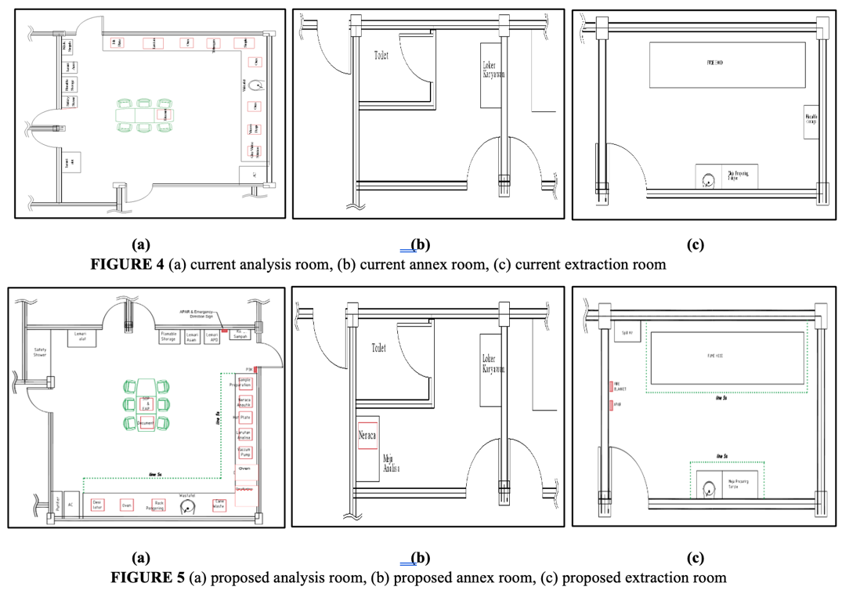
FIGURE 4. (a) current analysis room, (b) current annex room, (c) current extraction room

FIGURE 5. (a) proposed analysis room, (b) proposed annex room, (c) proposed extraction room

Rearranging the positions of each currently used tool layout in Figure 5(a) creates the suggested room layout design analysis room from the author's evaluation, which facilitates the analyst's movement during the sample analysis process. At this point, the author conducted field assessments in compliance with the SOP (standard operating procedures) to relay some of the tools in the Crude Palm Oil analysis room.
In figure 5 (b) proposed annex room the author has carried out measurements and observations in the annex room in the laboratory which has an additional table for conducting analysis the layout of the annex space.
The extraction room layout is shown in figure 5(c). The authors suggest identifying risks in this area by noting that the extraction room has the potential to explode, catch fire, or spill chemicals. For this reason, it is necessary to have fire blankets, spill kits, and fire extinguishers. Additionally, a safety line is provided for yellow fume hoods to indicate that the tool may not be moved, and a green safety line indicates that the analyst could walk through the area to prepare samples.
Discussion of TABLE 7, which displays the percentage of efficiency improvement based on the suggestions made using the HIRARC (Hazard Identification Risk Assessment) method and the ARC (Activity Relationship Chart) method of room design. TABLE 7 demonstrates the high quality and statistical significance of each productivity efficiency that could be achieved in the three analyses conducted in the Palm oil Laboratory.

TABLE 7 Proposed Efficiency Improvement
Analysis | Current |  |  | Proposed |  |  | %Efficiency Improvement
Analysis | Time (minute) | Footsteps (times) | Tool distance total (cm) | Time (minute) | Footsteps (times) | Tool distance total (cm) | Time (minute) | Footsteps (times) | Tool distance total (cm)
FFA Analysis | 17 | 6 | 42 | 10 | 3 | 21 | 41 | 50 | 50
Mouisture Analysis | 20 | 12 | 82 | 15 | 10 | 77 | 25 | 17 | 6
Impurities Analysis | 20 | 25 | 171 | 15 | 11 | 77 | 25 | 56 | 55
First, the FFA (free fatty acid) analysis yielded a 44% efficiency improvement with footsteps of 27% and a total distance between analyzers of 50%. Next, the moisture analysis produced a 31% efficiency improvement with footsteps of 18% and a total distance between analyzers of 6%. Finally, the impurities analysis produced a 31% efficiency improvement with 56% footsteps and a total distance between analyzers of 55%. Based on the findings, percentage efficiency Enhancing every analysis conducted is a great step toward having a secure, efficient, and fruitful analysis process. This is because there are high standards for security and productivity that should be met to produce good results for analysts and have remarkable effects on businesses operating in a sustainable manner. It has been demonstrated that the layout design, which was created using the data that was evaluated and computed for every tool and step of the analysis process, could prevent, or significantly reduce the risks of work accidents that analysts may experience while conducting analysis in the laboratory. Palm oil Lab with a low-risk hazard level, to establish a cozy working environment and give analysts a sense of security so they could work in compliance with the SOP (Standard Operational Procedure) in Palm oil Laboratory.

CONCLUSIONS
The HIRARC method was used to identify and assess 19 events with varying hazard levels. The ARC method was used to design the laboratory's tools for FFA, moisture, and impurities analysis. The analysis time was 17 minutes for each analysis, with steps taken 6 times, 12 times, and 25 times. A Laboratory instruments re-layout was proposed, reducing the extreme and high-risk level to low levels. After analysis and interviews, the proposed layout design showed a 40% efficiency improvement in each analysis, time spent (41%), analyst footsteps (50%), and tool distance (50%). This design improves efficiency and productivity, resulting in a more efficient and productive work environment at the Palm oil Laboratory.

References
- E. Haile, "Evaluation of Hospital Laboratories Design in Ethiopia," Ergonomics International Journal, vol. 1, 01/01 2017, doi: 10.23880/EOIJ-16000115.
- W. Li, "Probe into the management of laboratory equipment in colleges and universities," 2018: Atlantis Press, pp. 331-334.
- M. A. Hassanain, M. O. Sanni-Anibire, A. S. Mahmoud, and M. B. Hamida, "Design guidelines for the functional efficiency of laboratory facilities," Architectural Engineering and Design Management, vol. 16, pp. 115 - 130, 2020.
- D. Hayati, "Identifikasi resiko bahaya di pergudangan dengan menggunakan HIRADC," 2020, vol. 1, 1 ed., pp. 80-84.
- D. S. Purnama, "Analisa Penerapan Metode HIRARC (Hazard Identification Risk Assessment and Risk Control) dan HAZOPS (Hazard and Operability Study) dalam kegiatan identifikasi potensi bahaya dan resiko pada proses unloading unit di PT. Toyota Astra Motor," 2015.
- S. Rahayuningsih, "Identifikasi penerapan dan pemahaman kesehatan dan keselamatan kerja dengan metode hazard and operability study (HAZOP) pada UMKM Eka Jaya," JATI UNIK: Jurnal Ilmiah Teknik dan Manajemen Industri, vol. 2, no. 1, pp. 24-32, 2018.
- A. Wijaya, T. W. S. Panjaitan, and H. C. Palit, "Evaluasi Kesehatan dan Keselamatan Kerja dengan Metode HIRARC pada PT. Charoen Pokphand Indonesia," Jurnal titra, vol. 3, no. 1, pp. 29-34, 2015.
- M. Tarwaka, "Implementasi K3 di Tempat Kerja, Surakarta," ed: Harapan Press, 2008.
- S. Kristina and B. M. Wijaya, "Risk management for food and beverage industry using Australia/New Zealand 4360 Standard," 2017, vol. 277: IOP Publishing, 1 ed., p. 012025.
- N. Syahlan, "HAZARD IDENTIFICATION USING THE HAZARD IDENTIFICATION AND RISK ASSESSMENT AND DETERMINING CONTROL (HIRADC) TECHNIQUE (CASE STUDY AT LABORATORIES AT UNIVERSITAS ISLAM NEGERI SUMATERA UTARA)," Jurnal Penelitian Kesmasy, vol. 4, pp. 15-22, 10/31 2021, doi: 10.36656/jpksy.v4i1.753.
- R. I. Nirtha, M. Firmansyah, and H. Prahastini, "Analisis pengaruh penerapan keselamatan dan kesehatan kerja (K3) terhadap kinerja karyawan di perkebunan kelapa sawit PT. Hasnur Citra Terpadu," Jukung (Jurnal Teknik Lingkungan), vol. 5, no. 1, 2019.
- R. Widiastuti, P. E. Prasetyo, and M. Erwinda, "Identifikasi Bahaya dan Penilaian Risiko Untuk Mengendalikan Risiko Bahaya di UPT Laboratorium Terpadu Universitas Sarjanawiyata Tamansiswa," Ind. Eng. J. Univ. Sarjanawiyata Tamansiswa, vol. 3, no. 2, p. 51, 2019.

