Utilize The DMAIC Approach to Minimize Consumer Goods Package Damage During Delivery in E-Commerce
Fransisca Dini Ariyanti^{a)} and Jessica Valencia^{b)}
Industrial Engineering Department, Faculty of Engineering, Bina Nusantara University, Jakarta, Indonesia

^{a)} Corresponding author: dini.ariyanti@binus.ac.id
^{b)} jessica.valencia@binus.ac.id
Abstract. One of the top five e-commerce in Indonesia experienced obstacle (damage packaging, lost and late) 43.21%, in the process of sending consumer goods from their warehouse to customers. Focusing on reducing the percentage of this obstacle, because all parties, buyers, sellers, and e-commerce are significantly affected. To overcome these challenges, this study will analyze the obstacles that arise when shipping goods from the online retailer's warehouse to customers. The define, measure, analyze, improve, and control (DMAIC) method, a Six Sigma tool, is used in this study. Poor standards and materials used for consumer goods packaging, climate change, inadequate access roads to consumer locations, and lack of worker awareness and responsibility for SOPs, standard operating procedures, and consumer goods are the main causes of damage to goods during the shipping process, summarized in TABLE 5, during data collection on October - December 2022. After conducting a review of handling performance summarized in TABLES 6 and 7, refresher training, policy adjustments for packaging standards, e-commerce system updates, and proper product arrangement on courier vehicles, all of which were implemented and monitored during March – May 2023, the obstacle (damage, lost and late) reduce from 43.21% to 0,69%.
Keywords: damage packaging, consumer goods, DMAIC, Six Sigma, e-commerce

INTRODUCTION
A famous fifth rank e-commerce in Indonesia, is an e-commerce company with an online shopping mall concept was founded in 2011. The development of PT XYZ's platform has led to a growth in the number of users which resulted in an increase business which should be maintained to reach customer satisfaction. Damage, loss, and delays in the delivery of goods to consumers are often found in online buying and selling activities. The reliability provided by e-commerce, is a guarantee of customer satisfaction with the goods received. However, in practice, timeliness, and safety of goods in the delivery process could not always be achieved. If these obstacles continue to occur, the company will suffer losses. The causes of obstacles when they reach consumers should be analyzed with the aim of improving the services provided. Therefore, one way to improve quality in a company is to use the Six Sigma Method with the DMAIC Concept to map problems and opportunities that aim to improve company performance [1]. Sustainable Development Goal (SDG) 12, which focuses on ensuring sustainable consumption and production patterns, is particularly relevant when considering the issue of packaging waste. Packaging is a crucial component of the global supply chain, enabling the transportation and distribution of goods worldwide [2]. However, the environmental impact of packaging waste has become a growing concern, as it contributes to resource depletion, pollution, and greenhouse gas emissions.

- Six Sigma
Six Sigma has been effectively utilized across various sectors such as manufacturing, healthcare, finance, telecommunications, and service industries. in the service industry. Six Sigma has been applied to improve customer service, reduce costs, and increase efficiency [3]. Several famous Company have both utilized Six Sigma to improve package delivery times and customer service, respectively, leading to increased customer satisfaction and loyalty [4]. Identifying problems, decreasing defects, and enhancing quality and customer happiness are all critical goals for any firm looking to stay competitive in today’s market [5]. This is where Six Sigma comes in, as it is a systematic, data-driven strategy that could assist firms in meeting these objectives [6].

- DMAIC
The Define-Measure-Analyze-Improve-Control (DMAIC) approach is one of the most common tools of Six Sigma methodology, used to identify problems, reduce defects, and improve quality and customer satisfaction. It consists of five stages: Define (define the problem, goals, resources, and responsibilities), Measure (collection of data), Analyze (analysis of the collected data using different tools to identify cause of defects), Improve (designing and testing of possible solutions to eliminate the defects) and Control (controlling of improved process and monitoring) [7] [8].

- SIPOC diagram
A SIPOC (suppliers, inputs, process, outputs, customers) diagram is a visual too for documenting a business process from beginning to end prior to implementation [9].

- CTQ, critical to quality
CTQ (Critical to Quality) is the characteristics of a product or service that are “Critical to Quality” for the customer [10].

METHODS
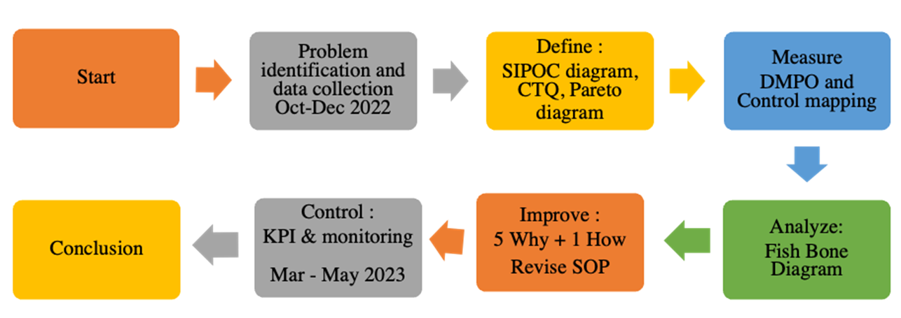
FIGURE 1 Research diagram
First, Identifying the causes of 34,8% damage consumer good package and formulate the research objective. Second, Data Collection. This research uses goods delivery data during the period October – December 2022. Third, The define stage uses SIPOC Diagram, Critical to Quality (CTQ), and Pareto Diagram. Fourth The measure phase uses the Defect Per Million Opportunities (DPMO) calculation, sigma value calculation, and control chart. Fifth, the analyze phase is carried out using a Fishbone Diagram. Sixth, The improve stage is carried out using the 5W+1H analysis then implementation of SOP, Seventh, evaluate KPI, key performance indicator during and March – May 2023. Last conclusion and suggestions are given to perfect the research results in accordance with the proposed improvements. The steps have been presented in FIGURE 1.

RESULTS AND DISCUSSION

DATA COLLECTION
Total shipments of goods to consumers during the period October 2022 to December 2022 are shown in TABLE 1. The total obstacles in the process of sending goods are shown in TABLE 1.

TABLE 1 Total shipment & obstacle to delivery
Period | Total Delivery | Barrier Type
Period | of Goods | Damage | Lost | Miss ETD (late)
Oct-22 | 1.531.756 | 399.177 | 22.256 | 70.148
Nov-22 | 1.504.447 | 527.394 | 41.652 | 131.040
Dec-22 | 1.351.580 | 604.658 | 26.260 | 73.580
Total | 4.387.783 | 1.531.229 | 90.168 | 274.768

TABLE 2 % allocation of obstacle
Obstacles Percentage Period Oct - Dec 2022
Warehouse | 70%
3rd Parties (Logistics and Seller) | 30%
Total | 100%

The total obstacles (damage, lost, and late/miss ETD,estimate time delivery) are 43,21% that occur are the total shipments made from PT XYZ's logistics, sellers, and warehouses with the percentage allocation for obstacles, occurring in TABLE 2.

DATA PROCESSING AND ANALYSIS

DEFINE
The define stage in this study was carried out to identify the problems that occur.
- SIPOC Diagram
The SIPOC diagram is used to briefly explain the business process flow of PT XYZ and shown in FIGURE 2.
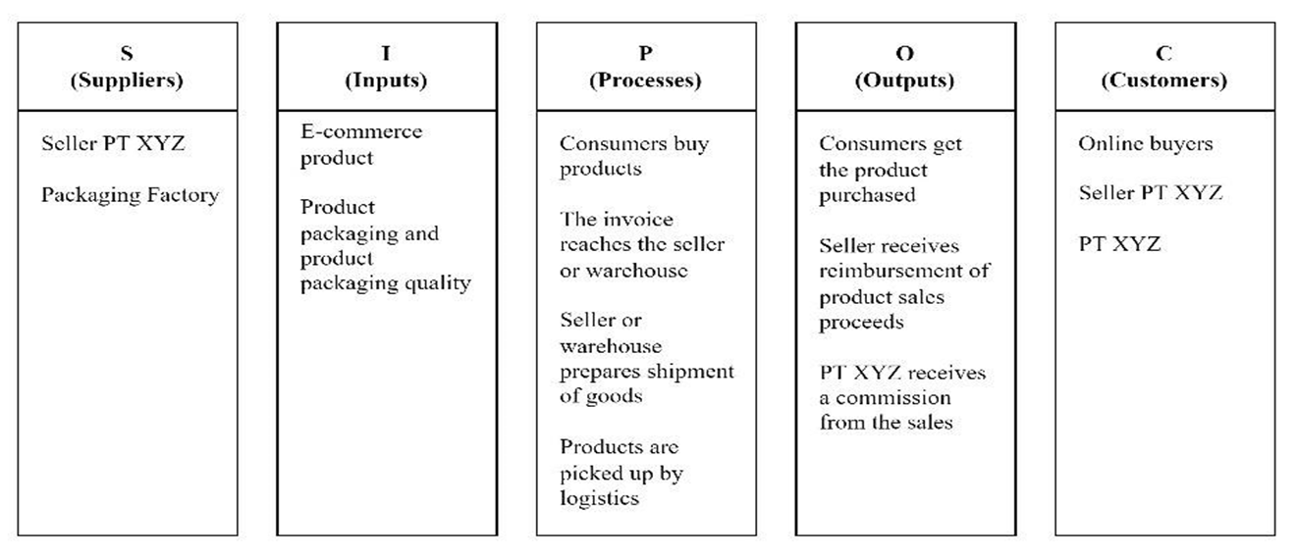
FIGURE 2 SIPOC diagram
- Critical to Quality (CTQ)
The CTQ diagram to find out which criteria could provide satisfaction for consumers [1] [6] [7] and is shown in FIGURE 3. E-commerce’s CTQ is Customer need their order safe, on time delivery in full quantity.
- Pareto Diagram
Pareto diagram are used to find out the most crucial types of problems in the process of shipping goods [11]. The percentage of each delivery barrier is shown in TABLE 3. Based on the Pareto Diagram, the most crucial obstacle is damage, therefore, the damage factor will be the factor analyzed in this research.

TABLE 3 % obstacles in the goods delivery process
Delivery Barriers | Frequency | Percentage
Damage | 1,531,229 | 80.75%
Miss ETD | 274,768 | 14.49%
Lost | 90,168 | 4.76%
Total | 1,896,165 | 100.00%
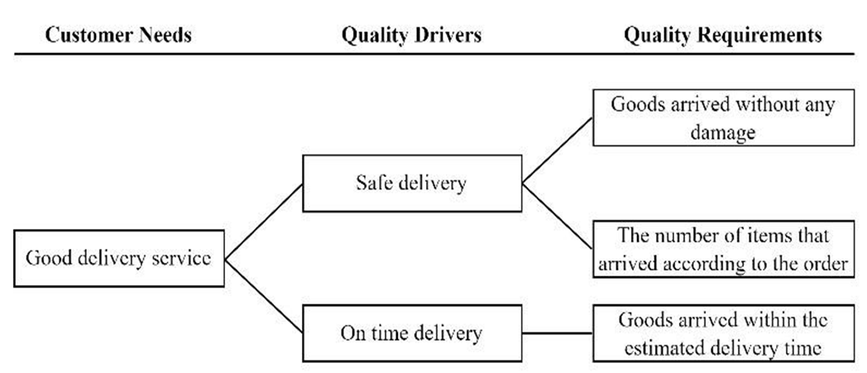
FIGURE 3 CTQ diagram

MEASURE
One tool for understanding and analyzing process variables as well as tracking how they affect process performance is the control chart. Control charts would use to assess a process's capabilities and assess whether it is operating within the bounds of statistical control [11]. FIGURE 4 shown the cause of unsatisfied e-commerce customer need is damage packaging (80%).
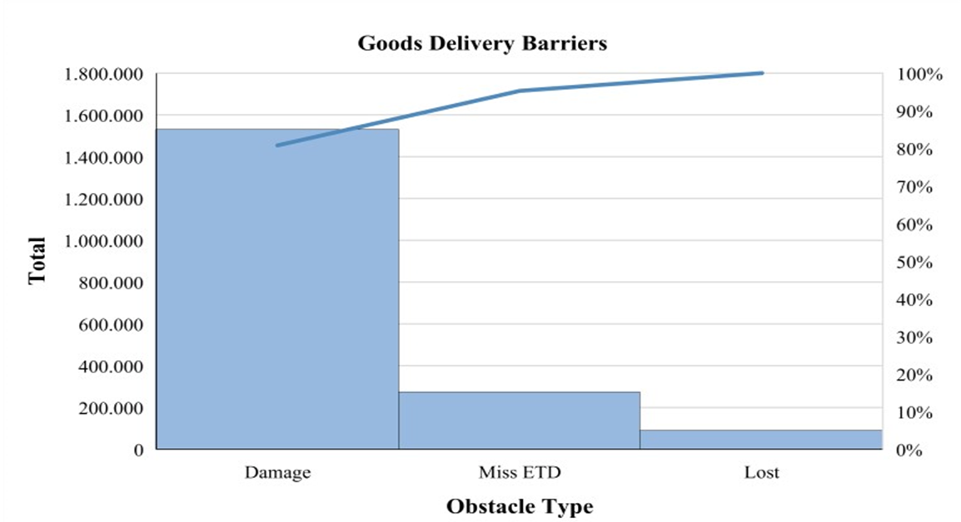
FIGURE 4 Pareto diagram of problem identification
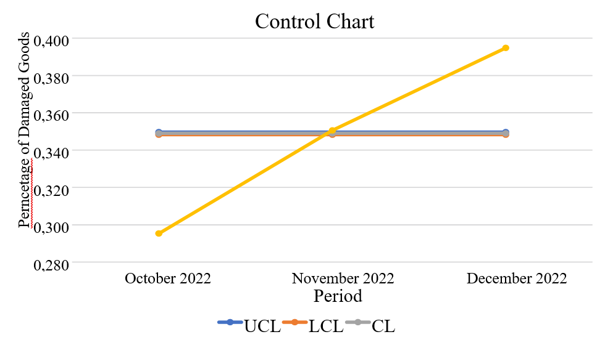
FIGURE 5 Control Map Damage in Delivery Process
Defect per Million Opportunity (DPMO)
Continuing to measure the initial condition of E-Commerce Damage packaging, author calculate the DPMO. It’s show the damage to goods that occurs in one million opportunities for goods delivery with calculation using Eq.1.
$DPMO= \frac{(number of obstacles x 1.000.000)}{(delivery amount x opportunity)}$ (1)
$DPMO=\frac{(1.531.229 x 1.000.000)}{(4.387,783 x 1)}$
$DPMO=348.975.55 ≈348.976$

The calculation is continued by calculating the sigma value using the Microsoft Excel application as show in Eq.2.
$k=NORMSINV \left\{1-\frac{DPMO}{106}+1.5\right\}$ (2)
$k=1.88808773713889 ≈1.89$

The DPMO value is 432,147 times per one million opportunities and the sigma is 1.67. The sigma value is less than the industry average in Indonesia ( 3 – 4 sigma) , therefore, it should to make improvements to increase company performance.

Control Chart
Control chart calculation is done by calculating the percentage of damage, Upper Center Line, Center Line, and Lower Center Line [12]. The results of calculating the percentage of damage, UCL, CL and LCL are in TABLE 4. A control chart graph shown in FIGURE 5.
Based on the chart on the control chart, damage is out of control in November and December 2022. Meanwhile in October 2022, the percentage of damaged goods is below the LCL limit, meaning that the average percentage of damaged goods is below the minimum control limit. Therefore, it should carry out further analysis regarding the causes of the increase in the percentage of damaged goods in November and December 2022 using the Fishbone Diagram.

TABLE 4 Calculation Result of control map for goods damage
Periode | Total Delivery of Goods | Total Damage to Goods | P | UCL | CL | LCL
October 2022 | 1,351,580 | 399,177 | 29.53% | 0.34966 | 0.34898 | 0.34829
November 2022 | 1,504,447 | 527,394 | 35.06% | 0.34966 | 0.34898 | 0.34829
December 2022 | 1,531,756 | 604,658 | 39.47% | 0.34966 | 0.34898 | 0.34829

ANALYSE
The method used in the analyse phase is the Fishbone Diagram.
Fishbone Diagram
Fishbone diagram to analyse the root causes of problems [10] and is contained in FIGURE 6.

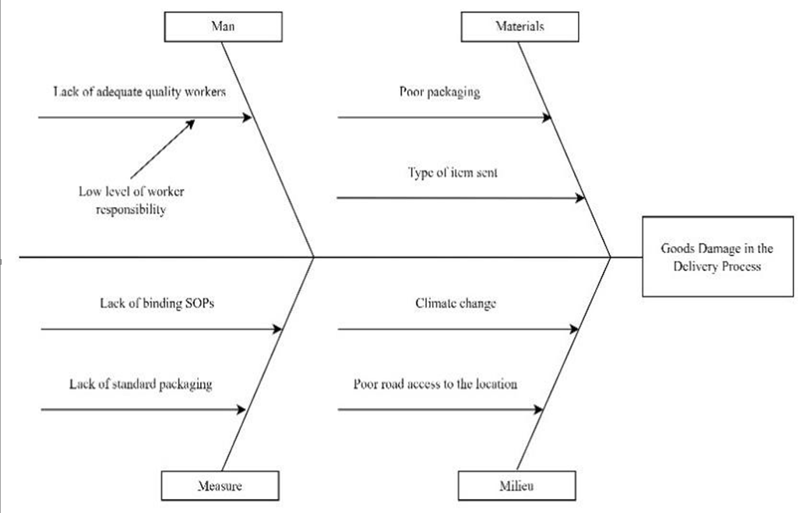
FIGURE 6 Fishbone diagram
An explanation of the root causes of the Fishbone Diagram as follow :
Man – The root cause: Low level of awareness and responsibility of workers towards existing SOPs, provisions for packing goods, and how to handle goods sent. The Impact : Damage to goods often occurs due to negligence of workers when handling goods to be sent, for example goods thrown by couriers when delivered to consumers and layouts for placing goods on vehicles that are not suitable. This is due to the low level of awareness and responsibility of workers regarding the applicable SOPs and procedures for handling goods that will be shipped safely to minimize damage.
Materials – The Root cause 1: Materials used for packing goods are not good. The Impact 1: Selection of inappropriate materials for packaging could cause damage to the goods. For example, the material used for packing goods is too thin so that when there is damage to the outer packing, it could cause damage to the goods inside. The Root cause 2: Types of delivery products include glassware, consumer goods, clothing, hobbies and accessories, and household equipment. Each type of goods has a different way of handling. The Impact 2: Each type of goods has a different handling. For example, glassware must be packaged using special packaging such as bubble wrap with the description fragile and food in the form of frozen food should use Styrofoam boxes to prevent damage to food.
Measure - The Root cause 1: Lack of SOPs that are binding on workers which include how to handle the goods sent. The Impact 1: The lack of binding SOPs is one of the reasons for the lack of workers' awareness of responsibility for the goods sent. The root cause 2: Lack of standard packaging for each type of goods sent to consumers. The Impact 2: There is a lack of standard packaging for each type of goods sent so that many items are packaged not according to the SOP, standard operating procedures, for example, only plastic packaging for glassware is used.
Milieu - The Root cause 1: Climate change could cause damage to the packaging and the product inside. The occurrence of rain could cause damage to packaging that has basic materials that are not waterproof, such as paper and cardboard. This could lead to damage to the goods in it. Inadequate road access to consumer locations. Poor road access could cause the goods carried by the courier to shake or even fall, impacted damage to the goods. The root cause 2: Inadequate Road access to consumer locations. The Impact 2: Poor road access could cause the goods carried by the courier to shake or even fall, impacted damage to the goods packages.

IMPROVE
The improve stage is carried out using the 5W+1H method [13]. The 5W+1H method in this study produces suggestions for improvements to reduce the occurrence of damage in the process of shipping goods. The table containing suggestions for improvement to prevent damage to goods in the delivery process is shown in TABLE 5.

TABLE 5 Analysis of 5W + 1H
Factor | The Root of the Problem | Description | Explanation
Man | Low level of worker responsibility | What | Low level of awareness and responsibility of workers regarding SOPs, provisions for packing goods, and how to handle goods sent
Man | Low level of worker responsibility | Why | The low level of awareness of responsibility causes the work carried out by each employee not in accordance with applicable procedures or regulations
Man | Low level of worker responsibility | When | Problems occur when the process of packing and shipping goods to consumers
Man | Low level of worker responsibility | Where | Improvements were made to PT XYZ's warehouse and logistics
Man | Low level of worker responsibility | Who | All employees at PT XYZ's warehouse and logistics
Man | Low level of worker responsibility | How | Conduct a review to the 3PL regarding performance handling to improve SOP, determine the target claim rate and punishment if the claim rate exceeds the target, and for the  internal side with refreshment training
Materials | Poor packaging | What | Materials used for packing goods are not good
Materials | Poor packaging | Why | Selection of materials that are not appropriate for the packaging of goods can cause damage to the goods
Materials | Poor packaging | When | The problem occurs when the process of packing goods
Materials | Poor packaging | Where | Improvements were made to the warehouse, especially the Packing Division which is related to the packaging of goods
Materials | Poor packaging | Who | Packing Division at PT XYZ warehouse and PT XYZ packaging supplier
Materials | Poor packaging | How | Changing the standard material for packing goods or coating the outermost part of the cardboard with plastic to prevent damage if exposed to water
Materials | Type of item sent | What | Each type of goods sent has a different way of handling and care must be taken to prevent damage, especially in terms of the packaging of goods
Materials | Type of item sent | Why | If there are no exceptions to the types of goods that require special treatment, damage to the goods may occur
Materials | Type of item sent | When | The problem occurs when the process of packing goods
Materials | Type of item sent | Where | Improvements were made to the warehouse, especially the Packing Division and systems in PT XYZ's e-commerce
Materials | Type of item sent | Who | Packing Division at PT XYZ warehouse and Information and Technology Division at PT  XYZ
Materials | Type of item sent | How | Determine the standard for packaging goods and update the system in PT XYZ ecommerce where food categories can be sent using instant services
Measure | Lack of binding  SOPs | What | Lack of SOPs that are binding on workers which include how to handle the goods sent
Measure | Lack of binding  SOPs | Why | The lack of binding SOPs causes a low level of awareness and responsibility of employees
Measure | Lack of binding  SOPs | When | Problems occur in the process of shipping goods to consumers
Measure | Lack of binding  SOPs | Where | Improvements were made to PT XYZ's warehouse and logistics
Measure | Lack of binding  SOPs | Who | All employees at PT XYZ's warehouse and logistics
Measure | Lack of binding  SOPs | How | Conduct a review to the 3PL regarding performance handling to improve SOP, determine the target claim rate and punishment if the claim rate exceeds the target, and for the  internal side with refreshment training
Measure | There is no standard packaging | What | There is no standard packaging for each type of goods sent to consumers
Measure | There is no standard packaging | Why | There is no standard packaging causing goods to be packaged not according to the provisions
Measure | There is no standard packaging |  | The problem occurs when the process of packing goods
Measure | There is no standard packaging | Where | Improvements were made to PT XYZ's warehouse and seller care
Measure | There is no standard packaging | Who | Packing Division at PT XYZ warehouse and seller
Measure | There is no standard packaging | How | Adjusting the SOP for the Packing Division in the warehouse and seller
Milieu | Climate change | What | Climate change can cause damage to packaging and products
Milieu | Climate change | Why | The occurrence of rain can cause damage to the packaging of goods
Milieu | Climate change | When | Problems occur in the process of shipping goods to consumers
Milieu | Climate change | Where | Packing Division at PT XYZ warehouse
Milieu | Climate change | Who | Packing Division at PT XYZ warehouse and PT XYZ packaging supplier
Milieu | Climate change | How | Changing the standard material for packing goods or lining the outside of the cardboard with plastic
Milieu | Poor road access to the location | What | Inadequate road access to consumer locations
Milieu | Poor road access to the location | Why | Poor road access can cause the goods carried by the courier to shake or fall
Milieu | Poor road access to the location | When | Problems occur in the process of shipping goods to consumers
Milieu | Poor road access to the location | Where | Improvements were made to PT XYZ's logistics
Milieu | Poor road access to the location | Who | Courier in charge of bringing goods to consumers
Milieu | Poor road access to the location | How | Arrange goods properly when packing and in the vehicle to prevent damage to goods due to shaking or falling

CONTROL
The control stage is carried out by compiling a Standard Operating Procedure (SOP) at the stage of packing goods and specifically for types of goods that require special treatment and are damaged easily [14]. Standard Operating Procedure (SOP) for Glassware Packing glassware was developed is shown in TABLE 6.

TABLE 6 SOP for packing types of glassware
 | Standard Operating Procedures for Glassware Packing
No. | Processed | Photo | Tools | Things to note
1. | Cover fragile products with paper or bubble wrap | 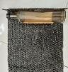 | Paper or bubble wrap | Make sure the paper or bubble wrap used to coat the product doesn't come  Off
2. | Prepare the cardboard that will be used as packing goods,  cover the bottom of the cardboard with plastic insulation. | 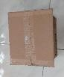 | Cardboard and plastic insulation | Make sure the bottom of the cardboard is tightly closed
3. | Use a few rolls of paper or bubble wrap inside the box to  fill the box and protect the item  from shock | 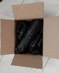 | Paper or bubble wrap | -Make sure the paper roll or bubble wrap is not too tight so that it still has cavity pads  -Make sure there are no voids around the items in the box
4. | Cover the top cardboard with plastic tape |  | Plastic insulation | Make sure the top of the cardboard is tightly closed
5. | Paste the fragile label on the top of the box | 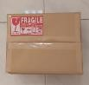 | Fragile label and plastic tape or glue | Make sure the fragile label is clearly visible
6. | Put the shipping receipt on the top of the cardboard | 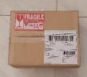 | Shipping receipt and plastic tape or glue | Make sure the delivery receipt is clearly visible

Standard Operating Procedure (SOP) for Frozen Food was developed [15] shown in TABLE 7.

TABLE 7 SOP for packing types of frozen food goods
 | Standard Operating Procedures for Packing Frozen Food Goods
No. | Processed | Photo | Tools | Things to note
1. | Prepare an aluminum foil box or styrofoam box that is used for packing  goods |  | Aluminum foil box or styrofoam box | -
2. | Cover the box with ice packs |  | Ice pack | Make sure the ice pack fills the box
3. | Place frozen food in a box equipped with an ice pack | 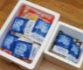 | - | Make sure frozen food is neatly arranged in the box
4. | Cover the top of the box with plastic insulation |  | Plastic insulation | Make sure the top of the box is tightly closed
5. | Paste the shipping receipt on the top of the box | 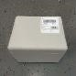 | Shipping receipt & plastic tape | Make sure the delivery receipt is clearly visible

Results of Application of Packaging Standards
Improvements focused on improving the packaging of goods with bubble wrap at the PT XYZ warehouse. The percentage allocation of damage is as follows.

TABLE 8 % allocation of obstacles
Obstacles Percentage Period March - May 2023
Warehouse | 80%
3rd PL & Seller | 20%
Total | 100%

TABLE 9 comparison of total damage after implementation
Delivery Barriers | Total Damage |  | % of Reduced Total Damage
Delivery Barriers | Before Improve (Oct. - Dec. 2022) | After Improve  (Mar-May 2023) | % of Reduced Total Damage
Total Data | 1,531,229 | 711,705 | 53.52%
Shipping from Warehouse | 1,071,860 | 569,364 | 46.88%

TABLE 10 Comparison of actual data vs target
Delivery Barriers | Total Damage |  | Percentage of reducing Number of Obstacles
Delivery Barriers | Before Improve | After Improve | Percentage of reducing Number of Obstacles
Damage, Lost, and Miss ETD | 1,896,165 | 13,163 | 99.31%

Data % allocation of obstacles show in TABLE 8. Data comparison of total damage after implementation show in TABLE 9. Data for comparison of the total obstacles that occur after repairs can be compiled as shown in TABLE 10.
The implementation of DMAIC steps during March to May 2023 had significant impact to reduce 46.88% damage packaging during delivery from warehouse to customers.
Estimated Claim Rate Determination Results
A target claim rate of 0.3% is given to each 3PL courier who pick up package every month of the total shipment of goods with the following comparison. The reduction in obstacles in the goods delivery process could reach target at 99.31%. Finally, the obstacle of (damage, lost and miss ETD) after implementation is 0,69%. Therefore, this improvement is expected to increase workers' awareness regarding handling performance during the goods delivery process.

CONCLUSIONS
First,The main causes of obstacles (damage, lost and late) during the shipping process from the warehouse to the end consumer have been identified during October - December 2022 summarized in TABLE 5, due to the absence of a binding SOP between the seller and 3PL, third party courier resulting in a low level of awareness and responsibility of workers, lack of packaging standards and poor materials used to package goods, climate change, and inadequate road access to consumer locations.
Second, Improvements and implementations summarized in TABLES 6 and 7 have been carried out during March - May 2023, namely refreshment training, setting claim rates and fines for 3PL couriers, and sellers, preparing policies regarding packaging standards, updating the system at PT XYZ, and preparing goods properly during packaging and in vehicles. Total obstacles (damage, loss, and delays) decreased from 43.21% to 0.69%.

Research limitations
First, Determining the cause of damage to goods should be done together with all 3PL courier parties, for constraint factors in the shipping process. Second, Further research to improve packaging standards should be conducted over a longer period of time so that trials can be conducted.

References
1. Yadrifil, A.A. Septyanti, and A.M.M. Rus, Implementation of lean-DMAIC method for reducing packing defect in a flour company. AIP Conference Proceedings, 2020. 2227(1): p. 040014.
2. Ribeiro, A.A., L. Madureira, and R. Carvalho, More urban gardens, less food waste: innovative ways to achieve SDGs, in The Role of Law in Governing Sustainability. 2021, Routledge. p. 118-133.
3. Purba, H.H., et al., Increasing Sigma levels in productivity improvement and industrial sustainability with Six Sigma methods in manufacturing industry: A systematic literature review. Advances in Production Engineering & Management, 2021. 16(3): p. 307-325.
4. Montororing, Y.D.R., M. Widyantoro, and A. Muhazir, Production process improvements to minimize product defects using DMAIC six sigma statistical tool and FMEA at PT KAEF. Journal of Physics: Conference Series, 2022. 2157(1): p. 012032.
5. Choi, D., C.Y. Chung, and J. Young Sustainable Online Shopping Logistics for Customer Satisfaction and Repeat Purchasing Behavior: Evidence from China. Sustainability, 2019. 11, DOI: 10.3390/su11205626.
6. Masyhuri, M., Key drivers of customer satisfaction on the e-commerce business. East Asian Journal of Multidisciplinary Research, 2022. 1(4): p. 657-670.
7. Nandakumar, N., P.G. Saleeshya, and P. Harikumar, Bottleneck Identification And Process Improvement By Lean Six Sigma DMAIC Methodology. Materials Today: Proceedings, 2020. 24: p. 1217-1224.
8. Widiwati, I.T.B., S.D. Liman, and F. Nurprihatin, The implementation of Lean Six Sigma approach to minimize waste at a food manufacturing industry. Journal of Engineering Research, 2024.
9. Nurprihatin, F., et al. Integration of Net Promoter Score and DMAIC Approach to Measure Customer Satisfaction in Packaging Industry. in 2022 International Conference on Computational Modelling, Simulation and Optimization (ICCMSO). 2022.
10. Idris, N.I., et al. A Case Study of Coffee Sachets Production Defect Analysis Using Pareto Analysis, P-Control Chart and Ishikawa Diagram. in Intelligent Manufacturing and Mechatronics. 2021. Singapore: Springer Singapore.
11. Saryatmo, M.A. and I.W. Sukania, Six Sigma Method for Improving the Quality of a Flat LM Type. An Evidence-Based Case Study of a PT. SPM. International Journal of Application on Sciences, Technology and Engineering, 2023. 1(1): p. 350-360.
12. Ramadhani, R.A., et al., Enhancing Quality Control of Packaging Product: A Six Sigma and Data Mining Approach. Jurnal Optimasi Sistem Industri, 2023. 22(2): p. 197-214.
13. Nguyen, V., et al. Practical Application of Plan–Do–Check–Act Cycle for Quality Improvement of Sustainable Packaging: A Case Study. Applied Sciences, 2020. 10, DOI: 10.3390/app10186332.
14. Tannady, H. and E. Purwanto, Quality Control of Frame Production Using DMAIC Method in Plastic PP Corrugated Box Manufacturer. Journal of Physics: Conference Series, 2021. 1783(1): p. 012078.
15. Park, Y.-J. Understanding Customer Preferences of Delivery Services for Online Grocery Retailing in South Korea. Sustainability, 2023. 15, DOI: 10.3390/su15054650.

