Analysis of The Dry Bulk Unloading Process At A Fertilizer Industry Port Using a Discrete Event Simulation Approach To Minimize Ship Congestion
Maulin Masyito Putri^{a)}, Alfiziza Farira^{b)}, Prita Meilanitasari^{c)}, Dwi Sekar Arumjani^{d)}, and Nindya Putri Prasodjo^{e)}
Department of Logistics Engineering, Universitas Internasional Semen Indonesia, Gresik, Indonesia

^{a)} Corresponding author: maulin.putri@uisi.ac.id
^{b)} alfiziza.farira18@student.uisi.ac.id
^{c)} prita.meilanitasari@uisi.ac.id
^{d)} dwi.arumjani21@student.uisi.ac.id
^{e)} nindya.prasodjo20@student.uisi.ac.id
Abstract. The loading and unloading processes at the fertilizer industry port are crucial for smooth operations. However, the dry bulk cargo unloading process often faces congestion, leading to ship queues that impact transportation costs and port efficiency. The port handles not only loading fertilizer products but also unloading raw materials such as phosphate rock, ammonium sulfate (ZA), sulfur, and potassium chloride (KCL), each requiring specific material handling. Unloaded raw materials are transported from the dock to a distant warehouse using conveyors, hoppers, and trucks, highlighting the need to improve unloading processes to reduce ship congestion. This research uses discrete event simulation to evaluate six unloading alternatives, each with different material handling and transportation combinations, considering that not all equipment can handle every cargo type. To identify the best strategy for minimizing ship waiting time, six improvement scenarios were developed. The most effective alternative is alternative two, which involves pier one, two VCs, hoppers, and dump trucks to transport the cargo to the warehouse. This alternative achieved the most significant reduction in total waiting time in almost all scenarios. The inclusion of dump trucks significantly reduces waiting times. This indicates that the bottleneck in the unloading process, when using a combination of a vessel crane (VC), hopper, and dump trucks, is the insufficient number of dump trucks.
Keywords: Unloading process, congestion, raw materials, discrete event simulation, waiting time.

INTRODUCTION
Indonesia is referred to as an archipelagic country because most of its territory consists of water areas. Indonesia is also an agrarian country because the agricultural sector plays an important role in the overall national economy, making the availability of fertilizers (organic and non-organic) a crucial domestic need. The role of fertilizers in soil is key to the success of farming operations in producing food such as rice and vegetables. Therefore, the role of fertilizers also impacts national food security. To address this, the government strives to maintain the availability of fertilizers for farmers by subsidizing them. The government also supervises the distribution of fertilizers as they are subsidized goods. Given Indonesia's condition, where most of its territory is composed of islands, much of the subsidized fertilizer distribution from factories to warehouses is conducted via sea or river. Terminals for Private Use (TUKS) managed by fertilizer companies are one of the supporting facilities for the distribution of fertilizer products, including subsidized and non-subsidized fertilizers, non-fertilizer products, and raw materials both domestically and internationally. Terminal management must regulate the entry and exit of ships at the docks to ensure smooth and scheduled operations. In addition to scheduling issues, TUKS may face cases such as port capacity mismatches with demand; for instance, available capacity might not be fully utilized, or demand may exceed the available capacity. When port demand exceeds available capacity, it affects port operations and leads to congestion.
Congestion has a significant impact on transportation costs and port performance. Congestion leads to time delays and increased costs for cargo owners and shipping companies. This makes it a critical concern at ports. Some of the contributing factors are bad weather, equipment failure, inadequate unloading facilities, or limited warehouse capacity and stacking areas. These issues can disrupt the scheduling of subsequent ship services. Delays in the loading and unloading process at one port cause delays in arrival at the next port [1].
Optimizing the use of transportation and material handling equipment during the loading and unloading process is a key strategy for reducing congestion [2]. Efficient handling of goods during the loading and unloading process can enhance material handling effectiveness and reduce ship waiting times. The unloading process at dry bulk ports is complex due to several factors. First, operational decisions related to daily production or services play a significant role. Second, interdependencies and variability in system activities or elements add to the complexity. Lastly, costs can increase when decisions exceed the expected simulation costs [3]. Several types of dry bulk materials are unloaded at dry bulk ports, such as fertilizers, phosphate rock, potassium chloride (KCL), and ammonium sulfate (ZA). Material handling options include the continuous ship unloader (CSU), kangaroo crane (KC), vessel crane grab portable (VC), and portable hoppers. These material handling systems unload cargo from ships and transfer it to conveyors or dump trucks, depending on the type of material and its designated storage warehouse.
The specific unloading process for dry bulk begins with the ship's arrival at the port. Next, the ship will wait in the berth queue if no berth is available. Then, the ship proceeds with pilotage and towing to the berth when it is ready. After pilotage and towing, the ship undergoes pre-time, which involves a series of activities to prepare for the port and administrative loading tasks. Pre-time activities include checking the initial draught, ensuring the cleanliness of the ship’s hold, preparing loading equipment, lowering the gangway, and waiting for truck arrivals. After pre-time, the ship can proceed with unloading dry bulk cargo. Once unloading is complete, the ship undergoes post-time, which is a series of activities that take place after loading is finished. These activities include checking the final draught, closing and securing the ship's hold, waiting for loading permits from the harbor master, and arranging for pilotage and towing to depart the berth.
During the COVID-19 pandemic, almost all activities, including those at the port, were restricted. As a key hub in the supply chain, the port was significantly affected by these restrictions. The additional time required for quarantine and other restrictions led to congestion at the port. This congestion has been shown to negatively impact air quality in the port area [4]. Modeling the dry bulk port system is a complex problem. Discrete event simulation can be used to determine the best alternative [3]. The optimal alternative is the one that offers the best trade-off between service level and loading and unloading costs. Discrete event simulation can also identify the impact of congestion on truck queues and emissions at bulk cargo terminal [5, 6]. This research will use discrete event simulation methods to analyze the unloading process at dry bulk ports, considering various alternative material handling approaches for loading and unloading. The goal of this research is to identify the best combination of material handling methods to minimize the waiting time of ships at the port. For validation, the best alternative will be evaluated against six other options.

METHODS
This research is based on the actual operations of a port that handles raw materials and fertilizer products. Each ship that docks carry one type of cargo from four categories of raw materials unloaded at the port: Phosphate Rock, KCL, Sulphur, and ZA. Annually, 145 ships arrive at the port, with cargo volumes ranging from 20,000 to 33,000 tons per ship. Various material handling equipment is used for loading and unloading, but not all equipment is compatible with every type of cargo. TABLE 1 explains the specifications of each material handling equipment.
CSU 1, CSU 2, KC and VC are responsible for unloading cargo from the ship and loading it onto the dump truck, hopper and conveyor. The conveyor, hopper and dump trucks transport the cargo from port to the available warehouse. There are 14 warehouses capable of storing all types of cargo. FIGURE 1 shows the activity cycle diagram of the problems addressed in this study. FIGURE 1 illustrates the sequence of processes that occur when a ship arrives at the port area, docks at the pier, undergoes unloading, and leaves the port area.

TABLE 1. Material Handling Equipment
Material Handling Equipment | Capacity | Cargo | Quantity  (Unit)
Continous Ship Unloader 1 (CSU 1) | 1000 tons per hour | P. Rock | 1
Continous Ship Unloader 2 (CSU 2) | 1000 tons per hour | KCL | 1
Kangaroo Crane (KC) | 300 – 500 tons per hour | MOP and ZA | 2
Vessel Crane Grab Portable (VC) | 5 – 8 tons per minute | P. Rock | 6
Conveyor System | 300 – 1000 tons per hour | Raw materials and bulk fertilizer | 2
Hopper Portable | 16 tons | Raw materials and bulk fertilizer | 6
Dump Truck | 25 tons | Raw materials and bulk fertilizer | 60

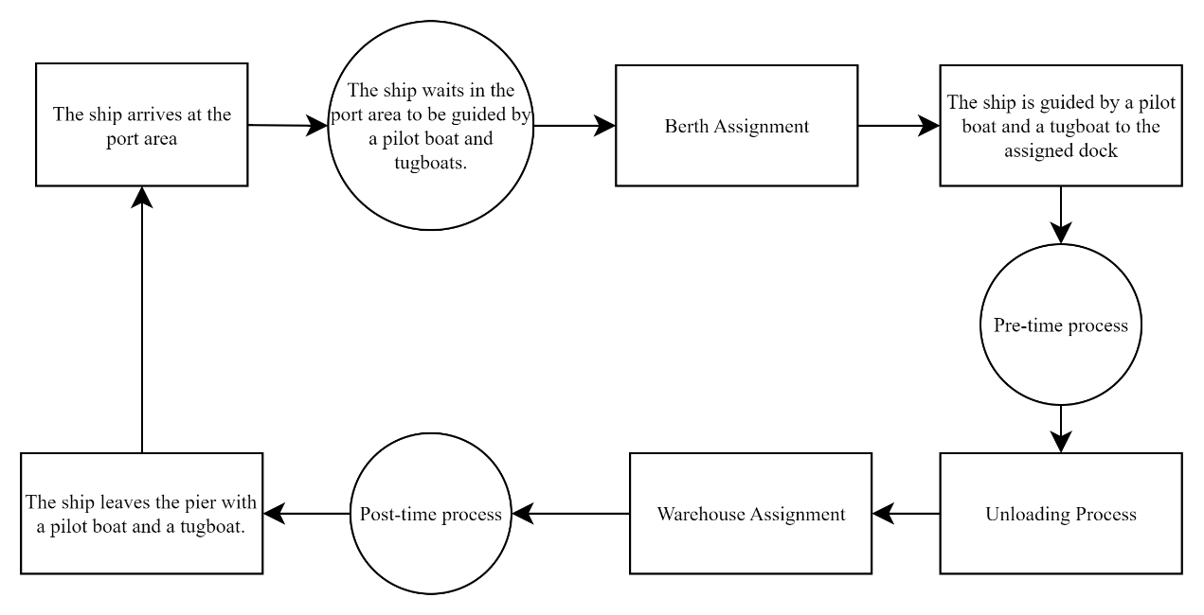
FIGURE 1. Activity Cycle Diagram

Upon arrival in the port waters, the ship waits in the dock queue until an available and appropriate dock assignment is given. The allocation of a dock considers the type of cargo loaded, the availability of unloading material handling equipment, and the material handling requirements for distribution to the warehouse. If a suitable dock is available, the ship proceeds with the guidance and delay process to reach the dock according to the cargo type. Once docked at the pier, the ship undergoes the pre-time process, a series of activities to prepare the port and manage loading administration. This process includes checking the initial draft, inspecting the cleanliness of the ship’s hold, preparing loading equipment, lowering the gangway, and waiting for the arrival of trucks or the readiness of the conveyor, depending on the unloading equipment used. During this time, the appropriate warehouse for the cargo is also determined. Following the pre-time process, the ship proceeds with unloading dry bulk cargo using designated unloading equipment. Once all cargo has been removed, the ship undergoes the post-time process, which includes final draft checks, closing and securing the ship’s hatches, waiting for the sailing permit from the harbor master, and waiting for tug guidance. Upon completing the post-time process, the ship then undertakes pilotage and tug operations to leave the dock and port area. In one year, 145 ships unload the cargo at the port with various types of cargo.
Berth assignment is determined by considering the type of cargo and the availability of material handling equipment. Ships carrying phosphate rock cargo are served by CSU 1, while those with KCL cargo are served by CSU 2. And KC handles ships carrying MOP and ZA cargo. FIGURE 2 illustrates the conceptual model used to solve this problem.
(1)
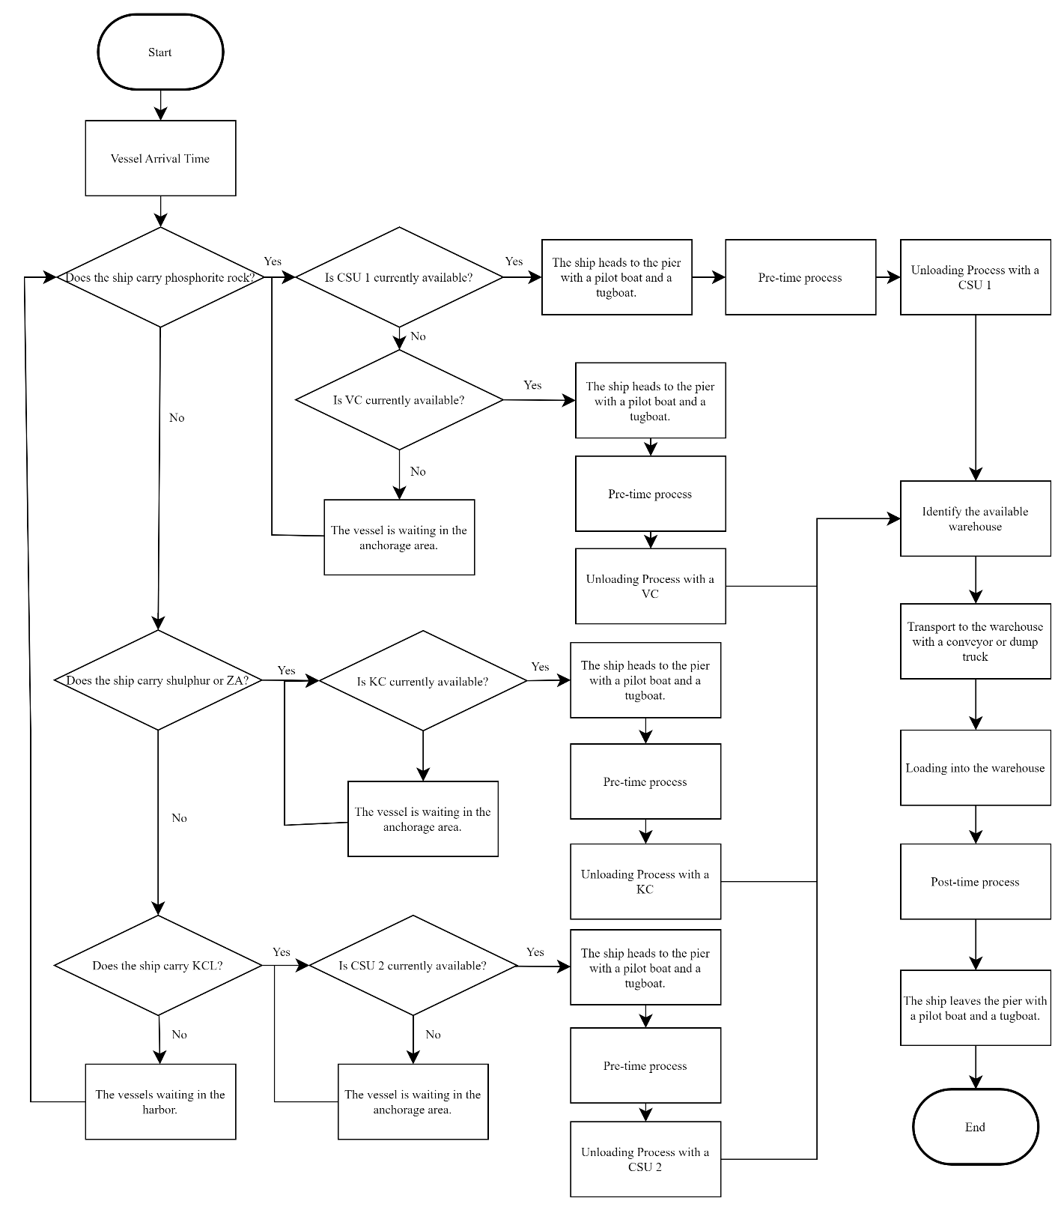
FIGURE 2. Conceptual Model

Equation 1 is used to determine the time required for the material handling equipment to unload the ship’s cargo volume. The time required for the conveyor to move all the ship's cargo from the dock to the warehouse is calculated using Equation 2. The last equation determines the time required for the dump truck or hopper to move all the ship's cargo from the dock to the warehouse.
$$UT=\frac{SV}{UR}$$
UT : Unloading Time (hour)
(1)
SV : Ship’s cargo volume (ton)
UR : The unloading rate of the material handling equipment (tons per hour)
(2)
$$TTC=\frac{SV}{C}$$
TTC : Transfer time from the port to the warehouse with conveyor (hour)
SV : Ship’s cargo volume (ton)
UR : The transport rate of the conveyor (tons per hour)
$$TT=\frac{SV}{C}×\frac{d_{ij}}{R}$$
TTC : Transfer time from the port to the warehouse with dump truck or hopper (hour)
(3)
SV : Ship’s cargo volume (ton)
UR : Capacity of dump truck or hopper (tons)
$d_{ij}$ : Distance from port i (location of material handling equipment) to warehouse j (km)
R : Traveling rate of the dump truck or hopper (km per hour)

RESULTS AND DISCUSSION
The simulation model is developed by considering three sides of the pier. This model is tested with six alternative combinations of three piers, material handling systems (CSU, VC, KC, and hopper), and transporters (conveyor and dump truck). The first alternative uses Pier 1 with CSU 1 and a conveyor system. The second alternative employs Pier 1 with two VCs for unloading cargo from the ship, along with hoppers and five dump trucks to transport the cargo to the warehouse. The third alternative utilizes Pier 2 with KC 1, a hopper, and five dump truck. The fourth alternative uses Pier 2 with VCs, a hopper, and five dump trucks. The fifth alternative utilizes Pier 3 with VCs, a hopper, and five dump trucks. The last alternative uses Pier 3 with CSU 2 and a conveyor system. The selection of alternatives is, of course, based on the type of cargo carried by the ship, as not all material handling equipment can unload all types of cargo.

FIGURE 3. Waiting Time of Conceptual Model

After creating and running a model based on existing conditions for one year, the results indicate that the dry bulk unloading process has a relatively high waiting time. FIGURE 3 shows the waiting time associated with each alternative in the dry bulk unloading process. The alternative with the lowest waiting time is alternative 2. Under current conditions, the following waiting times are observed for each unloading alternative: 378.8 hours for alternative 1, 143 hours for alternative 2, 881.6 hours for alternative 3, 664.6 hours for alternative 4, 228.7 hours for alternative 5, and 318.2 hours for alternative 6. To validate the simulation model and identify the best improvement scenario, several simulations were conducted using the scenarios described in TABLE 2. Since VC can unload all types of raw materials, the improvement scenario increases the percentage of cargo that can be unloaded by VC.
TABLE 2. Improvement Scenario
Scenario | Description
1 | Increase in the use of alternative 2 for dry bulk unloading by 10% and addition of 1 dump truck for each alternative.
2 | Increase in the use of alternative 2 for dry bulk unloading by 20% and addition of 1 dump truck for each alternative.
3 | Increase in the use of alternative 2 for dry bulk unloading by 10% and addition of 2 dump trucks for each alternative.
4 | Increase in the use of alternative 2 for dry bulk unloading by 20% and addition of 2 dump trucks for each alternative.
5 | Increase in the use of alternative 2 for dry bulk unloading by 10% and addition of 3 dump trucks for each alternative.
6 | Increase in the use of alternative 2 for dry bulk unloading by 20% and addition of 3 dump trucks for each alternative.

FIGURE 4. Waiting Time of Improvement Scenario Models

FIGURE 4 illustrates a general trend of decreasing waiting times across most alternatives and scenarios. The first improvement scenario proposes adding one dump truck, resulting in a total of seven dump trucks for each unloading alternative that uses dump trucks and increasing the use of alternative 2 dry bulk unloading by 10%. The second scenario also adds one dump truck (totaling seven dump truck), but increases the use of alternative 2 by 20%. The third scenario adds two dump trucks, bringing the total to eight, with a 10% increase in the use of alternative 2. The fourth scenario involves two additional dump trucks (totaling eight) and a 20% increase in the use of alternative 2. The fifth scenario proposes three additional dump trucks, totaling nine, with a 10% increase in alternative 2. The sixth scenario also includes three additional dump trucks, totaling nine, with a 20% increase in alternative 2.

CONCLUSIONS
Based on the results of the simulation model, which evaluated six alternatives and six improvement scenarios, Alternative Two exhibits the lowest waiting time. These findings are further validated by the results of the sixth scenario. The combination of a vessel crane (VC), hopper, and dump truck reduces waiting times due to the high availability of the VC and hopper, as well as the unloading speeds of the dump trucks. However, the prolonged unloading time leads to an overall total unloading time that exceeds expectations, causing subsequent ships to wait longer for an available dock. Significantly increasing the number of dump trucks can notably reduce waiting times. This indicates that, alongside the type of material handling equipment, the number of dump trucks serves as a critical bottleneck in the unloading process. Future research should also examine demurrage and associated costs resulting from ship congestion. Furthermore, it is essential to analyze the loading process when utilizing dump trucks as transporters.

Acknowledgments
The authors wish to thank the reviewers for their valuable suggestions to improve the quality of this paper. We also express our gratitude to the Ministry of Education, Culture, Research, and Technology for their financial support of this research under the PDP scheme.

References
1. Jiang, C., Y. Wan, and A. Zhang, Internalization of port congestion: strategic effect behind shipping line delays and implications for terminal charges and investment. Maritime Policy & Management, 2017. 44(1): p. 112-130.
2. Xu, B., et al., System dynamics analysis for the governance measures against container port congestion. Ieee Access, 2021. 9: p. 13612-13623.
3. Siswanto, N., et al., A Simulation study of sea transport based fertilizer product considering disruptive supply and congestion problems. The Asian Journal of Shipping and Logistics, 2018. 34(4): p. 269-278.
4. Gu, B. and J. Liu, COVID-19 pandemic, port congestion, and air quality: evidence from China. Ocean & Coastal Management, 2023. 235: p. 106497.
5. Neagoe, M., et al., Using discrete-event simulation to compare congestion management initiatives at a port terminal. Simulation Modelling Practice and Theory, 2021. 112: p. 102362.
6. Li, X., et al., The impact of port congestion on shipping emissions in Chinese ports. Transportation Research Part D: Transport and Environment, 2024. 128: p. 104091.

