Integration of Green Productivity and AHP for Enhancing Environmental Performance in Paint Production Systems
Zsa Zsa Syahadida Mustafa^{a)}, Ahmad Mubin^{b)}, and Thomy Eko Saputro^{c)}
Department of Industrial Engineering, University of Muhammadiyah Malang, Malang, Indonesia
^{b)} Corresponding author: ahmadmbn@umm.ac.id
^{a)} zsazsasyahadida27@gmail.com
^{c)} thomysaputro@umm.ac.id
Abstract. The obstacles or problems that exist in the company are that the waste generated during the production process is not processed properly so the presence of these wastes will greatly disturb or pollute the surrounding environmental ecosystem. Good environmental performance supports environmental protection efforts so as not to pollute the environment around the industry. The purpose of Green Productivity (GP) is to identify environmental performance that has been achieved in the good category and get improvement solutions that will increase business productivity by utilizing waste. Environmental performance indicator (EPI) is a parameter based on the amount studied or calculated. From the results of the calculation of productivity and environmental performance for each alternative, the selected alternative is the alternative solution to the addition of the filtration process. This is influenced by the increase in value from before the proposed alternative. In the alternative solution, the addition of the filtration process obtained a percentage increase in productivity to 130% which was 126% before the alternative. From the results of calculations that have been carried out related to increasing productivity and environmental performance, the proposed improvements selected in productivity and environmental performance problems can be seen from the Benefit-Cost Ratio (BCR) value which has a value of 1.005 in the alternative solution of adding a filtration process. With a contribution of 130% increase in productivity and 0.549 environmental performance.
Keywords: Green Productivity; Productivity; Environmental Performance Index (EPI); Analytical Hierarchy Process (AHP); Benefit Cost Ratio (BCR)

INTRODUCTION
Productivity is a measure of how efficiently a process produces an output. It is also defined as a ratio between inputs and outputs, with a focus on the output generated by a process. In addition to productivity, companies must also pay attention to environmental performance. Environmental performance refers to a company's efforts to participate in environmental conservation [1]. The concept of environmental performance itself pertains to the extent of environmental damage caused by company activities. Moreover, focusing on environmental performance is crucial for meeting increasingly stringent environmental regulations and improving the company's image among consumers who are increasingly concerned about environmental issues. Many companies now need to acknowledge the fact that environmentally friendly productivity is vital through clean manufacturing practices to compete in the global market [2]. Implementation of green productivity is an important way to achieve sustainable development [3].
[4] did research regarding to management of Green Productivity (GP) in Iran Aseman Airline Company's current situation is analyzed such as the consumption of energy, water, airplanes fuel, and evaluating environmental pollutants. The research results from [5] concluded that the best scenario suggested to improve the productivity of motorcycle tires was a combined treatment of controlling raw material characteristics and reusing water and materials. The research results from [6] showed that the Green Productivity Index depends on factors such as manpower, materials, energy and machinery, and environmental factors. [7] have conducted a study on the application of GP to improve productivity and environmental performance in the leather tanning industry.
By implementing the concept of Green Productivity, paint industries can enhance resource use efficiency, reduce waste, and create environmentally friendly products. Applying Green Productivity can improve a company's competitiveness. The most crucial part of implementing Green Productivity (GP) is examining and evaluating the production process to reduce its environmental impact and find the best solutions, which leads to increased productivity and product quality [8]. The goal of Green Productivity (GP) is to identify environmental performance that has reached a good category and obtain improvement solutions that will boost business productivity by utilizing waste [9].
In the paint production process, it is possible to encounter inefficiencies in the use of raw materials and energy. One of the challenges faced by companies is that the waste generated during production is not properly managed, which can significantly disrupt or pollute the surrounding ecosystem. Meanwhile, good environmental performance supports efforts to protect the environment from contamination and maintain the cleanliness of the surrounding area. With the concept of Green Productivity, it is hoped that companies can focus on minimizing environmental damage and reducing production costs. This means concentrating on more efficient resource use and waste reduction to mitigate the negative environmental impacts resulting from the production process. It also allows companies to optimize their production processes and reduce production time, thereby enhancing overall company performance.

METHODS
Productivity is the ratio of total output at a given time divided by the total input during that period. It is also defined as the relationship between actual or physical results (goods or services) and the actual inputs, which can be understood as a comparison between output and input, or output: input [7]. Productivity measurement is an indicator of how effectively a company can transform the inputs used into output with maximum added value, using Equation 1.

$TP=\frac{Total Output}{Total Input}$ (1)

The GP assessment methodology works within the framework of an Environmental Management System (EMS) to help a company concentrate on opportunities to prevent pollution and improve material productivity [10]. Environmental performance in the context of Green Productivity (GP) refers to a company's efforts to enhance productivity while minimizing negative environmental impacts. GP is an approach that integrates sustainability principles into the production process, focusing not only on economic efficiency but also on environmental protection. To measure a company's environmental performance, the Environmental Performance Indicator (EPI) is used. The Environmental Performance Indicator (EPI) is a parameter based on quantities that are studied or calculated. An environmental indicator is something that is expected to reflect various impacts of an activity on the environment and efforts to mitigate those impacts. By using the amounts of input and output, EPI demonstrates the environmental efficiency of the production process. Performance indicators can be combined with system indicators to show a process unit's efforts to improve its environmental impact. The EPI index can be calculated using Equation 2:

$Indeks EPI Ʃ_{i=1}^{k}=W_{i} . P_{1}$ (2)

Where Wi​ represents the weight of each criterion. These weights are obtained through the distribution of questionnaires to environmental experts. The weights are based on human health and environmental balance parameters. Both parameters are given equal percentages because if a chemical substance is deemed harmful to the environment, it is also harmful to human health, as humans consume food from plants and animals. The value Pi​ represents the percentage deviation between the standard waste quality and the company's analysis results, using Equation 3.

$P_{i}=\frac{Waste quality standards-analyzes}{Waste quality standards} x 100\%$ (3)

The Analytical Hierarchy Process (AHP) is a general theory of measurement used to derive ratio scales from both discrete and continuous pairwise comparisons [11]. The following are the steps in AHP:
- Define the Problem and Determine the Objective
- Create the Hierarchical Structure, Starting with the Main Objective
- Construct Pairwise Comparison Matrices
These matrices represent the relative contributions or influences of each element towards the goal or the criteria at the level above.
- Weight Calculation
If there are multiple respondents, the weights are determined by finding the geometric mean of the ratings provided by all respondents. Mathematically, the geometric mean is calculated using Equation 4:
GM = ${(Z_{1} x Z_{2} x Z_{3} x…x Z_{n}) }^{\frac{1}{n}}$ (4)
Explanation:
GM = Geometric Mean
Z1 = Rating given by the first respondent
Z2 = Rating given by the second respondent
n = Number of respondents
- Normalize the Weights
Normalization of the weights is done by dividing each weight by the sum of the weights in each column.
- Calculate the Eigenvector (EV)
The calculation of eigenvectors using Equation 5:
$EV=matriks awal \left(A\right)x bobot paramter (W_{i})$ (5)
- Calculate $λ_{maks}$/ eigenvalue
Equation 6 is used to calculate $λ_{maks}$
$λ_{maks}= \frac{Ʃ\frac{A x W_{i} }{W_{i}}}{n}$ (6)
Explanation:
A = Initial Matrix
$W_{i}$ = Weight of the parameter
n = Index of the matrix
- To calculate the Consistency Index (CI), using Equation 7:
$CI=\frac{λ_{maks}-n}{n-1}$ (7)
- Calculate consistency ratio (CR), using Equation 8
$CR=\frac{CI}{RI}$ (8)
The acceptable Consistency Ratio (CR) is less than or equal to 0.1

The Benefit-Cost Ratio (BCR) method is used to determine the magnitude of benefits or losses and the feasibility of a project. The BCR method emphasizes the ratio between the benefits to be gained and the costs and losses to be incurred. The Benefit-Cost Ratio (BCR) is a tool used for public decision-making by considering the welfare of the community. The BCR focuses solely on the efficiency of the use of production factors without addressing other issues such as distribution, economic stabilization, and so on. This method evaluates programs from an efficiency standpoint, while the decision to implement the program rests with the executive authorities, who also consider other factors in their decision-making. The formula for calculating the Benefit-Cost Ratio uses Equation 9 (BCR).

$BCR=\frac{PV Benefit (b)}{PV Cost (c)}$ (9)
Explanation:
B = Benefit
C = Cost
- If the BCR value is < 1, the benefits generated by the project are less than the economic costs required, and the project is not economically viable.
- If the BCR value is = 1, the benefits generated by the project are equal to the economic costs required, and the project is economically viable.
- If the BCR value is > 1, the benefits generated by the project exceed the economic costs required, and the project is economically viable.

RESULT AND DISCUSSION

PRODUCTIVITY
Using Formula 1, the productivity of the company for the period from March 2023 to February 2024 can be seen as shown in FIGURE 1.

FIGURE 1. Productivity level graph

From FIGURE 1, it is observed that the company's productivity is above 100%. In other words, productivity is already quite good. However, it would be beneficial for the company to further increase the productivity percentage. The average productivity for the period from March 2023 to February 2024 is 126%.

ENVIRONMENTAL PERFORMANCE
The weighting for the calculation of Environmental Performance Indicators (EPI) is derived from the results of a questionnaire completed by two individuals in the company’s laboratory. These weights are then calculated using the Analytical Hierarchy Process (AHP) to assess the hazard level of chemical substances in the waste. The Standard Quality Standards are obtained based on Governor Regulation No. 52 of 2014 concerning liquid waste. Table 1 below shows the results of the waste analysis.

TABEL 1. EPI index results
Parameter | Weight (Wi) | Quality Standards | Analysis results | Deviation (Pi) | Index EPI (Wi. Pi)
COD | 0.115 | 80 | 663.6 | -730% | -0.841
TSS | 0.103 | 50 | 24.5 | 51% | 0.052
Merkuri | 0.110 | 0.01 | 0.00003 | 100% | 0.110
Seng | 0.087 | 1 | 0.0076 | 99% | 0.086
Timbal | 0.103 | 0.3 | 0.0016 | 99% | 0.103
Tembaga | 0.102 | 0.8 | 0.0187 | 98% | 0.100
Krom Heksavalen (Cr+6) | 0.109 | 0.2 | 0.0152 | 92% | 0.101
Kadmium | 0.087 | 0.03 | 0.002 | 93% | 0.081
Fenol | 0.064 | 0.02 | 0.1351 | -576% | -0.370
Minyak dan Lemak | 0.066 | 10 | 1.5 | 85% | 0.056
pH | 0.053 | 9 | 6.8 | 24% | 0.013
Indeks EPI total |  |  |  |  | -0.509

From the results obtained, the Environmental Performance Indicator (EPI) index is -0.509. This indicates a very low value, suggesting that improvements are necessary. If no corrective actions are taken, the parameters involved could pose a danger to the surrounding environment. This is because all chemical substances contained in the waste can have adverse effects on the environment.

ANALYSIS OF ALTERNATIVE SOLUTIONS

ALTERNATIVE SOLUTIONS FOR ADDING FILTRATION PROCESSES
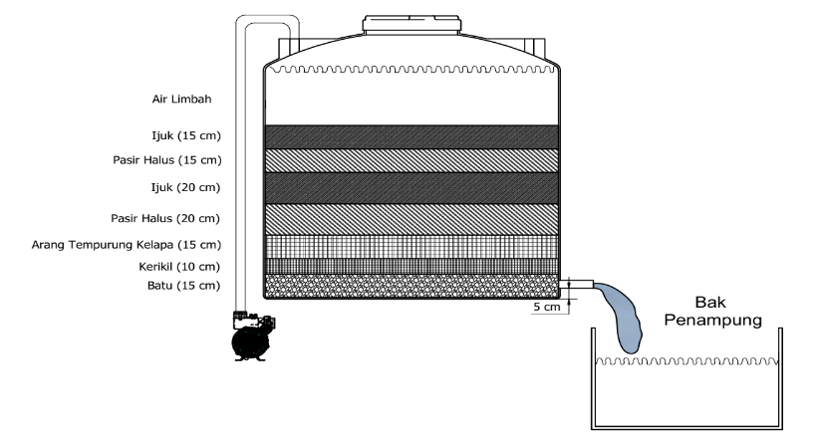
The first alternative involves improving the efficiency and quality of wastewater treatment by adding a filtration process. This filtration can be achieved using more effective and efficient technologies. One example is using a filter composed of coconut husk, sand, and activated carbon, which is highly effective in absorbing odors, tastes, and toxins in water. This type of filter can help reduce the volume of wastewater discharged, lower operational costs, and minimize negative environmental impacts. Additionally, it can decrease gas and particulate emissions associated with wastewater treatment. Therefore, filtration technology can be an effective alternative for reducing direct disposal and improving the quality of wastewater, as well as reducing water usage by up to 30%. (see in FIGURE 2)

FIGURE 2. Illustration of the addition of the filtration process

According to [12], in the filtration process, the reduction of phenol concentration is 63.62%. The reduction of COD concentration using the filtration process can reach 81.7%. Therefore, the filtered wastewater can be reused as clean water, safe for both the environment and human health. This requires a 2,500-liter plastic drum and filters such as coconut husk, fine sand, gravel, activated carbon, and stones. A total of 10 units are needed to reduce the contaminants in the wastewater. The estimated cost for this setup is Rp 74,990,000. With a monthly water requirement of 3 million liters, a 30% reduction translates to a savings of 900 m³ of water each month. This results in a total cost saving of Rp 40,500,000.
The investment cost for implementing Alternative 1 is estimated to be Rp 2,353,208,865. Based on the benefit-cost ratio (BCR) calculation, which has an index of 1.005, this investment is significantly more profitable compared to the situation before the alternative proposal. The addition of the filtration process effectively reduces the chemical content in the wastewater, and the change is quite substantial. Consequently, the chemical concentrations of COD and phenol in the EPI index improve. The EPI index for Alternative 1 increases to 0.549. Implementing Alternative 1 also boosts the company’s productivity to 130%.

ALTERNATIVE SOLUTIONS FOR IMPLEMENTING CONSTRUCTED WETLAND (CW)
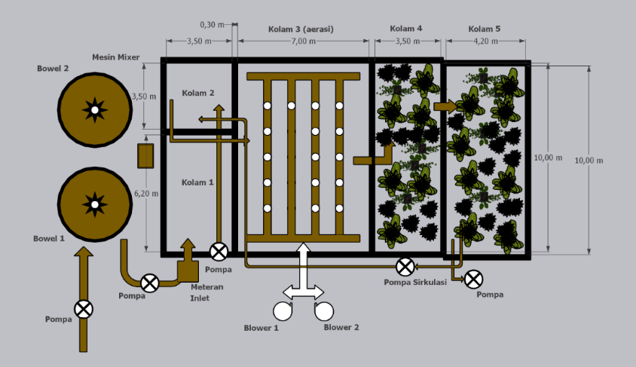
In developing the second alternative solution, which is the implementation of Constructed Wetlands (CW), the principle of treatment involves using the performance of water within the CW wastewater system. This generally involves aquatic plants, soil, and microorganisms present in the media around the plant systems, working naturally. The proposed wastewater treatment technology in this study involves using CW technology that utilizes water jasmine (Echinodorus Palaefolius) plants to reduce contaminants in wastewater. This type of plant can serve as an alternative for wastewater treatment. (see in FIGURE 3)
FIGURE 3. Illustration of the Addition of a Constructed Wetland (CW)

The advantages of using these two types of plants include their ability to reduce contamination levels, their easy availability, adaptability, and low cost. These plants have been tested and proven effective in reducing pollutant loads in wastewater, particularly in lowering COD and BOD [13]. Water jasmine plants are beneficial in reducing BOD, COD, and phosphates, with the highest reduction percentages being 90%, 90.79%, and 56.35%, respectively. Unfortunately, this alternative does not result in savings in water usage because water jasmine, alum, and lime cannot reduce phenol levels. Therefore, the treated wastewater cannot be reused. The cost of implementing Constructed Wetlands (CW) is IDR 22,235,000, while the water savings cost is IDR 0.
The investment cost for implementing Alternative 2 is estimated at IDR 2,353,208,865. Based on the benefit-cost ratio (BCR) calculation, which has an index of 0.801, the benefits of implementing Constructed Wetlands (CW) are less than the economic costs. Therefore, it can be concluded that this alternative is not feasible. Although the implementation of Constructed Wetlands (CW) can reduce the chemical COD content in the waste, the change is significant. However, there is no change in phenol levels. The EPI index for Alternative 2 increases to 0.361. If Alternative 1 is implemented, there is no increase in company productivity, which remains at 126%.

SELECTION OF ALTERNATIVE SOLUTION
Based on the calculations of productivity and environmental performance for each alternative, the chosen solution is the addition of the filtration process. This decision is influenced by the observed improvements in the metrics after implementing the alternative. In the filtration process solution, productivity increased to 130% from the previous 126%, resulting in a 3% improvement. Additionally, environmental performance improved significantly, with the EPI index rising from -0.509 to 0.549. With a value above 0, the environmental performance can be considered good. Therefore, the treated water can be reused in the production process. (see in Tables 3 and 4)

TABEL 2. Comparison of productivity levels and environmental performance
Consideration | Before Alternative | Adding Filtration Processes | Implementing Constructed Wetland (CW)
Productivity Level | 126% | 130% | 126%
Improved Environmental Performance | -0.509 | 0.549 | 0.361

TABEL 3. Comparison of benefit cost ratio (BCR) values
Alternative | Benefit Cost Ratio (BCR) Value
Adding Filtration Processes | 1,005
Implementing Constructed Wetland (CW) | 0,801
From the calculations, it is evident that the chosen alternative solution is indicated by the benefit-cost ratio (BCR) value being greater than 1. Specifically, the alternative of adding the filtration process has a BCR of 1.005. With the estimated and simulated calculations, the monthly savings in water usage costs. Additionally, the addition of the filtration process results in increased productivity and improved environmental performance, with productivity rising to 130% and environmental performance reaching an EPI index of 0.549. The implementation of filtration processes is considered more effective compared to Constructed Wetland (CW) due to the costs associated with additional filtration media and plastic drums with a water flow rate of 2,500 liters, amounting to IDR 74,990,000. This system has an operational lifespan of approximately 5 years. Despite the high installation costs, the company benefits significantly with a 30% water savings. This equates to a monthly water saving of 900 m³ out of 3,000 m³. With the cost of water at IDR 45,000 per m³, the monthly savings amount to IDR 40,500,000, and annual savings reach IDR 486,000,000. In contrast, implementing a Constructed Wetland (CW) involves costs for media such as water jasmine (Echinodorus Palaefolius), alum, and lime, with a total cost of IDR 22,235,000 for 5 filtration ponds. However, CW does not provide any measurable water savings, resulting in a 0% water savings.

CONCLUSIONS
The average productivity level of PT XYZ during the period from March 2023 to February 2024 is 126%. Based on these productivity calculations, it can be said that the productivity level is good. However, the Environmental Performance Indicator (EPI) index for PT XYZ is -0.509, which is a very low value and falls below the industrial waste quality standards set by Governor Regulation No. 52 of 2014. With the addition of the filtration process, productivity increased by 3% from 126%, while the environmental performance improved with an EPI index of 0.549. The benefit-cost ratio (BCR) calculation for this alternative yields a value of 1.005, indicating that the investment is feasible. In contrast, the implementation of Constructed Wetlands (CW) is estimated to not increase company productivity but does improve environmental performance, with an EPI index of 0.361. However, the implementation of CW does not reduce production costs, as there is no water savings to be calculated. Constructed Wetlands (CW) cannot be reused for the production of raw materials. The BCR for CW is 0.801, suggesting that this investment is not feasible. From the calculations related to improving productivity and environmental performance, the selected improvement proposal, based on the BCR value, is the addition of the filtration process. This alternative has a BCR value of 1.005 and offers a productivity improvement of 130% and environmental performance of 0.549. It is estimated that water savings of 900 m³ per month will result in cost savings of IDR 40,500,000. The filtration process can be used for approximately 5 years, leading to annual savings in waste treatment costs. The practical impact of filtration processes in paint factory wastewater treatment is substantial, as they significantly enhance the quality of effluent by effectively removing particulate matter and contaminants. This leads to improved compliance with environmental regulations, reduced treatment costs, and a lower environmental footprint, ultimately contributing to more sustainable and efficient operations within the paint manufacturing industry. Recommendations for PT XYZ are as follows: First, consider implementing the alternative solutions proposed in this study to enhance productivity, environmental performance, and cost savings. Second, future researchers are advised to explore alternatives beyond additional filtration and Constructed Wetlands (CW) to achieve more optimal results. This research aims to assess productivity and environmental performance metrics, with a clear objective of demonstrating that the proposed improvement solutions lead to significant enhancements in both areas. The study will provide a definitive evaluation showing how the implementation of these solutions results in increased productivity and better environmental performance.

REFERENCES
1. Haholongan, R., Kinerja lingkungan dan kinerja ekonomi perusahaan manufaktur go public. Jurnal ekonomi dan bisnis, 2016. 19(3): p. 413.
2. Nurcahyanie, D., Rusdiyantoro, and Sutrisno, Analisis Produktivitas Hijau dalam Rangka Keberlanjutan Produk Industri. 2013, Surabaya, Indonesia: Adibuana Press. 210.
3. Li, D. and R. Wu, A Dynamic Analysis of Green Productivity Growth for Cities in Xinjiang. Sustainability, 2018. 10(2): p. 515.
4. Moharamnejad, N. and S. Azarkamand, Implementation of Green Productivity Management in Airline Industry. International Journal of Environmental Science & Technology, 2007. 4: p. 151-158.
5. Marimin, et al., Green Productivity Improvement and Sustainability Assessment of the Motorcycle Tire Production Process: a Case Study. Journal of Cleaner Production, 2018. 191: p. 273-282.
6. Taher-Ghahremani, F. and M. Omidvari, Providing an Evaluation Model of Green Productivity in Paper-Making Industries. International journal of environmental science and technology, 2018. 15(2): p. 333-340.
7. Mubin, A. and S. Zainuri, Peningkatan Produktivitas dan Kinerja Lingkungan dengan Metode Green Productivity di PT. XYZ. Jurnal Teknik Industri, 2012. 13(2): p. 126-132.
8. Parwati, C.I., I. Sodikin, and R. Fiandita. Penerapan Konsep Green Productivity Dalam Upaya Minimalisasi Waste pada Proses Pelapisan Krom. in Seminar Nasional IENACO. 2017. Surakarta, Indonesia: Universitas Muhammadiyah Surakarta.
9. Pratama, H.H., Peningkatan Produktivitas dan Kinerja Lingkungan Menggunakan Metode Green Productivity. Jurnal Teknik Industri, 2015. 16(2): p. 63-73.
10. Balist, J., et al., Environmental Management System and Green Productivity (EMS_GP) Implementation in Kurdistan Cement Plant. International Journal of Business and Management Invention, 2016. 5(4): p. 1-7.
11. Oktapiani, R., et al., Penerapan Metode Analytical Hierarchy Process (AHP) untuk Pemilihan Jurusan di SMK Doa Bangsa Palabuhanratu. Jurnal Swabumi, 2020. 8(2): p. 106-113.
12. Edahwati, L. and D. Suprihatin, Kombinasi Proses Aerasi, Adsorpsi, dan Filtrasi pada Pengolahan Air Limbah Industri Perikanan. Jurnal Ilmiah Teknik Lingkungan, 2009. 1(2): p. 79-83.
13. Kasman, M., P. Herawati, and N. Aryani, Pemanfaatan Tumbuhan Melati Air (Echinodorus palaefolius) dengan Sistem Constructed Wetlands untuk Pengolahan Grey Water. Jurnal Daur Lingkungan, 2018. 1(1): p. 10-15.

