A Lean Approach to Reducing Non-Value Added Activities in Freight Forwarding: The Role of Value Stream Mapping
Shanty Kusuma Dewi^{a)}, Nur Indah Purnama^{b)}, and Thomy Eko Saputro^{c)}
Department of Industrial Engineering, Universitas of Muhammadiyah Malang, Malang, Indonesia

^{a)} Corresponding author: shanty@umm.ac.id
^{b)} nurindahpurnama@webmail.umm.ac.id
^{c)} thoms.engineering@gmail.com
Abstract. This research aims to identify waste and provide suggestions for improvements to reduce waste using the Value Stream Mapping (VSM) approach in a freight forwarding company. Value Stream Mapping is a tool in the form of a flowchart that documents each step in the production process, aiming to identify waste, reduce the cycle time, and increase productivity. The results of this study indicate that there are four types of waste with the highest impact on the shipping process: delay, lack of customer focus, duplication, and unnecessary movement. These wastes contribute to a high percentage of Non-Value Added (NVA) and Necessary Non-Value Added (NNVA) activities, making the shipping process less effective. After implementing improvements using the VSM approach, a significant reduction in NVA and NNVA time was achieved, along with an increase in process efficiency.
Keywords: Value Stream Mapping, Lean, Waste, Freight Forwarding service.

INTRODUCTION
Indonesia is an archipelagic country that requires two alternatives for shipping goods: by sea and by air. According to the Central Bureau of Statistics (BPS), the volume of goods transported by sea in April 2022 increased by 1.53% compared to the previous year. Expedition service companies in Indonesia have experienced significant growth. Due to the increasing competition among expedition services, companies must continuously innovate and improve the services they provide. Expedition services refer to the transportation of goods carried out by parties outside the company [1]. The application of lean concepts to increase productivity in both manufacturing and non-manufacturing processes is quite common. The development of lean concepts with the Value Stream Mapping (VSM) approach is frequently used to reduce waste. Waste is defined as anything that consumers do not want to pay for and that does not provide added value to the company's throughput [2]. Lean practices aim to minimize or eliminate non-value-added operations in a process and use only the necessary resources (human, mechanical, storage, etc.) to provide customers with products, services, or information according to their desired quality, price, and deadlines [3].
Freight forwarding companies face increasing pressure to improve efficiency, reduce operational costs, and enhance customer satisfaction amidst growing competition and global supply chain complexities. Value Stream Mapping (VSM), a lean management tool, offers a strategic approach to identifying and eliminating waste, optimizing processes, and improving overall operational performance. This article explores the application of VSM in a freight forwarding company, demonstrating how this technique can significantly reduce waste and drive continuous improvement in logistics operations.
Several studies have applied the Value Stream Mapping method to service companies. In a study conducted by Besser Freitag et al. [4], the application of lean principles in an IoT solution provider company benefited the operations department. Cahyadi et al. [5] demonstrated that applying lean service methods in logistics companies using several other methods—such as Value Stream Mapping (VSM), 5 Why's, Borda, and Fishbone—can reduce waste. Research by Mulyati & Rananisa [6] utilized Value Stream Mapping to map the process flow, the Waste Assessment Model (WAM) to identify critical waste, and the 5 Why's technique to find the root cause of waste. Research by Ginting et al. [7] applied the concept of lean service with the 5S improvement method in a firefighting company. The application of the lean service concept was also explored by Ilhamullah & Fitriadi [8] to reduce waste in fuel distribution service companies, where they found that critical waste occurred in waiting time. Daulay et al. [9] applied lean service and value stream mapping methods to identify waste in loading and unloading companies.
There are relatively few studies on the application of lean concepts with the Value Stream Mapping (VSM) approach in freight forwarding companies, and existing research is mainly limited to the container unloading process. Based on the above research, the application of the Value Stream Mapping method and lean concepts in the service industry can reduce waste that occurs during various activity processes. The method used in this research involves applying the Value Stream Mapping method and lean concepts. In this study, we propose a strategy that combines the Value Stream Mapping (VSM) approach with the Borda Count Method, Waste Finding Checklist, Value Stream Analysis Tool (VALSAT), and Root Cause Analysis using the 5 Why's approach. This research focuses on the shipping process from the beginning until the goods are received by the customer. The purpose of this research is to identify the causes of waste and provide suggestions for improvements to eliminate waste in freight forwarding companies by integrating the Value Stream Mapping (VSM) method with the Borda Count Method, Waste Finding Checklist, Value Stream Analysis Tool (VALSAT), and Root Cause Analysis using the 5 Why's approach. This research offers several advantages, such as the ability to identify waste in detail during the goods delivery process, increase efficiency in the goods delivery process, improve the quality of goods delivery by reducing errors, and save costs in the goods delivery process.

METHODS
The seven types of waste identified in lean management—overproduction, waiting, transportation, extra processing, inventory, motion, and defects—are all relevant in a freight forwarding context such as : overproduction: Shipping more goods than needed or earlier than required, waiting: Delays in customs clearance, loading/unloading, or waiting for documentation, transportation: Unnecessary movements of goods that increase transit time and costs., extra processing: duplicate data entry or excessive paperwork due to manual processes, inventory: excessive stockpiling of goods awaiting customs clearance or delivery, motion: Unnecessary movements of personnel or vehicles within a warehouse or terminal and defects: errors in documentation, misrouting of shipments, or damaged goods requiring rework. This research, conducted at PT Jasa Tunggal Bahari, follows a structured methodology to apply Value Stream Mapping (VSM) to reduce waste in a freight forwarding company. The methodology involves seven systematic steps designed to provide a comprehensive analysis and effective implementation of lean principles. These steps are illustrated in FIGURE 1 and are described as follows:
- Calculate the cycle time of each activity in the process of shipping Less Container Load (LCL) type goods.
- Creating Current State Value Stream Mapping (CVSM) to find out the initial description of the process of shipping goods. Current State Value Stream Mapping (CVSM) is a map that describes the initial conditions of the existing process, all processes in production consist of icons that represent each entity and operation in the value chain [10].
- Identifying waste types using the Waste Finding Checklist. Waste Finding Checklist is used to measure waste in each production activity to facilitate workers in identifying waste that occurs in the production process [11].
- Selecting detailed mapping using the VALSAT tool. There are seven tools used to analyze waste that occurs, namely Process Activity Mapping (PAM), Supply Chain Response Matrix (SCRM), Production Variety Funnel (PVF), Quality Filter Mapping (QFM), Demand Amplification Mapping (DAM), Decision Point Analysis (DPA), Physical Structure Mapping (PSM) [12].
- Determining critical waste using the Borda Count Method. By using the borda method, it can unite several decisions that have different views into a common decision. The principle of the borda method is to rank each alternative. Alternatives that have the highest rank will be given a high value and so on in decreasing value until the lowest rank is given a value of 0 or 1 [13].
- Identifying the causes of critical waste using Root Cause Analysis (RCA) with the 5 Why's approach. Root Cause Analysis is a method used to describe the various approaches, equipment and methods used to uncover problem triggers [14].
- Creating Future State Value Stream Mapping (FVSM). Future State Value Stream Mapping (FVSM) is a map that describes a vision of how to view the state of the value chain at one point in the future after improvements are made. This map focuses on mapping a more effective and waste-free production process along the value stream [10].

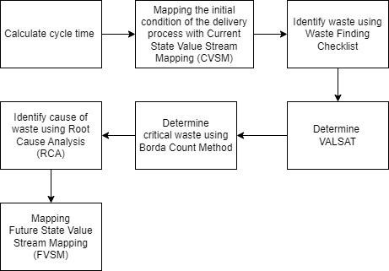
FIGURE 1. Research methodology

RESULTS AND DISCUSSION

Waste Identification
Identifying waste in a freight forwarding company using Value Stream Mapping (VSM) involves a systematic approach to analyzing all processes and activities within the organization. These are the types of waste identified in the process of shipping Less Container Load (LCL) [15]:
- Delay
  - Waiting time for a customer to send products to the port
  - Waiting time for closing schedule of product delivery
  - Waiting time for customer to pick up the product
  - Waiting time for customer to make payment
- Un-needed movement
  - Search for a document caused by the loss of a document
- Duplication
  - Rechecking products
- Lack of standardization
  - Shipment letters that are not immediately signed
  - There is a buildup of ordered products in the warehouse
- Lack of customer’s focus
  - Error inputting item data
  - The item was damaged during the shipping process
  - Incomplete road letter

Cycle Time of Freight Forwarding Process
The following is the cycle time for shipping Less Container Load products from the order process until the product arrived by the customer, as in TABLE 1.

TABLE 1. Cycle Time of Freight Forwarding Process
No | Activities | Cycle Time (Minutes)
1 | Receiving Orders | 5,57
2 | Confirmation of the type & quantity of products by the expedition | 10,76
3 | Admin staff confirm to port branch head | 6,02
4 | Job sleeves retrieval | 20,70
5 | Load products into container | 472,92
6 | Submission of the road letter to the expedition | 2,90
7 | Checking Products | 11,98
8 | Container Sealing | 2,40
9 | Preparation of manifax, SPB and bill notes | 59,93
10 | Delivery of manifax, SPB and bill notes | 0,83
11 | SPB distribution | 16,05
12 | Bill of lading retrieval | 56,91
13 | Unloading products | 139,74
14 | Load products into the car | 69,25
15 | Checking products | 6,13
16 | Delivery products | 94,74
17 | Making a road letter | 19,69
18 | Collection of shiping costs | 22785,40

Based on TABLE 1, It is known that there are 18 activities in the process of shipping goods starting from the customer placing an order to the process of billing for shipping costs with a total cycle time of 23791.20 minutes.

Current State Value Stream Mapping (CVSM)
The following mapping includes all activities in the process of shipping goods that are value added and non-value added which can be seen in FIGURE 2.

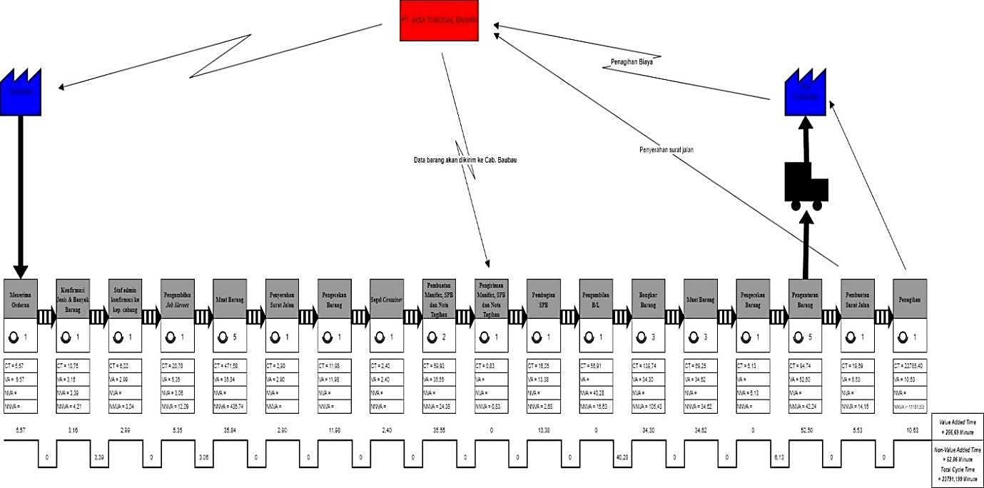
FIGURE 2. Current State Value Stream Mapping (CVSM)

Based on FIGURE 2. The total cycle time of the goods delivery process is 23791.20 minutes, total Value added time is 256.69 minutes, total Non-Value Added time is 52.86 minutes and total Necessary Non-Value Added time is 23481.65 minutes. It is known that Non-value added (NVA) and Necessary non-value added (NNVA) activity types still have a high ratio with a Value Added (VA) ratio of 52.37% with a total of 29 activities, Non-Value Added (NVA) of 7.27% with a total of 4 activities and Necessary Non-Value Added (NNVA) of 40% with a total of 22 activities.
Based on TABLE 2, several types of waste were found in the process of shipping goods at PT Jasa Tunggal Bahari, including Delay of 34.29% with a total of 12 wastes, Un-needed movement of 14.29% with a total of 5 wastes, Duplication of 8.57% with a total of 3 wastes, Lack of standardization of 5.71% with a total of 2 wastes and Lack of customer's focus of 37.14% with a total of 13 wastes.

VALSAT Tool Selection
The VALSAT tool selection aims to find out which tool is appropriate in identifying waste in the goods delivery process. Detailed Mapping that has the highest score will be used as a tool that will identify waste. The selection of the VALSAT tool is done by multiplying the points on the waste finding.

Process Activity Mapping (PAM)
Process Activity Mapping is one of the VSM tools used to map the process flow in detail to minimize waste, irrationality and inconsistency in the workplace so as to improve product quality, facilitate the service process and speed up the process so as to minimize costs. value added, non-value added and necessary non-value added [12].
TABLE 2. Process Activity Mapping (PAM)
Activities | Sum |  |  | Time (Minute)
Activities | Total | (%) | VA | NVA | NNVA | Total
O | 31 | 56,36% | 187,50 |  | 25,97 | 213,47
T | 4 | 7,27% | 51,95 |  | 14,15 | 66,10
I | 3 | 5,45% | 17,25 | 6,13 |  | 23,37
S | 0 | 0% |  |  |  | 0,00
D | 17 | 30,91% |  | 46,73 | 23441,52 | 23488,25
 | Total | 256,69 |  | 52,86 | 23481,65 | 23791,20
 | Percentage | 1,08% |  | 0,22% | 98,70%

Based on TABLE 2. it is known that operating activities have a high proportion of 56.36%, transport activities of 7.27%, inspection activities of 5.45%, delay activities of 30.91% and storage activities of 0%. With value-added activities (VA) of 1.08%, non-value-added activities (NVA) of 0.22% and important but non-value-added activities of 98.70%. Based on the lean concept, non-value-added activities need to be reduced to increase productivity in the company.

Borda Count Method (BCM)
The principle of the borda method is to rank each alternative. Alternatives that have the highest rank will be given a high value and so on in decreasing value until the lowest rank is given a value of 0 or . The calculation of the Borda method can be seen in TABLE 3.
TABLE 3. Result the Borda Count Method
Ranking
No | Waste | 1 | 2 | 3 | 4 | 5 | Final Score | Weight After Normalization | Ranking
1 | Delay | 3 | 1 | 0 | 0 | 0 | 15 | 0,319 | 1
2 | Un-needed movement | 0 | 2 | 0 | 2 | 0 | 8 | 0,170 | 4
3 | Duplication | 0 | 1 | 2 | 1 | 0 | 8 | 0,170 | 3
4 | Lack of  standardization | 0 | 0 | 2 | 1 | 1 | 5 | 0,106 | 5
5 | Lack of customer's focus | 1 | 1 | 2 | 0 | 0 | 11 | 0,234 | 2
 | Weight |  |  |  |  |  | 47 | 1

Based on the results of the borda method calculation in TABLE 3, it is known that the highest rank is the type of waste Delay, rank 2 with the type of waste Lack of customer's focus, rank 3 with the type of waste Duplication, rank 4 with the type of waste Un-needed movement and rank 5 with the type of waste Lack of standardization. The highest rank from the borda count method analysis is used as a waste priority that must be improved immediately.

Root Cause Analysis (RCA)
The following is an analysis of the root causes of waste based on the ranking results in TABLE 4. by using the Root Cause Analysis tool with the 5 why's approach which can be seen in TABLE 4.
TABLE 4. Root Cause Analysis
Waste | Why 1 | Why 2 | Why 3 | Why 4 | Why 5
Delay | Lack of communication and coordination between the expedition and the customer | There is no system  / platform that allows the expedition to share information on the process of shipping  products | There is no contractual agreement in the process of delivering products and there is no regular evaluation. | - | -
Lack of customer’s  focus | Lack of attention between the two parties in the process of shipping products | There is no effective communication between the two  parties | No training, SOPs, and MOUs regarding the products delivery process | - | -
Duplication | Frequent damage in the process of shipping products | Inappropriate type of packaging and misplaced product | Lack of understanding of the characteristics and layout of products | There is no SOP regarding the packaging process and layout of products | -
Un-needed movement | Ineffective document storage | Lack of awareness about the importance of maintaining documents | No document storage procedures | - | -

Based on TABLE 4. There are four types of waste that will be improved at the next stage, namely the types of waste Delay, Lack of customer's focus, Duplication and Un-needed movement. Where the waste is the result of ranking from the Borda Count Method (BCM) in TABLE 3.

Proposed Improvements
Proposed improvements for the type of waste Delay by conducting regular evaluations and making contractual agreements regarding the process of shipping goods. For the type of waste Lack of customer's focus, namely by implementing training, making SOPs, applying the 5S method and making an MOU for the process of shipping products. The type of waste Duplication is by implementing SOPs regarding the packaging process and the layout of products in the container and the type of waste Un-needed movement is by applying the 5S method.

Future State Value Stream Mapping (FVSM)
Future State Value Stream Mapping (FVSM) aims to find out what changes occur in the process of shipping products.
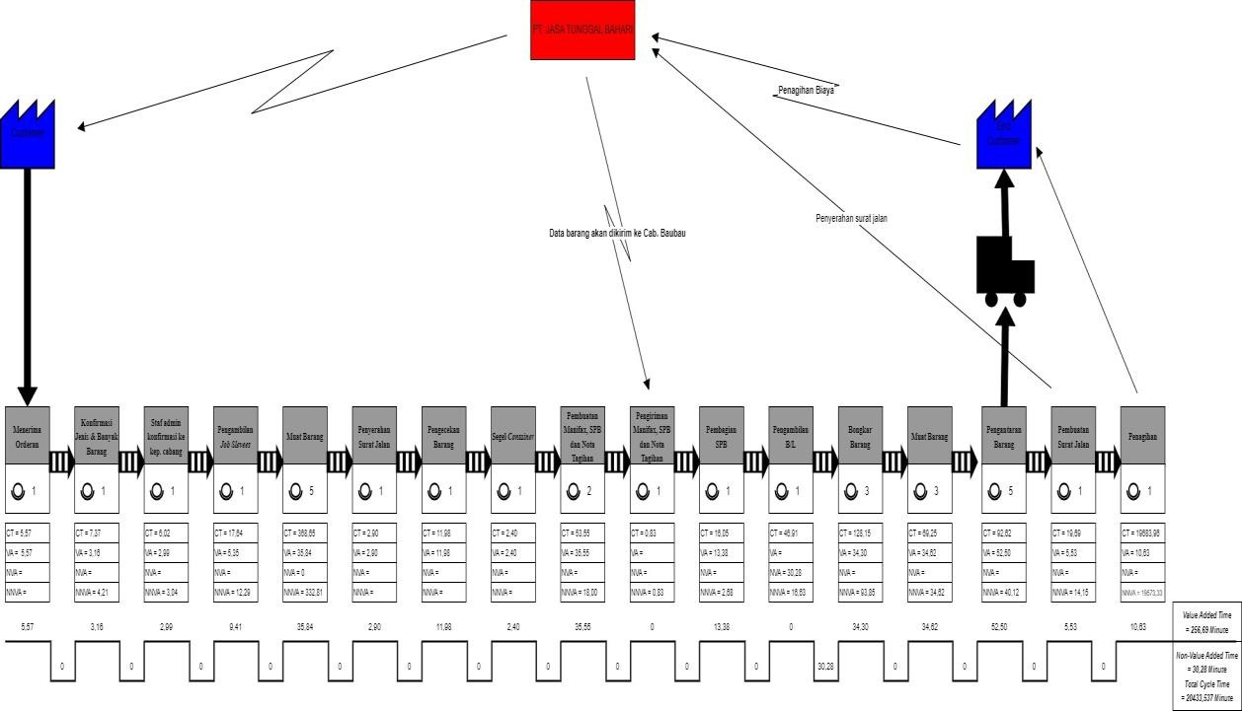
FIGURE 3. Future State Value Stream Mapping (CVSM)

After implementing the proposed improvements, there is an increase in the percentage of Future State Value Stream Mapping activities which can be seen in FIGURE 3. Total cycle time has been reduced to 20433.54 minutes, Non Value Added (NVA) activities have been reduced to 30.28 minutes or 0.15% and Necessary Non-Value Added (NNVA) activities have been reduced to 20146.56 minutes or 98.60%.

Conclusion
Waste identification using Value Stream Mapping (VSM) it started with creating a Current State Value Stream Mapping (CVSM) to determine the flow of the goods delivery process as well as the cycle time and types of activities classified into VA, NVA, and NNVA activity types. Next, identify the types of waste by using the Waste Finding Checklist tool to find out what types of waste often occur. Then the VALSAT tool is selected to find out what mapping is suitable for mapping the flow of the shipping process. After that, critical waste identification is carried out using the Borda Count Method (BCM) and four types of waste that often occur are Delay, Duplication, Un-needed Movement and Lack Of Customer's Focus. Furthermore, the root cause analysis of critical waste is carried out using the Root Cause Analysis (RCA) method and Future State Value Stream Mapping (FVSM) is carried out to determine whether the proposed improvements given are appropriate. The proposed improvements are in the form of making SOPs, implementing job training, applying the 5S method and making a contract for delivery of products (MOU).

References
1. Wulandari, P.F. and A. Arvianto, Pemilihan jasa ekspedisi dengan menggunakan metode analytical hierarchy process. Industrial Engineering Online Journal, 2016. 5(4).
2. Sudri, N.M., et al., Aplikasi Lean Manufacturing Pada Proses Produksi Produk Sanitary untuk Peningkatan Efisiensi (Studi Kasus Perusahaan Keramik). JURNAL ILMU PENGETAHUAN DAN TEKNOLOGI (IPTEK), 2021. 5(1).
3. Tóth, C.L., A Karcsúsított gyártás-A Lean Production A Lean, ahogy én látom. Magyar minőség, 2007. 2.
4. Freitag, A.E.B., J. das Chagas Santos, and A. da Cunha Reis, Lean office and digital transformation: a case study in a services company. Brazilian Journal of Operations & Production Management, 2018. 15(4): p. 588-594.
5. Cahyadi, U., D.S.d. Taptajani, and M. Nurjaman, Pendekatan Lean Service dengan Metode Value Stream Mapping untuk Meminimasi Waste di Logistic J&T Express. Jurnal Kalibrasi, 2019. 17(2): p. 78-85.
6. Erna Mulyati, S.T. and H. Rananisa, Analisis Penerapan Lean Service Untuk Mengurangi Waste Pada Order Fulfillment Di PLB PT Agility International (Semarang). Jurnal Logistik Bisnis, 2019. 9(02): p. 31-38.
7. Ginting, S.E.F., et al. Implementation of lean service and 5S methods to increase the efficiency of service time in fire department. in AIP Conference Proceedings. 2020. AIP Publishing.
8. Ilhamullah, T. and F. Fitriadi, Intervensi Lean Service PT Pertamina Fuel Terminal Meulaboh Menggunakan Metode Big Picture Mapping Untuk Identifikasi Waste. Jurnal Serambi Engineering, 2022. 7(3).
9. Daulay, M., A. Amri, and S. Syukriah, analisis waste pada proses pembongkaran peti kemas dengan pendekatan lean service di PT Pelindo I cabang Lhokseumawe. Industrial Engineering Journal, 2021. 10(2).
10. Vinodh, S., et al., Development of value stream map for an Indian automotive components manufacturing organization. Journal of Engineering, Design and Technology, 2015. 13(3): p. 380-399.
11. Gaspersz, V., Lean six sigma. 2007: Gramedia Pustaka Utama.
12. Hines, P. and N. Rich, The seven value stream mapping tools. International journal of operations & production management, 1997. 17(1): p. 46-64.
13. Syahputra, A., Sistem Pendukung Keputusan Pemilihan Lokasi Pre-Wedding di Kota Medan dengan Menggunakan Metode VIKOR dan BORDA. Jurnal Sistem Komputer dan Informatika (JSON), 2020. 1(3): p. 207-214.
14. Andersen, B. and T. Fagerhaug, Root cause analysis: Simplified tools and techniques. The Journal for Healthcare Quality (JHQ), 2002. 24(3): p. 46-47.
15. Andrés-López, E., I. González-Requena, and A. Sanz-Lobera, Lean service: reassessment of lean manufacturing for service activities. Procedia engineering, 2015. 132: p. 23-30.

