Integrating Systematic Layout Planning and Dedicated Storage Policy for Warehouse with Embedded Light Processing Activities
Muhammad Iqbal Alamsyah¹⁾ and Luki Trihardani^{1, a)}
Author Affiliations
¹Logistics Engineering Department Universitas Internasional Semen Indonesia
Kompleks PT. Semen Indonesia (Persero) Tbk, Jl. Veteran, Gresik, East Java 61122, Indonesia

Author Email
^{a)} Corresponding author: luki.trihardani@uisi.ac.id
Abstract. Warehouse layout plays a strategic role in ensuring the efficiency and responsiveness of logistics systems, especially in agricultural supply chains where seasonal fluctuations, diverse SKUs, and light processing requirements impose complex operational demands. In many developing regions, warehouse layout design remains suboptimal due to limited automation, spatial constraints, and the absence of integrated planning frameworks. To address these gaps, this study proposes a hybrid warehouse layout framework integrating Systematic Layout Planning (SLP) and Dedicated Storage Policy. SLP was employed to evaluate inter-area relationships across inbound, storage, processing, and outbound zones. Dedicated storage was then used to assign fixed positions to SKUs based on throughput analysis, calculated from historical inbound and outbound volumes. The model was implemented in a fertilizer warehouse in Gresik, Indonesia, which handles both bulk storage of various SKUs and light processing of ZA fertilizer. The SLP analysis identified critical adjacency requirements between zones such as bulk storage, color mixing, and packaging stations, resulting in a revised layout that minimized cross-traffic and improved workflow coherence. Throughput ranking and space requirement calculations enabled SKU placement optimization where high-turnover products were positioned near dispatch points. As a result, the proposed layout reduced material handling travel distance by 55.32% compared to the existing configuration and shortened functional relationship distances between processing areas by 32.34%. The findings confirm that combining SLP and dedicated storage provides a practical and adaptable approach for improving spatial utilization, flow alignment, and operational responsiveness in low-automation warehouse environments. This hybrid methodology contributes to the broader field of warehouse design by offering a replicable solution for facilities operating under resource constraints.

INTRODUCTION
The increasing complexity of global supply chains has heightened the strategic role of warehousing in enhancing overall logistical performance [1-3]. In agricultural sectors, warehouses play a vital role in absorbing seasonal demand fluctuations while ensuring the timely and uninterrupted supply of inputs. Fertilizer logistics, in particular, face stringent timing requirements due to the need for synchronization with planting calendars and cultivation cycles. Seasonal variability, heterogeneous SKU profiles, and limited automation further strain these operational demands. One of the critical challenges in such settings is the misalignment between spatial layout and workflow requirements. In many warehouses, especially in developing regions, layout planning is often neglected, resulting in inefficient configurations where inbound, storage, and outbound functions overlap without consideration of process interdependencies [4]. Moreover, the presence of light processing tasks such as repackaging, labeling, and quality control necessitates seamless integration with storage and dispatch operations [5]. Without layout strategies that reflect these multifunctional needs, spatial congestion arises, increasing the risk of product damage and disrupting operational flow. Compounding the issue, high-turnover SKUs are frequently placed far from main access points, resulting in excessive travel distances and inefficient labor utilization [6]. These shortcomings significantly impair order fulfillment speed and inventory accuracy, particularly during high-demand windows such as pre-planting seasons.
In response to these challenges, various warehouses have adopted generalized layout strategies such as random storage allocation and static zoning. While these methods offer short-term flexibility or simplicity, they often fall short in environments characterized by seasonal demand peaks and diverse SKU profiles. For example, random storage assigns locations purely based on availability, disregarding retrieval frequency or logical flow paths, which often results in fragmented workflows and prolonged picking times [7]. Similarly, static zoning based on broad product categories fails to account for dynamic variables such as item velocity, seasonal variation, or processing functions. Although some advanced strategies, such as class-based, many still lack an adaptable framework suited to low-tech, multifunctional warehouse settings. Consequently, there remains a critical gap in layout design methods that balance operational stability with responsiveness to dynamic flow requirements. To address this, the present study proposes a hybrid spatial design framework that integrates Systematic Layout Planning (SLP) with a dedicated storage policy. SLP is a structured methodology that evaluates interdepartmental relationships, material flow intensity, and spatial constraints to create logically sequenced layouts [8-10]. Though originally developed for manufacturing environments, SLP’s systematic logic is highly applicable to warehouses requiring coordinated flows among storage, inbound, outbound, and light processing areas. Paired with SLP, the dedicated storage approach assigns fixed locations to high-frequency SKUs, improving retrieval consistency, worker familiarity, and error reduction [11-12]. Especially in low-automation warehouses, this integration enhances visibility and operational efficiency without requiring complex technologies.
Several studies have explored individual components relevant to this study's proposed framework, including dedicated storage modeling, warehouse simulation, and SKU slotting strategies. For instance, researchers [11] utilized a simulation-based approach to optimize warehouse layouts under a dedicated storage policy, achieving reductions in retrieval time and travel distance. Researchers [13] focused on layout planning in production environments, emphasizing the role of flow-oriented zoning in improving operational efficiency. In parallel, researchers [14] and [15] applied multi-criteria decision-making tools—such as AHP and fuzzy logic—to prioritize SKUs based on demand variability and turnover rates. While these studies provide valuable insights, they tend to treat layout configuration as discrete problems, without addressing their interdependencies. Notably, researchers [9] integrated SLP with metaheuristic optimization in e-commerce settings, yet omitted a dedicated storage policy, limiting the model’s ability to ensure consistent retrieval and accessibility. Similarly, researchers [16] introduced an algorithm for SKU assignment based on product attributes but failed to embed it within warehouse flow patterns. Moreover, in developing regions, warehouses often operate with minimal automation, limited spatial flexibility, and seasonal demand surge, yet such settings remain underrepresented in the literature. Another overlooked aspect is the integration of light processing activities—such as fertilizer weighing, bagging, or labeling—into the layout design. These activities require functional zoning and smooth coordination with both storage and dispatch areas to avoid congestion, workflow delays, or product degradation. Taken together, these limitations highlight a research gap: the lack of an integrated, adaptable layout planning approach that explicitly incorporates storage logic, spatial flow alignment, SKU prioritization, and light processing needs.
Considering these research gaps, this study aims to develop a warehouse layout model that combines SLP and dedicated storage strategies to improve spatial efficiency, flow alignment, and SKU accessibility. By applying this integrated approach to a real-world fertilizer warehouse in Gresik, Indonesia, the research addresses both operational complexity and seasonal demand fluctuation in a low-automation environment. The selected warehouse stores a wide range of fertilizer products in multiple packaging sizes. It also supports light processing operations for ZA fertilizer, including weighing, mixing, bagging, and palletizing, making it a suitable case for hybrid layout evaluation. The novelty of this study lies in its dual focus: first, in integrating spatial flow principles (via SLP) with a fixed-location storage logic (via dedicated storage), and second, in explicitly accommodating light processing functions within the warehouse layout framework. By bridging these design dimensions, the proposed model offers a pragmatic and adaptable tool for improving layout quality in resource-constrained, multi-use warehousing environments. Ultimately, this study contributes to the broader field of logistics design by offering a replicable, hybrid methodology that supports practical implementation in industries with limited automation, fluctuating demand, and diverse SKU profiles.

LITERATURE REVIEW
The spatial design of warehouse layouts has long been recognized as a key factor influencing operational performance, particularly in systems with fluctuating demand and multifunctional workflows [17]. Among various storage strategies, dedicated storage—where each SKU is assigned a fixed location—offers advantages such as improved accessibility, faster retrieval, and operator familiarity [18]. These features are well-aligned with seasonal or cyclic demand environments. However, dedicated storage also presents limitations in adaptability. During high-demand seasons, fixed locations can create congestion, while in low-activity periods, they may lead to underutilized space and inefficiencies [19]. In response to such spatial inefficiencies, Systematic Layout Planning (SLP) has been widely adopted in manufacturing systems to arrange functional zones based on material flow, interaction frequency, and space constraints [20]. SLP promotes the systematic placement of activities, ensuring operational proximity and smooth transitions between processes. However, its application in warehousing, particularly in hybrid settings, involving both storage and light processing, remains limited [20]. Most applications of SLP focus on high-automation production environments and overlook the practical constraints of low-tech, labor-intensive warehouses.
Moreover, although several studies have explored order picking, SKU slotting, and space utilization, integrated frameworks that combine layout methodology with storage policy remain underdeveloped [21]. For example, researchers [14] and [15] incorporated decision-support tools such as AHP–Fuzzy logic to prioritize SKUs based on turnover rates but did not explicitly address spatial dependencies or inter-zonal relationships. Similarly, researchers [11] and [13] simulated dedicated storage systems in production environments without integrating flow-based layout design. Researchers [9] employed SLP with genetic algorithms for optimizing e-commerce warehouse layouts but omitted SKU-level storage logic, missing opportunities to enhance accessibility and space predictability. Researchers [16] developed algorithms for SKU allocation based on product attributes and demand patterns, yet failed to integrate these results into a spatially coherent layout model that accommodates material flow logic. Consequently, layout planning and SKU storage policies are often treated as parallel but disconnected design activities.
This fragmented approach presents a significant research gap. In warehousing contexts that combine periodic production, light processing, and seasonal inventory cycles, especially in developing economies, there is a need for integrated layout models that unify dedicated storage logic with spatial flow design. It is essential to enhance layout adaptability, throughput performance, and space utilization efficiency under operational constraints typical of low-tech, multifunctional facilities. The key research gaps synthesized by the literature are presented in Table 1.
TABLE 1. Synthesized Research Gap
Authors | ¹SLP | ²DS | Seasonality | Technology Level | Production Activity
[9] |  | X | X | high
[11] | X |  | X | ³n/m | x
[13] | X |  | X | low
[14] | X |  |  | ³n/m | x
[15] | X |  | X | ³n/m
[16] |  | X | X | ³n/m
This research |  |  |  | low
¹SLP = Systematic Layout Planning; ²DS = Dedicated Storage; ³n/m = not mentioned
This study seeks to bridge that gap by addressing the following research questions: (1) How can an integrated layout framework combining SLP and dedicated storage improve spatial efficiency and process alignment in hybrid-function warehouses? (2) What layout design principles are most effective for enhancing accessibility, flow continuity, and space utilization under conditions of seasonal SKU variability and limited mechanization? The framework initiates with the use of SLP to identify, prioritize, and structure functional zones based on their relationship. Subsequently, a dedicated storage strategy is incorporated to assign fixed storage positions for each SKU, ensuring high-turnover products are in high-access zones, while less frequently accessed items are positioned in peripheral spaces. The core contribution of this study lies in its conceptualization of warehouse layout design as an integrated optimization problem, balancing the need for spatial configurability with functional alignment for semi-manual processing operations.

method
The methodological framework of this study integrates SLP with a Dedicated Storage Policy, forming a proposed framework that unfolds across three key stages: input, analysis, and output (Fig. 1). The input phase initiates the process by gathering detailed operational information, including SKU profiles, handling frequencies, spatial usage patterns, and functional activity requirements. These inputs serve as the foundation for subsequent SLP-based layout planning and SKU-specific slotting strategies.
The analysis phase advances the SLP application by constructing an activity relationship diagram, which identifies the degree of closeness required between areas [8,20]. Simultaneously, SKU classification is carried out using the dedicated storage method, where products are grouped based on average demand levels to establish logical and consistent storage zones. The output phase enables a layout design that aligns operational flow with product movement needs, effectively minimizing internal transport distances. Finally, the phase involves a comparative analysis between the existing warehouse layout and the proposed configuration.
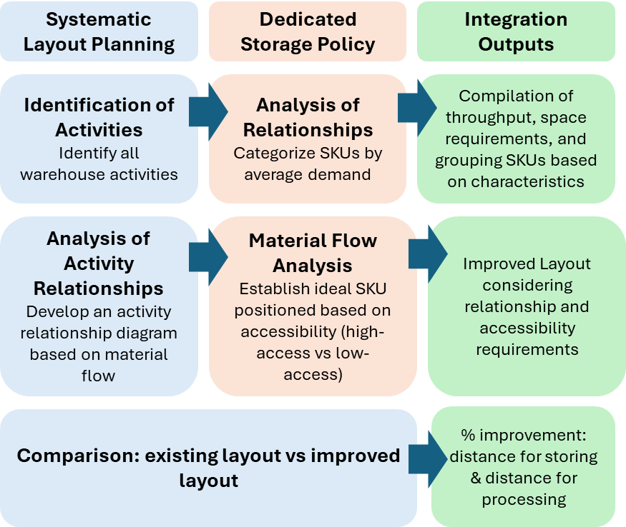
FIGURE 1. Hybrid Framework for Layout Planning in Warehouses with Embedded Processing Activities

Case Study
This study employs a case study methodology to investigate warehouse operations at a fertilizer production facility located in Gresik, East Java, Indonesia. The current warehouse layout is visualized in Fig. 2.

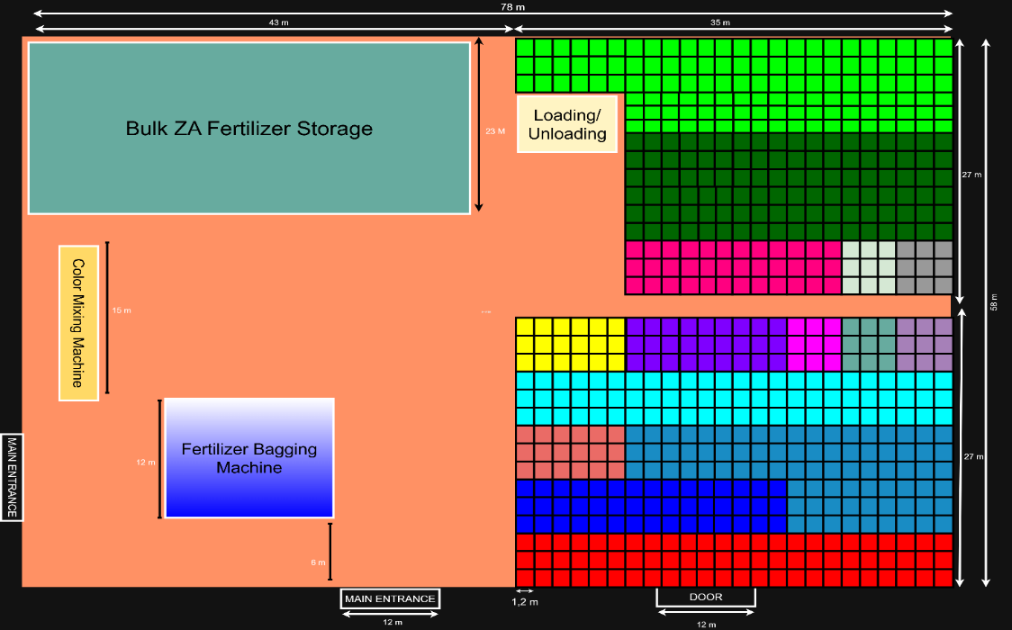
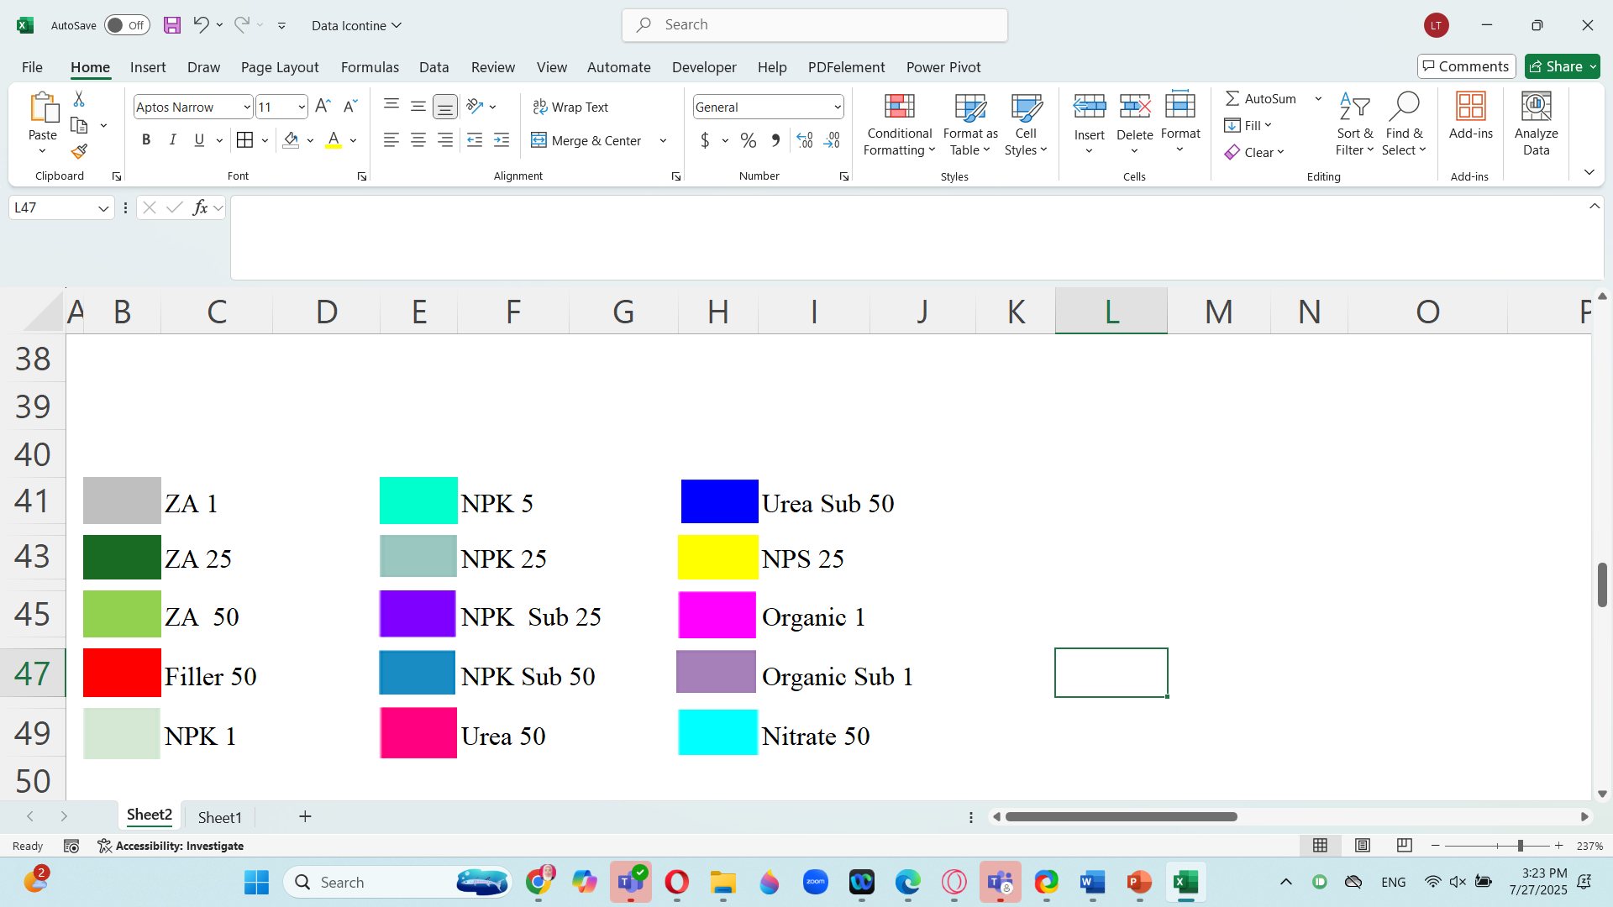
FIGURE 2.Existing Warehouse Layout

The facility features an effective storage capacity of approximately 2,400 metric tons and plays a dual role in the company’s supply chain system. First, it operates as a regional distribution hub, ensuring the availability of fertilizer across the East Java region. Second, it functions as a light processing centre, primarily for the handling and preparation of ammonium sulphate (ZA) fertilizer. These stages are facilitated by both manual and mechanized handling tools, including forklifts and hand pallet, which collectively support product readiness for downstream distribution. The warehouse handles a broad assortment of fertilizer types of 15 SKUs, including ZA, Filler, NPK, Urea, NPS, organic, and nitrate, in various packaging formats (1 kg, 5 kg, 25 kg, and 50 kg). For some products (NPK, Urea, and organic), include both government-subsidized and non-subsidized commercial fertilizers, each subject to distinct distribution regulations. In this research, the labeling of each product consists of both the fertilizer type and its packaging weight, a critical distinction for layout planning and inventory management. For instance, "NPK Sub 1" denotes a 1-kilogram bag of subsidized NPK fertilizer, typically aimed at smallholder farmers and retail-scale users. The types of fertilizer products and their packaging are shown in Table 2.
TABLE 2. Types of SKU Fertilizer Products
No | Fertilizer | 1 kg | 5 kg | 25 kg | 50 kg
1 | ZA |  | X
2 | Filler | X | X | X
3 | NPK |  |  |  | X
4 | NPK Sub | X | X
5 | Urea | X | X | X
6 | Urea Sub | X | X | X
7 | NPS | X | X |  | X
8 | Organic |  | X | X | X
9 | Organic Sub |  | X | X | X
10 | Nitrate | X | X | X

Monthly inbound and outbound flows for each fertilizer type are presented in a color-coded bar graph for 15 SKUs (Fig. 3), which visualizes stock movements over 12 months in 2024 based on the number of units received and dispatched.
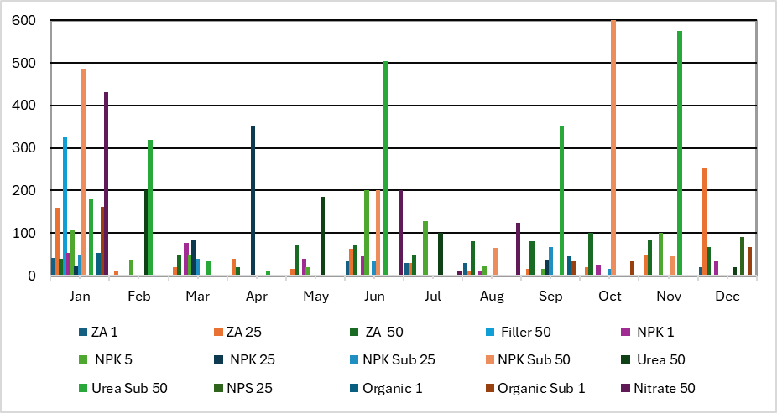
FIGURE 3. Stock Movement for Each SKU in 2024
Based on the existing layout and stock movement, critical operational areas are poorly positioned; the semi-automatic MBU packaging machine is located far from both the raw material and dispatch zones, which disrupts the workflow and increases internal transport time. Additionally, storage is not organized by product movement. High-turnover items, such as ZA 50 and ZA 25, are placed far from access points, while slow-moving products occupy prime areas. These issues result in inefficient space utilization, extended travel distances, and increased handling times, underscoring the need for a more structured, flow-oriented layout.

RESULTS AND DISCUSSIONS
The internal processing flow for ZA fertilizer involves a sequence of interrelated operations, beginning with the receipt of bulk ammonium sulfate, followed by the addition of coloring agents, manual levelling, semi-automated packaging, and culminating in palletizing before dispatch (Fig. 5a). These activities require spatial and functional coordination to ensure process efficiency. To evaluate the spatial proximity needs among these operations, a Systematic Layout Planning (SLP) approach was applied. Using an activity relationship diagram and closeness rating matrix, interactions between warehouse zones were categorized into five proximity levels: “Absolutely Necessary” (A, red), “Especially Important” (E, yellow), “Important” (I, green), “Ordinary” (O, blue), and “Unnecessary” (U, white). These classifications reflect and criticality of interactions between activity pairs within the warehouse.
The Activity Relationship Diagram (Fig. 4b) highlights that Bulk ZA Fertilizer Storage and the Color Mixing Machine share an “Absolutely Necessary” (A) relationship, requiring close placement due to direct material flow. The same applies to the link between Color Mixing and Fertilizer Bagging, ensuring uninterrupted processing. In contrast, the Bagging Machine has several “Unnecessary” (U) connections, allowing flexible placement. The Loading/Unloading Area holds an “Especially Important” (E) relationship with ZA Fertilizer Storage, emphasizing dispatch efficiency. Additionally, “Important” (I) relationships indicate moderate proximity needs between Bulk Storage–Bagging and Color Mixing–Loading zones

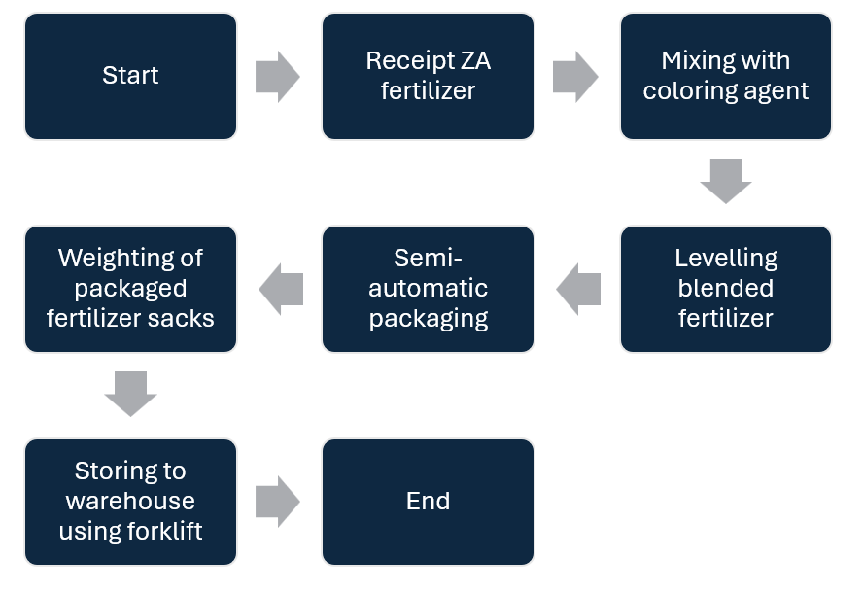 | 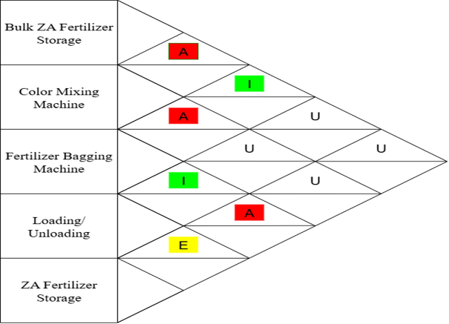
- Process Flow of ZA Fertilizer | - Activity Relationship Diagram
FIGURE 4. Analysis of Activity Relationships
Building upon the spatial flow analysis from SLP, a throughput-based storage strategy was employed to complement the dedicated storage policy. Throughput ranking was used to determine which fertilizer SKUs exhibited the highest and lowest movement frequencies, serving as a key criterion for fixed storage assignments under the dedicated storage policy. This moving activity is carried out using a forklift, which is assumed to that forklift can carry two pallets with a capacity of 3 tons. In this context, the throughput ($T_{j})$ For each SKU was made using the following:
$T_{j}=\left(\frac{average stock in}{the number of moving one time}\right)+\left(\frac{average stock out}{the number of moving one time}\right)$ (1)
To determine storage space requirements for each SKU ($T_{j})$, standard pallet configurations were considered. Each pallet is assumed to hold 1.5 tons of fertilizer, with four pallets stacked vertically, enabling each storage point to accommodate up to 6 tons. From throughput and space requirement calculation, to optimize spatial efficiency and minimize material handling distances, a throughput-to-space requirement ratio ($T_{j}/S_{j}$) was calculated (Table 5).
TABLE 3. Throughput Ratio and Space Requirements for Each SKU
Item | $$T_{j}$$ | $$S_{j}$$ | $$T_{j}/S_{j}$$ | Rank | Item | $$T_{j}$$ | $$S_{j}$$ | $$T_{j}/S_{j}$$ | Rank
ZA 1 | 5 | 1.67 | 0.37 | 7 | NPK Sub 50 | 18 | 3.06 | 0.17 | 14
ZA 25 | 72 | 15 | 0.21 | 13 | Urea 50 | 7 | 3.33 | 0.49 | 6
ZA 50 | 144 | 41.72 | 0.29 | 10 | Urea Sub 50 | 36 | 9.58 | 0.27 | 11
Filler 50 | 5 | 9 | 2 | 2 | NPS 25 | 2 | 3.5 | 2.33 | 1
NPK 1 | 6 | 1.39 | 0.23 | 12 | Organic 1 | 2 | 2.75 | 1.83 | 3
NPK 5 | 19 | 1 | 0.05 | 15 | Organic Sub 1 | 3 | 1.53 | 0.51 | 5
NPK 25 | 2 | 1.69 | 1.13 | 4 | Nitrate 50 | 11 | 3.72 | 0.35 | 8
NPK Sub 25 | 4 | 1.11 | 0.3 | 9

This metric served as a prioritization tool to assign fixed storage locations, with SKUs possessing the highest ratios positioned nearest to the outbound area to reduce retrieval time. For instance, NPS 25, with a high ($T_{j}/S_{j}$) ratio was placed closest to the dispatch point, while NPK 5, as low items, were allocated to peripheral zones. This placement strategy adheres to dedicated storage principles, which advocate locations based on item velocity and handling priority.
The proposed warehouse layout, as visualized in Fig. 6, is an integrated spatial solution that combines SLP with a dedicated storage policy. From the SLP analysis, the new configuration ensures a logical sequencing of functional areas that mirrors the actual workflow of ZA fertilizer processing. High-interaction zones—such as Bulk ZA Storage, Color Mixing Station, and the Semi-Automatic Bagging Unit—are co-located to minimize material handling time and facilitate uninterrupted processing. The Loading/Unloading Area is also repositioned to be near the palletized product staging zone, supporting efficient outbound logistics and reducing congestion.

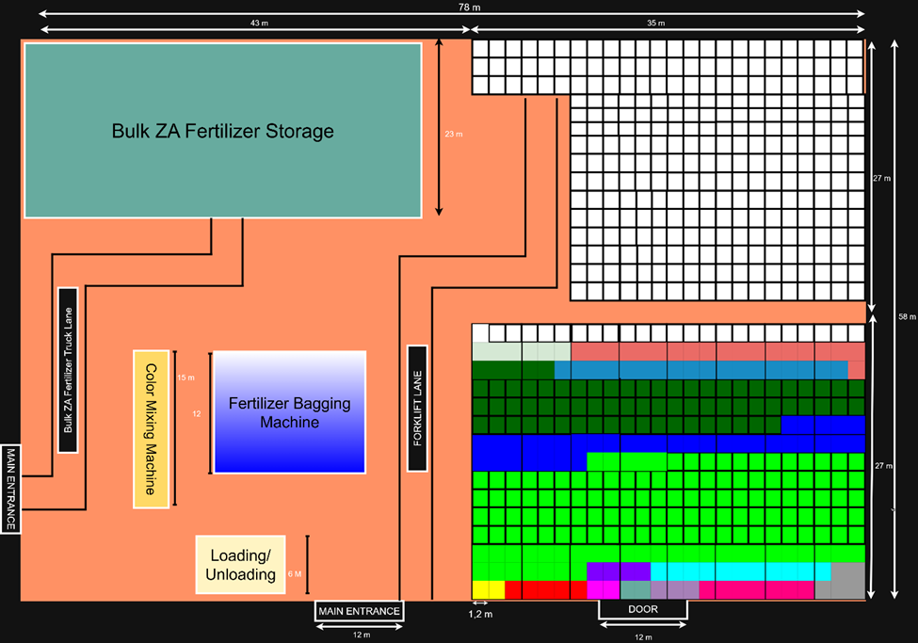
FIGURE 5. Proposed Warehouse Layout
To assess layout performance, a dual-distance analysis was conducted covering both processing activities and storage movements, as displayed in Table 4.
TABLE 4. Comparison Travel Distance: Existing and Proposed Layout
 | Distance for Processing Activity (m) | Distance for Storing (m)
Existing Layout | 199.5 | 14106.79
Proposed Layout | 135 | 6304.60
Improvement | 32.34% | 55.32%

The first component, Distance for Processing Activity, was measured using SLP principles by calculating the total rectilinear distance between interrelated workstations—such as mixing, bagging, and staging—reflecting material flow efficiency across functional areas. The second component, Distance for Storing, quantified the travel distance between each SKU’s fixed pallet location and the nearest input/output (I/O) point, weighted by the product’s throughput-to-space ratio. Under the existing layout, the processing distance totaled 199.5 meters, while storage-related movement reached 14,106.79 meters. In contrast, the proposed layout reduced these figures to 135 meters and 6,304.60 meters, respectively, representing improvements of 32.34% in process efficiency and 55.29% in storage-related travel distance. This significant reduction is attributed to the dedicated storage policy, which positions high-throughput SKUs (e.g., NPS 25 and Filler 50) closer to dispatch points.

ACKNOWLEDGMENTS
The author expresses his gratitude to LPPM UISI for providing financial support to complete this research through conference research grants in 2025.

REFERENCES
- Laosirihongthong, T., Adebanjo, D., Samaranayake, P., Subramanian, N., & Boon-itt, S. (2018). Prioritizing warehouse performance measures in contemporary supply chains. International Journal of Productivity and Performance Management, 67(9), 1703–1726.
- Kim, T. Y. (2020). Improving warehouse responsiveness by job priority management: A European distribution centre field study. Computers & Industrial Engineering, 139, 106170.
- Baglio, M., Creazza, A., & Dallari, F. (2023). The “Perfect” warehouse: How third-party logistics providers evaluate warehouse features and their performance. Applied Sciences, 13(12), 6862.
- Kudelska, I., & Jędrzejak, K. (2024). Methodology for designing spatial layout of a warehouse in the context of sustainable development. Annales Universitatis Mariae Curie-Skłodowska, 58(3), 51–68.
- Jum’a, L., & Basheer, M. E. (2023). Analysis of warehouse value-added services using Pareto as a quality tool: A case study of third-party logistics service provider. Administrative Sciences, 13(2), 51.
- Saleh, R. M., & Abdelmaguid, T. F. (2025). Comparative analysis of dedicated and randomized storage policies in warehouse efficiency optimization. Eng, 6(6), 119.
- Albert, P., Rönnqvist, M., & Lehoux, N. (2023). Trends and new practical applications for warehouse allocation and layout design: A literature review. SN Applied Sciences, 5(12).
- Zakirah, T., Emeraldi, R., Handi, O. M., Danil, D., & Kasih, T. P. (2018). Warehouse layout and workflow designing at PT. PMS using systematic layout planning method. IOP Conference Series: Earth and Environmental Science, 195, 012026.
- Hu, X., & Chuang, Y.-F. (2022). E-commerce warehouse layout optimization: Systematic layout planning using a genetic algorithm. Electronic Commerce Research, 23(1), 97-114.
- Khasanah, U., Sutarto, A. P., & Izzah, N. (2022). Work facilities improvement using systematic layout planning to reduce the risk of manual handling. Journal of Novel Engineering Science, 1(01), 15–23.
- Savsar, M., et al. (2023). Analysis of a warehouse system using dedicated storage assignment and a simulation model. 2023 Innovations in Intelligent Systems and Applications Conference (ASYU), 1–6.
- Syahron, M. I., Perdana, Y. R., Kusuma, T. Y. T., & Arief, S. (2024). Redesign of warehouse layout using dedicated storage method. Proceedings of the International Conference on Industrial Engineering and Operations Management. 504-514.
- Septiani, W., Divia, G. A., & Adisuwiryo, S. (2020). Warehouse layout designing of cable manufacturing company using dedicated storage and simulation Promodel. IOP Conference Series: Materials Science and Engineering, 847, 012054.
- Mohamud, H., Kafi, M. A., Shahron, S. A., Zainuddin, N., & Musa, S. (2023). The role of warehouse layout and operations in warehouse efficiency. Journal Européen Des Systèmes Automatisés, 56(1), 61–68.
- Alfathi, N., Lyhyaoui, A., & Sedqui, A. (2019). Fusion of dedicated and shared storage to maximize the use of space of static warehouses. Journal of Industrial and Production Engineering, 36(8), 512–532.
- Ruamsuke, T., Mingsakul, W., & Chanamool, N. (2025). Integrating systematic layout planning and fuzzy analytic hierarchy process in the design of sorting and packing fresh fruit facilities: A case study in Thailand. Engineering and Applied Science Research, 52(1), 17–26.
- Tang, Y.-M., Ho, G. T. S., Lau, Y.-Y., & Tsui, S.-Y. (2022). Integrated smart warehouse and manufacturing management with demand forecasting in small-scale cyclical industries. Machines, 10(6), 472.
- Solano-Charris, A., Rojas-Santiago, G. A., & Guerrero-Cusgüen, J. A. (2019). A systematic review of storage location assignment problem: From industrial applications to the industry 4.0 context. Computers & Industrial Engineering, 137, 106001
- Belil, S., Tchernev, N., & Kemmoé-Tchomté, S. (2022). Integrated production inventory and distribution problem of fertilizer products with additional storage constraints. IFAC-PapersOnLine, 55(10), 1343–1350.
- Kumar, V., & Malleswari, V. N. (2022). Improvement of facility layout design using Systematic Layout Planning methodology. Journal of Physics: Conference Series, 2312(1), 012089.
- García-Herreros, G., Cardona, S., & González, C. A. (2023). Trends and new practical applications for warehouse design and management: A systematic literature review. Applied Sciences, 13(5), 1–24.

