SCALLABI: Advanced 3D-Printed Biodegradable Bone Scaffold Technology for Indonesia Self-Sufficiency in Implant Materials
Nayaka Mahesa Putra Subagyo^{a)}, Baiq Firyal Salsabila Safitri^{b)}, Ulytz Sukma Susila^{c)}

Department of Industrial Engineering, University Of Muhammadiyah Malang, Malang, Indonesia
a) channelnayakamahesaps@gmail.com
b) Corresponding author: baiqfiryal@umm.ac.id
c) ulytzclassroom@gmail.com

Abstract. Mechanical properties are an important factor in scaffolds as tissue engineering implant materials. This study aims to determine the mechanical properties and biodegradability of scaffolds as a replacement for pin treatment in patients with bone fractures. Scaffolds were printed with different thicknesses to obtain maximum results related to the use of 3D-printed scaffolds as bone implant materials. The scaffolds were printed using a 3D printer with the Fused Deposition Modelling (FDM) method, using PolyLactid Acid (PLA) filament material and a Truncated Hexahedron unit geometry design. The research method employed an experimental approach with testing. The mechanical tests consisted of two types: tensile strength testing and compressive strength testing. The research results showed that the compression strength test revealed a negative trend between scaffold thickness and compressive strength, where thicker scaffolds had higher compressive strength values. The tensile strength test also showed a negative trend between scaffold thickness and tensile strength values. Biodegradation testing on the scaffold was conducted to determine the degradation properties of the scaffold in the body, and the results showed that the 3D-printed PLA-based scaffold was capable of degrading in the body. This was evidenced by a decrease in the pH of the Phosphate Buffer Saline (PBS) solution soaked with the scaffold and a decrease in the mass of the scaffold soaked in the PBS solution.

Introduction
Bone fractures represent a persistent health concern in Indonesia, particularly as a result of traffic accidents, which remain a leading cause of injury nationwide [1]. According to the Ministry of Health, Indonesia has one of the highest fracture prevalence rates in Southeast Asia, reaching 5.5% [2]. The World Health Organization (WHO) also reports that traffic-related injuries cause over 1.35 million deaths and more than 50 million non-fatal injuries globally each year [3]. Left untreated, bone fractures can lead to complications such as deformation, tissue damage, and chronic infection, especially when proper medical intervention is delayed or inaccessible [4].
In clinical settings across Indonesia, internal fixation using metal implants commonly called "pen" is the standard procedure for treating fractures [5]. Stainless steel is the most widely used material due to its low cost and adequate strength. However, its long-term use may lead to complications, including allergic reactions and bacterical accumulation, which can hinder bone regeneration [6]. Titanium implants, although offering better biocompatibility and healing potential, are significantly more expensive, both in installation and removal, making them unaffordable for much of Indonesia’s population [7].
As a result, many patients in rural areas rely on traditional bone-setting practices such as sangkal putung, which are culturally accepted and inexpensive [8]. However, these methods often lack clinical accuracy and safety, and in many cases lead to further internal damage, improper healing, and long-term complications [9].
These challenges highlight the urgent need for innovative, cost-effective, and biocompatible alternatives to conventional implant materials. This study, titled SCALLABI: Advanced 3D-Printed Biodegradable Bone Scaffold Technology For Indonesia Self-Sufficiency in Implant Materials, aims to develop a biodegradable bone scaffold made from PolyLactic Acid (PLA), fabricated using 3D printing technology with a Truncated Hexahedron design. The proposed scaffold is designed to promote faster and safer bone regeneration, reduce dependency on imported implants, and offer an eco-friendly, clinically viable solution tailored to Indonesia’s healthcare needs.

method
This study employed a quantitative experimental approach, aiming to examine the mechanical and biodegradable properties of 3D-printed scaffolds made from polylactic acid (PLA) filament.
The materials used include PLA filament with a 1.75 mm diameter as the scaffold printing material, and Phosphate Buffer Saline (PBS) with a pH of 7.5 for the biodegradation process. The tools involved consist of Inventor software, digital calipers, micrometer screw, pH meter, digital scale, and the Autograft Microcomputer-Controlled Universal Testing Machine for both compressive and tensile strength testing.
The research variables were categorized based on the type of test:
- Mechanical Testing:
Independent variable: 3D-printed scaffold thickness
Dependent variable: Mechanical testing machine readings
Controlled variables: Compressive strength, elongation
- Biodegradation Testing:
Independent variable: 3D-printed scaffold
Dependent variables: PBS solution and immersion duration
Controlled variables: Scaffold mass (grams), PBS pH

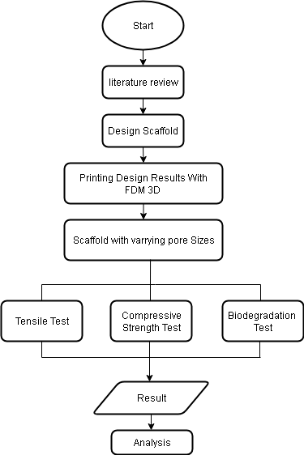
FIGURE 1. Scaffold Design Procces

Five Scaffold sample were prepared for each type of test (Compressive and Tensile Strength). Sample varied in thickenss by adjusting the spacing between struts during the CAD modelling process, in order to observe how geometry affects performance. The design process was conducted using Autodesk Inventor 2025, employing a Truncated Hexahedron unit cell structure. The process started with constructing an octagonal base on the top plane, followed by building structures on the front and right planes, then rotating them 90° to form a 3D geometry.

The scaffold was designed using the Swept Boss/Base feature to adjust cylindrical pore sizes, followed by assembling multiple unit cells into a complete geometry. The final design was exported in STL format and printed using PLA filament with a 3D printer under the following parameters: 180°C temperature, 0.4 mm nozzle diameter, 80% infill, 0.2 mm resolution, and 50 mm/s print speed.

Testing Procedures
Mechanical testing : Samples were measure for dimensional accuracy. For compressive strength, scaffolds were placed in the Universal Testing Machine and loaded gradually until structural failure occurred. For tensile strength, tapered ends were created to ensure centralizd load application and minimize stress concentration. Samples were tested until fracture.
The dimensions of each sample were measured first. Each scaffold was placed in the Universal Testing Machine, and load was applied gradually until failure. The load at which the sample fractured was recorded as the compressive strength. Samples were clamped between two grips, and tension was applied until the scaffold broke. The maximum force (Fmax) and the elongation of the sample were recorded. Each sample’s initial mass was measured, then immersed in 15 mL of PBS solution inside closed containers. Samples were observed on Day 0, 6, 12, and 18. Mass changes and PBS pH were recorded during each observation.

RESULT AND DISCUSSION
Scaffold were design using Autodesk-Inventor software to design the 3D-printed scaffold. All experimental procedures were conducted in accordance with standards established by the American Society for Testing and Materials (ASTM). In the biodegradation test, the scaffold was designed to suit bone-related applications; hence, variations in thickness were present depending on the specific anatomical needs. For the compressive strength test, the scaffold was designed in a cube shape, with each side comprising four unit cells. Meanwhile, the tensile strength test followed the specifications outlined in ASTM D638, using a 1:0.5 ratio for dimensions, ensuring consistency with standardized test methods. The CAD designs for the compressive strength test and tensile strength test are shown in FIGURE 2 and FIGURE 3, respectively. These scaffold models were prepared using computer-aided design (CAD) software and then exported in STL format for further processing in the 3D printing stage.

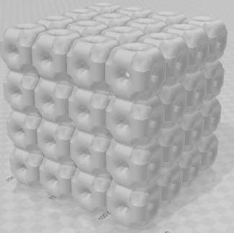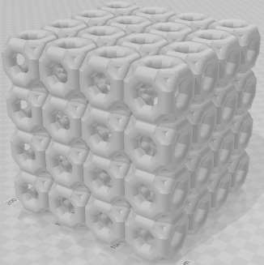
FIGURE 2. Scaffold Design Results for Compressive Strength

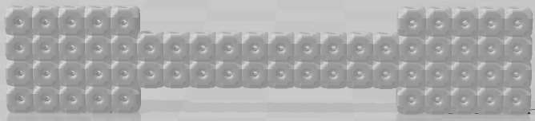
FIGURE 3. Scaffold Design Results for Tensile Strength Test

The designed scaffold was subsequently imported into the 3D printing machine and fabricated through an additive manufacturing process, in which the material was deposited layer by layer (FIGURE 4). The filament material used was Polylactic Acid (PLA) with a diameter of 1.75 mm. The 3D printer operated at a printing speed of 50 mm/s and a filament melting temperature of 180°C.
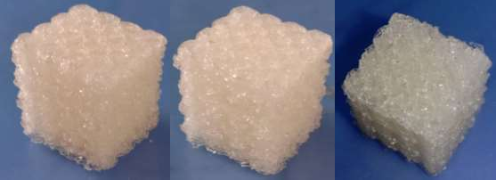
FIGURE 4. Printed Scaffold Results for Compressive Strength Testing

For tensile testing, the scaffold ends were trimmed to form tapered regions, ensuring centralized load application and minimizing stress concentration. The printed scaffolds closely matched the intended designs, though dimensional variations occurred due to printer settings. Smaller pore sizes resulted in thicker structures, while larger pores produced thinner scaffolds. These interconnected pores support cell migration and nutrient transport, essential for new bone formation. Dimensional measurements were taken prior to mechanical testing. Compressive strength values ranged from 1.723 to 4.159 MPa, indicating all samples met the mechanical criteria for bone implants. Thinner scaffolds showed lower compressive strength due to reduced support structure, whereas thicker scaffolds exhibited better mechanical performance. Tensile strength values also met literature standards, confirming the scaffold's suitability for load-bearing applications. The compressive test, based on force applied over cross-sectional area, provided insight into structural integrity under pressure. Results varied with design and thickness, with maximum strength reached prior to scaffold failure. A graph illustrating the relationship between vertical displacement and compressive strength was obtained.
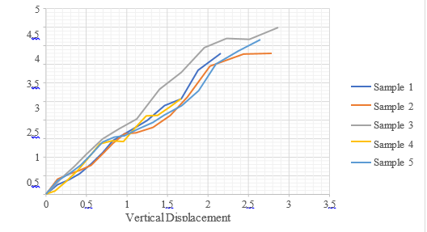
FIGURE 5. Compressive Strength Test Graph Showing Force-Displacement Behavior

FIGURE 5 shows the compressive test graph displays an upward trend, reflecting increasing compressive force. The compressive strength was identified at the first plateau in the curve, indicating the onset of scaffold deformation. Thicker scaffolds occasionally failed to generate valid data due to structural instability or testing errors, highlighting the need for improved scaffold design to prevent premature failure.
TABLE 1. Compressive Strength Results
Sample - | Compression Strength Results (MPa)
1 | 4.159
2 | 3.781
3 | 2.557
4 | 2.333
5 | 1.723

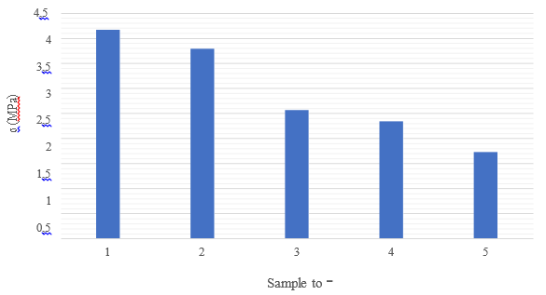
FIGURE 6. Compressive Strength Test Value Graph

TABLE 1 indicate that scaffold thickness has a significant impact on compressive strength. Thicker 3D-printed scaffolds demonstrated higher compressive strength, while thinner ones exhibited lower values. With measured strengths ranging from 1.723 to 4.159 MPa, all samples met the minimum mechanical threshold for cortical bone substitutes, which typically range between 1.5 and 7.8 MPa, thereby supporting their potential for new tissue growth.
To further evaluate their suitability as bone substitutes, tensile strength testing was performed at the Physics Laboratory, Universitas Airlangga. The test involved applying a uniaxial tensile force until fracture, providing insight into the material’s behavior under load. Tensile strength outcomes were governed by the stress–strain relationship, reflecting both elasticity and failure characteristics of the scaffold. The test results are summarized as follows.
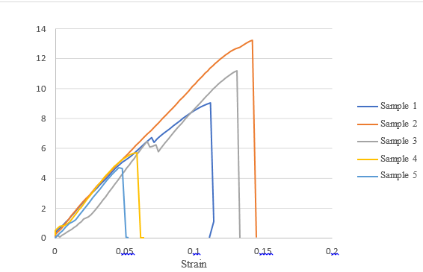
FIGURE 7. Graph of Tensile Strength Test Results

Data analysis was performed to determine the values of tensile strength and elongation. Tensile strength refers to the maximum tensile load that a material can withstand before failure or fracture occurs. The test was conducted once for each scaffold sample. The calculated tensile strength values, along with elongation data, are presented in TABLE 2 and FIGURE 8.
TABLE 2. Tensile Strength Test Value Results
Sample – | Tensile Strength (Mpa)
1 | 13.189
2 | 11.181
3 | 9.033
4 | 5.672
5 | 4.619

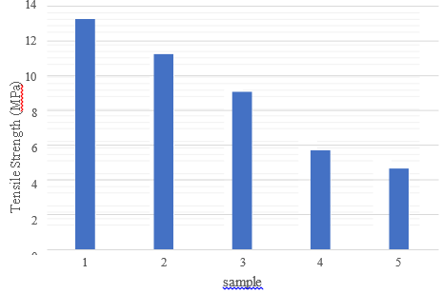
FIGURE 8. Tensile Strength Test Graph

The tensile test results and stress–strain curves revealed a linear increase in stress with applied force until sample fracture, after which the curve declined. The recorded tensile strength ranged from 4.619 MPa to 13.189 MPa, indicating variability likely due to differences in scaffold thickness or material uniformity. These values fall within the natural bone tensile strength range (3–20 MPa), confirming the scaffolds' suitability for bone tissue engineering. A positive correlation was observed between scaffold thickness, tensile strength, and elongation. The tensile strength values—4.619, 5.672, 9.033, 11.181, and 13.189 MPa—demonstrate the scaffold’s ability to endure tensile loads as bone substitutes.

TABLE 3. Elongation Test Results
Sample – | Elongation (%)
1 | 14.256
2 | 13.130
3 | 11.236
4 | 5.894
5 | 4.860

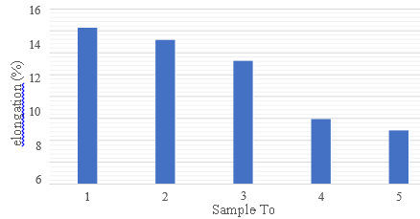
FIGURE 9. Elongation Test Results

TABLE 3 showed elongation values ranging from 4.860% to 14.256%, all within the accepted range for bone substitutes (3.6%–50%) as reported by Carter [10]. The individual elongation values 4.860%, 5.894%, 11.236%, 13.130%, and 14.256% demonstrate the scaffold’s adequate ductility to accommodate physiological stretching, mimicking natural bone behavior (FIGURE 9). While tensile strength confirms the scaffold's ability to bear loads, elongation reflects its deformation capability during functional movement.
The in vitro biodegradation test was carried out by immersing each 3D-printed PLA scaffold in 15 mL of Phosphate Buffered Saline (PBS) solution. Evaluations were conducted on day 0 and subsequently every 6 days over three intervals to monitor mass loss and pH changes, both serving as indicators of scaffold degradation. The results of the degradation test are presented in the following figure.

TABLE 4. Biodegradation Test Results
Sample | Mass (g) on day |  |  |  | pH on day -
Sample | 0 | 6 | 12 | 18 | 0 | 6 | 12 | 18
- 1 | - 0.70 | 0.74 | 0.73 | 0.72 | 7.57 | 7.53 | 7.53 | 7.48
2 | 0.67 | 0.66 | 0.66 | 0.62 | 7.57 | 7.52 | 7.52 | 7.51
3 | 0.80 | 0.80 | 0.80 | 0.76 | 7.55 | 7.53 | 7.52 | 7.51
4 | 0.64 | 0.64 | 0.64 | 0.62 | 7.55 | 7.53 | 7.50 | 7.5
5 | 0.69 | 0.69 | 0.69 | 0.65 | 7.57 | 7.55 | 7.50 | 7.49

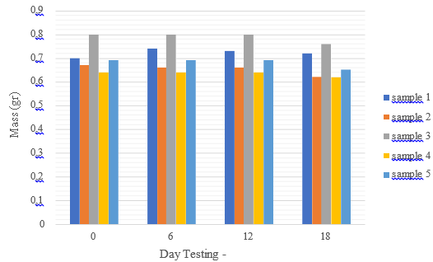
FIGURE 10. Results of Scaffold Mass Change After PBS Immersion
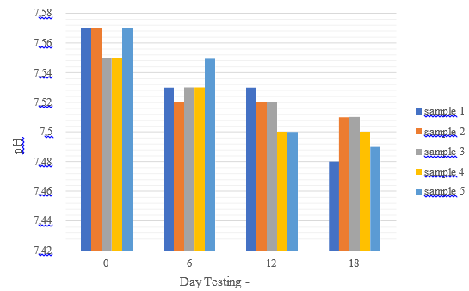
FIGURE 11. Results of PBS Solution pH Change Test

Based on TABLE 4, a graph was constructed to illustrate the relationship between immersion time (days) and both the mass (grams) and pH values. FIGURE 10 shows the changes in mass from day 0 to day 18. According to the data, by day 18, the PLA scaffold had not yet experienced a significant reduction in mass. However, this does not necessarily indicate that the 3D-printed scaffold material is non-degradable. Therefore, monitoring the pH of the PBS solution is crucial. According to Rodrigues et al. [11] a decrease in the pH of the PBS solution used to soak the scaffold can serve as an indicator of polymer degradation. Lactic acid, the degradation product of PLA, contributes to the reduction in the surrounding pH.
FIGURE 11 show a consistent decrease in the pH of the PBS solution over the 18-day immersion period. The most notable change occurred in sample 1, where the pH dropped from 7.57 to 7.48. This confirms that degradation had occurred, initiated by the breakdown of PLA polymer chains into monomers namely, lactic acid. The presence of H⁺ ions from lactic acid leads to a decrease in the environmental pH. This confirms that the 3D-printed scaffold is indeed biodegradable. Such materials can degrade naturally within the body over time. The prolonged degradation period adds value to the scaffold's function as a bone implant material.
The porous architecture of the scaffold mimics the extracellular matrix, promoting cell adhesion and new bone tissue growth. As regeneration occurs, the scaffold gradually degrades. Although no significant mass loss was observed during the 3-week biodegradation test due to PLA’s inherently slow degradation rate of approximately 6 to 24 months changes in pH provided evidence of ongoing degradation. Specifically, pH values decreased from 7.57 to 7.48 (sample 1), 7.57 to 7.51 (sample 2), 7.55 to 7.50 (sample 3), and 7.57 to 7.49, indicating acidification due to lactic acid release from PLA breakdown. This suggests that hydrolysis of the polymer chains had begun. Overall, mechanical and biodegradation tests confirm that the 3D-printed scaffold is both safe and effective as a bone implant capable of withstanding physiological loads and degrading naturally in the body without the need for secondary surgery.

CONCLUSION
- The scaffold design was developed using Autodesk Inventor software, with distinct configurations created for compressive and tensile testing, incorporating variations in scaffold thickness based on pore spacing. The printed scaffold was successfully produced in accordance with the design, exhibiting macroscopic interconnectivity between pores.
- The mechanical compression test results indicated differences in compressive strength between scaffolds of varying thicknesses. However, overall, all scaffolds met the criteria for bone substitute materials according to values reported in the literature. The elongation and tensile strength values of the 3D-printed scaffolds were consistent with standard bone literature. Based on all test data, it can be concluded that the scaffolds are capable of withstanding mechanical loads and supporting bone tissue growth effectively as a structural support until the formation of new bone tissue is achieved.
- The biodegradation test demonstrated that the PolyLactic Acid (PLA)-based scaffolds are biodegradable and can degrade within the body over a certain period, allowing for the formation of new bone structure. This was evidenced by a gradual decrease in pH and scaffold mass in each evaluation.

REFERENCE
1. M. N. Firdaus, M. B. Pratista, A. Rahman, H. D. Putera, and Z. Noor, “The Profile of Road Traffic Injury-Related Fracture Patient in the Emergency Department of H. Damanhuri Barabai General Hospital,” J. Orthop. Traumatol. Surabaya, vol. 14, no. 1, pp. 37–45, Apr. 2025, doi: 10.20473/joints.v14i1.2025.37-45.
2. M. Chandran et al., “Prevalence of osteoporosis and incidence of related fractures in developed economies in the Asia Pacific region: a systematic review,” Osteoporos. Int., vol. 34, no. 6, pp. 1037–1053, 2023, doi: 10.1007/s00198-022-06657-8.
3. D. Gu, S. Ou, and G. Liu, “Global burden of road injuries and their attributable risk factors from 1990 to 2021: A systematic analysis for the global burden of disease study 2021,” Prev. Med. Reports, vol. 53, no. January, p. 103051, 2025, doi: 10.1016/j.pmedr.2025.103051.
4. W.-J. Metsemakers et al., “The global burden of fracture-related infection: can we do better?,” Lancet Infect. Dis., vol. 24, no. 6, pp. e386–e393, Jun. 2024, doi: 10.1016/S1473-3099(23)00503-0.
5. D. N. Sakinah, “Comparison of Healing Time in Closed Fractures of the Tibial Diaphysis and Tibial- Fibula after ORIF Plate and Screw at Waled Regional Public Hospital , Indonesia,” vol. 8, no. 2, 2025.
6. Y. K. Erdogan and B. Ercan, “Anodized Nanostructured 316L Stainless Steel Enhances Osteoblast Functions and Exhibits Anti-Fouling Properties,” ACS Biomater. Sci. Eng., vol. 9, no. 2, pp. 693–704, 2023, doi: 10.1021/acsbiomaterials.2c01072.
7. C. C. Barber, M. Burnham, O. Ojameruaye, M. D. Mckee, and C. Frcs, “A systematic review of the use of titanium versus stainless steel implants for fracture fi xation,” no. C.
8. L. R. Wabula, S. Umamity, E. Fitriasari, E. Lombonaung, and A. Puspa, “Fracture patient experience in undergoing traditional massage therapy ( Topu Bara ) in Maluku Province : phenomenology study,” vol. 17, no. 2, pp. 196–203, 2022.
9. I. D. Winanto and C. Tirta, “International Journal of Surgery Case Reports Management of dead limb following traditional practices in Indonesia : A case report ☆,” Int. J. Surg. Case Rep., vol. 123, no. August, p. 110215, 2024, doi: 10.1016/j.ijscr.2024.110215.
10. Carter, D., Schwab, G., & Spengler, M., 1980. Tensile Fracture of Cancellous Bone. Acta Orthopaedica Scandinavica, 51:1-6, 733-741.
11. Rodrigues, N. et al., 2016. Manufacture and Characterization of PLA Scaffold. Procedia CIRP, Issue 49, Pp. 33-38.

