Proposed Improvements to the Jersey Production Process Using Six Sigma and Kaizen Methods as an Effort to Reduce Production Defects
Nizam Zaki Rayhan¹⁾ , Ahmad Mubin^{2,a)} and Ikhlasul Amallynda³⁾
^{1,2a,3}Department of Industrial Engineering, University of Muhammadiyah Malang, Malang, Indonesia
^{a)}Corresponding author: ahmadm@umm.ac.id
Abstract. AFR is a convection business that focuses on the production of sports jerseys on a make-to-order basis. In its implementation, the company faces the problem of high product defect rates that exceed the 2% tolerance threshold, set by the company. This study aims to identify the types and causes of product defects, measure defect rates and sigma levels, and provide proposals for improving the production process using the Six Sigma method and the Kaizen Five M-Checklist approach. The Six Sigma method is used to identify and measure defects through the stages of Define, Measure, Analyze, and Improve. The results of data processing during the period November 2024 to January 2025 showed a DPMO value of 25,589.56 and a sigma level of 3.45, with the dominant types of defects being cracked screen printing (30.7%), faded printing (28.3%), and sloppy stitching (24.0%). The analysis stage was carried out using cause-and-effect diagrams to find the root causes of defects, which then formulated improvement solutions through the Kaizen Five M-Checklist based on the aspects of Man, Machine, Material, Method, and Environment. This research produces systematic improvement proposals for each type of defect that are expected to help the company improve product quality and reduce defect rates in a sustainable manner.
Keywords: Six Sigma, Kaizen, DMAIC, Defect, Jersey, Produksi, AFR Activewear

INTRODUCTION
Product quality is defined as the process of creating an item where the quality of the product produced creates a positive response and generates satisfaction and loyalty from customers to the Company (Semnasti et al., 2023). One of the convection businesses in Malang City is AFR ACTIVEWEAR. This company focuses on making futsal and soccer jerseys with make to order production. The rapid development in the convection sector makes the company must be able to carry out good quality control so that the defects produced are reduced. Efforts to control quality can be improved through the application of the Six Sigma method with a combination of Kaizen, where the method focuses on minimizing defects, analyzing the types and causes of defects, calculating the DPMO (Defect per Million Opportunities) value, and providing improvement solutions to overcome the causes of defects.
Defective products are products that have undergone the production process but are considered unfit because they do not meet the quality specifications set by the company (Siregar & Handoko, 2021). AFR ACTIVEWEAR is still not good enough in implementing quality control because there are still many defective products in its production that exceed. Defective products can be reduced if the company is able to reduce the number of defects occurring in its products. By reducing the number of defects, it is hoped that the number of defective products will also decrease (Widodo & Soediantono, 2022). The targer of this company defective products do not exceed 2% of total production. The number of defects occurs due to the lack of specialized employees in the field of quality control so that workers in each production process double check quality. Defective products can make losses to the company because the company will repeat the production process to repair the product. The types of defects that most often occur at the printing stage include faded printing, faded printing, cracked or torn prints, while at the cutting stage there are often sizes that do not match, and at the stitching stage the stitches are not neat and strong. It can be interpreted that the company is still at an unfavorable level, so it is required to improvise in its production (Teja et al., 2022). Another problem is that the company has no action for an improvement plan so that defective products that occur can be reduced.
Based on some of the problems that occur in the company, this study in solving them researchers used the Six Sigma method approach by combining the Kaizen method. According to (Sirine et al., 2017) Six Sigma is a new method of controlling or improving comprehensive products to achieve, maintain, and maximize business. The Six Sigma method has 5 cycles, namely DMAIC (Define, Measure, Analyze, Improve, Control) which is a process to improve to the desired Six Sigma target. Meanwhile, the Kaizen method is a management technique to emphasize continuous quality improvement or completion by involving all parties and low costs (Harwan Ahyadi et al., 2023). Improving product quality with the Kaizen Five M-Checklist approach (Man, Machine, Material, Methods, Environment), this is because the Kaizen Five M-Checklist Analysis is compiled based on observations made in the field directly and the principle of sustainable kaizen eats improvements made every day. So with the implementation of these methods is expected to help AFR ACTIVEWEAR in providing proposals to solve these problems. Kaizen is a comprehensive and integrated perspective aimed at continuous improvement (Ekoanindiyo, 2013). The key to this method is to focus on the process. Focusing on the objectives of each area is an easy way to implement this method and will minimize the risks that may arise (Soesilo, 2017).
This study aims to identify the types and causes of defects, measure the level of production quality, and develop improvement proposals based on existing findings. The benefits of this research are expected to be able to assist AFR Activewear in reducing defect rates, increasing production efficiency, and maintaining customer satisfaction. Quality control can be implemented by using quality materials, adequate production equipment, experienced workers, and proper production processes (Shiyamy et al., 2021). The research limitations are focused on the jersey production process, and only cover the stage up to “Improve”, not up to the “Control” stage.

METHODS
The research method is intended as a guide to the sequence of processes from the beginning to the end of the work to achieve the desired target. In this research using qualitative and quantitative approaches. This chapter describes the stages of collection, processing, and analysis to provide a description of certain phenomena so as to get conclusions from this research. The research was conducted in the AFR ACTIVEWEAR shirt/jersey convection industry which is located at De banna Residence Kav A1-11, Ngijo, Dau District, Malang Regency, East Java. This location is an office as well as a shirt production house. The research was conducted during July - September 2024.

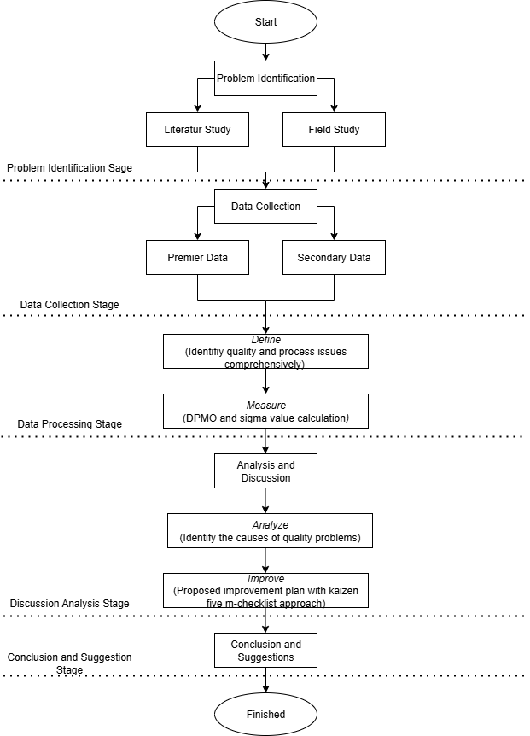
Figure 1 Flow Chart

The initial stage carried out in this research is to describe and identify the problems that occur to solve the obstacles that are relevant to the topic raised. This research focuses on quality control which is the main topic this time. Primary data was obtained through direct observation and interviews with the company, while secondary data was collected from the company's production documents during the period November 2024 to January 2025. Data collection and processing methods were carried out in stages to ensure that each stage of DMAIC could be implemented effectively, starting from problem identification, defect rate measurement, root cause analysis, to the formulation of improvement proposals.
With this methodology, the research was designed to provide a thorough understanding of the production process and the main causes of product defects. The end result of these stages is expected to produce improvement recommendations that are targeted, practical, and able to be implemented directly by AFR Activewear to improve product quality in a sustainable manner.

RESULTS AND DISCUSSION

Data Collection and Classification
Data was extracted from production records during the study period, including total jersey production, number of defective products, as well as defect categories. The defects found were grouped into four main types: Color mismatch, Screen fade, Screen crack, Seam defect. The following is the company's historical data for 3 months starting from November 2024 to January 2025:

Table 1. Jersey Production Process Data
Month | Week | Production Quantity | Types of Product Defects |  |  |  | Number of Product Defects
Month | Week | Production Quantity | Incorrect Color | Fading | Crack | Sewing Defect | Number of Product Defects
November  2024 | 1 | 544 | 5 | 6 | 14 | 16 | 41
November  2024 | 2 | 467 | 6 | 6 | 10 | 7 | 29
November  2024 | 3 | 528 | 11 | 29 | 12 | 6 | 58
November  2024 | 4 | 484 | 4 | 6 | 27 | 24 | 61
Desember 2024 | 1 | 808 | 15 | 21 | 21 | 20 | 77
Desember 2024 | 2 | 682 | 6 | 19 | 15 | 8 | 48
Desember 2024 | 3 | 389 | 17 | 22 | 13 | 9 | 61
Desember 2024 | 4 | 455 | 7 | 9 | 12 | 11 | 39
Januari 2025 | 1 | 549 | 12 | 27 | 17 | 27 | 83
Januari 2025 | 2 | 351 | 7 | 8 | 11 | 10 | 36
Januari 2025 | 3 | 345 | 6 | 8 | 21 | 4 | 39
Januari 2025 | 4 | 377 | 8 | 12 | 15 | 5 | 40
Total |  | 5979 | 104 | 173 | 188 | 147 | 612

To gain a more in-depth and accurate understanding of product defects, interviews were conducted directly with the head of production as well as operators who were actively on duty during the production process. These interviews aimed to gather more detailed and realistic information about the level of defects that occurred in jersey products during the specified time period. Critical To Quality (CTQ) is used to determine product characteristics that must be considered critically to ensure that the final product meets or exceeds customer expectations.

Define
The first stage of Six Sigma is defining the production process, particularly the quality improvement process. At this stage, interviews and observations are conducted to determine the SIPOC (Supplier - Input - Process - Output - Customer) diagram (Untoro & Iftadi, 2020). Define is the first step in the six sigma method. In this stage, identification of the object to be studied is carried out. Identification of the object of research in the form of problems often faced by the company, namely, the high number of defects that occur in the production process of screen printing t-shirt convection. Determination of the research object is focused on the production process of screen printing shirts.
Table 2. CTQ
Category | CTQ For the Company | CTQ for Customers
Incorrect Color | - Color consistency between production batches  - Use of stable and standard colorants. | - Color in accordance with the catalog or product image  - Not easy to fade after washing
Printing Fade | - Proper printing process  - Use of high quality screen printing ink | - Screen printing does not fade when washed  - Ink does not stick or sticky to the touch
Cracked Screen Printing | - Screen printing thickness according to standard  - Optimal drying and appropriate heating time | - Screen printing is not easily broken or cracked  - Remains elastic and flexible when worn
Sewing Defect | - Quality control in the sewing process  - Proper use of thread and sewing techniques | - Stitching is neat and not loose  - No loose threads or tears in the garment

Based on the Critical To Quality (CTQ) in table 2 above, important characteristics that affect product quality have been described and must be met to meet customer needs.
The use of a SIPOC (Supplier-Input-Process-Output-Customer) diagram can make it easier to identify the object to be studied. SIPOC is a visual tool used to document business processes from start to finish and serves to identify relevant elements of the improvement project to be carried out. This SIPOC identification is usually done before the process improvement project begins.

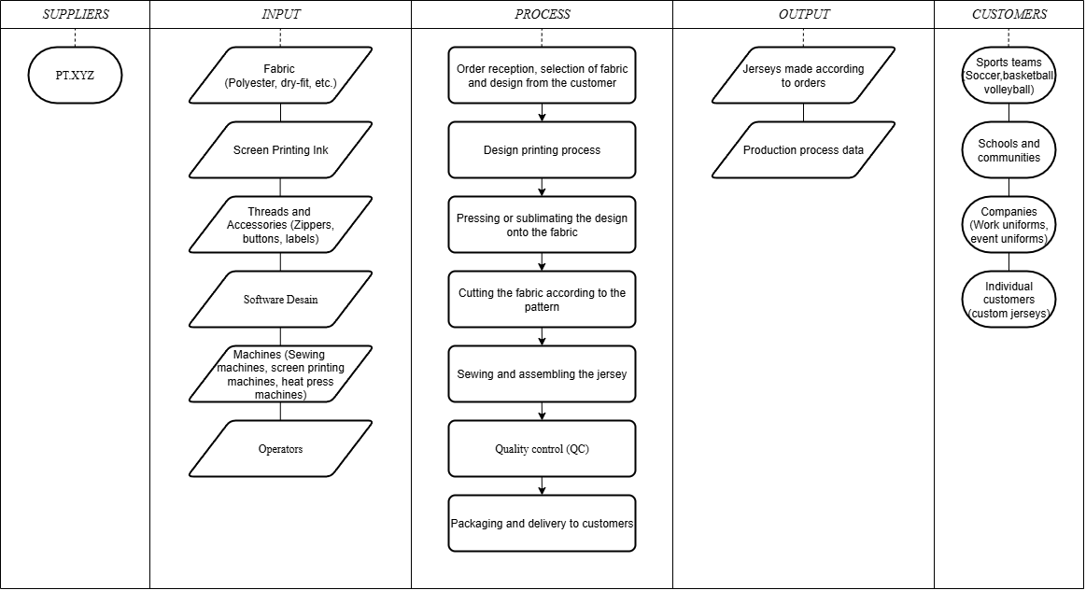
Figure 2 SIPOC Diagram

The SIPOC diagram in Figure 2 above provides an overall view of a process from start to finish. SIPOC diagrams are used to map the process flow from raw material suppliers, production processes, to finished products.

Measure
The DPMO (Defects Per Million Opportunities) level and sigma value were calculated. The results show that the initial sigma value is in the medium category, which means that the production process still produces defects that are quite high. It can be seen that there are 4 types of defects, namely color not matching 17%, printing fading 28%, cracked or torn prints 31%, and at the stitching stage, the stitches are not neat and strong 24% with a total defect of 612 pcs from a total production of 5979 pcs. Based on the pareto principle which states that about 80% of the problems come from 20% of the main causes then from the graph, we see that the top 3 defect types (Cracking, Fading, Stitching) account for 83% of the total defects. Priority of investigation and rectification for Cracks: Highest (188 cases, 30.7%), Fading: Second (173 cases, 28.3%), Stitching: Third (147 cases, 24.0%).
DPMO and Sigma Level are important concepts in quality management and process improvement. DPMO is used in assessing quality and process performance by calculating the number of defects that occur per-million opportunities. While sigma level is a statistical measurement tool that describes how well a process operates. The higher the sigma level, the fewer defects that occur in the process. The following is the calculation of DPMO and Level Sigma from the production defects that occur.

- Calculation of Defect Per Opportunity (DPO)
DPO $= \frac{Number of defects found}{Production quantity x Defect probability}=\frac{612}{5979x4}=$ 0,02558956

- Calculation of Defect Per Million Opportunity (DPMO)
DPMO = DPO x 1.000.000 = 0,02558956 x 1.000.000 = 25589,56

- Sigma Level Value
Sigma Level = NORMSINV((1.000.000 – DPMO)/1.000.000) +1,5
= NORMSINV((1.000.000 –2558956)/1.000.000) +1,5
= 3.45

Based on the results of the DPMO calculation, a DPMO value of 25589.56 defects per one million opportunities was obtained with a sigma value of 3.45. This figure reflects the level of defects in the production process that has been analyzed. Calculation of Sigma Level in the range of 3.45 which shows the quality of the production process is good, but can still be improved to achieve a higher Sigma level, reduce defects and increase efficiency. The sigma value of 3.45 also means that AFR Activewear is in the average performance process category, but has not yet reached the ideal stage in terms of efficiency and quality. The high DPMO value reflects that the current quality control system has not been effective in eliminating the root causes of defects.

Analyze
Analyze is the third stage where improvement proposals are made. A product can be said to be of quality if it meets the wants and needs of buyers (Ade Aditya & Budi Puspitasari, 2023) . In order for the company to correct errors to overcome defects, a fishbone diagram is needed to find out the details of the errors.

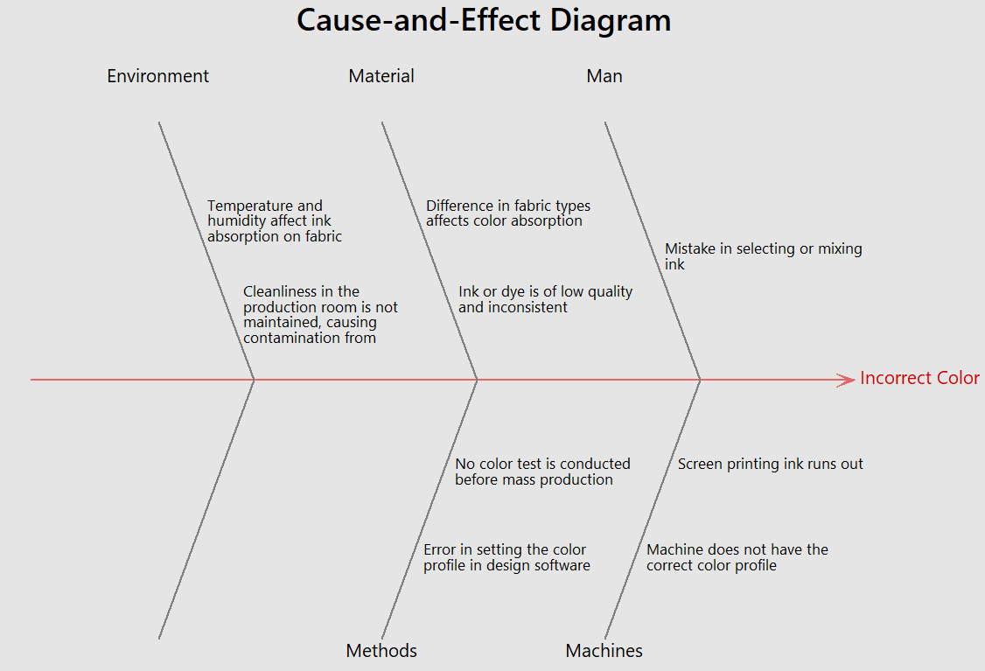
Figure 3 Fishbone Diagram
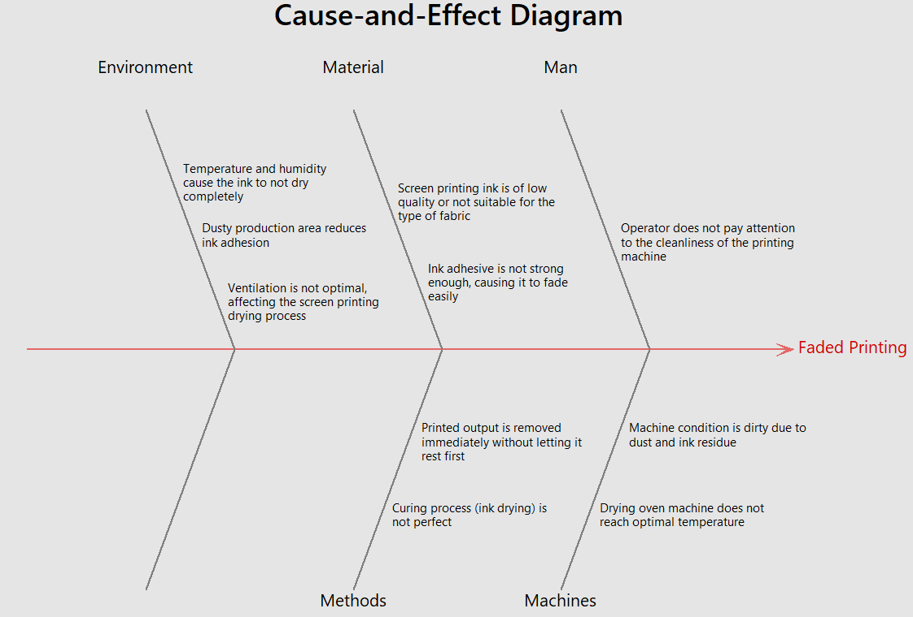
Figure 4 Fishbone Diagram
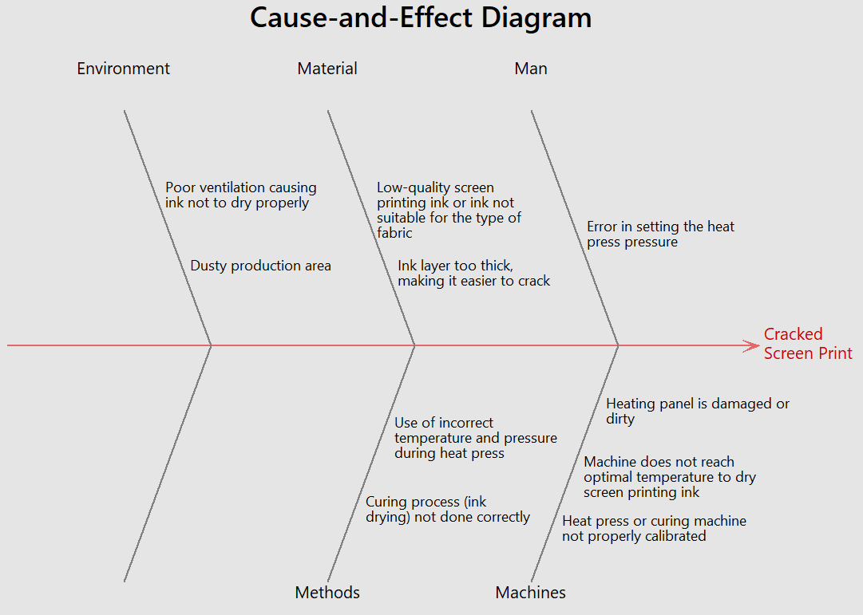
Figure 5 Fishbone Diagram
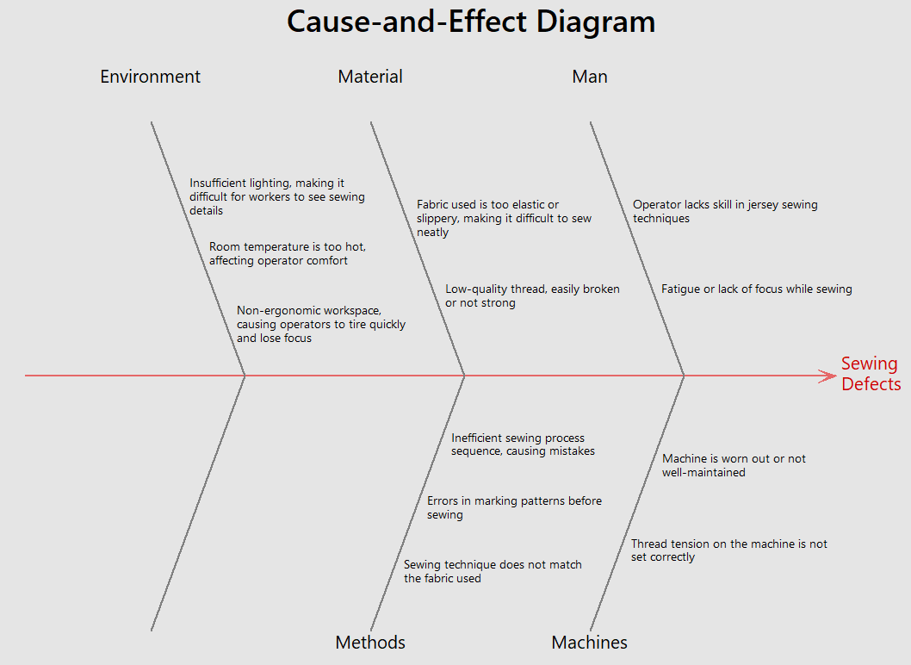
Figure 6 Fishbone Diagram

Can be seen in Figure 4.15 is a causal diagram to identify and categorize the various factors that contribute to jersey product defects, the analysis results show that the causes of product defects can be divided into several main categories: Man, Machine, Materials, Method and Environmrnt.

Improve
Improve is the fourth stage of DMAIC which is carried out by analyzing the Kaizen Five-M Check List. This method is a tool that focuses on five key elements of a problem: people, machines, materials, methods, and the environment. Improvements can be made within these processes and activities (Azis & Vikaliana, 2023). According to Indrawansyah & Cahyana (2019), this tool or method focuses on five aspects involving each activity: people, machines, materials, and methods. Based on the 80/20 pareto chart principle, it is known that the dominant defect is in the imperfect press process which causes cracks in the screen printing. Where an improve analysis technique that goes to 5 key factors in the process, namely man (people), machine (machine), material (raw material), methods (method) and environment (environment) can be seen in the table as below:

Table 3. Kaizen Five M Checklist defects cracks
Category (5M) | Cause of Problem | Proposed Improvement
Man | Error in heat press pressure setting | Make the standard temperature and pressure used on each machine and also the timer.
Machine | Heat press or curing machine is not calibrated properly. | Schedule regular calibration of the machine using proper pressure and temperature gauges. Create a daily calibration checklist.
Machine | Machine does not reach the optimum temperature for drying screen printing ink | Check the machine temperature before production with an infrared thermometer, repair the heating element if it is not suitable.
Machine | Broken or dirty heating panel | Clean the heating panel regularly and replace any malfunctioning parts.
Material | Screen printing ink quality is low or not in accordance with the type of fabric | Checking the material before the work process such as checking the stock of paint, coloring ink, and other raw materialsnneeded (Alista et al., 2024).
Material | The ink layer is too thick, making it easier to break | Apply a maximum thickness limit, use a layer measuring tool
Method | The curing process is not done properly | Apply clear curing SOPs including duration, temperature, and type of machine used. Test the curing results (e.g. crack or rub test).
Method | Use of inappropriate temperature and pressure during heat press | Establish standard temperature and pressure guidelines for each type of fabric and ink and post them on each heat press machine.
Media/  Environment | Poor ventilation, making the ink not dry properly | Improve air circulation by installing exhaust fans or additional ventilation systems to make the drying process more effective.
Media/  Environment | Dusty production area | Improve workspace hygiene with daily cleaning routines and install air filters to reduce dust particles.

Table 4. Kaizen Five M Checklist for printing fade defects
Category (5M) |  | Cause of Problem | Proposed Improvement
Man |  | Operators do not pay attention to the cleanliness of the printing machine | Clean the machine before and after production. Create a daily checklist for visual checking of machine cleanliness.
Machine |  | Drying oven machine does not reach the optimal temperature | Install digital temperature sensor and calibrate the dryer every week. Make sure the heating element is in top condition.
Machine |  | Dirty machine condition due to dust and ink marks | Perform machine maintenance and try to check the condition of the machine after each use (Alista et al., 2024).
Material |  | Low quality screen printing ink or not according to the type of fabric | Conduct ink trials before mass production and use only pre-tested inks.
Material |  | The ink adhesive is not strong enough so that it fades easily. | Add bonding agent according to the standard formula. Provide ink and adhesive  mixing guidelines based on material type.
Method |  | Incomplete curing (ink drying) | Set curing time and temperature standards for each type of ink. Use a digital timer  during the curing process.
Method |  | Printing results are immediately lifted not  allowed to stand first | Set a cooling time rule for printing results of at least 1 minute so that the ink hardens slightly and does not spread.
Media/  Environment |  | Temperature and humidity cause the ink to not dry completely | Use a dehumidifier or room temperature regulator in the screen printing area. Measure and record the daily temperature/humidity in the production  room.
Media/  Environment |  | Dusty production room reduces ink adhesion | Perform regular cleaning, install an air purifier or industrial dust filter in the screen  printing room. Implement a dust-free zone.
Media/  Environment |  | Ventilation is not optimal, affecting screen printing  drying process | Add exhaust fans or cross ventilation. Check airflow monthly to ensure good circulation.

The general conclusion obtained is that the table shows that all 5M elements contribute to manufacturing defects, but the most dominant one seems to come from the factor of : People and Methods as they concern work skills and consistency, Machines and Materials as they are directly related to the technical results of screen printing and stitching. Key recommendations: conduct regular training and evaluation of operator performance, create and implement standardized SOPs for all stages of production, implement thorough quality control from upstream to downstream (from materials to finishing), schedule regular machine maintenance and calibration.

Control
Control is the fifth stage of DMAIC which is carried out so that the process of standardizing production procedures can be much more optimal and minimize defects to a minimum. The actions that need to be taken are:
- Conduct routine checks every two weeks on maintenance and components.
- Conduct routine checks on all materials, methods, workers and machines.
- Perform DPMO and sigma value calculations every period routinely so that the production process is known to produce products without defects per million opportunities.
- Perform the Standard Operation Procedure (SOP) that has been made to avoid human error that can interfere with the screen printing t-shirt production process.

CONCLUSION
Based on research on the application of the Six Sigma method with the DMAIC approach to the jersey production process at AFR Activewear, it is found that the initial sigma level is at 3.45 sigma with a DPMO value of 25589.56, indicating that the process quality is still in the medium category with a relatively high level of defects. The dominant defect types were Screen Printing Cracks (30.7%), Printing Fading (28.3%), and Stitching Defects (24%) which cumulatively accounted for more than 80% of total product defects. A 5M-based cause-and-effect analysis revealed that the main factors causing defects included suboptimal operator skills, uncalibrated machines, non-standardized work procedures, variations in raw material quality, and unfavorable production environment conditions. Proposed improvements developed through the Kaizen Five M Checklist include regular training for operators, regular machine calibration and maintenance, standardization of SOPs, stricter selection of raw materials, as well as improved lighting and temperature-humidity regulation of the production room. With the implementation of quality control plans such as regular inspections, the use of color measuring devices, and periodic evaluations, this method is expected to significantly reduce defect rates, improve process efficiency, and produce products with more consistent quality, thus strengthening AFR Activewear's competitiveness.
AFR Activewear needed to improve its production quality through Six Sigma and Kaizen approaches. Six Sigma can be described as a breakthrough that enables businesses to achieve very high standards and is a customer-focused process (Sya'roni & Suliantoro, 2017). CTQ identification and DMAIC analysis help determine the root of the problem and design effective solutions. Implementation of proposed improvements such as human resource training, machine maintenance, and continuous quality control are needed to reduce the product defect rate.

REFERENCES
- Ade Aditya, K., & Budi Puspitasari, N. S. (2023). Analysis of the Causes of Defects of 8.5 Gram Wafer Roll Products in the Packing Process Pt. Dua Kelinci. Industrial Engineering Online Journal, 12(4), 1–9.
- Alista, S., Seda, G., Junita, I., Management, P. S., & Maranatha, U. K. (2024). QUALITY MONITORING TO AVOID DEFECTS IN T-SHIRT PRODUCTS AT CAPA DE FLORES COMPANY IN BANDUNG. 8(1), 108–121.
- Azis, D., & Vikaliana, R. (2023). Product Quality Control Using the Six Sigma and Kaizen Approaches as an Effort to Reduce Product Defects. Intent Journal: Journal of Integrated Industry and Technology, 6(1), 37–53. https://doi.org/10.47080/intent.v6i1.2596
- Ekoanindiyo, F. A. (2013). Quality Control Using the Kaizen Approach. Engineering Dynamics, VII(2), 1–10.
- Harwan Ahyadi, Rudi Saputra, & Eliya Noviani Putri. (2023). Analysis of the Application of the Kaizen 5S Method to Employee Performance in the Laboratory of Chemical Testing . Precision, 25(1), 10–17.
- Indrawansyah, I., & Cahyana, B. J. (2019). Analysis of the Quality of the Wafer Leakage Test Defect Production Process Using the Six Sigma Method and Kaizen as Efforts. Proceedings of the National Seminar on Science and Technology, 1–8.
- Semnasti, R. R., Nugraha, I., Semnasti, T. N. A., & Semnasti, S. B. H. (2023). Quality Control Analysis of PT XYZ T-shirt Products with Six Sigma and Kaizen Methods. Waluyo Jatmiko Proceeding,16 (1), 481-490. https://doi.org/10.33005/wj.v16i1.72
- Shiyamy, A. F., Rohmat, S., & Sopian, A. (2021). Article on product quality control analysis with. Scientific Journal of Management, 2(2), 32–45.
- Siregar, J. A. S., & Handoko, K. (2021). Quality Control Analysis of Defective Housing Products Comasie Journal,6 (2), 40-51. http://ejournal.upbatam.ac.id/index.php/comasiejournal%0AJurnal Comasie ISSN
- Sirine, H., Kurniawati, E. P., Pengajar, S., Ekonomika, F., Bisnis, D., & Salatiga, U. (2017). QUALITY CONTROL USING SIX SIGMA METHODS (Case Study at PT Diras Concept Sukoharjo). AJIE-Asian Journal of Innovation and Entrepreneurship,02 (03), 2477-3824. http://www.dirasfurniture.com
- Sya’roni, M., & Suliantoro, H. (2017). Analysis of Production Defect Reduction Using the Six Sigma Method in the Polytron Brand Smartphone Painting Unit. Industrial Engineering Journal, 1–9.
- Soesilo, R. (2017). Implementation of Kaizen and 5S in Product Drying in the Plating Process. Journal of Industrial Engineering, 18(2), 121–126. https://doi.org/10.22219/jtiumm.vol18.no2.121-126
- Teja, S., Ahmad, A., & Salomon, L. L. (2022). Improving the Quality of Clothing Production at Susilawati Convection Business Based on the Six Sigma Method. Scientific Journal of Industrial Engineering, 10(1), 9-20. https://doi.org/10.24912/jitiuntar.v10i1.15949
- Untoro, O. B., & Iftadi, I. (2020). Six Sigma as a Method for Controlling and Improving the Quality of Bed Series Products. Jurnal Ilmiah Teknik Industri, 19(2), 131–141. https://doi.org/10.23917/jiti.v19i2.11623
- Widodo, A., & Soediantono, D. (2022). Benefits of the Six Sigma Method (DMAIC) and Proposed Implementation in the Defense Industry: A Literature Review. International Journal of Social and Management Studies (Ijosmas), 3(3), 1–12.

