Banana Leaf Disease Identification Using Convolutional Neural Network With the VGG16 Architecture Model
Ivon Viqro Dini^{a)} and Christian Sri Kusuma Aditya ^{b)}
Department of Informatics, Universitas Muhammadiyah Malang, Malang, Indonesia

^{b)} Corresponding author: christianskaditya@umm.ac.id
^{a)} ivonviqrodini00@webmail.umm.ac.id
Abstract. Indonesia is a country with a tropical climate that is fertile in crops, one of the plants that can thrive is the banana plant. If banana plants are not cultivated properly, they can become vulnerable to various diseases spread by insects that transfer illnesses between plants. At the same time, these infectious diseases can lower the production yield on agricultural farms. Therefore, it's essential to identify diseases in leaves at an early stage. The use of image processing and deep learning techniques enables automatic disease detection, allowing farmers to efficiently monitor banana plant growth at a minimal cost. The study investigated deep learning techniques which led to the development of an approach that consists of four main phases. In phase one, images of Banana leaves were acquired using a standard digital camera. The second phase involved preprocessing, including resizing and morphological operations. The third phase focused on feature extraction, identifying traits such as petal shape, leaf color, and petal arrangement from the images to accurately detect diseases. Finally, the classifier's performance was assessed to determine if a leaf was diseased. The CNN (Convolutional Neural Network) method with the VGG (Visual Geometry Group) 16 architecture was trained with 2537 images of banana plants which already had 4 labels including Sigatoka, Pestalotiopsis, Cordona, and Healthy, this classification model achieved 95.77% accuracy, 96% precision, 94% recall, and F1- score 95%.
Keywords: banana, leaf, CNN, VGG16, disease

INTRODUCTION
Bananas can be grown in various countries, including Indonesia which is the largest producer in Asia and grows all year round. In 2020, banana production reached 8.18 million tons, an increase of 11% from the previous year, although several provinces experienced a decline in production [1]. Bananas contain starch (flour) as the main component, as well as various types of sugar that are easily digested by the body, such as 2% sucrose, 3.6% fructose, and 4.6% glucose [2] [3]. Apart from being rich in nutrients, banana leaves have various other benefits such as being used in packaging or as a base for food, as an ingredient for liquid organic fertilizer, and have many other applications [4].
Diseases and pests in banana plants often cause a lot of fruit to be wasted because it is not suitable for sale. If not addressed early, this problem can be detrimental to overall plant growth and yield. Diseases that attack crops can hamper agricultural production, and when not detected in time, can increase the risk of food instability [5]. Changes in leaf pattern and color can be an indication of disease in the plant, which also has an impact on the photosynthesis process. For example, diseases such as Sigatoka can significantly reduce fruit yields [6] .
Controlling diseases or pests in banana plants is increasingly important considering the large banana production and its impact on supply availability. Although farmers often seek help from agricultural experts to identify problems, limited time and resources are often obstacles. The development of an expert system is a promising solution, because this system can provide initial assistance in detecting and identifying diseases and pests that may attack banana plants. By providing easy and fast access to information and handling recommendations, expert systems can help farmers make more efficient decisions, reduce production losses, and increase overall crop yields [7]. Diseases in banana plants can cause plant death or produce bad fruit that is not suitable for consumption. Symptoms are often seen from changes in leaf color, such as yellowish spots that then turn brown and eventually the leaves die. Changes in leaf color in banana plants occur slowly and have certain patterns depending on the type of disease. Early detection can be done by image processing using the VGG16 model [8].
The CNN method is very popular in applying classification using deep learning and is an evolution of the multi-layer perceptron (MLP). In contrast to MLP which describes each neuron in one dimension, CNN uses a two-dimensional representation to process image information more effectively [9]. This research aims to identify diseases in banana plants using the CNN method. CNN was chosen because of its proven ability to recognize patterns in leaf images, making it easier to identify diseases in banana plants. There are several CNN models that can be used in this research, such as VGG16 and other models that have been proven effective in image processing tasks [10]. VGG16 stands for "Very Deep Convolutional Networks for large-scale Image Recognition 16-layer". This model consists of 16 layers, with 13 convolution layers and 3 fully connected layers. This deep architecture is known for being able to produce excellent representation of image features. VGG16 is well known for its ability to achieve high accuracy in image recognition, including on the ImageNet dataset which includes millions of images from thousands of different classes [11]. The CNN method with the VGG16 architecture was chosen because of its proven ability to recognize complex visual patterns, ideal for identifying diseases in banana leaf plants. The deep and complex architecture of VGG16 allows the extraction of deep features from images, significantly improving the CNN classification ability, so it is expected to provide accurate results in classifying plant diseases [12].
Research conducted by Gokula Krishnan et al. (2022) entitled "An automated segmentation and classification model for banana leaf disease detection" shows that the CNN method achieves 93.45% accuracy. This is much higher compared to other Machine Learning techniques which only achieve accuracy of around 75%–85% [13]. A study by Krishnaswamy Rangarajan Aravind & Purushothaman Raja (2020) entitled "Disease Classification in Eggplant Using Pre-trained VGG16 and MSVM" showed an increase in VGG16 performance which resulted in an accuracy of 89% [14]. Research by Putra Aprilian Prastianing Huda et al. (2021) entitled "Classification of Plant Diseases on Apple and Grape Leaves Using Convolutional Neural Networks" shows that the VGG16 Apple model for apple leaves achieved an accuracy of 79.33%, while the VGG16 Grape for grape leaves achieved an accuracy of 94.44% [15]. Research by Michael Jeffry Setiawan et al. (2023) entitled "Classification of Plant Leaf Diseases Using the CNN and Random Forest Algorithms" shows that the corn plant leaf classifier using the CNN algorithm achieved 94% accuracy, while the tomato plant leaf classifier using the Random Forest algorithm achieved 96% accuracy [16].
This research aims to use the CNN algorithm with the VGG16 model to classify various types of diseases on banana leaves into four classes: Sigatoka, Pestalotiopsis, Cordona, and Healthy. The aim is to detect and identify diseases on banana leaves early, facilitating the timely implementation of disease control measures.

METHODS
This research involves several important stages, starting from collecting datasets to using the VGG16 model architecture, as well as evaluating model performance. These stages include a comprehensive process to ensure success in classifying diseases on banana leaves. For the research flow diagram can be seen in FIGURE 1.

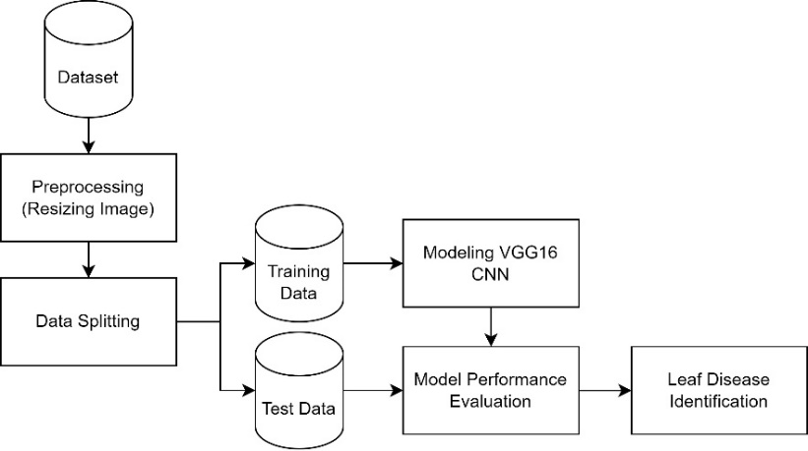

FIGURE 1. Research Flow Diagram

DATASET
The dataset used in this research is secondary data type obtained from the Kaggle website with the title Banana Leaf Spot Diseases (BananaLSD) Dataset [17], has data of 2537 images which are divided into four classes, namely, Sigatoka (a banana leaf disease caused by the fungus Pseudocercospora fijiensis), Pestalotiopsis (fungus Pestalotiopsis sp), Cordona (spotting), and Healthy (healthy leaves) with the format .jpg that can be seen in FIGURE 2.

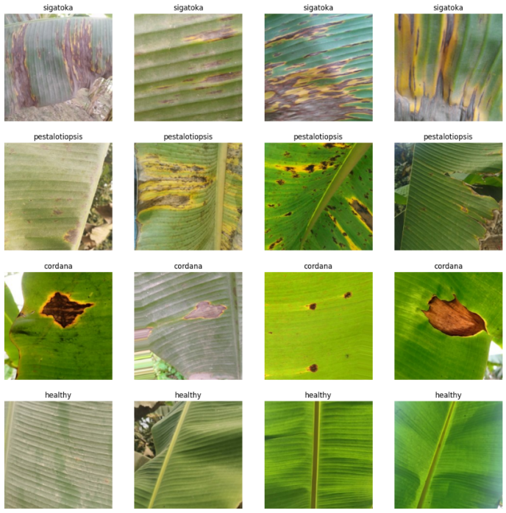
FIGURE 2. Sample Dataset of Banana Leaf Images

PREPROCESSING
Most of the neural network models assume a square shape input image, which means that each image needs to be checked if it is a square or not, and cropped appropriately. Scaling is useful in various image processing and machine learning applications. It helps to decrease the number of pixels in an image, which has multiple benefits [18]. For example, it can shorten the training time of a neural network since a higher number of pixels leads to more input nodes, thereby increasing the model's complexity. In the preprocessing stage of this research, the dataset used will be resized to 224x224 pixels, which is fairly low and will be computationally efficient.

DATA SPLITTING
In this research, data splitting was carried out by dividing the dataset containing images of banana leaves into two main parts: training data and test data. Training data, as much as 80% of the total data, will be used to train a CNN model with the VGG16 architecture so that it can recognize patterns related to various diseases on banana leaves. Meanwhile, test data, 20% of the total data, is used to test how well the trained model can generalize these patterns on data that has never been seen before [19].

MODELLING VGG16
VGG16 is one of the well-known CNN architectures for image recognition. This architecture is called VGG16 because it has 16 layers that can be learned, consisting of 13 convolution layers and 3 fully connected layers. VGG16 uses block convolution consisting of multiple 3x3 convolution layers followed by 2x2 max pooling to reduce the dimensionality of the feature map [20] [21]. At the end there are three fully connected layers which are responsible for classifying images, and end with a softmax layer which provides probabilities for each output class. The main advantage of VGG16 is its simplicity and its ability to achieve high accuracy in image recognition tasks, although it requires quite large computational resources due to its depth and large number of parameters [22] [23], as shown in FIGURE 3.

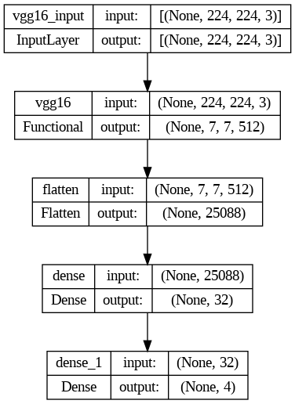
FIGURE 3. VGG16 Model Architectural Design

As any pre-trained models, VGG16 [20] requires extensive training if the weights start from random values. Typically, Convolutional Neural Network (CNN) models employ transfer learning (TL) techniques [24]. TL involves using a model trained on one task for another similar task. This means training a CNN model on a related problem, where the input remains the same, but the output differs. For instance, the VGG16 model [25] is trained on the ImageNet dataset, which includes a variety of real-world object images.

RESULTS AND DISCUSSION
This section talks about how the data is processed and ends with an evaluation using parameters such as accuracy, recall, precision, and F1-Score.After evaluating, we will make a comparison between the accuracy value and earlier studies that used the same dataset. Additionally, this study makes use of the confusion matrix, which furnishes information regarding the comparison of prediction outcomes from the categorization performed by the model.

NETWORK MODEL
At the evaluation stage of this research, a comparative test of the CNN and VGG16 models will be carried out to obtain the best performance from the developed model.
The model uses VGG16 as its base with output (None, 7, 7, 512) and total parameters 14.714.688. Followed by a Flatten layer to produce a one-dimensional vector with 25.088 elements. There are two Dense layers after that, each with 32 and 4 neuron units, total parameters 802.848 and 132. The total parameters of the entire model are 15.517.668, non-retrainable, and the rest from the Dense layer additional training. TABLE 1 shows the details of the Architectural VGG16 Model.

TABLE 1. Architectural VGG16 Model Summary
Layer (Type) | Output Shape | Param
VGG16 (Functional) | (None, 7, 7, 512) | 14714688
Flatten (Flatten) | (None, 25088) | 0
dense (Dense) | (None, 32) | 802848
dense_ (Dense) | (None, 4) | 132

At this stage, the model is compiled using the Adam optimizer with a learning rate of 0.001, the loss function chosen is categorical cross entropy, and the metric to be evaluated is accuracy. This compilation process aims to determine how the model will update its weights based on the loss values ​​generated when training, as well as evaluation metrics that will be used to monitor model performance during training. With this configuration, the model is ready to be trained with previously prepared training data.

MODEL EVALUATION
Once the model training is complete, the next step is to evaluate its performance using various methods such as classification reports, confusion matrices, and accuracy and loss graphs. The purpose of this evaluation is to understand the model performance, compare the effectiveness of several models, and identify problems such as bias or overfitting.

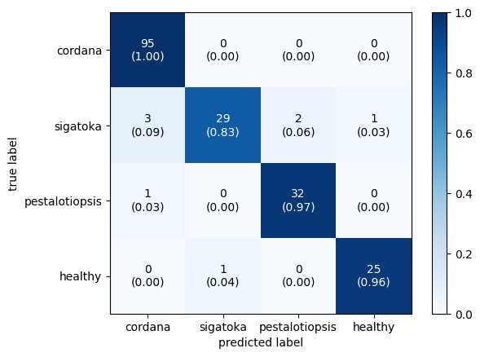
FIGURE 2. Confusion Matrix Model Evaluation Results

It can be seen in FIGURE 2, that in the Cordona class there are 95 data with correct predictions, and there are no wrong predictions in the data. In the Sigatoka class there are 29 data with correct predictions, and 6 data with wrong predictions. In the Pestalotiopsis class there are 32 data with correct predictions, 1 data with wrong predictions. In the Healthy class there are 25 data with correct predictions and 1 data with wrong predictions.

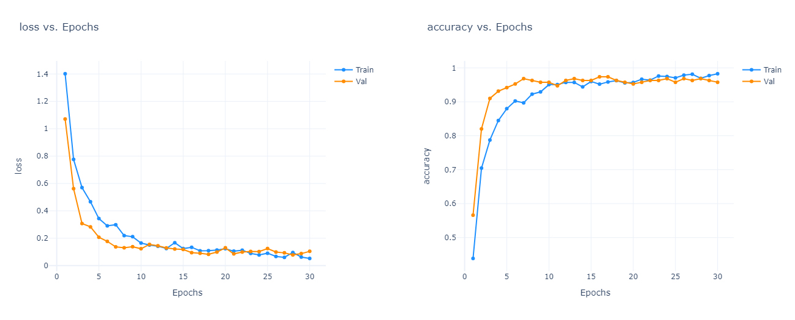
(a) (b)
FIGURE 3. (a) Loss Model Graph Evaluation Results (b) Model Accuracy Graph Evaluation Results

During the training process of the VGG16 architecture model, two graphs were created, namely the loss graph and the accuracy graph in FIGURE 3. The loss graph and accuracy graph show how the loss and accuracy values ​​of the model change over time during the training process. The model achieved the best performance with the highest accuracy of 95.77%, and the lowest loss of 0.1044. The model has been well trained and is able to achieve high performance in identifying diseases on banana leaves.

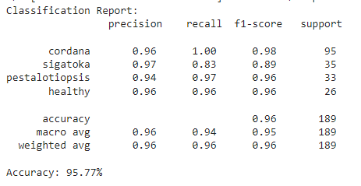
FIGURE 4. Classification Report VGG16

In the classification report that can be seen in FIGURE 4, we can see things like accuracy, which tells us overall how often our model is correct. We also see precision, recall, and F1 Score, which give us insights into how well our model is doing at correctly identifying different classes.

MODEL PERFORMANCE COMPARISON
In this study, the model that has been built using VGG16 will be compared with other models in the form of CNN. CNN is a type of artificial neural network specifically designed to process data that has a grid pattern, such as images. CNN consists of several layers, including convolutional layers, pooling layers, and fully connected layers.
TABLE 2 shows the details of the Architectural CNN Model which is built on this study.

TABLE 2. Architectural CNN Model Summary
Layer (Type) | Output Shape | Param
conv2d_4 (Conv2D) | (None, 222, 222, 32) | 896
dropout_4 (Dropout) | (None, 222, 222, 32) | 0
max_pooling2d_4 (MaxPooling2D) | (None, 111, 111, 32) | 0
conv2d_5 (Conv2D) | (None, 100, 100, 64) | 18496
dropout_5 (Dropout) | (None, 100, 100, 64) | 0
max_pooling2d_5 (MaxPooling2D) | (None, 54, 54, 64) | 0
conv2d_6 (Conv2D) | (None, 52, 52, 128) | 73856
dropout_6 (Dropout) | (None, 52, 52, 128) | 0
max_pooling2d_6 (MaxPooling2D) | (None, 26, 26, 128) | 0
conv2d_7 (Conv2D) | (None, 24, 24, 256) | 295168
dropout_7 (Dropout) | (None, 24, 24, 256) | 0
max_pooling2d_7 (MaxPooling2D) | (None, 12, 12, 256) | 0
flatten_7 (Flatten) | (None, 36864) | 0
dense_2 (Dense) | (None, 512) | 18874880
dense_3 (Dense) | (None, 4) | 2852

The resulting CNN model has a layered architecture, starting with a convolutional layer (Conv2D) with 32 filters, followed by dropout and max pooling to reduce dimensionality. This is followed by three additional convolutional layers with increasing filters (64, 128, and 256), followed by dropout and max pooling, respectively. After the convolutional layers, the model is flattened into a one-dimensional vector with 36,864 units, then passed to a dense layer with 512 units using ReLU activation, and finally to an output layer with 4 units using softmax activation for classification. The model has a total of 19,265,348 trainable parameters, indicating a fairly high complexity in capturing features from banana leaf images for disease classification. The following CNN training model can be seen in FIGURE 5.

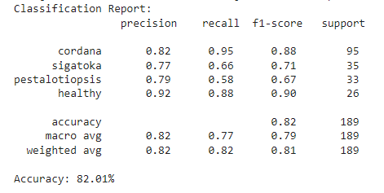
FIGURE 5. Classification Report CNN

TABLE 3. Model Performance Comparison
Model | Accuracy (%)
VGG16 | 95.77
CNN | 82.01

TABLE 3 shows the comparison of the accuracy performance of both models using VGG16 and CNN. VGG16 which has been optimized with advanced training techniques such as optimizers helps in achieving stable convergence. This makes VGG16 superior in performance and accuracy compared to the simple CNN model when used to classify diseases on banana leaves.

CONCLUSIONS
This study evaluates the application of the Convolutional Neural Network (CNN) method with the VGG16 architecture model to detect diseases in banana leaves. The results showed that the VGG16 model successfully achieved an accuracy of 95.77% in classifying diseases in banana leaves. This shows that VGG16, with its architectural depth and the use of optimization and regularization techniques such as dropout and batch normalization, is very effective in capturing complex features of banana leaf images and is able to provide very accurate classification results.
Based on the results of this study, to improve the accuracy and generalization of the model, it is recommended to use a larger and more diverse dataset, and apply data augmentation techniques such as rotation and lighting changes. In addition, exploration of other newer CNN models such as ResNet or EfficientNet can provide better performance. Combining multiple models with ensemble techniques can also improve prediction accuracy. Continuous evaluation with new datasets and different field conditions is important to ensure the model remains effective and accurate over time.

ACKNOWLEDGMENTS
This manuscript is based on research supported by the Informatics Study Program, Muhammadiyah University of Malang. The author also would like to thank the UMM Informatics Laboratory for supporting the implementation of this research.

REFERENCES
1. Anbi, M.N., et al., Sistem Pakar Diagnosis Penyakit dan Hama Tanaman Pisang dengan Metode Classical Probability. Krea-TIF: Jurnal Teknik Informatika, 2022. 10(1): p. 51-58.
2. Halim, J. and A.N. Fajar, Klasifikasi Pisang Berbasis Algoritma VGG16 Melalui Metode CNN Deep Learning. INFORMASI (Jurnal Informatika dan Sistem Informasi), 2023. 15(1): p. 1-17.
3. Nugrahani, A. and K.A. Parela, Leksikalisasi Pembungkus Tradisional Dari Daun Pisang: Kajian Etnosemantik. ALINEA: Jurnal Bahasa, Sastra dan Pengajarannya, 2022. 2(2): p. 148-159.
4. Huda, F. and M.P.K. Putra, Klasifikasi Jenis Buah Pisang Menggunakan Algoritma Convolutional Neural Network. Journal of Artificial Intelligence and Technology Information, 2023. 1(3): p. 100-105.
5. Andreanov, R., S. Aries, and R. Chaerur, Disease Detection in Banana Leaf Plants using DenseNet and Inception Method. Jurnal RESTI (Rekayasa Sistem dan Teknologi Informasi), 2022. 6(5).
6. Hasan, M.A., Y. Riyanto, and D. Riana, Grape leaf image disease classification using CNN-VGG16 model. J. Teknol. dan Sist. Komput, 2021. 9(4): p. 218-223.
7. Ilham Rahmana, S., et al., CNN Method to Identify the Banana Plant Diseases based on Banana Leaf Images by Giving Models of ResNet50 and VGG-19. Jurnal RESTI (Rekayasa Sistem dan Teknologi Informasi), 2023. 7(6).
8. Albakia, S.A.E. and R.A. Saputra, Identifikasi Jenis Daun Tanaman Obat Menggunakan Metode Convolutional Neural Network (CNN) Dengan Model VGG16. Jurnal Informatika Polinema, 2023. 9(4): p. 451-460.
9. Gunawan, R.J., B. Irawan, and C. Setianingsih, Pengenalan Ekspresi Wajah Berbasis Convolutional Neural Network Dengan Model Arsitektur VGG16. eProceedings of Engineering, 2021. 8(5).
10. Krishnan, V.G., et al., An automated segmentation and classification model for banana leaf disease detection. Journal of Applied Biology and Biotechnology, 2022. 10(1): p. 213-220.
11. Krishnaswamy Rangarajan, A. and R. Purushothaman, Disease classification in eggplant using pre-trained VGG16 and MSVM. Scientific reports, 2020. 10(1): p. 2322.
12. Huda, P.A.P., A.A. Riadi, and E. Evanita, Klasifikasi Penyakit Tanaman pada Daun Apel dan Anggur Menggunakan Convolutional Neural Networks. JURNAL MANAJEMEN INFORMATIKA (JUMIKA), 2021. 8(1).
13. Setiawan, M.J., B. Nugroho, and A.P. Sari, Klasifikasi Penyakit Daun Tanaman Menggunakan Algoritma CNN dan Random Forest: Classification Leaf Diseases. Teknologi: Jurnal Ilmiah Sistem Informasi, 2023. 13(2): p. 12-18.
14. Whardana, A.K., et al., Klasifikasi Penyakit Daun Anggur dengan Menggunakan Convolutional Neural Network dan Transfer Learning dari VGG16. Jurnal SISKOM-KB (Sistem Komputer dan Kecerdasan Buatan), 2024. 7(2): p. 198-202.
15. Mazdavilaya, T.K., et al., Implementasi VGG 16 dan Augmentasi Zoom Untuk Klasifikasi Kematangan Sawit. KLIK: Kajian Ilmiah Informatika dan Komputer, 2024. 4(6): p. 2881-2891.
16. Pranita, E., Analisis Karakterisasi Penyakit pada Tanaman Pisang Menggunakan Kamera Termal dengan Metode Tresholding. 2021.
17. Yuliany, S. and A.N. Rachman, Implementasi Deep Learning pada Sistem Klasifikasi Hama Tanaman Padi Menggunakan Metode Convolutional Neural Network (CNN). Jurnal Buana Informatika, 2022. 13(1): p. 54-65.
18. Rasidi, A.I., et al., Klasifikasi sampah organik dan non-organik menggunakan convolutional neural network. Jurnal Teknik Informatika dan Sistem Informasi, 2022. 8(1): p. 142-149.
19. Azmi, K., S. Defit, and S. Sumijan, Implementasi Convolutional Neural Network (CNN) Untuk Klasifikasi Batik Tanah Liat Sumatera Barat. JURNAL UNITEK, 2023. 16(1): p. 28 - 40.
20. Nining Putri, N., et al., KLASIFIKASI PENYAKIT EARLY BLIGHT DAN LATE BLIGHT PADA TANAMAN TOMAT BERDASARKAN CITRA DAUN MENGGUNAKAN METODE CNN BERBASIS WEBSITE. Jurnal Kecerdasan Buatan dan Teknologi Informasi, 2022. 1(3): p. 27-35.
21. Alwanda, M.R., R.P.K. Ramadhan, and D. Alamsyah, Implementasi metode convolutional neural network menggunakan arsitektur LeNet-5 untuk pengenalan doodle. Jurnal Algoritme, 2020. 1(1): p. 45-56.
22. Kurniawan, H., K. Kusrini, and K. Kusnawi, Klasifikasi Pengenalan Wajah Siswa Pada Sistem Kehadiran dengan Menggunakan Metode Convolutional Neural Network. Jurnal Media Informatika Budidarma, 2023. 7(2): p. 846-856.
23. Ety, S., et al., Penerapan Model Arsitektur VGG16 Untuk Klasifikasi Jenis Sampah. Decode: Jurnal Pendidikan Teknologi Informasi, 2023. 3(2): p. 407-419.
24. Hindarto, D., Comparison Accuracy of CNN and VGG16 in Forest Fire Identification: A Case Study. Journal of Computer Networks, Architecture and High Performance Computing, 2023. 6(1): p. 137-148.
25. Saputro, A., et al., DEEP TRANSFER LEARNING DENGAN MODEL ARSITEKTUR VGG16 UNTUK KLASIFIKASI JENIS VARIETAS TANAMAN LENGKENG BERDASARKAN CITRA DAUN. JATI (Jurnal Mahasiswa Teknik Informatika), 2022. 6(2): p. 609-614.

