U-Net Segmentation Driven CNN for Corn Leaf Diseases Detection
Zumro’atul Afifah^{1,a)}, Fath’ Hana Sarla Bajsair^{2,b)}, Yufis Azhar^{3,c)}, and Vinna Rahmayanti Setyaning Nastiti^{4,d)}
¹Informatics Engineering, University of Muhammadiyah Malang, Malang, Indonesia

^{d)} Corresponding author: vinastiti@umm.ac.id
^{a)} zumroatulafifah123@webmail.umm.ac.id
^{b)} sarlabajsair@webmail.umm.ac.id
^{c)} yufis@umm.ac.id

Abstract. Global agricultural productivity and food security heavily depend on corn as one of the world's most important staple crops. However, corn production in Indonesia has declined over the past two years, due to pests and diseases that significantly affect crop yields. This study proposes an innovative approach using a Convolutional Neural Network (CNN) combined with U-Net segmentation architecture to detect corn leaf diseases early, unlike previous methods that only use CNN without image segmentation. This study develops a predictive model using U-Net architecture for image segmentation that helps classify each pixel in a corn leaf image into disease-infected and healthy leaf categories. The dataset used consists of 2.152 images with a data division of 80% for training, 15% for validation, and 5% for testing, the results obtained a training accuracy of 95% and a validation accuracy of 92%. Then the model was tested using testing data with a testing accuracy of 92%. Implementing the CNN model with the U-Net architecture allows for precise and accurate detection of corn plant diseases in the field so that farmers can easily identify and treat their corn leaf diseases. This research is expected to provide solutions to improve farmer welfare and national economic stability by increasing corn harvest yields.
Keywords: CNN, U-Net, Corn Leaf Diseases, Image Segmentation, Agriculture

INTRODUCTION
Based on information from the FAO Statistical Yearbook 2023, corn is one of the most important staple crops in the world that influences global food security. Corn not only provides a primary food source for millions of people in various countries but is also an important raw material in the animal feed industry and various processed products. With its vital role, corn is the foundation of global food security and contributes significantly to maintaining the welfare of the world's people [1].
Corn plants, as one of the agricultural commodities in Indonesia, have faced production challenges over the past two years [2]. This condition has an impact on the country's economy and the welfare of farmers, who have experienced a decline in harvest yields. According to data from the Central Statistics Agency (BPS), corn production in 2023 decreased by 1.75 million tons or 10.61 percent compared to 2022 . This is caused by several factors, one of which is a disease that attacks corn plants. [3]. Diseases in corn plants occur due to several components, such as pathogens (parasites), hosts (parents), and the environment [4]. Basically, corn plant diseases are primarily known to farmers who are experienced in managing corn crops [5]. Therefore, early detection and accurate, real-time monitoring of corn diseases are very important during the planting season to reduce the impact of crop losses.
To address this issue, several prior studies have been carried out by [6] to detect and classify three corn leaf diseases using the Convolutional Neural Network (CNN) method, achieving an accuracy of 90%. Furthermore, research by [7] implemented the Screening-based Sparse Classifier method to detect four corn leaf diseases, achieving a classification accuracy of 88.55%. Based on the various studies mentioned above, the accuracy value is still regarded as relatively low, as this study relies solely on CNN without employing image segmentation or other supplementary methods. Image segmentation integration is essential for enhancing accuracy in image processing by partitioning the image into segments that are simpler to analyze. Image segmentation allows for the isolation and extraction of relevant information more efficiently, facilitating the identification and tracking of objects within images.
One of the most effective and efficient methods for image segmentation is using the U-Net deep learning model. This approach has demonstrated a high level of accuracy in detecting and segmenting areas impacted by the disease [8]. This U-Net method has been extensively utilized across various fields, including biomedical imaging for brain tumor segmentation and environmental applications such as road and satellite mapping. The primary features of U-Net comprise a symmetric architecture, which includes a contraction path (downsampling) and an expansion path (upsampling). Additionally, it effectively captures spatial features through skip connections that link symmetric layers between the contraction and expansion paths. U-Net operates at the pixel level and employs the ReLu activation function to achieve high accuracy results [9]. In this study, the U-Net method will be utilized for the segmentation of agricultural images related to corn leaf diseases.
This study aims to develop and test U-Net segmentation on three corn leaf diseases and one healthy corn leaf, including Nothern Leaf Blight, Gray Leaf Spot, Common Rust, and Healthy corn leaves. The urgency of this research stems from the necessity for real-time and accurate disease detection solutions to enhance crop yields and food security.

METHODS
This study aims to classify various types of corn leaf diseases using image processing techniques, specifically U-Net segmentation. In this corn leaf disease research methodology, the research flow will be presented visually to describe it clearly and precisely. The stages of the research can be outlined in the research method flow as shown in FIGURE 1.
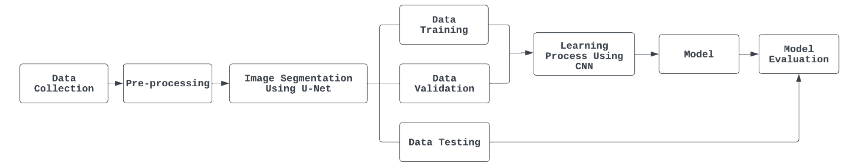
FIGURE 1. Research Method

DATASET
The corn leaf disease images used in this study consist of 2.152 images, depicting three corn leaf diseases and one healthy corn leaf. This dataset is sourced from the “Corn Diseases” collection on Kaggle.com. FIGURE 2 The following shows some sample of corn leaf datasets:

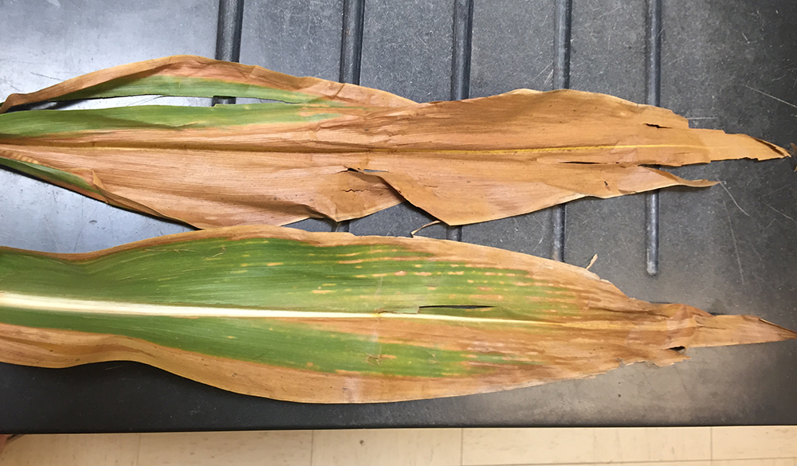 | 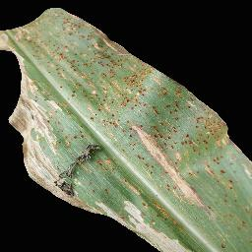 | 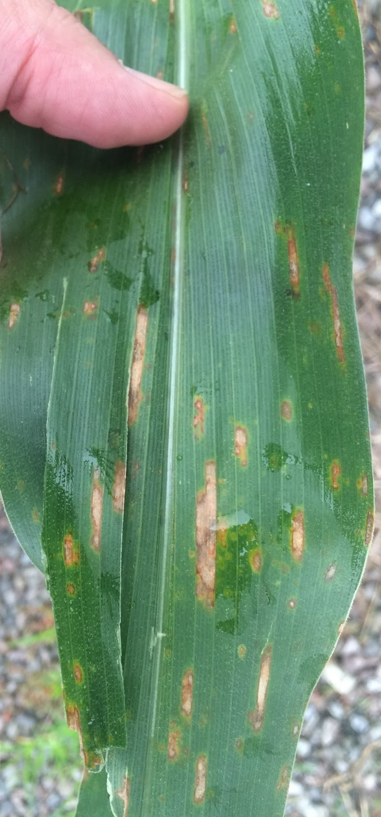 | 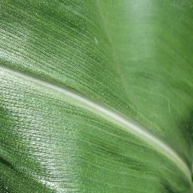
(a) | (b) | (c) | (d)

FIGURE 2. Sample datasets of (a) Nothern Leaf Blight, (b) Common Rust, (c) Gray Leaf Spot, (d) Healthy

PREPROCESSING
Data preprocessing is the first step before the data is processed and utilized for classification [10]. At this stage, the image data will be classified and labeled into four categories: Northern Leaf Blight, Gray Leaf Spot, Common Rust, and Healthy. The image size in this study was adjusted to 128 x 128 pixels, and the batch size was changed to 32. After the preprocessing stage, the dataset is prepared for processing with the appropriate algorithm. This preprocessing step is crucial for organizing the data, ensuring it can be processed effectively and accurately by the algorithm that will be employed [11].

IMAGE SEGMENTATION USING U-NET
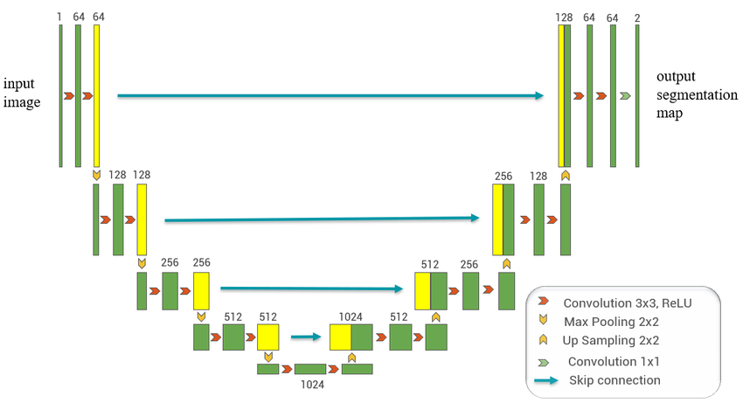
FIGURE 3. U-Net Architecture

FIGURE 3 The diagram illustrates the architecture of the U-Net network, which comprises a contraction path (on the left) and an expansion path (on the right). The contraction path adheres to a convolutional network architecture, consisting of the repeated application of two 3x3 convolutions (unlayered convolutions), followed by a rectified linear unit (ReLu) and a 2x2 max pooling operation with a stride size of 2 for downsampling. At each downsampling step, the number of feature channels is doubled. Each step in the expansion path includes upsampling and a feature map, followed by a 2x2 convolution (“up-convolution”) that reduces the number of feature channels by half, concatenation with the cropped feature map from the contraction path, and two 3x3 convolution operations, each followed by ReLu. The cropping is essential to address the boundary pixel loss that occurs with each convolution. In the final layer, a 1x1 convolution is employed to map the feature vector with 64 components to the required number of classes. Overall, this network consists of 23 convolutional layers. To ensure a smooth segmentation map, the input size should be selected so that all 2x2 max pooling operations are applied to even x and y dimension layers. FIGURE 4 below are the image results obtained through U-Net segmentation.

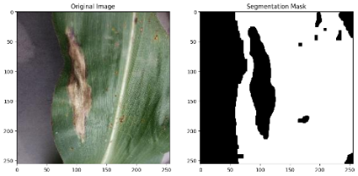 | 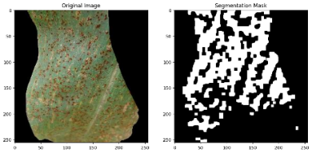
(a) | (b)
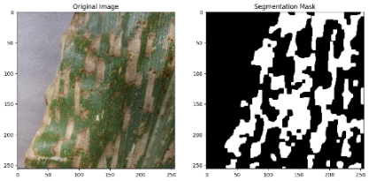 | 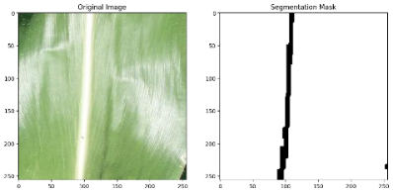
(c) | (d)

FIGURE 4. Segmentation Results of (a) Nothern Leaf Blight, (b) Common Rust, (c) Gray Leaf Spot, (d) Healthy

LEARNING PROCESS USING CNN
Model training entails splitting the dataset into training, validation, and testing sets in a ratio of 80:15:5. During the training process, the parameters are optimized using the Adam (Adaptive Moment Estimation) method, with a learning rate of 0.0001, to ensure more stable convergence and prevent overshooting. The model is trained and validated using the Categorical Cross-Entropy loss function to assess the uncertainty between the predicted probability distribution and the actual distribution [13]. Accuracy is used as a metric to track the percentage of correct predictions during training and evaluation. The training process is carried out for 10 epochs and will be stopped when the specified conditions are met.

EVALUATION MODEL
Next, model evaluation is carried out; this aims to assess the performance of the trained model using testing data. This process is important to understand how well the model works. This process involves several important parameters, such as precision, which measures the accuracy of the model's positive predictions [14]. Recall, which measures the model's ability to find all true positive samples [15] and F1-Score, which provides an overview of the balance between precision and recall [16]. Additionally, Support provides context about the number of samples from each class in the dataset. Accuracy measures how often the model makes correct predictions overall. Macro AVg measures the overall performance of the model without considering the class distribution, while weighted avg takes the class distribution into account [17]. These parameters allow for a comprehensive evaluation of model performance, both for each individual class and as a whole.

RESULTS AND DISCUSSION
Overall, the results show that the model with U-Net segmentation is able to classify corn leaf diseases with a very good level of accuracy on training data of 95% and an accuracy level on validation data of 92%. FIGURE 5 and FIGURE 6 are the graphic visualization results of training iterations for 10 epochs.

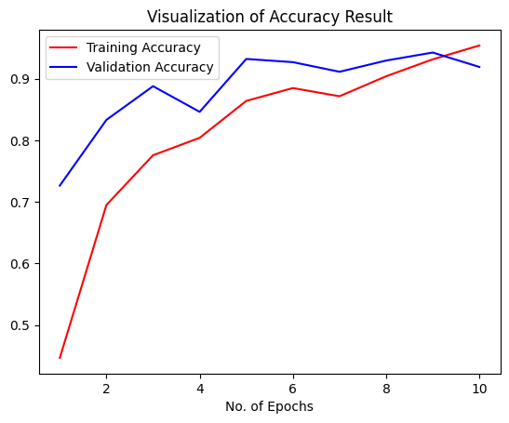
FIGURE 5. Accuracy Result

In FIGURE 6 it can be seen that there is a decrease in validation accuracy at several points, which shows a slight indication of overfitting. This can occur because the validation data used is not representative enough or there are natural fluctuations in performance because the data used for validation is different in each epoch. In addition, the lack of regularization can cause the model to fit too much to the validation data, so that it cannot generalize well and cause a decrease in accuracy on the validation data.

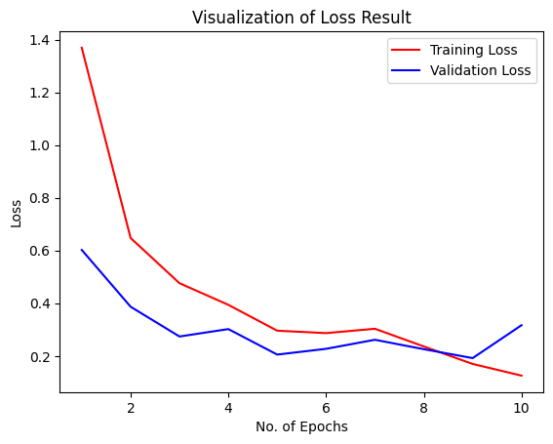
FIGURE 6. Loss Result

In FIGURE 7 the increase in validation loss in several epochs indicates the beginning of overfitting, where the model begins to be overtrained on the training data and performance on the validation data decreases. However, the difference is still relatively small. This could be caused by unrepresentative validation data or a lack of regularization techniques. To overcome the problem of overfitting and instability of model performance, further evaluation of the trained model is needed.
TABLE 1 below shows the comparison results of the evaluation of the corn leaf disease classification model without segmentation with a model using U-Net segmentation. Model performance varies based on the use of segmentation. The following table summarizes the precision, recall, and f1-score metrics, as well as accuracy for each class.
TABLE 1. Comparison of Results Without Segmentation and Segmentation Using U-Net
Corn Leaf Disease | Without Segmentation |  |  |  | Using Segmentation U-Net
Corn Leaf Disease | precision | recall | f1-score | acc | precision | recall | f1-score | acc
Common_Rust | 0.99 | 0.99 | 0.99 | 93% | 0.99 | 0.99 | 0.99 | 95%
Gray Leaf Spot | 0.75 | 0.53 | 0.82 | 93% | 0.76 | 0.90 | 0.82 | 95%
Healthy | 0.91 | 1.00 | 0.95 | 93% | 0.95 | 1.00 | 0.97 | 95%
Nothern Leaf Blight | 0.81 | 0.73 | 0.83 | 93% | 0.95 | 0.75 | 0.87 | 95%

Based on the table above, it can be seen that the use of a model with U-Net segmentation is able to improve the overall performance of the model. The model with segmentation achieved an accuracy of 95%, higher than the model without segmentation, which reached 93%. Especially in detecting common rust disease and healthy leaf conditions. However, detection of Gray Leaf Spot and Northern Leaf Blight diseases still needs improvement, as shown by the precision and recall values lower than other classes, so this evaluation provides insight for further improvement steps in the development of corn disease classification models. In this study, when compared to research conducted by [8], which implemented the Screening-based Sparse Classifier method and obtained classification accuracy results of only 88.55%, the results of this U-Net segmentation study were able to show superior performance.

CONCLUSIONS
This study successfully created a prediction model using the U-Net architecture approach on the Convolutional Neural Network (CNN) to help sort each pixel in an image of a corn leaf into two groups: areas with diseased leaves and areas with healthy leaves. This approach makes it easier for CNN to perform detection with higher accuracy compared to the CNN method without segmentation, which only achieved 93% accuracy and in previous studies using the Screening-based Sparse Classifier which only achieved 88.5% accuracy. The U-Net segmentation model implemented in this study was able to achieve a training accuracy of 95%, a validation accuracy of 92%, and a testing accuracy of 92% higher than the model without segmentation and the Screening-based Sparse Classifier method, which shows that the model with U-Net segmentation has good overall performance.
However, the detection of Gray Leaf Spot and Northern Leaf Blight diseases still needs improvement. to be able to recognize and classify corn diseases well. Therefore, further research is needed to optimize this model, including the addition of more diverse training data, hyperparameter adjustment, and exploration of more effective data augmentation techniques.

ACKNOWLEDGMENTS
We would like to express our deepest gratitude to all parties who have provided support and contributions in completing this research. First of all, we would like to express our sincere gratitude to our supervisor for the guidance, direction, and invaluable knowledge in directing this research towards a satisfactory conclusion. Without the assistance and encouragement of our supervisor, this research would not have achieved the desired results. We would also like to express our gratitude to our family, friends, and colleagues for their moral support and motivation during the research process. Their words of encouragement and support have motivated us to overcome the challenges and difficulties that have arisen. Last but not least, we would like to express our gratitude to all authors, researchers, and practitioners in this field who have contributed through their works. This research cannot be separated from their contributions and scientific thoughts.

REFERENCES
1. Saefudin, S., STRATEGI PERENCANAAN MENGHADAPI KRISIS PANGAN DAN EL NINO. Warta BSIP Perkebunan, 2023. 1(3): p. 21-30.
2. Ashwini, C. and V. Sellam. Analyzing The Prediction Accuracy Of Corn Leaf Diseases Using A Pre-Trained Network Model. IEEE.
3. Taus, I. and H.D. Tukan, Identifikasi Penyebab Gagal Panen Jagung Lamuru (Studi Kasus Pada Kelompok Tani Stiper Flores Bajawa Desa Turekisa Kecamatan Golewa Barat). Jurnal Agriovet, 2022. 4(2): p. 143-152.
4. Rahmanita, E., et al., Implementasi Metode Naive Bayes dan Information Gain Untuk Klasifikasi Penyakit dan Hama Tanaman Jagung. Teknika, 2023. 12(3): p. 198-204.
5. Azizah, Q.N., Klasifikasi Penyakit Daun Jagung Menggunakan Metode Convolutional Neural Network AlexNet. sudo Jurnal Teknik Informatika, 2023. 2(1): p. 28-33.
6. Akhyari, M.W., A. Suyoto, and F.W. Wibowo, Klasifikasi Penyakit Pada Daun Jagung Menggunakan Convolutional Neural Network. Jurnal Informa: Jurnal Penelitian dan Pengabdian Masyarakat, 2021. 7(2).
7. Acharya, A.K., et al., Screening based sparse classification method for the detection of corn leaf diseases.
8. Suta, I., M. Sudarma, and I.N.S. Kumara, Segmentasi Tumor Otak Berdasarkan Citra Magnetic Resonance Imaging Dengan Menggunakan Metode U-NET. Majalah Ilmiah Teknologi Elektro, 2020. 19(2): p. 151.
9. Chen, L.-C., et al. Encoder-decoder with atrous separable convolution for semantic image segmentation.
10. Arifin, T. and A. Herliana, Optimasi decision tree menggunakan particle swarm optimization untuk identifikasi penyakit mata berdasarkan analisis tekstur. Jurnal Teknologi Dan Sistem Komputer, 2020. 8(1): p. 59-63.
11. Li, L.-H. and R. Tanone, Improving Robustness Using MixUp and CutMix Augmentation for Corn Leaf Diseases Classification based on ConvMixer Architecture. Journal of ICT Research & Applications, 2023. 17(2).
12. Guo, Y., et al., Cloud detection for satellite imagery using attention-based U-Net convolutional neural network. Symmetry, 2020. 12(6): p. 1056.
13. Chen, C.-H., et al. Robust multi-class classification using linearly scored categorical cross-entropy. IEEE.
14. Murdoch, W.J., et al., Interpretable machine learning: definitions, methods, and applications. arXiv preprint arXiv:1901.04592, 2019.
15. Chy, M.S.R., et al. Classifying Corn Leaf Diseases using Ensemble Learning with Dropout and Stochastic Depth Based Convolutional Networks.
16. Humphrey, A., et al., Machine-learning classification of astronomical sources: estimating F1-score in the absence of ground truth. Monthly Notices of the Royal Astronomical Society: Letters, 2022. 517(1): p. L116-L120.
17. Kassem, M.A., et al., Machine learning and deep learning methods for skin lesion classification and diagnosis: a systematic review. Diagnostics, 2021. 11(8): p. 1390.

