A Dataset on UX Journey Activities for Enhancing Novice Requirement Engineer Productivity and Self-Efficacy
Wahyu Andhyka Kusuma^{1,2,a)}, Azrul Jantan^{2,b)}, Noris Norowi^{2,c)}, Novia Admodisastro^{2,d)}, Briansyah Setio^{1,e)}, Evi Wahyuni^{1,f)} and Ilyas Nuryasin^{1,g)}
¹Department of Informatics Engineering, University of Muhammadiyah Malang, Malang, Indonesia
²Department of Informatics Engineering, Universiti Putra Malaysia, Selangor, Malaysia

^{a)} Corresponding author: kusuma.wahyu.a@gmail.com
^{b)} azrul@upm.edu.my
^{c)} noris@upm.edu.my
^{d)} novia@upm.edu.my
^{e)} brian@umm.ac.id
^{f)} evidwi@umm.ac.id
^{g)} ilyas@umm.ac.id
Abstract. This data describes data on student and novice developers' productivity and self-efficacy toward software requirement activity at an Indonesian higher education institution during 2022-2023. This study was conducted with 400 full-time students at Universitas Muhammadiyah Malang. All respondents were determined using purposive sampling. Criteria for the respondents are students that pass software engineering and software requirement courses. To gather the data for productivity, the UX Journey workbook was employed, and all respondents were required to record their activity and write the time to complete each activity in the workbook. The General Self-Efficacy Scale (GSE) developed by Schwarzer was used for self-efficacy. The dataset is available as an image in the PDF file and table data of Microsoft Excel. The collected data would be significant and provide new insight concerning novice developer productivity and self-efficacy regarding requirement quantity, requirement quality, time to work, and optimistic self-beliefs to cope with various difficult demands in work. The dataset would be significant for researchers, lecturers, tutors, and curriculum developers designing appropriate educational programs to enhance student software requirement skills.
Keywords: Solo software development, student motivation, student performance, optimistic self-beliefs

INTRODUCTION
Software development is a particular process, meaning each feature of the user and business processes within the user's organization differs from the user needs of others. Previous studies have explained that no software process currently exists in scientific articles, books, and standards that can guarantee that the software can be delivered successfully to users [1] . Efforts to identify the features of the software requirements are important activities to ensure the success of the software. At least it was reported from previous research that four features can determine it, consisting of complexity [2, 3], suitability, changeability [4-6], and transparency. The useful developer’s soft skill is to grasp the characteristics that help the developer increase the success of software products or services. The four primary feature that determines the software product's success is a socio-technical skill [4, 5, 7]. This important soft skill determines understanding what users need from a more human point of view. This expertise complies with the principles of user-collaborative development appropriate in modern development methods. Self-efficacy is a socio-technical skill concerning a person's belief in his ability to achieve certain goals [6, 8].
A pilot test was conducted to ensure the robustness of the UX Journey activity. For our pilot, we took 115 responses and checked the timing consistency of each activity. Each respondent in the pilot study has the same task and topic. They voluntarily work on the topic of big data, disability, and education. After the pilot survey, we conducted a final experiment with 247 students through regular weekly meetings. Data collection is done by selecting students who have passed software engineering courses. They were offered to participate in data collection. Students who agree to participate in data collection are then given directions for each activity, for each student will work on five different projects. At the end of each project, they will collect UX Journey worksheets, work videos, and test reports and fill out the GSE questionnaire (available at https://github.com/uxjourney/requirement). Each project is given two weeks with sequential topics ordering train or plane tickets using common elicitation techniques, booking train or plane tickets using UX Journey, technology for children, technology for the elderly, and technology for people with mental illnesses.

METHODS
The research was conducted in three stages: briefing, experimentation, and data analysis, as given in FIGURE 1. This dataset's respondent population comprises students enrolled in a capstone project course. Each student was allowed to choose whether to participate in this research project. If they chose to participate, they were provided with guidance on the scope of the research and permission to collect certain information. During this process, students were also informed that there would be no consequences for joining or declining to participate in grades, academics, or other aspects. Those who expressed their willingness were then explained the activities they had to perform. In this case, two methods were explained to them: the first method involved simple elicitation techniques. In contrast, the second method involved elicitation techniques available in the UX Journey activity book, as given in FIGURE 2. The orientation process, including activity explanations, took approximately two weeks until the students indicated their understanding of what must be done. The final stage of the orientation phase involved informing them that they could stop at any time if they felt frustrated or burdened by the activities and assuring them that this would not have any implications.

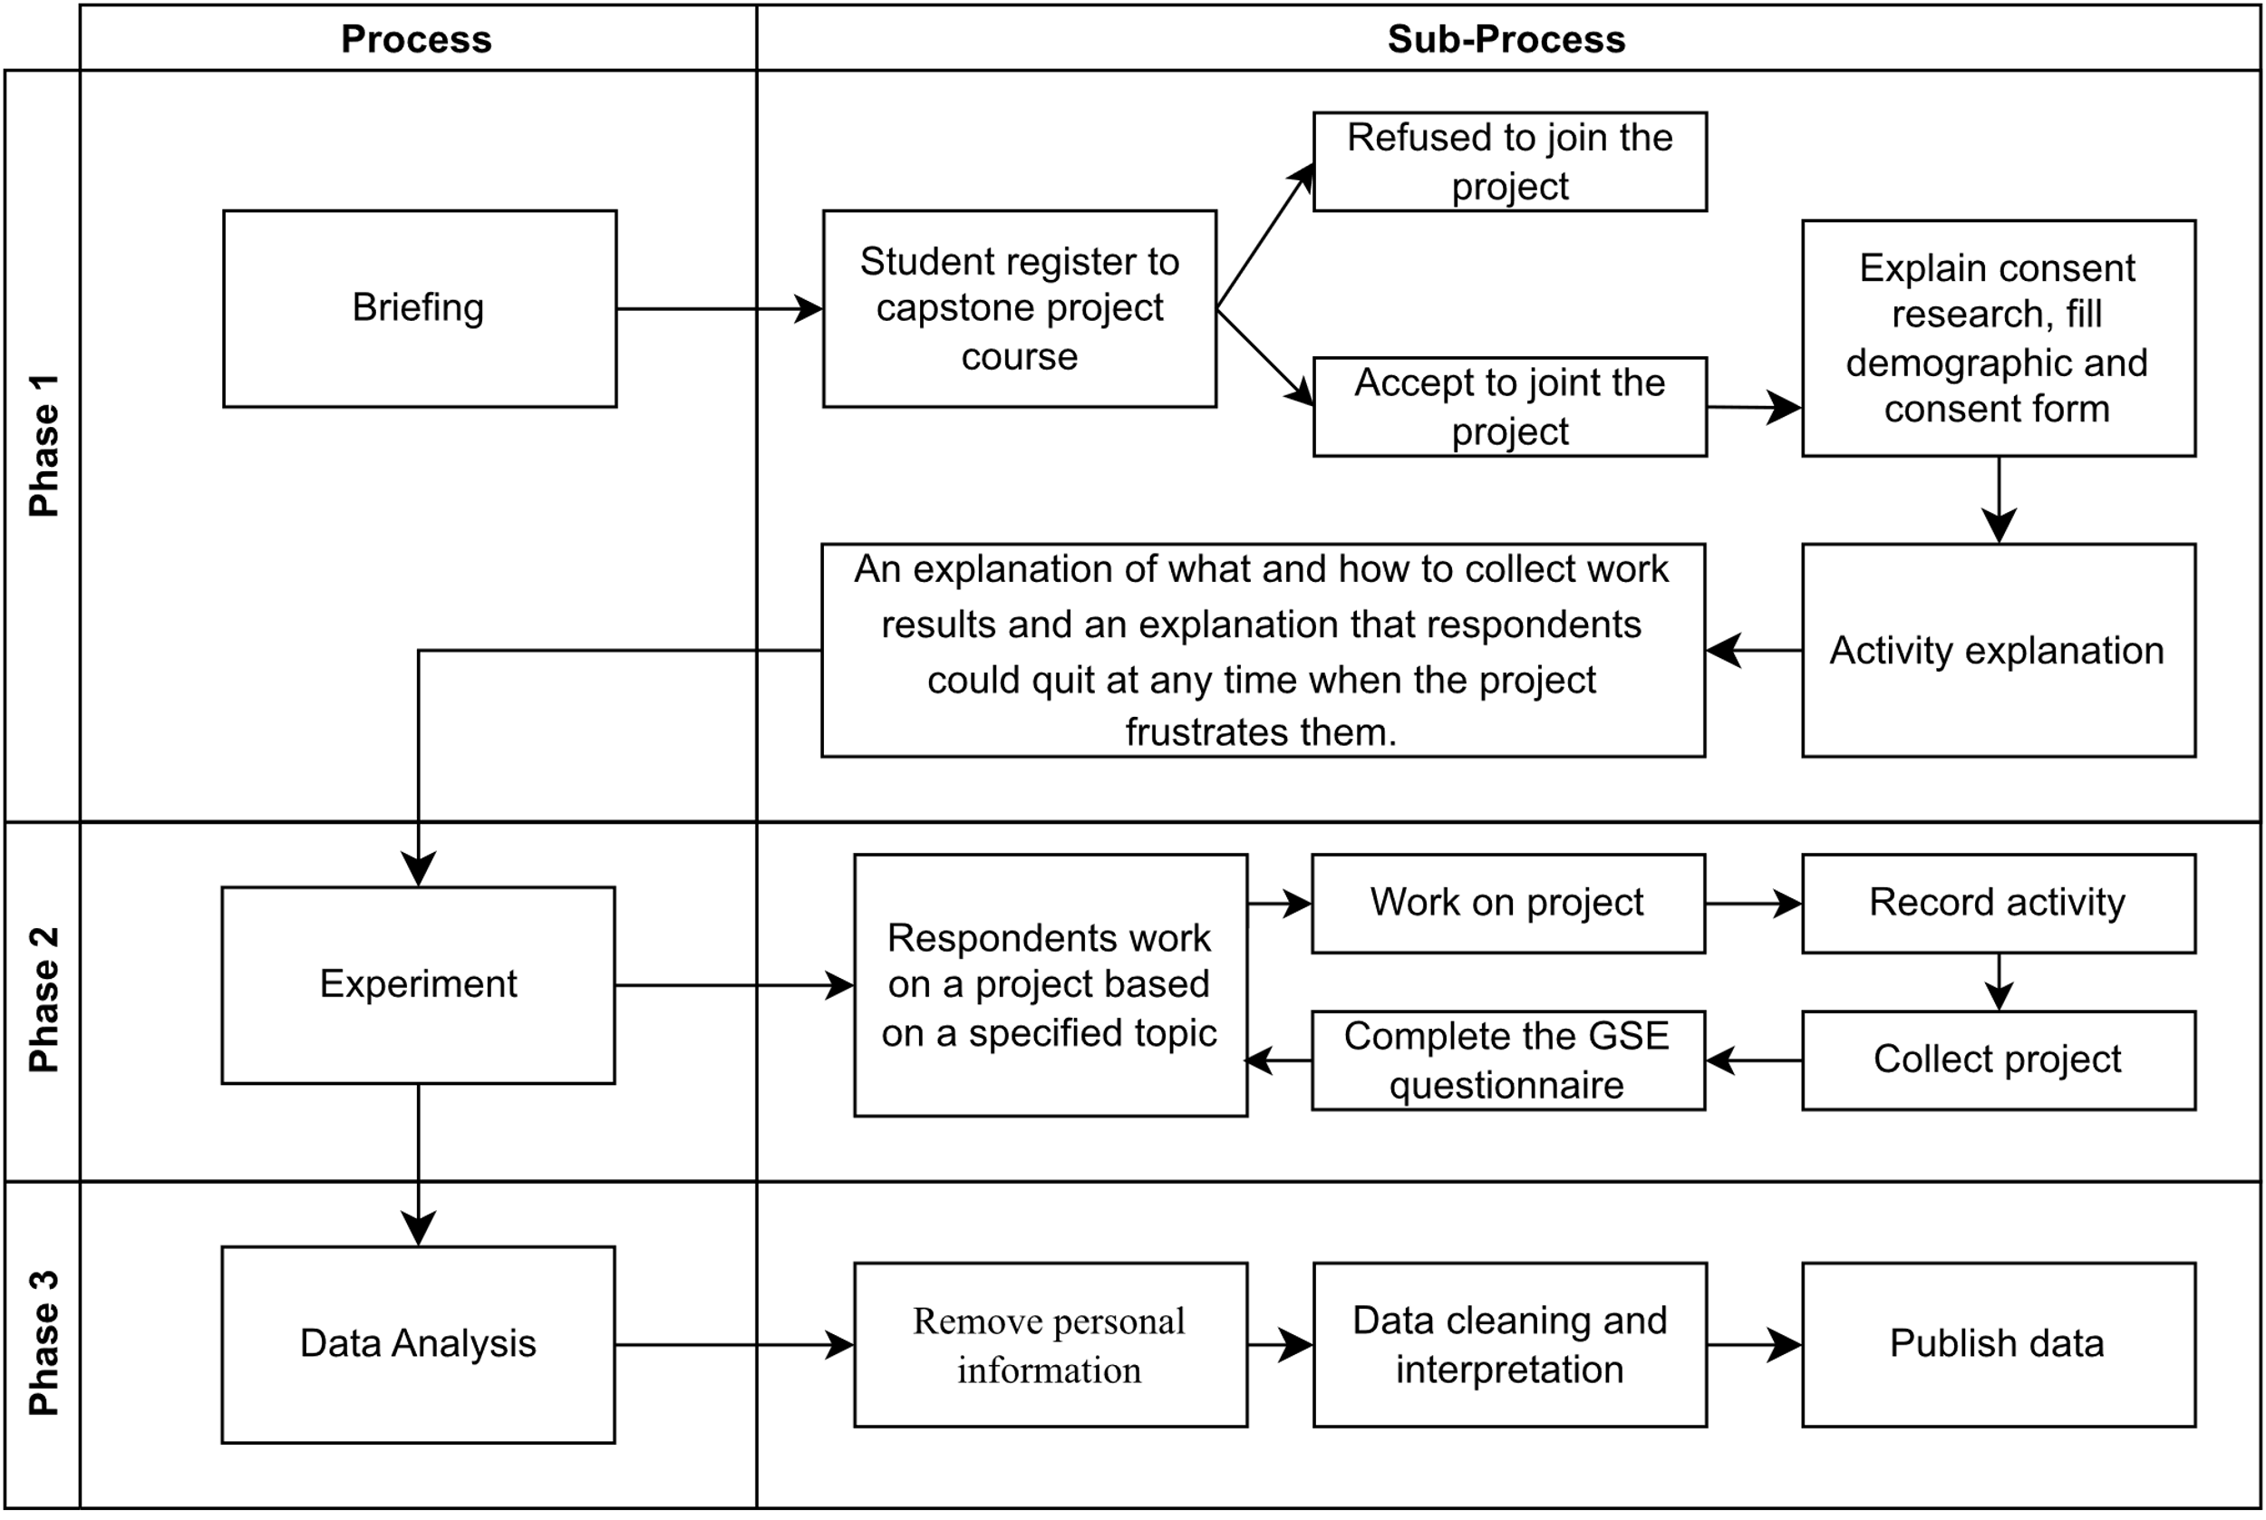
FIGURE 1. Experimental design
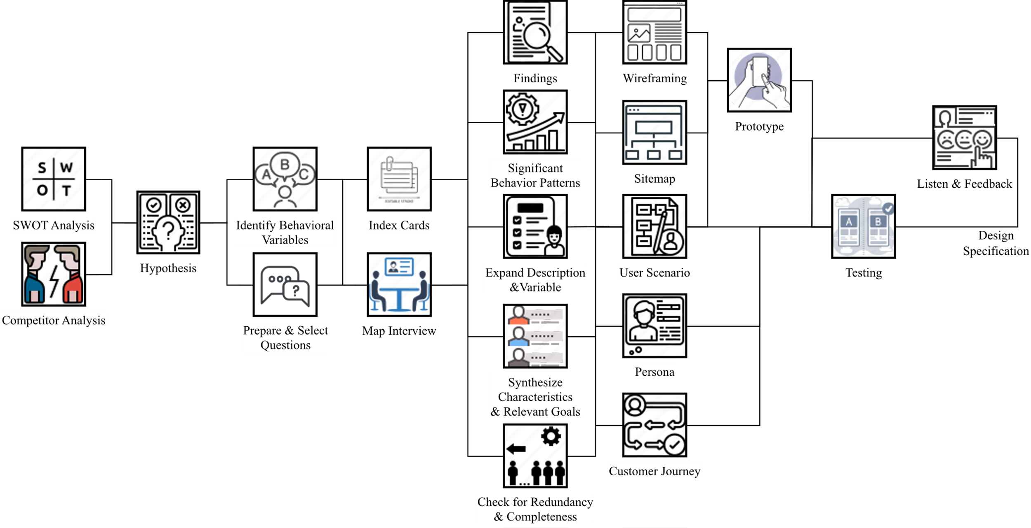
FIGURE 2. Activity in UX Journey [9]
In the second phase, after indicating their readiness to work on the project, the respondents were given the same topic to work on. Each respondent was given two weeks to complete one topic. They worked based on the provided instructions and recorded their activities while working on the project. Additionally, they were allowed to ask questions or provide updates on their progress. At the end of each project, they submitted their work through a Google Form (including activity books for both conventional elicitation and UX Journey in PDF format, a schedule summary of each activity and user stories in an Excel file, a video of their work, and a testing rubric in a Word file) and completed the GSE questionnaire. The researcher then reviewed and evaluated the work done by the respondents, providing feedback on any errors, inaccuracies, or missing data and informing them that they could make improvements if desired. Each respondent was given one week to make revisions. This process continued for three projects in the pilot study and five in the experiment. In each transition between project sessions, the respondents were informed that they could stop if the workload became burdensome.
The third phase is data analysis. In this phase, the researcher collected and summarized all the respondents' answers and organized them into categories according to the analysis needs. The most important aspect of this activity was to ensure that all data did not contain personal information from the respondents or to replace it with fictional identities for certain parts, such as user personas, validator names, and usernames. In the final stage, data publication and statistical data analysis were conducted.

RESULTS AND DISCUSSION
This study presents the productivity dataset on students' software requirement activity. Data were collected through a Google Form to ease the data collection and tabulation. This study consists of a pilot and experiment study. Data collection took about two years, between 2022 and 2023, and the description of the data is shown in TABLE 1. We used purposive sampling to select 400 full-time students at Universitas Muhammadiyah Malang who passed software engineering and software requirement courses. This strategy allowed to target a specific group of individuals who met the criteria relevant to the study. The demographic characteristics of the respondents were sampled at a private university in Malang, Indonesia, and are given in TABLE 2. The demographic data of the respondents were coded as follows: age group (18-20 years as 1, 21 years or more as 2), gender (male as 1, female as 2), year grade (first year as 1, second year as 2, third year as 3, fourth year as 4, fifth year as 11), working experience (professional/full-time as 1, part-time as 2, no as 3), have a portfolio (yes as 1, no as 2). However, we can not provide data on our work experience and portfolio. We ensured representativeness in different year classes or other relevant factors. We used stratified sampling to divide the population into subgroups (first year, second year, etc.) and then randomly sampled from each subgroup.
The dominant respondents were men in the two dataset groups that were collected. Most respondents are in their second year (73% from the experience) and third year (97% from the pilot study). The age distribution in the pilot study and the experiment was slightly different, whereas, in the pilot study, all respondents were 21 years and over. Unfortunately, we did not collect data on work experience and portfolio in the pilot study. In contrast, the experiment found that most respondents were without work experience, and only 7% worked part-time or full-time. However, 64% of respondents already have a portfolio on Dribbble, Github, or other closed projects. Response rates from respondents indicate representativeness to be able to lead to more reliable findings. Out of a total of 400 respondents, 115 completed the pilot study, and for the experiment, 247 respondents completed projects 1-5 or more than 90% for the two studies.
TABLE 1. Data descriptor characteristics
Subject | Computer Science
Specific subject area | Human-Computer Interaction, Software Engineering, Social and Personality Psychology
Data format | Raw and analyzed.
Type of data | Tables and image
Data collection | A pilot test was conducted to ensure the robustness of the UX Journey activity. For our pilot, we took 115 responses and checked the timing consistency of each activity. Each respondent in the pilot study has the same task and topic. They voluntarily work on the topic of big data, disability, and education. After the pilot survey, we conducted a final experiment with 247 students through regular weekly meetings. Data collection is done by selecting students who have passed software engineering courses. They were offered to participate in data collection. Students who agree to participate in data collection are then given directions for each activity, for each student will work on five different projects. At the end of each project, they will collect UX Journey worksheets, work videos, and test reports and fill out the GSE questionnaire (available at https://github.com/uxjourney/requirement). Each project is given two weeks with sequential topics ordering train or plane tickets using common elicitation techniques, booking train or plane tickets using UX Journey, technology for children, technology for the elderly, and technology for people with mental illnesses.
Data source location | Institution: University of Muhammadiyah Malang (UMM)  City/Town/Region: East Java  Country: Indonesia
Data accessibility | Repository name: Mendeley Data  Data identification number:  - 10.17632/hvjbnx2frc.2  - 10.17632/6hr3w4vz6r.2  - 10.17632/2672vmdmkt.2  - 10.17632/52bmtrhsct.2  - 10.17632/h9kznbnbvy.2  Direct URL to data:  - https://data.mendeley.com/datasets/hvjbnx2frc/2  - https://data.mendeley.com/datasets/6hr3w4vz6r/2  - https://data.mendeley.com/datasets/2672vmdmkt/2  - https://data.mendeley.com/datasets/52bmtrhsct/2  - https://data.mendeley.com/datasets/h9kznbnbvy/2  Instructions for accessing these data:  The dataset consists of two versions, in the first version the respondents worked on the project using the language they use every day, while in the second version it was equipped with language translation into English which was carried out by the respondents voluntarily. This dataset is divided into five links, Project 1 flight train booking system using the general elicitation method, Project 2 flight train booking system using the UX Journey method, Project 3 Technology for Child (UX Journey), Project 4 Technology for Elderly (UX Journey with Generative AI), Project 5 Technology for Mental Illness (UX Journey with Generative AI). Each dataset consists of several parts. The original file folder is the Initial analysis file from a novice developer. Folder Revision 1 is the result of the first improvement of several substantial notes. Folder Revision 2 is the result of the second improvement from several significant notes. Folder Revision 3 is the result of the third improvement from several substantial notes. The Evaluation Rubric folder is Tests conducted by novice developers, through self-reviews, peer reviews, and walkthrough evaluations. The Self Efficacy Excel File is the Results of the General Self Efficacy Scale questionnaire. The Time and User Stories Excel file is a recap of the time the respondents needed to work on, and the results of the user stories collected.

TABLE 2. Data descriptor characteristics
Variable | Categories | Code | Pilot |  | Experiment
Variable | Categories | Code | Frequency | Percentage | Frequency | Percentage
Gender | Male | 1 | 98 | 85,22 | 202 | 81,78
 | Female | 2 | 17 | 14,78 | 45 | 18,22
Age | 18-20 years | 1 | 0 | 0,00 | 181 | 73,28
 | 21 years or more | 2 | 115 | 100,00 | 66 | 26,72
Years grade | First year | 1 | 0 | 0,00 | 0 | 0,00
 | Second year | 2 | 0 | 0,00 | 181 | 73,28
 | Third year | 3 | 112 | 97,39 | 60 | 24,29
 | Fourth year | 4 | 3 | 2,61 | 2 | 0,81
 | Fifth year | 5 | 0 | 0,00 | 4 | 1,62
Working Experience | Profesional | 1 | N/A | N/A | 2 | 0,81
 | Part-time | 2 | N/A | N/A | 16 | 6,48
 | No | 3 | N/A | N/A | 229 | 92,71
Portfolio | Yes | 1 | N/A | N/A | 64 | 25,91
 | No | 2 | N/A | N/A | 183 | 74,09

TABLE 3. Sample of the respondent activity (in minutes)
ID | 1-Personality and ability | 2-UX Journey Activities Checklist | 3-My Goals | 4-Discover | 4-1-Field Studies | 4-2-SWOT | 4-3-Competitor | 4-4-Hypothesis | 4-5-Identify Behavioral Variable | 5-Explore | 5-1-Prepared questions | 5-2-Meet Stakeholders | 5-3-Findings | 5-4-Index cards/sticky notes | 5-5-Map interview | 5-6-Significant behavior pattern | 5-7-Synthesize characteristics and relevant goals | 5-8-Check for redundancy and completeness | 5-8-1-Validation | 5-8-2-Verification | 5-9-Expand Description and Variable | 5-10-Persona | 5-11-Customer Journey | 5-12-User Scenarios and user stories | 5-13-Site map | 5-14-Wireframing | 6-Test | 6-1-Qualitative & Quantitative selection | 6-2-A/B Testing | 6-3-Verification | 6-4-Objective Behavioural Variables | 6-5-Acceptance Criteria | 7-Listen | 7-1-Follow-up
A | 15 | 25 | 30 |  | 15 | 25 | 30 | 20 | 15 |  | 15 | 20 | 15 | 25 | 30 | 15 | 10 | 20 | 10 | 15 | 10 | 60 | 20 | 60 | 15 | 60 |  | 20 | 60 | 50 | 60 | 30 |  | 20
B | 20 | 10 | 10 |  | 60 | 60 | 50 | 40 | 60 |  | 30 | 30 | 30 | 10 | 50 | 60 | 30 | 60 | 20 | 60 | 60 | 60 | 60 | 60 | 60 | 60
C |  |  | 20 |  | 15 | 10 | 10 | 25 | 15 |  | 10 | 15 | 10 | 10 | 10 | 20 | 15 | 30 | 5 | 15 | 5 | 15 | 10 | 45 |  |  |  | 20 | 60 | 50 | 60 | 30 |  | 20
D | 5 | 5 | 10 |  | 15 | 30 | 10 | 10 | 10 |  | 10 | 60 | 20 | 15 | 15 | 30 | 10 | 20 | 15 | 10 | 10 | 15 | 20 | 15 | 10 | 30 |  | 15 | 20 | 15 | 15 | 15 |  | 10
E | 20 | 10 | 5 |  | 20 | 5 | 15 | 15 | 10 |  | 20 | 10 | 10 | 15 | 20 | 5 | 10 | 10 | 10 | 10 | 15 | 10 | 20 | 5 | 10 | 45 |  | 30 | 15 | 4 | 4 | 10 |  | 10
F | 10 | 40 | 20 |  | 20 | 12 | 20 | 40 | 20 |  | 20 | 40 |  | 20 | 20 | 15 | 20 | 20 | 20 | 60 | 20 | 10 | 15 |  |  |  |  | 20 | 10 | 15 | 10 | 10 |  | 20

The dataset has two subdimensions for each set of projects carried out by the respondents: the productivity of the respondents using two different approaches. The first approach for the initial project involves conventional direct elicitation methods such as interviews, observations, and brainstorming. Meanwhile, the second approach involves sequential UX Journey activities, as shown in TABLE 3. Furthermore, the observation method is carried out similarly, recording the respondents' activities while working on the project. An example of statistical analysis for the obtained data can be seen in FIGURE 3. Additionally, user stories were obtained from the conducted requirement mining in the collected data, as shown in TABLE 4.

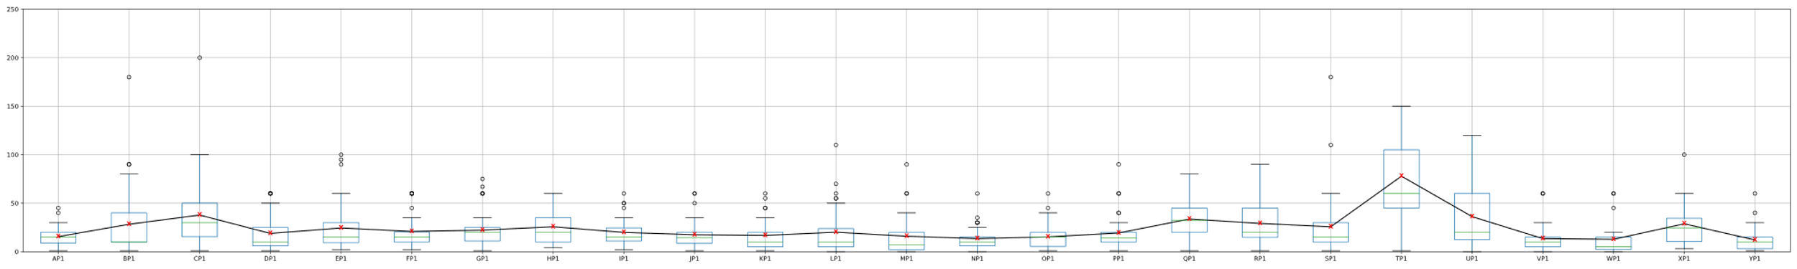
FIGURE 3. Developer Productivity in Project 5
TABLE 4. Sample of the user stories in two languages
NIM | User stories (Bahasa) | User stories (Language)
A | Pendalaman desain ui ; sebagai pengguna saya ingin desain pada setiap fitur dapat dengan mudah dipahami ; sebagai pengguna saya ingin warna pada tampilan tidak terlalu mencolok ; sebagai pengguna saya ingin aplikasi ini meminimalisir bug sehingga, pembelajaran tidak ada kendala ; sebagai pengguna fitur menu menggunakan desain ui yang sederhana dan mudah dipahami ; pengunaan database yang terstruktur agar data pada game tidak dalah dan berantakan ; perlu ada tutorial adalam awalan game ini ; aplikasi memiliki desain yang menarik ; game yang berguna untuk pembelajaran anak-anak ; aplikasi yang memiliki daftar list nama pahlawan secara lengkap ; sebagai pengguna saya ingin desain game digital wayang ini mudah dan nyaman ; sebagai pengguna saya ingin desain yang simpel tapi tidak ada komponen yang kosong pada tampilan ; saya ingin fitur rematch ada pada aplikasi ini ; menu pada game tidak terlalu rumit dan mudah dipahami ; pengguna bisa mengatur suara, musik dan bahasa yang ingin mereka pakai | UI design in-depth; as a user i want the design on every feature to be easily understood ; as a user i want the colors on the display not to stand out too much ; as a user I want this application to minimize bugs so that learning has no obstacles; as a menu feature user using a simple and easy-to-understand UI design; the use of a structured database so that the game data is not messy and messy; there needs to be a tutorial at the start of this game; the application has an attractive design; useful games for children's learning; an application that has a complete list of hero names; as a user I want this puppet digital game design to be easy and comfortable; as a user i want a simple design but no empty components in the view ; I want the rematch feature in this application; the menu in the game is not too complicated and easy to understand; users can set the sound, music and language they want to use
B | user ingin aplikasi yang memilki fitur keamanan seperti login ; user ingin aplikasi yang memiliki tampilan menarik ; user ingin adanya fitur notifikasi ; user ingin adanya fitur audio dan video guna memudahkan belajar dan memahami materi | the user wants an application that has security features such as login; the user wants an application that has an attractive appearance; the user wants a notification feature; users want audio and video features to make it easier to learn and understand the material

The second dimension of this dataset is the self-efficacy data obtained from the General Self-Efficacy Scale (GSE) questionnaire in the Indonesian language version [10]. The data were collected using Google Forms at the end of each project. GSE was used as a measurement tool to assess self-efficacy in optimistically facing job-related challenges. The obtained analysis was then processed using Microsoft Excel. An example of the analysis results from the data can be seen in TABLE 5, which shows the GSE results for the third and fifth projects. The descriptive analysis of mean, median, standard deviation, skewness, and kurtosis found that the values were still within the range of -2 to +2, indicating a normal data distribution [11].
TABLE 5. Sample of statistical analysis of the GSE questionnaire on Project 1
Questions | Mean | Median | Std. Dev | Kurtosis | Skewness | P-Value
1. I can always manage to solve difficult problems if I try hard enough. | 3.225 | 3.000 | 0,53 | -0.148 | -0.679 | 0.000
2. If someone opposes me, I can find the means and ways to get what I want. | 3.305 | 3.000 | 0,54 | 0,27 | -0.938 | 0.000
3. It is easy for me to stick to my aims and accomplish my goals. | 2.887 | 3.000 | 0,59 | -0.497 | -0.370 | 0.000
4. I am confident that I could deal efficiently with unexpected events. | 3.146 | 3.000 | 0,53 | -0.651 | -0.434 | 0.000
5. Thanks to my resourcefulness, I know how to handle unforeseen situations. | 2.960 | 3.000 | 0,48 | -0.552 | -0.070 | 0.000
6. I can solve most problems if I invest the necessary effort. | 3.033 | 3.000 | 0,55 | -0.524 | -0.382 | 0.000
7. I can remain calm when facing difficulties because I can rely on my coping abilities. | 3.060 | 3.000 | 0,53 | -0.219 | -0.460 | 0.000
8. When I am confronted with a problem, I can usually find several solutions. | 3.053 | 3.000 | 0,55 | -0.514 | -0.415 | 0.000
9 .If I am in trouble, I can usually think of a solution. | 3.093 | 3.000 | 0,50 | 0,25 | -0.569 | 0.000
10. I can usually handle whatever comes my way. | 3.404 | 4.000 | 0,51 | 0,23 | -1.005 | 0.000

CONCLUSIONS
Some of the images in the PDF file may have low quality; at the time of data collection, the quality standards were not applicable, but it is still possible to read them. The time written on the Excel file data set is rounded up in minutes. The data we collect may be biased because the sampling process is not random, and the data does not reflect the entire population of individual or novice developers. However, even though the data has the potential for bias, the data is still very useful in many contexts, such as for analyzing patterns, trends, and relationships in the data so that it can be used to provide relevant and informative research results. In addition, by realizing that there is a possibility of bias, we have taken steps to mitigate the effect by cross-referencing reference sources and using a variety of topics in each project compared to the latest trends.

Acknowledgments
This project was funded by the Ministry of Higher Education (Kementerian Pengajian Tinggi) and Research Management Centre (RMC), Universiti Putra Malaysia, for supporting/funding this article under its Fundamental Research Grant Scheme (FRGS) – Project Code 08-01-20-2319FR – 5540451 and Universitas Muhammadiyah Malang for the APC support. We also thank the anonymous reviewers for their valuable feedback and comments.

References
[1] R. Pressman and B. Maxim, Software Engineering: A Practitioner's Approach 9th Edition. McGraw Hill, 2019.
[2] N. Nelson, C. Brindescu, S. McKee, A. Sarma, and D. Dig, "The life-cycle of merge conflicts: processes, barriers, and strategies," Empirical Software Engineering, vol. 24, no. 5, pp. 2863-2906, 2019/10/01 2019.
[3] E.-M. Schön, J. Thomaschewski, and M. J. Escalona, "Agile Requirements Engineering: A systematic literature review," Computer Standards & Interfaces, vol. 49, pp. 79-91, 2017/01/01/ 2017.
[4] M. Bourimi, T. Barth, J. M. Haake, B. Ueberschär, and D. Kesdogan, "AFFINE for Enforcing Earlier Consideration of NFRs and Human Factors When Building Socio-Technical Systems Following Agile Methodologies," in Human-Centred Software Engineering, Berlin, Heidelberg, 2010, vol. 6409, pp. 182-189: Springer Berlin Heidelberg.
[5] G. Getto, "Managing experiences: Utilizing user experience design (UX) as an agile methodology for teaching project management," International Journal of Sociotechnology and Knowledge Development (IJSKD), vol. 7, no. 4, pp. 1-14, 2015.
[6] T.-C. Hsu, H. Abelson, E. Patton, S.-C. Chen, and H.-N. Chang, "Self-efficacy and behavior patterns of learners using a real-time collaboration system developed for group programming," International Journal of Computer-Supported Collaborative Learning, vol. 16, no. 4, pp. 559-582, 2021/12/01 2021.
[7] N. Ahmadi Eftekhari, S. Mani, J. Bakhshi, and S. Mani, "Project Manager Competencies for Dealing with Socio-Technical Complexity: A Grounded Theory Construction," Systems, vol. 10, no. 5, p. 161. doi: 10.3390/systems10050161
[8] A. Issaee, R. Motschnig, and O. Comber, "Pair- versus solo-programming of mini-games as a setting for learning to program: An Action Research approach," in 2021 IEEE Frontiers in Education Conference (FIE), 2021, pp. 1-9.
[9] W. A. Kusuma, A. H. Jantan, N. I. Admodisastro, and N. M. Norowi, "Reframed Design Thinking and Feasibility Analysis of UX Journey: Integrating User Experience and User Requirement for Solo Software Development," 2023.
[10] M. Jerusalem and R. Schwarzer, "Generalized self-efficacy scale," Measures in health psychology: A user’s portfolio. Causal and control beliefs, vol. 1, pp. 35-37, 1995.
[11] A. Leguina, "A primer on partial least squares structural equation modeling (PLS-SEM)," International Journal of Research & Method in Education, vol. 38, no. 2, pp. 220-221, 2015/04/03 2015.

