Classification of Microsatellite Status in Gastrointestinal Cancer Cells Using Convolutional Neural Networks
Agus Eko Minarno^{1,a)}, Muhammad Rifal Alfarizy^{1,b)}, and Dana Marsetiya Utama^{2,c)}
¹ Department of Informatics Engineering, University of Muhammadiyah Malang, Malang, Indonesia
² Department of Industrial Engineering, University of Muhammadiyah Malang, Malang, Indonesia

^{a)} Corresponding author: aguseko@umm.ac.id
^{b)} m.rizal.alfa@umm.ac.id
^{c)} dana@umm.ac.id
Abstract. Microsatellites are a unique type of repetitive genomic circuit that is spread throughout the genome, and exhibits a high degree of allelic polymorphism. Microsatellites can become unstable or mutate due to errors in the deoxyribonucleic acid (DNA) mismatch repair (MMR) system during DNA replication. Microsatellite instability (MSI) is commonly found in gastrointestinal cancer, and can be detected using multiplex polymerase chain reaction (PCR) or multiplex immunohistochemistry (IHC), but it is costly, and additional genetic tests. Therefore, this study proposes a deep learning method, Convolutional Neural Networks (CNN) to detect MSI. Similar studies have been carried out but there are problems with model stability, and less than optimal accuracy caused by overfitting. Based on these problems, this study proposes a modification of the VGG19 model. The data used is the image of colorectal cancer cells with a total of 93,408 data, and gastric cancer cells with a total of 100,570 data. In colorectal cancer cells, the model proposed 76.2% gain accuracy, additional augmentation obtain 77.1% accuracy, then add the dropout APL lowered into a 76.3% accuracy but it gives a stable chart. While gastric cancer cell testing was carried out using the proposed model with augmentation, and the addition of callbacks to obtain 76% accuracy. Based on experiments, the proposed model is still overfitting but augmentation can slightly overcome the overfitting, and improve accuracy. While dropout APL can reduce accuracy but provide stable graph development, and no indication of overfitting. The proposed model is effective in classifying colorectal cancer cells.
Keywords: Cancer; Gastrointestinal; CNN; Classification; Augmentation

INTRODUCTION
Microsatellite or simple sequence repeats (SSRs) are a unique type of repeating genomic circuit that is spread throughout the genome, and exhibits a high level of allele polymorphism [1]. Microsatellite status can become instable (MSI) due to deoxyribonucleic acid (DNA) mismatch repair (MMR) system errors in identifying, and removing merge errors during DNA replication [2]. The status of microsatellite is divided into three groups, a high-level mutation (MSI-H) that indicates two or more mutated locus counts, a low-level mutation (MSI-L) indicating one mutated locus count, stable locus (MSS) indicating no mutated locus [3].
Microsatellite Instability (MSI) is found in the colorectal, and gastric cancer can also be called gastrointestinal cancer. Approximately 15% to 30%, and 10% to 20% MSI are present in patients with colorectal, and gastric cancer [4][5]. Gastrointestinal cancer patients with microsatellite instability (MSI) get good guesses about the level of recovery, and therapy. However, patients with stage II, and III colorectal cancer did not get any side effects from chemotherapy (5-Fu) (ACT) performed after surgery [6]. Identification of the status of microsatellites is needed to determine the next step in the treatment of gastrointestinal cancer patients. Identification is performed using a multiplex polymerase chain reaction (PCR) test kit or a multiplex immunohistochemistry (IHC) panel.
Identification of microsatellite instability (MSI) status costs a fortune, and additional genetic tests may not be available to all patients [7][8]. Other factors such as time, the accuracy of identification, and experts are also considered when identifying the status of microsatellites. Therefore, it takes technology that can identify the status of microsatellite in gastrointestinal cancer cells with a fast time, and accurate results [1][5]. In this problem, there is one part of artificial intelligence called Deep Learning. Deep Learning can classify the status of microsatellite by using histopathological image data of cancer cells in the gastrointestinal [9]. There are many methods that can be used for image classification in Deep Learning, one of which is Convolutional Neural Networks (CNN) [10][11]. CNN has proven successful in image interpretation issues, and can be used in obtaining additional information from histopathology imagery [12][13].
Research on the classification of microsatellite status using Deep Learning, and CNN has been conducted before, one of them by the U.S. Echle in a study titled “Clinical-grade Detection of Microsatellite Instability in Colorectal Tumors by Deep Learning”. The study used Deep Learning with a modified Shufflenet architecture. The data used is The Cancer Genome Atlas (TCGA) amounting to 5,000 data of patients with stage I-IV colorectal cancer in the United States and found in portal.gdc.cancer.gov. The results obtained AUC values of 0.92, AUPRC 0.63, Specificity 63%, and Sensitivity 95% [2][7].
The next research was conducted by T. Wang with the title Microsatellite Instability Prediction of Uterine Corpus Endometrial Carcinoma Based On H&E Histology Whole-Slide Imaging. The data used were from the UCEC Cohort with 516 patients obtained from the TCGA. The method used is CNN architecture ResNet-18 with additional PALHI. The results of this study are in the form of AUC values of 0.73 [8].
Another study was conducted by O.J. Skrede titled “Deep learning for prediction of colorectal cancer outcome: a discovery, and validation study”. The data used for testing came from 920 colorectal cancer patients in UK, and 1122 colorectal cancer patients in Norway. The data used is an image of colorectal cancer cells. The methods used are CNN MobilenetV2 giving AUC results of 0.71, Accuracy of 76%, Specificity of 78%, and Sensitivity of 52% [12].
The same research was also conducted by Wang, L. with the title “A novel approach combined transfer learning, and deep learning to predict TMB from histology image”. The method used is CNN with the model architecture that gets the best accuracy in this study, namely VGG19. The data used from zenodo.org/record/2530835#.X8hXeWgzbIU amount 217,916 TMB-STAD, and 154,063 TMB-COAD-DX with classes divided into TMB High, and TMB Low patients. The study obtained an AUC score of 0.82, and an accuracy of 77% in coad-dx TMB data while the TMB-STAD data obtained an AUC value of 0.75, and an accuracy of 71% [14]
In previous studies, there are some problems, and suggestions for further research. One of them was in a study conducted by A. Echle that provided advice for researching with larger datasets to test the stability of the CNN model used [7]. This can be addressed by using data augmentation techniques that are proven to improve model training results better than adding new data [15][16][17][18]. In addition to the research conducted by A. Echle, another study using the same dataset as this study conducted by Wang, L has a deficiency in the proposed CNN VGG19 model to obtain unsatisfactory accuracy in the test data which is 77% for microsatellite in colorectal cells, and 71% in gastric cells [14] This may be caused by an overfitting model or a model that is used inappropriately to handle that data. The problem can be addressed by trying other models, adding layer or increasing the dropout layer parameters in the CNN model. In some cases, dropout layers can be used to handle overfitting models, and improve training accuracy [2].
Based on the issues outlined, and research conducted previously by O.J. Skrede, A. Echle, and Wang, L [7][12][13]. This research will be conducted experiments at the stage of modeling, augmentation, and modification of models. In model creation, it would be proposed that the model has the same structure as VGG19 with multiple layer reduction and optimize parameter combination with Hyperparameter Tuning as scenario 1. In the augmentation stage, experiments were conducted using several augmentation techniques as scenario 2. Then at the modification stage is done with some changes one of which is to add a dropout layer placed after the entire pooling layer as scenario 3. The experiment will be conducted on a dataset of colorectal cancer cells, then the best-case scenario is used to test gastric cancer cell data. Data augmentation techniques, and Hyperparameter Tuning are expected to improve train, and test accuracy as well as modification of dropout layer placement is expected to reduce, and stabilize the graph of accuracy, and loss development during model training.

METHODS
This chapter will discuss the stages of research including data, methods, scenarios, and evaluations that will be conducted. This study was conducted testing two different datasets separately. Testing to determine the influence of the proposed model, augmentation technique, and dropout APL will be conducted on colorectal cancer cell datasets (COAD) with scenarios 1, 2, and 3. Then the best model of all three scenarios will be used directly on the gastric cancer cell datasets (STAD) with the addition of callback techniques. An overview of the research stages can be seen in FIGURE 1.

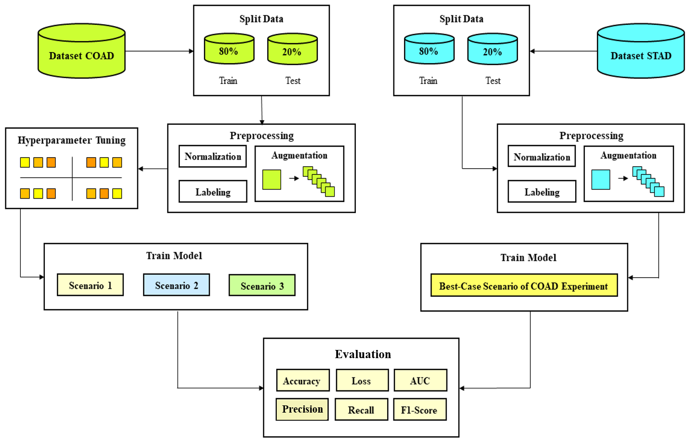
FIGURE. 1. Research Stage Diagram

Dataset
The dataset used for this study is a histological image of cancer cells from FFPE (Formalin-Fixed Paraffin-Embedded). The data is sourced from doi.org/10.5281/zenodo.2530835. Data has two classes, namely MSIMUT (Microsatellite Instable High Mutation), and MSS (Microsatellite Stable). Data has been preprocessed, such as resizing the image to 224 x 224 pixels at a resolution of 0.5 μm/px, and normalizing colors with the Macenko method [19]. The dataset initially amounted to 411,890 image data, but in this study only 193,978 data were used with the same composition of MSI, and MSS to the make model could study features well [20]. The data is used only in the CRC, and STAD train folders. The dataset is divided by the composition of 80% of train, and 20% of the test follows the Pareto Principle math rules which state that about 80% of wealth is concentrated in 20% of the total population [21]. Pareto Principle can improve results, and make models more efficient [21][22]. Details on sample datasets on colorectal and gastric cancer cells can be seen in FIGURE 2.

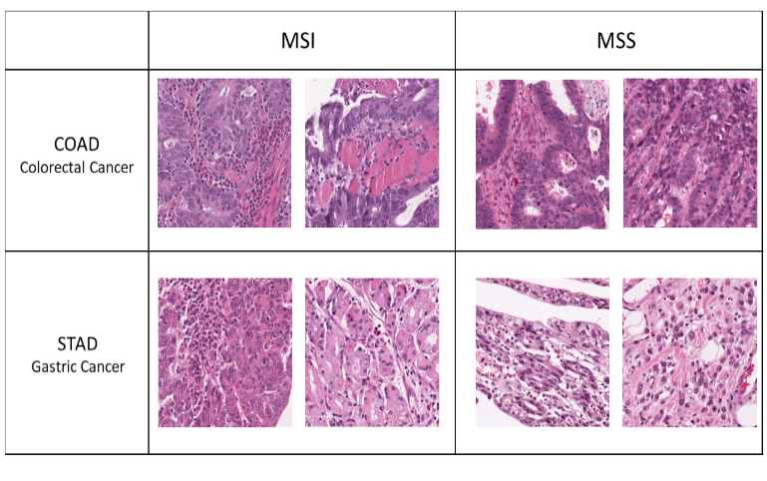
FIGURE 2. Sample Data COAD, and STAD

Preprocessing
At the preprocessing stage will be done several processing steps on the histopathology image data. The first stage is to set the data size to 224x224 pixels to maintain the consistency of the image size, then label each class on the data, the MSIMUT image data will be labeled 0, and the MSS image data will be labeled 1, the next stage is normalizing the data to be input for CNN, and the last stage is to augmentation [23].

Augmentation
The augmentation stage is done to increase the amount of data by creating new data by modifying existing data until the program recognizes that the data is different data[23][24][25]. This augmentation stage is performed in cases with a small amount of data to makes the data have more variability that can make it easier for the model to process the classification of objects, and avoid overfitting [25]. The techniques used in this study are horizontal flip = True, vertical flip = True, rotation = 180°, zoom = 10%, width shift = 10%, height shift = 10%, and fill mode = reflect [18][24]. The proposed augmentation makes the image data to be 8x more, the previous data of colorectal cancer cells 93,408 data to 747,264 data, and gastric cancer cell data that was previously 100,570 data to 804,560 data. Details of the augmentation results can be seen in FIGURE 3.

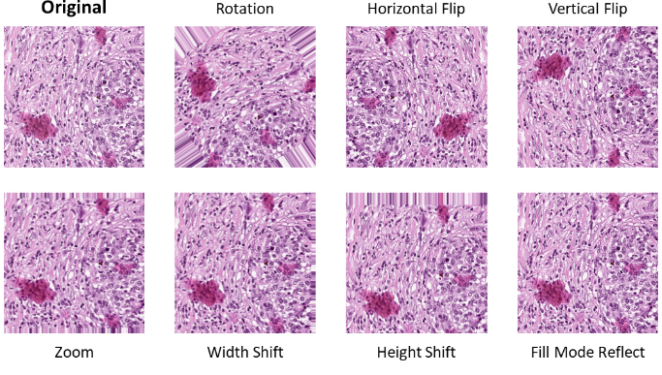
FIGURE 3. Result of augmentation

Hyperparameter Tuning
Hyperparameter tuning is the process before training the model to get the best combination of parameters. In this study, hyperparameter tuning is focused on finding the combination of optimizer and dropout parameters. Dropouts on the model are divided into two parts based on their location, namely on the after pooling layer (Dropout APL), and at the fully connected layer (Dropout FCL) [17]. This stage provides improved the model performance and shortens the research [16]. In this study, the parameters to be compared were Optimizer (Adam, RMSprop, SGD), Dropout APL (5%, and 10%), and Dropout FCL (25%, and 50%).

Proposed architecture model
At this stage of the study, the architectural model in this study followed the VGG19 model used by Wang, L [5]. with slight modifications to convolution layer reduction, use of average pooling, the addition of batch normalization, the addition of dropouts after pooling layers, and parameter changes based on the results of hyperparameter tuning. On the convolution layer, the filter used is valued (64, 128, 256, 256, 512, 512, 512, 512), the kernel size to be used is worth (3, 3), the stride is 1, padding is 'same', and the activation used is ReLu. While in the pooling layer will be selected average pooling with pool size value (2, 2), and padding value 'same'. In the dropout layer, the value used depends on the result of the Hyperparameter Tuning that has been done, the dropout layer will be divided into two parts based on its location, namely dropout on after pooling layer (Dropout APL), and dropout on the fully connected layer (Dropout FCL). Before the fully connected layer, Global Average Pooling is inserted after the last dropout. In a fully connected layer, there are three dense layers just like VGG19 models with values 4096, 4096, 1000, flatten, and then output layers using one class with sigmoid activation.

RESULTS AND DISCUSSION
Model testing will be carried out differently on colorectal cancer cell data (COAD) and gastric cancer cell data (STAD). Tests to determine the effect of the proposed model, augmentation, and dropout APL will be performed on the data COAD with scenario 1 as the testing of the proposed model, scenario 2 is the addition of the augmentation, and scenario 3 is the addition of the dropout APL. Then the best-case scenario will be used to test the data STAD by adding some callback techniques to enhance the results. Tests will be performed with the parameters as the epoch was 50 and a batch size of 32.

Hyperparameter tuning
Hyperparameter tuning was performed only on colorectal cancer cell data (COAD) using the proposed model. Additional test parameters that will be used in this process are epoch numbered 5 and a batch size of 32. Details about the results of best five parameters combination from hyperparameter tuning process sorted by accuracy values can be seen in TABLE 1.
TABLE 1. The best parameter combination from hyperparameter tuning
Optimizer | Dropout APL | Dropout FCL | Accuracy | Loss
SGD | 0.05 | 0.25 | 0.6584 | 0.6233
Adam | 0.05 | 0.5 | 0.6113 | 0.6609
SGD | 0.15 | 0.25 | 0.6054 | 0.7202
Adam | 0.15 | 0.5 | 0.5995 | 0.6619
SGD | 0.15 | 0.5 | 0.5872 | 0.8552

Scenario 1: Proposed model
In the first scenario, testing is carried out using the proposed model with best parameter combination from hyperparameter tuning. Based on the resulting accuracy and loss graph, this scenario gives less than optimal results due to fluctuating, and overfitting indications. The graph of the results from the first scenario can be seen in FIGURE 4.
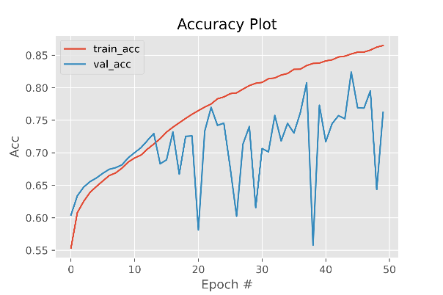  (a) | 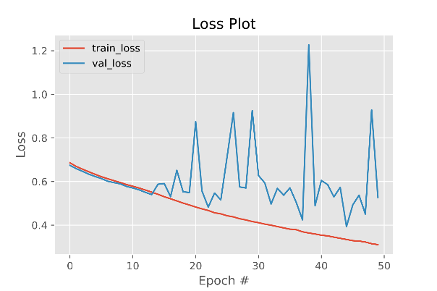  (b)
FIGURE 4. Result of Scenario 1. (a) Graph of accuracy and (b) Graph of loss

Scenario 2: Proposed model + augmentation
In the second scenario, testing is carried out with a model like the first scenario, but in preprocessing an augmentation process is carried out. This second scenario gives good results because it can provide higher accuracy and reduce overfitting. The accuracy and loss graphs provided are also slightly more stable than in the first scenario. Details regarding the results of the second scenario can be seen in FIGURE 5.
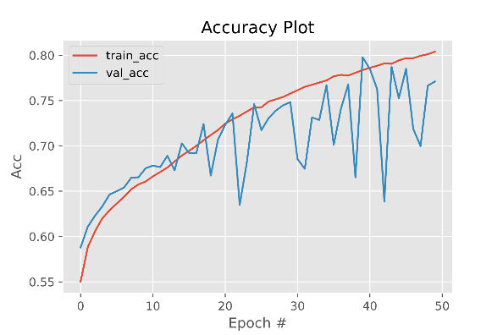  (a) | 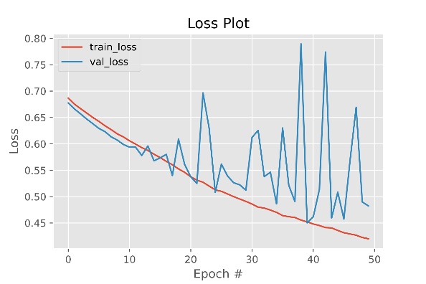  (b)
FIGURE 5. Result of Scenario 2. (a) Graph of accuracy and (b) Graph of loss

Scenario 3: Proposed model + augmentation + dropout APL
In this third scenario, testing is carried out using the second scenario with the addition of APL Dropout on the proposed model. The augmentation process is also used in this scenario. The given Dropout APL reduces accuracy slightly but makes the model performance more stable than the second scenario, and there is no indication of overfitting. The graph of this third scenario can be seen in FIGURE 6.
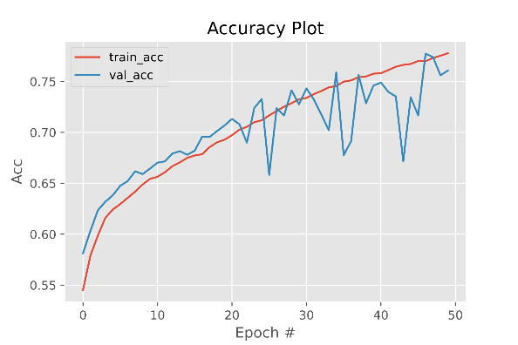  (a) | 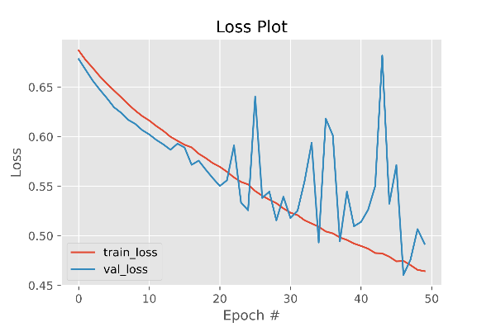  (b)
FIGURE 6. Result of Scenario 3. (a) Graph of accuracy and (b) Graph of loss

Scenario dataset STAD
This test is carried out using the second scenario on the COAD because gets the highest accuracy results than the other scenarios. This scenario is added callbacks Early Stopping, Learning Rate Scheduler, and Model Checkpoint. The Callback can make the model reach optimal conditions, but the results are not good. The graph of this scenario can be seen in FIGURE 7.
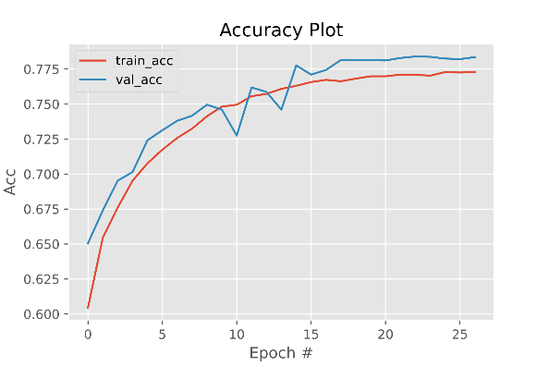  (a) | 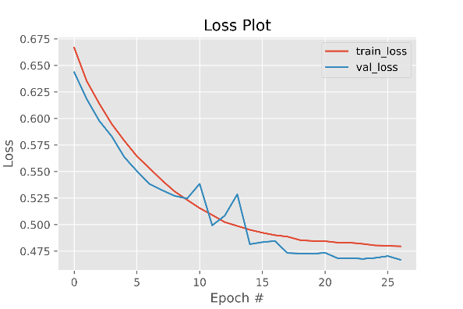  (b)

FIGURE 7. Result of Scenario STAD. (a) Graph of accuracy and (b) Graph of loss

Compare and analysis model
This study proposes a modification of the VGG19 model with hyperparameter tuning, augmentation technique, and dropout of APL (After Pooling Layer) for classification of microsatellite status in gastrointestinal cancer cells. Testing of the influence of the proposed model, augmentation techniques, and Dropout APL was conducted on COAD data. The proposed VGG19 modification model is close to the results of the VGG19 model that has previously been tested on COAD data by getting an accuracy of 76.2% in scenario 1 with a training time of 71 hours. Then the proposed augmentation technique has a good impact on accuracy by getting 77.1% accuracy, and reducing overfitting, and fluctuations in the graph but requires ±39% longer training time with 115 hours. Meanwhile, the addition of the Dropout APL can make the graph continue to increase but reduce the accuracy to 76.3% and make the training time ±13% longer with 132 hours. Then the last was conducted on STAD data with the purposed model with augmentation given callbac221k, can provide optimal performance in the model on STAD data with an accuracy of 76.4%, and reduce training time to 27 hours or ±77% faster using only 27 epochs. Details regarding the summary of the results of this study, and previous studies can be seen in TABLE 2 for COAD data, and TABLE 3 for STAD data.
A similar subsequent study was conducted by Wang, L. The study used the same dataset as this study. Wang, L. proposed the VGG19 method for the colorectal cancer cell dataset, attaching the results with an accuracy of 77%, and AUC of 0.82. In this study, trimming the convolution layer of the VGG19 architecture or in scenario 1 does not exceed the accuracy of the VGG19 model carried out by Wang, L. However, the addition of augmentation techniques in scenario 2 can increase the accuracy to exceed that of Wang, L.'s research, although only slightly with a value of 77.1%, and The AUC obtained is only 0.775, it cannot exceed the research of Wang, L. The proposed Dropout APL technique also cannot exceed the research of Wang, L., but it is very likely that the technique will get better accuracy if it is tested at larger epochs because the graph of development obtained steadily rising.
In identifying the microsatellite status of gastric cancer cells, a similar study was only carried out by Wang, L. using the same dataset. Research conducted by Wang, L. using CNN with VGG19 architecture. In this study, the method, and model used are the same as in the colorectal cancer cell experiment, namely VGG19 which has been modified by trimming the number of convolutions layers and using the proposed augmentation technique with the addition of callbacks. This study obtained better results than Wang, L. with a comparison of accuracy, and AUC values of 71%, and 0.75 in Wang, L.'s study, and 76.4%, and 0.764 in this study. This is caused by the proposed augmentation technique with the addition of model checkpoint callbacks to get the best accuracy than learning rate scheduler, and early stopping to prevent overfitting.

TABLE 2. Summary of research result on data COAD
Method  (Researcher) | Time (D:H:M) | AUC | Train |  | Val |  | Macro Avg
Method  (Researcher) | Time (D:H:M) | AUC | Acc | Loss | Acc | Loss | Precision | Recall | F1-Score
MobileNetV2 [14] | - | 0.71 | - | - | 76 | - | - | 52 | -
VGG19 [19] | - | 0.82 | - | - | 77 | - | - | - | -
Proposed Model (Scenario 1) | 2:23:57 | 0.762 | 79.6 | 44.6 | 76.2 | 52.8 | 78 | 76 | 76
Proposed Model + Augmentation (Scenario 2) | 4:19:18 | 0.775 | 77.7 | 47.1 | 77.1 | 48.1 | 79 | 77 | 77
Proposed Model + Augmentation + Dropout APL (Scenario 3) | 5:12:09 | 0.763 | 76.2 | 48.6 | 76.3 | 49 | 77 | 76 | 76

TABLE 3. Summary of research result on data STAD
Method  (Researcher) | Time (D:H:M) | AUC | Train |  | Val |  | MacroAvg
Method  (Researcher) | Time (D:H:M) | AUC | Acc | Loss | Acc | Loss | Precission | Recall | F1-Score
VGG19 [19] | - | 0.75 | - | - | 71 | - | - | - | -
Proposed Model + Augmentation + Callback (Scenario 3) | 1:03:55 | 0.764 | 76.6 | 49.8 | 76.4 | 50.2 | 76 | 76 | 76

CONCLUSIONS
The proposed models achieved accuracy, loss, and AUC of 76.2%, 52.8%, and 0.762. The addition of augmentation led to increased training time ±39% but got the best results in the study with this data in accuracy, loss, and AUC of 77.1%, 48.1%, and 0.775. The addition of this augmentation also reduces overfitting, and makes accuracy, and loss per epoch more stable. The addition of Dropout APL combined with augmentation techniques increases training time by ±13% longer than not using Dropout APL. The addition of Dropout APL also did not provide better results with accuracy, loss, and AUC values of 76.3%, 49%, and 0.763. However, the Dropout APL provides a very stable, and continuously rising accuracy, and loss per epoch chart development. This allows for better performance than not using Dropout APL if using a higher number of epochs.
On the STAD data, testing was carried out using a proposed model with augmentation added. This test got better performance results than previous research that used STAD data. Testing is done by adding several callbacks to reduce training time and overcome fluctuating problems in accuracy and loss. The callback method gets good results with accuracy, loss, and AUC values of 76.4%, 50.2%, and 0.764. Training time can be reduced ±77% faster. In addition, overfitting and fluctuating problems can be handled with this scenario.
In future research, methods are needed especially in preprocessing so that the dataset is more easily understood by the model. The image enhancement technique in focusing the contrast of the image can support the previous color normalization method, the Gaussian Blur Technique can also be added to reduce noise in the image. Then, trying to use texture analysis techniques might be able to help models that have data with irregular patterns such as this cancer cell data.

Acknowledgments
This research was supported by the Computer Vision Laboratory of Informatics Engineering Universitas Muhammadiyah Malang in devices, and intellectuals.

References
- D. A. Chistiakov, B. Hellemans, and F. A. M. Volckaert, “Microsatellites and their genomic distribution, evolution, function and applications: A review with special reference to fish genetics,” Aquaculture, vol. 255, no. 1–4, pp. 1–29, May 2006.
- P. Alhopuro et al., “Candidate driver genes in microsatellite-unstable colorectal cancer,” International journal of cancer, vol. 130, no. 7, pp. 1558–1566, Apr. 2012.
- G. Yang, R. yi Zheng, and Z. shun Jin, “Correlations between microsatellite instability and the biological behaviour of tumours,” Journal of cancer research and clinical oncology, vol. 145, no. 12, pp. 2891–2899, Dec. 2019.
- S. Velho, M. S. Fernandes, M. Leite, C. Figueiredo, and R. Seruca, “Causes and consequences of microsatellite instability in gastric carcinogenesis,” World journal of gastroenterology, vol. 20, no. 44, pp. 16433–16442, Nov. 2014.
- C. G. Kim et al., “Effects of microsatellite instability on recurrence patterns and outcomes in colorectal cancers,” British journal of cancer, vol. 115, no. 1, pp. 25–33, Jun. 2016.
- Y. Fu et al., “A qualitative transcriptional signature for predicting microsatellite instability status of right-sided Colon Cancer,” BMC genomics, vol. 20, no. 1, Oct. 2019.
- A. Echle et al., “Clinical-Grade Detection of Microsatellite Instability in Colorectal Tumors by Deep Learning,” Gastroenterology, vol. 159, no. 4, pp. 1406-1416.e11, Oct. 2020.
- T. Wang et al., “Microsatellite Instability Prediction of Uterine Corpus Endometrial Carcinoma Based on HE Histology Whole-Slide Imaging,” Proceedings - International Symposium on Biomedical Imaging, vol. 2020-April, pp. 1289–1292, Apr. 2020.
- S. H. Lee, I. H. Song, and H. J. Jang, “Feasibility of deep learning-based fully automated classification of microsatellite instability in tissue slides of colorectal cancer,” International Journal of Cancer, vol. 149, no. 3, pp. 728–740, Aug. 2021.
- A. E. Minarno, M. Rifal Alfarizy, A. Hendryawan, S. Syaifuddin, and Y. Munarko, “Pneumonia Classification using Gabor-Convolutional Neural Networks and Image Enhancement,” 2021 9th International Conference on Information and Communication Technology, ICoICT 2021, pp. 180–185, Aug. 2021.
- A. E. Minarno, M. H. C. Mandiri, Y. Munarko, and H. Hariyady, “Convolutional Neural Network with Hyperparameter Tuning for Brain Tumor Classification,” Kinetik: Game Technology, Information System, Computer Network, Computing, Electronics, and Control, vol. 6, no. 2, pp. 127–132, May 2021.
- O. J. Skrede et al., “Deep learning for prediction of colorectal cancer outcome: a discovery and validation study,” Lancet (London, England), vol. 395, no. 10221, pp. 350–360, Feb. 2020.
- A. E. Minarno, K. M. Ghufron, T. S. Sabrila, L. Husniah, and F. D. S. Sumadi, “CNN Based Autoencoder Application in Breast Cancer Image Retrieval,” Proceedings - 2021 International Seminar on Intelligent Technology and Its Application: Intelligent Systems for the New Normal Era, ISITIA 2021, pp. 29–34, Jul. 2021.
- L. Wang, Y. Jiao, Y. Qiao, N. Zeng, and R. Yu, “A novel approach combined transfer learning and deep learning to predict TMB from histology image,” Pattern Recognition Letters, vol. 135, pp. 244–248, Jul. 2020.
- M. Frid-Adar, I. Diamant, E. Klang, M. Amitai, J. Goldberger, and H. Greenspan, “GAN-based synthetic medical image augmentation for increased CNN performance in liver lesion classification,” Neurocomputing, vol. 321, pp. 321–331, Dec. 2018.
- M. P. Ranjit, G. Ganapathy, K. Sridhar, and V. Arumugham, “Efficient deep learning hyperparameter tuning using cloud infrastructure: Intelligent distributed hyperparameter tuning with Bayesian optimization in the cloud,” IEEE International Conference on Cloud Computing, CLOUD, vol. 2019-July, pp. 520–522, Jul. 2019.
- P. L. Neary, “Automatic hyperparameter tuning in deep convolutional neural networks using asynchronous reinforcement learning,” Proceedings - 2018 IEEE International Conference on Cognitive Computing, ICCC 2018 - Part of the 2018 IEEE World Congress on Services, pp. 73–77, Sep. 2018.
- I. Kandel and M. Castelli, “The effect of batch size on the generalizability of the convolutional neural networks on a histopathology dataset,” ICT Express, vol. 6, no. 4, pp. 312–315, Dec. 2020.
- M. Macenko et al., “A method for normalizing histology slides for quantitative analysis,” Proceedings - 2009 IEEE International Symposium on Biomedical Imaging: From Nano to Macro, ISBI 2009, pp. 1107–1110, 2009.
- S. Qummar et al., “A Deep Learning Ensemble Approach for Diabetic Retinopathy Detection,” IEEE Access, vol. 7, pp. 150530–150539, 2019.
- Y. S. Chen, P. P. Chong, and M. Y. Tong, “Mathematical and computer modelling of the Pareto principle,” Mathematical and Computer Modelling, vol. 19, no. 9, pp. 61–80, May 1994.
- R. Sanders, “The pareto principle: Its use and abuse,” Journal of Services Marketing, vol. 1, no. 2, pp. 37–40, 1987.
- S. Pandey, P. R. Singh, and J. Tian, “An image augmentation approach using two-stage generative adversarial network for nuclei image segmentation,” Biomedical Signal Processing and Control, vol. 57, p. 101782, Mar. 2020.
- Y. S. Perl et al., “Data augmentation based on dynamical systems for the classification of brain states,” Chaos, Solitons & Fractals, vol. 139, p. 110069, Oct. 2020.
- U. Blazhko, V. Shapaval, V. Kovalev, and A. Kohler, “Comparison of augmentation and pre-processing for deep learning and chemometric classification of infrared spectra,” Chemometrics and Intelligent Laboratory Systems, vol. 215, p. 104367, Aug. 2021.

