Development of an Augmented Reality-Based Human Anatomy Learning System

Kharisma Indhiarto Putra¹ᵃ, Kevin Aurelius Suryono¹ᵇ, Gusti Pangestu¹ᶜ
¹Computer Science Department, Bina Nusantara University, Malang, Indonesia
ᵃkharisma.putra@binus.ac.id, ᵇkevin.suryono@binus.ac.id, ᶜgusti.pangestu@binus.ac.id
Abstract—This study was motivated by the limitations of traditional anatomy learning methods, especially the lack of interaction. Research shows that 78% of students have difficulty understanding if they only use books, while 65% of students have difficulty imagining complex body systems. The purpose of the study was to evaluate the effectiveness of anatomy learning using AR and measure user satisfaction. The study used a mixed method approach and waterfall methodology, developed an AR application based on Unity and ARCore covering seven anatomical systems. Participants consisted of 30 students with data collection through demographic questionnaires, knowledge tests, System Usability Scale (SUS), and perception questionnaires. The average score results reached 63.4% (3.17/5) with 40% of students achieving satisfactory understanding. The SUS score reached 70.6 which indicates good usability. However, 23.3% of participants experienced technical difficulties which reduced learning outcomes (35.5%) and user satisfaction (30.9%). As many as 73.3% of students stated that learning using AR could be an alternative to traditional learning methods. It can be concluded that AR has potential in education, especially anatomy, with the note that it must be balanced with technical stability, age-appropriate UI design, and adequate infrastructure as success factors.
Keywords : Augmented Reality, Human Anatomy Education, Elementary School, Learning Effectiveness, Educational Technology, System Usability Scale

INTRODUCTION
Human anatomy instruction is principal to health-related areas, but conventional educating strategies are getting to be less compelling as innovation changes learning situations (Arsyad, 2010). Advanced students, encompassed by advanced innovation, appear diminished engagement with ordinary learning approaches, making a require for imaginative instructive arrangements(Chernobilsky & Granito, 2012; Goet, 2022; Hanaysha et al., 2023) .
Conventional anatomy instruction faces critical challenges including limited textbook interaction, restricted laboratory access, and difficulty visualizing complex 3D structures across diverse learning styles. Research shows 78% of students struggle with textbooks alone, while 65% have trouble visualizing body systems (Mukhoyyaroh et al., 2023; Sinou et al., 2023). Traditional cadaver-based education has limitations including access, costs, and ethical considerations (Hermans, 2011; Petersson et al., 2009; Rodríguez-Abad et al., 2021)
Expanded Reality (AR) innovation has risen as a promising arrangement to these instructive challenges. AR empowers students to imagine and associated with anatomical structures without requiring physical examples, advertising immersive three-dimensional encounters that conventional strategies cannot give (Jamali et al., 2015; Moro et al., 2017; Shin et al., 2022; Younis & H. Al-Hemiary, 2022). Considers have illustrated critical advancements in learning results, with AR-based instruction appearing 35% way better execution compared to conventional reading material strategies (Gerup et al., 2020; Zafar & Farooq, 2021).
This consider was conducted to comprehensively evaluate the adequacy of AR innovation in human anatomy instruction for basic school students. The inquire about seeks after three particular targets: to begin with, to create an intuitively AR framework that improves understanding of human anatomical structures through three-dimensional visualization; moment, to degree the adequacy of AR-based learning approaches in progressing understudy comprehension; and third, to assess client fulfillment levels with AR-enhanced anatomy learning encounters.
Two essential inquire about questions direct this examination. RQ1 looks at the comparative viability of AR-based anatomy learning versus conventional reading material strategies in terms of quantifiable learning results. RQ2 distinguishes and analyzes the challenges experienced amid AR-based learning usage, giving experiences into potential boundaries and arrangements for instructive innovation selection.
This inquire about contributes to the field through specialized advancement of an AR-based anatomy learning framework covering seven major anatomical frameworks (respiratory, circulatory, stomach related, apprehensive, solid, skeletal, and endocrine), experimental assessment of AR viability in rudimentary instruction settings, and viable execution rules for teachers and teach inquisitive about embracing AR innovation for anatomy instruction.

METHODOLOGY
This research employs a mixed-method approach conducted in two phases: (1) development of an AR-based human anatomy application, and (2) evaluation of user satisfaction and learning effectiveness.
The AR framework development follows waterfall methodology for systematic approach with clear milestones (Herawati et al., 2021). Development utilizes ARCore for AR tracking, Unity engine for interactive experiences, and Sketchfab for 3D anatomical models, targeting Android 7.0+ devices with C# scripting.
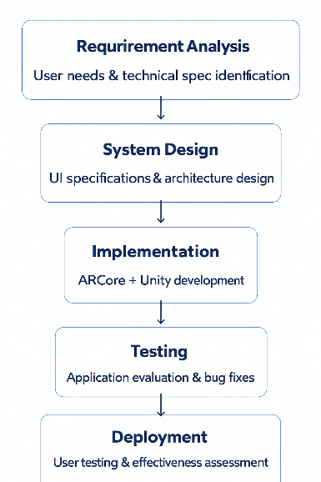
Figure 1 : Research Methodology Flow
The improvement utilizes a few key innovations to attain the desired usefulness. ARCore serves as the essential AR stage, giving strong protest following and rendering capabilities basic for anatomical visualization. Solidarity amusement motor capacities as the improvement environment, advertising comprehensive devices for making intelligently AR encounters. Three-dimensional anatomical models are sourced from Sketchfab, guaranteeing high-quality visual representations of human anatomy. The target stage is Android gadgets running least Android 7.0 (API level 24), with C# programming dialect utilized for Solidarity scripting.
Figure 2 outlines the most interface of the created AR life structures learning application, exhibiting the intuitively 3D anatomical models and client interface components outlined for basic school understudies
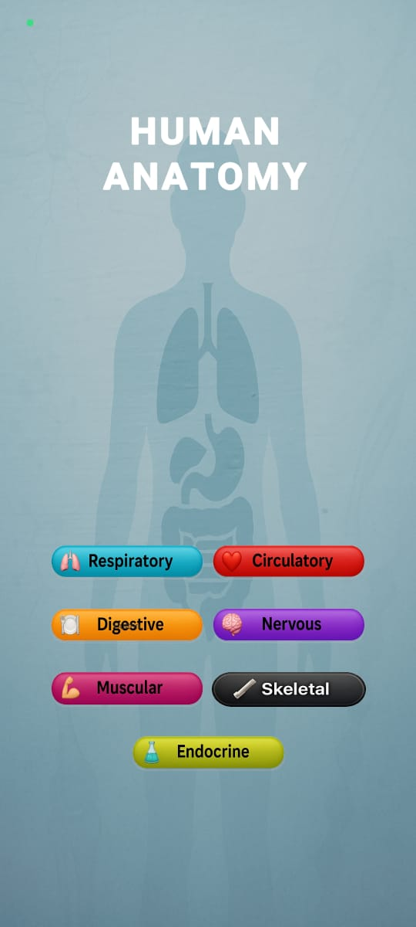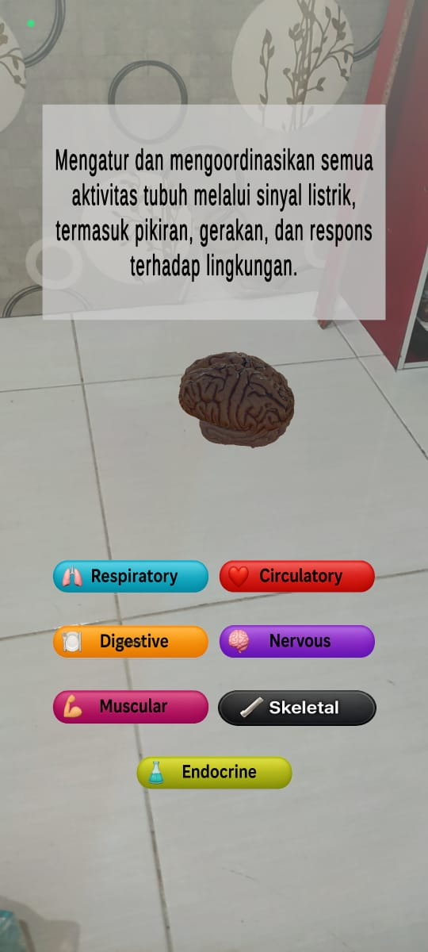
Figure 2 : AR Anatomy Learning Application Interface

The completed application consolidates seven major human anatomical frameworks: respiratory framework for understanding breathing instruments, circulatory framework for blood stream visualization, stomach related framework for supplement preparing comprehension, apprehensive framework for neural pathway investigation, strong framework for development understanding, skeletal framework for basic back visualization, and endocrine framework for hormone control comprehension.
The study employs a simple experimental design utilizing quantitative approaches to evaluate AR application effectiveness and user satisfaction. The research incorporates both independent and dependent variables to examine the relationship between AR-based learning and educational outcomes. The independent variable consists of the AR-based learning method implementation, while dependent variables include learning effectiveness measured through knowledge assessments, user satisfaction evaluated using the System Usability Scale, and user perceptions assessed through Likert-scale questionnaires.

The target population for this study consists of elementary school students engaged in human anatomy learning. The sampling approach utilizes convenience sampling methodology, selecting participants who are readily accessible and meet the established criteria. The sample size of 30 elementary school students was determined based on practical considerations and resource constraints while maintaining sufficient statistical power for meaningful analysis.
Consideration criteria require members to be current basic school students with get to to Android gadgets running least Android 7.0 working framework. Avoidance criteria dispense with members with earlier encounter utilizing AR applications for anatomy learning, guaranteeing that the assessment reflects honest to goodness first-time client encounters.
The information collection prepare utilizes different disobedient to comprehensively evaluate diverse angles of the AR learning encounter. Statistic surveys accumulate basic member data counting age, sex, review level, and earlier AR involvement. Information assessment utilizes a carefully planned test comprising five multiple-choice questions covering the anatomical frameworks examined through the AR application.
Client fulfillment appraisal utilizes the Framework Ease of use Scale (SUS), a approved instrument containing ten questions measured on a five-point Likert scale extending from "Emphatically Oppose this idea" to "Unequivocally Concur"(Bangor et al., 2008; Brooke, 1996). Learning recognition assessment utilizes a custom survey planned to survey different perspectives of the AR learning encounter, measuring ease of fabric comprehension, changes in learning inspiration, intrigued levels in AR-based learning approaches, and inclinations between AR and conventional learning strategies.
Data collection was conducted through a structured online survey methodology implemented via Google Forms platform. The survey mechanism involved distributing questionnaire links to participating elementary school students through their classroom teachers, with data collection supervised directly by researchers during a single Google Meet session. The survey comprised multiple components: demographic questionnaires were administered first, followed by hands-on interaction with the AR application for 15-20 minutes, after which participants completed the knowledge assessment test, System Usability Scale (SUS) evaluation, and learning perception questionnaires. All survey responses were automatically recorded and compiled through Google Forms' integrated data collection system, ensuring data integrity and eliminating manual transcription errors.
The investigation approach combines clear and inferential factual strategies to comprehensively assess the collected information. Expressive investigation gives point by point member profiles and score dispersions for each measured variable. Unwavering quality testing utilizes Cronbach's Alpha coefficient to survey inside consistency of the estimation rebellious. Measurable investigation utilizes Python programming dialect with specialized libraries counting Pandas for information control, NumPy for numerical calculations, and Matplotlib for information visualization.

RESULTS AND DISCUSSION
The ponder effectively selected 30 basic school students who met all built up interest criteria. The member socioeconomics uncover imperative characteristics that impact the translation of ensuing discoveries. Sexual orientation dispersion among members was generally adjusted, with 16 male students (53.3%) and 14 female students (46.7%) partaking within the ponder.
Table 1 presents the statistic characteristics of the consider members. The member socioeconomics uncover critical characteristics that impact the elucidation of consequent discoveries and give setting for understanding the inquire about comes about.

Table 1: Participant Demographics (N=30)
Characteristic | Category | Frequency | Percentage
Gender | Male | 16 | 53.3%
 | Female | 14 | 46.7%
Age | 7 years | 4 | 13.3%
 | 8 years | 9 | 30.0%
 | 9 years | 6 | 20.0%
 | 10 years | 6 | 20.0%
 | 11 years | 3 | 10.0%
 | 12 years | 2 | 6.7%
Grade Level | Grade 1 | 9 | 30.0%
 | Grade 2 | 4 | 13.3%
 | Grade 3 | 3 | 10.0%
 | Grade 4 | 8 | 26.7%
 | Grade 5 | 4 | 13.3%
 | Grade 6 | 2 | 6.7%
Prior AR Experience | Yes | 5 | 16.7%
 | No | 25 | 83.3%

Age dissemination ranges from 7 to 12 a long time, with an normal age of 9.0 a long time and a standard deviation of 1.5 a long time. The foremost spoken to age gather comprises 8-year-old students (30.0%), taken after by break even with representation of 9-year-old and 10-year-old students (20.0% each). Review level dissemination reflects the age conveyance, with Review 1 students comprising the biggest bunch (30.0%), taken after by Review 4 students (26.7%).
Prior AR experience was limited with only 5 students (16.7%) having previous exposure, ensuring authentic first-time user evaluation. Knowledge test results revealed mixed outcomes with mean score of 3.17/5 (63.4% accuracy) and standard deviation of 1.05, indicating considerable performance variation
Execution dissemination examination gives extra bits of knowledge into learning results. As it were 2 students (6.7%) accomplished amazing execution (4.5-5.0 focuses), whereas 10 students (33.3%) illustrated great execution (3.5-4.4 focuses). Palatable execution (2.5-3.4 focuses) was accomplished by 8 students (26.7%), whereas 6 students (20.0%) required enhancement (1.5-2.4 focuses) and 4 students (13.3%) illustrated destitute execution (0-1.4 focuses).

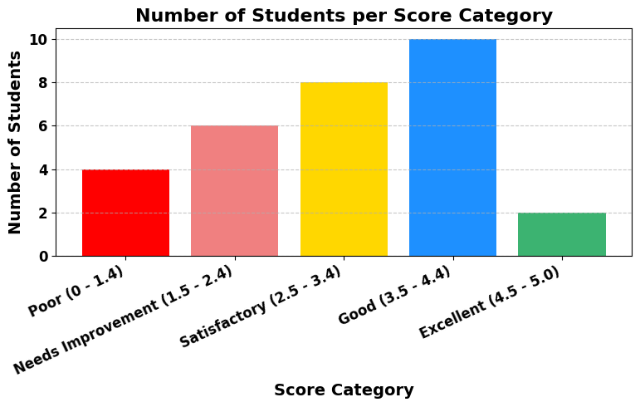
Figure 3: Bar Chart Knowledge Score Distribution

These comes about demonstrate that whereas 40% of students accomplished palatable or superior understanding, a noteworthy extent (33.3%) scored underneath palatable levels. This dissemination proposes that AR-based learning appears guarantee but requires refinement to realize more steady instructive results over assorted understudy populaces. Figure 3 outlines the dissemination of information test scores over all members, appearing the variety in learning results accomplished through AR-based instruction.

The affect of specialized challenges on learning results uncovers a basic figure influencing AR instruction viability. Students who experienced specialized issues amid AR application utilize (n=7) illustrated altogether lower execution compared to those without specialized issues (n=23). The cruel score for student swith specialized challenges was 2.29 (SD=0.92), whereas students without specialized issues accomplished a cruel score of 3.52 (SD=0.94).
Table 2 provides a detailed comparison of performance measures between participants who experienced technical difficulties and those who did not.

Table 2 : Performance Comparison by Technical Issues

Measure Difference | With Technical Issues  (n=7) | Without Technical Issues  (n=23)
Knowledge Score (Mean±SD)  -35.5% | 2.29±0.92 | 3.52±0.94
SUS Score (Mean±SD)  -30.9% | 52.7±15.2 | 76.3±16.8
Usage Time (minutes)  -18.4% | 6.2±1.1 | 7.6±1.3

This execution crevice of 1.23 focuses speaks to a 35.5% contrast in learning viability, clearly outlining how specialized issues can significantly meddled with instructive results. These discoveries highlight the basic significance of specialized solidness and unwavering quality in AR instructive applications.

The System Usability Scale (SUS) evaluation gives standardized assessment of client fulfillment and framework convenience. In general SUS execution illustrates by and large positive client encounters, with a cruel score of 70.6 and standard deviation of 18.9. The middle score of 73.4 recommends that most members found the framework sensibly usable, in spite of the fact that the wide extend (35.5-100) demonstrates critical variety in client encounters.

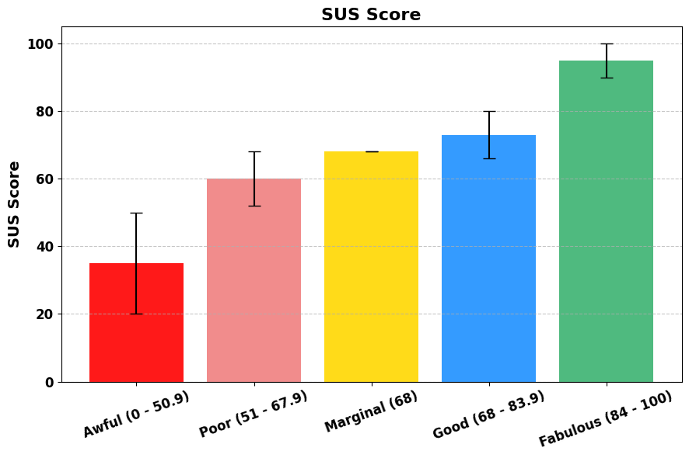
Figure 4: Box Plot of SUS Scores

The cruel SUS score of 70.6 falls inside the "great" category agreeing to built up SUS elucidation rules, recommending that the AR application gives worthy ease of use for most clients(Bangor et al., 2008). Be that as it may, the truth that roughly 30% of members experienced destitute or appalling ease of use highlights regions requiring enhancement to guarantee steady client encounters.Figure 4 presents the dissemination of SUS scores over all members, outlining the inconstancy in client fulfillment and framework convenience encounters.

The learning perception assessment used a five-point Likert scale questionnaire to evaluate various dimensions of the AR learning experience. Ease of understanding evaluation yielded a mean score of 3.53 with a standard deviation of 1.10, indicating generally positive perceptions of AR's ability to facilitate comprehension. The response distribution shows that 56.7% of participants found AR helpful for understanding anatomical concepts.
Figure 4 shows the conveyance of understudy discernments over four key measurements of the AR learning involvement: ease of understanding, inspiration increment, intrigued in AR learning, and inclination for AR versus conventional strategies.

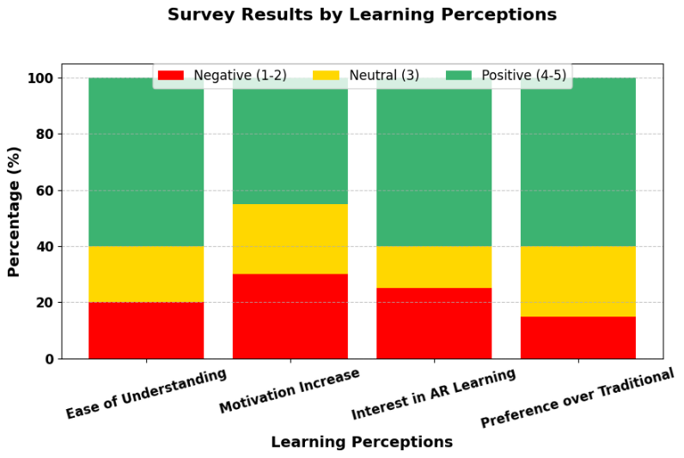
Figure 5: Histogram of Learning Perceptions

Interest in AR learning demonstrated higher scores with a mean of 3.63 and standard deviation of 1.19, indicating strong student interest in AR-based learning approaches. A considerable majority (60%) expressed positive interest in AR learning. Most altogether, inclination for AR versus conventional learning strategies yielded the most noteworthy scores with a cruel of 3.83 and standard deviation of 1.01, with 63.3% of members favoring AR over conventional strategies.
Specialized challenges risen as a basic figure influencing both learning results and client fulfillment. The analysis of technical issues provides crucial insights into the practical considerations required for successful AR deployment. Students experiencing technical difficulties showed consistently lower performance across all measured dimensions compared to those without technical issues.
Qualitative analysis of user feedback identified three primary categories of technical challenges. Unstable object tracking when the device was moved was reported by 71% of participants experiencing technical challenges, representing the most common and disruptive issue. Model rendering delays affected 57% of users with technical issues, causing frustration and hindering the learning flow. User interface responsiveness issues were reported by 43% of affected participants, preventing their ability to interact effectively with the application.
The research findings reveal both potential and limitations of AR for elementary anatomy education. Regarding learning effectiveness (RQ1), AR shows promise but falls short of optimal levels with 63.4% average score and only 40% achieving satisfactory performance.
For implementation challenges (RQ2), technical issues affected 23.3% of participants, resulting in 35.5% reduction in learning outcomes and 30.9% reduction in satisfaction. Interface complexity particularly challenged younger students (Grades 1-2) who struggled with navigation beyond their developmental capabilities. Successful AR implementation requires comprehensive tutorials, offline content capabilities, and age-appropriate interface design.

CONCLUSIONS AND SUGGESTIONS
This ponder assessed the viability of expanded reality innovation for human anatomy among 30 basic school students. The inquire about tended to both learning adequacy and usage challenges of AR-based instructive approaches.
The evaluation of learning adequacy uncovers that AR innovation illustrates direct instructive potential, with an normal execution score of 63.4%(Bölek et al., 2021; García-Robles et al., 2024). Whereas 40% of members accomplished palatable understanding levels, the significant extent of students (33.3%) requiring advancement shows that AR viability changes altogether among person learners.
Client fulfillment appraisal through the Framework Ease of use Scale yielded a score of 70.6, setting the AR application within the "great" ease of use category. This finding shows that 53.4% of members experienced palatable framework convenience, in spite of the fact that specialized unsettling influences influenced 30% of clients and essentially affected their encounter.
Learning recognition investigation uncovers empowering discoveries with respect to understudy acknowledgment of AR innovation, with a tall inclination score of 3.83 for AR-based learning approaches. Most essentially, 73.3% of members communicated readiness to embrace AR learning strategies when specialized challenges are settled, demonstrating solid potential for instructive innovation appropriation.
The execution challenges distinguished through this investigate uncover basic variables that must be tended to for fruitful AR arrangement in instructive settings. Specialized issues experienced by 23.3% of members come about in considerable negative impacts, lessening learning results by 35.5% and client fulfillment by 30.9%. These discoveries illustrate the foremost significance of specialized soundness in instructive AR applications.
Technical improvements should focus on stable object tracking, rendering optimization, and UI responsiveness with age-appropriate design and integrated tutorials. This study demonstrates AR's significant potential for elementary anatomy education. Despite current technical limitations, positive student responses and increased learning interest provide compelling evidence for AR as a valuable alternative to conventional approaches.

DATA AVAILABILITY STATEMENT
The datasets generated and analyzed during this study are not publicly available due to ethical considerations involving elementary school student participants (minors under 18 years old) and privacy protection requirements as per institutional research ethics guidelines. Anonymized summary data supporting the conclusions of this article may be available from the corresponding author upon reasonable request and with appropriate ethical approval.
ACKNOWLEDGMENTS
The authors feel thankful for every person and institution which helped achieve the successful completion of this research. We thank SDN Lesanpuro 4, Malang, East Java, Indonesia for their institutional support and student access during our research on educational technology. The classroom teachers deserve special recognition for their assistance in data collection and the 30 student participants who dedicated their enthusiasm to this study.
The CRediT (Contributor Roles Taxonomy) system was used to identify the precise contributions made by the authors. Kharisma Indhiarto Putra played a leading role in the development of concepts and methodology designs and completed literature reviews and theoretical framework construction and instrument validation and supervised data collection and took lead responsibility for drafting the original manuscript and handling project administration. The AR application development and technical implementation work of Kevin Aurelius Suryono included building the application through Unity and ARCore and incorporating Sketchfab 3D models and performing statistical analysis through Python libraries and conducting data validation and reliability tests and generating visualizations for the manuscript. The study received academic supervision and research guidance from Gusti Pangestu who also reviewed the manuscript for academic quality and ensured research ethics compliance and institutional guidelines adherence and secured funding and institutional support for final manuscript submission approval.
The research depended on technical resources that Sketchfab provided for high-quality 3D anatomical models alongside Unity Technologies' development environment and Google ARCore SDK and Google Meet platform for online data collection. All authors jointly participated in interpreting results and producing the final version of the manuscript.

REFERENCES

Arsyad, A. (2010). Media pembelajaran. Azhar Arsyad. In Ed (Vol. 1).
Bangor, A., Kortum, P. T., & Miller, J. T. (2008). An empirical evaluation of the system usability scale. International Journal of Human-Computer Interaction, 24(6). https://doi.org/10.1080/10447310802205776
Bölek, K. A., De Jong, G., & Henssen, D. (2021). The effectiveness of the use of augmented reality in anatomy education: a systematic review and meta-analysis. Scientific Reports, 11(1). https://doi.org/10.1038/s41598-021-94721-4
Brooke, J. (1996). SUS -A quick and dirty usability scale Usability and context. Usability Evaluation in Industry, 189(194).
Chernobilsky, E., & Granito, M. D. (2012). The Effect of Technology on a Student’ s Motivation and Knowledge Retention. Conference Proceedings Northeastern Educational Research Association, 17.
García-Robles, P., Cortés-Pérez, I., Nieto-Escámez, F. A., García-López, H., Obrero-Gaitán, E., & Osuna-Pérez, M. C. (2024). Immersive virtual reality and augmented reality in anatomy education: A systematic review and meta-analysis. In Anatomical Sciences Education (Vol. 17, Issue 3). https://doi.org/10.1002/ase.2397
Gerup, J., Soerensen, C. B., & Dieckmann, P. (2020). Augmented reality and mixed reality for healthcare education beyond surgery: an integrative review. International Journal of Medical Education, 11. https://doi.org/10.5116/ijme.5e01.eb1a
Goet, J. (2022). Impact of social media on Academic Performance of Students. KIC International Journal of Social Science and Management, 1(1). https://doi.org/10.3126/kicijssm.v1i1.51100
Hanaysha, J. R., Shriedeh, F. B., & In’airat, M. (2023). Impact of classroom environment, teacher competency, information and communication technology resources, and university facilities on student engagement and academic performance. International Journal of Information Management Data Insights, 3(2). https://doi.org/10.1016/j.jjimei.2023.100188
Herawati, S., Negara, Y. D. P., Febriansyah, H. F., & Fatah, D. A. (2021). Application of the Waterfall Method on a Web-Based Job Training Management Information System at Trunojoyo University Madura. E3S Web of Conferences, 328. https://doi.org/10.1051/e3sconf/202132804026
Hermans, M. H. E. (2011). Preservation methods of allografts and their (lack of) influence on clinical results in partial thickness burns. Burns, 37(5). https://doi.org/10.1016/j.burns.2011.01.007
Jamali, S. S., Shiratuddin, M. F., Wong, K. W., & Oskam, C. L. (2015). Utilising Mobile-Augmented Reality for Learning Human Anatomy. Procedia - Social and Behavioral Sciences, 197. https://doi.org/10.1016/j.sbspro.2015.07.054
Moro, C., Štromberga, Z., Raikos, A., & Stirling, A. (2017). The effectiveness of virtual and augmented reality in health sciences and medical anatomy. Anatomical Sciences Education, 10(6). https://doi.org/10.1002/ase.1696
Mukhoyyaroh, Q., Nugraheni, L. S., Ripauji, R., & Sumedi, S. H. (2023). Development of Learning Modules Assisted by Augmented Reality (AR) to Improve Learning Outcomes of High School Students on the Concept of the Circulatory System",. Bioedukasi: Jurnal Pendidikan Biologi, 16(2).
Petersson, H., Sinkvist, D., Wang, C., & Smedby, Ö. (2009). Web-based interactive 3D visualization as a tool for improved anatomy learning. Anatomical Sciences Education, 2(2). https://doi.org/10.1002/ase.76
Rodríguez-Abad, C., Fernández-De-la-iglesia, J. D. C., Martínez-Santos, A. E., & Rodríguez-González, R. (2021). A systematic review of augmented reality in health sciences: A guide to decision-making in higher education. In International Journal of Environmental Research and Public Health (Vol. 18, Issue 8). https://doi.org/10.3390/ijerph18084262
Shin, M., Prasad, A., Sabo, G., Macnow, A. S. R., Sheth, N. P., Cross, M. B., & Premkumar, A. (2022). Anatomy education in US Medical Schools: before, during, and beyond COVID-19. BMC Medical Education, 22(1). https://doi.org/10.1186/s12909-022-03177-1
Sinou, N., Sinou, N., & Filippou, D. (2023). Virtual Reality and Augmented Reality in Anatomy Education During COVID-19 Pandemic. Cureus. https://doi.org/10.7759/cureus.35170
Younis, S. B., & H. Al-Hemiary, E. (2022). Augmented Reality for Learning Human Body Anatomy and Total Hip Replacement Surgery. Iraqi Journal of Information and Communication Technology, 5(2). https://doi.org/10.31987/ijict.5.2.196
Zafar, A., & Farooq, M. S. (2021). Augmented Reality in Healthcare Education for Human Anatomy. VFAST Transactions on Software Engineering, 9(3). https://doi.org/10.21015/vtse.v9i3.694

