Harnessing AI for Health Anxiety Assessment in Chronic Disease: A Performance Evaluation of Random Forest and Artificial Neural Network

Nyoman Wira Prasetya^{1, a),} Wina Permana Sari^{1,b)}, Richard Wijaya Harianto^{1,c),} Ni Made Ayu Wulan Sari ^{2,d)}

¹Computer Science Department, School of Computer Science, Bina Nusantara University, Jakarta, Indonesia 11480
²Nursing Science Department, Stikes Telogorejo, Semarang, Indonesia

Corresponding author: ^{a)}nyoman.wira@binus.ac.id
^{b)}wina.sari001@binus.ac.id
^{c)}richard.harianto@binus.ac.id
^{d)} nimadeayu@stikestelogorejo.ac.id
Abstract. Health anxiety functions as a vital psychological element that affects the quality of life and therapeutic results for people with chronic illnesses, although healthcare professionals seldom handle it adequately. The research investigates the effectiveness of Artificial Neural Networks (ANN) and Random Forest (RF) algorithms in predicting health anxiety levels through self-reported psychometric data from chronic patients in Semarang, Indonesia. The study utilized 394 records obtained using the 18-item Short Health Anxiety Inventory (SHAI), a psychometrically validated instrument for assessing health anxiety domains. The RF model, applying Gini Index optimization, displayed 92.5% accuracy at the 10% test size scenario, while the successful ANN model results amounted to 70.00% but showed a performance discrepancy of 22.50%. The research demonstrates that Random Forest has outstanding potential as a reliable, understandable, and efficient diagnostic approach, facilitating the development of AI-based diagnostic tools for clinical mental health applications. The most influential and purposeful variables used in classifying health anxiety were somatic preoccupation, symptom monitoring, perceived consequences of illness, and age, as indicated by feature importance analysis.
Keywords: Chronic Disease; Anxiety Classification; Artificial Neural Network; Random Forest; Machine Learning

INTRODUCTION
Chronic diseases are medical conditions that require more than twelve months to treat, significantly compromising the quality of life and functional capacity of patients [1]. They constitute long-term physical, psychological, and socioeconomic burdens [2]. In Indonesia, these diseases tend to extend to more than six months, and they interfere with biological, psychological, and sociocultural functioning [3]. Their physical effects are well-documented, but little is known about the psychological aspect, specifically the health anxiety, despite its linkages to treatment adherence and healthcare use [4,5]. This highlights the importance of efficient early screening and assessment tools that would be applicable in clinical practice.
Predictive health analytics has seen the rise of artificial intelligence (AI), which is used in the diagnosis of anxiety, depression, and stress disorders [6, 7, 8]. More complex models, such as deep neural networks, have high predictive accuracy [9, 10], but are commonly criticized for being black boxes, which restricts their interpretability and clinical implementation [11]. This is particularly concerning in low-resource health systems, where models must be transparent and easily deployable to be trusted by practitioners and scalable [12]. Despite the potential of ensemble and neural network models, such as Random Forest (RF) and Artificial Neural Networks (ANN), in health-related tasks [13,14], there is a limited systematic comparison of the models in predicting health anxiety, especially in the Indonesian context [15].
This research fills this gap by conducting a comparative analysis of RF and ANN in the assessment of health anxiety of patients with chronic diseases. The contributions are three-fold: (1) a high-fidelity head-to-head comparison of optimized RF and ANN models on a dataset of 349 Indonesian patients, (2) the identification of the most important psychometric features related to health anxiety to make the models more interpretable, and (3) the analysis of the accuracy-interpretability trade-off, which provides practical guidance on the deployment of AI-based mental health assessment tools in resource-limited clinical settings. Placing this study in both methodological and clinical contexts, the paper will contribute to the development of integrating AI into transparent and scalable healthcare solutions.

LITERATURE REVIEW

Anxiety
Anxiety, especially in the context of chronic illness, often contains a psychosocial element in the form of an interaction of emotional and physiological responses. The central aspect of anxiety is that it is associated with intolerance of uncertainty, which interferes with the emotional regulation process [16]. The only issue here is health anxiety, but a specific subtype of anxiety, that becomes of special concern in the cases of chronic illnesses. The phenomenon of health anxiety is described as persistent fear, exaggerated perception of risk, and physiological manifestations such as an increase in heart rate [17]. The presence of childhood trauma is a determinant of health anxiety severity [18], given that this latter association has a lasting effect on adult mental health. Pathological health anxiety is extremely detrimental to cognitive and emotional functioning. The enhanced priming of the bilateral amygdalae that drives pathological health anxiety appears to be associated with exaggerated pathological responses to benign bodily sensations and a tendency to misconstrue these sensations as harbingers of severe illness [19].

Factors Risk of Anxiety in Patients with Chronic Disease
Comorbid chronic disease in conditions such as HIV increases anxiety symptoms, and patients are 2.5 times more likely to have elevated psychological distress compared with patients with no comorbid conditions [20]. Social determinants of anxiety are intricately linked, and the pervasiveness of stigma needs interventions addressing both psychosocial and medical needs. Reducing stigma and creating an environment that is supportive towards such individuals plays a crucial role in diminishing the psychological burden borne by the affected.

Income, Social Support, Social Activities, and History of Trauma
Key anxiety determinants among elderly patients include income level, social engagement, and trauma history. Financial dependency in old age can be a provocation source to increase anxiety because of intergenerational stress and the lack of autonomy. On the other hand, if a patient has insufficient social support or a narrow network of close contacts, this psychiatric burden is made worse among those with chronic conditions [21][22].
Alone, elderly individuals feel more anxious, and in addition to aging processes and disease progression, are further isolated through social participation decline. Furthermore, a history of trauma has a profound impact on mental health. Among them, defence mechanisms such as avoidance impede the use of relevant coping strategies for managing chronic illnesses [23][24]. Taken collectively, these factors highlight the complex interplay between socio-economic, relational, and psychological domains, underscoring the need for an intervention that targets simultaneously the emotional and social needs of individuals with chronic disease.

Related Studies
Random Forest is a robust ensemble algorithm that can produce very high predictive performance and exhibits good resistance to overfitting; therefore, it is well-suited for complex clinical datasets [25, 26]. Its performance is dictated by splitting criteria, such as the Gini Index, which determines the class impurity of an efficient split, and a criterion called Entropy, which addresses information giving to deal with data uncertainty [27].
Artificial Neural Networks (ANNs) are great at capturing complex, non-linear patterns of interest in psychological data [28, 29]. Activation functions have a significant impact on their ability. The current work contrasts the classic Sigmoid with the contemporary default, Rectified Linear Unit (ReLU), which is characterized by its computational grounds and usefulness in thwarting the vanishing gradient issue in deep nets [32, 33]

METHODOLOGY
The process of this research followed a systematic pipeline (FIGURE 1), starting with data acquisition and preprocessing, model development, hyperparameter optimization, and performance evaluation and interpretability analysis. This multi-stage design was able to guarantee reproducibility and clinical relevance in the prediction of health anxiety in chronic disease patients..

FIGURE 1. Conceptual Framework of the Health Anxiety Prediction Pipeline using ANN and Random Forest

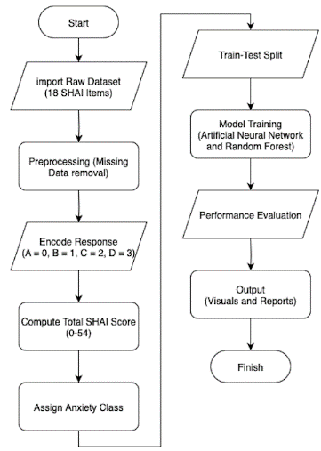

Data Acquisition and Preprocessing
The dataset included 394 anonymized patient responses collected at one of the most extensive primary healthcare facilities in Semarang, Indonesia. The entries included demographic data (age, gender, diagnosis) and psychometric data from the 18-item Short Health Anxiety Inventory (SHAI), which was divided into a main section (14 items) and a section on negative consequences (4 items). To standardize feature representation, responses were numerically encoded (A = 0, B = 1, C = 2, D = 3).

TABLE 1. Structure and dimension of the health anxiety dataset
Feature Group | Number of Variables | Example Column
SHAI Main Section | 14 | AOB 3, TSA 5
SHAI Negative Consequence | 4 | PCI 17, PLD18
Total Score | 1 | SHAI Total Score
Class Label | 1 | Anxiety Level
Demographics | 3 | Gender, Diagnosis, Age

To clarify, the representative SHAI columns were assigned shorter notations that can be used in modeling. The AOB (Awareness of Bodily Sensations, question 3), TSA (Threat of Serious Ailment, question 5), PCI (Perceived Consequence of Illness, question 17), and PLD (Perceived Loss of Dignity, question 18) are Awareness of Bodily Sensations, Threat of Serious Ailment, Perceived Consequence of Illness, and Perceived Loss of Dignity, respectively. The abbreviations represent the cognitive and behavioral areas of the SHAI inventory.
The sum of SHAI points (0-54) was calculated for each participant and subdivided into four groups: non-clinical, mild, moderate, and severe anxiety. Data quality control was applied, which excluded incomplete responses. Stratified thresholds were used to maintain class balance, and the data was divided into training and test sets (with a 90:10 ratio). The composition of the datasets is presented in a structured format in Table 1, while Table 2 provides examples of encoded responses and categorical labeling.

TABLE 2. Sample of encoded Shai responses and classification
Participant ID | AOB 3 | TSA 5 | PCI 17 | PLD 18 | … | Total Score | Anxiety Level
P001 | 1 | 3 | 3 | 2 | … | 32 | Moderate
P017 | 2 | 1 | 3 | 0 | … | 13 | No Anxiety
P018 | 3 | 3 | 2 | 3 | … | 41 | Severe
… | … | … | … | … | … | … | …

TABLE 2 shows the simplified coding image of the SHAI responses that have been encoded, the generated total score, and the anxiety category that protrudes as a result thereof. Although not all the items of SHAI are provided to explain the point, the use of all 18 features was included in the machine learning pipeline. The style is designed to be readable yet selective, allowing for reproduction in a narrow-page environment. Data supporting this study are available from repository (original primary datasets) at https://bit.ly/originaldatasets. Access to the data is subject to approval and a data sharing agreement due to health ethics.

Artificial Neural Network (ANN)
Artificial Neural Networks (ANNs) were implemented to capture non-linear psychometric patterns. The architecture consisted of 72 features in the input layer, two hidden layers (128 and 64 neurons), and four nodes in the output layer with softmax activation. Two activation functions, ReLU (Equation 1) and Sigmoid (Equation 2), were used, as they are commonly used in clinical predictive modeling [30].
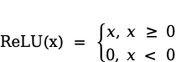(( ( (1)
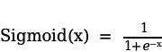 (2)
Optimization was performed using Adam and SGD, with the loss function being categorical cross-entropy. To reduce overfitting, early stopping with validation monitoring was applied. Comparing accuracy, precision, recall, and F1-score over several training runs identified the best configuration.

Random Forest (RF)
Random Forest, an ensemble method of decision trees, was chosen because of its robustness and interpretability. All trees were built on randomly sampled training data, and a majority vote combined predictions. Two splitting criteria were compared, Gini Index (Equation 3) and Entropy with Information Gain (Equations 4-6).
(3)

(4)

(5)
(6)
Hyperparameter tuning was performed by varying the number of estimators (10-100) and test sizes (0.1-0.4). Model stability was evaluated using five-fold cross-validation, and the optimal setup was chosen by balancing training and testing accuracy.

Feature Importance Analysis

To improve clinical interpretability, the RF feature importance was extracted based on the mean decrease in Gini impurity. The top predictive features were identified (e.g., somatic preoccupation, symptom monitoring, age, and disease-related literacy), and the healthcare practitioners could use this information to prioritize early screening and intervention.

Evaluation Metrics

Four standard metrics tested ANN and RF models. Accuracy was a measure of overall correctness in classification (Equation 7). The proportion of correct optimistic predictions was measured as precision (Equation 8), the proportion of actual positives that were correctly identified was measured as recall (sensitivity) (Equation 9), and the F1-score (the harmonic mean of precision and recall) (Equation 10) gave a balanced assessment that is particularly pertinent to clinical decision-making [30].

(7)
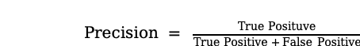 (8)
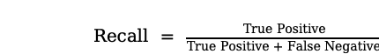 (9)
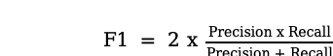 (10)

RESULT AND DISCUSSION
The study will conduct a comparative performance study of Artificial Neural Networks (ANN) and Random Forest (RF) to classify the status of health anxiety in chronically ill patients. With a dataset of 394 anonymized records, this research evaluates the performance of models using a 90/10 train-test split, which helps ascertain a robust and unbiased measure of the generalization capability. The evaluation targeted the generalizing power and sensitivity, as well as practical utility for healthcare classification of each model.

FIGURE 3. ANN Testing Scenario
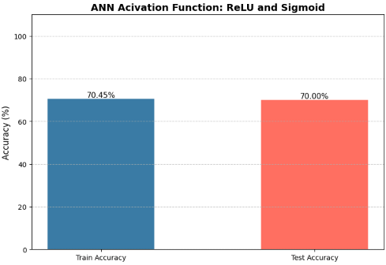

Figure 3 presents the ANN results, and the ReLU activation achieved a training accuracy of 70.45% and a testing accuracy of 70.00%. The narrow difference between training and testing accuracy suggests limited overfitting; however, the overall performance remained modest, indicating that the ANN has difficulty in capturing complex psychometric trends in tabular data. There were the highest frequencies of misclassifications in moderate-to-severe anxiety cases, which reflects low sensitivity. The same results have been observed in previous research where shallow ANNs failed in structured health data [34].

FIGURE 4. Random Forest Testing Scenario Gini
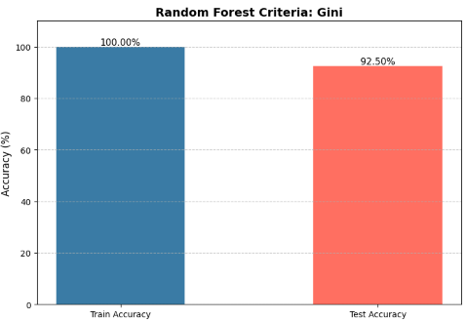

By contrast, the Random Forest model performed significantly better. It achieved a training accuracy of 100 percent and a testing accuracy of 92.50 percent, as demonstrated in Figure 4 (using the Gini criterion). Although a training score of 100 percent is a possible indication of overfitting, the model’s strong test performance demonstrates robust generalization. The entropy criterion (Figure 5) had a slightly lower but still higher testing accuracy of 90.00 percent compared to the ANN. Such consistency of criteria validates the reliability of RF, which is consistent with previous research on its robust flexibility in clinical prediction tasks [35].

FIGURE 5. Random Forest Testing Scenario Entropy
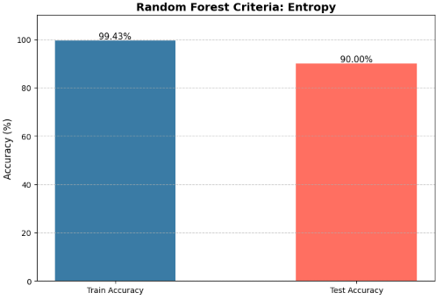

The summarized results are presented in Table 3; the Gini-based RF demonstrated the best overall performance (F1 = 92.65) in comparison to the ANN (F1 = 58.09). This 22 percent margin highlights the diagnostic value of RF, especially when it comes to reducing misclassification of high-anxiety patients. Supporting evidence from other healthcare AI studies also highlights the better precision-recall trade-off of RF [36].

TABLE 3. Accuracy comparison across ML models

Model | Test Accuracy (%) | Precision | Recall | F1 Score
ANN (relu) | 70.00 | 49.48 | 70.34 | 58.09
ANN (sigmoid) | 70.00 | 49.48 | 70.34 | 58.09
Random Forest (Gini) | 92.50 | 93.21 | 92.50 | 92.65
Random Forest (Entropy) | 90.00 | 89.48 | 90.00 | 89.05

For interpretability, Figure 6 (Confusion Matrix) illustrates that RF had balanced predictions in all classes, whereas ANN classified severe cases as mild ones. The most influential predictors identified by the Random Forest model were somatic preoccupation, symptom monitoring, age, and disease-related literacy. The results also increase clinical relevance by guiding practitioners of important psychometric indicators of early intervention, in line with the demands of explainable AI in healthcare [37].

FIGURE 6. Confusion Matrix Random Forest and ANN
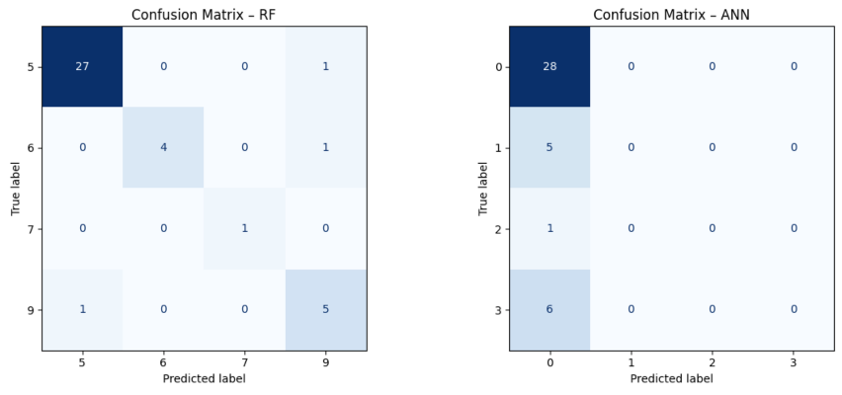

In summary, RF consistently outperformed ANN in both predictive. Such findings justify the use of ensemble approaches as more practical in low-resource healthcare systems for psychological assessment. The identification of influential features also enhances the novelty of this study, as it provides evidence-based information for clinical implementation in the Indonesian chronic disease setting.

CONCLUSION
This research showed that Random Forest (RF) performed better than Artificial Neural Networks (ANN) in predicting health anxiety in patients with chronic diseases, with a testing accuracy of 92.50 percent and an F1-score of 92.65 percent, compared to 70.00 percent accuracy and a 58.09 percent F1-score for ANN. Although the ANN demonstrated stable convergence, its predictive ability was low, particularly in differentiating severe cases of anxiety. Conversely, RF, in addition to having a greater generalizability, also yielded interpretable results, with somatic preoccupation, symptom monitoring, disease-related literacy, and age becoming the most important predictors. These results underscore the practical applicability of ensemble techniques in clinical psychology, offering valid and interpretable tools to identify health anxiety in low-resource healthcare facilities at an early stage. The potential future developments of this approach include utilizing larger datasets and hybrid architectures that combine the explainability of RF with the representational power of deep learning, thereby further supporting the responsible application of AI in mental health assessment.

ACKNOWLEDGMENTS

This work is supported by the Research and Technology Transfer Office, Bina Nusantara University, as a part of Bina Nusantara University’s International Research Grant entitled “Revealing Health Anxiety In Patients With Chronic Disease: Multimodal Emotion Analysis Recognition” with contract number: 085/VRRTT/V/2024 and contract date: May 01, 2025.”

Nyoman Wira Prasetya: Analysis, Resources, Investigation, Writing-Reviewing and Editing, and Data curation. Wina Permana Sari: Conceptualization, Analysis, Supervision, Writing-Reviewing and Editing, Project administration. Richard Wijaya Harianto: Conceptualization, Methodology, Software, Writing-Original Draft. Ni Made Ayu Wulan Sari: Resources, Validation, Investigation.

References
- Tan, Alexa & Angelina. (2021). Prevalence of Depression, Anxiety, and Stress Among Indonesian Healthcare Workers During the COVID-19 Pandemic and Its Related Factors. Medicines. 9. 44. 10.19166/med.v9i2.4702.
- Ihmig, F. R., H, A. G., Neurohr-Parakenings, F., Schäfer, S. K., Lass-Hennemann, J., & Michael, T. (2020). Online anxiety level detection from biosignals: Machine learning based on a randomized controlled trial with spider-fearful individuals. PLoS ONE, 15(6), e0231517. https://doi.org/10.1371/journal.pone.0231517.
- Razavi, M., Ziyadidegan, S., Mahmoudzadeh, A., Kazeminasab, S., Baharlouei, E., Janfaza, V., Jahromi, R., & Sasangohar, F. (2024). Machine learning, deep learning and data preprocessing techniques for detection, prediction, and monitoring of stress and stress-related mental disorders: A Scoping Review (Preprint). JMIR Mental Health, 11, e53714. https://doi.org/10.2196/53714.
- Wang, G., Huang, Y., Zhang, Y., Liu, H., Shou, Z., & Wang, P. (2025). Accurate identification of anxiety and depression based on the dlPFC in an emotional autobiographical memory task: A machine learning approach. Biomedical Signal Processing and Control, 104, 107503. https://doi.org/10.1016/j.bspc.2025.107503.
- Shafiei, S. B., Lone, Z., Elsayed, A. S., Hussein, A. A., & Guru, K. A. (2020). Identifying mental health status using deep neural network trained by visual metrics. Translational Psychiatry, 10(1). https://doi.org/10.1038/s41398-020-01117-5.
- He, L., Niu, M., Tiwari, P., Marttinen, P., Su, R., Jiang, J., Guo, C., Wang, H., Ding, S., Wang, Z., Dang, W., & Pan, X. (2021, May 27). Deep Learning for Depression Recognition with Audiovisual Cues: A Review. arXiv.org. https://arxiv.org/abs/2106.00610
- Chandrasekar, R., Hasan, M. R., Ghosh, S., Gedeon, T., & Hossain, M. Z. (2024, September 16). Machine Learning to Detect Anxiety Disorders from Error-Related Negativity and EEG Signals. arXiv.org. https://arxiv.org/abs/2410.00028.
- Bendebane, L., Laboudi, Z., Saighi, A., Al-Tarawneh, H., Ouannas, A., & Grassi, G. (2023). A Multi-Class Deep Learning Approach for Early Detection of Depressive and Anxiety Disorders Using Twitter Data. Algorithms, 16(12), 543. https://doi.org/10.3390/a16120543.
- Madububambachu, U., Ukpebor, A., & Ihezue, U. (2024). Machine Learning Techniques to Predict Mental Health Diagnoses: A Systematic Literature Review. Clinical Practice and Epidemiology in Mental Health, 20(1). https://doi.org/10.2174/0117450179315688240607052117.
- Ramzan, M., Hamid, M., Alhussan, A. A., AlEisa, H. N., & Abdallah, H. A. (2023). Accurate prediction of anxiety levels in Asian countries using a Fuzzy expert system. Healthcare, 11(11), 1594. https://doi.org/10.3390/healthcare11111594.
- Choirunnisa, R., Anshori, M., & Kusuma, W. T. (2025). Improving Random Forest Evaluation in Mental Health Disorder Identification with Cross Validation. RIGGS Journal of Artificial Intelligence and Digital Business, 4(2), 3526–3534. https://doi.org/10.31004/riggs.v4i2.1053.
- Al-Alim, M. A., Mubarak, R., Salem, N. M., & Sadek, I. (2024). Deep neural network based for stress detection. Procedia Computer Science, 246, 3178–3187. https://doi.org/10.1016/j.procs.2024.09.355
- Nath, R. K., & Thapliyal, H. (2021, June 6). Machine Learning Based Anxiety Detection in Older Adults using Wristband Sensors and Context Feature. arXiv.org. https://arxiv.org/abs/2106.03019.
- Yan, K., Ikani, N., Yusainy, C., Witteman, C., & Spijker, J. (2025). A brief online mindfulness intervention: study protocol for Indonesian undergraduate students, a randomized controlled trial. Trials, 26(1). https://doi.org/10.1186/s13063-025-08858-y.
- Dhariwal, N., Sengupta, N., Madiajagan, M., Patro, K. K., Kumari, P. L., Samee, N. A., Tadeusiewicz, R., Pławiak, P., & Prakash, A. J. (2024). A pilot study on AI-driven approaches for classification of mental health disorders. Frontiers in Human Neuroscience, 18. https://doi.org/10.3389/fnhum.2024.1376338.
- Y. Gu, S. Gu, Y. Lei, and H. Li, “From uncertainty to anxiety: How uncertainty fuels anxiety in a process mediated by intolerance oHindawitainty,” 2020, Hindawi Limited. doi: 10.1155/2020/8866386.
- S. Lebel et al., “Health anxiety and illness-related fears across diverse chronic illnesses: A systematic review on conceptualization, measurement, prevalence, course, and correlates,” Jul. 01, 2020, Public Library of Science. doi: 10.1371/journal.pone.0234124.
- S. J. Reiser and K. D. Wright, “Fetal health anxiety: development and psychometric properties of the fetal health anxiety inventory,” Journal of Psychosomatic Obstetrics and Gynecology, vol. 40, no. 4, pp. 264–273, Oct. 2019, doi: 10.1080/0167482X.2018.1490722.
- Z. Yan, M. Witthöft, J. Bailer, C. Diener, and D. Mier, “Scary symptoms? Functional magnetic resonance imaging evidence for symptom interpretation bias in pathological health anxiety,” Eur Arch Psychiatry Clin Neurosci, vol. 269, no. 2, pp. 195–207, Mar. 2019, doi: 10.1007/s00406-017-0832-8.
- S. Assefa, B. Boru, D. A. Gebeyehu, and B. Terefe, “Depression, anxiety and their associated factors among patients with tuberculosis attending in Gondar city health facilities, North West Ethiopia,” BMC Psychiatry, vol. 23, no. 1, Dec. 2023, doi: 10.1186/s12888-023-04573-7.
- Nicoloro-SantaBarbara, Jennifer & Carroll, Judith & Lobel, Marci. (2021). Coping, social support, and anxiety in people with Mast Cell Disorders. Annals of Allergy, Asthma & Immunology. 127. 10.1016/j.anai.2021.06.014.
- Huang, Wei-Lieh & Liao, Shih-Cheng & Chen, I-Ming & Wei-Chia, Huang. (2024). The epidemiology of somatic symptom disorder in Taiwan: findings from community survey and population-based matched cohort study.
- DesRoches, Danika & Mattheisen, Manuel & von Plessen, Kerstin & Pagsberg, Anne & Marin-Dragu, Silvia & Orr, Matt & Meier, Sandra. (2023). The Impact of Parental Mental Health Diagnoses, Trauma, and Coping Mechanisms on Their Children’s Well-Being. Child Psychiatry & Human Development. 1-9. 10.1007/s10578-023-01626-6.
- S. Özdin and Ş. Bayrak Özdin, “Levels and predictors of anxiety, depression and health anxiety during COVID-19 pandemic in Turkish society: The importance of gender,” International Journal of Social Psychiatry, vol. 66, no. 5, pp. 504–511, Aug. 2020, doi: 10.1177/0020764020927051.
- Dong, Jia & Qian, Quan. (2022). A Density-Based Random Forest for Imbalanced Data Classification. Future Internet. 14. 90. 10.3390/fi14030090.
- Agusta, Zahra & Adiwijaya, Kang. (2019). Modified balanced random forest for improving imbalanced data prediction. International Journal of Advances in Intelligent Informatics. 5. 10.26555/ijain.v5i1.255.
- Saud, Arjun & Shakya, Subarna & Neupane, Bindu. (2022). Analysis of Depth of Entropy and GINI Index Based Decision Trees for Predicting Diabetes. Indian Journal of Computer Science. 6. 19-28. 10.17010/ijcs/2021/v6/i6/167641.
- A. J. Khalil, A. M. Barhoom, B. S. Abu-Nasser, M. M. Musleh, and S. S. Abu-Naser, “Energy Efficiency Prediction using Artificial Neural Network,” 2019. [Online]. Available: www.ijeais.org/ijapr
- S. Aleem, N. U. Huda, R. Amin, S. Khalid, S. S. Alshamrani, and A. Alshehri, “Machine Learning Algorithms for Depression: Diagnosis, Insights, and Research Directions,” Electronics (Switzerland), vol. 11, no. 7, Apr. 2022, doi: 10.3390/electronics11071111.
- K. Bond and A. Sheta, “Medical Data Classification using Machine Learning Techniques,” 2021.
- Y. Yu, K. Adu, N. Tashi, P. Anokye, X. Wang, and M. A. Ayidzoe, “RMAF: Relu-Memristor-Like Activation Function for Deep Learning,” IEEE Access, vol. 8, pp. 72727–72741, 2020, doi: 10.1109/ACCESS.2020.2987829.
- Rasamoelina, Andrinandrasana & Adjailia, Fouzia & Sincak, Peter. (2020). A Review of Activation Function for Artificial Neural Network. 281-286. 10.1109/SAMI48414.2020.9108717.
- Mercioni, Marina & Stefan, Holban. (2023). A Brief Review of the Most Recent Activation Functions for Neural Networks. 1-4. 10.1109/EMES58375.2023.10171705.
- Xu, S., Song, Y., & Hao, X. (2022). A comparative study of shallow machine learning models and deep learning models for landslide susceptibility assessment based on imbalanced data. Forests, 13(11), 1908. https://doi.org/10.3390/f13111908
- Fife, D. A., & D’Onofrio, J. (2022). Common, uncommon, and novel applications of random forest in psychological research. Behavior Research Methods, 55(5), 2447–2466. https://doi.org/10.3758/s13428-022-01901-9
- Pham, T., Tran, T., Phung, D., & Venkatesh, S. (2017). Predicting healthcare trajectories from medical records: A deep learning approach. Journal of Biomedical Informatics, 69, 218–229. https://doi.org/10.1016/j.jbi.2017.04.001
- Fernandez-Lozano, C., Hervella, P., Mato-Abad, V., Rodríguez-Yáñez, M., Suárez-Garaboa, S., López-Dequidt, I., Estany-Gestal, A., Sobrino, T., Campos, F., Castillo, J., Rodríguez-Yáñez, S., & Iglesias-Rey, R. (2021). Random forest-based prediction of stroke outcome. Scientific Reports, 11(1). https://doi.org/10.1038/s41598-021-89434-7

