Emotion-Based Tourism Analysis: Leveraging Natural Language Processing on Google Maps Reviews in
Pacitan Regency
Wildan Suharso^{1,a)}, Nadzrul Khair^{1,b)}, Hardianto Wibowo^{1,c)}, Irfan Wahyu Wijaya^{2,d)}, Hariyady Hariyady^{3,e)}, Didih Rizki Chandranegara^{4,f)}, Hylmun Izhar^{5,g)},
Imam Riadi^{6,h)}
¹Faculty of Engineering, Universitas Muhammadiyah Malang, Malang, Indonesia.
²Yayasan Asrama IPB Ekasari, Bogor, Indonesia.
³Faculty of Computing and Informatics, Universiti Malaysia Sabah, 88400 Kota Kinabalu, Malaysia.
⁴Faculty of Computer Science, Electronics and Telecommunication, AGH University of Science and Technology, Krakow, Poland.
⁵ISDB Institute, Jeddah, Kingdom of Saudi Arabia.
⁶Faculty of Applied Sciences and Technology, Universitas Ahmad Dahlan, Yogyakarta, Indonesia.

^{a)} Corresponding author: wsuharso@umm.ac.id
^{b)} ndzrlkhair@webmail.umm.ac.id
^{c)} ardi@umm.ac.id
^{d)} irfan.wijaya.dvm@gmail.com
^{e)} hariyady_di21@iluv.ums.edu.my
^{f)} didihrizki@agh.edu.pl
^{g)} hizhar@isdb.org
^{h)} imam.riadi@is.uad.ac.id
Abstract. This study aims to classify tourist emotions based on text reviews from Google Maps regarding natural tourist destinations in Pacitan Regency. The six emotion categories analyzed include joy, sadness, anger, fear, love, and disgust. The dataset was obtained from the Kaggle platform and has been annotated. The methods applied involve standard text preprocessing techniques (data cleaning, tokenization, stopword removal, and stemming), as well as feature extraction using Term Frequency–Inverse Document Frequency (TF-IDF) and Word2Vec word embedding. Two models were implemented: Support Vector Machine (SVM) and Long Short-Term Memory (LSTM). To address data imbalance, the Synthetic Minority Over-sampling Technique (SMOTE) was employed. Model evaluation was conducted using accuracy, precision, recall, and F1-score metrics. Results show that the LSTM model with word embedding achieved higher accuracy than the SVM model, at 81.45% and 79.86%, respectively. Visualizations such as WordCloud, Confusion Matrix, and performance graphs per epoch further supported the model interpretation. This research demonstrates that deep learning approaches are more effective in capturing emotional context within tourist reviews and can serve as a foundation for developing NLP-based opinion analysis systems in the tourism sector.

Introduction
Sustainable tourism development is a primary focus for many regions, including Pacitan Regency, where the success of a destination like Klayar Beach often depends not only on its natural beauty but also on internal dynamics such as active local community participation, as described by Tamrin and Raharja (2021) in their study on tourism development in the area. Alongside these internal development efforts, understanding tourist perceptions and experiences is crucial for measuring a destination's true appeal and identifying areas for improvement. Therefore, this research focuses on analyzing tourist emotions toward various tourist destinations in Pacitan Regency, utilizing review data available on Google Maps through a natural language processing (NLP) approach, to provide comprehensive insights from the visitors' perspective [1], Analyzing tourist emotions from online reviews has become a rapidly growing area of research. Various approaches have been developed to process unstructured text data into structured insights, one of which is the Lexicon Text Analysis method. This approach, as applied by Rahmadani et al. (2024), enables the identification and categorization of emotions such as joy, sadness, or anger from the words found in the text, thereby providing a more in-depth picture than a simple positive or negative sentiment analysis. Therefore, by adopting a similar approach, this study aims to specifically identify and map the emotional patterns of tourists at Pacitan Regency's destinations, using Google Maps review data as the primary source [2].
While emotion analysis through text reviews is an effective approach, it is important to acknowledge that emotion recognition is a broad field with diverse methodologies. Advanced research in emotion recognition, as reviewed by Hariyady et al. (2025), often focuses on methods based on physiological data such as EEG (electroencephalography) signals to achieve high levels of accuracy. However, these methods typically require specialized equipment and controlled conditions, making them impractical for large-scale passive data analysis collected from online platforms like Google Maps. Therefore, a natural language processing (NLP) based approach remains the most relevant and efficient methodological choice for extracting emotional insights from publicly available tourist reviews, offering a balance between analytical depth and data collection feasibility [3].
In general, sentiment and emotion analysis have become a rapidly developing field with various challenges and methodologies, particularly in the context of online reviews [4][5][6]. Research has shown that deep learning-based methods are highly effective for sentiment analysis, especially in domains like e-commerce, where data volume is large and reviews are often complex [7]. The use of these methods allows for more sophisticated recognition of linguistic patterns, moving beyond simple keyword analysis to capture the emotional nuances within text. This forms an important foundation for studies that aim to measure public emotional responses, including in the context of tourist reviews.
The application of sentiment and emotion analysis is particularly relevant to the tourism industry, as tourist reviews are a rich source of insights into visitor experiences. Studies have compared various approaches for sentiment analysis in tourism and demonstrated that automated methods can effectively identify sentiments and perceptions [8]. Furthermore, other studies have used advanced algorithms, such as a combination of LSTM (Long Short-Term Memory) and Fuzzy Control, to analyze the emotional tendencies of tourism consumers, proving the viability of deep learning methods in this domain [9]. These methods have also been successfully used to predict the sentiment and ratings of tourist reviews using machine learning, indicating great potential for gaining predictive insights from available data [10].
To achieve accurate analysis, various techniques are employed to process text data. Text preprocessing (such as normalization, stopword removal, and stemming) has been shown to significantly influence the quality of sentiment analysis [11]. For feature extraction, the TF-IDF (Term Frequency-Inverse Document Frequency) method is a popular choice for weighting words, and this technique has been successfully used in numerous sentiment analysis studies, including those on hotel reviews and public opinions [12][13][14][15]. Additionally, for more sophisticated sentiment modeling, machine learning-based methods like SVM (Support Vector Machine) or Logistic Regression are often used [13][16]. Research also shows that deep learning architectures such as LSTM and its variants, like Bidirectional LSTM, are highly effective for sentiment analysis, particularly for complex and sequential review data [17][18][19].
Given this background, this research is very important for tourism in Pacitan. While there are existing studies on tourism development and sentiment analysis, few have specifically delved into the emotions of tourists in Pacitan in detail. By using Google Maps reviews and applying advanced analysis methods like LSTM and SVM, this study aims to fill that gap. The findings will provide clear insights to local government and tourism managers about what tourists are truly feeling. This information can help them make better decisions to improve services, enhance the visitor experience, and ultimately drive stronger, more sustainable tourism growth in Pacitan Regency.

research methods
The research process begins with Data Collection, where a comprehensive dataset of tourist reviews is gathered from Google Maps. This raw, unstructured text data then undergoes a crucial Preprocessing phase to ensure its quality. In this step, the text is cleaned by removing irrelevant characters, punctuation, and stop words, and is normalized for consistent analysis. Following this, Feature Extraction converts the cleaned text into a numerical format, such as vectors, that machine learning models can process. The prepared data is then used for SVM and LSTM Modeling. Both models are trained on this data to learn the patterns necessary for emotion classification. Finally, the Model Evaluation stage measures the performance and accuracy of both the SVM and LSTM models using various metrics. This final comparison determines which methodology is most effective and reliable for accurately analyzing tourist emotions towards destinations in Pacitan, as shown in Figure 1.

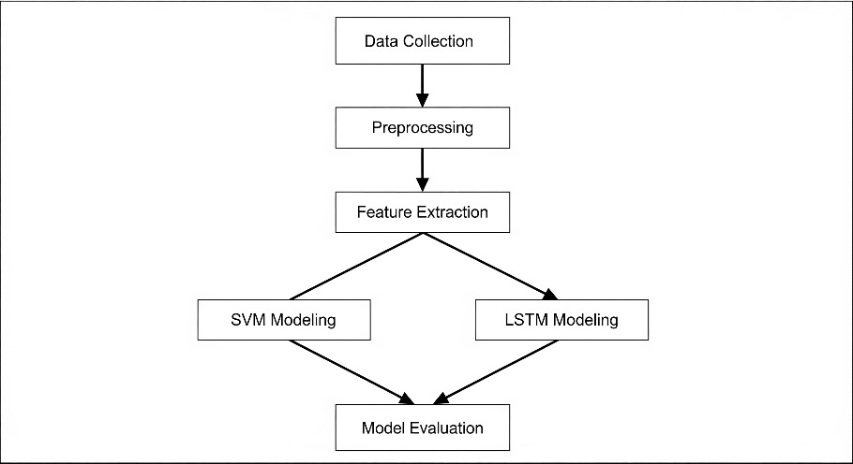
Figure 1. Stages of Research

Data Collection

The dataset used in this study was sourced from the Kaggle platform and prepared by a contributor named Wildan Abid19. This dataset specifically consists of Google Maps reviews in Indonesian about various natural tourist destinations located in Pacitan Regency, East Java. For the purpose of this research, we used a portion of the dataset named GMaps_Review_Classified, which is a collection of text reviews that have been annotated or labeled with emotions by the original contributor. This dataset is highly relevant as each review has been classified into six main emotion categories: happy, sad, angry, scared, love, and disgust. With this labeling, the dataset is well-suited for a supervised learning approach to text-based emotion classification using Natural Language Processing (NLP). An example of the data can be seen in Table 1.

Tabel 1. Example Data Set
Local Tourists | Reviews | Place | Labels
True | goa yang sangat menarik wajib dikunjungi untuk menambah wawasan tentang alam | Goa Gong Pacitan | Senang
False | pantai dengan sensasi pulau pulau seperti di raja ampat semoga  kedepan nya semakin ramai | Pantai Kasap | Senang
False | itu bangunan yang katanya cafe seharusnya jangan menjorok seperti itu mengganggu spot foto dan view jadi terlihat jelek karena adanya bangunan agak lucu si wkwkwk mau foto raja ampat kok  ada bangunan dulu masih asri banget belom ada bangunan sekarang malah aneh dengan adanya bangunan | Pantai Kasap | Takut
True | Sangat menyentuh hati | Pantai Klayar  Pacitan | Cinta

Preprocessing

The first process in preprocessing is Data Cleaning, which is a fundamental step to remove irrelevant elements from the review data. In this stage, the raw text data is cleaned of "noise" that can interfere with the analysis, such as URL links, HTML tags, symbols, numbers, and unimportant punctuation. The goal is to ensure that the remaining data consists only of pure and meaningful text, allowing the model to process relevant linguistic information without being distracted by unnecessary characters or formatting.
After the data is clean of irrelevant elements, the next step is Case Folding. This process aims to standardize all text into a single letter format, typically lowercase. By converting all letters to lowercase, the same words like "Indah" and "indah" will be treated as a single entity by the model. This step is crucial to prevent the model from incorrectly interpreting capitalization as a meaningful feature, thus increasing the consistency and accuracy of the analysis.
The next stage is Tokenization, where the standardized text is broken down into smaller, more manageable units called "tokens." Simply put, this process separates each sentence in a review into a list of individual words. For instance, the sentence "Tempatnya indah banget!" would be split into separate tokens like ["Tempatnya", "indah", "banget!"]. Tokenization allows each word to be analyzed and processed individually, forming a critical foundation for subsequent natural language processing steps.
Following tokenization, the Stop Word Removal process is performed to eliminate common and frequent words that have little or no emotional meaning. Words like "yang," "di," and "dengan" are known as stop words because they do not provide significant value in determining sentiment or emotion. By removing these words, the data becomes more concise and the model can focus more on the keywords that are truly relevant in expressing emotion, such as specific adjectives or verbs.
The final stage of preprocessing is Stemming, a process to reduce each word to its basic or root form. The main goal is to group all variations of a word with a similar meaning into a single form. For example, the words "berkunjung," "dikunjungi," and "kunjungan" would all be changed to the base form "kunjung." This ensures that the model recognizes all these variations as a single concept, which significantly reduces vocabulary complexity and helps the model generalize emotional patterns more effectively.

Features Extraction

In the text analysis process, converting data into a numerical format is a crucial prerequisite for it to be processed by machine learning algorithms. To achieve this, this study utilizes the Term Frequency–Inverse Document Frequency (TF-IDF) method for feature extraction. TF-IDF is a statistical technique that transforms each review into a numerical vector. This method calculates a word’s weight by combining its term frequency (how often a word appears in a specific review) with its inverse document frequency (how rare or common the word is across the entire dataset). This dual-factor weighting helps to suppress the influence of common, less informative words while simultaneously highlighting unique keywords that are more representative of the review’s emotional content. This efficient numerical representation then serves as the input for our classification algorithms, specifically the Support Vector Machine (SVM) and Long Short-Term Memory (LSTM) models, enabling them to classify tourist emotions more accurately.

SVM Modeling

After the review data has been successfully converted into a numerical representation using TF-IDF, the next stage is SVM (Support Vector Machine) Modeling. SVM is a supervised learning algorithm that works by finding the optimal hyperplane to act as a separation boundary between data classes. In this study, the SVM will be trained to identify the most effective hyperplane to separate the six emotion categories (happy, sad, angry, etc.) based on the TF-IDF feature vectors of each review. SVM’s advantage lies in its ability to perform well with high-dimensional data, making it a strong choice for classifying emotions based on the calculated word weights. The results are expected to provide accurate classification by maximizing the distance between the separation boundary and the nearest data points of each class.

LSTM Modeling

In addition to SVM, this study also uses LSTM (Long Short-Term Memory) Modeling as a comparative method. LSTM is a type of Recurrent Neural Network (RNN) specifically designed to process sequential data. Unlike SVM, which processes data as separate vectors, LSTM is able to understand the context and order of words in a sentence, which is crucial for capturing emotional nuances in reviews. The LSTM model will be trained on the processed review data to learn long- and short-term dependencies between words. With an architecture equipped with "memory gates," LSTM can remember important information and forget irrelevant details, allowing it to classify emotions more effectively based on the overall sentence sequence. This approach is expected to provide different insights from SVM, particularly in analyzing reviews with complex sentence structures.

Model Evaluation

The final stage in this research methodology is Model Evaluation, where the performance of both the SVM and LSTM models is measured quantitatively. We will use a variety of standard evaluation metrics such as accuracy, precision, recall, and F1-score to assess how well both models classify the six emotion categories. The results from this evaluation will then form the basis for a comprehensive comparative analysis. This comparison will not only show which model has a higher performance—whether it's the traditional machine learning approach (SVM) or the deep learning approach (LSTM)—but will also provide insight into the strengths and weaknesses of each method in capturing the emotional nuances of Indonesian text reviews. The conclusion of this comparative analysis will be the main finding that identifies the best method for future research.

results and discussion

Preprocessing and Features Extraction

After undergoing a series of preprocessing steps, the raw and unstructured review data was successfully transformed into a clean and consistent format. The process began with data cleaning to remove noise, followed by case folding to standardize the text. Tokenization broke sentences into individual words, while stop word removal eliminated unimportant common words. The final stage, stemming, simplified words to their root form. As a result, the generated data now has high quality, is free from distractions, and is ready for the next stages of feature extraction and modeling, ensuring that the algorithms can work more efficiently and accurately. The results of preprocessing are shown in Table 2.

Tabel 2. The Results of Preprocessing
Review | Cleaning | Case Folding | Tokenization | Stopword | Stemming
hidden gem | hidden gem | hidden gem | ['hidden', 'gem'] | ['hidden', 'gem'] | ['hidden', 'gem']
goa yang  sangat  menarik  wajib  dikunjungi  untuk  menambah  wawasan  tentang alam | goa yang  sangat menarik  wajib  dikunjungi  untuk  menambah  wawasan  tentang alam | goa yang  sangat  menarik wajib  dikunjungi  untuk  menambah  wawasan  tentang alam | ['goa', 'yang',  'sangat',  'menarik',  'wajib',  'dikunjungi',  'untuk',  'menambah',  'wawasan',  'tentang', 'alam'] | ['goa', 'menarik',  'wajib',  'dikunjungi',  'menambah',  'wawasan',  'alam'] | ['goa', 'tarik',  'wajib', 'kunjung',  'tambah',  'wawas', 'alam']
resik resik  tour gaetnya  ramah  istimewa | resik resik tour  gaetnya ramah  istimewa | resik resik  tour gaetnya  ramah  istimewa | ['resik', 'resik',  'tour',  'gaetnya',  'ramah', 'istimewa'] | ['resik', 'resik',  'tour', 'gaetnya',  'ramah',  'istimewa'] | ['resik', 'resik',  'tour', 'gaet',  'ramah',  'istimewa']

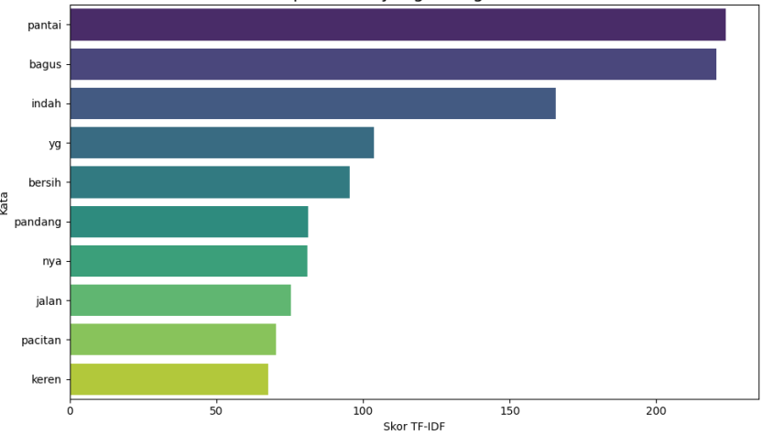
Figure 2. Words that often appear

To gain an initial understanding of the content of tourist reviews, I conducted a word frequency analysis by counting the occurrences of each word after the preprocessing stage. As a result, I ranked the top 10 most frequently appearing words in the entire dataset. This analysis provides a direct overview of the main focus of the reviews, such as names of tourist attractions, facilities, or the adjectives most frequently used to describe their experiences. By identifying these dominant keywords, I gained important foundational insights before proceeding to a more in-depth emotion analysis using the classification models, as shown in Figure 2.
The application of TF-IDF in this study serves to transform tourist reviews into an efficient numerical feature representation, which can then be used by classification algorithms such as Support Vector Machine (SVM) and Long Short-Term Memory (LSTM). This method is able to suppress the influence of common words and highlight important words that more accurately represent tourist emotions. A visualization of the Top 10 words with the highest TF-IDF weights is shown in Figure 3, illustrating the dominant words in the dataset. Because the emotion distribution in the initial data was imbalanced, the SMOTE technique was applied to perform oversampling on the minority classes after the TF-IDF process. The application of SMOTE helps to balance the number of data points between classes so that the model is not biased toward the majority emotion. Tabel 3 shows a comparison of the label distribution before and after SMOTE was applied.
Tabel 3. Comparison using Smote
Emotion | Before Using SMOTE | Using SMOTE
Cinta | 36 | 2838
Jijik | 52 | 2838
Marah | 112 | 2838
Sedih | 2838 | 2838
Senang | 102 | 2838

In applying the Long Short-Term Memory (LSTM) model for text-based emotion analysis, the feature extraction process is a crucial step that determines the effectiveness of the input data representation. One of the common and highly recommended feature extraction techniques for LSTM models is word embedding. Word embedding is a method of representing words as dense, low-dimensional vectors that contain semantic and syntactic information from the words in the corpus. Unlike traditional textual representation techniques like Bag of Words or TF-IDF, which are sparse and do not consider word meaning, word embedding can capture the semantic relationships between words based on their context of use in a sentence. Word embedding can be obtained from pre-trained models such as Word2Vec, GloVe, or FastText, or trained directly from the review data using a built-in embedding layer from deep learning frameworks like TensorFlow or Keras. In the context of this study, the embedding is used as an input layer before being passed to the LSTM layers. By converting each word into a numerical vector, the LSTM can better learn emotional patterns in the word sequence because the embedding stores information about the semantic proximity between words. This allows the model to understand the sentence context more comprehensively and improves accuracy in classifying tourist emotions based on text reviews. A visualization of the Word2Vec vector distribution in 3D space is shown in Figure 3, which demonstrates how words with similar meanings tend to be clustered together semantically.
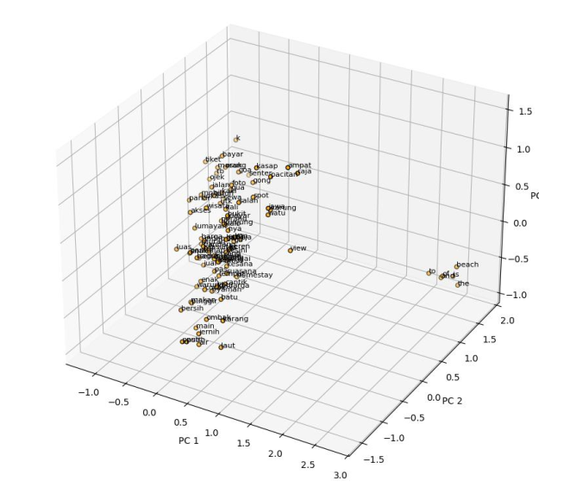
Figure 3. Words Visualization

To obtain a visual overview of the words that frequently appear in each emotion category, a visualization was created using WordCloud. This technique maps word frequency into a graphical representation, where more frequent words are displayed in a larger size. This visualization is very helpful in identifying the characteristic words that tourists often use when expressing a particular emotion towards a tourist destination. For example, in the happy emotion category, words like “indah,” “pantai,” and “bagus” frequently appear, while the fear emotion is dominated by words like “gelap” or “seram.” Each emotion, including happy, sad, angry, scared, love, and disgust, displays a different word pattern that can provide deep insights into tourist perceptions. All WordCloud visualizations for each of these emotion categories can be seen in Figure 4.
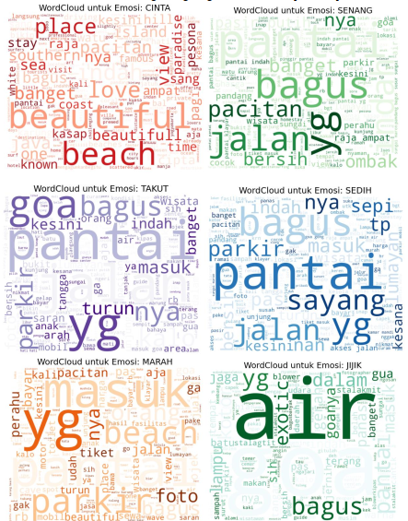
Figure 4. Word Cloud for Emotion Labels

Model Implementation and Evaluation
The Support Vector Machine (SVM) classification model with a linear kernel was initialized and trained using training data that had been numerically represented through the TF-IDF feature extraction process. This was done after the tourist review data for destinations in Pacitan Regency underwent preprocessing and class balancing using the SMOTE technique to address class imbalance. The trained model was then used to predict emotions on the test data, which included six emotion categories: senang, sedih, marah, takut, jijik, dan cinta, and jijik.
Performance evaluation was conducted using standard metrics for multi-class classification, such as precision, recall, and f1-score, which are displayed in the Classification Report in Figure 5. This evaluation stage is a crucial step in measuring the model's initial ability to understand the emotional patterns contained in the tourist text reviews. Furthermore, to visualize the distribution of classification errors between emotion classes, a confusion matrix was used and displayed in Figure 6. These results provide a detailed overview of the extent to which the SVM model can differentiate each emotion category and serve as a basis for comparison against the performance of other models, such as the LSTM model also applied in this study.
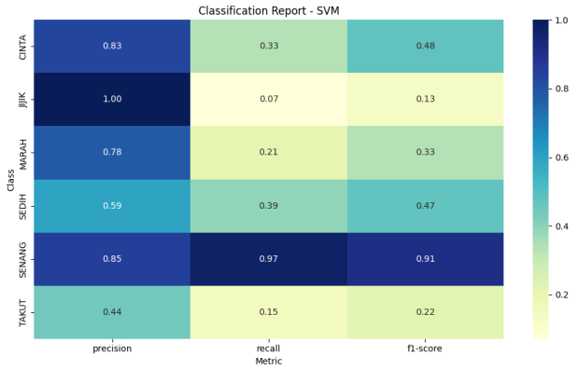
Figure 5. Classification Report Model SVM
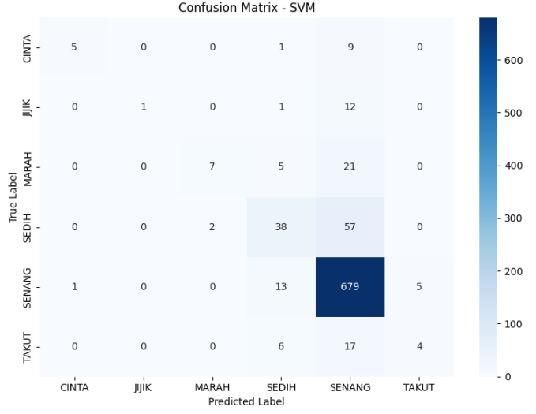
Figure 6. Confusion Matrix Model SVM
The Support Vector Machine (SVM) classification model, trained using the Term Frequency-Inverse Document Frequency (TF-IDF) feature representation, was then evaluated through a 10-fold cross-validation method. This evaluation aimed to measure the model's stability and generalization to data it had not been trained on. The two main metrics used were accuracy and F1-score, which respectively represent the level of classification correctness and the balance between precision and recall in a multi-class classification scenario.
The evaluation results are visualized in Figure 7, which shows the model's performance in each cross-validation iteration. The graph demonstrates that the accuracy and F1-score values tend to be stable across all folds, indicating that the model has good predictive consistency without signs of overfitting. Thus, SVM can be used as a reliable baseline model for classifying emotions in tourist review texts based on the numerical features from TF-IDF extraction.
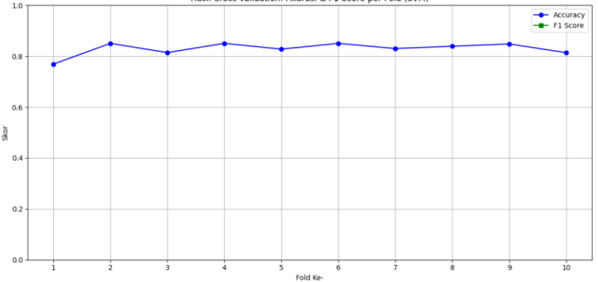
Figure 7. Model Performance at Each Iteration of Cross-Validation
The Long Short-Term Memory (LSTM) model implemented in this study showed progressive performance during the training process. In the first epoch, the model achieved a training accuracy of 77.73% with a loss value of 0.9130, and it gradually increased to an accuracy of 87.94% with a decrease in loss to 0.3883 by the fifth epoch. This improvement indicates that the model was able to effectively adapt the data representation, with the ability to minimize prediction errors during training. Furthermore, the validation accuracy also showed a positive trend, from 78.96% to 81.45%, which suggests that the model has good generalization ability on the test data without showing significant signs of overfitting. The visualization of the accuracy and loss performance graphs per epoch in Figure 11 reinforces this finding, showing a consistent improvement in the model's performance on both the training and validation data. The LSTM architecture, which is based on sequential data processing and the use of word embedding representation, proved effective in identifying emotional patterns in tourist review texts. This demonstrates that the model is capable of capturing the contextual dependencies between words in depth, resulting in a more accurate emotion classification. With a test accuracy of 79.86%, the LSTM model has strong potential as an approach for text-based emotion analysis in Indonesian.
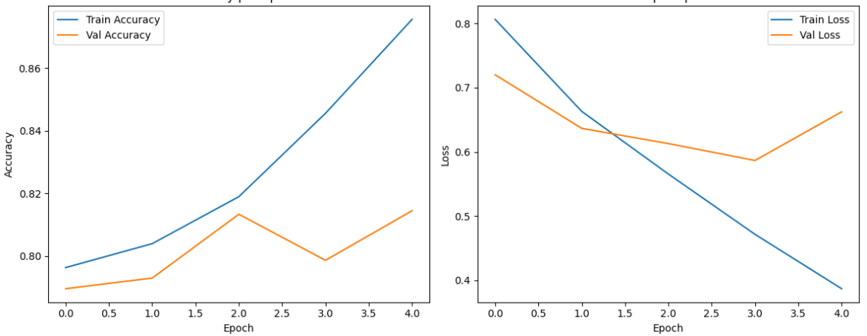
Figure 8. Visualization of Accuracy and Loss Per Epoch
Based on the summary of model evaluation results shown in Figure 9, the Support Vector Machine (SVM) model was found to have a more stable performance compared to Long Short-Term Memory (LSTM) on the task of classifying tourist emotions. SVM achieved an accuracy of 83.03% with a precision score of 0.7506 and an f1-score of 0.4245, while LSTM recorded an accuracy of 80.77% with significantly lower precision and f1-scores of 0.2303 and 0.2051, respectively. Although LSTM previously showed competitive validation accuracy, the significant differences in other metrics may indicate that the LSTM model suffered from overfitting or was less optimal in handling the data structure used. Therefore, within the context of this data, SVM can be considered more reliable for the task of classifying emotions based on tourist text reviews.
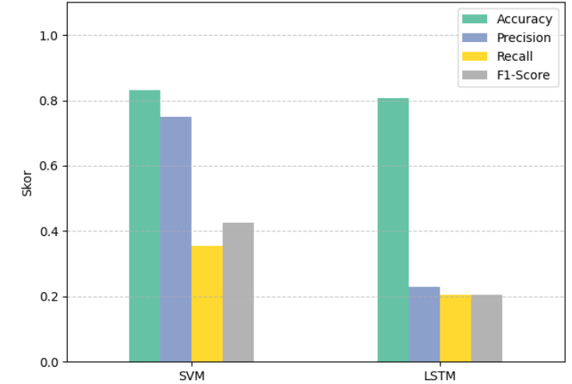
Figure 9. Comparison of SVM and LSTM performance

Based on the bar chart visualization, the performance comparison between the Support Vector Machine (SVM) and Long Short-Term Memory (LSTM) models shows a significant difference. The SVM model recorded an accuracy of 83.03% with a precision of 0.7506 and an F1-score of 0.4245. This relatively high F1-score indicates a good balance between precision and recall. Conversely, the LSTM model, despite having a competitive accuracy of 80.77%, showed significantly lower performance on other metrics, with a precision of only 0.2303 and an F1-score of 0.2051. This discrepancy confirms that SVM provides more stable and reliable results. While LSTM may have a good ability to predict the majority class, its low precision and recall values indicate its inability to effectively identify minority classes. Therefore, in this study, SVM is proven to be a more superior and robust model for emotion classification.

conclusion
This study aimed to analyze tourist emotions toward tourist destinations in Pacitan through collected text reviews. Based on the results obtained, this analysis successfully identified distinct emotional patterns, where each emotion tends to be associated with specific keywords. Through a comparison of classification models, we found that one of the models used demonstrated a more stable and reliable performance in classifying emotions than the other. This finding provides deep insights into tourist perceptions and emotional experiences. With a better understanding of how tourists feel about a destination, tourism managers and stakeholders in Pacitan can design more effective strategies to improve service quality, manage the tourism image, and ultimately, create a more positive experience for every visitor.

References
- M. H. Tamrin and W. T. Raharja, “Local Participation in the Development of Klayar Beach Tourism
in Pacitan Regency,” JKMP (Jurnal Kebijak. dan Manaj. Publik), vol. 9, no. 2, pp. 56–63, 2021, doi:
10.21070/jkmp.v9i2.1576
- D. C. Rahmadani, S. Khomsah, and M. Y. Fathoni, “Analisis Emosi Wisatawan Menggunakan
Metode Lexicon Text Analysis,” J. Tek. Inform. dan Sist. Inf., vol. 10, no. 1, pp. 13–27, 2024, doi:
10.28932/jutisi.v10i1.6690.
- Hariyady, Hariyady, et al. "EEG-based emotion recognition: A state-of-the-art review of dataset and method." AIP Conference Proceedings. Vol. 3179. No. 1. AIP Publishing LLC, 2025.
- D. M. E. D. M. Hussein, “A survey on sentiment analysis challenges,” J. King Saud Univ. - Eng. Sci., 30(4), pp. 330–338 (2018).
- E. Kim and R. Klinger, “A Survey on Sentiment and Emotion Analysis for Computational Literary Studies,” arXiv preprint arXiv:1808.03137 (2018)
- P. Nandwani and R. Verma, “A review on sentiment analysis and emotion detection from text,” Soc. Netw. Anal. Min., 11(1), p. 19 (2021).
- A. Chamekh, M. Mahfoudh, and G. Forestier, “Sentiment Analysis Based on Deep Learning in E-Commerce,” in Lect. Notes Comput. Sci., 13369 LNAI, pp. 498–507 (2022).
- A. P. Kirilenko, S. O. Stepchenkova, H. Kim, and X. (Robert) Li, “Automated Sentiment Analysis in Tourism: Comparison of Approaches,” J. Travel Res., 57(8), pp. 1012–1025 (2018).
- W. Meng, D. Ji, and H. Wang, “Analysis of Emotional Tendency of Tourism Consumers Based on LSTM and Fuzzy Control Algorithm,” Int. J. Comput. Intell. Syst., 17(1), p. 547 (2024).
- K. Puh and M. Bagić Babac, “Predicting sentiment and rating of tourist reviews using machine learning,” J. Hosp. Tour. Insights, 6(3), pp. 1188–1204 (2023).
- S. Khairunnisa, A. Adiwijaya, and S. Al Faraby, “Pengaruh Text Preprocessing terhadap Analisis Sentimen Komentar Masyarakat pada Media Sosial Twitter (Studi Kasus Pandemi COVID-19),” J. Media Inform. Budidarma, 5(2), p. 406 (2021).
- H. Liu, X. Chen, and X. Liu, “A Study of the Application of Weight Distributing Method Combining Sentiment Dictionary and TF-IDF for Text Sentiment Analysis,” IEEE Access, 10, pp. 32280–32289 (2022).
- J. E. Br Sinulingga and H. C. K. Sitorus, “Analisis Sentimen Opini Masyarakat terhadap Film Horor Indonesia Menggunakan Metode SVM dan TF-IDF,” J. Manaj. Inform., 14(1), pp. 42–53 (2024).
- R. Wati, S. Ernawati, and H. Rachmi, “Pembobotan TF-IDF Menggunakan Naïve Bayes pada Sentimen Masyarakat Mengenai Isu Kenaikan BIPIH,” J. Manaj. Inform., 13(1), pp. 84–93 (2023).
- V. W. D. Thomas and F. Rumaisa, “Analisis Sentimen Ulasan Hotel Bahasa Indonesia Menggunakan Support Vector Machine dan TF-IDF,” J. Media Inform. Budidarma, 6(3), p. 1767 (2022).
- M. Y. Aldean, M. D. Hilmawan, R. Indriyati, and J. Lasama, “Analisa Relevansi Tweet terhadap Hashtag dengan Metode Logistic Regression,” Centive, 2(1), pp. 32–38 (2019).
- X. H. Le, H. V. Ho, G. Lee, and S. Jung, “Application of Long Short-Term Memory (LSTM) neural network for flood forecasting,” Water (Switzerland), 11(7), p. 1387 (2019).
- D. R. Alghifari, M. Edi, and L. Firmansyah, “Implementasi Bidirectional LSTM untuk Analisis Sentimen Terhadap Layanan Grab Indonesia,” J. Manaj. Inform., 12(2), pp. 89–99 (2022).
- W. Gouda, M. Almurafeh, M. Humayun, and N. Z. Jhanjhi, “Detection of COVID-19 Based on Chest X-rays Using Deep Learning,” Healthc., 10(2), pp. 1–19 (2022).

