Optimal Agent Selection in Valorant Maps Using Nash Equilibrium: A Game-Theoretic Approach to Decision-Making
Shetma Ikmal Zakka^{1, a)}, Briansyah Setio Wiyono^{1, b)*}, Sofyan arifianto^{1, c)}, Hardianto Wibowo^{1, d )}
Department of Informatics Engineering, University of Muhammadiyah Malang, Malang, Indonesia
^{a)} ikmalzakka@webmail.umm.ac.id
^{b)} Corresponding author : brian@umm.ac.id
^{c)} sofyan_arifianto@umm.ac.id
^{d)} ardi@webmail.umm.ac.id
Abstract. This research applies a Nash Equilibrium theory to optimize the agent selection strategies in Valorant, it is a competitive 5v5 tactical First Person Shooter (FPS). We analyze the match data across of the multiple maps to construct the payoff matrices to representing the agent performance, where entries correspond to win probabilities when the specific agents are being selected in opposition. Using the Nashpy library, we computed all of the mixed strategy of Nash equilibria to identify which one is the optimal agent selection distributions for each of the map in a Valorant game. Our research reveal a significant map dependent variations in Nash equilibrium strategies, with the certain agents demonstrating consistent dominances in optimal mixed strategies. The computed equilibria has been provide the quantitative evidence for the strategic depth of agent selection in competitive play, showing that rational players can employ the probabilistic selection strategies that has been computed rather than their deterministic choices. These results establish a mathematical methode foundation for tactical decision making in competitive scene.
Keyword. Game Theory, Nash Equilibrium, Valorant, Multi-agent Systems, Decision Making, eSports Analytics.

INTRODUCTION
In competitive scene, strategic decision making plays a vital role in determine the outcomes of the match. Valorant is a tactical First Person Shooter (FPS) developed by Riot Games, is a highly tactical, team based 5v5 character-based tactical FPS where a precise gunplay meets an unique agents abilities. The effectiveness of these agent abilities is not only influenced by the player individual capabilities but also by their interactions with the opponents, map features and environments, and their team compositions. This research applies Nash Equilibrium theory to optimize the decision making agents selection strategies on a various maps, providing a formal, game-theoretic framework for understanding the competitive agent selection within game valorant.
in Valorant agents is categorized into four roles which there is a Duelist, Initiator, Controller, and Sentinel each of this roles serves a vital function within team compositions. The optimal selection of agents is influenced by both individual agent strengths and the anticipated selections of opposite players. Thus, the problems of the agent selection can be modeled as a game, where players select their strategies of the agent compositions to maximize their expected payoff.
The application of a Nash Equilibrium theory allows for the identification of the optimal decision making of an mixed strategies, where players can select agents with certain probabilities to account for the uncertainty of opponent choices. This research contributes to the growing field of the game theoretic applications in a competitive scene by formalizing an agent selection in Valorant as a tactical strategic game and providing insights into equilibrium strategies for competitive scene play.

BACKGROUND AND RELATED WORK

Nash Equilibrium Theory
${U​}_{i}(S_{i}^{*}​,S_{-i}^{*}​)≥U_{i}({S​}_{i},S_{-i}^{*}​){∀​}_{S_{i}}∈{S​}_{i},∀_{i}$Nash Equilibrium theory, introduced by John Nash in 1950 (Nash, 1950), it is a solution concept in non-cooperative game theory. It describes a situation where no player can unilaterally improve their payoff by changing their strategy, given the strategies of all other players remain fixed. Mathematically, a strategy profile $S^{*}=(S_{1}^{*}​,S_{2}^{*}​,...,S_{n}^{*})$ is a Nash Equilibrium if, for all players$i$, the following condition holds:

where $U_{i}$​ is the utility function of player $i$, $S_{i}$​ represents the strategy of player $i$, and $S_{-i}$​ denotes the strategies of all other players. This equilibrium concept is central to understanding strategic interactions in competitive environments, where each player's decision impacts the outcomes of the game.

Application of Game Theory in Competitive Gaming
Game theory has been widely applied into various competitive game domains, including in poker strategy optimization (V. Knight, M. Harper, 2019) and in a real time strategy games (R. Kowalczyk and N. Bard, 2020). These applications more often focus on a modeling individual player behavior to predict the optimal decisions. However, Valorant introduces an additional complexity by incorporating multi agent or multi player interactions, where the outcomes can be influenced by both individual agent performances and the team dynamics. This study aims to bridge the gap between the theoretical game models and practical applications in competitive gaming by developing a game theoretic framework to agent selection optimization in Valorant.

Multi Agent Systems and Valorant
In the context of Valorant, the agent decision selections problem can be framed as a multi agent system, where multiple players must coordinate their strategies with their team to achieve a collective outcome while competing against an opponent team. This framework aligns with coalition games, where agents form coalitions to maximize their collective payoffs in a competitive setting (M. Hota and S. Kapoor, 2017). By applying Nash Equilibrium theory into Valorant, we can obtains an optimal agent selection strategies that take into account both individual agent abilities and the team level synergy.

METHODOLOGY

Data Collection and Preprocessing
The dataset that we used in this study was sourced from Kaggle, that include from multiple competitive seasons of Valorant player, including performance metrics for agents across various maps. The dataset comprehend :
- Match records spanning of multiple competitive seasons games.
- Agent performance metrics : win rates, pick rates per map.
- Coverage across multiple maps, including Ascent, Bind, Breeze, Fracture, Haven, Icebox, Lotus, Pearl, Split, and Sunset.
- Rank distribution to ensuring the representative sampling of competitive play.
The data preprocessing steps included :
- Data Cleaning : Removal of incomplete or inconsistent match records and remove the duplicate.
- Normalization : Standardization of performance metrics across different time (S. Ganzfried, D. Laughlin, and T. Sandholm, 2018)periods to ensure consistency.
- Aggregation : Calculation of agent vs. agent win probabilities per map
- Validation : Cross-validation of results against a held-out dataset to ensure the model's robustness

Payoff Matrix Construction
For each map $m$, we constructed the payoff matrix $P_{m}$​, where entry $P_{m,i,j}$ represents the probability that agents $i$ wins against the enemy agent $j$ on map $m$. These matrices were obtained from match data, reflecting the observed win rates. To handle sparse data, Laplace smoothing was applied :
$$P_{m,i,j}​=\frac{{Wins}_{i,j}​+α}{{Total​}_{i,j}+2α}​$$
where $α=0.5$ is the smoothing parameter. Matrix symmetry was enforced, ensuring $​P_{m,i,j}=1-P_{m,i,j}$.
The result all of the payoff matrix from each map in Figure 1.

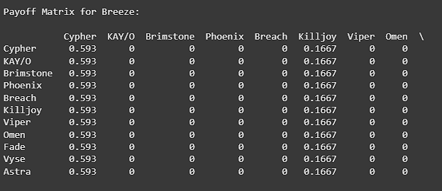
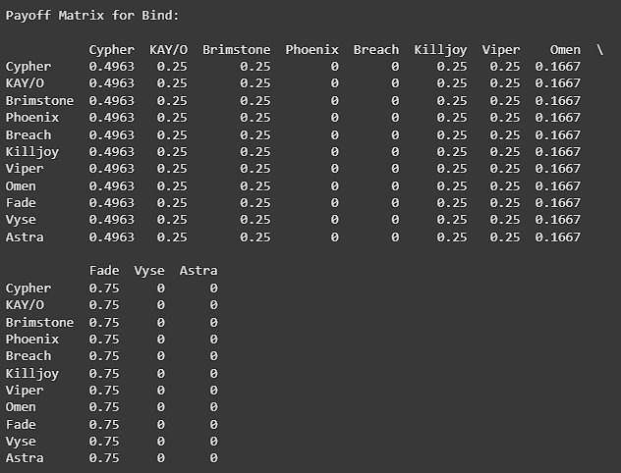
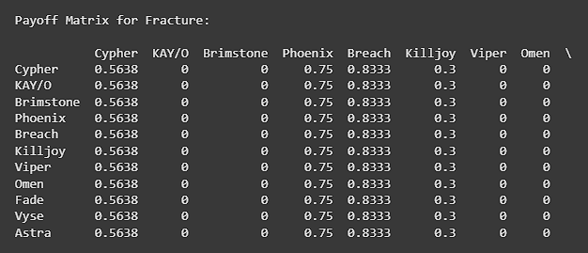
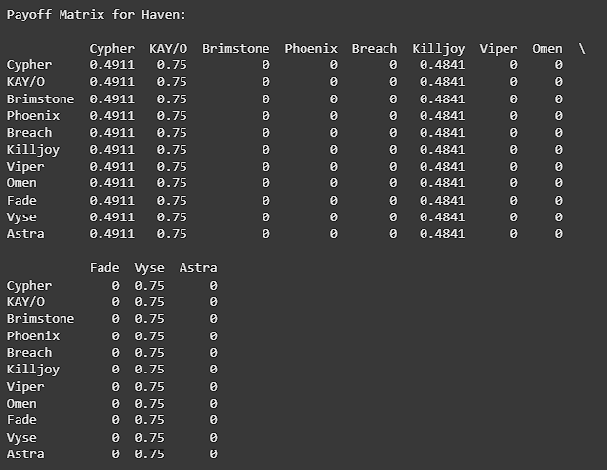
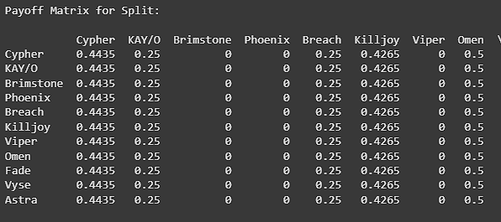
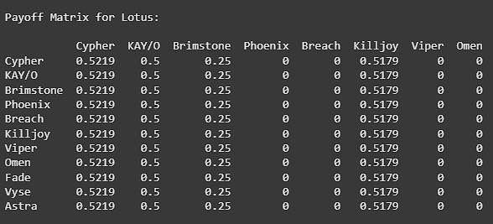
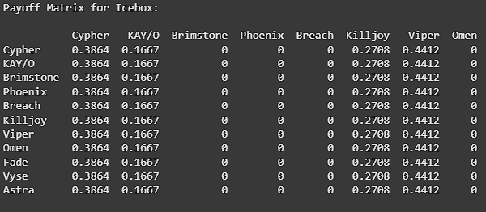
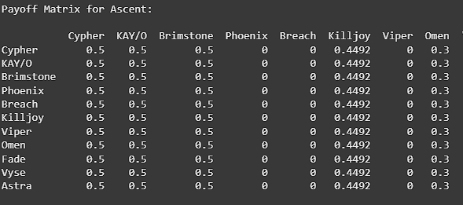
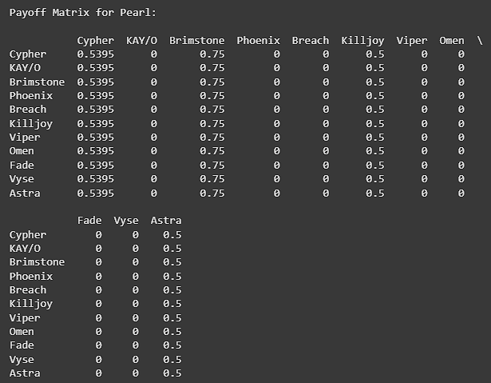
FIGURE 1. Result Of The Payoff Matrix Calculation

Nash Equilibrium Computation
We used the support enumeration algorithm from the Nashpy library (S. Ganzfried, D. Laughlin, and T. Sandholm, 2018) to computed the mixed strategy of Nash equilibria. The algorithm systematically examines all the possibilities that support the combinations to identify the equilibrium points. The computational process involved :
- Support Enumeration : Identifying feasible support pairs $(I.J).$
- Linear System Solving : Solving the linear system to computed the mixed strategies that satisfy equilibrium conditions.
- Feasibility Verification : Ensuring that the computed probabilities are non negative and sum to one.
- Optimality Confirmation : Verifying that no player can improve their payoff by deviating from the equilibrium strategy.

RESULTS AND ANALYSIS

Map Specific Equilibrium Analysis
This section outlines the computed Nash equilibrium strategies for agents selection across the various maps within Valorant. The equilibrium points indicated the probability distribution of the agent selections that can optimized a player's chances of winning, given the selections made by the opponent team. By analyzing each map’s equilibrium, we can gain insights into which agents are the most strategical advantageous in the game’s competitive environment base on the dataset.
Importantly, the equilibrium or the heatmap does not directly display agent abilities. Rather, it reflects the outcomes of the equilibrium calculations based on empirical performance data between of each agent in each map. The inclusion of an agent in a specific equilibrium implies that their selection contributes a positive to the stability and effectiveness of the strategy. Since the utility of an agent is defined by their in game abilities, the equilibrium patterns observed the heatmap that can be interpreted as a results of their functional impact. In this way, the heatmap or the equilibrium has indirectly reveals how of each agent's abilities shape their tactical strategic value in balance compositions. The computed Nash equilibria for each map are outlined below:

Ascent

Ascent is a medium sized map with open mid control and narrow chokepoints into sites.
Frequent picks as shown from the Figure 2 : Brimstone, Cypher, Kay/O, Killjoy, Omen.
Explanation why : High pick probability for Brimstone and Omen aligns with their smoke control over mid and site entries. Cypher and Killjoy’s high heatmap scores match their ability to defend flanks. Kay/O’s utility suppression appears often in aggressive setups.
Supports : Ascent is defined by its open mid area, which acts as the pivot for both attacking and defending rotations. Winning mid gives access to both sites, so smoke control and information denial are crucial. The narrow lane entries mean traps and utility can reliably stall pushes, making Sentinel agents very effective (Stolze, 2025).

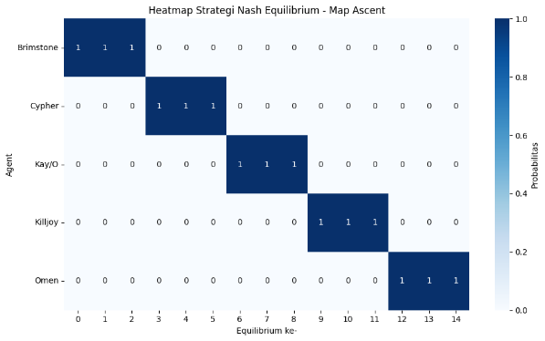
FIGURE 2. Heatmap equilibria Strategies of Map Ascent

Sunset

Sunset is an urban map with long sightlines and multiple mid paths.
Frequent picks as shown from the Figure 3 : Omen, Cypher, Vyse.
Explanation why : Omen’s smokes cut off long sightlines, Cypher secures mid flanks, and Vyse can deny open areaswith large coverage abilities.
Supports : Sunset rewards teams that can split their focus between mid and site control. Since defenders often hold deep angles, smokes are essential to break those lines of sight. Rotations through mid are frequent, so trap-based flank control and area denial are key to maintaining map dominance (Teixeira, 2024 ).
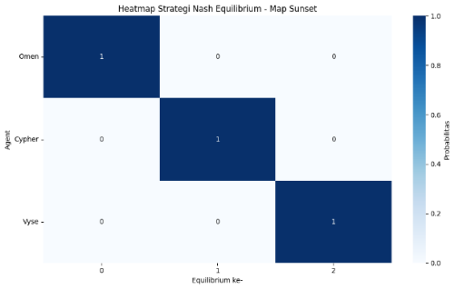
FIGURE 3. Heatmap equilibria Strategies of Map Sunset

Bind

Bind is a two site map with teleporters and tight lanes.
Frequent picks as shown from the Figure 4 : Fade, Cypher, Brimstone, Kay/O, Killjoy
Explanation why : Fade gathers information quickly, Brimstone blocks chokepoints, Cypher/Killjoy anchor sites, Kay/O disables defender utilities.
Supports : Bind has no traditional mid, so rotations happen through two main lanes or via teleporters. This creates opportunities for fast executes but also risks being flanked. Controlling space with traps and early info is critical. Smoke and suppression tools prevent defenders from locking down narrow entries (Stolze, 2025; Muhammed, 2023).

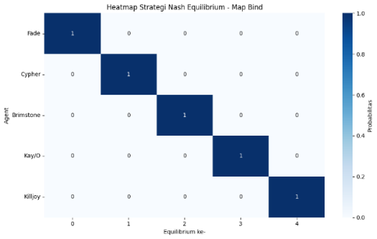
FIGURE 4. Heatmap equilibria Strategies of Map Bind

Breeze

Breeze is a large map with open spaces and long sightlines.
Frequent picks as shown from the Figure 5 : Cypher, Killjoy
Explanation why : Both Sentinels excel at holding large areas with minimal backup.
Supports : Breeze favors long range fights, making it difficult for attackers to approach without intel and area control. Traps and turrets prevent backstabs during these long pushes, and the large bomb sites benefit from agents who can watch multiple lanes at once (Stolze, 2025; Muhammed, 2023).
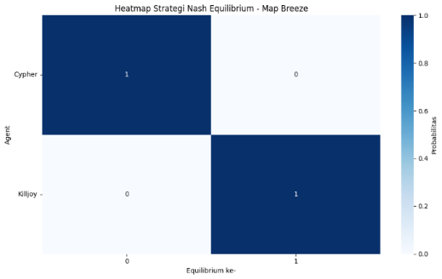
FIGURE 5. Heatmap equilibria Strategies of Map Breeze

Fracture

Fracture is a H-shaped map with dual attacker spawns.
Frequent picks as shown from the Figure 6 : Breach, Phoenix, Cypher, Killjoy
Explanation why : Breach and Phoenix provide multi-angle entry tools, while Cypher/Killjoy secure flanks.
Supports : Fracture unique spawn system lets attackers pressure sites from two directions instantly. This creates chaos for defenders, but also opens attackers to counter flanks. Coordinated flashes and crowd control utility are essential for synchronized site hits, while Sentinels protect against fast enemy retakes (Stolze, 2025).

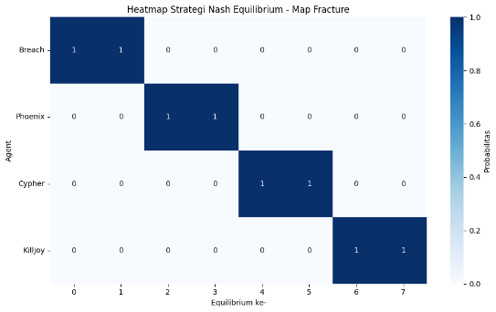
FIGURE 6. Heatmap equilibria Strategies of Map Fracture

Icebox

Icebox is a vertical map with compact sites.
Frequent picks as shown from the Figure 7 : Viper, Cypher, Killjoy, Kay/O
Explanation why : Viper excels at walling off vision and post-plant control, Cypher/Killjoy secure close angles, Kay/O suppresses defenders’ stall abilities.
Supports : Icebox sites have multiple vertical positions and tight entries, making smoke walls and toxic screens incredibly effective. Post plants are often played from long angles, so vision blocking abilities and traps for flank protection are invaluable (Stolze, 2025; Muhammed, 2023).

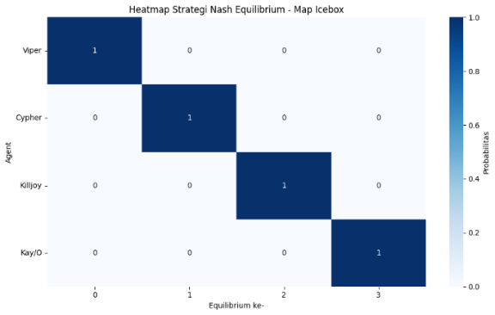
FIGURE 7. Heatmap equilibria Strategies of Map IceBox

Lotus

Lotus is a three sites map with rotating doors and fast rotations.
Frequent picks as shown from the Figure 8 : Cypher, Killjoy, Kay/O, Brimstone
Explanation why : Cypher/Killjoy monitor rotation-heavy flanks, Brimstone blocks choke points, Kay/O aids aggressive site entries.
Supports : Lotus rotating doors create unpredictable rotation timings, forcing teams to guard flanks constantly. Attackers benefit from blocking off defender access points, while defenders rely on traps to detect site shifts early (Stolze, 2025; Teixeira, 2024 ).
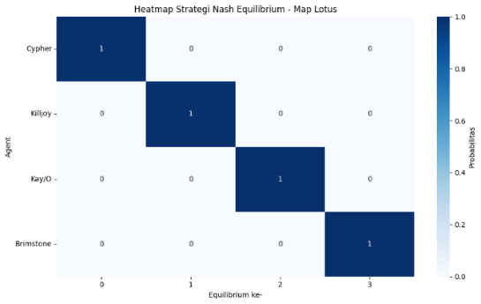
FIGURE 8. Heatmap equilibria Strategies of Map Lotus

Pearl

Pearl is a map with narrow corridors and a large open mid.
Frequent picks as shown from the Figure 9 : Brimstone, Cypher, Astra, Killjoy
Explanation why : Brimstone and Astra shape fights with smokes and gravity wells, Cypher/Killjoy lock down sites.
Supports : Pearl mid is highly contested winning it allows rapid rotations and site pressure. Controllers are critical for blocking sightlines, while Sentinels help secure side lanes against pushes and lurks (Stolze, 2025).

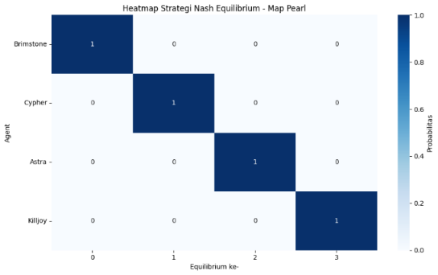
FIGURE 9. Heatmap equilibria Strategies of Map Pearl

Split

Split is a vertical map with tight mid and short sightlines.
Frequent picks as shown from the Figure 10 : Omen, Cypher, Killjoy, Breach, Kay/O
Explanation why : Omen smokes off elevated angles, Breach/Kay/O break entrenched setups, Cypher/Killjoy defend sites.
Supports : Split choke heavy layout and verticality make coordinated utility clears essential. Sentinels excel because once a site is taken, defenders have limited retake routes, which can be trapped or delayed (Stolze, 2025; Teixeira, 2024 ).

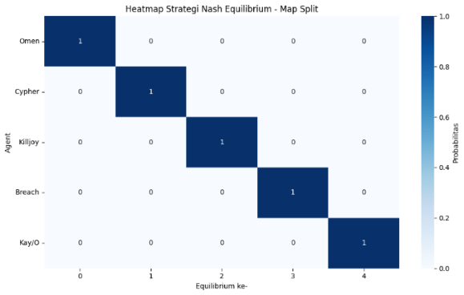
FIGURE 10. Heatmap equilibria Strategies of Map Split

Haven

Haven is a three site layout map with high rotation pressure.
Frequent picks as shown from the Figure 11 : Kay/O, Vyse, Cypher, Killjoy
Explanation Why : Kay/O helps with fast entries, Vyse denies space, Cypher/Killjoy secure sites.
Supports : Haven’s three sites stretch defensive resources thin, so utility that can instantly secure space or delay enemy advances is invaluable. Flank detection is also critical since rotations are frequent and can be short (Stolze, 2025).

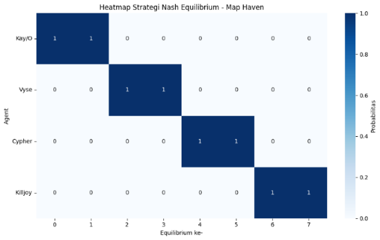
FIGURE 11. Heatmap equilibria Strategies of Map Haven

Heatmap Analysis
We conducted a win-rate heatmap analysis to visualize how agents perform on different Valorant maps as shown in Figure 12. In the heatmap, dark red means higher win rate, while blue indicates lower win rate. This revealed standout agents on specific maps:
- Cypher excels on Breeze, thanks to his Trapwire and Spycam that help control its wide-open sightlines and multiple pathways.
- Viper dominates on Icebox, where her Toxic Screen and Snake Bite work perfectly in tight vertical spaces.
- Sova shines on Abyss, using Recon Bolt and Owl Drone to gather intel and help teams execute through complex mid and site layouts.
The heatmap analysis highlights the areas where these agents dominate, providing further insight into how players should adapt their strategies based on the map and the opponent's agent selection. For instance, when facing Cypher on Breeze, teams may want to focus on disrupting his surveillance tools or selecting agents that can provide more area control, such as Viper or Brimstone.
This visual representation allows players to better understand the meta and make informed decisions about agent selection and tactical adjustments in response to the map and their opponents' strengths. The heatmaps also reinforce the notion that role specialization plays a significant role in determining success, as agents with complementary abilities to the map's design tend to perform better.selection.

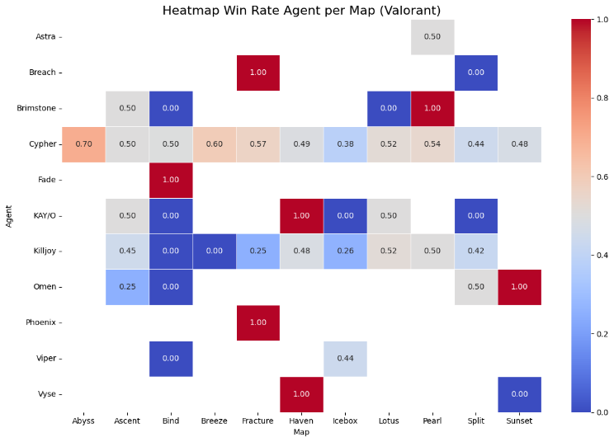
FIGURE 12. Heatmap Win Rate Agent per Map

DISCUSSION

Theoretical Implications
This study shows that Nash Equilibrium is a useful way to model competitive decision-making in Valorant. Using mixed strategies, rather than fixed ones, makes teams less predictable and improves performance, which matches earlier findings in game theory for multiplayer games (Y. Li and J. Zhu, 2021; A. Cowling and D. M. Small, 2020) . The fact that equilibrium strategies change across different maps shows how much map layout and agent synergy affect the best choices.
In real matches, this means players must adapt their agent picks to the map’s unique challenges. Riot’s own data confirms that pick rates shift by map based on how well each role works in that environment (Blog, 2024).
By combining Nash Equilibrium with map-specific agent performance data, teams can make smarter, flexible choices that improve their chances of winning in the constantly changing competitive meta.

Practical Applications
The equilibrium strategies presented have several practical applications for both players and teams :
- Professional Team Strategy : Nash Equilibrium offers pro teams a mathematically grounded way to choose agents per map, helping them shape more effective, unpredictable game plans. Research across competitive esports and strategic games supports the value of such equilibrium-based selection (Y. Li and J. Zhu, 2021; A. Cowling and D. M. Small, 2020).
- Training Prioritization : By identifying which agents consistently appear in equilibrium configurations, teams can prioritize practice for those picks—building skill and coordination around strategies proven to offer a competitive edge (Y. Li and J. Zhu, 2021; F. Christianos, G. Papoudakis, and S. V. Albrecht, 2022) .
- Meta Analysis : Tracking how equilibrium selections shift over time reveals emerging trends in the meta, spotlighting which agents or strategies are gaining or losing influence. This dynamic view complements traditional win-rate analytics (Y. Li and J. Zhu, 2021; Y. Fujimoto, K. Ariu, and K. Abe, 2025).

Limitations and Future Directions
While this study offers a comprehensive analysis of Nash Equilibrium in Valorant, there are several limitations that must be addressed in future research :
- Static Strategics : This study uses fixed strategies and doesn’t factor in players adapting to opponents mid-game. In reality, constant adjustments can shift equilibrium outcomes (al M. L., 2017.; al N. B., 2020).
- Game Meta and Updates : Frequent patches, balance changes, and agent reworks can alter strategies over time. Future studies should model how equilibrium changes with these updates (Patch Notes, 2025)
- Team level Compositions : We focus on single-agent choices, but real matches depend heavily on team synergy and coordinated play. Future work could study Nash Equilibria that account for full team setups (F. Christianos, G. Papoudakis, and S. V. Albrecht, 2022; al N. B., 2020).
- Real Time Adaptations : Players often change strategies under time pressure, after unexpected enemy picks, or due to in-game communication. Models that include these adaptive behaviors could give more accurate predictions (Shum, 2022; al M. L., 2017.).

CONCLUSION
This study demonstrates the practical application of Nash Equilibrium to optimize agent selection strategies in Valorant, using empirical match data from a variety of maps. By applying game-theoretic models and analysing interactions between agents across different maps, we identified optimal mixed strategies for agent selection, offering valuable insights for strategic decision making in competitive play.
Our findings reveal significant variations in equilibrium strategies across different maps. Certain agents, such as Brimstone, Cypher, and Viper, emerge as dominant players, each with distinct strategic roles that depend on the map in question. For example, on Ascent, Brimstone dominance highlights the importance of area control and utility management, while on Breeze, Cypher strategic significance emphasizes information gathering and map control.
The heatmap analysis further supports these findings by visually representing the areas where certain agents dominate, allowing for deeper tactical insights. For instance, Cypher high win rate on Breeze demonstrates how map geometry and agent abilities align to form winning compositions, while Viper success on Icebox highlights her strength in controlling vertical spaces and denying sightlines.
The results suggest that the optimal team compositions in Valorant should be based on a balance of roles, information gathering, area denial, and utility suppression, all of which are critical components for achieving success across various maps. As agent abilities continue to evolve, understanding their functional impact within equilibrium strategies will be essential for maintaining competitive advantage.
Looking forward, this analysis offers a solid foundation for further exploration of dynamic Nash equilibria that account for game meta changes, patch updates, and team level strategies. By incorporating the interactions between multiple players and adapting the equilibrium model to consider real-time dynamics, future research could provide a more comprehensive understanding of optimal decision making in Valorant.
Ultimately, this study not only deepens our understanding of agent selection but also offers insights into team level compositions, helping teams enhance their overall performance in high-stakes competitive environments. As Valorant continues to evolve, Nash Equilibrium will remain a valuable tool in navigating the complexities of competitive play and strategic decision making.

REFERENCES
- A. Cowling and D. M. Small. (2020). Game-Theoretic Modelling of Competitive Multiplayer Games. Proceedings of the IEEE Conference on Computational Intelligence and Games, pp. 1–8.
- al, M. L. (2017.). A Unified Game-Theoretic Approach to Multiagent Reinforcement Learning,. Advances in Neural Information Processing Systems, vol. 30, pp. 4190–4203.
- al, N. B. (2020). The Hanabi Challenge: A New Frontier for AI Research,. Artificial Intelligence, vol. 280, 103216.
- Blog, R. G. (2024). Data Insights: Valorant Agent Pick Rates by Map,. Retrieved from Riot Games: https://playvalorant.com/en-us/news/dev/data-insights-valorant-agent-pick-rates-by-map
- F. Christianos, G. Papoudakis, and S. V. Albrecht. (2022). Pareto Actor-Critic for Equilibrium Selection in Multi-Agent Reinforcement Learning. arXiv preprint arXiv:2209.14344.
- F. Christianos, G. Papoudakis, and S. V. Albrecht. (2022). Pareto Actor-Critic for Equilibrium Selection in Multi-Agent Reinforcement Learning. arXiv preprint arXiv:2209.14344.
- M. Hota and S. Kapoor. (2017). Nash equilibrium and stability in network selection games. Game Theory for Networks, LCNS Vol. 212, Springerx pp. 40-50.
- Muhammed, T. ". (2023, May 22). VALORANT Competitive Map Pool: An Analysis. Retrieved from BLIX: https://blix.gg/news/valorant/valorant-map-pool-an-analysis/
- Nash, J. F. (1950). Equilibrium points in n-person games. Proc. Natl. Acad. Sci. USA, vol. 36, no. 1, pp. 48–49.
- Patch Notes. (2025). Retrieved from Riot Games: https://playvalorant.com/en-us/news/tags/patch-notes
- R. Kowalczyk and N. Bard. (2020). Game-theoretic analysis of poker strategies using Nash equilibrium computation. Artif. Intell, vol. 287.
- S. Ganzfried, D. Laughlin, and T. Sandholm. (2018). Successful Nash equilibrium agent for a 3-player imperfect-information game. arXiv preprint arXiv:1804.10167.
- Shum, M. (2022). Dynamic Game Theory Models of Strategic Adaptation in Competitive Environments. Games and Economic Behavior, vol. 136, pp. 274–297.
- Stolze, L. (2025, June 29). Valorant Maps Guide: Full List, Ranked Pool and Best Picks. Retrieved from Exitlag: https://www.exitlag.com/blog/valorant-maps
- Teixeira, M. (2024 , 04 07). These map hacks will help you dominate VALORANT's battlegrounds. Retrieved from Rebull: https://www.redbull.com/us-en/valorant-map-strategy-tips
- V. Knight, M. Harper. (2019). Nashpy: A Python library for the computation of Nash equilibria in two-player games. J. Open Source Softw, vol 4, no. 42.
- Y. Fujimoto, K. Ariu, and K. Abe. (2025). Nash Equilibrium and Learning Dynamics in Three-Player Matching m-Action Games. Proc. AAMAS ’25.
- Y. Li and J. Zhu. ( 2021). Game Theory for Esports: A Nash Equilibrium Approach to Competitive Strategy,. International Journal of Computer Games Technology, vol. 2021, pp. 1–12.

