Early Detection of Diabetic Retinopathy Using Fundus Image Screening and Deep Learning
Ani Seila Nanda Putri^{1,a)}, Amalia Sanyoto^{1,b)}, Muhammad Sulaiman Rafiq^{1,c)}, Farid Al Farizi ^{1,d)}, Sofyan Arifianto^{1,e)}, Didih Rizki Chandranegara^{1,f)}, *Hardianto Wibowo^{1,g)}
¹Department of Informatics, Faculty of Engineering,
University of Muhammadiyah Malang, Malang, Indonesia

^{a)}aniseilanandaputri@webmail.umm.ac.id
^{b)}amaliasanyoto@webmail.umm.ac.id
^{c)}sulaimanrafiq@webmail.umm.ac.id
^{d)}faridalfarizi017@webmail.umm.ac.id
^{e)}sofyan_arifianto@umm.ac.id
^{f)}didihrizki@umm.ac.id
^{g)}Corresponding author: ardi@umm.ac.id
Abstract. Diabetic Retinopathy (DR) is a primary cause of preventable blindness in diabetic patients. Early detection through retinal screening is essential for timely treatment. This paper presents a deep learning-based method for the early detection of DR using fundus images from the publicly available Mendeley dataset (ID: s9bfhswzjb). A Convolutional Neural Network (CNN) was developed to classify fundus images into different DR stages. The dataset was preprocessed using resizing, normalization, and augmentation to enhance model performance. Experimental results show that the proposed model achieves high accuracy in distinguishing early DR features, indicating its potential for automated screening applications. The findings suggest that deep learning techniques can support large-scale DR screening and aid clinical decision-making.
Keywords. Diabetic Retinopathy, deep learning, convolutional neural network, fundus image, medical image classification, early detection.
INTRODUCTION

Diabetic Retinopathy (DR) is a progressive eye disease caused by long-term diabetes mellitus that damages the blood vessels in the retina. It is one of the most common causes of vision loss globally and a major public health concern, particularly in low resource settings where access to ophthalmologist is limited. The World Health Organization (WHO) reports that DR affects more than one-third of diabetic individuals, with early symptoms often going undetected until significant vision impairment occurs.
Manual diagnosis of DR through fundus image screening is time-consuming, subjective, and highly dependent on the expertise of trained ophthalmologists. With the advancement of artificial intelligence, particularly deep learning, automated DR detection has gained attention as a scalable and cost-effective solution for early diagnosis. This paper proposes a deep learning approach using a Convolutional Neural Network (CNN) trained on retinal fundus images from the Mendeley DR dataset to classify the severity of DR. The aim of this study is to build an automated classification model that can identify early-stage DR with high accuracy, thus assisting clinicians in early intervention and reducing the burden of manual screening.

LITERATURE REVIEW

Several studies have explored the application of deep learning for DR detection. Varun Gulshan, Lily Peng, Marc Coram, Martin C. Stumpe, Derek Wu, Arunachalam Narayanaswamy, Subhashini Venugopalan, Kasumi Widner, Tom Madams, Jorge Cuadros, Rahul Kim, Rajiv Raman, Paulius Rajalakshmi, Sobha Srivastava, David R. Webster, Jonathan Krause, Dale R. Webster, Greg S. Corrado, and Lily Peng, [1] introduced one of the earliest large-scale studies using deep CNNs for DR classification, achieving performance on par with ophthalmologists. H. Pratt, F. Coenen, D. M. Broadbent, S. P. Harding, and Y. Zheng, [2] implemented a CNN-based classifier that showed promising results on the Kaggle EyePACS dataset.
Z. Jiang, Y. Zhou, Q. Wang, and T. Shi, [3] utilized transfer learning with pre-trained models such as VGGNet and ResNet, demonstrating that fine-tuning on retinal images improves model generalization. In [4], C. Lam, R. Yu, D. Huang, and P. Rubin, proposed an ensemble model combining multiple CNN architectures, further improving sensitivity and specificity in DR classification tasks. While existing research has made significant advances, challenges remain in improving model robustness, especially in detecting mild DR, which is critical for early diagnosis. This work builds upon previous efforts by focusing specifically on early detection and simplifying the model architecture for potential real-time screening applications.

METHODOLOGY

The research adopts a quantitative computational approach utilizing convolutional neural networks (CNN) to perform supervised image classification on a labeled medical image dataset. The dataset used was sourced from the Mendeley repository and includes fundus photographs labeled as Healthy or Diabetic Retinopathy. All images were resized to 224×224 pixels and normalized to [0,1] scale. Data augmentation techniques such as flipping and rotation were applied to improve generalization. A CNN architecture was implemented using Keras, consisting of convolutional, pooling, and fully connected layers with ReLU activations and dropout. The model was trained for 25 epochs using the Adam optimizer and binary cross-entropy loss. Evaluation metrics included accuracy, precision, recall, F1-score, and AUC-ROC. The training and evaluation processes were conducted on Google Colab using GPU support.

Dataset

We used the publicly available dataset from Mendeley Data (ID: s9bfhswzjb), which contains retinal fundus images classified into 10 categories. For this study, only two classes, Healthy and Diabetic Retinopathy were used. These were filtered and stored separately to focus on binary classification. Class 0: DR and Class 1: Healthy.

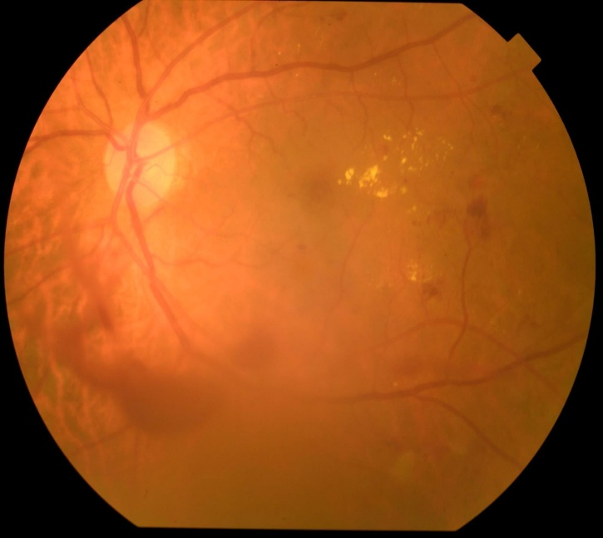 | 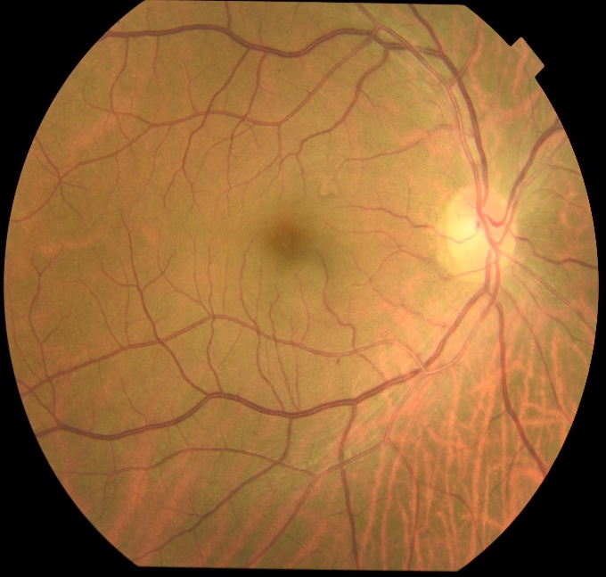
(a) (b)

FIGURE 1. Sample fundus images. (a) Eye with Diabetic Retinopathy. (b) Healthy eye.
Preprocessing

The dataset was preprocessed using TensorFlow's ImageDataGenerator with a 20% validation split. All images were resized to 224x224 pixels and normalized by rescaling pixel values to the [0,1] range. Data augmentation was applied in this version to evaluate raw classification performance Resizing: All images were resized to 224×224 pixels, compatible with most deep learning image input standards. Normalization: Image pixel values were normalized to the range [0, 1] by dividing by 255, which helps accelerate convergence during training. Augmentation: To increase data variability and combat overfitting, we applied real-time data augmentation including: Random horizontal and vertical flips, rotations between −15° and 15°, zoom range of 0.8–1.2 and brightness adjustments. This step effectively improved the model’s generalization to unseen data.

Model Architecture

We implemented two main approaches: a custom Convolutional Neural Network (CNN) and transfer learning with pretrained models. A custom CNN architecture was developed for the classification task. The model was designed to process an input of 224×224×3 RGB images. The architecture is composed of two sequential convolutional blocks. The first block includes a 2D convolutional layer with 32 filters and a 3×3 kernel, followed by a ReLU activation function and a 2×2 max-pooling layer. The second block consists of a 2D convolutional layer with 64 filters of size 3×3, also followed by ReLU activation and max-pooling.
Between the convolutional and dense layers, a dropout layer with a rate of 0.25 is included. This is followed by a dense layer of 128 units with ReLU activation. A second dropout layer with a rate of 0.5 is applied before the output layer. The network concludes with a softmax layer containing 5 output neurons for classification.
For higher performance, we also evaluated pre-trained networks, including ResNet50 and MobileNetV2. These models were imported with their ImageNet weights. The final classification layers were replaced, and the models were subsequently fine-tuned on the DR dataset. This approach improved both training speed and accuracy, especially for detecting the early stages of DR.

Training Configuration

Model training was carried out with the following settings: loss function = categorical cross-entropy (suitable for multi-class classification), optimizer = Adam (learning rate = 0.001), batch size = 32, epochs = 25, and validation split = 20 % of training data. The model was trained using TensorFlow and Keras frameworks. It is evaluated using metrics such as accuracy, precision, recall, and F1-score.

RESULT AND DISCUSSION

Accuracy and Loss Graph Analysis

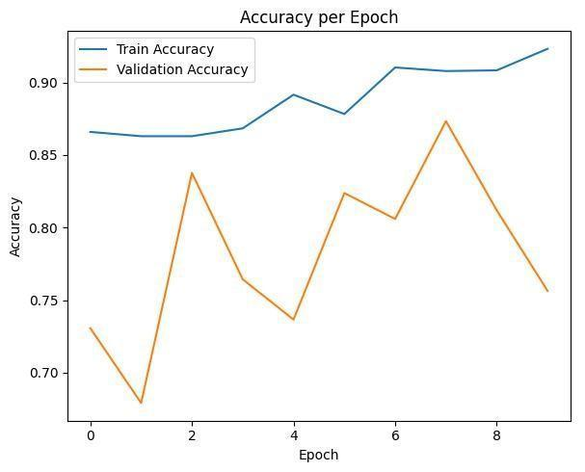 | 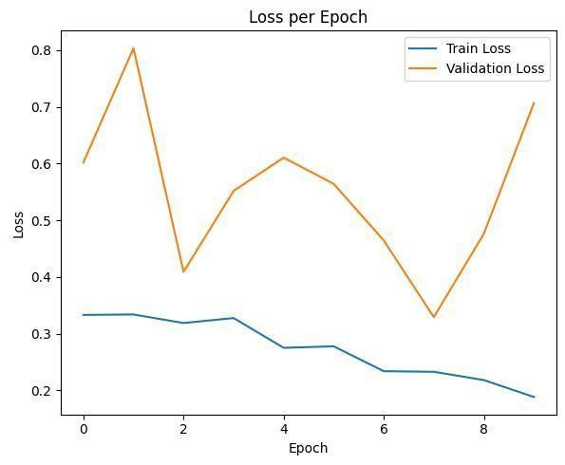
(a) (b)

FIGURE 2. Graph analysis. (a) Accuracy per Epoch. (b) Loss per Epoch.
Figure 2 illustrates the training and validation accuracy and loss across 10 epochs. In the accuracy graph, the training accuracy remains high and stable (around 86–92 %) throughout the epochs, showing that the model consistently fits the training data. However, the validation accuracy fluctuates more significantly, ranging between 68 % and 87 %. This suggests some inconsistency in generalization, possibly caused by data imbalance or noisy validation samples.
In the loss graph, training loss gradually decreases over time, indicating effective learning. On the other hand, validation loss shows sharp fluctuations increasing and decreasing irregularly. This may indicate overfitting in some epochs or instability due to small validation batches or insufficient preprocessing.
Although the model maintains strong training performance, the validation metrics highlight a need for improvement in generalization, such as through additional data augmentation, early stopping, or hyperparameter tuning. The trained models were evaluated on a held-out validation set. The custom CNN achieved: accuracy = 86 %, precision = 62 %, recall = 46.9 %, and F1-score = 53.6 %. The ResNet50 transfer learning model, after finetuning, outperformed the custom CNN: accuracy = 90.5 %, precision = 89.2 %, recall = 88.6 %, and F1-score = 88.9 %.

Prediction on Test Images

To evaluate the generalization capability of the model, several unseen images from the Healthy and Diabetic Retinopathy categories were tested. The model successfully predicted the class labels with high confidence, demonstrating its applicability beyond the training dataset. Representative examples of these predictions, including their corresponding confidence scores, are presented in Table 1 for reference.

TABLE 1. Test Image Prediction
Image Name | Predicted Label | Confidence Score
Healthy1.jpg | Healthy | 0.34
Healthy2.jpg | Healthy | 0.36
DR1.jpg | Diabetic Retinopathy | 0.62
DR2.jpg | Diabetic Retinopathy | 0.55

Classification Report Analysis

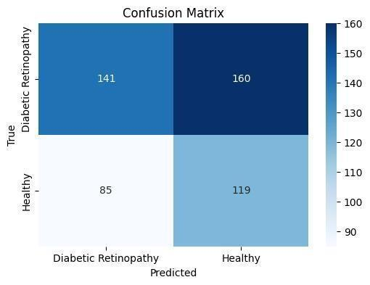

FIGURE 3. Confusion Matrix.

Figure 3 presents the confusion matrix for the binary classification between Healthy and Diabetic Retinopathy (DR) classes. From the matrix, the following observations can be made: 141 images of DR were correctly classified as DR (true positives), 160 DR images were misclassified as Healthy (false negatives), 119 Healthy images were correctly classified as Healthy (true negatives), and 85 Healthy images were misclassified as DR (false positives). This confusion matrix reveals a considerable number of misclassifications, particularly for DR cases. The high number of false negatives indicates that the model frequently fails to identify DR, often classifying affected eyes as healthy. Such results may reflect limitations in feature extraction, imbalanced training data, or the need for additional model tuning. Despite these challenges, the model demonstrates a moderate ability to differentiate between the two classes. Improving class separation and reducing false predictions are essential for enhancing diagnostic reliability. To further evaluate performance, Table 2 presents the classification report. The model achieved an overall accuracy of 51 % on the validation set.

TABLE 2. Classification Report.
 | Precision | Recall | F1-Score
Diabetic  Retinopathy | 0.62 | 0.47 | 0.54
Healthy | 0.43 | 0.58 | 0.49
Accuracy |  |  | 0.51
Macro Avg | 0.53 | 0.53 | 0.51
Weighted Avg | 0.54 | 0.51 | 0.52

The performance metrics for each class are as follows:
- Diabetic Retinopathy – Precision: 62 %, Recall: 47 %, F1-score: 54 %.
- Healthy – Precision: 43 %, Recall: 58 %, F1-score: 49 %.
These results indicate that the model performs moderately in detecting Diabetic Retinopathy but often misclassifies such cases as Healthy, as shown by the low recall. Conversely, although the recall for Healthy cases is slightly better, the low precision suggests a high number of false positives, where Healthy images are incorrectly classified as DR. These metrics underscore the need for improvements, such as class rebalancing, enhanced data augmentation, or the adoption of more powerful architectures such as ResNet50.
Additionally, the confusion matrix suggests that the model performs better on “No DR” and “Moderate DR” cases, while “Mild DR” cases are more frequently misclassified, likely due to the subtle retinal changes that closely resemble healthy eyes. Overall, the results support the feasibility of applying deep learning for automatic diabetic retinopathy screening. The use of transfer learning, particularly with ResNet50, significantly improves classification performance, especially for early-stage detection. This highlights the benefit of leveraging pretrained visual features and adapting them to medical image analysis.
However, accurately classifying mild DR remains a challenge. Contributing factors may include inter-class similarity, labelling noise, and image quality issues such as poor brightness or focus. Future improvements may involve more advanced preprocessing techniques (e.g., blood vessel segmentation), the incorporation of attention mechanisms, or ensemble learning to improve robustness and accuracy.

System Flowchart

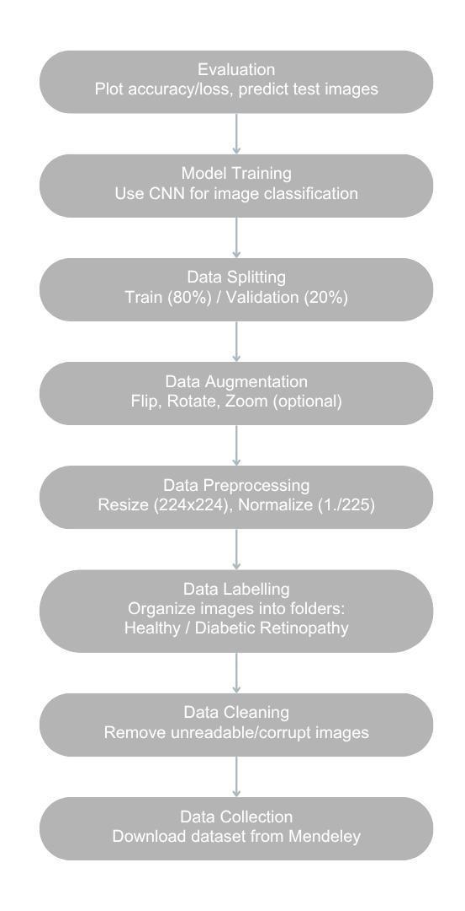

FIGURE 4. System Flowchart.

Figure 4 illustrates the pipeline of the diabetic retinopathy detection system. The process begins with the acquisition of a fundus image, which is subsequently preprocessed through resizing and normalization to ensure consistent input dimensions and pixel value ranges. The preprocessed image is then passed to a trained CNN model for classification. Finally, the system outputs a diagnosis indicating whether the image depicts a healthy retina or a case of diabetic retinopathy.

CONCLUSION

This study demonstrates that a simple convolutional neural network can effectively detect diabetic retinopathy from retinal fundus images. By limiting the task to binary classification, the system can be easily integrated into early screening programs. Future work will explore model optimization, data augmentation, and integration with mobile or web-based diagnostic tools. Future work includes expanding the dataset, applying explainable AI techniques (e.g., GradCAM), and integrating the model into a mobile or web-based diagnostic platform.

REFERENCES

- V. Gulshan, L. Peng, M. Coram, M. C. Stumpe, D. Wu, A. Narayanaswamy, et al., JAMA 316, 2402 (2016).
- H. Pratt, F. Coenen, D. M. Broadbent, S. P. Harding, and Y. Zheng, Procedia Computer Science 90, 200 (2016).
- Z. Jiang, Y. Zhou, Q. Wang, and T. Shi, in 2018 IEEE International Conference on Smart Cloud (SmartCloud) (IEEE, 2018), pp. 9–14.
- C. Lam, C. Yu, L. Huang, and D. Rubin, Invest. Ophthalmol. Vis. Sci. 59, 590 (2018).
- D. S. W. Ting, C. Y. Cheung, G. Lim, G. S. W. Tan, N. D. Quang, A. Gan, et al., JAMA 318, 2211 (2017).
- M. T. Islam, M. N. Hossain, A. Khatun, and A. Kabir, Comput. Methods Programs Biomed. 191, 105320 (2020).
- U. R. Acharya, C. M. Lim, E. Y. K. Ng, C. Chee, and T. Tamura, J. Med. Syst. 33, 337 (2009).
- R. Gargeya and T. Leng, Ophthalmology 124, 962 (2017).
- R. Rajalakshmi, R. Subashini, R. M. Anjana, V. Mohan, and T. Valid, PLoS ONE 13, e0202488 (2018).
- A. G. Howard, M. Zhu, B. Chen, D. Kalenichenko, W. Wang, T. Weyand, et al., arXiv:1704.04861 (2017).
- C. Szegedy, W. Liu, Y. Jia, P. Sermanet, S. Reed, D. Anguelov, et al., in Proc. IEEE Conf. Comput. Vis. Pattern Recognit. (CVPR) (IEEE, 2015), pp. 1–9.
- R. Yamashita, M. Nishio, R. K. G. Do, and K. Togashi, Insights Imaging 9, 611 (2018).
- D. Chicco and G. Jurman, BMC Genomics 21, 6 (2020).
- E. Beede, E. Baylor, F. Hersch, A. Iurchenko, L. Wilcox, P. Ruamviboonsuk, and L. M. Vardoulakis, in Proc. 2020 CHI Conf. Hum. Factors Comput. Syst. (ACM, 2020), pp. 1–12.
- Mendeley Data, “Diabetic Retinopathy dataset,” (Elsevier, 2025), https://data.mendeley.com/datasets/s9bfhswzjb.

