MALWARE CLASSIFICATION USING EXTRA TREE FEATURE SELECTION AND OVERSAMPLED ENSEMBLE MACHINE LEARNING
Al Fatehah Fahmi Abdurrahim Al Gozali^{1,a)}, Denar Regata Akbi^{2,b)}, Vinna Rahmayanti Setyaning Nastiti ^{3,c)}
Author Affiliations
^{1,2,3}Universitas Muhammadiyah Malang
Author Emails
^{a)} aagfahmi08@gmail.com,
^{b)}Corresponding author: dnarregata@umm.ac.id,
^{c)}vinastiti@umm.ac.id
Abstract. Malware is one the most severe cyber threats, targeting the confidentiality, integrity, resources, and availability of data and systems without user consent. Its detection is challenging due to the use of advanced encryption techniques, making data recovery difficult. This study investigates malware classification using an ensemble machine learning approach with six base learners: Random Forest, Logistic Regression, SVM, KNN, Multi-Layer Perceptron, and Decision Tree. the models are combined through a stacking technique, with an averaging method applied o reduce variance and improve stability. Performance is evaluated on the CCCS-CIC-AndMal2020 dataset, consisting of 53,750 Android application samples categorized into 14 malware classes and described by 144 features. Extra-tree feature selection is applied in two scenarios: with and without outlier handling, reducing feature from 144 to 125 and 55, respectively. Result show that Random Forest achieved the highest stand alone with 88% accuracy. Oversampling using SMOTE significantly improved the stacking model’s performance across all metrics, with the R2 score increasing from 0,7063 to 0,9329. Five-fold cross validation demonstrated consistent accuracy between 0,875 and 0,890. The model achieved high classification performance for Riskware, Trojan Banker, and Trojan Dropper with accuracy 0,926. The result obtained from this study show that the model has an accuracy rate of 97,11%, 93,29% for R2, F1-Score has 97,10%, 97,11% for recall, and Precision has 97,12%. Overall, the findings confirm that combining stacking with SMOTE effectively addresses class imbalance and enhances malware detection performance.

INTRODUCTION
Malware is one of the most dangerous types of software. It targets the confidentiality, integrity, resources, or availability of data and systems without the victim’s consent [1]. This type of attack is considered one of the most severe classes of cybercrimes due to its high level of difficulty to detect. Malware often employs advanced data encryption techniques, making data recovery extremely difficult once a system is infected. Based on its classification, malware can be divided into several types according to its behavior and characteristics, such as: adware, worms, viruses, rootkits, trojan horses, backdoors, spyware, logic bombs, and ransomware [2]. It can be used to steal personal data and information or exploit the victim’s computing resources to launch attacks on other targets. On the other hand, the formation of anti-malware software has also been widely discussed in several asticles and journals. The methods of analyzing and detecting malware themselves have many approaches, such as: environmental analysis (network, personal computer, mobile devices, cloud systems), data analysis (honeypot, static analysis, dynamic analysis, statistics), machine learning (Bayesian, decision tree, dimension reduction, instance based, clustering, deep learning, ensemble, neural network, regularization, rule system, regression) [3]. Several studies have discussed analytical methods for handling malware, which are implementations of various machine learning techniques.
The first study was conducted by Achmad Rizal Yogasware, Denar Regata Akbi, and Vinna Rahmayanti Setyaning Nastiti [1]. This research classifies malware families using the K-Nearest Neighbors method on secondary data from Canadian Institute for Cybersecurity in 2019. Using a 90:10 train-test split, KNN achieved 65% recall and 83% precision. Preprocessing with the C5.0 algorithm was noted to enhances classification performance.
The second study was conducted by Ahmed Hashem El Fiky, Mohamed Ashraf Madkour, and Ayman El Shenawy [4]. This study presents a parallel machine learning model for dynamic detection of Andorid malware categories and families using the CCCS-CIC-AndMal2020 dataset (14 categories, 180 families). The model achieved over 96% accuracy in category detection and over 99% in family identification, outperforming recent methods while significantly reducing acnalysis time on smartphones.
The third study was conducted by Vishnu Sripriya Akondi, Vineetha Menon Jerome Baudry, and Jana Whittle [5]. This research discusses the performance of feature selection in improving the accuracy of the K-means clustering method. The result of study indicated that the most effective feature selection method to enhance the accuracy of K-means clustering is the Extra-tree feature selection approach.
The forth study wa conducted by Rejwana Islam, Moinul Islam Sayed, Sajal Saha, Mohammad Jamal Hossain, and Md Abdul Masud [2]. this study employs a weighted voting ensemble of six classifier on the CCCS-CIC-AndMal2020 dataset for dynamic multi-classification of Andorid applications and malware. using R2 base weighting, the model achieved 95% accuracy despite reducing features by 60,2%.
The fifth study was conducted by Dwinanda Bagoes Ansori, Joko Slamet, Muhammad Zakky Ghuffron, Muhammad Aidiel Rachman Putra, Tohari Ahmad [6]. This study proposed an approach for detecting Android malware and classifying it into five categories by using gain ratio feature selection and an ensemble machine learning algorithm. Feature were reduced based on their importance values calculated through the gain ratio method. Subsequently, the most significat features were used in a classification process that combined multiple models. Experiments conducted using the CIC-AndMal-2020 dataset demonstreated that the proposed approach improved detection performance. Result has increased detection accuracy acros several machine learning algorithms: by 2,59% for Naïve Bayes, 0,90% for KNN, and 2,29% for SVM.

METHODOLOGY
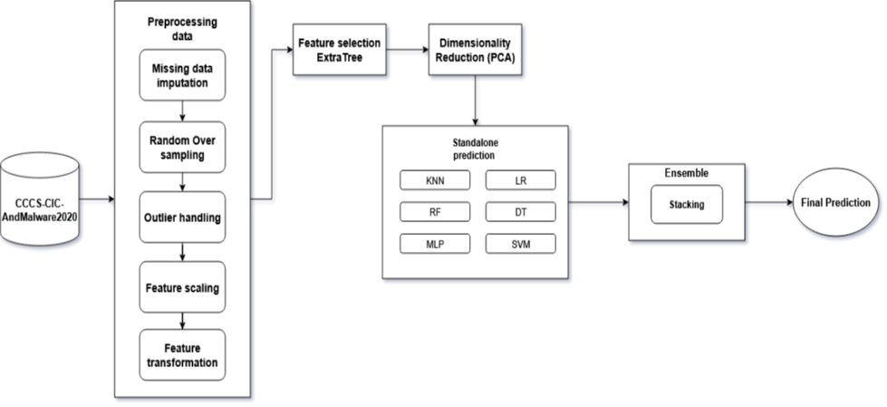
FIGURE 1. Framework of our proposed methodology.
Essentially, the ensemble machine learning technique combines multiple models to enhance classification accuracy and robustness by leveraging the strengths of diverse models. This approarch reduces the risk of overfitting and improves predictive performance, especially when the individual model are uncorrelated. As illustrated in figure 1, six types of models are employed in this study: Random Forest, Logistic Regression, Support Vector Machine, K-Nearest Neighbors, Multi-Layer Perceptron, and Decision Tree. these models serve as base learners for generating predictions, which are then combined through a stacking approach into a single model. To reduce variance and improve model satbility, the regression outputs from al base models will be averaged using the Averaging method to produce the final prediction. To combined model will then be analyzed and its accuracy compared between two scenarios: one using Extra-tree feature selection and the other without it. The result of this analysis and comparison will form the basis for evaluating the performance and effectiveness of the porposed model.

Dataset
CCCS-CIC-AndMal-2020 is a publicly available dataset released in 2020 by the Canadian Center for Cyber Security and the Canadian Institute for Cybersecurity [7]. It is a large collection of Andorid applications totaling approximately 400,000, consisting of 200,000 beign application and 200,000 malicious applications [4],[8]. For dynamic analysis, the dataset contains 144 categorizable features. In addtion, it includes 53,750 samples classified into 14 distinct types of malwares [9],[10].

TABLE 1. Dataset Structure.
Categories | Families | Samples | Feature
Adware before reboot | 42 | 5.143 | 144
Adware after reboot | 41 | 5.838 | 144
Backdoor after reboot | 10 | 546 | 144
Backdoor before reboot | 10 | 591 | 144
FileInfector after reboot | 5 | 119 | 144
FileInfector before reboot | 5 | 129 | 144
PUA after reboot | 9 | 625 | 144
PUA before reboot | 9 | 665 | 144
Ransomware after reboot | 8 | 1.861 | 144
Ransomware before reboot | 8 | 1.861 | 144
Riskware after reboot | 18 | 6.792 | 144
Riskware before reboot | 19 | 7.261 | 144
Scareware after reboot | 4 | 424 | 144
Scareware before reboot | 4 | 462 | 144
Trojan after reboot | 37 | 4.025 | 144
Trojan before reboot | 38 | 4.412 | 144
Trojan_Banker after reboot | 10 | 123 | 144
Trojan_Banker before reboot | 11 | 118 | 144
Trojan_Dropper after reboot | 10 | 733 | 144
Trojan_Dropper before reboot | 9 | 837 | 144
Trojan_SMS after reboot | 10 | 911 | 144
Trojan_SMS before reboot | 10 | 1.028 | 144
Trojan_Spy after reboot | 10 | 1.039 | 144
Trojan_Spy before reboot | 11 | 1.801 | 144

Preprocessing.
First step preprocessing is exploration data analysis, the fisrt step involves exploring the dataset to understand its structure and content using function such as head(), info(), and describe(). Data cleaning, missing values (null values) are removed or imputed using methods such as mean, median, interpolation, or mode imputation. This ensures dataset completeness, prevent errors due to missing values, and minimizes data distortion. Outlier handling (optional), significant deveiation from general data patterns are detected and addressed using the interquatile range (IQR) methods to maintain the validity and accuracy of analysis. Data transformation, for normalization we applying MinMaxScaler() to rescale numeric values into a uniform range, while for encoding we using LabelEncoder to convert catagorical variables into numerical form for model preprocessing. Data splitting, the dataset is split into 60% training set (28,219 samples), 20% validation set (9,406 samples), and 20% test set (9,406 samples).

Missing Data Imputation.
Many supervised machine learning methods cannot be applied to dataset containing missing values, such as regression technique or neural network [2]. To ensure the dataframes is free from missing values, the SimpleImputer from Scikit-Learn library was used with the mean strategy. The first step involved replacing all infinite values (both positive and negative) with Numpy np.inf, which represents values greater than any real number. Next, all empty values were converted to Numpy np.nan to indicate missing data, allowing algorithms to ignore them during computation. Finally, all np.nan and np.inf values were replaced with the mean value of the corresponding feature.

Random Oversampling
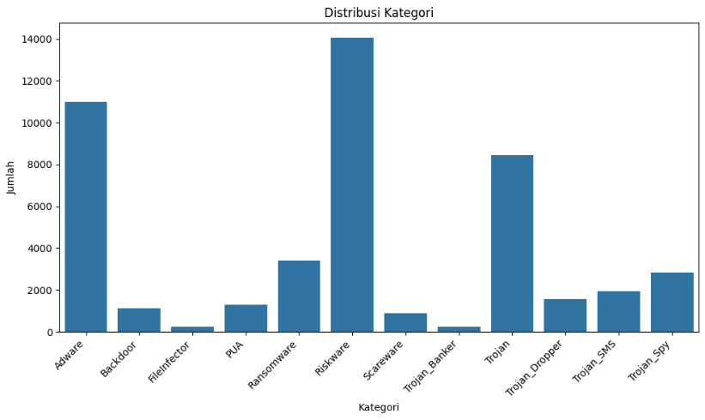
FIGURE 2. Category Distribution.
Figure 2 illustrates and visualizes the distribution of each malware category in the CCCS-CIC-AndMal2020 dataset. According to the dataset structure in Table 1, the number of Trojan_banker sampels is 141, while Riskware has 14,053 samples. This imbalance can affect the performance of machine learning algorithms during the training phase. The CCCS-CIC-AndMal2020 dataset is considered imbalanced in term of sample counts, as show in Figure 2. The frequency ratio between Trojan_banker and Riskware is 1:58. This poses a challenge because some algorithms tend to overlook minority classes, even though prediction for minority classes are often more important. To address this class imbalance, a resampling technique was applied. The method used is the Synthetic Minority Oversampling Technique (SMOTE), with the simplest approach being duplicating samples from the minority class.

Outlier Handling.
A data point, number, or value that deviates significantly from the majority of the data is called an outlier. The presence of outliers can affect the mean, median, standart deviation, and interpretation of analyis result, which many ultimately cause a model or algorithm to become inaccurate or biased. Moreover, outliers can obscure the true patterns in the data, resulting in bias. To prevent this, outlier handling is necessary before feeding data into a model. The CCCS-CIC-AndMal2020 dataset has highly skewed distribution, causing the distribution tail to be longer in one direction. This skeweness is due to the characteristics of the data collected for dynamic Android malware analysis. Each malware type has different operational characteristics, which typically lead to varying values related to memory management, logcat, API calls, and so on. The technique used to identify outliers is the Interquartile Range (IQR), which is calculated using the foolowing formula:
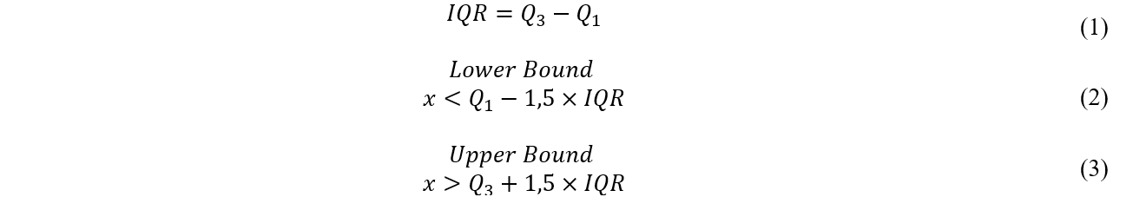
Where $IQR$ is interquartile range, $Q_{1}$is first quartile, $Q_{3}$is third quartile, and $x$is recent values.

Feature Scaling.
If the values of feature in a machine learning algorithm are similar to each other, there is agreater likelihood that the algorithm will be trained more efectively and quickly compared to a dataset with highly varied feature values. Dataset with widely differing feature values generally require more time for the model to learn and tend to produce lower accuracy. The function of feature scaling is to normalize or equalize the range of values across the dataset’s features, ensuring that all features are on the same or uniform scale. This is important because features in dataset often have very different value ranges. Without scaling, features with larger valuesmay dominate the model training process, which can result in biased and less accurate predictions. In this study, the researcher employed the MinmaxScaler from the Scikit-Learn library to normalize the data for each feature based on the minimum and maximum values within that feature.

Categorical Values Encoding.
Since the CCCS-CIC-AndMal2020 dataset is categorical, it requires transformation into intergers. The resercher utilized the One-Hot-Encoder form the Keras library to convert categorical data in interger form into binary vector representations, where each category is represented by a vector containing a single element with values 1 and rest with the values 0. This means that a feature represented by a given column will have a value of 1 if it belongs to the category converted into a binary feature, and 0 otherwise.

Feature Selection.
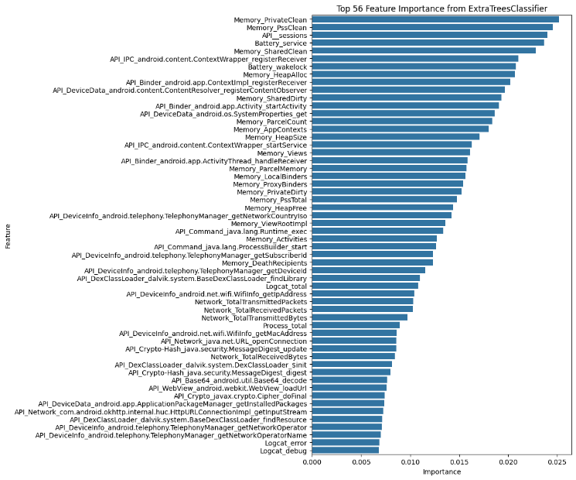
FIGURE 3. Feature Selection using ExtraTreeClassifier.
Since the CCCS-CIC-AndMal2020 is categorical with large number of features, it is necessary to apply a method for optimally selecting the most influential feature using a feature selection technique. This technique aims to identify the most relevant and important subset of features from the entire dataset in order to improve the performance of the machine learning model. In this study, the Extra-tree feature selection method we employed, considering the complex and categorical nature of the CCCS-CIC-AndMal2020 dataset. In general, Extra-tree operates in a manner similar to decision tree. Once random splits are generated, importance scores are automatically calculated to indicated the relative contribution of each feature to the model predictions. Features with high importance scores are selected for calssification, while features with low importance score are discarded to reduce model complexity, thereby minizing the risk of overfitting. In the experiments, without outlier handling, 125 feature were found to be related to the classification labels out of the total 144 features. With outlier handling applied 56 features were found to be related to the classification, as explained in the Figure 3.

Dimensionality Reduction.
In this study, the reserachers applied Principal Component Analysis (PCA) and t-distributed Stichastic Neighbor Embedding (t-SNE) to the dataset. PCA tranforms data from a high-dimensional space into a lower-dimensional space, aiming to keep the lower-dimensional representation as close as possible to the original data. In analyses involving large numbers of observatons or variables, dimensionality reduction is highly beneficial, as smaller dataset are easier to analyze and visualize.
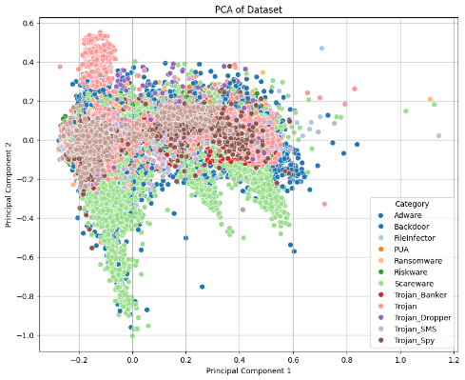 | 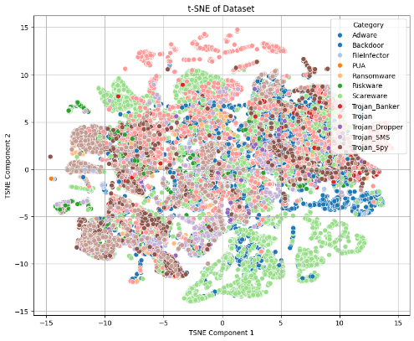
(a) | (b)
FIGURE 4. Dimensionality Reduction using PCA and t-SNE.
Figure 4 (a) present a PCA biplot after applying the Outlier Capping process to each category. The PC1 (Principal Component) axis represents the largest vaiability within the dataset and serves to separate various malware categories, while the PC2 axis capture significat variability that helps distinguish between closely related categories. It can be observed that certain categories are more concentrated in specific areas, particularly in the upper region of the plot, indicating clear clustering for categories with high density. Furthermore, there ara high-density regions that indicate freaquent occurences of certain categories. Figure 4 (b) present a biplot generated by t-SNE for dimensionality reduction after applying the outlier capping process. This biplot is useful for identifying distribution patterns of the data in its reduced- dimensional space. Clear clustering between categories can be observerd, indicating that the data is well-organized based on malware types. Some categories show high-density regions, such as Trojan, which appears widely distributed, and Ransomware, which exhibits a certain degree of concentration. Meanwhile, other categories appear more scattered. Futher analysis can be conducted to explore the specific characteristics of each cluster.

Hyperparameter Tuning.
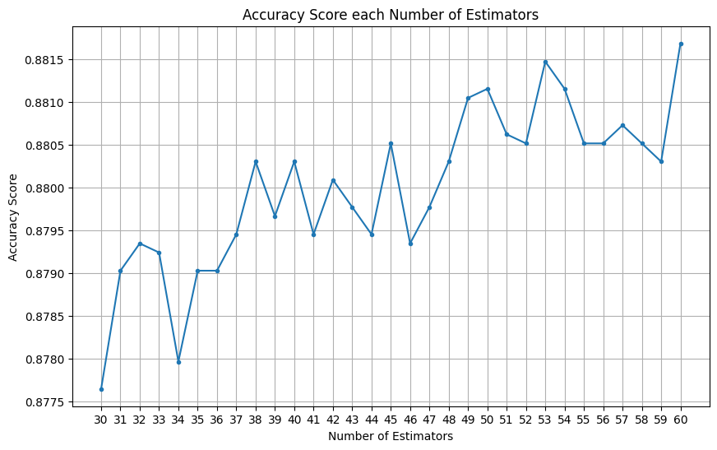
FIGURE 5. Accuracy Model RF for each n_estimators.
The implementation of GridSearchCV, purpose of hyperparameter tuning is to search for and determine the optimal combination of hyperparameter values so that a machine learning model can perform at its best on a given dataset. This process allows the model to adapt to the characteristic of the data, improve accuracy, reduce the risk of overfitting or underfitting, and enhance overal prediction results. To evaluate the hyperparameters, the reserchers used GridSearchCV to identify the best combination of hyperparameters for machine learning model. This tool tests various parameters combinations to determine the best performance based on predefined metrics. Ther process inherently applies a five-fold cross-validations, which makes the model evaluation more accurate. For RF models, there are hyperparameters tuning such as; n_estimator = 60, for max_depth = ‘None’, min_samples_split = 2, and random_state= 42, with achieving accuracy 0,8826 as can be seen in the Figure 5. For KNN model we used n_neighbors = 3, with achieving accuracy 0,7470. MLP model, there are hyperparameters tuning such as; random_state = 3, max_iter = 300, activation= ‘relu’, alpha = 0,0001, hidden_layer_sizes = 100, with achieving accuracy 0,8010. For DT we used; random_state = 36, max_depth = 20, min_samples_split = 2, with achieving accuracy 0,8175. For SVM, there are hyperparameter tuning such as; Kernel = ‘rbf’, gamma = 10, C = 100, with achieving accuracy 0,8155. Figure 5 shows the Random Forest model’s accuracy for varying n_estimators. Accuracy fluctuates between 30 and 60 estimators but generally improves with more estimators, peaking at about 0,8815 at 60 n_estimators. Some variations suggest other factor may also affect accuracy.

RESULT AND DISCUSSION

Comparison Model
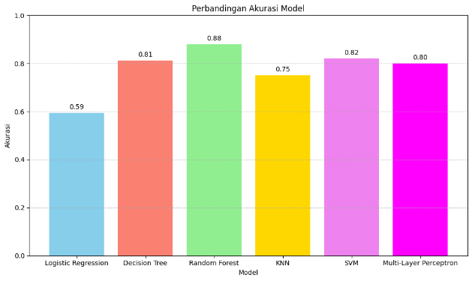 | 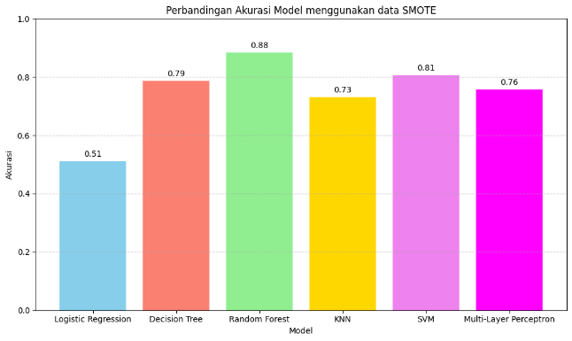
(a) | (b)
Figure 6. Comparison Model when standing alone.
Figure 6 (a) present the accuracy comparison of each model without applying random oversampling, while Figure 6 (b) shows the result after the process was applied. The Logistic Regression model achieved an accuracy of 51%, a decrease of 8% from its previous score. The K-Nearest Neighbors model experienced a 2% drop, from 75% to 73%. The Multi-Layer Perceptron model decreased by 4%, from 80% to 76%. The Decision Tree model recorded an accuracy of 79%, down 2% from 81%. The Support Vector Machine model saw a slight decline of 1%, from 82% to 81%. Meanwhile, the Random Forest model maintained a consistent accuracy of 88%, remaining the highest among the six models. It appears that the oversampling process using SMOTE has a significant effect on the model learning process when standing alone.

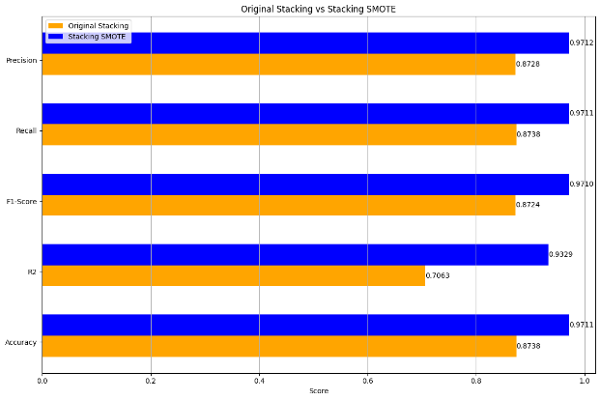
Figure 7. Performance Ensemble Machine Learning.

Oversampled Ensemble Machine Learning
In Figure 7, it is evident that ensemble learning using stacking with oversampled data demonstrates better performance across all matrics compared to stacking without oeversampling. The most significant improvement is observed in the R2 score, where stacking with SMOTE achieved 0,9329, while the original stacking only reached 0,7063. Performance in other metrics, such as precision, recall, F1-score, and accuracy, also indicates that stacking with SMOTE is more effective for classification. This suggests that applying the SMOTE technique in stacking can enhance the model’s ability to address class imbalance issues.

Evaluation Model
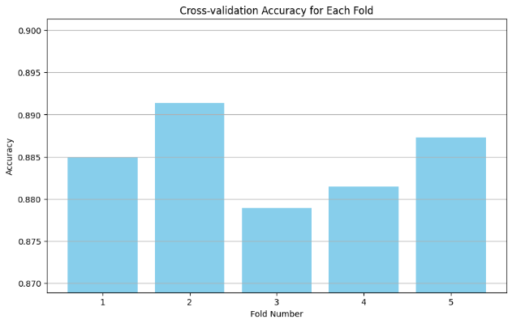 | 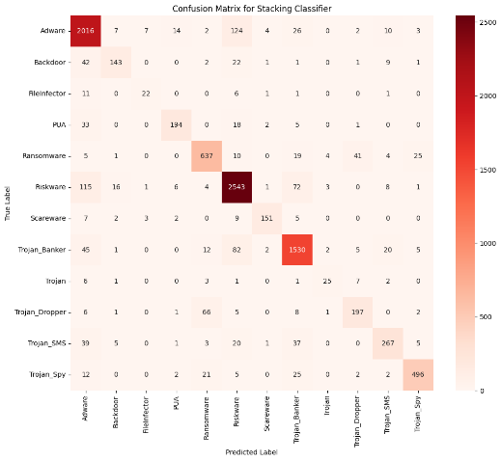
(a) | (b)
Figure 8. Accuracy of Five-Fold Cross Validation.
Figure 8 (a) present the accuracy levels from five-fold cross validation. The first fold achieved an accuracy of 0,875, the second fold 0,890, the third fold 0,875, the fourth fold approximately 0,880, and the fifth fold around 0,890, this pattern shows that the second and fifth folds have the highest accuracy, indicating strong model performance in those folds. In contrast, the third fold shows the lowest accuracy, wich may be due to specific factor in the data used for that fold. Overal, the model demonstrates consistent performance with slight fluctuations, despite some variation across folds. The highest accuracies in certain folds indicates that the model’s efficiency in Classification is genrally quite good. Figure 8 (b) shows the confusion matrix of the ensemble machine learning model after oversampling. This matrix is used to evaluate the classification performance by comparing the actual labels with the predicted labels. As shown in Figure 8 (b), the model performs well for most classes, particularly for the Riskware, Trojan_Banker, and Trojan_Dropper categories, each achieving an accuracy of over 0,926. However, the FileInfector category shows a relatively low accuracy of around 0,275, which may indicate classification issues specific to that category.

CONCLUSION
Malware is one of the most dangerous types od software, targeting the conficentiality, integrity, resources, or availability of data and systems without the victims’s consent. Such attacks are difficult to detect and often employ advanced encryption techniques, making data recovery challenging. Malware analysis and detection can be carried out through various approaches, such as environmental analysis, data analysis, and machine learning. this study employe six of these models as base learners, combined through stacking. The averaging method is applied to reduce variance and improve model stability. Performance is compared between models with and without Extra-tree feature selection. Without outlier handling, 125 out of 144 features are relevant; with outlier handling, only 56 features remain relevant. Random Forest achieved the highest accuracy (88%). Oversampling using SMOTE enhanced the stacking model’s performance across all metrics, especially R2 (0,9329). The five-fold Cross-Validation result show consistent accuracy between 0,875 and 0,890. The model performs exceptionally well for the Riskware, Trojan_Banker, and Trojan_Dropper categories, with achieved accuracy 0,926, but shows weaker performance for FileInfector. Although the accuracy of the model when stand alone with SMOTE is quite significant, it is possible that the same thing will happen during the ensemble learning process. The result obtained from this stady show that the model has an accuracy rate of 97,11%, 93,29% for R2, F1-Score has 97,10%, 97,11% for recall, and Precision has 97,12%. It has been proven that oversampling using SMOTE can improve the performance of ensemble’s stacking models.

References
[1] A. R. Yogaswara, “Klasifikasi Malware Family menggunakan Metode k-Nearest Neighbor (k-NN),” J. Repos., vol. 3, no. 3, pp. 305–314, 2021, doi: 10.22219/repositor.v2i3.1313.
[2] I. . Fernando, “Android Malware Classification Using Optimum Feature Selection and Ensemble Machine Learning,” Tour. Covid-19 Pandemic a Perspect. With Swot Anal., vol. 15, no. 2, pp. 14–21, 2020.
[3] B. Yamany, M. S. Elsayed, A. D. Jurcut, N. Abdelbaki, and M. A. Azer, “A New Scheme for Ransomware Classification and Clustering Using Static Features,” Electron., vol. 11, no. 20, Oct. 2022, doi: 10.3390/electronics11203307.
[4] A. H. El Fiky, M. A. Madkour, and A. El Shenawy, “Android Malware Category and Family Identification Using Parallel Machine Learning,” J. Inf. Technol. Manag., vol. 14, no. 4, pp. 19–39, 2022, doi: 10.22059/jitm.2022.88133.
[5] V. S. Akondi, V. Menon, J. Baudry, and J. Whittle, “Novel K-Means Clustering-based Undersampling and Feature Selection for Drug Discovery Applications,” Proc. - 2019 IEEE Int. Conf. Bioinforma. Biomed. BIBM 2019, no. Mcl, pp. 2771–2778, 2019, doi: 10.1109/BIBM47256.2019.8983213.
[6] D. B. Ansori, J. Slamet, M. Z. Ghufron, M. A. R. Putra, and T. Ahmad, “Android Malware Classification Using Gain Ratio and Ensembled Machine Learning,” Int. J. Saf. Secur. Eng., vol. 14, no. 1, pp. 259–266, 2024, doi: 10.18280/ijsse.140126.
[7] A. Rahali, A. H. Lashkari, G. Kaur, L. Taheri, F. Gagnon, and F. Massicotte, “DIDroid: Android malware classification and characterization using deep image learning,” ACM Int. Conf. Proceeding Ser., pp. 70–82, 2020, doi: 10.1145/3442520.3442522.
[8] A. Taha, A. H. Osman, and Y. S. Baguda, “An Intelligent Technique for Android Malware Identification Using Fuzzy Rank-Based Fusion,” Technologies, vol. 13, no. 2, Feb. 2025, doi: 10.3390/technologies13020045.
[9] T. Sanamontre, V. Visoottiviseth, and C. Ragkhitwetsagul, “Detecting Malicious Android Game Applications on Third-Party Stores Using Machine Learning,” Lect. Notes Data Eng. Commun. Technol., vol. 202, pp. 238–251, 2024, doi: 10.1007/978-3-031-57916-5_21.
[10] M. Ababneh, A. Al-Droos, and A. El-Hassan, “Modern Mobile Malware Detection Framework Using Machine Learning and Random Forest Algorithm,” Comput. Syst. Sci. Eng., vol. 0, no. 0, pp. 1–10, 2024, doi: 10.32604/csse.2024.052875.

