Livestock Tracking System Based On LoRa Module And RSSI-Multilateration
Choki Andriano^{1, a)} and Mahar Faiqurahman^{2, b)}
Author Affiliations
^{1,2} Department of Informatics, Universitas Muhammadiyah Malang, Indonesia
Author Emails
^{a)} chokiandriano0505@gmail.com
^{b)} Corresponding author: mahar@umm.ac.id
Abstract. Smart farming is a popular agricultural model that leverages Internet of Things (IoT) and Wireless Sensor Network (WSN) technologies. IoT is utilized in smart farming to connect various components, such as sensors and actuators, which monitor livestock conditions and the surrounding agricultural areas. This study aims to implement LoRa technology for livestock tracking within smart farming and to determine the location of livestock using Received Signal Strength Indicator (RSSI) and multilateration. We conducted experiments using the OMNeT++ simulator and the Flora framework, simulating the movement of livestock and calculating their locations through multilateration. The results indicate a correlation between RSSI values and distance, which can be used to estimate the positions of livestock. These findings highlight the potential of using LoRa technology in real environments. However, further optimization is necessary, particularly in adjusting the parameters for calculating distance using RSSI and refining the multilateration method to improve the accuracy of node positioning. The outcomes of this study can serve as a foundational model or initial analysis for developing a livestock tracking system based on LoRa technology.

Keyword: Livestock tracking-system, smart farming, LoRa, multilateration

INTRODUCTION
Smart farming has become one of the most popular models for livestock farming and agriculture today. This approach utilizes Internet of Things (IoT) and Wireless Sensor Network (WSN) technologies. In smart farming, IoT is employed to monitor livestock conditions, track crops, and assess the surrounding environments of farms through internet connectivity [1]. The IoT system in smart farming can be accessed and managed via mobile devices such as smartphones and tablets, as well as through various platforms, including websites and cloud systems [2].
In the livestock sector, smart farming technology allows farmers to monitor and manage critical data, such as animal temperature, livestock health, barn temperature and humidity, livestock location tracking, animal movement, milk stock, and more [3], [4]. This technology enhances efficiency in livestock tracking and reduces the risk of theft [4]. By integrating location-determining technologies like GPS and GNSS, farmers can continuously monitor the position of their livestock from any location [5], [6] .
Several technologies are utilized for tracking livestock positions. GNSS, which includes GPS, GLONASS, Galileo, and BeiDou, is the most widely used technology for this purpose due to its high accuracy in determining object locations. In a study by Melzer et al. [7], ultra-wideband Real-Time Location Systems (RTLS) were implemented to monitor and track cattle on a farm. The results indicated that this technology requires calibration for improved accuracy. Additionally, RFID technology can be beneficial for livestock monitoring and tracking, though its limited range makes it more suitable for smaller farm areas[8], [9]. Another study conducted by Shelemia et al. employed LoRa modules to measure the distance traveled by livestock in real-time [10].
LoRa communication modules have great potential for use in livestock position tracking systems within smart farming, as they are cost-effective, have a wide signal range, and are energy-efficient[11]. Several studies have explored object positioning using LoRa modules. Research by Premsankar et al.[12] and Slabicki et al.[13] modeled and analyzed LoRa signals to derive distance information based on Received Signal Strength Indicator (RSSI) values. Other study compared distances calculated from the LoRa module with actual distances [14]. The findings indicated that the calculated distances had relatively small errors. Further research by Marcelic et.al [15] applied the multilateration method to determine positions based on RSSI values from LoRa; however, this study did not provide a detailed analysis of location accuracy.
This study focuses on the application of LoRa technology for livestock tracking in the context of smart farming. The primary objective is to simulate a position tracking system using LoRa communication modules, employing distance measurement methods based on RSSI and multilateration.

METHODs
This study utilizes the Omnet++ simulator to track livestock on farmland using the LoRa module. It is assumed that each livestock animal is equipped with a LoRa module (referred to as a LoRa Node), which transmits signals in broadcast mode at regular intervals to four LoRa Gateways positioned around the farmland. These LoRa Gateways are strategically located at each corner of the square that defines the farm area, while the LoRa Nodes are distributed between the LoRa Gateways, as illustrated in Figure 1.

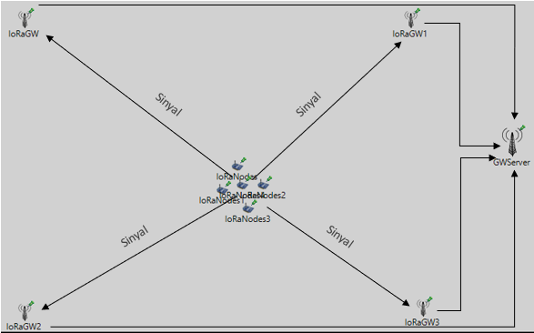

FIGURE 1. Live Stock Tracking using LoRa Module
Signals from LoRa nodes are captured by LoRa gateways to calculate distance using the RSSI (Received Signal Strength Indicator) information received. By determining the relative distance of the LoRa nodes to each LoRa gateway, the positions of the nodes are calculated using the multilateration method. If the LoRa nodes move, their locations are updated based on the RSSI values received by each gateway and the multilateration calculations.
Theoretically, previous research indicates that the RSSI value has a strong correlation with the distance between a LoRa Node and a LoRa Gateway[14], [16] . According to the findings of [16], the RSSI value can be calculated using the following equation (1):

$RSSI=P_{T}-P_{0}-10n log (\frac{d}{d0})-X_{δ}$ (1)
Where P_{T} is the transmission signal strength, P₀ is the reference path loss at distance d₀, n is the path loss exponent which depends on the environment. X_{δ} is a Gaussian distribution random variable with values ranging from (4-10) based on [16].

From this equation, equation (2) can be derived to calculate the distance from the RSSI value obtained from the LoRa Node.

$d=d_{0}\log^{(\frac{P_{T}- P_{0}-RSSI- X_{δ} }{10n} )}$ (2)

The relative distance d obtained at each LoRa Gateway is used for position calculation using multilateration [17].

(x – $x_{0}$)² + (y – $y_{0}$)² = ($r_{0}$)² (3)

(x – $x_{1}$)² + (y – $y_{1}$)² = ($r_{1}$)² (4)

(x – $x_{2}$)² + (y – $y_{2}$)² = ($r_{2}$)² (5)

(x – $x_{3}$)² + (y – $y_{3}$)² = ($r_{3}$)² (6)
In the given context, r_{i} represents the distance calculated from the RSSI of LoRa Node at LoRa Gateway i. The coordinates x_{i} and y_{i} denote the position of LoRa Gateway i on the x and y axes within the simulation area. Meanwhile, x and y represent the coordinates of the LoRa Node whose location is being determined.
The testing was conducted using LoRa Nodes positioned at 20 different locations within the farm area, utilizing 4 LoRa Gateways. The LoRa Nodes emitted signals that were captured by these 4 Gateways. The received RSSI values from the Gateways were then used to calculate the distance between the LoRa Nodes and the Gateways, as well as to determine their positions through a process called multilateration.
In this study, several assumptions were made regarding the parameter values used in the simulation. The positions of each LoRa Gateway were fixed at the corners of the square that defines the farm area. The parameter values used to model LoRa signal transmission were obtained from prior research [13]. Specific for for the Path Loss Exponent, we use the Loss Space value as a reference [14]. These parameters include reference distance, path loss, LoRa transmitter power, path loss exponent, and noise. A detailed summary of each parameter value used in the simulation can be found in Table 1

TABLE 1. Parameters Value Being Used in Simulation
Parameters |  | Value
LoRa Gateway Coordinate | Gateway 0 | (32, 27)
LoRa Gateway Coordinate | Gateway 1 | (39, 327)
LoRa Gateway Coordinate | Gateway 2 | (635, 37)
LoRa Gateway Coordinate | Gateway 3 | (605, 427)
Reference Distance (d₀) |  | 1000 Meters
Path Loss (P₀) |  | 128,95 dBm
Power Transmitter (P_{T}) |  | 14 dBm
Path Loss Exponent (n) |  | 2
Noise ($X_{σ}$) |  | 7,08

result and discussion
he distance calculation data is presented in Figure 2. Each LoRa Gateway (Gateway_0, Gateway_1, Gateway_2, and Gateway_3) records the RSSI data from signals transmitted by LoRa Nodes located in the farm area. The relative distance between each LoRa Gateway and the LoRa Nodes is determined based on the RSSI values.
The simulation and testing results depicted in the graph demonstrate a strong correlation between changes in the RSSI values (X-axis) and the distances calculated from these values (Y-axis). This finding aligns with path-loss modeling, which indicates that more negative RSSI values correspond to longer calculated distances. However, the RSSI values recorded at each LoRa Gateway tend to fluctuate, leading to discrepancies with the actual distances between the LoRa Nodes and the LoRa Gateways.
As shown in Figure 2, the average distance deviation varies significantly. The greatest distance deviation occurs within the RSSI value range of -95 to -110 dBm. This variation is mainly due to the differing RSSI values received by the LoRa Gateways from the LoRa Nodes. The differences in RSSI values during this simulation are heavily influenced by signal modeling and the parameters that were set. Because the calculated distance is an exponential function of RSSI and path loss, even minor changes in RSSI values can lead to significant shifts in the calculated distances.

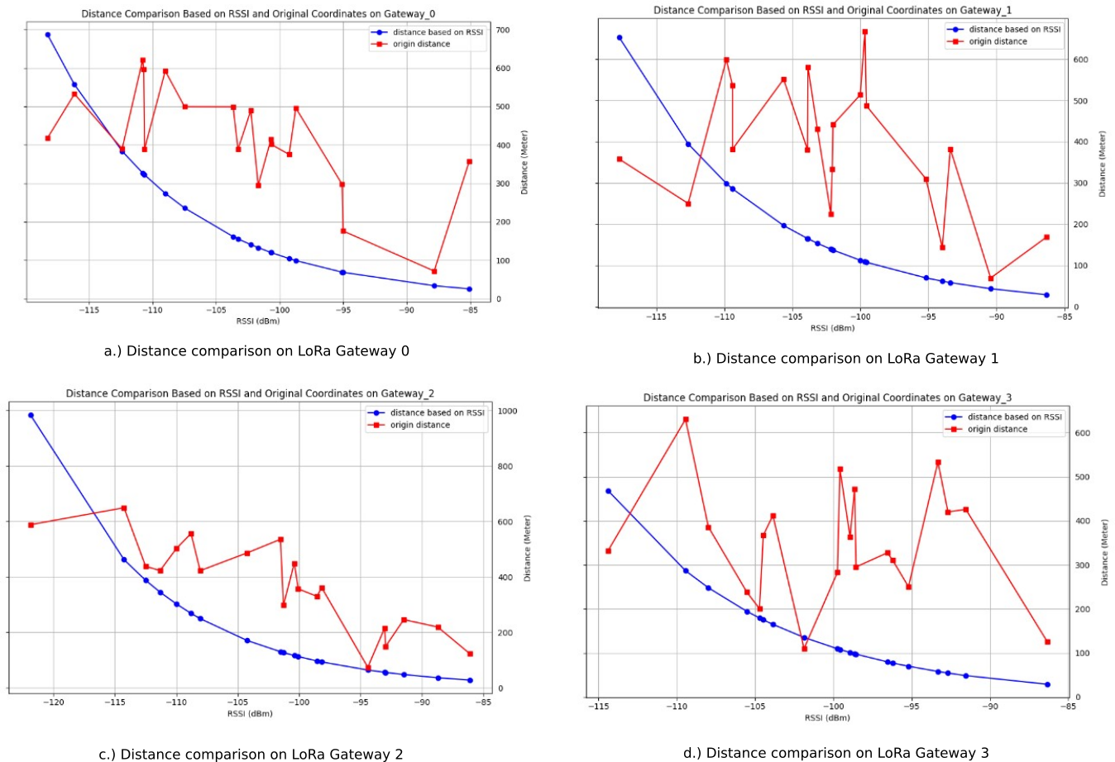

FIGURE 2. Distance comparison based on RSSI and Original Coordinates for each LoRa Gateway
Figure 3 illustrates the results of determining the position of the LoRa Node using the multilateration method (represented by red dots). In comparison, the position calculations based on specific coordinates are shown with blue dots. The results from the multilateration method reveal significant deviations, as indicated by the dotted lines. When the LoRa Node is centrally located between the LoRa Gateways, the deviation values are relatively small. However, when the LoRa Node is positioned closer to one of the Gateways, the deviations increase considerably. These deviation values are influenced by several factors, one of which is the variation in RSSI values captured by the LoRa Gateway from different locations. The RSSI values are significantly affected by signal modeling parameters, including reference distance, path loss, path loss exponent, and the shadowing effect, all of which are incorporated into the simulation.
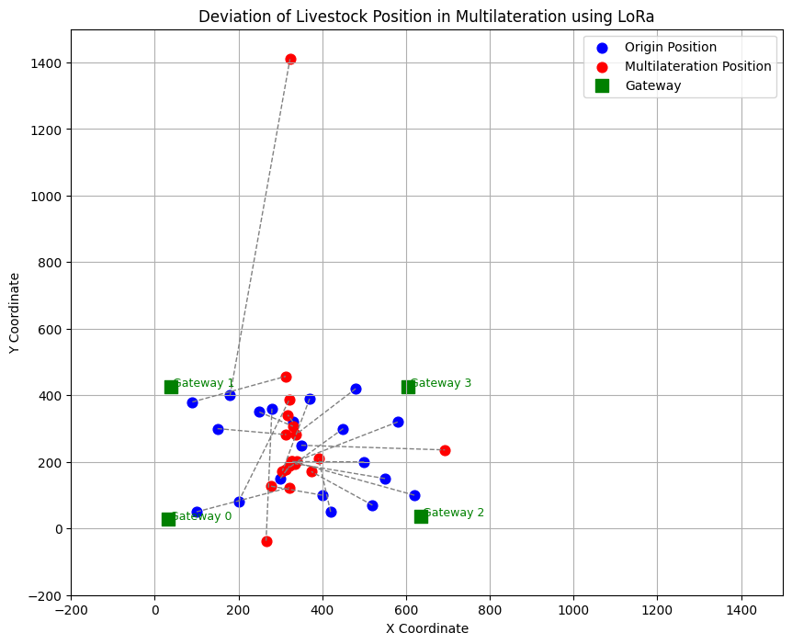
FIGURE 3. Deviation of livestock position in multilateration using LoRa

CONCLUSION
This study simulated the positioning and tracking of livestock using the LoRa module. The results indicate that the estimated distance based on RSSI differs significantly from the actual distance based on origin coordinates. This discrepancy is due to various factors in the simulation modeling, such as path loss and the shadowing effect, which influence the calculation of the RSSI value.
While the simulation results do not fully capture the complexities of real-world conditions, the multilateration method that utilizes RSSI is still capable of determining the position of livestock with varying degrees of accuracy. These results demonstrate the potential of using LoRa technology in actual environments, although further optimization is necessary. Improvements that could be made in this study include adjusting the simulation parameters to better model the signal, which would produce more accurate RSSI values. Furthermore, the findings need to be validated by collecting data directly from devices in real testing environments.
Overall, the results of this study can serve as a foundational model or provide initial insights into the relationship between RSSI and distance, which could be valuable for the development of tracking systems.

References

[1] E. S. Mohamed, A. A. Belal, S. K. Abd-Elmabod, M. A. El-Shirbeny, A. Gad, and M. B. Zahran, “Smart farming for improving agricultural management,” The Egyptian Journal of Remote Sensing and Space Science, vol. 24, no. 3, pp. 971–981, 2021.
[2] S. De Alwis, Z. Hou, Y. Zhang, M. H. Na, B. Ofoghi, and A. Sajjanhar, “A survey on smart farming data, applications and techniques,” Comput Ind, vol. 138, p. 103624, 2022.
[3] S. A. Sivakumar, B. Maruthi Shankar, M. Mahaboob, N. Adhish, R. Dineshkumar, and N. Rahul, “Sustainable farming and customized Livestock Management using Internet of Things,” in Proceedings of Third International Conference on Sustainable Expert Systems: ICSES 2022, 2023, pp. 543–552.
[4] A. O. Ajani, K. K. Agbalaya, and others, “Conceptual Review on Smart Livestock Health Management, Productivity and GPS Tracking System Powered by IoE Technology,” European Journal of Applied Science, Engineering and Technology, vol. 3, no. 3, pp. 230–239, 2025.
[5] M. O. Ojo, I. Viola, M. Baratta, and S. Giordano, “Practical experiences of a smart livestock location monitoring system leveraging gnss, lorawan and cloud services,” Sensors, vol. 22, no. 1, p. 273, 2021.
[6] G. Hofstra, J. Roelofs, S. M. Rutter, E. van Erp-Van Der Kooij, and J. de Vlieg, “Mapping welfare: Location determining techniques and their potential for managing cattle welfare—A review,” Dairy, vol. 3, no. 4, pp. 776–788, 2022.
[7] N. Melzer, B. Foris, and J. Langbein, “Validation of a real-time location system for zone assignment and neighbor detection in dairy cow groups,” Comput Electron Agric, vol. 187, p. 106280, 2021.
[8] E. Pereira et al., “RFID technology for animal tracking: a survey,” IEEE Journal of Radio Frequency Identification, vol. 7, pp. 609–620, 2023.
[9] R. Surendran, S. M. Uma, K. Lakshmi Narayanan, G. Kalyani, and others, “Precision Livestock Management: Real-Time Monitoring and Health Assessment of Livestock using IoT and RFID Tag Technology for Enhanced Agricultural Productivity and Animal Welfare,” in 2025 7th International Conference on Intelligent Sustainable Systems (ICISS), 2025, pp. 231–235.
[10] B. R. Dos Reis, Z. Easton, R. R. White, and D. Fuka, “A LoRa sensor network for monitoring pastured livestock location and activity,” Transl Anim Sci, vol. 5, no. 2, p. txab010, 2021.
[11] M. A. M. Almuhaya, W. A. Jabbar, N. Sulaiman, and S. Abdulmalek, “A survey on Lorawan technology: Recent trends, opportunities, simulation tools and future directions,” Electronics (Basel), vol. 11, no. 1, p. 164, 2022.
[12] G. Premsankar, B. Ghaddar, M. Slabicki, and M. Di Francesco, “Optimal configuration of LoRa networks in smart cities,” IEEE Trans Industr Inform, vol. 16, no. 12, pp. 7243–7254, 2020.
[13] M. Slabicki, G. Premsankar, and M. Di Francesco, “Adaptive configuration of LoRa networks for dense IoT deployments,” in NOMS 2018-2018 IEEE/IFIP Network Operations and Management Symposium, 2018, pp. 1–9.
[14] B. Budi and A. R. Machdi, “Distance Testing on Point to Point Communication with Lora Based on RSSI and Log Normal Shadowing Model,” Journal Of Energy And Electrical Engineering, vol. 5, no. 2, 2024.
[15] M. Marcelić, B. Sandrić, J. Jelenić, and M. Jurčević, “Determining location in LPWAN using multilateration,” in 2019 2nd International Colloquium on Smart Grid Metrology (SMAGRIMET), 2019, pp. 1–4.
[16] P. D. P. Adi and A. Kitagawa, “A performance of radio frequency and signal strength of LoRa with BME280 sensor,” TELKOMNIKA (Telecommunication Computing Electronics and Control), vol. 18, no. 2, pp. 649–660, 2020.
[17] D. Jiawey, A. Espinal, and V. S. Padilla, “Lorawan-Based RSSI-Trilateration Model for Node Location: A Simulation Integrating Flora and Omnet++,” Transport and Telecommunication, vol. 25, no. 2, pp. 218–229, 2024.

