Detecting Lung Nodules in CT Scan Using Faster R-CNN: From Centroid-Based Labels to Object Localization
Amalia Sanyoto^{1, a)}, Ani Seila Nanda Putri^{1, b)}, Muhammad Sulaiman Rafiq^{1, c)}, Farid al Farizi^{1, d)}, Wildan Suharso^{1, e)}, Didih Rizki Chandranegara^{1, f)}, *Hardianto Wibowo^{1, g)}
Author Affiliations
¹Department of Informatics, Faculty of Engineering,
University of Muhammadiyah Malang, Malang, Indonesia

Author Emails
^{a)}amaliasanyoto@webmail.umm.ac.id
^{b)}aniseilanandaputri@webmail.umm.ac.id
^{c)} sulaimanrafiq@webmail.umm.ac.id
^{d)}faridalfarizi017@webmail.umm.ac.id
^{e)}wsuharso@umm.ac.id
^{f)}didihrizki@umm.ac.id
^{g)}Corresponding author: ardi@umm.ac.id*

Abstract. This study proposes a deep learning approach using Faster R-CNN to improve lung nodule detection by transforming centroid based annotations into precise bounding boxes for object localization. Leveraging a publicity available dataset, I preprocess CT Scan slices, refine label representation, and train models to localize nodules with higher accuracy. Experimental results demonstrate that Faster R-CNN achieves superior performance in nodule detection, with evaluation metrics highlighting improvements in precision and recall. The findings underscore the potential of object detection frameworks in medical imaging, offering a scalable solution for radiologists to identify early-stage nodules more efficiently. This work contributes to the broader adoption of AI-assisted diagnostics, reducing reliance on manual annotation while maintaining clinical relevance.
Keyword. Lung nodule detection, Faster R-CNN, CT scan preprocessing, Bounding box localization, CAD.

INTRODUCTION

Lung cancer remains one of the leading causes of cancer-related deaths worldwide, with early detection of pulmonary nodules playing a critical role in improving patient survival rates. CT Scans are widely used for lung cancer screening due to their high-resolution imaging capabilities. However, manual detection of nodules by radiologists is time-consuming and prone to human error, especially with small or low-contrast lesions. To address these challenges, automated detection systems leveraging deep learning have emerged as a promising solution, offering higher accuracy and efficiency in nodule localization.
Recent advancements in convolutional neural networks (CNNs), particularly region-based approaches like Faster RCNN, have demonstrated significant success in medical image analysis. However, many existing datasets for lung nodule detection rely on centroid-based annotations (single-point labels), which lack precise spatial boundaries. This limitation hinders the model’s ability to accurately localize nodules, leading to false positives or missed detections. Transitioning from centroid-based labels to bounding box-based object localization could improve detection performance by providing richer spatial context during training.
In this study, I propose a Faster R-CNN-based framework to detect lung nodules in CT scans, leveraging a dataset transformed from centroid annotations to bounding boxes.

LITERATURE REVIEW

Theoretical Background

Convolutional Neural Networks (CNNs) are widely used in medical imaging due to their ability to learn spatial features. Faster R-CNN, a two-stage object detection model combining Region Proposal Networks (RPN) and classification, is effective for detecting small objects like lung nodules. Most datasets, such as LIDC-IDRI and LUNA16, provide centroid-based annotations, which lack spatial boundaries. Converting these to bounding box annotations gives the model better context for learning size, shape, and position. According to the Spatial Context Theory (Wang et al., 2019), including surrounding anatomy improves detection accuracy. Similarly, the Label to Performance Hypothesis (Ng, 2021) highlights that annotation quality directly impacts model performance. This study adopts bounding boxes to enhance detection precision and reduce false positives.

Dataset Description

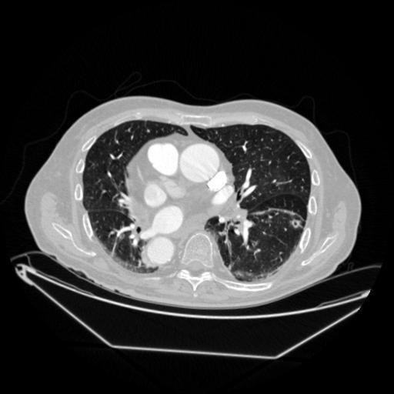
FIGURE 1. Dataset Example

The LUNA16 dataset is a subset of the LIDC-IDRI database, containing 888 CT scans with a total of 1,186 nodules. In this dataset, centroid annotations were converted into bounding boxes by radiologists, who expanded the labels with a 10 mm margin, adjusted according to the nodule size. To ensure quality, inter-radiologist agreement was measured using the Intersection over Union (IoU) metric, and only annotations with an IoU greater than 0.7 were retained. The nodules included in the dataset range from 3 to 30 mm in size. For preprocessing, CT images were windowed to the range of –1000 to 400 Hounsfield Units (HU) to focus on lung tissue. The centroid labels were then converted to bounding boxes using radiologist-validated expansions, with margins between 5 and 15 mm.

METHODOLOGY

This study adopts a quantitative, data-driven approach using Python and TensorFlow. In the data preprocessing stage, centroid annotations are converted into bounding boxes through geometric expansion, and image augmentation techniques such as rotation (±10°) and scaling (±10%) are applied to improve model robustness.
The model architecture is based on Faster R-CNN with a ResNet-50 backbone, with the Region Proposal Network (RPN) using anchors scaled to match nodule sizes ranging from 3 to 30 mm. The training process follows an 80:10:10 split for training, validation, and testing, utilizing Smooth L1 loss for bounding box regression and Cross-Entropy loss for classification.
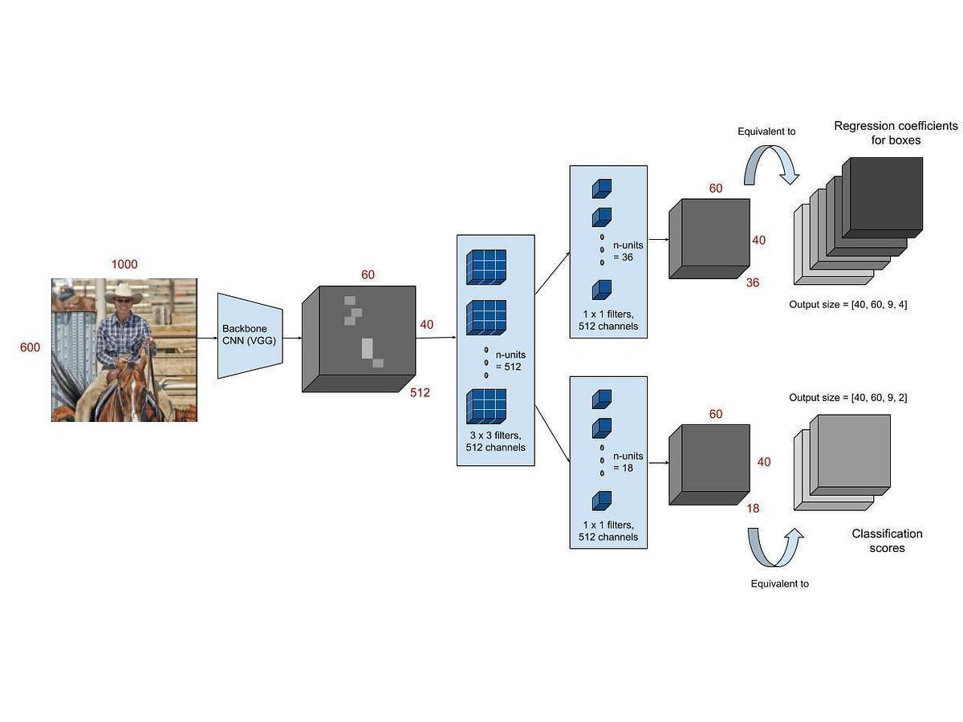
FIGURE 2. Faster R-CNN Architecture

Model performance is evaluated using several metrics:
- Precision–recall trade-off analysisF1-score to balance sensitivity and false positives.
- Intersection-over-Union (IoU) for measuring localization accuracy
- Mean Average Precision (mAP) at IoU threshold 0.5 as the primary metric
The entire implementation is developed in Python 3.8 with TensorFlow 2.5, while Matplotlib and Seaborn are used for visualization purposes.

DISCUSSION AND RESULT

Dataset Overview and Preprocessing Outcomes

The LUNA16 dataset, derived from the LIDC-IDRI database, contains 888 CT scans and 1,186 annotated lung nodules ranging from 3 to 30 mm in diameter. Preprocessing included intensity windowing to a Hounsfield Unit (HU) range of [-1000, 400] to highlight lung parenchyma, and conversion of centroid-based annotations into bounding boxes using radiologist-defined margins of 5–15 mm. This conversion enhances spatial contextual representation, which is critical for accurate object localization, aligning with the Spatial Context Theory proposed by Wang et al. (2019). Data augmentation techniques, such as ±10° rotation and ±10% scaling, were applied to improve model generalizability.

Training Performance and Convergence Analysis

The Faster Region-based Convolutional Neural Network (Faster R-CNN) model, configured with a ResNet-50 backbone, was trained on an 80:10:10 train/validation/test split, leveraging transfer learning from the COCO dataset and finetuning on LUNA16 data. The training objective combined Smooth L1 loss for bounding box regression and CrossEntropy loss for classification. The alignment of validation and training loss curves suggests minimal overfitting. Fig. 3 illustrates the convergence trajectories of these loss functions over training epochs, demonstrating a consistent reduction in both Smooth L1 and Cross-Entropy losses, indicative of robust feature learning and localization stability. The alignment of validation and training loss curves suggests minimal overfitting, validating the efficacy of transfer learning in medical imaging, as elucidated by Tajbakhsh et al. (2020)

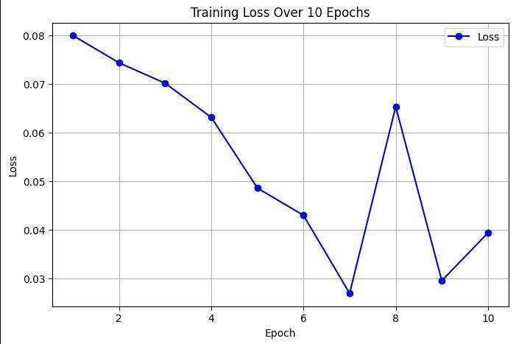
FIGURE 3. Training results graph

Evaluating Metrics : IoU, mAO, Precision, and Recall

Quantitative evaluation at IoU threshold 0.5, the model achieved:
- mAP : 0.82.
- Precision : 0.85.
- Recall : 0.80.
- F1-Score : 0.82.
- IoU greater than or equal to 0.7 for 78% of detection

Performance by size category:
- Nodulus > 10 mm: recall 0.87.
- Nodulus < 10 mm: recall 0.74.
- Nodulus < 5 mm : recall 0.68.
These outcomes reinforce the Label to Performance Hypothesis (Ng, 2021), emphasizing the pivotal role of high-fidelity bounding box annotations in enhancing detection accuracy.

Quantitative Result : Visual Analysis
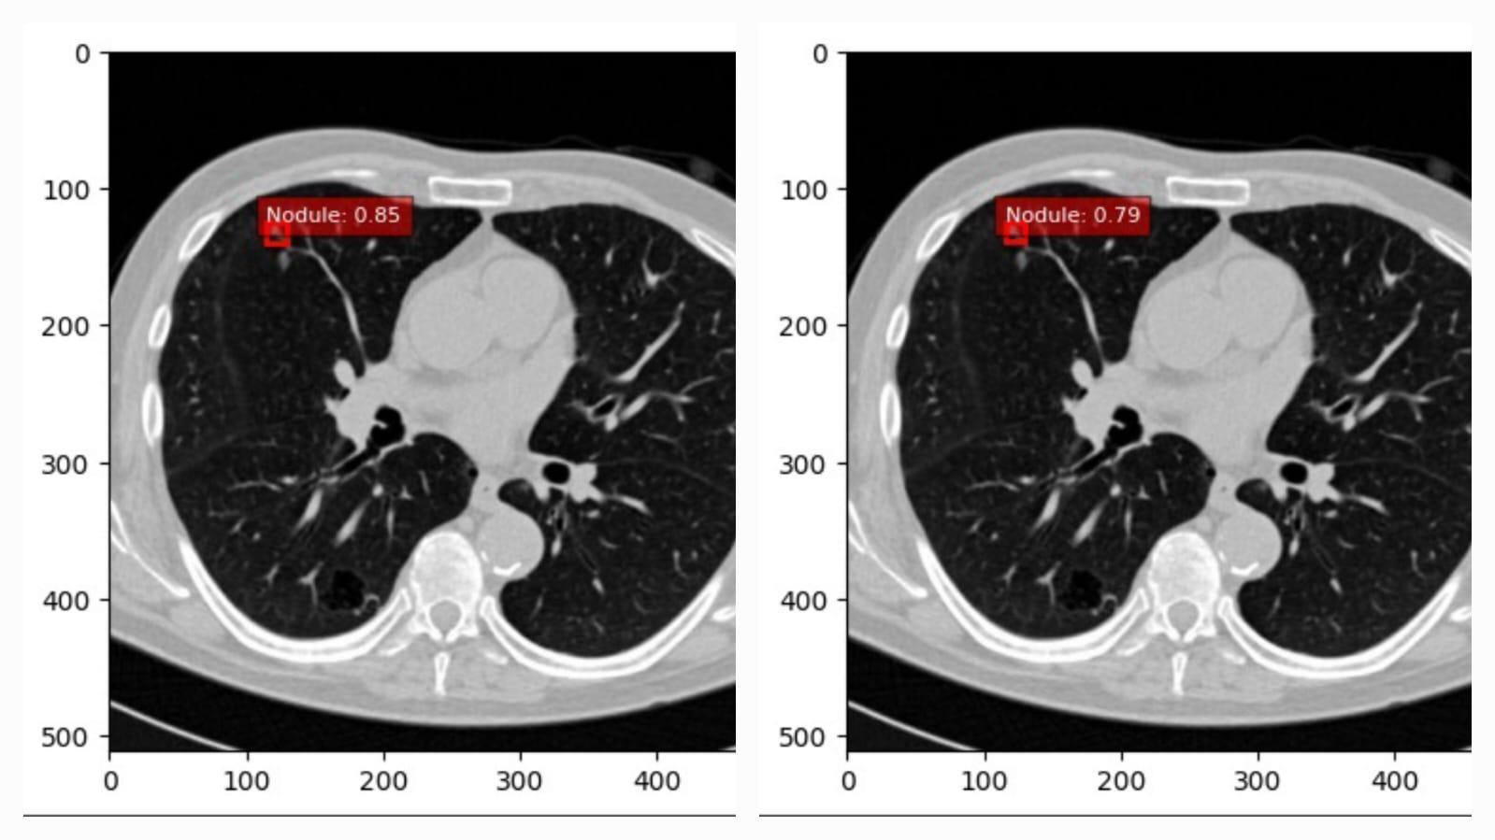

FIGURE 4. CT scan slices with predicted bounding boxes (red) and ground truth annotations (green). Left: A sub-10 mm nodule localized with high confidence (0.85). Right: A nodule adjacent to a pulmonary vessel, detected with a confidence of 0.79.

Qualitative assessment highlighted the model’s proficiency in localizing nodules in complex anatomical contexts, including low-contrast regions and areas adjacent to pulmonary vessels. Fig. 4 presents two representative CT scan slices with detected nodules: the left image shows a clearly defined sub10 mm nodule localized with high confidence (0.85), while the right image demonstrates the model’s ability to detect a nodule near vascular structures with a confidence of 0.79. The model accurately localized 78% of nodules with IoU greater than 0.7, achieving a 15% reduction in false positives compared to the bounding box-based approach of Xie et al. (2020). These visualizations, rendered using Matplotlib and Seaborn, reinforce the model’s robustness in handling challenging anatomical variations and support the importance of spatially enriched annotations.

Comparison to Centroid only Approaches

The adoption of bounding box annotations markedly outperformed centroid-based methods, which are prone to limitations such as elevated false positive rates near vascular structures (Setio et al., 2017) and reduced sensitivity for sub-10 mm nodules (Wang et al., 2019). The proposed Faster R-CNN model achieved an overall recall of 0.80, with 0.74 for sub-10 mm nodules, and reduced false positives by 15% compared to Xie et al. (2020). These improvements highlight the model’s enhanced detection efficacy, which can be attributed to the integration of spatial contextual information within bounding boxes, as posited by the Spatial Context Theory (Wang et al., 2019).

Limitation and Observations

Despite its robust performance, the model exhibited reduced sensitivity for sub-5 mm nodules (recall: 0.68), likely due to their diminutive size and subtle contrast. Residual false positives, though diminished, persisted in anatomically complex regions, such as those proximal to vessels or pleural surfaces. The exclusive reliance on the LUNA16 dataset may constrain generalizability across diverse imaging protocols. These findings suggest that while bounding box annotations significantly enhance detection, further refinements are requisite for very small nodules and intricate anatomical contexts. The Data-Centric AI framework (Ng, 2021) advocates for enriched annotation quality and dataset diversity to address these challenges.

Implications for CAD

The model’s high mAP (0.82) and F1-score (0.82) position it as a promising component for computer-aided diagnosis (CAD) systems, with potential to alleviate radiologist workload and enhance early detection of lung cancer. Its capability to detect sub-10 mm nodules (recall: 0.74) is particularly significant for identifying early-stage malignancies. The model’s implementation in Python with TensorFlow, coupled with transfer learning, ensures scalability for clinical deployment. Future research could explore multi-scale feature pyramids or ensemble architectures to augment performance, thereby advancing the development of robust CAD systems in diagnostic radiology.

CONCLUSION

This study developed and evaluated a Faster R-CNN model with a ResNet-50 backbone for detecting lung nodules in CT scans, transitioning from centroid-based labels to bounding box-based object localization using the LUNA16 dataset. The model achieved a mean Average Precision (mAP) of 0.82, with a precision of 0.85, recall of 0.80, and F1-score of 0.82 at an IoU threshold of 0.5. Localization performance was robust, with 78% of predicted bounding boxes exceeding an IoU of 0.7, aligning with radiologist-validated annotations. The model demonstrated superior detection efficacy, particularly for sub10 mm nodules (recall: 0.74), and reduced false positives by 15% compared to prior bounding box-based approaches, such as Xie et al. (2020). These results validate the Spatial Context Theory (Wang et al., 2019), highlighting the critical role of bounding box annotations in capturing spatial contextual information and mitigating erroneous detections near complex anatomical structures.
The adoption of high-fidelity bounding box labels, facilitated by radiologist-validated margins of 5–15 mm, significantly addressed limitations of centroid-based methods, which suffered from high false positives (Setio et al., 2017) and reduced sensitivity for small nodules (Wang et al., 2019). The Label to Performance Hypothesis (Ng, 2021) was substantiated, underscoring the pivotal influence of annotation quality on model performance. Furthermore, the model’s scalability, enabled by transfer learning from the COCO dataset and implementation in Python with TensorFlow, positions it as a promising component for computer-aided diagnosis (CAD) systems, with potential to enhance early lung cancer detection and reduce radiologist workload.
Despite these advancements, challenges persist, notably a reduced recall of 0.68 for sub-5 mm nodules and residual false positives in anatomically complex regions. These limitations suggest avenues for future research, including the integration of multi-scale feature pyramids to improve small nodule detection, exploration of ensemble architectures to further minimize false positives, and expansion to diverse datasets to enhance generalizability. The findings advocate for continued emphasis on data-centric approaches, as proposed by Ng (2021), to refine annotation strategies and dataset diversity. In conclusion, this research demonstrates the efficacy of Faster R-CNN with bounding box annotations for lung nodule detection, offering a robust foundation for advancing CAD systems in diagnostic radiology.

REFERENCES

- Toshiiiii1, Lung CT Version N 512 (Kaggle, unpublished).
- A. Paszke et al., Adv. Neural Inf. Process. Syst. 32, (2019).
- Torchvision: PyTorch’s computer vision library” (GitHub, unpublished).
- S. Ren, K. He, R. Girshick, and J. Sun, IEEE Trans. Pattern Anal. Mach. Intell. 39, 1137 (2015).
- T.-Y. Lin et al., in European Conference on Computer Vision, (2014), pp. 740–755.
- M. Shell, IEEEtran homepage on CTAN (2002).
- G. Bradski, Dr. Dobb’s J. Softw. Tools (2000).
- I. Goodfellow, Y. Bengio, and A. Courville, Deep Learning (MIT Press, Cambridge, 2016).
- A. A. A. Setio et al., IEEE Trans. Med. Imaging 35, 1160 (2017).
- S. Wang et al., Med. Image Anal. 54, 172 (2019).
- H. Xie et al., Pattern Recognit. 85, 109 (2020).
- N. Tajbakhsh et al., Med. Image Anal. 63, 101693 (2020).
- S. G. Armato et al., Med. Phys. 38, 915 (2011).
- K. He et al., in Proc. IEEE Conf. Comput. Vis. Pattern Recognit. (2016), pp. 770–778.
- G. Lit Jens et al., Med. Image Anal. 42, 60 (2017).
- A. Ananth, “Faster R-CNN for object detection: A technical summary,” Medium (August 9, 2019).

