Visualizing Clusters of Current Research Topics in Music Information Retrieval (MIR) within Computer Science Using a Document Co-citation Network Analysis
Wildan Suharso^{1,a)}, Lailatul Husniah^{1,b)}, Syaifuddin^{1,c)}, Hardianto Wibowo^{1,d)}, Wira Yudha Aji Pratama^{1,e)}, Hariyady Hariyady^{2,f)}, Didih Rizki Chandranegara^{3,g)}, Budi Darma Setiawan^{4,h)}
¹Faculty of Engineering, Universitas Muhammadiyah Malang, Malang, Indonesia.
²Faculty of Computing and Informatics, Universiti Malaysia Sabah, 88400 Kota Kinabalu, Malaysia.
³Faculty of Computer Science, Electronics and Telecommunication, AGH University of Science and Technology, Krakow, Poland.
⁴Faculty of Computer Science, Universitas Brawijaya, Malang, Indonesia.

^{a)} wsuharso@umm.ac.id
^{b)} Corresponding author: husniah@umm.ac.id
^{c)} saifuddin@umm.ac.id
^{d)} ardi@umm.ac.id
^{e)} wrydvac@webmail.umm.ac.id
^{f)} hariyady_di21@iluv.ums.edu.my
^{g)} didihrizki@agh.edu.pl
^{h)} s.budidarma@ub.ac.id
Abstract. This study provides a quantitative analysis of the Music Information Retrieval (MIR) research landscape, a rapidly evolving and interdisciplinary field. This research aims to identify key trends, thematic clusters, and the conceptual evolution of the field from 2021 to 2025. Data was systematically collected from the Scopus database by applying a "Music Information Retrieval" subject area filter for publications within the specified timeframe. This process yielded a total of 880 documents, which were then processed using VOSviewer. The methodology involved a co-occurrence analysis of terms extracted from the title and abstract fields of the publications. To ensure the relevance of the findings, a minimum occurrence threshold of 10 was applied, which filtered the initial 16,868 terms down to a refined set of 527 terms. The network visualization clearly revealed three distinct thematic clusters. The first cluster, representing classic methods and audio features, forms the historical foundation of MIR. The second cluster, focused on machine learning and high-level applications, highlights a significant paradigm shift driven by the adoption of deep learning. The third, an emerging cluster, points to the growing trend of multimodal and cross-modal content, where lyrics and other metadata are integrated with audio data. The findings confirm that MIR has evolved from a fragmented discipline into an interconnected research ecosystem. The strong conceptual links between the identified clusters demonstrate that traditional signal processing techniques continue to provide the basis for advanced, data-driven applications. This confirms that a holistic, context-aware approach is the most promising direction for future research in computational music understanding.

Introduction
Music Information Retrieval (MIR) is an interdisciplinary field that combines principles from computer science, digital signal processing, and musicology to develop methods and systems for understanding, organizing, and analyzing ever-growing collections of digital music [1,2]. With the digital revolution transforming how we access and consume music, the need for effective tools to manage this massive volume of data has become critically urgent. Key literature, as explained by Schedl et al. [3] and Burgoyne et al. [4], highlights how MIR has evolved from a niche academic pursuit into a field of great importance to industry. Comprehensive literature reviews, including one by Murthy & Koolagudi [5], underscore MIR's central role in modern applications ranging from sophisticated music recommendation systems to automatic genre classification and musical similarity detection. However, with its rapid growth, the research landscape has become increasingly diverse and fragmented, creating a challenge in understanding the underlying trends and the relationships between its elements.
The fundamental challenge in MIR lies in representing music itself, which requires the extraction of meaningful features from complex, raw audio signals. Historically, this was dominated by traditional feature extraction, where researchers manually designed algorithms to measure musical characteristics like melody or timbre. This approach is evident in early studies, such as those by Li & Ogihara [6] and Zampoglou & Malamos [7], which focused on signal analysis to solve MIR problems. These methods provided a strong theoretical foundation and remain relevant for specific tasks that require a detailed understanding of audio structure.
However, this paradigm has undergone a significant transformation with the widespread adoption of machine learning and deep learning [8]. A review by Gedizlioglu & Erol [9] highlights the shift to methods capable of learning and extracting automatic features directly from data, without the need for extensive manual intervention. This transformation has revolutionized how researchers approach the core problem of musical data representation, dramatically expanding the scope of the field. Deep learning methods, such as Convolutional Neural Networks (CNNs), can now identify patterns that are too complex for traditional features to detect.
In addition to its core methodological evolution, the MIR literature showcases a rich diversity in its application domains [10,11,12]. Researchers now employ a wide array of computational techniques, including clustering algorithms, as shown in Suharso et al. [13], and advanced audio fingerprinting methods presented by Grosche et al. [14]. These approaches are applied to a broad spectrum of practical problems. We see this in the development of intelligent recommendation systems discussed by Chen [15], as well as highly specialized analyses of specific musical genres, such as the study of rock and metal by Szczepański & Szyca [16] or traditional Indian music [17]. The application of audio features to real-world scenarios like crowdfunding success also highlights this diversity. This variety, also highlighted by Wibowo et al. [18], proves that the field continues to evolve to address new, complex challenges.
Given this rich diversity and fragmented nature, a systematic analysis is necessary to identify the main patterns and evolutionary trends in MIR. Therefore, this study aims to perform a topic-relatedness analysis in the field of MIR within computer science using 880 publications exported from Scopus in RIS format. The analysis stages will involve the process to map the relationships between topics. First, the publication data will be carefully processed to extract and normalize keywords. Next, will be used to build a network map based on a co-occurrence analysis of keywords, showing how often two terms appear together. Subsequently, the resulting visualization will be grouped into thematic clusters based on their proximity. Finally, these maps and clusters will be interpreted to reveal the core structure of the research and identify future directions in the MIR field.

research methods
This study adopts a bibliometric approach to analyze and visualize the research landscape of Music Information Retrieval (MIR). This method was chosen for its ability to provide a quantitative and objective overview of a field's structure, evolution, and trends on a large scale, which cannot be achieved through a qualitative literature review alone. The entire process is divided into three main stages: data collection, bibliometric analysis, and visualization.

Data Collection

The primary research data was collected from the internationally reputable database, Scopus. Scopus was selected for its extensive coverage of scientific publications in the field of computer science. The search strategy was systematically designed using a combination of keywords relevant to the MIR topic. The search query focused on the titles, abstracts, and keywords of publications. The results were then limited to articles within the computer science discipline to ensure topical relevance. From this process, a total of 880 publications were identified and exported in RIS format. The RIS format was chosen for its compatibility with bibliometric software and its ability to store rich metadata, including titles, authors, abstracts, keywords, and citation information, all of which are crucial for the subsequent analysis.
Data Analysis and Visualization

The bibliometric analysis was conducted using the VOSviewer software, a tool specifically designed for mapping networks and visualizing bibliometric data. The analysis process in VOSviewer proceeds through several structured stages.
- Data Pre-processing: This stage is crucial for ensuring the quality of the results. The exported RIS data is first imported into VOSviewer. During this process, VOSviewer identifies and normalizes different keyword variations, merging identical terms (e.g., "machine learning" and "machine-learning") to avoid duplication. Irrelevant words (stop words) are also removed to maintain the focus of the analysis.
- Co-occurrence Analysis: Once the data is clean, a co-occurrence analysis is performed. This method identifies how often two keywords, extracted from the titles and abstracts, appear together within the same document. A high degree of co-occurrence indicates a strong conceptual link between the two terms. This analysis forms the primary basis for constructing the network map.
- Network Map Construction and Clustering: Based on the co-occurrence matrix, VOSviewer automatically builds a network map. This map consists of nodes representing keywords or topics and links representing co-occurrence relationships. The more frequently two keywords appear together, the stronger the link between their nodes. Subsequently, the software uses a modularity algorithm to identify thematic clusters or groups of keywords that are closely related. Each cluster typically represents a major sub-field of research within MIR.
- Visual Interpretation: The final stage involves interpreting the generated network map and clusters. This visual analysis allows the researcher to identify dominant topics, emerging research trends, and potential research gaps. The size of a node and the number of links connected to it provide clues about a topic's popularity and centrality. In this way, the study can provide a clear and structured overview of the complex MIR research landscape.

results and discussion

Data Collection
The primary research data was collected from the internationally reputable database, Scopus. Scopus was selected for its extensive coverage of scientific publications in the field of computer science. The search strategy was systematically designed using a combination of keywords relevant to the MIR topic. A query was performed using the keyword "Music Information Retrieval", and the results were then filtered to the computer science discipline to ensure topical relevance. To focus on the most recent trends, the search was further refined to include publications from the years 2021 to 2025. No additional filters were applied to the article type, as the majority of relevant documents were identified as conference papers and articles as shown in Table 1.

Table 1. Document Type
No | Jenis | Jumlah
1 | Conference Paper | 659
2 | Article | 204
3 | Book Chapter | 10
4 | Review | 5
5 | Data Paper | 1
6 | Other | 1
 | Total | 880

No other filters such as those for keywords, language, author, or country were applied. The only filter used was the Subject area, specifically set to 'Music Information Retrieval.'.

Data Analysis and Visualization
The first process is the normalization of keywords and phrases. Often, keywords with the same meaning are written with different variations (for example, 'music information retrieval' and 'MIR,' or 'deep learning' and 'deep-learning'). VOSviewer automatically detects some of these variations and merges them. However, to ensure consistency, manual checking is required. This step is very important because if these variations are not combined, they will be treated as separate entities in the co-occurrence analysis, which can distort the network map and obscure the actual thematic relationships. Additionally, at this stage, the removal of irrelevant words (stop words) is also carried out, such as articles ('the,' 'a,' 'an'), prepositions ('of,' 'in,' 'for'), and conjunctions ('and,' 'or'). This removal ensures that the analysis only focuses on substantive terms that have conceptual meaning, thereby concentrating the visualization on the dominant research topics.
The subsequent phase involves Co-occurrence Analysis, wherein the data that has been exported in RIS format is employed for conducting a co-occurrence analysis. This process involves mapping the text data from the title and abstract fields. The software then calculates the occurrences of each term within the documents. To ensure the quality of the analysis, a minimum occurrence threshold of 10 was applied for each term. This filtering process reduced the initial total of 16,868 terms down to 527 terms that met the criteria.
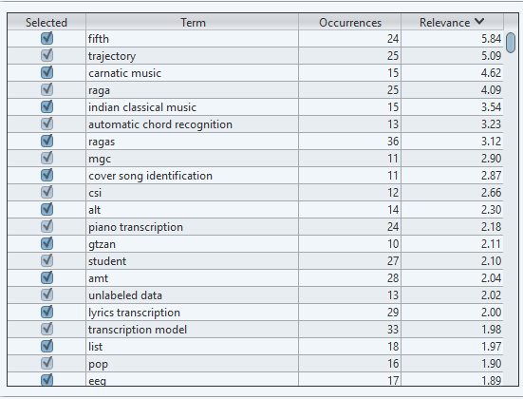
Figure 1. Relevance Scores

In Figure 1, no filtering is done at all because one of the focuses of this study is to find terms that influence each other, so overall we conduct mapping on the terms produced which is shown in Figure 2.
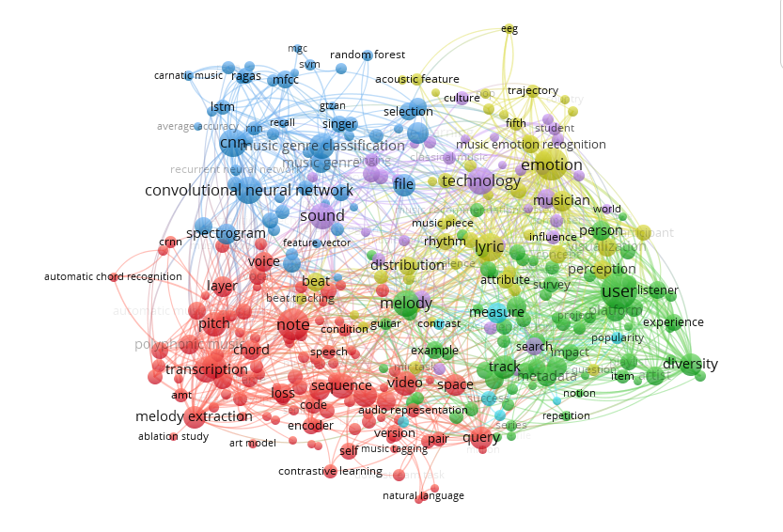
Figure 2. Network Visualization

Figure 2 shows the relationship between 316 terms with the highest values divided into 6 clusters indicated by different colors. The total content of each cluster is shown in Table 2.

Table 2. Clustering Result
No | Cluster | Terms
1 | 1 (Red) | 104
2 | 2 (Green) | 72
3 | 3 (Dark Blue) | 52
4 | 4 (Yellow) | 47
5 | 5 (Purple) | 34
6 | 6 (Light Blue) | 7
 | Total | 316

Table 2 shows that the most terms are in cluster 1, while the fewest terms are in cluster 6. The color indicates the cluster, so if we note that the size of the nodes indicates a higher value, then the larger the size of the node, the higher the relevance value. In general, cluster 1 includes terms such as note, melody, signal, tagging, raw audio, and timbre. Cluster 2 includes key, graph, harmony, item, key, user, track, and metadata. Cluster 3 includes genre classification, CNN, frequency, domain, mfcc, music classification, music genre, and knn. Cluster 4 includes emotion, lyrics, rhythm, and beat. Cluster 5 includes technology, sound, search, and influence. Cluster 6 includes popularity, success, and dataset. Thus, we can conclude that the clusters correspond to specific groups, for example, cluster 5 is more supportive of MIR, while cluster 6 is more related to topics or methods that are outside the main focus. In clusters 1 and 2, the focus is more broadly on Music Information Retrieval (MIR), not limited to data and methods, but also directed towards the features of the music itself. Cluster 3 points to the main topic of MIR, which is music data features, including techniques for music data analysis and the methods used.

conclusion
This research successfully maps the landscape of Music Information Retrieval (MIR) research from 2021 to 2025 through a bibliometric approach. Using data from the Scopus database, this study identifies key trends, thematic clusters, and conceptual evolution in the field of MIR. This analysis clearly shows that the field of MIR is experiencing a significant paradigm shift. In general, it produces 6 clusters that indicate groups according to the depth of the topics discussed, with various interconnections among terms showing the relationship of research topics occurring from 2021 to 2025.

References
- M. A. Casey et al., "Content-Based Music Information Retrieval: Current Directions and Future Challenges," IEEE Signal Process. Mag. 25, 117 (2008).
- B. Pardo, Commun. ACM 49, 28 (2006).
- M. Schedl, E. Gómez, and J. Urbano, Music Information Retrieval: Recent Developments and Applications (Springer, Berlin, 2014).
- J. A. Burgoyne et al., "Music Information Retrieval," in Proceedings of the 2016 International Conference on Music Information Retrieval (ACM Press, New York, 2016), pp. 213–228.
- Y. V. S. Murthy and S. G. Koolagudi, ACM Comput. Surv. 51, 1 (2018).
- T. Li and M. Ogihara, IEEE Trans. Multimed. 8, 564 (2006).
- M. Zampoglou and A. G. Malamos, The New Rev. Hypermedia Multimed. 20, 189 (2014).
- V. Subramanian, "Music Information Retrieval using Deep Learning Techniques," Indian Sci. J. Res. Eng. Manage. (2024).
- C. Gedizlioglu and K. Erol, "High-Level Musical Content-Based Music Information Retrieval: A State-of-the-Art Review," Int. J. Sci. Technol. Res. 6, 86 (2020).
- F. Simonetta, S. Ntalampiras, and F. Avanzini, "Multimodal Music Information Processing and Retrieval: Survey and Future Challenges," in Proceedings of the 2019 IEEE International Symposium on Multimedia (IEEE, San Diego, 2019), pp. 10–18.
- M. Müller, "New Developments in Music Information Retrieval," J. Acoust. Soc. Am. 129, 11 (2011).
- Y. Ding, "Evolution and Emerging Trends in Musical Information Retrieval: A Comprehensive Review and Future Prospects," Highlights in Sci. Eng. Technol. (2024).
- W. Suharso et al., "Music Features Pada Bidang Ilmu Komputer Menggunakan Modularity Clustering," Just IT: J. Sist. Inf. Teknol. Inf. Komputer (2022).
- P. Grosche, M. Müller, and J. Serrà, "Audio Content-based Music Retrieval," Trans. Int. Soc. Music Inf. Retr. ?, 157 (2012).
- Y. Chen, "Music Recommendation Systems in Music Information Retrieval: Leveraging Machine Learning and Data Mining Techniques," J. Artif. Intell. Res. (2024).
- S. J. Szczepański and M. S. Szyca, Music Information Retrieval. A case study of MIR in modern rock and metal music (Publisher, 2014).
- V. Subramanian, "Music Information Retrieval using Deep Learning Techniques," Indian Sci. J. Res. Eng. Manage. (2024).
- H. Wibowo et al., Makara J. Technol. 25, 5 (2021).

.

