The Effect of Crank Positions of Quarter-elliptical Chainring on Cycling Performance
Muhammad Syafiq^{1,a)}, Ardi Lesmawanto^{2,b)}, and Shinn-Liang Chang^{1,c)}
¹Department of Power Mechanical Engineering, National Formosa University, Huwei Township, Taiwan
²Mechanical Engineering Department, University of Muhammadiyah Malang, Malang City, Indonesia

^{b)} Corresponding author: ardilesmawanto@umm.ac.id
^{a)} D1275101@nfu.edu.tw
^{c)} changsl@nfu.edu.tw
Abstract. Extensive research has been conducted on the enhancement of bicycle performance, specifically focusing on the design of noncircular chainrings. This study aims to assess the effectiveness of quarter-elliptical chainrings at a specific crank installation position, in comparison to standard circular chainrings with the same number of teeth. In this study, the maximum radius of the quarter-elliptical chainring is placed at two different position angles relative to the crank, 45 degrees and 135 degrees. Pedaling tests were conducted using a bicycle mounted on a cycling platform. Four amateur cyclists participated in this study. Each participant pedaled at a constant cadence rate of 90 rpm. Pedaling torque data were obtained using left and right crank power meters at a rate of 200 Hz, and the rear wheel speed data were obtained using a rotary encoder at the same data rate (200 Hz). The knee joint moment was then calculated using a five-bar link analysis. The results show that pedaling at a constant cadence using the tested noncircular chainring with the maximum chairing radius positioned at 135 degrees produced the highest peak torque, knee joint moment, and rear wheel speed. The maximum chainring radius positioned at 45 degrees resulted in the lowest knee joint moment but generated a higher rear wheel speed compared to the circular chainring. This result implies that installing quarter-elliptical chainrings at a specific position can be utilized for different purposes: to reduce the knee joint moment or to maximize the cycling speed.
Keywords: Noncircular, quarter-elliptical chainrings, bicycle performance.

INTRODUCTION
These studies investigating the effect of the two-crank arrangement in a quarter-elliptical combination chainring on bicycle have shown inconclusive findings. Cycling efficiency and performance are significantly influenced by the mechanical design of the bicycle's drivetrain components, particularly the chainring and sprocket. Recent advancements in chainring design have introduced non-circular geometries that aim to optimize the transfer of leg power by modifying the chainring configuration according to the pedaling cycle's power and dead zones [1].
The non-circular chainrings approach is not entirely new; however, the design and optimization of these components are continually developing to maximize pedaling efficiency [1]. Lesmawanto et al. [2] proposed introduced the two-ellipse combination technique to make a bi-ellipse chairing. It can be observed that the designed bi-ellipse sprocket prototype at specific position toward the crank, the asymmetric pedaling torque is reduced. Malfait et al. [3] implemented an optimization technique to enhance the dynamic component of joint loading. This was performed by creating a suitable non-round chainring with certain characteristics such as ovality, shape, crank orientation angle, and cadence. The findings indicate substantial difference in the cornering characteristics and maximum values for both dynamic joint moments and dynamic joint forces as compared to the circular lead, resulting in a noticeable enhancement in crank performance. Non-circular chainrings might potentially enhance sprint cycling performance. Hintzy et al. [4] conducted a study comparing an Osymetric non-circular chainring with a circular chainring. Twenty sprint cyclists are recruited to undertake an 8-second sprint. It can be observed that during sprint cycling The Osymetric non-circular chainring considerably increase crank power by 4.3%, in contrast with a circular chainring. O’Hara [5] performed a study comparing the duration it required to execute and the physiological reactions when riding using a conventional circular chainring vs a Rotor Q-Ring noncircular chainring. The study showed that the implementation of Rotor Q-Rings led to a noticeable augmentation in the mean power output (26.7 watts) and mean speed (0.7 kph) throughout the 1 km time trial.
In addition, related to the effect of crank position,.[6] conducted an analysis of the mechanical efficiency of cycling using a novel pedal-crank prototype. The length of the pedal crank changed in relation to the angle of the crank, being at its maximum during the period of pushing and at its minimum during the phase of recovery. This modification was anticipated to decrease the energy required for cycling. The torque generated by the leg that is pushing increased, while the counter-torque produced by the opposing leg dropped. Effectively, power generation may be increased by placing the pedaling action during the power phase on the area of the chainring with a greater circumference [7]. A noncircular chainring could be achieved using the bi-ellipse chainring design previously proposed [8]. In this design, the bigger radius is positioned in the power phase region based on the peak power ratio between the right and left legs. Nevertheless, the construction of the chainring lacks flexibility in terms of its intended shape, since it is restricted to only two typical elliptical curves that may be merged to create the chainring.
Within this research investigation, we explored the use of a quarter elliptical combination chainring by placing the maximum radius at specific crank installation positions and analyzing its cycling performance. The theoretical design approach, the experimental tests, and the comparison results to the traditional circular chainring are discussed in this paper.

METHODS

CHAINRING GENERATION
Several approaches were used to investigate cycling performance, by modifying the chainring shape it is possible to maximize average crank power during pedaling [9]. Shi et al. [10] proposed a generalized version of a link function which is a log-hyperbolic function and a log-quadratic function to enhance the accuracy of Gielis equation and to optimized the curve shape. Moreover, theoretical approaches for generating geometry have been extensively conducted by researchers.
Non-circular chainring can be modeled using various methods. Due to the customizable nature of the chainring ellipse form, the conventional equation for an ellipse cannot be used to build the chainring pitch curve. A comprehensive formulation of the elliptical shape, capable of producing an appropriate curvature, is essential for customizing the design of the chainring. In this study, the chainring is made based on the equation proposed by Lesmawanto et al. [1] by employing equations (1)-(3) as follows:

(1)
where is the pitch of the chainring, a is the major axis length, b is the minor axis length, and N is teeth number of the chainring.

(2)
where is the super-ellipse equation, is the eccentric angle, and m is the shape factor.

Then, the calculation of the distance (L) between two pitch coordinates can be determined using equation (3) as follows:

(3)
where n is the number of the chainring pitch, x and y are the coordinate of the chainring pitch.

Firstly, the pitch size and the required number of teeth (N) must meet the criteria stated in equation (1). Next, in designing a non-circular chainring, the initial parameters must determine, such as length of major axis (a), minor axis (b), and shape factor (m) of each curve. Furthermore, the super-ellipse curve is determined by equation (2). Then, calculate the pitch length (L) using equation (3). However, several initial conditions must be considered before proceeding with further calculations.
Due to the presence of eccentricity in the ellipse design, the conventional ellipse equation is not suitable for constructing the chainring pitch curve in this approach. The equation for a generalized ellipse curve, capable of accommodating a wider range of curvatures than a regular ellipse, is required for designing the chainring. Consequently, the super-ellipse equation is applied [1]. In this study, the chainring was developed using two customized combination ellipses, as shown in FIGURE 1. In this approach, each ellipse curve can be modified according to the desired coordinate point.

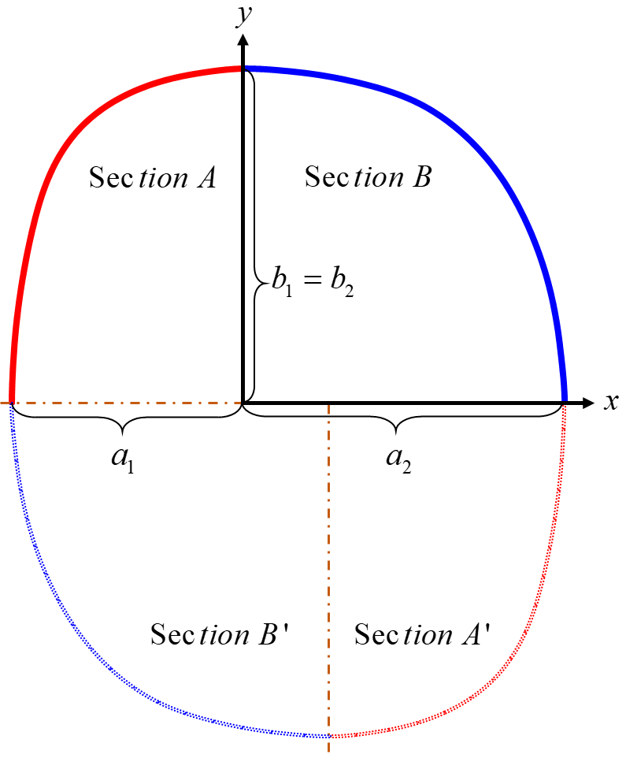
FIGURE 1 Conceptual design of chainring combination model

where ​and ​ are the major and minor axes in section A, respectively. Meanwhile, and are the major and minor axes in section B. Furthermore, sections A' and B' are the result of rotational transformation along y axis and x axis of the two generated curves to form a complete ellipse for the desired design chainring, as shown in FIGURE 1.

THE DESIGN EXAMPLE SPROCKET
This study is a continuation of Lesmawanto's paper on the novel quarter elliptical combinations chainring - the design and verification [1]. The design input variables , ​ , , N, (shape factor at section A), and ​ (shape factor at section B) are 50 mm, 68 mm, 70 mm, 34, 0.7, and 0.8, respectively. In this case, the major axis against the right crank is selected using two variants, namely placement at major axis (position 1) and (position 2), as shown in FIGURE 2

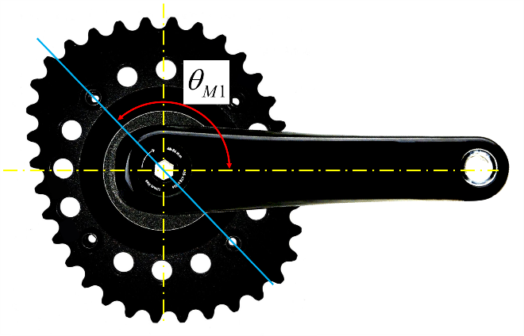 | 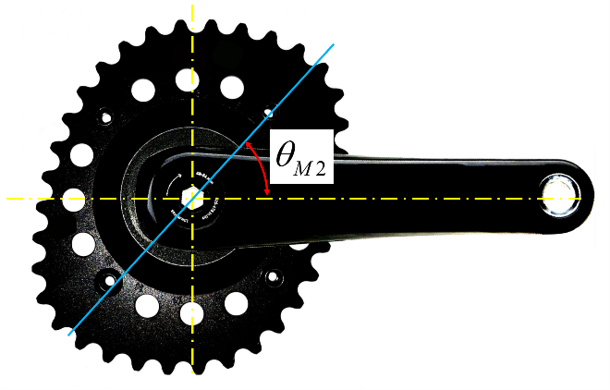
(a) | (b)
FIGURE 2 (a) Assembled chainring at position 1, (b) Assembled chainring at position 2

INSTRUMENTATION
In this study, a mountain bike is used to examine the effect of crank positions of quarter-elliptical chainring, as illustrated in FIGURE 3. A Wahoo bike trainer (Wahoo KICKR '14) was connected to the rear chainring to enable participants to cycle with a natural pedaling motion. Additionally, the output power data were captured from the right and left cranks at 0.005 seconds intervals. The front and rear wheels chainring's output rotational speed was measured using two rotary encoders (HCTec ES50-360, 200 Hz, Taiwan). The bicycle was also equipped with specially designed strain gauge on both right and right crank (LabView based Crank-Meter V.1.0, Chief SI, 200 Hz, Taiwan).

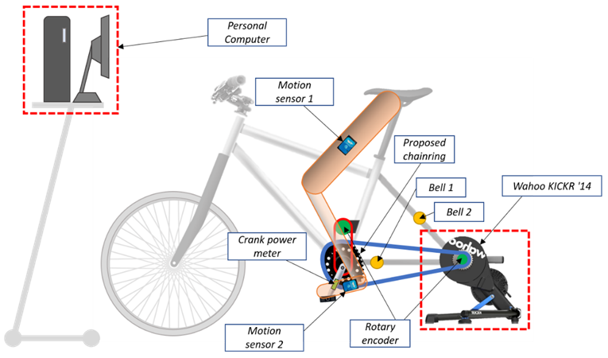

FIGURE 3. Schematic diagram of experimental setup

Four participant amateur cyclists took part in this experiment. To help the cyclist maintain a consistent pedaling speed, the auditory method was employed by installing Metronome Software (Tempo Perfect V.5.00, NHC) to play on the computer during the experiment. To enabling it to accurately measure the angular motion of the thigh during riding, motion sensor (WIT Motion) were mounted on the cyclist’s thigh. Furthermore, bell systems were mounted on the crank and the rear wheel (see FIGURE 3). Thus, the bell on the rear wheel generated a sound that could be synchronized with the metronome. Data were recorded for 30 seconds, capturing 45 pedaling rotations per test. Each experiment was repeated three times, and the data from each pedaling rotation were averaged and analyzed using commercial statistical software. FIGURE 4 shows the flowchart of the experiment to obtain the data parameter.
In this study, the three chainrings (traditional circular chainring, position 1, and position 2) were compared by analyzing the left and right pedaling torque, rear wheel speed, and peak knee joint moment. This experiment investigates the changes in the speed of the rear wheel that can be obtained by cycling with various chainrings. The aim is to identify the chainring that produces the maximum crank torque. In this study, a cadence of 90 RPM was selected, as this cadence range is known to generate maximum power in cycling.[11].

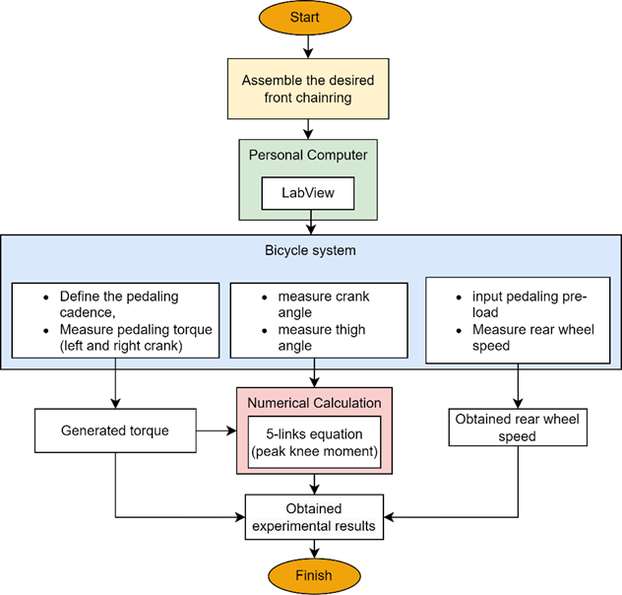
FIGURE 4. Flow chart of the experiment

RESULTS AND DISCUSSION
The decrease in power at the knee joint in the sagittal plane, along with the rise in power at the hip joint in the sagittal plane, may indicate a transition from focusing on performance optimizing to enhancing power generation. The change in sagittal knee and hip joint power are influenced by cadence rather than workload. with higher cadences causing more pronounced differences in downward crank angular velocity between circular and non-circular chainrings [12]. The leg mechanism is represented as a closed loop of a five-link mechanism, with the frame serving as the fixed link and three joints representing the human leg: the hip joint, knee joint, and ankle joint, respectively, as shown in FIGURE 5

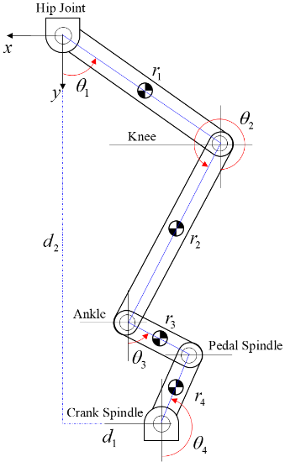

FIGURE 5. Five-links mechanism represent leg mechanism during pedalling [13]

TABLE 1 displays the empirical findings of the three chainrings that were specifically constructed. The rear wheel speed outputs of the traditional circular chainring, design example position 1, and design example position 2 are 145.65 RPM, 149.69 RPM, and 147.22 RPM, respectively. It is reveals that the effect of position 1 and position 2 result in an average increase in rear-wheel speed of 2.77% and 1.07%, respectively, compared to traditional circular chainring during pedaling at 90 RPM cadence.
Next, the peak torque and knee moment produced show significant differences. The maximum peak torque generated using the traditional circular chainring, Position 1, and Position 2 are 32.12 Nm, 35.69 Nm, and 30.07 Nm, respectively. Moreover, this is a very significant difference. Position 1 showing differences of 11.10% higher than the circular chainring and Position 2 showing differences of 6.84% lower than the circular chainring.
A similar pattern can be found in the peak knee moment. The peak knee moments produced by the circular, position 1, and position 2 chainrings are 82.96 Nm, 87.34 Nm, and 70.62 Nm, respectively. Position 1 has a peak knee percentage that is 5.01% higher than the circular chainring, while Position 2 has a peak knee percentage that is 17.49% lower than the circular chainring. From the experimental results, it can be seen that using the design example chainring in positions 1 and 2 can reduce the peak knee moment during pedaling. However, the lowest peak knee moment is observed when using position 2.

TABLE 1. Comparison results between three chainrings at the same pedalling cadence (90 rpm)
Chainring Type | Rear Wheel Speed (rpm) | Diff (%) | Peak Torque (Nm) | Diff (%) | Peak Knee Moment (Nm) | Diff (%)
Circular | 145.65 |  | 32.12 |  | 82.96
Position 1 | 149.69 | ↑2.77 | 35.69 | ↑11.10 | 87.34 | ↑5.01
Position 2 | 147.22 | ↑1.07 | 30.07 | ↓6.84 | 70.62 | ↓17.49

CONCLUSIONS
This study investigates the effect of crank positions of quarter-elliptical chainring on cycling performance by generating two sections of super-ellipse curves. First, the super-ellipse equation is utilized as the primary equation to generate a quarter-elliptical shape. Next, the design variables are substituted to the equation to generate the desired curve of section A and section B. Third, Position 1 and Position 2 are configured by adjusting the major axis in the power phase area and reducing the minor axis length in the dead zone.
Verification results are obtained by comparing the outcomes of the cycling experiment conducted with two proposed positions to the conventional circular chainring. The experimental results indicated that pedaling with the two positions is more efficient and results in a reduced peak knee moment while maintaining the same number of teeth.
Future research could explore additional applications of the proposed method, which has the potential to facilitate the development of various chainring designs. This includes aspects like analyzing human movement and optimizing power distribution and dead zones across different segments.

Acknowledgments
This research is supported financially by the National Science and Technology Council – Taiwan (Grant number NSTC 112-2221-E-150-041-MY3), and the chainring prototypes were supported by SAMOX company Taiwan.

References
- A. Lesmawanto and S.-L. Chang, "Novel quarter elliptical combinations chainring-the design and verification," Journal of Advanced Mechanical Design, Systems, and Manufacturing, vol. 17, no. 2, pp. JAMDSM0030-JAMDSM0030, 2023.
- Y. L. Hwang, J. K. Cheng, and V. T. Truong, "Computer-aided dynamic analysis and simulation of multibody manufacturing systems," Applied Mechanics and Materials, vol. 764, pp. 757-761, 2015.
- L. Malfait, G. Storme, and M. Derdeyn, "Why do appropriate noncircular chainrings yield more crank power compared to conventional circular systems during isokinetic pedalling," ed: Research Report 2012). Retrieved from http://www. noncircularchainring. be …, 2012.
- F. Hintzy, F. Grappe, and A. Belli, "Effects of a non-circular chainring on sprint performance during a cycle ergometer test," Journal of sports science & medicine, vol. 15, no. 2, p. 223, 2016.
- C. R. O'Hara, Effects of chainring design on performance in competitive cyclists. California Polytechnic State University, 2011.
- P. Zamparo, A. E. Minetti, and P. E. di Prampero, "Mechanical efficiency of cycling with a new developed pedal–crank," Journal of biomechanics, vol. 35, no. 10, pp. 1387-1398, 2002.
- J. W. Rankin and R. R. Neptune, "A theoretical analysis of an optimal chainring shape to maximize crank power during isokinetic pedaling," Journal of biomechanics, vol. 41, no. 7, pp. 1494-1502, 2008.
- A. Lesmawanto, K.-K. Hsu, and S.-L. Chang, "Computer-aided design of bi-ellipse bicycle sprocket," Journal of Advanced Mechanical Design, Systems, and Manufacturing, vol. 16, no. 1, pp. JAMDSM0008-JAMDSM0008, 2022.
- J. Gielis, "A generic geometric transformation that unifies a wide range of natural and abstract shapes," American journal of botany, vol. 90, no. 3, pp. 333-338, 2003.
- P. Shi, D. A. Ratkowsky, and J. Gielis, "The generalized Gielis geometric equation and its application," Symmetry, vol. 12, no. 4, p. 645, 2020.
- N. A. Turpin and B. Watier, "Cycling biomechanics and its relationship to performance," Applied Sciences, vol. 10, no. 12, p. 4112, 2020.
- G. Strutzenberger, T. Wunsch, J. Kroell, J. Dastl, and H. Schwameder, "Effect of chainring ovality on joint power during cycling at different workloads and cadences," Sports Biomechanics, vol. 13, no. 2, pp. 97-108, 2014.
- M. O. Ericson, "Mechanical muscular power output and work during ergometer cycling at different work loads and speeds," European journal of applied physiology and occupational physiology, vol. 57, pp. 382-387, 1988.

