Response Spectrum Analysis for Seismic and Buckling Performance of Straight and Tapered Wind Turbine Towers
Rizqinta Febiantari Purnama^{a)}, Alvian Iqbal Hanif Nasrullah^{b)}, and Daryono^{c)}
Department of Mechanical Engineering, University of Muhammadiyah Malang, Malang, Indonesia

^{b)} Corresponding author: alvianiq@umm.ac.id
^{a)} rizqintafebiantari10@gmail.com
^{c)} daryono@umm.ac.id
Abstract. The seismic and buckling performance of straight and tapered wind turbine towers was analyzed using the Response Spectrum Method and a finite element approach. Static and buckling analyses were conducted to evaluate deformations and stresses in both tower geometries. Results from the spectrum analysis show that straight towers experience significantly higher stress levels under seismic excitation, while tapered towers demonstrate superior resistance to dynamic loads, including earthquakes. The analysis utilized SS400 material with a mesh size of 200 mm, applying loads of 60 tons on the blade and 30 tons on the nacelle, with boundary conditions at the tower base. Earthquake data from El Centro was used for the response spectrum analysis. The findings highlight that the tapered tower configuration exhibits lower maximum stresses, contributing to enhanced structural integrity and resilience of wind turbine towers. These insights are crucial for improving wind turbine design and extending the operational lifespan of wind power plants.
Keywords: Wind turbines, earthquake loads, structure, buckling, spectrum analysis

INTRODUCTION
Indonesia's burgeoning electricity demand has compelled the government and society to explore alternative energy sources. Historically, coal has been the cornerstone of the nation's power generation [1]. Despite Indonesia's abundant non-renewable resources, including coal, the mineral remains the primary fuel for electricity production [2]. According to the Indonesian Ministry of Energy and Mineral Resources, the current rate of coal extraction could deplete reserves within the next 83 years. Moreover, low-quality coal, accounting for approximately 60% of Indonesia's reserves, further exacerbates the challenge [3]. To secure a sustainable energy future, Indonesia must capitalize on its renewable energy potential. Wind energy, in particular, offers a viable solution. By converting wind energy into electricity through wind turbines, the nation can reduce its reliance on fossil fuels and mitigate environmental impacts
Wind power plants, utilizing wind turbines to convert wind energy into electricity, represent a significant step towards renewable energy adoption [4]. Indonesia has embraced this potential, with the Sidrap wind farm in South Sulawesi serving as a prime example. Developed by PT UPC since 2012, this 75 MW facility comprises 30 turbines, each generating 2.5 MW in average 7 m/s wind speeds [5]. Constructed primarily from steel due to its strength, toughness, and corrosion resistance, wind turbine towers are critical components. However, their immense height exposes them to significant stresses, making them susceptible to buckling and cracking. Regular inspection and maintenance are crucial to ensure the long-term performance and safety of these structures. The Sidrap wind farm has contributed to Indonesia's renewable energy goals while generating economic benefits and reducing greenhouse gas emissions. As the country strives for a sustainable energy future, expanding wind power to other regions and implementing supportive policies will be essential.
A high-profile incident in Germany in 2022 underscored the critical issue of wind turbine tower buckling. A wind turbine tower collapsed due to buckling during peak operation, highlighting the significant structural challenges posed by these structures. Buckling, a structural failure mode characterized by wave-like deformation, occurred as a result of excessive loads induced by wind and rotational forces acting on a tower weakened by adverse weather conditions and material degradation [6]. To address the complexities of shell buckling, a previous worldwide study assessed computational expertise in this field. The research, conducted by [researchers/organization], attracted 29 submissions, with 66% of participants utilizing ABAQUS finite element software (versions 6.14-1, 6.17, and 2017-2022)
Existing methods for assessing wind turbine tower performance have limitations in capturing the complex dynamic behavior induced by various periodic loads. This research addresses this gap by employing the spectrum analysis method, which excels at identifying fluctuations associated with different frequencies and quantifying their energy contribution. By applying the spectrum analysis method to both seismic and buckling analysis, this study aims to enhance understanding of wind turbine tower response and develop strategies for preventing catastrophic failures.

METHODS

RESEARCH METHODS

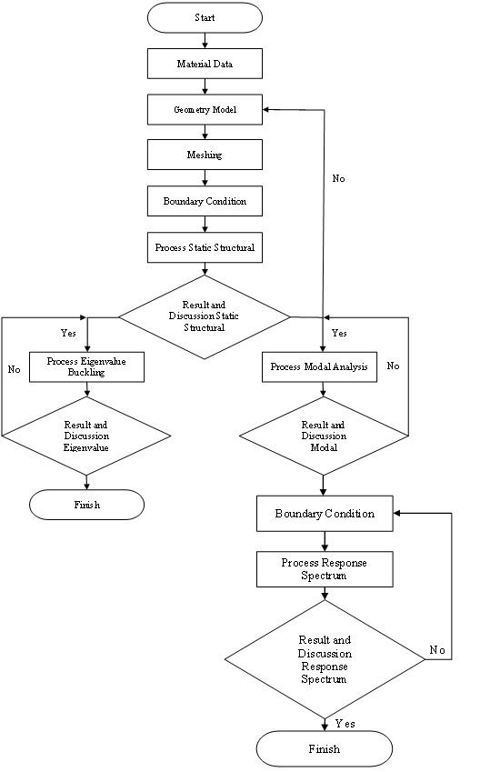
FIGURE 1. Flowchart response spectrum and buckling analysis

The flowchart of this research has shown in FIGURE 1. The wind tower was modeled using SS400 steel, a commonly used structural steel with properties outlined in TABLE 1. The selection of SS400 was based on its strength. A linear elastic material model was employed in the analysis, assuming consistent material properties throughout the tower.

TABLE 1. Material properties of wind tower
Material | SS400
Elasticity modulus | 215 GPa
Poisson’s ratio | 0,29
Yield strength | 245 Mpa
Tensile strength | 510 Mpa
Density | 7,9 g/cm³
Shear Modulus | 82 GPa
Damping Ratio | 1%
Material | SS400

The geometries used in this study were two wind turbine towers, one conical tapered tube and one straight tube, both modeled as surfaces using Ansys software. The geometries is shown in FIGURE 2 and FIGURE 3.

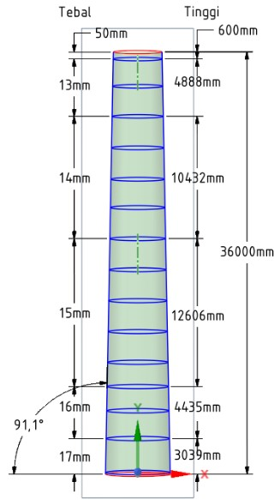
FIGURE 2. Tapered Geometry
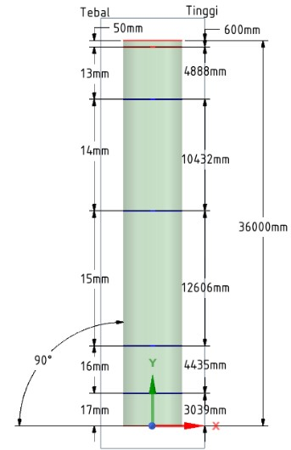
FIGURE 3. Straight Geometry

Meshing is a small element that results from the division of components. Meshing is also used as a numerical solution solver for the finite element method. The use of fine or small meshing on the geometry of the numerical results will be more accurate. In the wind turbine tower analysis using 200mm mesh quality. The mesh used is edge sizing and face mashing. The meshing used 2 types of mesh, namely edge sizing and face meshing as shown on FIGURE 4 to FIGURE 7.
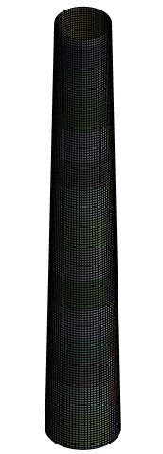
FIGURE 4. Face Meshing Tapered Geometry
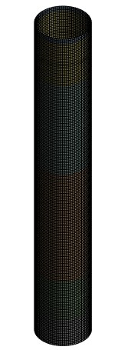
FIGURE 5. Face Meshing Straight Geometry
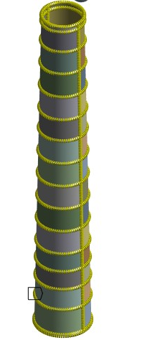
FIGURE 6. Edge Sizing Tapered Geometry
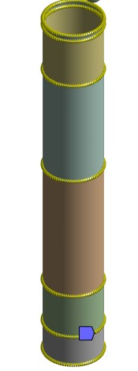
FIGURE 7. Edge Sizing Straight Geometry

Boundary conditions in static structures are given to provide restrictions on a movement by real conditions. Certain standards or regulations on boundary conditions are also to meet the requirements of the model during the simulation process. The load is located above the center of the top surface of the tower at a height of 1500 mm, the load nacelle is 1000 mm away from the center point of the top surface of the tower towards the rear and 2500 mm towards the front for the blade location from the center point of the top surface of the tower. In this wind turbine tower research, boundary conditions are given fixed support at the base position of the turbine tower. Blade and nacelle loading with blade mass 60 tonnes and nacelle 30 tonnes [7]. The boundary conditions is shown in FIGURE 8 and FIGURE 9.

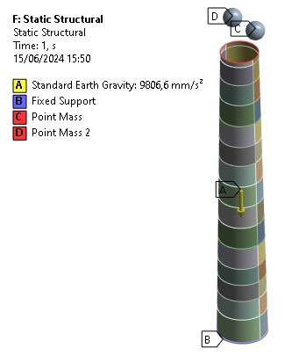
FIGURE 8. Static Structural Method Tapered Geometry

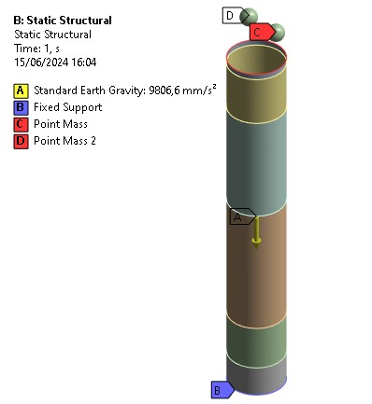
FIGURE 9. Static Structural Method Straight Geometry
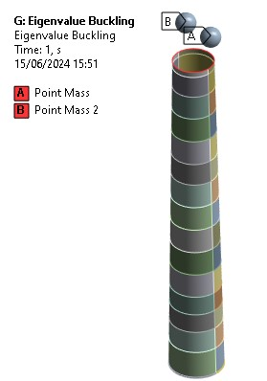
FIGURE 10. Eigenvalue Buckling Method Tapered Geometry
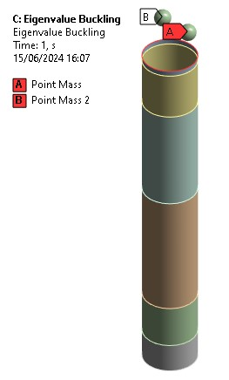
FIGURE 11. Eigenvalue Buckling Method Straight Geometry

The simulation results using the structural static method are then connected to the eigenvalue buckling method. Eigenvalue buckling is used to analyze structural failure in the form of buckling from blade and nacelle loading as shown in FIGURE 10 and FIGURE 11.

The eigenvalue buckling method is then linked to modal analysis. Modal analysis is used to avoid resonant vibrations or vibrate at a certain frequency and provide an overview of how the design can respond to various loads given. This method gives boundary conditions that aim to limit a movement according to real conditions. Standards and regulations of certain boundary conditions are also to fulfill the requirements of the simulation process as shown in FIGURE 12 and FIGURE 13.

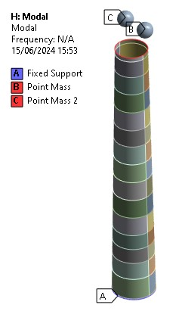
FIGURE 12. Modal Analysis Method Tapered Geometry
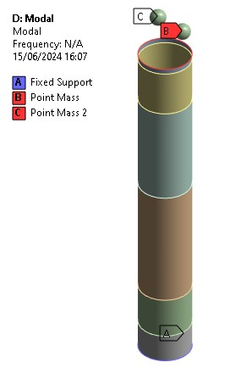
FIGURE 13. Modal Analysis Method Straight Geometry

After the modal method of analysis, it is then linked to the response spectrum method. Response spectrum aims to understand how structures behave under excitation of a certain frequency as critical information for the design and evaluation of structural resistance to dynamic loads and vibrations. Giving RS Acceleration as a load that uses earthquake data in longitudinal directions as shown in FIGURE 14 and FIGURE 15.

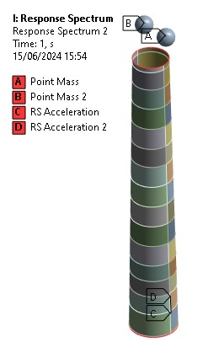
FIGURE 14. Response Spectrum Method Tapered Geometry
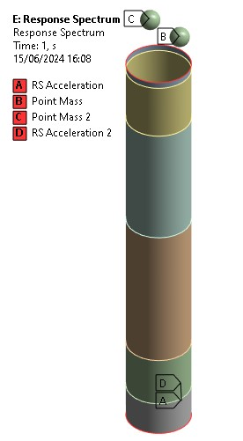
FIGURE 15. Response Spectrum Method Straight Geometry.

The table below is earthquake data including natural frequency (Hz) and Acceleration (mm/s2) used in the Response Spectrum method simulation process on RS acceleration. Earthquake data is data from Vibration data in El Centro shown in TABLE 2.
TABLE 2 Earthquake Data
No | Frequency (Hz) | Acceleration (mm/s²)
1 | 0,29903 | 840,28
2 | 0,50117 | 1158,4
3 | 0,7002 | 1540
4 | 0,89923 | 1893,5
5 | 1,1014 | 2155
6 | 1,3004 | 2322,3
7 | 1,4994 | 2461,3
8 | 1,6985 | 2539
9 | 1,9006 | 2451,9
10 | 2,0996 | 2414,2
11 | 2,2987 | 2706,3
12 | 2,5008 | 2923,1
13 | 2,6998 | 3172,8
14 | 2,8989 | 3363,7
15 | 3,101 | 3495,6
16 | 3,3001 | 3655,8
17 | 3,4991 | 3957,4
18 | 3,7012 | 4452,2
19 | 3,9003 | 4742
20 | 4,0993 | 4958,8
21 | 4,3014 | 5121,3
22 | 4,5004 | 5250,9
23 | 4,6995 | 5536
24 | 4,8985 | 5894,1
25 | 5,1007 | 6103,8
26 | 5,2997 | 6200,4
27 | 5,4987 | 6139,2
28 | 5,7009 | 6075,6
29 | 5,8999 | 5913
30 | 6,0989 | 5757,5
31 | 6,3011 | 5818,7
32 | 6,5001 | 5887,1
33 | 6,6991 | 5964,8
34 | 6,9013 | 6200,4
35 | 7,1003 | 6292,3
36 | 7,2993 | 6292,3
27 | 7,5015 | 6266,4
38 | 7,7005 | 6537,4
39 | 7,8995 | 6848,4
40 | 8,0986 | 6935,5
41 | 8,3007 | 7279,5
42 | 8,4997 | 7762,5
43 | 8,6988 | 8144,2
44 | 9,0999 | 8540,1
45 | 9,299 | 8646,1
46 | 9,5011 | 8474,1
47 | 9,7001 | 8184,3
48 | 9,8992 | 8191,3
49 | 10,101 | 8523,6
50 | 10,3 | 8877
51 | 10,499 | 9152,6
52 | 10,701 | 9334,1
53 | 10,9 | 9449,5
54 | 11,1 | 9597,9
55 | 11,299 | 9661,6
56 | 11,501 | 9597,9
57 | 11,7 | 9473,1
58 | 11,899 | 9383,5
59 | 12,101 | 9319,9
60 | 12,3 | 9216,3
61 | 12,499 | 9195,1
62 | 12,701 | 9279,9
63 | 12,9 | 9345,8
64 | 13,099 | 9319,9
65 | 13,301 | 9282,2
66 | 13,5 | 9449,5
67 | 13,699 | 9597,9
68 | 13,899 | 9491,9
69 | 14,101 | 9107,9
70 | 14,3 | 8773,3
71 | 14,499 | 8961,8
72 | 14,701 | 9364,7
73 | 14,9 | 9659,2
74 | 15,099 | 9600,3
75 | 15,301 | 9574,4
76 | 15,5 | 9397,7
77 | 15,699 | 9383,5
78 | 15,901 | 9131,4
79 | 16,1 | 9027,8
80 | 16,299 | 9025,4
81 | 16,501 | 9143,2
82 | 16,7 | 9256,3
83 | 16,899 | 9256,3
84 | 17,099 | 9206,8
85 | 17,301 | 9046,6
86 | 17,5 | 8877
87 | 17,699 | 8872,3
88 | 17,901 | 8900,5
89 | 18,1 | 8825,1

RESULTS AND DISCUSSION

STATIC STRUCTURE
Static structural analysis of the wind turbine tower to determine the effect on static loading from the mass load of the blade and wind turbine nacelle. The output is given in the static structural method such as total deformation, equivalent stress, and moment reaction. The simulation results provide important insights into the mechanical behavior of structures under static loading, such as stress distribution and deformation to assist in the design of efficient and safe structures [8]. It is important to understand the practical implications of the simulation results and perform design optimization where necessary.

Total Deformation
The total deformation analysis on the static structural wind turbine tower straight geometry gives the maximum deformation of 3.8826 mm. Then the tapered geometry gives the maximum deformation of 5.0778 mm. So it can be concluded that the tapered geometry has a larger deformation than the straight geometry as shown in FIGURE 16 and FIGURE 17.
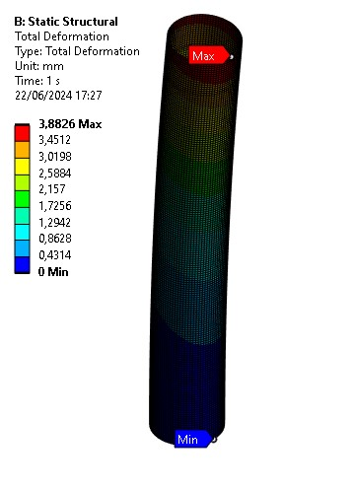
FIGURE 16. Total Deformation Static Structural Straight Geometry
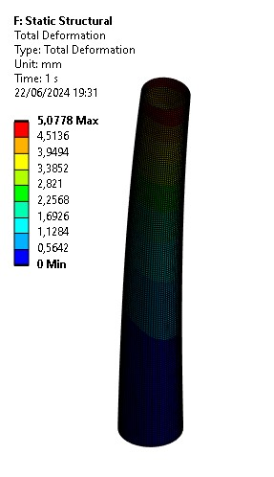
FIGURE 17. Total Deformation Static Structural Tapered Geometry

Equivalent Stress
The equivalent stress analysis on the structural static wind turbine tower of straight geometry gives a stress result of 9.1533 MPa. Then the tapered geometry gives a stress result of 12.443 MPa. So it can be concluded that the conical geometry is more affected by the stress than the straight geometry as shown in FIGURE 18 and FIGURE 19.

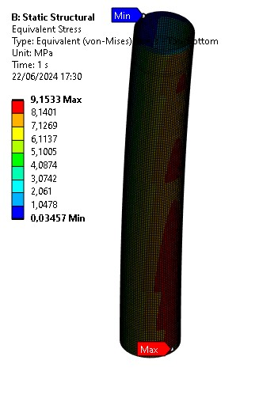
FIGURE 18 Equivalent Stress Static Structural Straight Geometry
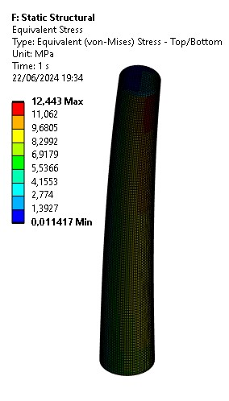
FIGURE 19. Equivalent Stress Static Structural Tapered Geometry

EIGENVALUE BUCKLING
Eigenvalue buckling analysis is used to determine the critical load at which the structure will buckle (failure due to compressive load) [9]. The simulation results provide insight into the critical loading factors and buckling modes that are important for reliable and safe design [10]. Eigenvalue buckling analysis also makes it possible to correct and identify potential stability problems before actual structural failure occurs [11]. The eigenvalue buckling analysis provides simulation results as presented in TABLE 3.

TABLE 3. Eigenvalue buckling analysis of wind turbine tower
Mode | Geometry Wind Tower Straight | Geometry Wind Tower Tapered
1 | 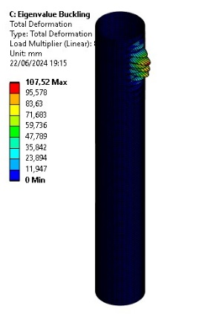  Load Multiplier: 87,216 | 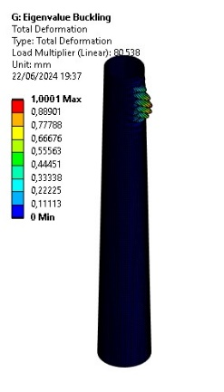  Load Multiplier: 80,538
2 | 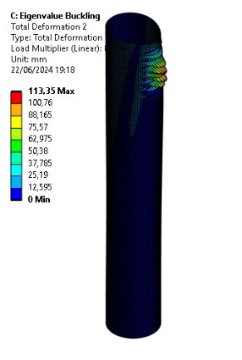  Load Multiplier: 87,584 | 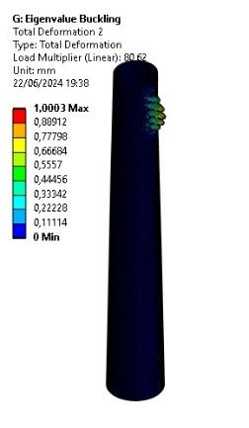  Load Multiplier: 80,62
3 | 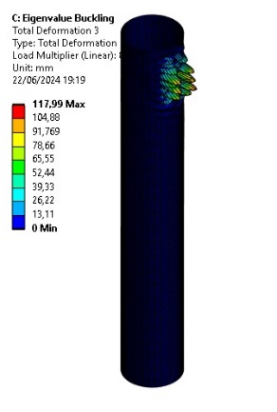  Load Multiplier: 88,787 | 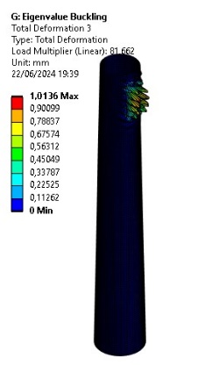  Load Multiplier: 81,662
4 | `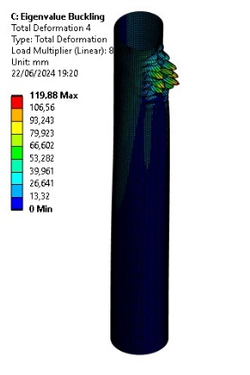  Load Multiplier: 88,988 | 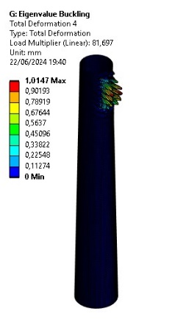  Load Multiplier: 81,697
5 | 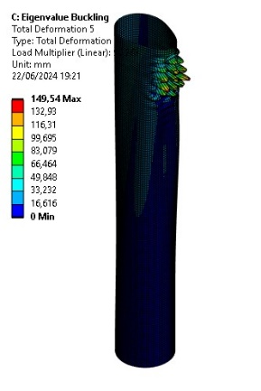  Load Multiplier: 90,262 | 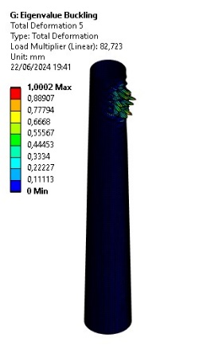  Load Multiplier: 82,723

MODAL ANALYSIS
The simulation results are influential for preventing resonance and for designing vibration-safe structures. Modal analysis is also to understand how the structure will behave at various frequencies and make design modifications where necessary for the structure to operate effectively and safely [12].
Modal analysis is used to determine the natural frequencies [13]. The result of the straight geometry gives the total deformation of the straight geometry of 2.6736 mm at a frequency of 1.5368 Hz. Then the tapered geometry gives the maximum total deformation of 2.672 mm at a frequency of 1.3928 Hz as shown in FIGURE 20 and FIGURE 21.
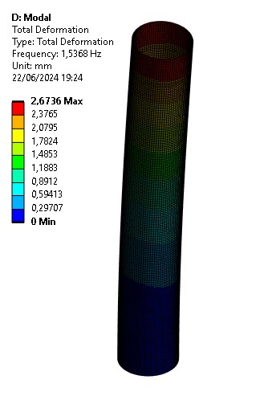
FIGURE 20. Total Deformation Modal Analysis Straight Geometry
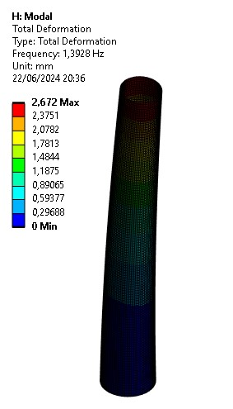
FIGURE 21. Total Deformation Modal Analysis Tapered Geometry

RESPONSE SPECTRUM
Response spectrum analysis is used to analyze the dynamic response of structures to earthquakes or other dynamic loads given in the form of response spectra [14]. The results of these simulations provide the basis for informative design decisions and corrective actions necessary to ensure the integrity and safety of the structure. Response spectrum analysis makes it possible to ensure that the structure meets safety and comfort standards and is capable of withstanding dynamic loads such as earthquakes, and to make design modifications where necessary to enable the structure to operate effectively and safely. The response spectrum analysis gives a maximum stress of 1.4291e-9 MPa in the straight geometry. The tapered geometry gives a maximum stress of 1.191e-11 MPa as shown in FIGURE 22 and FIGURE 23.
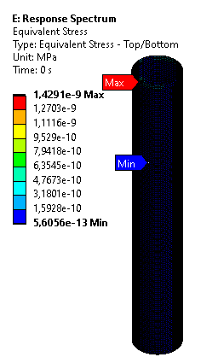
FIGURE 22. Equivalent Stress Response Spectrum Straight Geometry
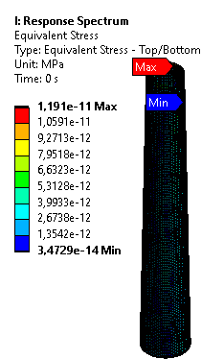
FIGURE 23. Equivalent Stress Response Spectrum Tapered Geometry

CONCLUSIONS
Geometry | Load Multiplier Eigenvalue Buckling | Response Spectrum Stress | Deformation Static Structural | Static Structural Stress
Straight | 87,216  87,584  88,787  88,988  90,262 | 1,429 X 10⁻⁹ Mpa | 3,8826 mm | 9,1533 MPa
Tapered | 80,538  80,62  81,662  81,697  82,723 | 1,191 X 10⁻¹¹ Mpa | 5,0778 mm | 12,443 MPa

This study investigated the buckling behavior of straight and conical wind turbine towers subjected to earthquake loads. The results demonstrate that the conical tower design exhibits superior resistance to buckling compared to its straight counterpart. The spectrum analysis method effectively captured the dynamic response of both tower configurations, revealing that the straight tower experiences significantly higher stress levels under seismic excitation. These findings strongly advocate for the adoption of tapered tower designs with larger or smaller angles and considering their geometric size to give the most optimized design result in regions prone to earthquakes to enhance structural integrity and safety in future research.

References
1. Simanjuntak, J.P., R.A.M. Napitupulu, and P. Lumbangaol, Rancangan Fasilitas Pembangkit Listrik Tenaga Sampah: Studi Kasus di Kota Medan Sumatera Utara. SPROCKET JOURNAL OF MECHANICAL ENGINEERING, 2022. 3(2): p. 84-93.
2. Adedoyin, F.F., et al., Energy policy simulation in times of crisis: Revisiting the impact of renewable and non-renewable energy production on environmental quality in Germany. Energy Reports, 2023. 9: p. 4749-4762.
3. Afin, A.P. and B.F.T. Kiono, Potensi energi batubara serta pemanfaatan dan teknologinya di indonesia tahun 2020–2050: gasifikasi batubara. Jurnal Energi Baru Dan Terbarukan, 2021. 2(2): p. 144-122.
4. Gusriani, N. and M. Yuhendri, Monitoring Pembangkit Listrik Tenaga Angin Menggunakan Arduino Berbasis GUI Matlab. JTEIN J. Tek. Elektro Indones, 2020. 1(2): p. 229-233.
5. Saleh, A.A., M. Ammar, and R. Andriyani, Transformasi Sosial Dan Lingkungan Melalui Energi Terbarukan: Studi Dampak PLTB Sidrap Di Sulawesi Selatan. TheJournalish: Social and Government, 2023. 4(5): p. 263-274.
6. Sadowski, A.J., et al., 8-MW wind turbine tower computational shell buckling benchmark. Part 1: An international ‘round-robin’ exercise. Engineering Failure Analysis, 2023. 148: p. 107124.
7. Zhao, Z., et al., Wind Turbine Tower Failure Modes under Seismic and Wind Loads. Journal of Performance of Constructed Facilities, 2019. 33(2): p. 04019015.
8. Strouboulis, T., I. Babuška, and K. Copps, The design and analysis of the Generalized Finite Element Method. Computer Methods in Applied Mechanics and Engineering, 2000. 181(1): p. 43-69.
9. Jiang, D., C.M. Landis, and S. Kyriakides, Effects of tension/compression asymmetry on the buckling and recovery of NiTi tubes under axial compression. International Journal of Solids and Structures, 2016. 100-101: p. 41-53.
10. American Society of Civil, E. Minimum design loads and associated criteria for buildings and other structures. 2013. American Society of Civil Engineers.
11. Xu, W., External pressure buckling analysis of large pressure vessels. Journal of Physics: Conference Series, 2019. 1303(1): p. 012019.
12. Ramesha, C.M., et al., Modal analysis and harmonic response analysis of a crankshaft. International Journal of Emerging Technology and Advanced Engineering, 2015. 5(6): p. 323-327.
13. Mekalke, G.C. and A.V. Sutar, Modal analysis of cantilever beam for various cases and its analytical and FEA analysis. International journal of engineering technology, management and applied sciences, 2016. 4(2): p. 60-66.
14. Hassani, H., Singular spectrum analysis: methodology and comparison. Journal of Data Science, 2007. 5: p. 239-257.

