The Effect of Using Catalytic Converter Varied Models of Wood Charcoal Briquettes with Physics Activation
Syamsuri^{1,a)}, Evi Yuliawati^{2,b)}, and Marita Nilam Kusuma^{3,c)}
¹Department of Mechanical Engineering, ITATS, Surabaya, Indonesia
²Department of Industrial Engineering, ITATS, Surabaya, Indonesia
³Department of Environmental Engineering, ITATS, Surabaya, Indonesia

^{a)} Corresponding author: syamsuri@itats.ac.id
^{b)} eviyulia103@itats.ac.id
^{c)} marita.kusuma.mk@gmail.com
Abstract. Vehicle exhaust is the most significant cause of air pollution, and technological developments in various fields, especially in the field of transportation, have increased the number of vehicles of different types and brands. One solution to reduce air pollution due to vehicle exhaust emissions is a catalytic converter. The commonly used catalytic converter is the metal type, which has a high price, long manufacturing time, and low adsorption ability compared to activated carbon or briquettes. So, this study was conducted to reduce vehicle exhaust emissions using a catalytic converter of wood charcoal briquettes with variations of solid cylinders and hole cylinders. In this research, physical activation was used by heating the briquettes up to 400 0C. In this study, researchers used the method of idle engine rotation 2000 rpm and Supra X 125 motorcycle. This test uses a gas analyzer and dyno test. The study found a significant reduction in the exhaust emission levels of Carbon Monoxide (CO) and Hydrocarbons (HC) using catalytic converters with bore cylinder variations compared to solid cylinder variations. This study produced CO exhaust gas of 0.96% in the hole cylinder, 1.47% in the concrete cylinder, and 1.87% in the standard exhaust. HC exhaust emissions are 341 ppm for bore cylinders, 601 ppm for solid cylinders, and 1894 ppm for stock exhaust. The conclusion of this study is that the use of catalytic converter briquettes can reduce vehicle exhaust emissions. Regarding engine performance, power and torque are almost identical for solids and holes.
Keywords: Catalytic converter, briquettes, emissions, motorbike

INTRODUCTION
The higher the concentration of carbon dioxide emitted by humans, the more dangerous it will even cause death. CO is colorless, odorless, and highly toxic, so it is sometimes referred to as silent killer.Impact of CO on health: The ability of CO gas to come into contact with Hb is 240 times higher than the ability of CO gas to increase O2, so it is a gas that is harmful to the body. If the level of carbon dioxide (HbCO) in the blood is high enough, headache (HbCO 10 percent), shortness of breath (HbCO 20 percent), impaired research and difficulty concentrating (HbCO 30 percent), loss of consciousness and coma (HbCO) may occur. happen. (40-50%), and if it continues it can lead to death. Chronic exposure can cause nerve damage, stroke, heart attack, and death of the baby in the womb. High levels of CO in the blood can be caused by smoking habits and vehicle exhaust. CO gas is also a gas in indoor air that can cause construction-related illness with symptoms such as headaches, nausea, and vomiting [1].
Carbon monoxide (CO) is a colorless, odorless, flammable, and highly toxic gas. This is mainly due to the incomplete combustion of carbon monoxide and carbon monoxide-containing compounds. To meet the quality standards of CO emissions in exhaust gases, it is necessary to modify combustion engines and develop exhaust gas combustion reactors. Because the concentration of pollutants at the time of combustion is lower, the replacement of gasoline with fuel is an implementation of exhaust gas innovation by adding glass wool, activated carbon, water or other materials that are adsorbent or absorbent. Activated carbon is charcoal whose physical and chemical properties have been modified through activation treatment with chemical activators and high-temperature heating, thereby increasing the adsorption capacity and surface area of particles and improving charcoal performance [2].
Therefore, research was carried out to determine engine performance and exhaust emissions from the motorcycle is installed a converter catalytic with wood charcoal briquettes in the form of solid cylinders and hollow cylinders that have previously been done on the briquettes physically activated.

GASOLINE MOTOR
Gasoline-fueled motorcycles (spark plug ignition type) are one type of internal combustion engine that can convert heat energy from fuel into mechanical energy in the form of shaft power when the crankshaft rotates. The spark released by the spark plug burns fuel along with air in the combustion chamber (internal combustion engine), produces combustion gas and produces heat energy. Gasoline bikes are divided into two types based on their operating cycle: 2-stroke gasoline bikes and 4-stroke gasoline bikes. A two-stroke gasoline engine is a gasoline engine that requires two piston strokes and one crankshaft rotation to produce power (work). While a four-stroke gasoline engine is a gasoline engine that requires four piston strokes and two crankshaft rotations to produce power (effort) [3].

WORKING PRINCIPLE OF GASOLINE MOTOR
A simple explanation of the principle of a gasoline bike is that a mixture of air and gasoline is sucked into the cylinder from the carburetor, compressed by the reciprocating motion of the pistons, and burned to obtain thermal energy. When the piston moves up and down in the cylinder and gets high pressure due to combustion, the force acting on the piston pushes it down. The piston rod and crankshaft convert vertical motion into rotational motion. The piston drives the piston rod, which rotates the crankshaft. It is also important to remove residual combustion gases and ensure a suitable air-gasoline mixture. The piston moves periodically and can perform certain tasks as shown in FIGURE 1.
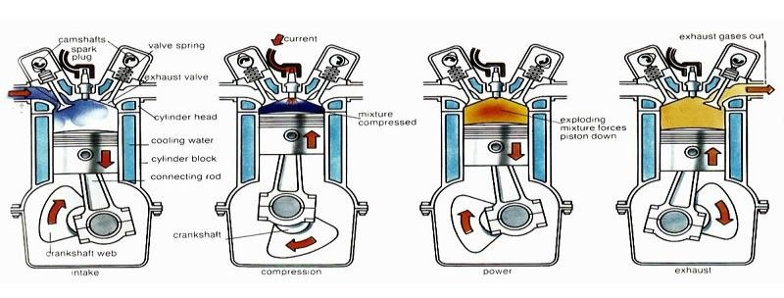
FIGURE 1. How a four-stroke gasoline motor works

EXHAUST EMISSIONS
Vehicle exhaust gases are the residual results of fuel combustion in the vehicle engine and are removed through the engine exhaust system. In contrast, the combustion process involves a chemical reaction between oxygen in the air and hydrocarbon compounds in the air fuel. After the reaction is complete, the rest of the combustion results in the form of exhaust gas containing carbon dioxide (CO2), water vapor (H2O), oxygen (O2), and nitrogen (N2). In fact, combustion in vehicle engines is not always complete, the exhaust gas contains harmful compounds such as carbon dioxide (CO), hydrocarbons (HC), nitrogen oxides (NOx), and particulates. In addition, the combustion of lead- and sulfur-containing fuels in motorcycle engines produces exhaust gases containing sulfur dioxide (SO2) and heavy metals (Pb) [4].
Generally, the exhaust gas composition of gasoline-fueled vehicles is 71% N2, gasoline-fueled motorcycles can also emit small amounts of sulfur dioxide (SO2), displayed in following FIGURE 2.
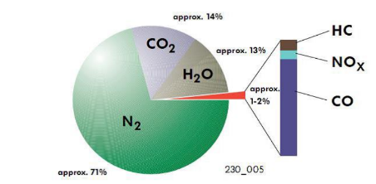
FIGURE 2. Exhaust Gas Composition of Gasoline Motor

CATALYCTIC CONVERTER
Catalytic converters in the exhaust line convert exhaust gases containing toxic chemicals such as HC, CO, and NOx into harmless chemicals. Catalytic materials that can be used as catalysts include metals and metal oxides such as platinum, plutonium, palladium, copper, vanadium, cobalt iron, nickel, mangan, and chromium [1].
The principle of catalytic reduction in chemical reactions is to increase the activity of NO molecules such as nickel and copper in CO (without O2 that can cause oxidation), thus forming N2 and CO2. NO reacts with CO to recover metal molecules such as iron, nickel, and copper, which can be used as reduction catalysts [5].
Many studies have investigated physical, technical, and chemical to reduce pollutants from exhaust gas emissions [6]. One of the most effective ways to reduce pollution is to use catalytic converters [7]. The purpose of this study is to determine the effect of the use of catalytic converters with varying models of wood charcoal briquettes that are given physical activation to reduce exhaust emissions in motor vehicles.

METHODS

FLOW CHART
Research flowchart is shown in following FIGURE 3.

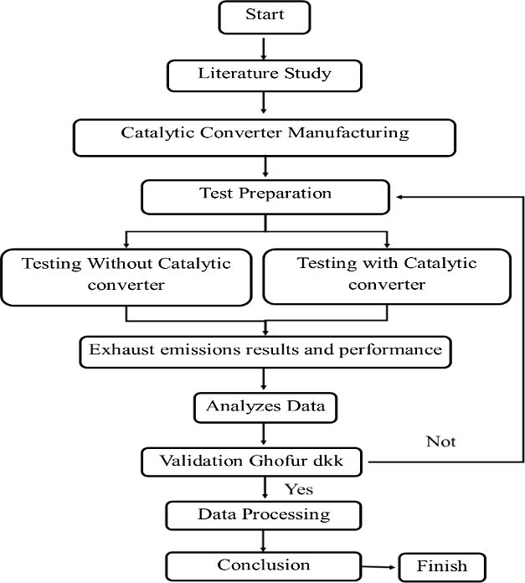
FIGURE 3. Flow Chart

EXHAUST EMISSION TESTING STEPS
The steps in the testing process can be detailed as follows:
Testing without catalytic converter. Start the test with the machine at working temperature, which is 60°C, Start the engine at 2000 rpm idle revolution, Turn on the blower, Insert the probe sensor into the exhaust gas pipe 30 cm deep and wait until the value read on the gas analyzer stabilizes, Take exhaust gas data by recording data on the paper provided, After data retrieval is complete, remove the probe sensor from the exhaust gas pipe, then recalibrate the gas analyzer and finally, turn off the engine of the test vehicle.
After the first test is completed, the second test is carried out in the following way: After the temperature has cooled, start removing the connection between the exhaust with the chasing catalytic converter by removing the spring that hooks between the two connections. Then plug in the catalytic converter and reconnect the springs to reconnect. Make sure the connection is tight and does not leak, Once the catalytic converter is properly installed, the motorcycle engine is restarted and the test is repeated according to the first test, Repeat the test according to the number of variants of the catalytic converter, and the last the data has been obtained.

DYNOTEST
Dynotest Testing Steps: Start the motorcycle then let it sit for a while to reach working temperature, The program is in run mode where the program is ready, Operate the motor in 3rd gear, then turn the gas motor to 8,000 rpm engine speed (the rear tire must rotate continuously). When reaching 8,000 rpm engine speed, wait for the code from the person operating the start button, When the start button has been pressed, the motorcyclist must open the maximum throttle until the engine shows its maximum capability (RPM MAX). Knob; Start pressed indicates that the process on the computer performs the process of disabling graphics, so pressing the start button should coincide with the driver opening the throttle. After the motorcycle reaches its maximum capability, immediately the start button is pressed again. Then on the computer monitor can be seen the results in the form of graphs and tables and finally, Then, save the data retrieval results.
Once the testing process is complete, the next steps are:
  - Return engine speed at idle speed, then turn off the engine.
  - Turn off the blower when not in use.
  - Turn off all electronic devices used at the time of testing.
  - Disconnecting the RPM sensor cable on the coil.
  - Remove the tiedown from the motorcycle.
  - Lower the motorcycle from the dynotest engine.

DESIGN
This experimental study investigated the effects of using catalytic converters, solid cylinders and hole cylinders on reducing motorcycle exhaust emissions. In this study, the physical activation method was used, where briquettes in the form of granules were heated first for 1 hour at a heating temperature of 400 ⁰C. This treatment is intended to obtain the outer surface of the briquettes to form wide pores so that it is easy to capture CO and HC exhaust gases when passing through them. Emission and performance tests performed on the 2007 Honda Supra X 12. The dimension of the design and its variation are shown in FIGURE 4 and 5.

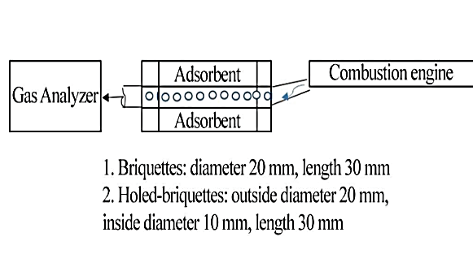
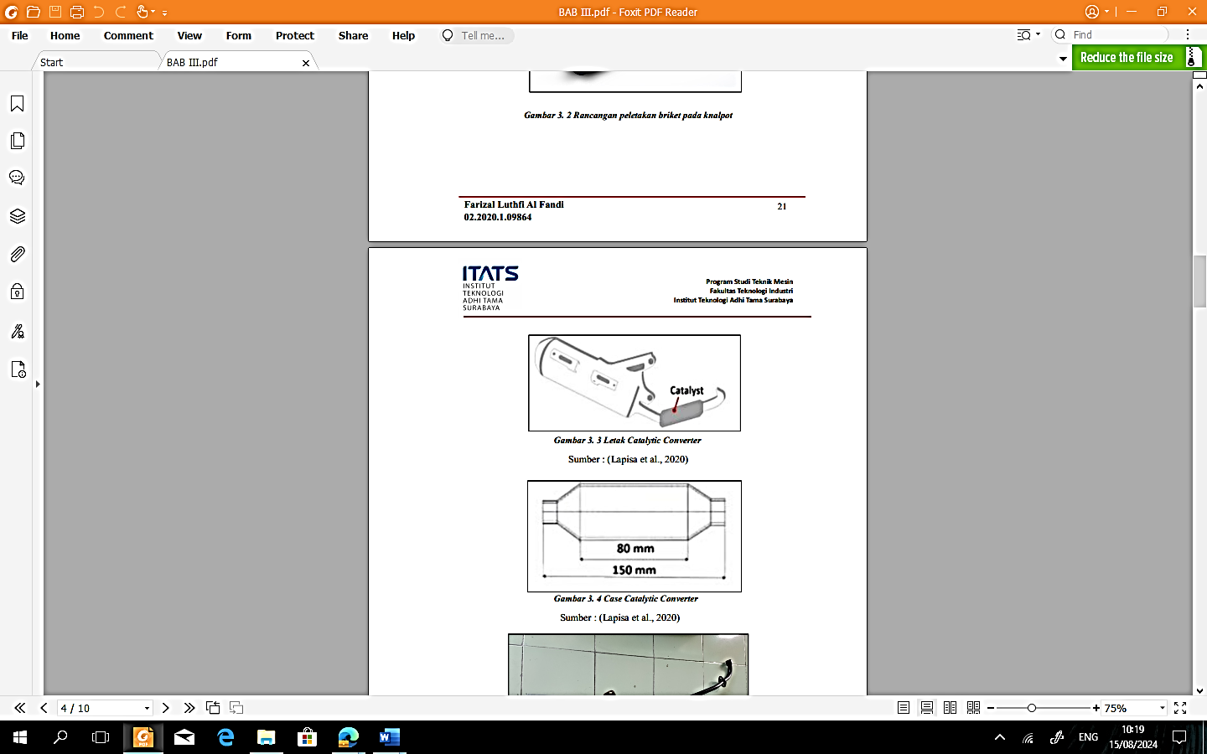
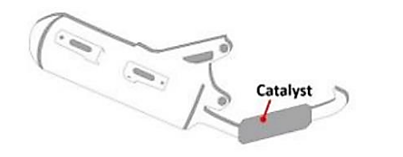

FIGURE 4. Position and dimensions

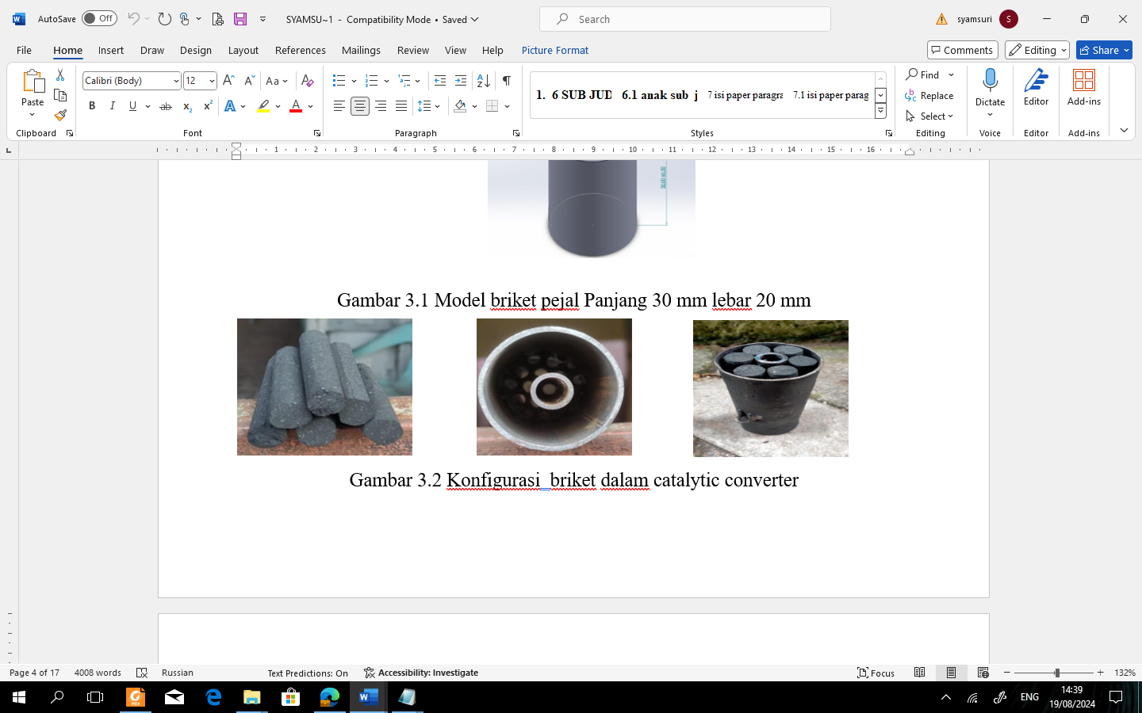
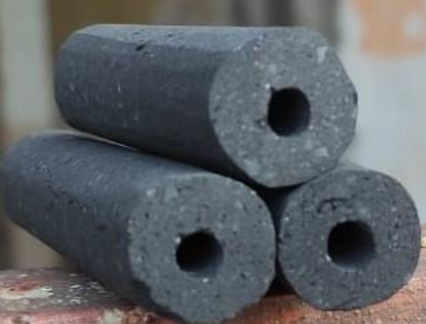

- solid cylinder (b) hole cylinder
FIGURE.5. Variation of research models

RESULTS AND DISCUSSION

VALIDATION
The results of the exhaust emission validation from the Charisma Motor and Supra X 125 Motor are:

TABLE 1. Validation

No | Vehicle Type | CO
1 | Ghofur et al 2023 (Kharisma) [9] | 1,57%
2 | Current research (Supra X 125) | 1,87%

TABLE 1. above is a validation table of research conducted by [9] with current research. In the table it can be seen that for CO gas, research with Charisma vehicles in 2005 CO gas emissions amounted to 1.57% while the current study with Supra X 125 vehicles in 2007 produced CO exhaust gas of 1.87% in general, the difference from the study was as large as $\frac{1,57-1,87}{1,57} x 100 or 19,10 \%.$This difference is due to differences in the frequency of motorcycle use and is also influenced by motorcycle maintenance.

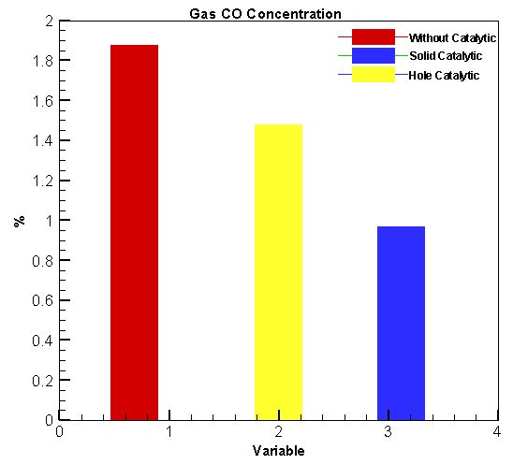
EFFECT OF EXHAUST WITHOUT CATALYTIC CONVERTER, WITH SOLID CYLINDRICAL CATALYTIC CONVERTER AND HOLE CYLINDER CATALYTIC CONVERTER ON CO EMISSIONS

FIGURE 6. Comparison of CO gas between exhausts without catalytic Converter, with Solid Cylindrical Catalytic Converter and Hole Cylindrical Catalytic Converter.

FIGURE 6. is the ratio of CO gas between without catalytic converter, with solid cylinder catalytic converter and hole cylinder catalytic converter. Seen in the figure, the hole cylindrical catalytic converter produced lower emissions by 0.96% and in this study the difference between the solid cylinder catalytic converter type and the hole cylinder catalytic converter has a difference $\frac{1,47-0,96}{1,47} x 100 or 34,6\%$. This is because the hole cylinder catalytic converter has a lower flow compared to the solid cylinder catalytic converter because there are parts that are not hollow. So that with a lower flow speed, the exhaust gas hitting the hole cylinder catalytic converter can absorb emissions at the top and inside the hole. This is in accordance with research conducted by [9] .

EFFECT OF EXHAUST WITHOUT CATALYTIC CONVERTER, WITH SOLID CYLINDER CATALYTIC CONVERTER AND HOLE CYLINDER CATALYTIC CONVERTER AGAINTS HC EMISSIONS
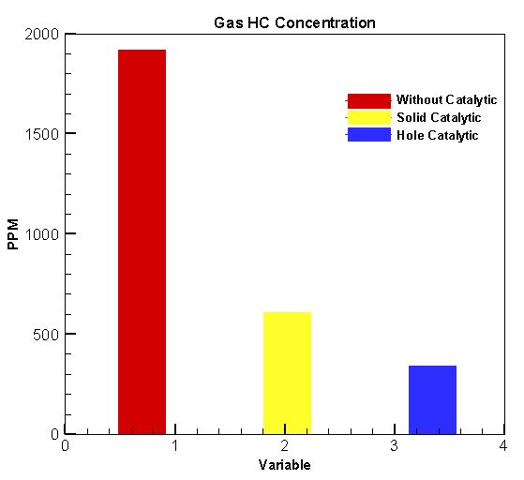

FIGURE 7. Comparison of HC Gas Between Exhaust Without Catalytic Converter, with Solid Cylindrical Catalytic Converter and Hole Cylindrical Catalytic Converter.

FIGURE 7. is a picture of the comparison of HC gas emissions between without a catalytic converter with a solid cylinder catalytic converter and a hole cylinder catalytic converter. In general, the hole model produces 341 ppm lower emissions than others. This is because the hole cylinder catalytic converter has a lower flow than the solid cylinder catalytic converter because there are parts that are not perforated. So that with a lower flow speed, the exhaust gas that hits the hole cylinder catalytic converter can absorb emissions at the top and in the hole. This is in accordance with research conducted by [8].

THE EFFECT OF WITHOUT CATALYTIC CONVERTER, SOLID CYLINDER CATALYTIC CONVERTER AND HOLE CYLINDER CATALYTIC CONVERTER ON ENGINE PERFORMNACE, TOTQUE
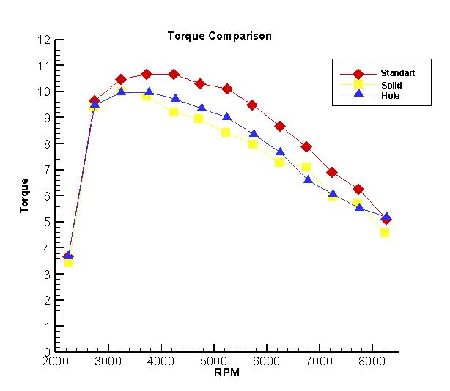
FIGURE 8. Torque Comparison without Catalytic Converter, Catalytic Solid Cylindrical Converter and Catalytic Converter Cylindrical Holes.

FIGURE 8. is a standard torque comparison between a solid catalytic converter and a hole catalytic converter. In general, the torque produced is almost the same, the solid catalytic converter has the highest torque of 9.83 Nm at 3000 rpm and the hole catalytic converter has the highest torque of 10.03 Nm at 3000 rpm and the difference is $\frac{10,03-9,83}{10,03} x 100 or 1,99 \%$. This shows that between the solid cylinder and the hole cylinder for torque there is no significant difference in the increase. This is in accordance with research conducted by [8] . Once the engine power and torque reach its maximum point (peak power and torque), the graph tends to move downward. Thus, even though the throttle valve is added to the full opening, the vehicle speed will continue to rise, but the vehicle's power and torque will decrease because it has reached its maximum point.

THE EFFECT OF EXHAUST WOTHOUT CATALYTIC CONVERTER, SOLID CYLINDER CATALYTIC AND HOLE CYLINDER CATALYTIC CONVERTER ON ENGINE PERFORMANCE, POWER
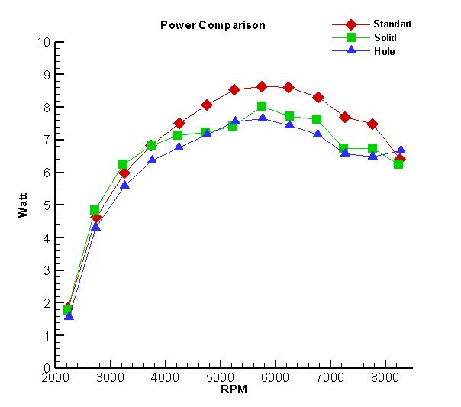

FIGURE 9. Power Comparison without Catalytic Converter Catalytic Solid Cylindrical Converter and Catalytic Converter Cylindrical Holes.

FIGURE 9 is a power comparison drawing between a solid catalytic converter and a hole catalytic converter. In general, the power produced is almost the same, the solid catalytic converter has the highest power of 7.45 HP at 5500 rpm and the hole catalytic converter has the highest power of 7.69 HP at 5500 rpm and the difference is $\frac{7,69-7,45}{7,69} x 100 or 3,1 \%$ . This shows that for power there is also no significant difference between solid cylinders and bore cylinders. This is in accordance with research conducted by [8].

RESULT OF SEM-EDX ANALYSIS ON WOOD CHARCOAL BRIQUETTES
SEM-EDX is a combination of 2 types of instruments, namely SEM and EDX. SEM (Scanning Electron Microcope) is a tool that serves to determine the morphology or surface structure of a solid sample through an image. While EDX (Energy Dispersive X-Ray) is an instrument that functions to analyze the elements or chemical characteristics of a material. SEM-EDX owned by Integrated Laboratories is the brand SEM-EDX Phenom Desktop ProXL. By testing using SEM-EDX, morphological results or surface structure of the sample will be obtained.
FIGURE 10. are an overview of the surface morphology and elemental composition of carbonized wood charcoal briquettes with magnifications of 200x. It can be seen that the substance has a relatively smooth surface area, irregular beam structure, and pore structure that is clearly visible at 200x. With this pore causes by this wood charcoal briquettes can adsorb exhaust gas emissions so that less exhaust gas is produced due to absorption by these wood charcoal briquettes. The condition of pore existence is caused by the relatively low temperature of the carbonization process for its pyrolysis temperature.

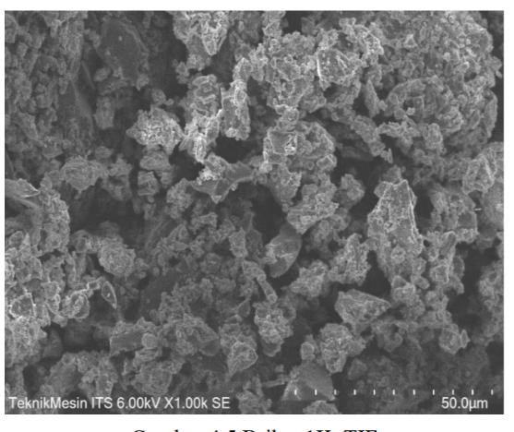
FIGURE 10. Magnification 200

COMPOSITION RESULT WITH EDX
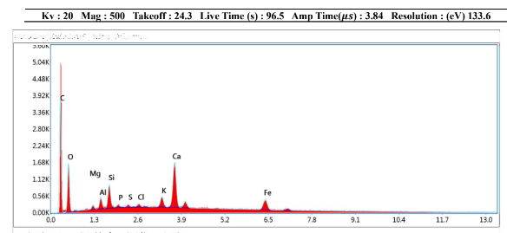
FIGURE 11. EDX Element Composition

FIGURE 11. Above is a picture of the elemental composition of wood charcoal briquettes. In the picture above using EDX it can be seen that the content of C 46.17%, O 32.32%, Mg 0.72%, ai 1.49%, Si 2.51%, P 0.41%, S 0.35%, Ci 0.45%, K 1.70%, Ca 9.14% and Fe 4.74%. That in general its greatest elemental composition is element C.

CONCLUSIONS
The result show that catalytic converter cylinder hole produces lower CO emissions compared to exhaust without catalytic converter and catalytic converter with solid cylinder. For HC emissions, hole cylinder catalytic converter produces lower emissions than exhaust without catalytic converter and solid cylinder catalytic converter, for the example hole cylinder catalytic converter has 341 ppm lower than the others. The torque produced is almost the same, the solid catalytic converter has the highest torque of 9.83 Nm at 3000 rpm and the hole catalytic converter has the highest torque of 10.03 Nm at 3000 rpm. In general, there is no significant difference in the increase in torque. As for the power produced is also almost the same too, the solid cylinder catalytic converter has the highest power of 7.45 HP at 5500 rpm and the hole cylinder catalytic converter has the highest power of 7.69 HP at 5500 rpm.

Acknowledgments
We would like to thank the DRTPM from the Ministry of Education and Culture, which has funded this research with contract number, number 109/E5/PG.02.00.PL/2024 dated June 11, 2024.

References
1. Karnauskas, K.B., S.L. Miller, and A.C. Schapiro, Fossil Fuel Combustion Is Driving Indoor CO2 Toward Levels Harmful to Human Cognition. GeoHealth, 2020. 4(5): p. e2019GH000237.
2. Maryanto, D., et al., PENURUNAN KADAR EMISI GAS BUANG KARBON MONOKSIDA (CO) DENGAN PENAMBAHAN ARANG AKTIF PADA KENDARAAN BERMOTOR DI YOGYAKARTA. Jurnal Kesehatan Masyarakat (Journal of Public Health), 2014. 3.
3. Wiratmaja, I.G., Analisa unjuk kerja motor bensin akibat pemakaian biogasoline. 2010.
4. Winarno, J., Studi emisi gas buang kendaraan bermesin bensin pada berbagai merk kendaraan dan tahun pembuatan. Jurnal Teknik, 2014. 4(1).
5. Rahangmetan, K., C. Wullur, and F. Sariman, Effect Variations And Types of Smaw Welding Electrodes on A36 Steel to Tensile Test. Journal of Physics: Conference Series, 2020. 1569: p. 032052.
6. Jena, S.P., et al., Investigation of the effect of FeCl3 on combustion and emission of diesel engine with thermal barrier coating. Sustainable Environment Research, 2018. 28(2): p. 72-78.
7. Sharma, S.K., P. Goyal, and R.K. Tyagi, Conversion efficiency of catalytic converter. International Journal of Ambient Energy, 2016. 37(5): p. 507-512.
8. Ghofur, A., et al., Implementation peat soil adsorbent & variation of filter for reduce emission improvement from motor vehicle. Eastern-European Journal of Enterprise Technologies, 2023. 1: p. 27-36.

