Production and Characterization of Duck Eggshell Powder for Dental Implant Application
Iis Siti Aisyah^{a)}, Ricky Andri Gunawan^{b)}, Dini Kurniawati^{c)}, Nur Hasanah^{d)}, Ali Saifullah^{e)}, and Amroe Umar^{f)}
Department of Mechanical Engineering, Universitas Muhammadiyah Malang, Malang, Indonesia

^{a)} Corresponding author: siti@umm.ac.id
^{b)} rickyandri753@gmail.com
^{c)} dini@umm.ac.id
^{d)} nur_hasanah@umm.ac.id
^{e)} ali_s@umm.ac.id
^{f)} amruumar123@gmail.com
Abstract. The working principle of a ball mill is that material inserted into a tube will be exposed to high-energy collisions. During milling the material will experience deformation which causes changes in particle size to become smaller. The aim of this research is to determine the effect of variations in time and number of milling balls on the grain distribution and particle size of duck egg shells using the ball milling method. The ball mill machine used is a UVBM made by UMM with a tube capacity of 200 mg. The samples were treated using varying milling times of 30 minutes, 60 minutes, 90 minutes, 120 minutes and 150 minutes and the number of balls was 5 and 10. Then the powder was put into the sieve shaker machine for 15 minutes and the size of the powder was examined using the test. microstructure. based on the results of the best grain distribution obtained at a milling time of 150 minutes and 10 balls with a weight percentage of 200 mesh of (1gr), 140 mesh of (23gr), 120 mesh of (2.3gr), 100 mesh of (4.2gr), 80 mesh of (8.8gr), and <80 mesh of (31.4gr). From the photo of the micro test results, it shows that as the milling time and number of balls increase, the powder grains are uniformly small and increasingly fine. So, it can be concluded that the longer and larger the number of balls, the finer the particle size of the duck egg shell.
Keywords: Ball Milling, sieving, Microstructure, Egg Shell, dental implant

INTRODUCTION
Ball mill is a simple, fast, cost-effective, and environmentally friendly technology with enormous potential. Ball milling is a widely used mechanical technique to grind and blend materials into fine particles. As an environmentally friendly and cost-effective technique, ball mills have been widely applied in industries around the world. [1] Ball mills use steel balls to produce the grinding action, which is through collision and abrasion of the steel balls. The rotation speed, ball size, and ball to material ratio have an influence on the grinding efficiency of the ball mill. [2] Faster rotation speed produces material with smaller particle size and low cementite. When larger ball sizes are used, the crystallization process decreases, while the grinding efficiency and specific surface area of the material increase. Conversely, the smaller the ball size, the lesser the decrease in crystallization. As a result, the use of small ball sizes can produce nanoparticles with greater crystallinity. [3] Ball mill is an effective way to reduce particle size with the possibility of forming smaller agglomerates to be ground into microparticles. The ball mill grinding mechanism reduces particle size and particle spacing, while increasing particle area. [4] [5]
The principal in ball milling is to subject the material fed into the tube to a high-energy impact. During ball milling, the material undergoes severe plastic deformation, fracture, and cold welding. Particle deformation causes particle size changes and fractures break particles into smaller sizes (nanoparticles). [6] Grinding combined with sieving will produce a particle size suitable for further processing. Sieving is a separation process based on the size of the wire holes contained in the sieve, materials smaller than the mesh size will enter, while large ones will be retained on the surface of the wire. [7]
Technological developments have driven the need for materials with superior properties. Powder metallurgy is a production technique using powder as the starting material before forming. [8] Powder metallurgy is the most common method used to make MMCs with discontinuous reinforcement because it has several advantages over other methods. [9] Powder metallurgy includes powder production, compacting and shaping of powders, and sintering. [10] Nanoparticles are particles with sizes ranging from 1-100 nm. Materials with nanoparticle structures generally have properties that are different from the original structure. These properties can be modified through controlling particle size, chemical composition, surface modification, and controlling interactions between particles. [11] CaO nanoparticles have been widely used in various applications such as catalysts, adsorption, water purification, and act as antibacterials. In addition, CaO is of particular interest because it is considered a safe material for humans and animals. [12]
Eggshell has two components, eggshell (ES) and eggshell membrane (ESM), which differ in chemical composition. The eggshell is a complex and highly structured permeable bio ceramic material. The eggshell contains about 8.5-11% of the total egg mass, with a thickness of about 355 ŷm. Generally, eggshells are composed of 94% calcium carbonate (CaCO3), 1% magnesium carbonate (MgCO3), 1% calcium phosphate (Ca3(PO4)2), and 4% organic matter. [13] Due to these properties, eggshells have the potential to be reused in papermaking, chemical, agricultural and even medical industries. [14, 15] Eggshell powder, mainly composed of calcium carbonate is emerging as a promising additive due to its hardness, strength, and biocompatibility. The use of eggshell powder not only improves the mechanical properties of composites but also utilizes environmentally friendly and low-cost waste. [16]
Microstructure is a structure that is not visible to the naked eye, in order to observe and analyze it requires the use of an observing device. [17] Microstructure tests are used to observe the shape and particle size of the material being tested. [18] In this research, microstructure testing was used to measure the nano particle size of the duck eggshell material. [19]
Based on the research that has been done, this research will be carried out to make eggshell powder from duck eggshells with the effect of variations in time and number of balls on the microstructure of nano-sized duck eggshell powder using a ball mill machine with a capacity of 200 mg made by UMM, namely the UVBM machine (UMM Vertical Ball Milling).

METHODS
This research uses the True Experiment Research method, because the necessary data can only be generated from research. This experimental research is carried out by obtaining data from the test results that have been passed by the Ball Milling process, Sieving Shaker, and Micro test. This literature review quotes from several related book and journal sources to add the concrete data needed. The following FIGURE 1 is a flow chart of the research that has been done:

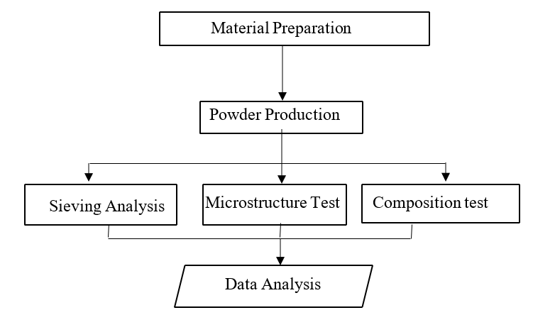
FIGURE 1. Testing Flowchart

RESEARCH METHODS
This research was conducted at the Mechanical Engineering Laboratory of Universitas Muhammadiyah Malang and Microstructure testing was carried out at the Laboratory of Universitas Muhammadiyah Malang.

The equipment used to make the material in this test is as follows:
1. Duck Egg Shell
2. Digital Scales
3. Plastic clip
4. Stopwatch
5. UVBM (UMM vertical Ball Mill)
6. Sieve shaker
7. Microstructure test equipment

This research is a True Experiment Research method. True experiment is research that can control all external variables that affect the course of the experiment, the main feature is that the samples used in an experiment and control are taken randomly as shown in TABLE 1.

TABLE 1. Table information
No. | Number of Milling Balls | Milling Time Variation (Minutes)
1 | 5 | 30 | 60 | 90 | 120 | 150
2 | 10 | 30 | 60 | 90 | 120 | 150

RESULTS AND DISCUSSION
The powder milled with the difference number of ball and difference time variation, then the powder results were tested for grain distribution using a Sieve Shaker machine and the following results were obtained on the TABLE 2 and TABLE 3 below:

TABLE 2. Grain Distribution Test Results with 5 Balls in (grams)
No | Milling Time (minutes) | Total Powder Weight (gr)
No | Milling Time (minutes) | <80 mesh | 80 mesh | 100 mesh | 120 mesh | 140 mesh | 200 mesh | Total (gr)
1 | 30 | 48,2 | 0,6 | 0,4 | 0,3 | 0,3 | 0,2 | 50
2 | 60 | 48,1 | 0,7 | 0,4 | 0,3 | 0,3 | 0,2 | 50
3 | 90 | 46,9 | 1 | 0,6 | 0,4 | 0,6 | 0,5 | 50
4 | 120 | 46,8 | 1,1 | 0,6 | 0,5 | 0,5 | 0,5 | 50
5 | 150 | 46,2 | 1,4 | 0,7 | 0,6 | 0,7 | 0,4 | 50

TABLE 3. Grain Distribution Test Results with 10 Balls in (grams)
No | Milling Time (minutes) | Total Powder Weight (gr)
No | Milling Time (minutes) | <80 mesh | 80 mesh | 100 mesh | 120 mesh | 140 mesh | 200 mesh | Total (gr)
1 | 30 | 46,2 | 1,3 | 0,7 | 0,6 | 0,7 | 0,5 | 50
2 | 60 | 44 | 2,5 | 1,5 | 0,8 | 0,7 | 0,5 | 50
3 | 90 | 37,6 | 4,8 | 2,9 | 1,5 | 2,7 | 0,5 | 50
4 | 120 | 35,8 | 5,7 | 3,8 | 1,8 | 2,1 | 0,8 | 50
5 | 150 | 31,4 | 8,8 | 4,2 | 2,3 | 2,3 | 1 | 50

From the results, it can be concluded that each grain has a different size at time variations of 30 minutes, 60 minutes, 90 minutes, 120 minutes and 150 minutes with the number of balls 5 and 10. The results of powder sieving shows that the longer and more milling, the smaller the particle size produced. This means that we can use milling time and the number of balls as an assessment of the degree of fineness of the powder.

FIGURE 2. Graph of grain distribution in mesh size with 5 balls

FIGURE 3. Graph of grain distribution in mesh size with 10 balls

From the FIGURE 2 and FIGURE 3, it can be concluded that the longer the milling time shows the mesh size of 80 decreases. This is because the powder begins to shrink and begins to migrate into smaller particle sizes. The powder increases in distribution sizes of 140 and 200 mesh. The fine powder is caused by the ball mill tube rotating vertically and creating centrifugal force. So the ball rises up and falls down, hitting the powdered material inside

The results of microstructural testing using duck eggshells baked at 100o C and crushed by ball mill method using the number of balls 5 and 10 and time variations of 30 minutes, 60 minutes, 90 minutes, 120 minutes, and 150 minutes, show in FIGURE 4 and 5 below.

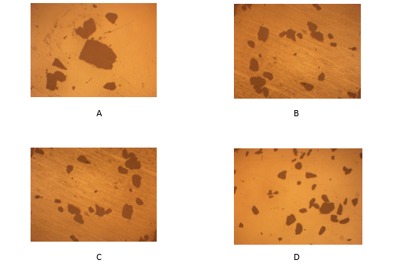
FIGURE 4. Figure Microstructure test results with 5 balls

FIGURE 4 shows a 100.00µm magnification of the duck eggshell powder. Figure 3.1.A with a milling time of 60 minutes obtained particle size data of 103.37µm-151.81µm. Figure 3.1.B with a milling time of 90 minutes obtained particle size data of 90.09µm-127.41µm. Figure 3.1.C with a milling time of 120 minutes obtained particle size results 78.79µm-106.31µm. Figure 3.1.D with a milling time of 150 minutes obtained particle size results 60.36µm-96.65µm. For milling time 30 minutes is not included because the results of the powder has not reached nano size.

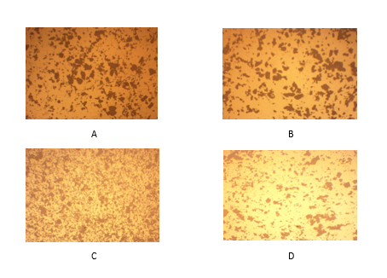
FIGURE 5. Figure Microstructure test results with 10 balls

FIGURE 5 shows 100.00µm magnification of duck eggshell powder, with a milling time of 60 minutes obtained particle size data of 34.70µm-59.46µm. Figure 3.2.B with a milling time of 90 minutes obtained particle size data of 24.87µm-43.24µm. Figure 3.2.C with a milling time of 120 minutes obtained particle size data 13.52µm-27.23µm. FIGURE 6 with a milling time of 150 minutes obtained particle size data of 10.45µm-18.04µm. for milling time 30 minutes is not included because the results of the powder has not reached nano size.
From the results of the micro testing data, each grain has a different size at varying times of 30 minutes, 60 minutes, 90 minutes, 120 minutes, 150 minutes with the number of balls 5 and 10. The average size of the powder from optical microscope observations in FIGURES 4 and 5 can be displayed in graphic below.

123,21625
108,035
99,075
77,4675
50,25363636
38,62454545
28,26727273
,
97
21
0
20
40
60
80
100
120
140
60
90
120
150
Powder size (µm)
Time (minutes)
5
Ball ola
10
Ball Bola
FIGURE 6. Comparison of Average Sizes of powder milled by 5 and 10 Ball

The particle diameter decreases due to grinding, because the powder particles are subjected to repeated collisions. When the milling balls collide, the crushed powder will lie between the impact steel balls in the tube. Causes the powder to deform so that it changes shape and crumbles, then produces powder with a small particle size. From the 5 variations in milling time, namely 30, 60, 90, 120 and 150 minutes, it can be seen that the results of the duck egg shell milling process produce the best powder or the most fine powder, with a milling time of 150 minutes and using 10 balls. This is because the ball mill tube rotates vertically which causes centrifugal force on the pounding balls to rise high and fall freely when the pounding balls are in the upper path of the ball mill. When the impact ball rotates and falls, it will have an impact effect on the shell so that it will be deformed and crushed into powder. The longer the ball mill milling time, and the more crushing balls used, the finer the powder produced due to the impact effect received by the shell continuously based on the length of milling time so that the impact effect can erode the eggshell shell.

CONCLUSIONS
Based on the experimental results and discussions that have been carried out, it can be concluded as follows: Milling time and number of balls can be used as the achievement of powder fineness level. While the best powder distribution results were obtained at a milling time of 150 minutes with a weight percentage of 200 mesh of (1gr), 140 mesh of (23gr), 120 mesh of (2.3gr), 100 mesh of (4.2gr), 80 mesh of (8.8gr), and <80 mesh of (31.4gr). From the photo of the micro test results, it shows that as the milling time and the number of balls increase, the powder grains are evenly distributed in small shapes and are getting finer.
For further research, it is hoped that this research can be a reference for developing further experiments and research in powder metallurgy innovation, such as testing the compound elements contained in duck eggshells that have gone through the milling process.

Acknowledgments
The first Author wish to thanks to the Puskareka Blog grant of Faculty Engineering - UMM for financial support under grant Penelitian Internal for the year of 2024 with the grant number 1/P2M-HDL/FT-UMM/VI/2024.

REFERENCES
- C. C. Piras, S. Fernández-Prieto, and W. M. De Borggraeve, "Ball milling: a green technology for the preparation and functionalisation of nanocellulose derivatives," Nanoscale Advances, vol. 1, no. 3, pp. 937-947, 2019.
- I. S. Aisyah, W. Caesarendra, and A. Suprihanto, "Design and testing of umm vertical ball mill (uvbm) for producing aluminium powder," 2018, vol. 1007: IOP Publishing, p. 012063.
- G. S. Abdelhaffez, A. A. Ahmed, and H. M. Ahmed, "Effect of grinding media on the milling efficiency of a ball mill," Rudarsko-geološko-naftni zbornik, vol. 37, no. 2, pp. 171-177, 2022.
- N. H. Ononiwu and E. T. Akinlabi, "Effects of ball milling on particle size distribution and microstructure of eggshells for applications in metal matrix composites," Materials Today: Proceedings, vol. 26, pp. 1049-1053, 2020.
- H. Sübütay and İ. Şavklıyıldız, "Effect of High-Energy Ball Milling in Ternary Material System of (Mg-Sn-Na)," Crystals, vol. 13, no. 8, p. 1230, 2023.
- S. Vasamsetti, L. Dumpala, and V. V. Subbarao, "Optimization of milling parameters of planetary ball mill for synthesizing nano particles," Int J Mech Eng Technol, vol. 9, no. 11, pp. 1579-1589, 2018.
- P. P. Chinedu and W. I. C. Isaiah, "Implication of tillage and soil mineralogy on the setting and sieving efficiency of FTLHV–0200 filtra electromagnetic sieve shaker," Communications in Soil Science and Plant Analysis, vol. 47, no. 19, pp. 2168-2177, 2016.
- I. S. Aisyah, "Pengaruh Variasi Waktu Sintering Terhadap Karakter Intermetallic Bonding Al-Ti Hasil Metallurgi Serbuk," 2019, 5 ed., pp. 76-81.
- M. T. Hayajneh, M. A. Almomani, and M. a. M. Al-Shrida, "Effects of waste eggshells addition on microstructures, mechanical and tribological properties of green metal matrix composite," Science and Engineering of Composite Materials, vol. 26, no. 1, pp. 423-434, 2019.
- Z. Z. Fang et al., "Powder metallurgy of titanium–past, present, and future," International Materials Reviews, vol. 63, no. 7, pp. 407-459, 2018.
- V. A. Fabiani, F. Sutanti, D. Silvia, and M. A. Putri, "Green synthesis nanopartikel perak menggunakan ekstrak daun pucuk idat (Cratoxylum glaucum) sebagai bioreduktor," Indonesian Journal of Pure and Applied Chemistry, vol. 1, no. 2, pp. 68-76, 2018.
- M. Yani, G. A. P. K. Wardhani, and A. Taufiq, "Pembuatan Nanopartikel CaO dari Cangkang Telur Ayam Menggunakan Ekstrak Etanol Daun Salam (Syzygium polyanthum): Synthesis of CaO Nanoparticles from Chicken Eggshells Using Ethanol Extract of Bay Leaves (Syzygium polyanthum)," JURNAL SAINS TEKNOLOGI & LINGKUNGAN, vol. 9, no. 1, pp. 25-34, 2023.
- M. Baláž, "Ball milling of eggshell waste as a green and sustainable approach: a review," Advances in colloid and interface science, vol. 256, pp. 256-275, 2018.
- P. Puspitasari, M. A. Iftiharsa, H. F. N. Zhorifah, and R. W. Gayatri, "Analysis of physical properties and compressibility of avian eggshell nanopowders in solid state reaction," EUREKA: Physics and Engineering,(5), pp. 110-120, 2021.
- J. Kausar and I. Naureen, "Benefit of Egg Shell as Calcium Source in Egg Production and Bone Development," Sch. Int. J. Anat. Physiol, vol. 4, pp. 196-200, 2021.
- A. G. Atiyah¹ and N. H. Al-Falahi, "Egg shell hydroxyapatite implant for repair of radial bone in rabbits," Online Journal of Veterinary Research, vol. 23, no. 6, pp. 606-614, 2019.
- S. Jannet et al., "Effect of egg shell powder on the mechanical and microstructure properties of AA 2024 metal matrix composite," Materials Today: Proceedings, vol. 44, pp. 135-140, 2021.
- T. Pasang et al., "Microstructure and mechanical properties of welded additively manufactured stainless steels SS316L," Metals and Materials International, vol. 25, pp. 1278-1286, 2019.
- A. H. Z. Chfat, H. Yaacob, N. H. M. Kamaruddin, Z. H. Al-Saffar, and R. P. Jaya, "Effects of nano eggshell powder as a sustainable bio-filler on the physical, rheological, and microstructure properties of bitumen," Results in Engineering, vol. 22, p. 102061, 2024.

