The Effect of Rod and Current on Shielded Metal Arc Welding (SMAW) Process on the Hardness Value and Microstructure of ST41 Steel
Moh. Jufri^{1,a)}, Aldi Winata^{1,b)}, Roro Heni Hendaryati^{1,c)}, Baiq Firyal Salsabila Safitri^{2,d)}, Nurul Aisyah Ramadhani^{2,e)}
¹Department of Mechanical Engineering, Universitas Muhammadiyah Malang, Malang, Indonesia
²Department of Industrial Engineering, Universitas Muhammadiyah Malang, Malang, Indonesia

^{a)} Corresponding author: jufri@umm.ac.id
^{b)} aldiwinata81@gmail.com
^{c)} heni@umm.ac.id
^{d)} baiqfiryal@umm.ac.id
^{e)} nurulaisyahramadhani96@gmail.com
Abstract. Microstructure and hardness are two very important concepts in materials science, especially in metallurgy. The two are closely interrelated and can significantly affect the mechanical properties of a material. This study aims to analyze the influence of electrode and current variations on the SMAW welding process on the hardness value and microstructure of ST 41 steel. This study uses an experimental method with variations of E7016 and E7018 electrodes, as well as current variations of 90A, 100A, 110A, and 120A. The results showed that the variation of electrodes and currents affected the hardness value and microstructure of ST 41 steel. The E7016 electrode produces a higher hardness value compared to the E7018 electrode at the same current. The higher the current used, the lower the hardness value and percentage of perlite, and the higher the percentage of ferrite in the microstructure. This study provides insight into the optimal electrode and current selection for SMAW welding on ST 41 steel, which can improve the quality and efficiency of the welding process.
Keywords: SMAW welding, ST41 steel, microstructure, hardness value

INTRODUCTION
The rapid development of the construction industry cannot be separated from the crucial role of welding techniques in designing and repairing metal materials. The increasing use of metal in modern construction requires the application of accurate welding techniques from the planning stage. This requires competent welders to produce high-quality metal joints. Welding technology has wide applications in the construction industry, including shipbuilding, bridges, steel structures, pressure vessels, transportation, railway infrastructure, pipes, and more [1]. Welding techniques offer various advantages in assembly. In addition to being cost-effective and efficient, this technique produces lightweight yet strong structures. Another advantage is the flexibility in creating a variety of unique and innovative construction forms. Therefore, welding techniques are an attractive choice in various construction projects [2].
The success of the welding process is determined by various factors, both at the planning and implementation stages. Careful planning includes selecting the right welding method according to specifications, as well as identifying the components needed. Meanwhile, production factors such as schedule, type of process, equipment, materials, work sequence, and preparation (selection of welding machine, welding equipment, welder, electrodes, and type of welding) also play an important role in producing quality welded joints [3].
Welding processes can be classified into three main groups based on their working mechanism: liquid welding, pressure welding, and brazing welding. In liquid welding, the materials to be joined are first melted using a heat source. Some of the popular liquid welding techniques are electric and gas arc welding. There are four main types of electric arc welding, namely covered electrode arc welding, gas arc welding (such as TIG, MIG, and CO2), gasless arc welding, and submerged arc welding. For example, SMAW (Shielded Metal Arc Welding) falls under the category of covered electrode arc welding [4].
SMAW welding machines can be categorized into three types based on the electric current used: direct current (DC) welding machines, alternating current (AC) welding machines, and dual current welding machines that can use both. DC welding has two methods, namely direct polarity and reverse polarity. Direct polarity (DC-) is suitable for materials with high melting points and large capacity electrodes, where the electrode is connected to the negative pole and the base material to the positive pole. Conversely, reverse polarity (DC+) is used for materials with low melting points and small capacity electrodes, with the electrode connected to the positive pole and the base material to the negative pole [5]. In this welding process, E7018 and E7016 electrodes with a diameter of 3.2 mm are used, so that the electric current required ranges from 100 to 120 Amperes. The use of current in this range will produce welding results that vary according to needs. [6] In a previous study entitled the effect of variations in current strength in SMAW welding on distortion and mechanical properties of dissimilar stainless steel 304 and steel a 36 [7]. Analysis of the Effect of Electric Current and Electrodes on Strength and Hardness in the SMAW Welding Process of Low Carbon Steel [8]. And the Effect of Welding Current Variations on the Strength of SMAW Welding of Low Carbon Steel St 37.
Pipes are one of the crucial components in the liquid and gas distribution system, pipes also play a role in the process of changing the state of refrigerant gas from the gas phase to the liquid phase. Welded joints on pipes must be of high quality to ensure their resistance to pressure and prevent leakage. Low carbon steel, such as ST 41 steel, is generally chosen as the main material in making pipes. Steel is a metal alloy formed from a combination of iron (Fe) and carbon (C), unlike pure metals such as iron (Fe), aluminum (Al), zinc (Zn), copper (Cu), or titanium (Ti). In the composition of steel, iron dominates as the main element, while carbon plays a role as an additional element with levels varying between 0.2% to 2.1% of the total weight of the steel, depending on the type of steel produced [9]. ST 41 steel is a type of low carbon steel with a carbon content of around 0.08% to 0.20%. This steel is widely applied in the manufacturing industry for various components such as machine components, gears, chains, screws, shafts, as well as in automotive and construction production. ST 41 steel has superior characteristics such as high strength, adequate hardness, and good dimensional stability. The amount of electric current used during the welding process of low carbon steel such as ST 41 has a significant effect on the mechanical properties of the welded material, including its tensile strength and toughness. Increasing the electric current will increase the tensile strength of the welded steel, but on the other hand can reduce the toughness of the material due to the increase in the ferrite phase. Increasing the electric current used in the welding process of carbon steel will have an impact on increasing the distortion angle that occurs in the welded material [10]. Electric current has a major impact on the cooling process during welding, which will then affect the hardness level of the base metal, weld area, and heat-affected zone [11]. The hardness of the weld area and heat-affected zone (HAZ) will increase along with the increase in the electric current used in the welding process, while the average hardness of the base metal will decrease with the increase in the electric current [12]. Weld metal is the part of the metal that melts during the welding process with welding wire, then solidifies again. The microstructure of the weld metal generally consists of needle ferrite, grain boundary ferrite, and Widmanstatten ferrite. The arrangement of each of these phase forms is influenced by the level of heat that occurs during the welding process. Therefore, further research is needed on the effect of electrode and current variations in smaw welding process on the hardness value and microstructure of ST 41 steel. This research is mainly aimed at welding and repairing pipes, with the aim of obtaining welded joints that meet high safety standards.

METHODS
The research method is a procedure used by researchers to overcome the problems faced, including research steps and materials. This study uses experiment research to test hypotheses related to the final assignment. Additional sources of information were obtained from books, journals, and articles on the effects of current and electrode variations. The current variations used were 90, 100, 110, and 120 amperes, while the electrodes used were E7016 and E7018. The material to be tested was ST 41 steel.
Independent variables are variables that are not affected by other variables. The size of this variable can be adjusted, which acts as internal causes in the study. In this study, the independent variables include ST41 carbon steel, the current used in the welding process. It is 90A, 100 A, 110 A, and 120 A. Moreover, the type of welding rods of E7016 and E7018 is also the independent variable of this study. The dependent variable is a variable whose value depends on the value of the independent variable and can be known after the research is completed. In this study, the dependent variables observed after welding include hardness value and microstructure. Control variables are variables whose values ​​are determined before the study and are kept constant during the test. In this study, controlled variables include variation of welding current, ST41 steel, and SMAW with current variation of 90A, 100 A, 110 A, and 120 A.
The procedure of this research began with the preparation of specimen. The specimen of ST41 steel was determined to be 8 mm thick. The groove angle in the specimen was determined in 60o of angle. The welding rods used in this study were E7016 and E7018 with 3,2 mm diameter. The welding process was conducted using SMAW welding machine with current variation of 90A, 100 A, 110 A, and 120 A and 1G positions of welding process. The results of welding were tested with Rockweel hardness test and hardness test.

RESULTS AND DISCUSSION
Rockwell testing is carried out on a Rockwell B1/16" machine. The purpose of this test is to determine the average hardness.

FIGURE 1. The results of hardness test with welding rods E7016

Based on FIGURE 1, here are changes in hardness values ​​in the HAZ, weld metal, and base metal. In general, increasing welding current results in a decrease in hardness values. When using E7018 electrodes with a current of 90A, the hardness value in the HAZ area is 41.7 HRC, in the weld metal 44 HRC, and in the base metal 44 HRC. The highest hardness value in specimens welded with E7018 electrodes was achieved at a current of 100A, with a HAZ value of 44.2 HRC, weld metal 44.8 HRC, and base metal 45.5 HRC. At a current of 110A, the hardness value in the HAZ decreased to 42.7 HRC, in the weld metal to 42.2 HRC, and in the base metal to 43.5 HRC. The lowest hardness value was found at a current of 120A, with a HAZ value of 39.3 HRC, weld metal 39.2 HRC, and base metal 41 HRC.
There are changes in hardness values ​​in the HAZ, weld metal, and base metal, as shown in FIGURE 2. In general, increasing welding current results in a decrease in hardness values. When using E7018 electrodes with a current of 90A, the hardness value in the HAZ area is 40.7 HRC, in the weld metal 42.2 HRC, and in the base metal 43.2 HRC. The highest hardness value in specimens welded with E7018 electrodes was achieved at a current of 100A, with a HAZ value of 41.2 HRC, welded metal 43.2 HRC, and base metal 44.3 HRC. At a current of 110A, the hardness value in the HAZ decreased to 39.3 HRC, in the weld metal to 42.8 HRC, and in the base metal to 41.2 HRC. The lowest hardness value was found at a current of 120A, with a HAZ value of 39.2 HRC, weld metal 41.8 HRC, and base metal 40.2 HRC.

FIGURE 2. The results of hardness test with welding rods E7018

In this study, macrostructure analysis was conducted to assess the width of the welding zone, hot zone (HAZ), and base metal zone formed after the welding process. This aims to facilitate observers in identifying the base metal, weld metal, and (HAZ) when observing the microstructure directly or through a camera. The results of microstructural observations show a structure consisting of ferrite, marked with a light color, and pearlite, marked with a dark color. The following FIGURE 3, 4, and 5 is a photo of the results of microstructural testing with a magnification of 400x.

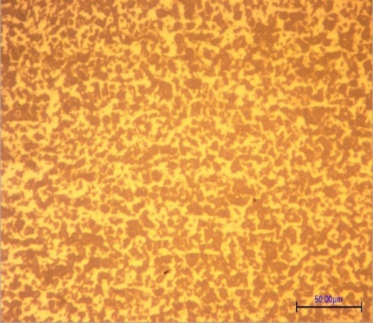
ferrite
perlite
FIGURE 3. HAZ

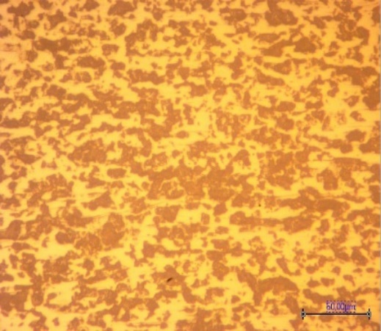
ferrite
perlite
FIGURE 4. Base metal

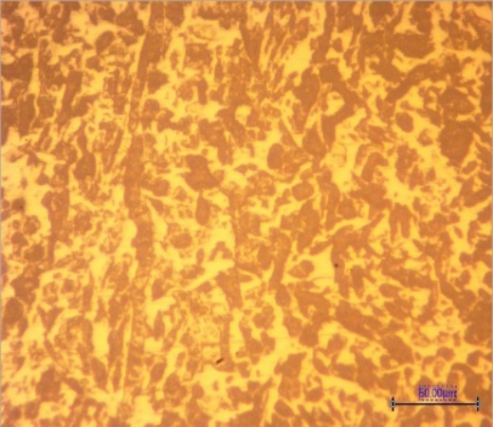
ferrite
perlite
FIGURE 5. Weld metal

After analyzing the data of the Rockwell hardness test and the microstructure test in the image above shows the overall relationship, the microstructure of the steel is a key factor in determining its hardness. By controlling the microstructure through heat treatment, chemical composition, and other processing processes, we can adjust the hardness of the steel according to the needs of a particular application.

CONCLUSIONS
Based on the research results regarding the effect of current and electrode variations on the hardness and microstructure of ST 41 steel, the welding rods variations in SMAW welding affect the hardness value. The increase is at a current of 100A and if welding is carried out at a current above it, the hardness value gradually decreases. Welding rods variations in SMAW welding affect the microstructure of ST 41 steel, with the E7016 electrode producing a higher pearlite percentage than E7018 at currents of 90A, 100A, 110A,120A. The significant difference is that the E7016 electrode produces higher hardness values ​​and pearlite percentage than the E7018 electrode at currents of 90A, 100A, 110A, 120A.

References
1. Gusniar, I.N., A. Juhri, and V. Noubnome, Pengaruh Variasiarus Dan Posisi Pengelasan SMAW Terhadap Sifat Mekanik Baja ST 37. Jurnal Teknik Mesin, 2021. 14(2): p. 134-139.
2. Siddiq, M., et al., Analisa Pengaruh Kampuh Pengelasan SMAW Pada Penyambungan Baja Karbon Rendah dan Karbon Sedang Terhadap Uji Ketangguhan. Jurnal Mesin Sains Terapan, 2021. 5(1): p. 31-37.
3. Triwibowo, N.A. and E. Supriatna. Effects of Electrode Movement on Smaw Welding to The Quality of ST-37 Steel Welds. in Conf. Senat. STT Adisutjipto Yogyakarta. 2019.
4. Muliadi, D., R. Ridho, and C.P. Marpaung, Pengaruh Kuat Arus terhadap Sifat Mekanis dan Struktur Mikro Sambungan Las Smaw Baja Sa 516 Gr. 70. Mekanik, 2018. 4(2): p. 329177.
5. Ichsan, M., et al., PENGARUH PENGELASAN SMAW TERHADAP KEKUATAN TARIK PADA BAJA TULANGAN BETON POLOS (BJTP) 24. Buletin Utama Teknik, 2023. 18(3): p. 268-272.
6. Darsono, M.H., Prinob Aksar, Analisis Pengaruh Arus Pengelasan Dan Jenis Elektroda Pada Struktur Mikro
Material Baja Karbon Rendah. ENTHALPY: Jurnal Ilmiah Mahasiswa Teknik Mesin, 2021. 6: p. 7-12.
7. Nur Subeki, I.S.P., Achmad Fauzan H S, PENGARUH VARIASI KUAT ARUS PADA LAS SMAW (SHIELDING METAL ARC WELDING) TERHADAP DISTORSI
DAN SIFAT MEKANIK DESSIMILAR STAINLESS STEEL 304 DAN BAJA A 36, in Seminar Nasional Teknologi dan Rekayasa (SENTRA). 2019. p. 159-165.
8. Rahangmetan, K.A., C.W. Wullur, and F. Sariman. Effect variations and types of Smaw welding electrodes on A36 steel to tensile test. in J. Phys. Conf. Ser. 2020. IOP Publishing.
9. Aditia, A., N. Nurdin, and A.S. Ismy, Analisa kekuatan sambungan material AISI 1050 dengan ASTM A36 dengan variasi arus pada proses pengelasan SMAW. Journal of Welding Technology, 2019. 1(1): p. 1-4.
10. Mauliza, A. and S. Usman, Analisa Pengaruh Arus Terhadap Kekuatan Tarik Material Baja Karbon AISI 1050 Hasil Pengelasan SMAW. Journal of Welding Technology. Volume, 2022. 4(1): p. 22.
11. Salim, V., R. Rosehan, and S.Y. Lubis, Analisis Dampak Perubahan Arus Pengelasan Terhadap Kekuatan Sambungan Las Pada Material Stainless Steel 316. Jurnal Teknik Industri Terintegrasi (JUTIN), 2023. 6(1): p. 231-241.
12. Habibi, F., S.M.B. Respati, and I. Syafa’at, Perlakuan Pemanasan Awal Elektroda Terhadap Sifat Mekanik Dan Fisik Pada Daerah HAZ Hasil Pengelasan Baja Karbon ST 41. Prosiding Sains Nasional dan Teknologi, 2015. 1(1).

