Effect of Surface Treatment and Zn3(PO4)2 Coating Layer to the Roughness and Corrosion Rate on AISI 1020 using Spray Coating
Suheni^{1,a)}, Afira Ainur Rosidah^{1,b)}, Gatot Basuki HM^{2,c)}, and Ezar Hamed Alem^{1,d)}
¹Department of Mechanical Engineering, ITATS, Surabaya, Indonesia
²Department of Industrial Engineering, ITATS, Surabaya, Indonesia

^{a)} Corresponding author: suheni@itats.ac.id
^{b)} afiraar@itats.ac.id
^{c)} gatotbasukihm@itats.ac.id
^{d)} ezarneo@gmail.com
Abstract. Metal materials easily undergo corrosion, which is the degradation of materials due to interaction with their environment. Many ways can inhibit the corrosion rate. One way that can be used is coating. This research conducted surface treatment and added a coating using zinc phosphate to protect AISI 1020 steel in a 10% sulfuric acid as the corrosion medium. The research method tested the steel surface roughness with a roughness tester and the corrosion rate using the weight loss method. The results of testing the roughness and varying surface treatments such as sandblasting, wire cup brushing, and 60-grit sandpaper showed that the highest average roughness value existed in the sandblasting preparation at 94.73 µin. On the contrary, the lowest average roughness value happened in the wire cup brush treatment at 36.93 µin. Furthermore, the results of the corrosion rate test after 7 days of immersion showed that the highest average corrosion rate value was without treatment or coating at 2045.90 mpy. Meanwhile, the lowest average corrosion rate value occurred in the sandblasting variation with 3 layers of zinc phosphate at 299.07 mpy.
Keywords: AISI 1020, coating, corrosion rate, surface treatment, roughness

INTRODUCTION
Corrosion that occurs in metal cannot be avoided, but it can be prevented and controlled so that the metals have a longer service life or use [1]. Applying a coating layer is one way to protect materials from the corrosion process. The coating layer relies on its adhesive power to protect the surface of a material. If the adhesive power of the coating increases, then the life time of the coating on the material will increase [2]. Some coating materials have been proven to decrease the corrosion rate, such as epoxy, alkyd, and zinc phosphate [3] [4] [5]. The use of zinc phosphate as a protective coating for alloy steel is a promising method for increasing corrosion resistance [6]. The phosphate layer typically forms a continuous and adherent coating on the underlying metal, making it significantly more absorbent than the metal itself. It is usually a widely used surface pre-treatment method before painting metal alloys. In addition, previous studies have shown that it also provides a reduction in corrosion rates when applied directly to metal surfaces and then exposing the metal to a corrosive environment [7].
The coating result is influenced by several factors, such as the type of coating material, surface preparation, and number of layers [4] [8] [9]. The type of surface preparation used will affect the adhesion strength of the metal to the coating material [10] [11]. This preparation is intended to cause friction on the surface of the material so that the material becomes rougher and cleaner. Previous study compares the use of sandblasting and wire cup brush as the surface treatment on low carbon steel, the results show that the surface preparation using sandblasting provides higher roughness. This higher roughness leads to an outstanding adhesive strength so that results in higher corrosion resistance [5]. In addition, the number of coating layers also affects corrosion resistance. A higher number of layers results in increased thickness, thereby increasing the barrier distance between the metal surface and the environment. This research has been proven by Setyawan et al., the corrosion rate decreased from 19.51 mpy to 2.376 mpy with 3 layers of coating with a distance of 20 cm in NaCl solution [8].
Coating application can be carried out in several methods, such as spray coating, hit dipping, and electroplating [12] [13] [14]. Among those methods, spray coating is the most widely used and obvious method to use on low carbon steel. Some researches performed spray coating on low carbon steels, such as AISI 1020. The spray coating with 10% sulfuric acid as a corrosion medium showed a decrease in corrosion rate of AISI 1020 from 832.754 mpy (without coating) to 136.124 mpy (epoxy coating) [4]. This spray coating method has proven effective in increasing the corrosion resistance of AISI 1020 steel, which is steel with a low carbon content and high iron content so that it is easily oxidized.
This research focused on studying the effect of surface preparation variations using sandblasting, wire cup brushing, and 60-grit sandpaper, additionally, the variations in the zinc phosphate (Zn3(PO4)2) coating layer in sulfuric acid medium. Then the corrosion rate characteristics of low carbon steel AISI 1020 after coating were observed using the weight loss method in sulfuric acid medium.

METHODS

SPECIMEN AND DIMENSION
The carbon steel material used in this study was low-carbon steel AISI 1020 (0.2% C; 0.24% Si, 1.067% Mn; 0.025% P; 0.024 S) with the density of 7.87 g/cm³. The steel was prepared with 50 x 30 x 5 mm in dimension and a hole diameter of 5 mm. So that, the surface area was 38.39 cm². The specimen dimension is illustrated in FIGURE 1.
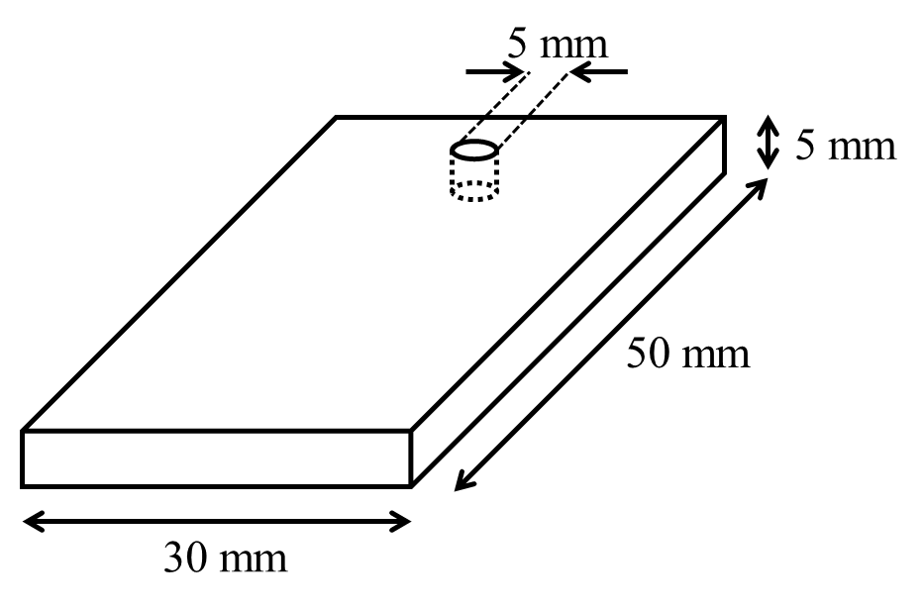 | 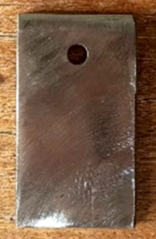
FIGURE 1. Specimen dimension

SURFACE TREATMENT
The specimens were treated with three types/variations of surface preparation before coating process. 1) Sandblasting process, the sand used was 2.5 SA sea sand with a compressor pressure of 5 bar, a shooting distance of 5 cm and a spraying speed of 20 mm/second; 2) Wire cup brushing, wire cup brush with WB10752 grinding type, wire diameter 0.3 mm which was attached to a hand grinder with the rotation speed of 12,000 rpm. This process was done by clamping the specimen to be ground using pliers and turning on the grinder, after which the brush was applied to the surface of the specimen; and 3) 60-grit sandpaper, 60 grit sandpaper is used and the surface of the specimen is rubbed with sandpaper in one direction. The visual differences of these surface treatments are displayed in FIGURE 2.

COATING PROCESS
The coating process of the specimens was carried out using spray coating with zinc phosphate (Zn3(PO4)2) material. The coating material was diluted with zinc phosphate and thinner B ratio of 3:1. The output air pressure on the compressor was set at 26 psi and the coating distance was 10 cm. Coating is done by varying the number of coating layers as many as 1, 2, and 3 layers.

ROUGHNESS TESTING
Surface roughness testing was carried out using the SJ-301 roughness tester at CNC Laboratory, Mechanical Engineering Department, ITATS. The specimen is placed on the roughness tester tool stand, then adjust the tool to a height according to the specimen so that the needle on the tool can touch the surface of the specimen. Then the tool is run by pressing the start button. The surface roughness results are obtained from the movement signal of the diamond-shaped stylus that moves along a straight line on the surface as an indicator of the surface roughness of the test object.

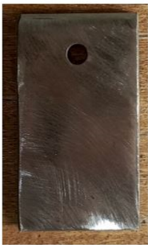 | 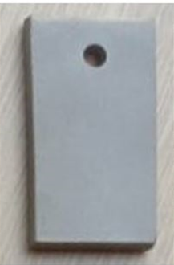 | 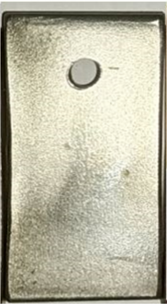 | 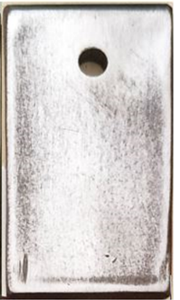
(a) | (b) | (c) | (d)
FIGURE 2. Surface treatment results of a) no surface treatment (raw); b) sandblasting; c) wire cup brush; and d) 60-grit sandpapering specimen

WEIGHT LOSS TESTING
The corrosion rate test used is the weight loss method with ASTM G31-72 standard. The specimens were weighed initially, then immersed in corrosive media for some time. After immersion, the final weight of specimen is measured and then the corrosion rate is calculated using the following formula (1) [15].

$CR=\frac{K.W}{D.A.t}$ (1)

where
CR = corrosion rate (mpy)
K = a constant (3.45 x 10⁶)
W = weight loss (gram) = initial weight – final weight
D = density of the specimen (g/cm³)
A = surface area (cm²)
T = exposure time (hours)
In this research, the corrosive medium used was 10% sulfuric acid (98% purity) with a soaking time of 7 days or 168 hours.

RESULTS AND DISCUSSION

ROUGHNESS TEST
The specimens were performed surface treatment before the coating process. Each surface treatment process used three specimens. After the sandblasting, wire cup brushing, and 60-grit sandpapering, the specimens were measured the roughness value using a roughness tester which results are averaged and shown in FIGURE 3. The untreated (no surface treatment/raw) specimens obtain an average roughness of 52.76 µin. In the sandblasting surface treatment, the highest average roughness value is obtained with the value of 94.73 µin. The lowest roughness value is the specimen with wire cup brush surface treatment, 36.93 µin.

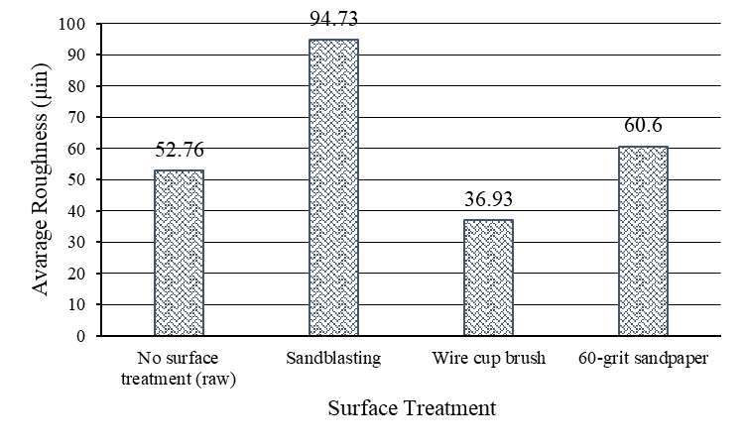
FIGURE 3. Roughness value of specimen after sandblasting, wire cup brushing, and sandpapering process

Sandblasting variations are carried out by shooting sand on the steel surface, this causes erosion to be much more abrasive than the others so that it can form a rough and random profile on the surface. Hence, it results in the highest roughness value. A 60-grit sandpaper gives a smoother surface profile compared to sandblasting, but not as smooth as a wire cup brush because the sandpapering direction is only one way so that it does not cause an even distribution of the surface profile. Moreover, the wire cup brush produces the lowest roughness value due to the friction that happens between the wire cup brush and the steel surface occur in a rotating direction, not in one direction like using 60-grit sandpaper. So that the wire cup brushing is not concentrated on one point on the surface, but evenly distributed over the entire surface which results in it being smoother than sandpaper or sandblasting. This result is in line with the previous research that implies the sandblasting surface treatment provides higher roughness than wire cup brushing [5]. The more uniform and consistent the movement of the abrasive tool on the metal surface, the smoother the surface will be. Hence, the highest roughness value is found in sandblasting, and the lowest is in wire cup brushing.

CORROSION RATE
The corrosion rate was carried out using weight loss method based on ASTM G31-72 standard. The initial and final weight was measured to calculate the corrosion rate. Each variation of this corrosion test used 3 specimens and then the average corrosion rate was calculated as seen in TABLE 1. The specimens without surface treatment and coating exhibit the highest weight difference which led to the highest corrosion rate as well. In contrary, the specimens with sandblasting surface treatment and 3 layers of coating show the lowest weight difference that result in the lowest corrosion rate.
The highest corrosion rate is reached at the value of 2045.90 mpy for the raw specimen (without surface treatment and coating). Moreover, the lowest corrosion rate 299.07 mpy is obtained at the specimen with sandblasting and 3 layers of coating. In terms of surface treatment, sandblasting gives the lowest corrosion rate followed by 60-grit sandpapering and wire cup brushing (the highest corrosion rate). These results are correlated with the roughness value mentioned in the sub-section above, a higher roughness value after surface treatment delivers a lower corrosion rate after coating. This is due to a rougher surface of the specimen after surface treatment leads to better binding of coating material which possibly causes outstanding corrosion resistance [5].
Furthermore, a higher amount of coating layer results in a lower corrosion rate (see FIGURE 4). This is because the increasing number of layers causes the coating thickness to increase as well, so that the barrier between the steel surface and the environment also escalates. The same results were obtained by Setyawan et al, their results show that 3 layers of coating produce lower corrosion rates compared to 1 layer [8]. The more coating, the thicker the coated surface, the denser, the more zinc phosphate content that can bind Fe atoms and protect the steel so that it is more difficult to be oxidized by sulfuric acid corrosion media. As mentioned in the introduction, phosphates can form a typical bond that adhere to metal surfaces.

TABLE 1. Initial, final weight, and corrosion rate results of the specimens
Surface treatment | Amount of layer | Initial weight  (gram) | Final weight  (gram) | Weight difference  (gram) | Corrosion rate  (mpy) | Average corrosion rate  (mpy)
No surface treatment (raw) | - | 54.7 | 24.1 | 30.6 | 2079.88 | 2045.90
No surface treatment (raw) | - | 55.7 | 25.4 | 30.3 | 2059.48 | 2045.90
No surface treatment (raw) | - | 54.4 | 25 | 29.4 | 1998.31 | 2045.90
Sandblasting | 1 | 55.5 | 31.2 | 24.3 | 1651.66 | 1590.50
Sandblasting | 1 | 53 | 30.7 | 22.3 | 1515.72 | 1590.50
Sandblasting | 1 | 54.4 | 30.8 | 23.6 | 1604.09 | 1590.50
Wire cup brush | 1 | 53.3 | 24.5 | 28.8 | 1957.53 | 2009.64
Wire cup brush | 1 | 53.5 | 23.8 | 29.7 | 2018.70 | 2009.64
Wire cup brush | 1 | 54.9 | 24.7 | 30.2 | 2052.69 | 2009.64
60-grit sandpaper | 1 | 53.8 | 29.6 | 24.2 | 1644.87 | 1681.12
60-grit sandpaper | 1 | 53.4 | 28.3 | 25.1 | 1706.04 | 1681.12
60-grit sandpaper | 1 | 54.1 | 29.2 | 24.9 | 1692.45 | 1681.12
Sandblasting | 2 | 54.6 | 43.2 | 11.4 | 774.85 | 781.65
Sandblasting | 2 | 52.7 | 40.8 | 11.9 | 808.84 | 781.65
Sandblasting | 2 | 55.9 | 44.7 | 11.2 | 761.26 | 781.65
Wire cup brush | 2 | 54.8 | 32.1 | 22.7 | 1542.91 | 1495.34
Wire cup brush | 2 | 54.4 | 32.7 | 21.7 | 1474.94 | 1495.34
Wire cup brush | 2 | 55.2 | 33.6 | 21.6 | 1468.15 | 1495.34
60-grit sandpaper | 2 | 55.2 | 34.8 | 20.4 | 1386.58 | 1363.93
60-grit sandpaper | 2 | 55.8 | 35.1 | 20.7 | 1406.97 | 1363.93
60-grit sandpaper | 2 | 55.6 | 36.5 | 19.1 | 1298.22 | 1363.93
Sandblasting | 3 | 53.7 | 49.2 | 4.5 | 305.86 | 299.07
Sandblasting | 3 | 55.1 | 51.1 | 4 | 271.87 | 299.07
Sandblasting | 3 | 55.9 | 51.2 | 4.7 | 319.45 | 299.07
Wire cup brush | 3 | 54.7 | 46.5 | 8.2 | 557.35 | 582.28
Wire cup brush | 3 | 53.8 | 44.9 | 8.9 | 604.93 | 582.28
Wire cup brush | 3 | 54.1 | 45.5 | 8.6 | 584.54 | 582.28
60-grit sandpaper | 3 | 54 | 49.1 | 4.9 | 333.05 | 369.30
60-grit sandpaper | 3 | 53.8 | 48.2 | 5.6 | 380.63 | 369.30
60-grit sandpaper | 3 | 55.1 | 49.3 | 5.8 | 394.22 | 369.30

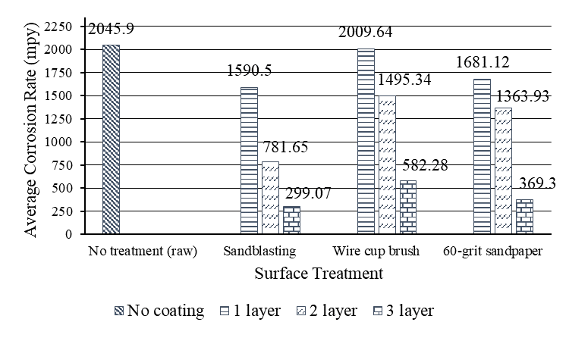
FIGURE 4. Average corrosion rate with the variations of surface treatment and coating layer

CONCLUSIONS
Based on the results of the research and discussion that has been done, it can be concluded that the surface treatment of AISI 1020 steel affects the surface roughness. The test results showed that the sandblasting surface treatment produced the highest average roughness value of 94.73 µin. This is related to the results of the corrosion rate, with the highest roughness value, the lower the corrosion rate obtained. Because the rougher the metal surface, the coating material applied will have more adhesion, so that the metal will be more difficult to react with its corrosive environment. In addition, the large number of layers given to the metal surface is able to effectively reduce the corrosion rate to reach the lowest corrosion rate 299.07 mpy. The results of this research are expected to serve as a reference in optimizing the reduction of corrosion rate in low-carbon steel AISI 1020, which is widely used in the production of various automotive components.

REFERENCES
1. Sidiq, M.F., ANALISA KOROSI DAN PENGENDALIANNYA. JURNAL FOUNDRY, 2022. 3(1): p. 25-30.
2. Khorasanizadeh, S., The effects of shot and grit blasting process parameters on steel pipes coating adhesion. World academy of science, engineering and technology, 2010. 66(6): p. 1304-1312.
3. Khodair, Z.T., A.A. Khadom, and H.A. Jasim, Corrosion protection of mild steel in different aqueous media via epoxy/nanomaterial coating: preparation, characterization and mathematical views. Journal of Materials Research and Technology, 2019. 8(1): p. 424-435.
4. Priyahutama, A.A. and A.A. Rosidah, ANALISIS LAJU KOROSI DAN KEKERASAN BAJA AISI 1020 DALAM MEDIA ASAM SULFAT DENGAN VARIASI SUDUT BENDING DAN MATERIAL PELAPISAN. JURNAL ILMIAH TEKNIK MESIN, 2023. 11(2): p. 97-101.
5. Setiawan, A., A.K. Dewi, and M. Mukhlis, Pengaruh Surface Treatment Terhadap Ketahanan Korosi Baja Karbon Tercoating Zinc Fosfat Pada Media Asam Sulfat. Jurnal Teknologi, 2019. 11(1): p. 57-66.
6. Tamilselvi, M., et al., Nano zinc phosphate coatings for enhanced corrosion resistance of mild steel. Applied Surface Science, 2015. 327: p. 218-225.
7. Kumar, A., S.K. Bhola, and J.D. Majumdar, Microstructural characterization and surface properties of zinc phosphated medium carbon low alloy steel. Surface and Coatings Technology, 2012. 206(17): p. 3693-3699.
8. Setyawan, I.R. and A.A. Rosidah, Analisis pengaruh variasi jumlah pelapisan dan jarak pelapisan spray coating pada baja AISI 1020 terhadap kekasaran dan laju korosi dengan media air garam. Jurnal Teknik Mesin Indonesia, 2023. 18(2): p. 10-14.
9. Dewi, A.K. and A. Setiawan. Analisa Pengaruh Surface Preparation, Coating dan Konsentrasi H2SO4 terhadap Laju Korosi Pada A36. in Proceedings Conference On Design Manufacture Engineering And Its Application. 2017.
10. Sharma, M.M., T.J. Eden, and B.T. Golesich, Effect of Surface Preparation on the Microstructure, Adhesion, and Tensile Properties of Cold-Sprayed Aluminum Coatings on AA2024 Substrates. Journal of Thermal Spray Technology, 2015. 24(3): p. 410-422.
11. Anam, M.A.S., P. Manik, and G. Rindo, Analisis Pengaruh Material Abrasif Pada Blasting Dengan Variasi Metode Coating Terhadap Prediksi Laju Korosi Dan Daya Rekat Adhesi. Jurnal Teknik Perkapalan, 2024. 12(2).
12. Kenteurachmat, A., P. Manik, and A. Wibawa, Analisis Pengaruh Tekanan dan Jarak Air Spray Terhadap Ketebalan Coating dan Laju Korosi Pada Baja A36. Jurnal Teknik Perkapalan, 2024. 12(3).
13. Gao, Y., et al., Galvanic corrosion behavior of hot-dip Al and 55Al–Zn coatings applied to steel bolted joints in atmospheric environments. Construction and Building Materials, 2023. 401: p. 132694.
14. Yusuf, A., et al., PENGARUH WAKTU DALAM PROSES ELEKTROPLATING DENGAN PELAPISAN KUNINGAN TERHADAP KETEBALAN DAN KETAHANAN BAJA KARBON. TEKTONIK : Jurnal Ilmu Teknik, 2024. 1(4): p. 193-199.
15. Fontana, M.G. and N.D. Greene, CORROSION ENGINEERING. 1967, Country unknown/Code not available: 1967.

