Analysis of Variations in Electric Current Welding GMAW S-355J-2 Steel on Mechanical Properties and Welding Defects
Murjito^{a)}, Mohamad Irkham Mamungkas^{b)}, and Irfan Setiawandi^{c)}
Department of Engineering, UniversitasMuhammadiyah Malang, Malang, Indonesia

^{a)} Corresponding author: murjito@umm.ac.id
^{b)} irkham@umm.ac.id
^{c)} irfansetiawandi4@gmail.com
Abstract. The strength of Gas Metal arc welding joints is influenced by many factors, including current strength, electrodes, welding speed, and cooling rate. The purpose of this study is to determine the effect of strong current variations on tensile strength, HAZ macro width, magnetic test, and ultrasonic test. The steel material used is S355J2, Joint single V 60° boot welding capability with 1G position, and ER70S-6 metal filler with GMAW welding with strong current variations of 100 A, 200 A, and 300 A. In the magnetic test, there are no welding defects, and in the ultrasonic test, there are Incomplete fusion welding defects at currents of 100 A and 200 A. Based on this study, the highest tensile strength value is at 200 A with a value of 538.77 Mpa, then at a current of 300 A with a value of 533.5 Mpa and the lowest tensile strength at 100 A with a value of 517.87 MPa. The highest HAZ macro width test result at 300 A current with a value of 4 mm. These results indicate that the best GMAW weld at 200 amps with a tensile strength value of 538.77 Mpa and the greater the welding current used, the greater the width of the weld HAZ.
Keywords: GMAW Welding, Ultrasonic Test, Magnetic Test, Tensile Test, Macro

INTRODUCTION
Welding is a technique for permanently connecting two metal parts, different from connections that use bolts and nuts that can be removed or are not permanent. According to the German Industrial Standard (DIN) welding is defined as a metallurgical connection of metal or metal alloy joints, which is carried out in a melted or liquid state [1]. Gas Metal Arc Welding (GMAW) is a welding process that is widely used in industry. The GMAW welding process uses a solid wire filler metal that is fed continuously and the resulting arc is protected by an inert gas such as argon or helium [2].
Inspection of metal structures such as steel is very important to determine the condition of the material and take preventive measures before the product is damaged during use. Cracks, corrosion, splicing, and fatigue due to prolonged use of the material cause a decrease in function. The Non-Destructive Test (NDT) testing method tests materials without damaging them. The purpose of this inspection is to find and confirm the location, size and characteristics of defects [3]. Destructive tests are tests that damage or damage a material or component permanently. This method is used to understand the mechanical, physical, chemical or other characteristics of the material or component being tested [4].
To determine the quality of GMAW welding joints, several tests were carried out such as Non-Destructive Test (NDT) and Destructive Testing (DT). The NDT tests used in this research were the Magnetic Test and Ultrasonic Test, the DT tests used were the Tensile Test and Macro Area HAZ.
Magnetic Test (MT) is a test that uses a magnetic field and small magnetic particles, such as iron powder, to detect weld defects in components. The only requirement from a testability point of view is that the material of the component under test must be made of ferromagnetic material, because ferromagnetic materials such as iron, nickel, or their alloys can be magnetized to such an extent that the inspection will be effective. This method is appropriate for detecting surface discontinuities in materials [5].
Ultrasonic Test (UT) is a non-damaging test of materials that uses ultrasonic waves to identify weld defects in materials and structures by sending ultrasonic waves [6]. Tensile Test is a tensile testing process which is a test where a tensile force or strain is applied to a material with the aim of determining the tensile strength of the material.
Macro Test HAZ is a test on the heat affected zone area. Heat Effected Zone (HAZ) is the base metal adjacent to the weld metal which experiences rapid heating and cooling cycles during the welding process, so it is the most critical area in the weld. Micro observations of welding results are carried out to determine the shape and width of the HAZ (Heat Effected Zone).
In this research, the problem observed is the effect of variations in current strength of 100 A, 200 A, and 300 A on tensile strength and macro tests on HAZ width in GMAW welding on S355J2 steel using the magnetic test and ultrasonic test methods. This research aims to observe and compare the effect of variations in current strength of 100 A, 200 A, and 300 A on tensile strength and macro tests on HAZ width in GMAW welding on S355J2 steel using magnetic test and ultrasonic test methods.
The benefits obtained in this research are being able to determine the effect of differences in current variations on tensile strength and macro test HAZ width resulting from GMAW welding on S335J2 Steel. This research is able to provide information to the Company and can be used as material for consideration for the next steps to improve the quality of welding results and this research. can be used as a reference for further research that will address the same topic.
The limitations of the problems in this research include, the material used is carbon steel S355J2. The connection process uses GMAW welding with filler metal ER70S-6 with a diameter of 1.2 mm. The welding joint is in the form of a single V 60˚ but joint with position 1G with variations in current strength of 100 A, 200 A and 300 A for GMAW welding. Test methods include (NDT) Magnetic Test and Ultrasonic Test and (DT) Tensile Test and Macro Test methods.

METHODS
The equipment that will be used in this test is: GMAW welding machine, Taper gauge/V seam ruler, Wire brush, Welded ceramic backing, Chipping hammer, Grinder, Handlebar, Personal protective equipment, Yoke Y-2 Magnetic test, Head lamp, White contrast paint, Cleaner, Black Ink, SIUI SMARTOR Ultrasonic test, Zwick Roell Z330 tensile testing machine and macro test lens.
The materials that will be used in this test are: S355J2 steel material, 1.2 mm ER70S-6 electrode, ultrasonic test liquid, sandpaper/rubbing paper, 32% HCL, 68% HNO³, and alcohol.
In this research, the material used is carbon steel S355J2 which has the chemical composition in TABLE 1.

TABLE 1. Chemical Composition of S355J2 Low Carbon Steel [7]

Carbon Steel | C  (max.%) | Mn (max.%) | Si (max.%) | P (max.%) | S (max.%) | N (max.%) | Cu (max.%) | CUV (max.%)
S355J2 | 0.2 | 1.6 | 0.55 | 0.03 | 0.03 | - | 0.55 | 0.47

Before the material is processed into specimen material, the raw material is still a complete plate. First, design a picture of the specimen with the size we want to cut. Next, after drawing the desired design, we must use marking, which here aims to mark the raw material according to the design drawing determined before going to the Cutting Plan stage. This cut is for S355J2 plate, 6 test pieces before welding with a size of 300 mm x 150 mm.
The process of making the test piece for this research uses a V-butt joint connection type with a slope angle of 30˚. Before the welding process takes place, auxiliary materials to facilitate the welding process include ceramic backing and fittings to support the test object during welding.
GMAW welding process with butt joint connection, 6 mm root gap, and filler metal ER70S-6. During the welding process there are 3 welding repetitions with varying currents of 100 A, 200 A and 300 A.
The NDT Magnetic Test testing process is detecting weld defects to determine the weld results on the (surface) surface of the weld. Ultrasonic Test is the detection of weld defects that exist at (sub-surface) the depth and length of the weld.
The Macro Test observation test aims to determine the base metal, weld metal, and HAZ (Heat Affected Zone) width. Macro tests are carried out on welded joints and show the results of the welds and the surrounding area.
The specimen cutting scheme for this test piece uses the international standard ISO 15614-1:2017(E), shown in FIGURE 1.

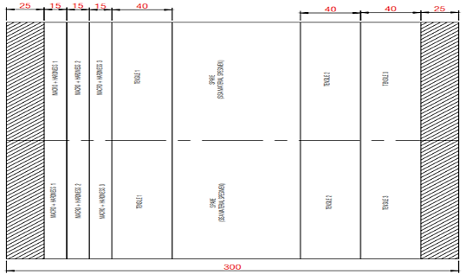
FIGURE 1. Specimen Cutting Scheme [8]

In this tensile test research using the ISO 4136:2022(E) standard, seen in the FIGURE 2 and 3 below.

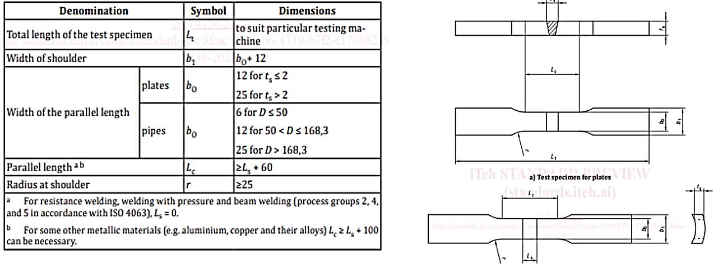
FIGURE 2. Tensile Test Specimen Dimensions Based on ISO 4136:2022 [9]

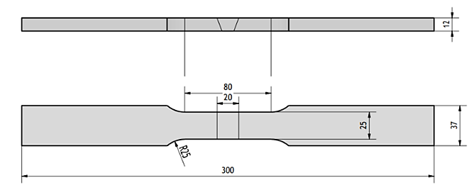
FIGURE 3. Tensile Test Dimensions

RESULTS AND DISCUSSION

Magnetic Test Results
Observation of this magnetic test is to determine the presence of discontinuities on the surface of the material. The following FIGURE 4 and TABLE 2 are the results of testing the S355J2 material for GMAW welding at currents of 100 Ampere, 200 Ampere and 300 Ampere.

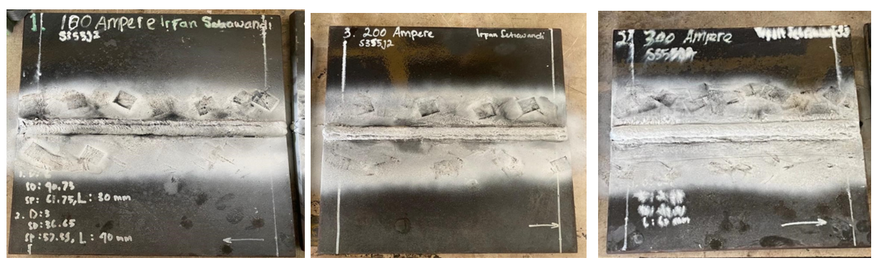
FIGURE 4. Testing Magnetic Particle Test Weld GMAW 100 A, 200 A and 300 A

TABLE 2. Magnetic Test Report Results

No | Material | Ampere | Thickness (mm) | Evaluation |  | Remarks
 |  |  |  | Accepted | Repaired | Remarks
1 | S355J2 | 100 | 12 | √ | - | -
2 | S355J2 | 200 | 12 | √ | - | -
3 | S355J2 | 300 | 12 | √ | - | -

Based on the results of the test data in the table above, it shows that no defects appeared on the surface of the material during the magnetic test inspection process. From observing the magnetic test results of the three specimens, it was concluded that the AWS D1.1, M:2020 standard Acceptance Criteria were accepted. Thus, during the welding process, the skill abilities of a professional welder greatly influence the welding results of the S355J2 material.

Ultrasonic Test Results
This ultrasonic test inspection method uses ultrasonic waves to identify weld defects in the material (Sub-Surface) by sending ultrasonic waves. These waves are reflected from the defect surface and converted into electrical signals that are displayed on the monitor layer. However, if there are no defects it will pass through the structure without resistance. The following TABLE 3 are the results of ultrasonic GMAW welding test observations at currents of 100 Ampere, 200 Ampere and 300 Ampere below:

TABLE 3. Ultrasonic Test Report Results

Ampere | Probe angle (◦) | Frequency (MHz) | Leg | Decibels |  |  |  | Record of Discontinuity |  |  |  |  |  | Evaluation |  | Remarks
 |  |  |  | Indication Level | Reference Level (b) | Attenuation Factor (c) | Indication Rating (d) | Class of Indication | Length (mm) | Angular Distance (mm) | Depth from Face A (mm) | Distance from Y (mm) | Discontinuity Type | Accepted | Repaired
100 | 0 | 2.5 | - | - | 22 | - | - | - | - | - | - | - | - | √ |  | -
100 | 70 | 2 | 1-2 | 59.5 | 55 | 1 | 3.5 | A | 40 | 37.2 | 25 | 11 | IF |  | √ | -
200 | 0 | 2.5 | - | - | 22 | - | - | - | - | - | - | - | - | √ |  | -
200 | 70 | 2 | 1-2 | 65.5 | 55 | 2 | 8.5 | A | 25 | 49 | 29 | 7 | IF |  | √ | -
300 | 0 | 2.5 | - | - | 22 | - | - | - | - | - | - | - | - | √ |  | -
300 | 70 | 2 | - | - | 55 | - | - | - | - | - | - | - | - | √ |  | -
Discontinuity Type : CR : Crack IF : Incomplete Fusion IP : Incompete Penetration EI : Elongated Indication

Based on the results of the ultrasonic inspection test of the GMAW welding electrode ER70S-6 at a current of 100 Ampere, defects were detected in the range of 30 – 60 mm with the distance of the probe to the weld defect being 17.02 mm with a depth of 11.25 and a weld defect length of 40 mm. At a current of 200 Amperes, defects were detected in the range of 30 - 60 mm with the distance between the probe and the weld defect being 28.05 mm with a depth of 7.24 mm and a weld defect length of 25 mm. Meanwhile, at a current of 300 Amperes, no weld defects were detected during the ultrasonic test inspection process. So, it can be concluded that currents of 100 Ampere and 200 Ampere do not meet (Acceptance Criteria) AWS D1.1, M:2020 standards, while currents of 300 Ampere meet (Acceptance Criteria) AWS D1.1, M:2020 standards.

Tensile Test Results
Following TABLE 4 are the results of the tensile strength test table for variations in current strength of 100 Ampere, 200 Ampere, and 300 Ampere.
TABLE 4. Tensile Test Results Data

Arus | No. Spesimen | Yield Strength | Tensile Strength | Elongation % | Failure Location
100 | 1 | 379 | 539,1 | 25,7 | Weld Metal
100 | 2 | 380,8 | 523,6 | 16,3 | Weld Metal
100 | 3 | 378,7 | 490,9 | 13,3 | Weld Metal
100 | Rata - rata | 379,5 | 517,87 | 18,43
200 | 1 | 385,3 | 542,4 | 28,2 | Base Metal
200 | 2 | 381,7 | 545,3 | 33,2 | Base Metal
200 | 3 | 366,2 | 528,6 | 31,4 | Base Metal
200 | Rata - rata | 377,73 | 538,77 | 30,93
300 | 1 | 377,5 | 534,1 | 27,3 | Base Metal
300 | 2 | 379 | 536,5 | 30,4 | Base Metal
300 | 3 | 373,4 | 529,9 | 27,7 | Base Metal
300 | Rata - rata | 376,63 | 533,5 | 28,47

In the TABLE 4, the average values ​​obtained along with the tensile test results for each current variation of 100 A, 200 A and 300 A have an influence on the tensile strength of the material. The average tensile strength value of the 100 A current variation obtained was 517.87 Mpa, with the largest tensile strength value being the tensile strength of the 1st specimen, namely 539.1 Mpa. The average tensile strength value of the 200 A current variation obtained was 538.77 Mpa, with the largest tensile strength value in the second specimen, namely 545.3 Mpa. The average tensile strength value of the 300 A current variation obtained was 533.5 Mpa, with the largest tensile strength value in the second specimen, namely 536.5 Mpa.
In research on current variations of 100 A, 200 A and 300 A, GMAW welding ER70S-6 electrodes with a diameter of 1.2 mm on S355J2 steel material, these results show that the increasing welding current will reduce the tensile strength value and the best GMAW welding is at a current of 200 Ampere with tensile strength value 538.77 Mpa.
The tensile strength results of the 100 A variation have the lowest value because it is difficult to ignite an unstable electric arc resulting in fractures in the weld metal area. The tensile strength results from varying currents of 200 A are greater than 100 A, at a current of 200 A the electric arc ignition is better and more stable. In contrast to the current of 300 A, it produces a larger arc spark and the melting of the electrode wire together with the shielding gas is faster and more stable. So it can be seen that current variations of 200 A and 300 A result in fractures in the base metal area and have better tensile strength values ​​compared to current variations of 100 A.
The results of this tensile test include Ultimate Tensile Strength and Yield Strength. The acceptance requirements for tensile tests in the ASME Sec standard. IX QW-153 [10]

Macro Test Results
The results of the macro testing that has been carried out will be reviewed based on the acceptance criteria of AWS D1.1 6.10.4.1 of 2020 (American Welding Society, 2020) and test objects that can pass visual inspection must meet the requirements
Visual analysis of macro test specimens based on the acceptance criteria of AWS D1.1 6.10.4.1 can be seen in the following FIGURE 5, 6, and 7.
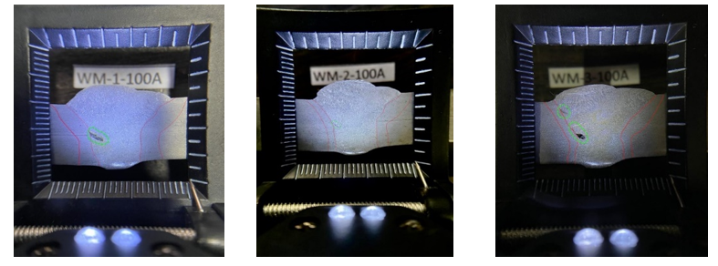
FIGURE 5. 100 A Specimen Macro Test Results

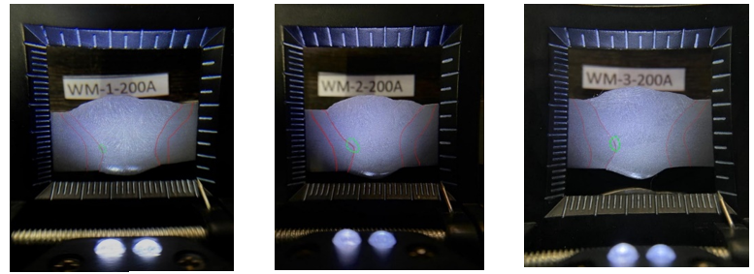
FIGURE 6. 200 A Specimen Macro Test Results

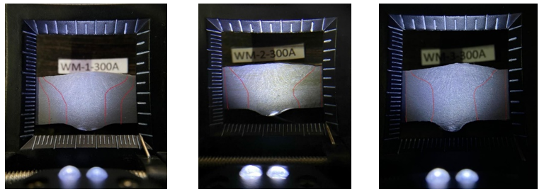
FIGURE 7. 300 A Specimen Macro Test Results

In the figure above, it can be seen in the image of the first specimen of GMAW welding with a current of 100 A, there is an incomplete fusion weld defect with dimensions of 4 mm. In the second specimen with a current of 100 A, there was an incomplete fusion weld defect with dimensions of 3 mm. Meanwhile, in the third specimen with a current of 100 A, there was an incomplete fusiom weld defect with dimensions of 3 mm and 2 mm. In GMAW welding with a current of 200 A, the first specimen has an incomplete fusion weld defect with dimensions of 2 mm, the second specimen also has an incomplete fusion weld defect with dimensions of 2 mm and finally the third specimen has an incomplete fusion weld defect with dimensions of 2 mm. Meanwhile, in Specimens 1, 2 and 3, there were no welding defects in the HAZ (Heat Affected Zone) area of ​​the S355J2 material at a current of 300 A. Overall, there were no cracks in all specimens. However, there is an incomplete fusion welding defect between weld metal and base metal in GMAW welding currents of 100 A and 200 A which causes the specimens to not comply with the acceptance criteria of AWS D1.1 6.10.4.1 of 2020. Meanwhile, at 300 A current specimens 1, 2 and 3 in accordance with the acceptance criteria of AWS D1.1 6.10.4.1 2020.
The results of the HAZ width macro test data obtained from each right and left side of the specimen are as following TABLE 5.

TABLE 5. Macro Test Results Data

Current (Ampere) | No. Spesimen | HAZ width (mm)
Current (Ampere) | No. Spesimen | Right | Left | Average
100 | 1 | 2 mm | 2 mm | 2
100 | 2 | 2 mm | 2 mm | 2
100 | 3 | 2 mm | 2 mm | 2
Average |  |  |  | 2 mm
200 | 1 | 3 mm | 3 mm | 3
200 | 2 | 3 mm | 3 mm | 3
200 | 3 | 3 mm | 3 mm | 3
Average |  |  |  | 3 mm
300 | 1 | 4 mm | 4 mm | 4
300 | 2 | 4 mm | 4 mm | 4
300 | 3 | 4 mm | 4 mm | 4
Average |  |  |  | 4 mm

In the table you can see the relationship between HAZ width and welding current, where the 100 A current variation has an average value of 2 mm HAZ width, the 200 A current variation has an average HAZ width value of 3 mm, and the 300 A current variation has an average value -average HAZ width 4 mm. These results show that the higher the welding current value used, the wider the resulting HAZ. This is supported by [11], who stated in his research that the influence of heat input is directly proportional to the width of the resulting HAZ, and current is one of the parameters that influences the amount of heat input in welding.

CONCLUSIONS
Based on the results of research that has been carried out regarding the influence of variations in welding current strength on mechanical properties and non-destructive test observations, the following conclusions were obtained:
1. The results of the magnetic test on GMAW welding with current variations of 100 A, 200 A and 300 A showed no welding defects on the surface of the S355J2 base metal. Thus the magnetic test meets AWS D1.1, M:2020 standards. In the ultrasonic test of GMAW welding results with variations in current of 100 A, 200 A, there was a weld defect with a length of 40 mm and a weld defect length of 200 A of 25 mm, an indication that the defect was incomplete fusion at the (sub-surface). Meanwhile, at a current of 300 A, there are no welding defects and meets AWS D1.1, M:2020 standards. In testing the tensile strength of GMAW welding with varying currents of 100 A, 200 A and 300 A, it has an influence on the tensile strength of each S355J2 low carbon steel specimen. At a welding current of 100 A, an average tensile strength of 517.87 Mpa is obtained. At a welding current of 200 A, an average tensile strength of 538.77 Mpa was obtained. Meanwhile, a welding current of 300 A gets an average tensile strength of 533.5 Mpa. In the results of GMAW welding research, the influence of current variations of 100 A, 200 A and 300 A, the best welding current in this research was obtained at a current of 200 Ampere with a tensile strength value of 538.77 Mpa.
2. Observation results of macro HAZ (Heat Affected Zone) testing, the 100 A variation has a HAZ width value of 2 mm, the 200 A current variation has a HAZ width value of 3 mm, while the 300 A current variation has a HAZ width value of 4 mm. It can be concluded that the greater the welding current used, the HAZ width of the weld area also increases or widens.

References
1. Sari, D.P., et al., Flow Rate Effects on Microstructure and Mechanical Properties for Titanium Weld Joint. Journal of Energy, Mechanical, Material, and Manufacturing Engineering, 2021. 6(3): p. 189-196.
2. Toruan, H.H.L., et al., Use of DC Motor Control in Development of Pipe Welding Technology by Using the GMAW Process for Variation of Welding Nozzle Movement. International Journal of Research in Vocational Studies (IJRVOCAS), 2023. 3(3): p. 28-31.
3. Subiyanto, L. and T.A. Sardjono, Deteksi cacat pada material baja menggunakan ultrasonik non-destructive testing dengan metode continuous wavelet transform. Semantik 2012, 2012: p. 466-472.
4. Sutisna, N.A., Rancang Bangun Mesin Uji Universal Untuk Pengujian Tarik dan Tekuk Bertenaga Hidrolik. Jurnal Teknik Mesin dan Mekatronika (Journal of Mechanical Engineering and Mechatronics), 2021. 6(1): p. 32-41.
5. Dwivedi, S.K., M. Vishwakarma, and A. Soni, Advances and researches on non destructive testing: A review. Materials Today: Proceedings, 2018. 5(2): p. 3690-3698.
6. Kroworz, A. and A. Katunin, Non-destructive testing of structures using optical and other methods: A review. Structural Durability & Health Monitoring, 2018. 12(1): p. 1.
7. Seitl, S., et al., Comparison of the fatigue crack propagation rates in S355 J0 and S355 J2 steel grades. Key Engineering Materials, 2018. 784: p. 91-96.
8. Zakaria, N.A.M., et al., Power Efficiency Analysis based on Lightning Effect on Large-Scale Solar Photovoltaic System. Journal of Advanced Research in Applied Sciences and Engineering Technology, 2023. 31(2): p. 19-30.
9. Iso, E.N., Destructive tests on welds in metallic materials—Transverse tensile test. 2012.
10. Irawan, B.H., N.P. Ariyanto, and J.F. Siregar, Destructive Test Material SA516 70N Untuk Kualifikasi Pengelasan Standar ASME BPVC Sec. IX-2021. Jurnal Teknik Mesin, 2023. 16(2): p. 133-138.
11. Bagaskoro, R., Analisa Pengaruh Variasi Heat Input Terhadap Cacat Pengelasan, Lebar Haz, Dan Kekerasan Pada Pengelasan SMAW Material Tembaga C81300. 2018.

