Design Gravitational Energy Storage System with an Inclined Track
Suwarsono^{1,a)}, Budiono^{1,b)}, Ardi Lesmawanto^{1,2,c)}, and Alifia Oriana Prabaswara^{3,d)}
¹Department of Mechanical Engineering, University of Muhammadiyah Malang, Malang, Indonesia
²Department of Power Mechanical Engineering, National Formosa University, Huwei, Taiwan
³Department of Civil Engineering, University of Muhammadiyah Malang, Malang, Indonesia

^{a)} Corresponding author: suwarsono@umm.ac.id
^{b)} budionoft@umm.ac.id
^{c)} ardilesmawanto@umm.ac.id
^{d)} alifiaoriana@gmail.com
Abstract. Indonesia's vast archipelago, with its growing network of power plants, requires a dependable electrical grid system. Electricity demand varies widely with time and seasons, leading to energy wastage during low-consumption periods. To mitigate this issue, an efficient and integrated energy storage solution is essential. Conventional chemical energy storage systems, such as batteries and power banks, become costly and inefficient at large scales. As an alternative, converting electrical energy into gravitational energy offers a promising solution. This research focuses on designing a control system for gravitational energy storage using an inclined track. The system integrates a transmission mechanism, braking system, mechanical-to-electrical conversion, and electrical-to-mechanical conversion. This study extends previous research on gravitational energy storage methods utilizing modular load masses. The research includes a comprehensive mathematical analysis of mechanical reliability, material strength, and component longevity. The proposed system presents several advantages: it is simpler to construct, can efficiently store and release small amounts of electrical energy, and offers ease of control and maintenance. Additionally, it is well-suited for hilly terrains and exhibits resilience to humid weather conditions.
Keywords: Electrical energy storage, gravitational energy, inclined track, modular.

INTRODUCTION
Energy storage is a critical component of achieving a sustainable and resilient energy system, offering both economic and environmental benefits [1, 2]. A diverse array of energy storage technologies has emerged, including Compressed Air Energy Storage (CAES) [3], Flywheel Energy Storage (FES) [4], Pumped Hydro Energy Storage (PHES) [5], Battery Energy Storage (BES) [6], Flow Battery Energy Storage (FBES) [7], Superconducting Magnetic Energy Storage (SMES) [8], Supercapacitor Energy Storage (SCES) [9], hydrogen storage [10], synthetic fuels [11], and Thermal Energy Storage (TES) [12]. While each technology possesses unique advantages and limitations, comprehensive reviews have provided valuable insights into their efficiency, cost-effectiveness, and suitability for specific applications.
Gravitational energy storage, a principle harnessed in ancient pendulum clocks, offers a promising alternative for large-scale energy storage. Traditional methods, such as mass stacking using cranes, have been hindered by high costs and operational complexity [13]. This research proposes a more efficient and economical approach: the Mountain Gravity Energy Storage (MGES) system. MGES involves elevating solid masses using electric motors to store gravitational potential energy, which is subsequently converted back into electricity during discharge [14]. This concept has been explored in various sectors, including construction and mining, utilizing materials like sand or gravel as energy storage mediums, demonstrating its potential for long-term, scalable energy storage.
MGES systems offer several advantages, including lower construction and maintenance costs compared to chemical batteries [14], adaptability to hilly terrains, and resilience to humid conditions [15]. Additionally, their ability to store energy for extended periods, ranging from days to years, makes them ideal for balancing fluctuations in energy supply and demand. However, currently, there are still very few commercially viable technologies that offer affordable long-term energy storage with low generation capacity, especially below 20 MW. Therefore, this study aims to design a modular gravitational energy storage system using inclined tracks that requires less energy, easier to construct, and more reliable especially for low generation capacity energy storage. By developing this technology, it is expected that renewable energy integration will be enhanced, energy wastage will be reduced, and a more economical alternative to traditional storage methods will be provided.

METHODS
This study aims to design an optimal Gravitational Energy Storage mechanism capable of supporting a modular gravitational energy storage system. A control system is required to ensure the stability of the generated electricity, even if the load descent speed varies.
The data used to design the new system includes detailed functions and sub-functions of several existing designs developed by Emrani, Chaturvedi, and ARES. Emrani et al. [16] combined a gravity system with a motor storage mode and a turbine release mode (see FIGURE 1). Chaturvedi et al. [17] developed an electric gravity energy storage system using a pulley system. The load is lifted using an electric motor and stacked around the tower. When the potential energy of the load is converted into electricity, a generator is required (see FIGURE 2). The energy storage technique developed by ARES [18] uses a train series on a hillside, with modular loads functioning as potential energy (see FIGURE 3). FIGURE 4 illustrates the ARES gravity energy storage and release system.

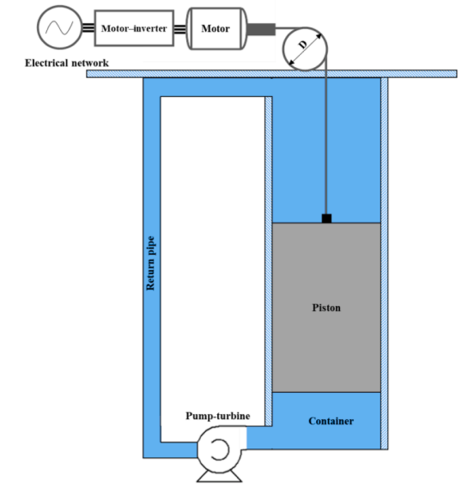
FIGURE 1. The gravitational electric energy storage system by Emrani et al.

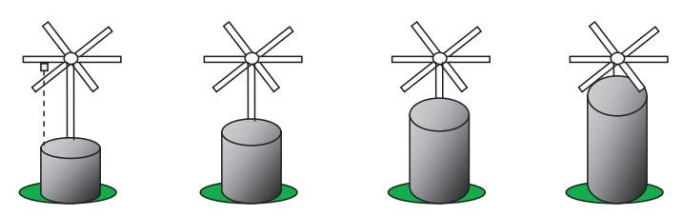
FIGURE 2. The gravitational electric energy storage system developed by Chaturvedi et al.

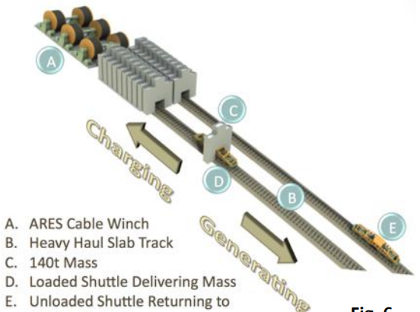
FIGURE 3. The gravitational electric energy storage system developed by ARES

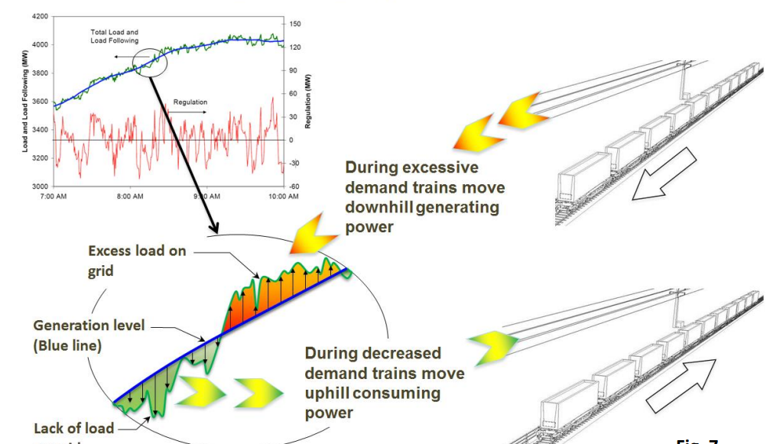
FIGURE 4. The energy storage and release system for gravitational electric energy developed by ARES

In this study, the Pahl-Beitz method and the TRIZ method are combined to achieve an optimal design.
- Pahl-Beitz Method
Functionally, a gravitational energy storage system must have the capability to convert electrical energy into potential energy (height). It must also be able to safely hold potential energy until the load is converted back into electrical energy. Additionally, it should have a load descent speed control system to ensure that the generated electricity remains sufficiently constant. Furthermore, the system must be equipped with a mechanism to convert potential energy into kinetic energy, and finally, it should have the ability to convert kinetic energy into electrical energy.
- TRIZ Method
The TRIZ method helps in the product design process by utilizing the contradictions in design requirements. For a gravitational electric energy storage system, there is a contradiction that must be resolved: the stored electrical energy must be large to store and release a large amount of electrical energy, but the released electrical energy must also be small to store and release a small amount of electrical energy.
According to the TRIZ 40 Principles, the 'segmentation' technique can be chosen, where the load is arranged modularly so that electrical energy can be converted in both large and small amounts. A functional summary of each design is tabulated in a Morphological Matrix as shown in TABLE 1.

TABLE 1. Morphological Matrix of the Gravitational Energy Storage Design
Items | Emrani et al. [16] | Chaturvedi et al. [17] | ARES[] | This study
Load Mass | Single | Modular | Modular | Modular
Loading Mass | Not Required | Required | Required | Required
Track | Vertical | Vertical | Rail | Rail
Electrical Capacity | Small | Medium | Large | Large
Manufacturing Cost | Medium | High | High | High
Reliability | Medium | Low | High | High
Operation | Easy | Difficult | Difficult | Easy
Maintenance | Inexpensive | Expensive | Expensive | Inexpensive

RESULTS AND DISCUSSION
The TRIZ method helps the product design step take advantage of the contradictions of the design requirements. In the case of gravitational electrical energy storage systems, there are contradictions that must be resolved, namely:
- The stored electrical energy "must be large", in order to be able to store and release large amounts of electrical energy. but,
- also the electrical energy released "must be small", capable of storing and releasing small amounts of electrical energy.
- In accordance with TRIZ 40 Principles, a “segmentation” technique can be chosen. Where the load is arranged in a modular manner, so that electrical energy can be converted in large or small quantities.
By using the Pahl-Beitz method, TRIZ, and the Morphological Matrix in Table 1, the proposed new Gravitational Electric Energy Storage design can schematically adopt several advantages of existing energy storage systems. FIGURE 5 illustrates a schematic of a gravitational electric energy storage system with modular loads on parallel rails on an inclined track proposed in this study.

Mass 1
Mass 3
Mass 2
Rope 3
Rail 1
Rope 1
Motor & Genarator
Mass 1
Rail 1
Mass 2
Reil 2
Rope 1
Motor & Genarator
Rise Angle
Mass 1
Mass 3
Mass 2
Rope 3
Rail 3
Rope 1
Motor & Genarator
Rise Angle
FIGURE 5. Sketch of the gravitational energy storage system with load/mass modules on several parallel rails on an inclined track

CONCLUSIONS
The conclusions from this research are:
- Obtained a novelty (invention) from a gravitational force electrical energy storage system, modular loads on inclined track rails (hills)
- This system is very suitable to be implemented in Indonesia, which has many hilly areas
- This gravitational force electrical energy storage system is relatively reliable compared to chemical, pneumatic and hydraulic electrical energy storage methods. Because it has a stable storage time for a long time
- Gravity-style electrical energy storage systems are relatively easy to operate and maintain

Acknowledgments
Financial assistance for this work was granted by Directorate Research and Public Service, Universitas Muhammadiyah Malang, through the project Nomor: E.2.a/334/BAA-UMM/IV/2022.

References
1. Mohanty, A., et al., Power system resilience and strategies for a sustainable infrastructure: A review. Alexandria Engineering Journal, 2024. 105: p. 261-279.
2. Amir, M., et al., Energy storage technologies: An integrated survey of developments, global economical/environmental effects, optimal scheduling model, and sustainable adaption policies. Journal of Energy Storage, 2023. 72: p. 108694.
3. Bazdar, E., et al., Compressed air energy storage in integrated energy systems: A review. Renewable and Sustainable Energy Reviews, 2022. 167: p. 112701.
4. Choudhury, S., Flywheel energy storage systems: A critical review on technologies, applications, and future prospects. International transactions on electrical energy systems, 2021. 31(9): p. e13024.
5. Blakers, A., et al., A review of pumped hydro energy storage. Progress in Energy, 2021. 3(2): p. 022003.
6. Mustafa, M.B., et al., Evaluation of a battery energy storage system in hospitals for arbitrage and ancillary services. Journal of Energy Storage, 2021. 43: p. 103183.
7. Shigematsu, T. and T. Shibata, Vanadium FBES s installed by Sumitomo Electric Industries, Ltd. Flow Batteries: From Fundamentals to Applications, 2023. 3: p. 1055-1078.
8. Chen, X., et al., Energy-saving superconducting magnetic energy storage (SMES) based interline DC dynamic voltage restorer. CSEE Journal of Power and Energy Systems, 2021. 8(1): p. 238-248.
9. Yang, B., et al., Robust fractional-order PID control of supercapacitor energy storage systems for distribution network applications: A perturbation compensation based approach. Journal of Cleaner Production, 2021. 279: p. 123362.
10. Tarhan, C. and M.A. Çil, A study on hydrogen, the clean energy of the future: Hydrogen storage methods. Journal of Energy Storage, 2021. 40: p. 102676.
11. Rozzi, E., et al., Green synthetic fuels: Renewable routes for the conversion of non-fossil feedstocks into gaseous fuels and their end uses. Energies, 2020. 13(2): p. 420.
12. Mahon, H., et al., A review of thermal energy storage technologies for seasonal loops. Energy, 2022. 239: p. 122207.
13. Tong, W., et al., Solid gravity energy storage: A review. Journal of Energy Storage, 2022. 53: p. 105226.
14. Franklin, M., et al., Gravity energy storage systems, in Storing Energy. 2022, Elsevier. p. 91-116.
15. Zhang, Y., et al. Key Technologies and Development Paths of Gravity Energy Storage in Large Scale Development of Renewable Energy Bases. IEEE.
16. Emrani, A., A. Berrada, and M. Bakhouya, Modeling and performance evaluation of the dynamic behavior of gravity energy storage with a wire rope hoisting system. Journal of energy storage, 2021. 33: p. 102154.
17. Chaturvedi, D.K., et al. Electricity storage system: A gravity battery. IEEE.
- ARES, “Advance Rail Energy Storage, Ridgeline Animation-System Charging,” YouTube, [Online Video], Available: https://www.youtube.com/watch?v=t0-4rMGAbD8&t=16s. [Accessed: Aug. 1, 2024].

