Effect of Current Variations and Welding Edge on Hardness and Microstructure in SMAW Welding Using Aluminum 5083
Mohamad Irkham Mamungkas^{a)}, Nur Subeki^{b)}, and Murjito^{c)}
Department of Engineering, Universitas Muhammadiyah Malang, Malang, Indonesia

^{a)} Corresponding author: irkham@umm.ac.id
^{b)} nursubeki@umm.ac.id
^{c)} murjito@umm.ac.id
Abstract. Welding is a core process in the shipping industry, especially in Indonesia. Almost all ship parts involve welding techniques. Type 5083 aluminum, with its resistance to corrosion, is a popular choice for ship structures. In the 5083-aluminum welding process, factors such as electric current (Ampere) and electrode type (E 4043) greatly influence the final result. This research was carried out systematically, starting from the planning stage to data collection. The process includes making samples, testing the quality of weld joints, preparing samples for microscopic analysis, and measuring mechanical properties. The highest hardness value in the welding part was obtained from the Vickers test results with variations in current strength parameters of 140 Ampere, 160 Ampere, and 180 Ampere on Aluminum 5083. The highest average value from welding results with a current strength of 180 Ampere can reach 4.65 HV of the average of all types of welding seams at that current strength. In the microstructure results, the compound content of Mg2Si particles is more dominant in the base metal area so that the hardness data also validates the hardness value in that area. Variations in the electric current strength of 140A, 160A, and 180A with respect to the hardness value of SMAW welding. The highest hardness value is owned by base metal at a current strength of 180 A with a single V grove weld seam and the lowest hardness is owned by base metal at a current strength of 160 A with a bevel weld seam.
Keywords: Aluminum 5083, SMAW, Metal Testing.

INTRODUCTION
In terms of developing and manufacturing technology in the increasingly advanced shipping sector, especially in Indonesia, it cannot be separated from welding [1], because the construction of each part of the ship involves a lot of welding elements [2]. It is almost impossible for the shipbuilding process in a factory without involving welding. One of the advantages of this series is that welding is easier because it is a non-heat treatable alloy [3] [4]. The 5083 series alloy is a type that is widely used in industry, because it has good mechanical properties and weldability. The most common use is for shipping and pressure vessel construction [5]. Once the electrode moves away from the processing area, the weld lump hardens and the welding operation is completed [6] [7]. Electrodes are generally coated with flux, which melts and decomposes during the welding operation and forms a protective layer that protects the weld lump from atmospheric oxygen [8] [9].
The welding process is a process of joining materials using heat energy. Local heating of the plate to the melting temperature and a rapid cooling process can produce residual stresses due to uneven heat distribution [10]. Based on this explanation, it cannot be denied that the development of metal welding technology makes it easier for humans to carry out their lives [11] [12]. The most widely used welding is electrode welding, where the electrode is wrapped in flux. This flowing current is called an arc which can melt metal. This causes the base metal to melt and the electrode to also melt, resulting in a mixing of the two liquid metals.
The use of aluminum materials is a type of non-ferrous metal which has certain advantages compared to other metals used in the industrial world [13]. Aluminum is a light metal, has good corrosion resistance and good electrical conductivity and has other good properties as metal properties, apart from that, aluminum also has formability where this aluminum alloy can be worked or processed both in cold working and hot working [14]. Pure aluminum is a soft, durable, light, and malleable metal with an external appearance varying from silvery to gray, depending on the roughness of the surface. This alloy has good corrosion resistance, is very light, has a low coefficient of expansion and is a good conductor of heat and electricity.
After the welding process, dry penetrant testing is required [15]. This method is used to find defects on the open surface of solid components, both metal and non-metal, such as ceramics and plastic fibers. The aim of this research was to determine how the results of several different treatments on specimens can influence the number and type of weld defects by visual inspection of the results of penetrant testing.
Macro observation is basically looking at differences in the intensity of reflected light from a metal surface that is put into a microscope so that different images occur. As a result, the color that appears on the microscope is black. Meanwhile, a slightly corroded surface will appear light in color. The process of differences in color, grain size, shape and grain size which underlies the determination of the type and nature of the phase in the results of microphoto observations is caused by the etching process [16] [17].

METHODS
In this study, 5083 aluminum material was used with SMAW welding 3 (three) repetitions, 1 (one) hardness testing area for each specimen and 1 (one) photo of each weld metal, HAZ and base metal welding area for microstructural testing.
Experimental research is research used to find the effect of certain treatments on others under controlled conditions. Experimental design is the complete steps that need to be taken before an experiment is carried out so that the data that is needed can be obtained, so that it will lead to objective analysis and conclusions that apply to the problems being discussed.
The welding machine in FIGURE 1 is used to carry out welding of material that has been cut into 2 parts using a predetermined current strength, with the following specifications:
• Brand: Miller Electric
• Series: Syncrowave 250 DX
• Process: Stick Welding (SMAW); TIG Welding (GTAW); Air Carbon Arc Cutting and Gouging (CAC-A)
• Phase: Single
• Input Frequency: 50/60 Hz
• Polarity: AC/DC
• Input voltage: 220 to 575 V AC
• The welding power source type is CC
• Rated output (TIG) : 200A, 28V AC 60%; 250A, 30V AC 40%
• Ampere (TIG): 3 – 310 A
• For types of materials: Aluminum and steel

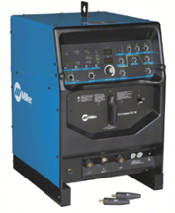
FIGURE 1. SMAW/TIG Miller Welding Machine

Aluminum 5083 material is displayed in FIGURE 2. The material used is aluminum 5083 with a length of 10 mm, a width of 10 mm and a thickness of 12 mm, totaling 9 pieces.
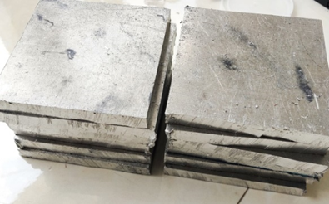
FIGURE 2. 5083 Series Aluminum Material

The type of electrode used in SMAW welding is Al-43 brand Grilumin 14 in FIGURE 3 as a welding filler in this research, with material specifications as follows:
- Brand: Grilumin 14
- AWS Code: A-5.3 Al-43, DIN 1732 S-ALSi 5.
- Size: 3.2 × 350 mm
- Current: AC and DC EP
- Welding material: Aluminum
- Ampere: 60 – 90 A (Heat treatment)

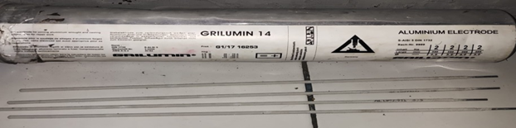
FIGURE 3. SMAW Grilumin 14 (Al-43) Welding Electrodes

RESULTS AND DISCUSSION
In this study, 5083 aluminum material was used with SMAW welding 3 (three) repetitions, 1 (one) hardness testing area for each specimen and 1 (one) photo of each weld metal, HAZ and base metal welding area for microstructural testing.
TABLE 1. Hardness Value Data from VHN (Vickers Hardness Number)
Variation | Bevel |  |  | Single V Grove |  |  | Double V Grove
Variation | Weld | HAZ | Base | Weld | HAZ | Base | Weld | HAZ | Base
140 | 2,7 | 3,39 | 5,75 | 3,21 | 3,86 | 4,84 | 3,83 | 5,12 | 4,86
140 | 3,61 | 4,28 | 4,14 | 3,53 | 4,33 | 4,35 | 6,73 | 4,48 | 4,61
140 | 2,9 | 4,11 | 5,53 | 3,4 | 3,92 | 3,75 | 4,89 | 5,14 | 4,34
Mean | 3,07 | 3,92 | 5,14 | 3,38 | 4,04 | 4,31 | 5,15 | 4,91 | 4,61
160 | 4,28 | 3,08 | 2,68 | 5,02 | 3,62 | 7,48 | 4,63 | 4,26 | 6,79
160 | 2,76 | 2,5 | 2,6 | 3,72 | 3,25 | 4,85 | 4,87 | 4,23 | 4,06
160 | 2,69 | 2,68 | 2,64 | 3,79 | 3,73 | 4,27 | 4,48 | 6,44 | 4,93
Mean | 3,24 | 2,75 | 2,64 | 4,18 | 3,53 | 5,53 | 4,66 | 4,98 | 5,26
180 | 4,83 | 4,03 | 4,86 | 3,65 | 6,25 | 5,77 | 4,03 | 5,57 | 5,48
180 | 3,85 | 3,46 | 3,31 | 3,28 | 5,95 | 6,68 | 5,25 | 4,03 | 5,15
180 | 3,48 | 3,17 | 2,98 | 4,07 | 4,48 | 6,29 | 5,89 | 4,63 | 5,15
Mean | 4,06 | 3,55 | 3,72 | 3,67 | 5,56 | 6,24 | 5,05 | 4,74 | 5,26

In the TABLE 1 above, it can be seen that the data on the influence of the parameters of variations in current strength and type of welding seam on the level of material hardness are arranged in columns and rows with an average level of hardness resulting from 3 (three) repetitions of 1 (one) hardness testing area for each specimen.
From the table above, it can be seen that the resulting level of hardness can be grouped into three parts, namely weld metal, HAZ (Heat Affected Zone), and base metal. The weld metal or welding fluid with the bevel weld seam type has the highest hardness value with 3 (three) different types of current variations respectively starting from 3.61 HV; 4.28 HV; and 4.83 HV produces an average hardness value of 3.07 HV; 3.24 HV; and 4.06 HV. For single V grove weld seam types, respectively, starting from 3.53 HV; 5.02 HV; and 4.07 HV produces an average hardness value of 3.38 HV; 4.18 HV; and 3.67 HV. Meanwhile, for the double V grove weld seam type respectively starting from 6.73 HV; 4.87 HV; and 5.89 HV produces an average hardness value of 5.15 HV; 4.66 HV; and 5.05 HV.
In the HAZ (Heat Affected Zone) section or the area that experiences changes in properties, the bevel weld seam type has the highest hardness value with 3 (three) different types of current variations respectively starting from 4.28 HV; 3.08 HV; and 4.03 HV produces an average hardness value of 3.92 HV; 2.75 HV; and 3.55 HV. For single V grove weld seam types, respectively, starting from 4.33 HV; 3.73 HV; and 6.25 HV produces an average hardness value of 4.04 HV; 3.53 HV; and 5.56 HV. Meanwhile, for the double V grove weld seam type, respectively, starting from 5.14 HV; 6.44 HV; and 5.57 HV produces an average hardness value of 4.91 HV; 4.98 HV; and 4.74 HV.
Meanwhile, the base metal part is the part of the parent metal that is not exposed to the welding fluid, with the bevel weld seam type having the highest hardness value with 3 (three) different types of current variations respectively starting from 5.75 HV; 2.68 HV; and 4.86 HV produces an average hardness value of 5.14 HV; 2.64 HV; and 3.72 HV. For the single V grove weld seam type respectively starting from 4.84 HV; 7.48 HV; and 6.68 HV produces an average hardness value of 4.31 HV; 5.53 HV; and 6.24 HV. Meanwhile, for the double V grove weld seam type respectively starting from 4.86 HV; 6.79 HV; and 5.48 HV produces an average hardness value of 4.61 HV; 5.26 HV; and 5.26 HV.

FIGURE 4. Graph of Hardness Values ​​against Bevel Welding Seam Variations

It can be seen in the FIGURE 4 that the lowest hardness value for bevel weld seam variations is found in base metal at a current strength of 160 Ampere with a hardness value of 2.64 HV.

FIGURE 5. Graph of Hardness Values ​​against Variations in Single V Grove Welding Seams
It can be seen in FIGURE 5, the graph that the lowest hardness value for single V Grove weld seam variations is found in weld metal at a current strength of 140 Ampere with a hardness value of 3.38 HV.

FIGURE 6. Graph of Hardness Values ​​against Variations in Double V Grove Welding Seam

It can be seen in FIGURE 6 that the lowest hardness value for variations in double V Grove welding seam is found in base metal at a current strength of 140 Ampere with a hardness value of 4.61 HV.

Microstructural Testing
This microstructural test was carried out in 3 (three) areas according to the hardness test, namely weld metal, HAZ, and base metal. The specimen to be micro tested is first etched using a chemical liquid in the form of Keller's Reagent solution which is used for 5083 series Aluminum material consisting of: 2ml HF, 3ml HCl, 5ml HNO3, and 190ml H2O where the function of this solution is to erode the surface of the test piece that will be tested to get a clear surface image.
TABLE 2. Micro-etched test piece
Variation | Bavel | Single V Grove | Double V Grove
140 | 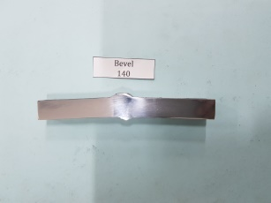 | 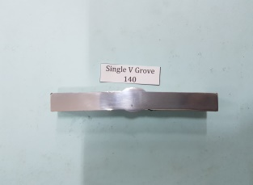 | 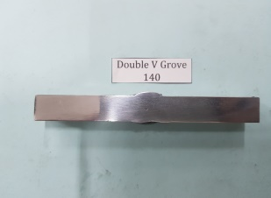
160 | 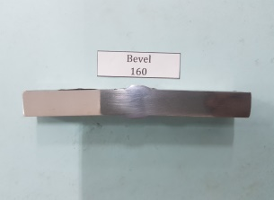 | 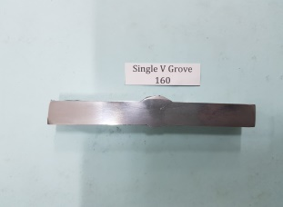 | 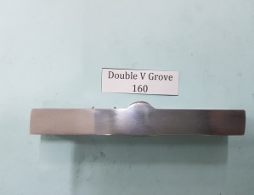
180 | 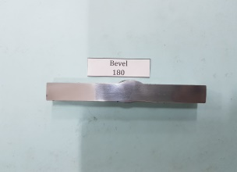 | 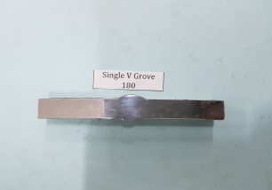 | 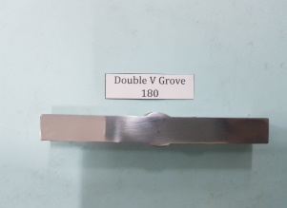

Micro testing itself was carried out to determine changes in the shape of the micro structure in the weld metal, HAZ and base metal positions with a magnification of 400×. The following TABLE 2 is a figure of the results of microstructural testing of SMAW aluminum 5083 welding, bevel welding seam types in the weld metal, HAZ and base metal areas.

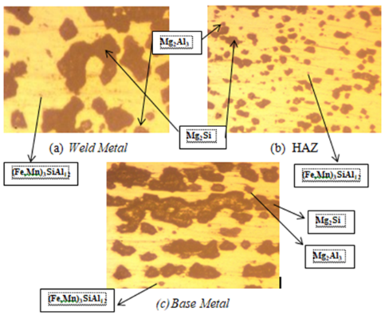
FIGURE 7. Welding Microstructure Test Results

In this specimen it can be seen in FIGURE 7 that in the 3 areas weld metal, HAZ, and base metal contain compounds that are formed from mechanical processes in the material which then form compounds that are visible in the microstructure. The initial microstructure of aluminum 5083 is Mg2Al3 because mechanical treatment and the welding process can change the microstructure of this material.
Therefore, in the Head Affected Zone (HAZ) area the black grains appear rougher than the same black grains in the weld metal and base metal areas. The more black grains (Mg2Si) will result in increased hardness and decreased ductility, in line with increasing Mg2Si, the (Fe,Mn)3SiAl12 particles shown in a grayish color, which are integrated with the aluminum matrix also decrease, although not drastically. Likewise, Mg2Al3 (shown as a slightly bluish color) will decrease as a result of increasing heat input to the weld metal, and Mg which bonds with Si to form Mg2Si. The decrease in these two particles causes the strength and toughness of the weld to decrease.
In the weld metal area, it can be seen that the result of changes in the microstructure shows that the dendrite (Mg2Si) has a wider diameter so that the hardness of the weld metal section increases but the ductility decreases. This section generally has greater hardness than the HAZ section. This is also followed by the toughness of the material from the presence of the compound (Mg2Al3), as is generally always followed by the presence of this compound as a link.
These fine lines and other fine gray grains are an indication of the compound (Fe,Mn)3SiAl12 which tends to make the material more brittle due to its hardness, stiffness and tensile strength. Because of these three areas, weld metal, HAZ, and base metal only have a few, so they don't have a big influence on changes in the material properties.

CONCLUSIONS
Variations in the electric current strength of 140A, 160A, and 180A with respect to the hardness value of SMAW welding. The highest hardness value is owned by base metal at a current strength of 180 Ampere with a single V grove weld seam and the lowest hardness is owned by base metal at a current strength of 160 Ampere with a bevel weld seam. There are several compounds that can affect the mechanical properties, one of these particles is that it can be ensured that the hardness value also increases, so that using a current strength of 180 Amperes is better in influencing the microstructure of the material. The welding seam on the hardness value of the weld metal part also has a big influence on the formation of the microstructure of the material and the hardness value of the material. From the results of testing the effect of variations in weld seam on the microstructure, it can be seen that the Mg element will combine with Si, which is an additional filler metal element. Basically, the occurrence of compounds in Mg2Si particles will increase if re-welding is carried out frequently.

Acknowledgments
This research was made possible through the generous support of Universitas Muhammadiyah Malang. The authors would like to express their sincere gratitude to all parties for their invaluable guidance, encouragement, and expertise throughout this project.
Special thanks are extended to Laboratory staff and technicians for their technical assistance and contributions. Their support was instrumental in the successful completion of this research.
Finally, the authors would like to acknowledge the contributions of Mr. Nur Subeki and Mr. Murjito for their valuable insights and contributions to this research.

ReferenceS
- R. A. Mabrullah, K. Kosjoko, and R. Shofiyah, "Pengaruh Variasi Arus Pada Pengelasan SMAW Terhadap Uji Kekuatan Bending dan Struktur Micro Baja ST 42," Journal of Engineering Science and Technology, vol. 2, no. 2, pp. 53-61, 2024.
- C. González-González, J. Los Santos-Ortega, E. Fraile-García, and J. Ferreiro-Cabello, "Environmental and economic analyses of tig, mig, mag and smaw welding processes," Metals, vol. 13, no. 6, p. 1094, 2023.
- A. R. Dwicahya and O. H. Cahyonugroho, "Analisis Kekuatan Bending Akibat Variasi Arus Pengelasan SMAW Pada Sambungan Pipa Api 5L GR. B SCH 80," Jurnal Serambi Engineering, vol. 9, no. 3, pp. 9848-9856, 2024.
- A. Purwanto, W. Wijoyo, and A. F. Riyadin, "Pengaruh Polaritas Mesin Las pada Pengelasan SMAW (Shielded Metal Arc Welding) Terhadap Sifat Fisik dan Mekanik Baja Karbon Rendah," Jurnal Teknik Indonesia, vol. 2, no. 4, pp. 150-158, 2023.
- P. Corigliano and V. Crupi, "Review of fatigue assessment approaches for welded marine joints and structures," Metals, vol. 12, no. 6, p. 1010, 2022.
- M. A. Mubarok, D. Hermawan, and A. Arifiansah, "ANALISA WELD DEFECT PENGELASAN SMAW PADA PROSES FABRIKASI TANGKI AIR DENGAN MENGGUNAKAN MATERIAL BAJA 36," Metrik Serial Humaniora dan Sains, vol. 5, no. 1, pp. 35-46, 2024.
- A. Ardi, M. H. Asri, and M. Mardin, "Analisis Pengaruh Variasi Bentuk Sambungan Terhadap Karakteristik Mekanis Baja Karbon Rendah Hasil Pengelasan SMAW Dan GTAW," Innovative: Journal Of Social Science Research, vol. 4, no. 1, pp. 12201-12219, 2024.
- H. Zhang, Y. Shi, Y. Gu, J. Xie, and C. Li, "Effects of electrode polarity on the droplet transfer mode in self-shielded flux-cored arc welding," Journal of Manufacturing Processes, vol. 58, pp. 478-488, 2020.
- S. Yue, Y. Huang, X. Yu, J. Zhang, Y. Ni, and D. Fan, "Improving Welding Penetration and Mechanical Properties via Activated-Flux Smearing by Tungsten Inert Gas Arc Welding," Metals, vol. 13, no. 12, p. 2017, 2023.
- T. Sonar, V. Balasubramanian, S. Malarvizhi, T. Venkateswaran, and D. Sivakumar, "An overview on welding of Inconel 718 alloy-Effect of welding processes on microstructural evolution and mechanical properties of joints," Materials Characterization, vol. 174, p. 110997, 2021.
- M. Waaddulloh, S. Sulardjaka, and G. D. Haryadi, "Pengaruh Arus dan Tegangan Pengelasan SMAW Baja Karbon Rendah Grade A dan Baja Karbon Rendah Grade B terhadap Sifat Mekanik," JMPM (Jurnal Material dan Proses Manufaktur), vol. 4, no. 2, pp. 103-114, 2020.
- A. J. G. Jurewicz et al., "Space Weathering of Genesis Mission Solar-wind Collectors with Inferences for Weathering on Airless Bodies," The Planetary Science Journal, vol. 4, no. 5, p. 98, 2023.
- K. Yu and X. Wang, "Parameter analysis and optimization of welding sequence for the aluminium alloy sidewall in a high-speed train body," Journal of Physics: Conference Series, vol. 1549, no. 3, p. 032080, 2020 2020.
- R. Chinnasamy, S. J. S. Chelladurai, and T. Sonar, "Investigation on Microstructure and Tensile Properties of High‐Strength AA2014 Aluminium Alloy Welds Joined by Pulsed CMT Welding Process," Advances in Materials Science and Engineering, vol. 2021, no. 1, p. 8163164, 2021.
- E. D. Susatyo and N. Y. Nugroho, "MECHANICAL PROPERTIES OF ALUMINUM 5052 IN MIG WELDING WITH VARIATION OF CERAMIC BACKING SIZES," JURNAL JALASENA, vol. 4, no. 2, pp. 114-121, 2023.
- N. Fang et al., "Effect of shielding gas on microstructures and mechanical properties of TC4 titanium alloy ultranarrow gap welded joint by laser welding with filler wire," Advances in Materials Science and Engineering, vol. 2021, no. 1, p. 9582421, 2021.
- E. O. Ogundimu, E. T. Akinlabi, and M. F. Erinosho, "Effect of welding current on mechanical properties and microstructure of tig welding of type-304 austenite stainless steel," Journal of Physics: Conference Series, vol. 1378, no. 3, p. 032022, 2019 2019.

