Design of a Semi-Automatic Tile Making Machine Using the Pahl and Beitz Method
Brigas Cahyono^{a)}, Herry Supianto^{b)}, Galih Rakasiwi^{c)}, and Fikri Yuda Pranata^{d)}
Department of Mechanical Engineering, University of Muhammadiyah Malang, Malang, Indonesia

^{a)} Corresponding author: hery@umm.ac.id
^{b)} brigascy@gmail.com
^{c)} galihrasiw@gmail.com
^{d)} fikriyudap141@gmail.com
Abstract. Tiles are an essential component of building construction. Currently, the tile manufacturing process still relies on conventional methods, which present several drawbacks, such as high production costs, lengthy production times, and suboptimal product quality. To address these issues, a semi-automatic tile-making machine needs to be developed. The Pahl and Beitz method, known for its comprehensive and structured approach, was selected with the goal of reducing production time and improving product quality. The design results show that the mold dimensions are 22.5 cm x 27.5 cm x 1.5 cm, with a mold weight of 2.43 kg. The machine utilizes a single-threaded shaft with an outer diameter of 24 mm and a length of 60 cm, along with an iron pulley with a diameter of 6 cm. The belt length is 85.84 cm, using belt number 1. Additionally, the machine includes bearing number 6004, a 3-phase switch, and a frame made of iron. This design offers several advantages, such as increased production efficiency, cost reduction, and improved product quality compared to conventional methods.
Keywords: Tile Machine, Tile Industry, Pahl and Beitz method, Semi-automatic Machine

INTRODUCTION
Tile is one of the important parts of the building [1]. A roof tile is a flat or curved piece of material that’s used to cover the roof from a building [2]. Roof tiles serve as a protective layer against weather elements like rain, snow, and sun [3]. Roof tiles made from various materials like clay, glass, ceramics, zinc, etc [4-7]. There are several types of roof tiles that’s made from clay, like plentong roof tiles, Mantili roof tiles, Garuda roof tiles, and Frog roof tiles [8]. Currently, especially in the Dinoyo Village, malang, east java most of the clay roof tile small industry is still using simple methods with clamping mechanisms [9]. This method has some weaknesses, like high production cost, long production times, and low quality from the tiles that’s produced [10]. Based on that problem a semi-automatic tile making machine for small roof tile manufacturing industry needs to be designed[11]. The objective of this research is to design and develop a semi-automatic tile-making machine that enhances production efficiency and product quality in small-scale industries. By introducing this technology, the study seeks to offer a viable solution to the existing problems faced by traditional clay roof tile manufactures , thereby improving their competitiveness and sustainability. There are several methods for designing machines like Pahl and Beitz method[12]. The Pahl and Beitz method is a systematic approach to engineering design[13], detailed in the book Engineering Design: A Systematic Approach by Peter Pahl and Wolfgang Beitz[14]. It provides a structured framework for designing products and systems, and is particularly known for its emphasis on problem-solving and decision-making processes[15].

METHODS
In this study, the Pahl and Beitz method was systematically employed to guide the design of a semi-automatic tile-making machine, specifically tailored to address its unique design requirements and challenges. The process commenced with Problem Definition, focusing on enhancing production efficiency while ensuring product quality, with key constraints including cost-effectiveness, operational ease, and durability in a high-demand environment.
During the Conceptual Design phase, various design alternatives were explored and evaluated against criteria such as production speed, energy consumption, and ease of maintenance. Through rigorous brainstorming and comparative analysis, the most viable concept was selected. In the Embodiment Design stage, this concept was further refined by optimizing its mechanical structure, selecting appropriate materials, and determining effective manufacturing methods. Emphasis was placed on ensuring smooth integration with existing production workflows.
The Detail Design phase involved developing comprehensive technical specifications, including detailed drawings and material lists. Each component was meticulously designed to ensure compatibility and efficient assembly, considering the machine’s long-term operational needs. The design underwent Evaluation and Testing, with prototypes constructed and assessed to verify performance against predefined criteria. Iterative adjustments were made based on testing feedback to enhance functionality. By applying the Pahl and Beitz method in this structured manner, the design process was streamlined, resulting in a machine that effectively meets the intended production goals while adhering to the specified constraints.
TABLE 1. Morphological Matrix from Conceptual Design
Component | 1st Desain | 2nd Desain | 3rd Desain
Drive (A) | 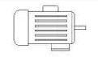  1 Phsase  Electric motor | 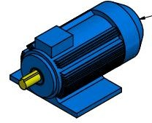  3 Phsase  Electric motor | 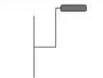  Manual Driven
Pressing System (B) | 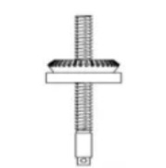  Screw | 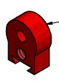  Press Pin | 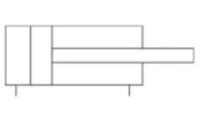  Jack
Transmission (C) | 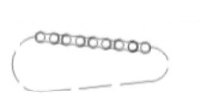  Chain | 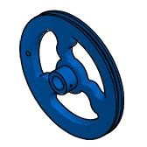  Pulley | 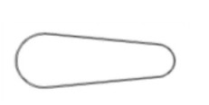  V – Belt
Roof Tile Mold (D) | 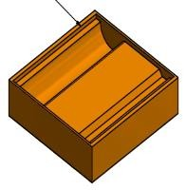  Iron | 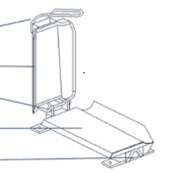  Wood | 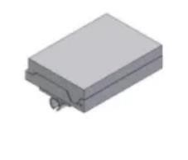  Steel
Based on TABLE 1 there are several alternative design concepts for tile making machine, then it can be made as matrix as presented in TABLE 2.
1st concept: A3 + B2 + C3 + D2
2nd concept: A1 + B2 + C1 + D1
3rd concept: A2 + B2 + C2 + D3
4th concept: A3 + B3 + C1 + D3
5th concept: A2 + B1 + C3 + D1

TABLE 2. Decision Making Matrix
No | Criteria | 1st concept | 2nd concept | 3rd concept | 4th concept | 5th concept
1 | Strong and Durability | 6 | 8 | 8 | 6 | 9
2 | There are not too many component | 7 | 8 | 8 | 7 | 8
3 | Lifting Ability | 7 | 8 | 8 | 7 | 10
4 | Dimension from machine | 6 | 7 | 8 | 8 | 9
5 | Material cost | 9 | 8 | 9 | 9 | 8
6 | Manufacturing cost | 9 | 8 | 7 | 9 | 10
7 | Light | 8 | 8 | 7 | 7 | 9
8 | Easy to operation | 7 | 8 | 8 | 7 | 8
9 | Easy to maintenance | 7 | 7 | 8 | 8 | 10
10 | Can be used for everybody | 7 | 9 | 8 | 9 | 9
11 | Energy transfer | 7 | 8 | 8 | 8 | 8
12 | Easy to production | 7 | 8 | 8 | 7 | 7
13 | Safety | 8 | 9 | 8 | 8 | 9
14 | Reliability | 6 | 9 | 8 | 8 | 10
Total |  | 101 | 113 | 111 | 108 | 124

RESULTS AND DISCUSSION

CALCULATIONS ON 3 PHASE ELECTRIC MOTORS
$$n_{1}=\frac{120 x f}{P}=1500 Rpm$$
Where:
$n_{1}$ = Rotational speed of the electric motor (Rpm)
f = Electric frequency (50 Hz)
P = Pools Number from electric motor (4)

If the transmission ratio is 1:25, then:
$$n_{2}=\frac{1500}{25}=60 Rpm$$

$$T=\frac{N x 716.2}{n}= 0,2387 Kgm$$
Where:
N = Power of the electric motor (0.5 HP)
T = Torque of the electric motor (Kgm)
n = Rotational speed (Rpm)

If the transmission ratio is 1:25, then the torque become:
$$T=\frac{N x 716.2}{60}= 5,96 Kgm$$
The next step is to determine the weight capacity of the force that can be lifted, which can be calculated using the following formula:
$$F= \frac{T}{r}= \frac{0,2387}{150/(2 . 1000)}= 3,2 Kg$$
Where:
F = force that can be lifted (kg)
15$0$ = Diameter from the pulley (mm)

If the transmission ratio is 1:25, then the force that can be lifted become:
$$F= \frac{T}{r}= \frac{5,96}{150/(2 . 1000)}= 79,4 Kg$$
Translation speed calculation:
$$V=2πrn= 28,27 m/det$$
Where:
V = Translation speed $(m/det)$
r = Radius (mm)
n = Rotational speed (Rpm)

If the transmission ratio is 1:25, then the Translation speed become 0,471 𝑚/𝑑𝑒𝑡

CALCULATIONS ON PULLEY
$$L=2C+ \frac{π}{2} \left(D+d\right)+ \frac{{\left(D-d\right)}^{2}}{4C}= 85,84 cm$$
Where:
L = Length (circumference) of the pitch belt ($cm$)
d = Diameter from small pulley ($cm$)
D = Diameter from large pulley ($cm$)
C = Distance between centers of pulley ($cm$)

CALCULATIONS ON V – BELT
$$Ks=Ko+Ki+Ke=1.4$$
Where:
Ks = Service factor
Ko = Service correction factor (1.1)
Ki = Idler correction factor (0.1)
Ke = Environment correction (0.2)

The next step is choosing belt type with design power 0,5 𝐻𝑃 (0,37 𝑘𝑊) and rotational speed 1500 𝑅𝑝𝑚. The type of V$-$Belt can be seen in FIGURE 1. Based on the figure 1, the suitable V$-$Belt is type A.
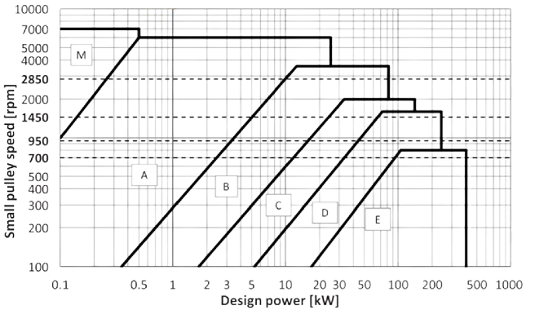
FIGURE 1. Type of V$-$Belt

Distance between V$-$Belt shafts, can be calculated using the following formula:
$$C=\frac{b±\sqrt{b^{2} -{(Dp - dp)}^{2}}}{8} = 138,58 mm$$

Where:
C = Distance between V$-$Belt shaft ($mm$)
b = 2𝐿𝑝 − 𝜋 (𝐷𝑝 + 𝑑𝑝)
𝐿𝑝 = Length from V$-$Belt shaft ($mm$)

Number of belts that’s required (nb):
$nb= \frac{Pd}{Pc}= 0,62 ≈ 1$
$Pc= (Ps + Pa) . Kc$ = 5.92
$Kc= Kθ . Kl=1.36$
$Kθ= \frac{Dp - dp}{C}= 1,03$

Where:
C = Distance between shafts (mm)
dp = Diameter from small pulley (mm)
Dp = Diameter from large pulley (mm)
Kl = Correction factor from belt length
Kθ = Correction factor from contact angle
Kc = Average power correction factor
Pa = Power rating for the average speed
Ps = Basic power rating (kW)
Pc = Aaverage power correction (kW)
Pd = Design power (kW)
nb = number of belts that’s needed

CALCULATIONS ON 3 PHASE SWITCH
$$I= \frac{P}{V} x \sqrt{3}x cos φ= 1,43 A$$
Where:
𝑃 = 0,37 𝑘𝑊 = 0,37 𝑥 1000 = 370 𝑊𝑎𝑡𝑡 (𝑊)
V = 380 𝑉
cos 𝜑= 0,85

FIGURE 2 shows the wiring diagram of 3 phase switch.
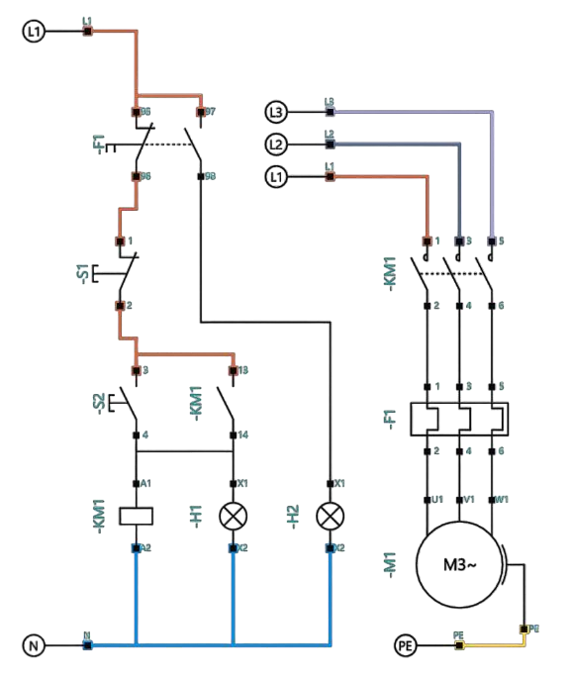
FIGURE 2. 3 Phase Switch Wiring Diagram

CALCULATIONS ON THREADED SHAFT
$$ra =\frac{σB}{Sf1 x Sf2}= 611,1 kg/{mm}^{2}$$

Where:
𝑟𝑎 = Shear stress that’s allowed
𝜎𝐵 = Tensile strength from the shaft ($kg/{mm}^{2}$)
𝑆𝑓1 = Safety factor from shaft material
𝑆𝑓2 = Safety factor for shaft shape
$$T=9.74 x {10}^{5} \frac{Pd}{n}= 6006,33 kg. mm$$
Where:
𝑇 = torsional moment (𝑘𝑔. 𝑚𝑚)

$$d1= {\left[\frac{5.1}{ra} . Kt . Cb . T\right]}^{\frac{1}{3}}= 20,05 mm ≈ 20 mm$$
Where:
𝑑1 = Shaft diameter (mm)
𝐾1 = Correction factor for torsion (1.5 to 3.0)
𝐶𝑏 = Correction factor for bending (1.2 to 2.0)
$$p= \frac{1}{\sqrt{3}} x Outer Diameter screw=13.85 mm$$
Where:
P = The average pitch distance from the thread axis (mm)

$$width from pitch= \frac{24 -(20 -\frac{\sqrt{3}}{2}width from pitch) }{2}$$
$$width from pitch= \frac{24 -20+\frac{\sqrt{3}}{2}width from pitch }{2}$$
$$width from pitch= \frac{4+\frac{\sqrt{3}}{2}width from pitch }{2}$$
$$2 x width from pitch= 4+\frac{\sqrt{3}}{2}width from pitch$$
$$width from pitch= \frac{8 }{2-\frac{\sqrt{3}}{2}}$$
$$width from pitch= \frac{8 }{\frac{4-\sqrt{3}}{2}}$$
$$width from pitch= \frac{16}{4 -\sqrt{3}}$$

$$width from pitch= \frac{16 x (4+\sqrt{3)}}{(4-\sqrt{3)}(4+\sqrt{3)}}= 7,05 mm$$

$$Vte= \left( d_{2}^{2}- d_{1}^{2}\right)\left(p - δ\right)= 0,0000012 m^{3}= 1,2 x {10}^{-6}m^{3}$$
Where:
𝑉𝑡𝑒 = Theoretical volume ($m^{3}$)
𝑑1 = Shaft diameter (20 mm)
𝑑2 = Outer diameter of the thread (24 mm)
𝑝 = Distance on the pitch (13.85 mm)
𝛿 = Width of the pitch (7.05 mm)

CALCULATIONS ON ROOF TILE MOLDING
$$W=\left(\left(p_{1} . l_{1} . t_{1}\right) - \left(p_{2} . l_{2} . t_{2}\right)\right) x specific gravity from iron= 2432,91 gram ≈ 2,43 kg$$
Where:
𝑃1 = Length from roof tile molding (cm)
𝑙1 = Width from roof tile molding (cm)
𝑡1 = Height from roof tile molding (cm)
𝑃2 = Length from roof tile (cm)
𝑙2 = Width from roof tile (cm)
𝑡2 = Height from roof tile (cm)

$$p=\frac{F}{A}= \frac{m . v}{A}= 5,3 x 10-5 N/cm2$$
Where:
𝑃 = Pressure that’s generated by the mold ($N/cm2)$
F = Force (N)
A = cross-sectional area (${cm}^{2})$
v = Speed form mold that’s caused by Rpm and distance between pitch (0,0138 m/s)

CALCULATIONS ON BEARING
Based on “perencanaan dan pemilihan elemen mesin” book by Sularso and kiyokatsu suga, then the suitable bearing specification are:
Bearing number : 6004
Inner diameter : 20 mm
Outer diameter : 42 mm
Width from bearing : 12 mm
Weight from bearing : 0,165 lb
Basic static load bearing : 1025 lb
Basic dynamic load bearing : 1620 Ib
$$L_{2}=L_{1}{\left[\frac{P_{1}}{P_{2}}\right]}^{k}= 3.940.000$$
Where:
𝑃1 = Basic dynamic load rating (1620 Ib)
𝑃2 = Basic static load bearing (1025 Ib)
𝐿1 = Bearing lifetime at C = 1.000.000
k = ball bearing Constanta (3)
$$Lm= \frac{bearing rotation}{Minutes}=65.666 minutes$$

If the machine operation assumed 5 hours per day, then:
$$Lh= \frac{Lm}{Hours}=218.8 Day≈7 month$$

CALCULATIONS ON FRAME
$$w= γ . V$$
Where:
w = Weight (N)
$γ$ = specific gravity
V = Volume from each component ($m^{3}$)

3 phase electric motor = 15 kg
Threaded shaft = 1,6 kg
Bearing (2 units) = 0,075 kg x 2 = 0,15 kg
Threaded shaft support (2 units) = 346 gram x 2 = 0,692 kg
Tile molding = 2,43 kg
Large pulley = 0,779 kg
Small pulley = 0,443 kg
V belt = 120 gram (0,12 kg)
3 phase switch = 86 gram (0,086 kg)
Cable = 76 gram (0,076 kg)
Total cross sectional area from frame legs = 2560 mm2

$$p= \frac{W total}{A}= 83 N/{mm}^{2}= 83 MPa$$
From this result we can see that’s the pressure is still lower than compressive strength that’s allowed from iron, i.e 150 MPa.

DESIGN MODEL
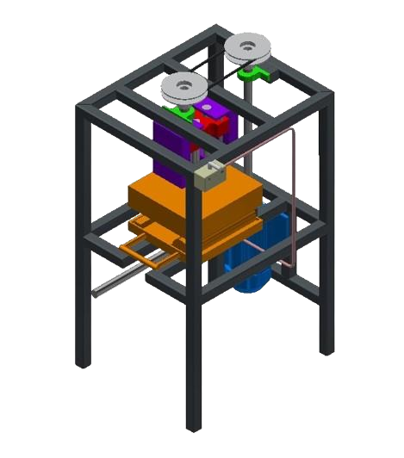
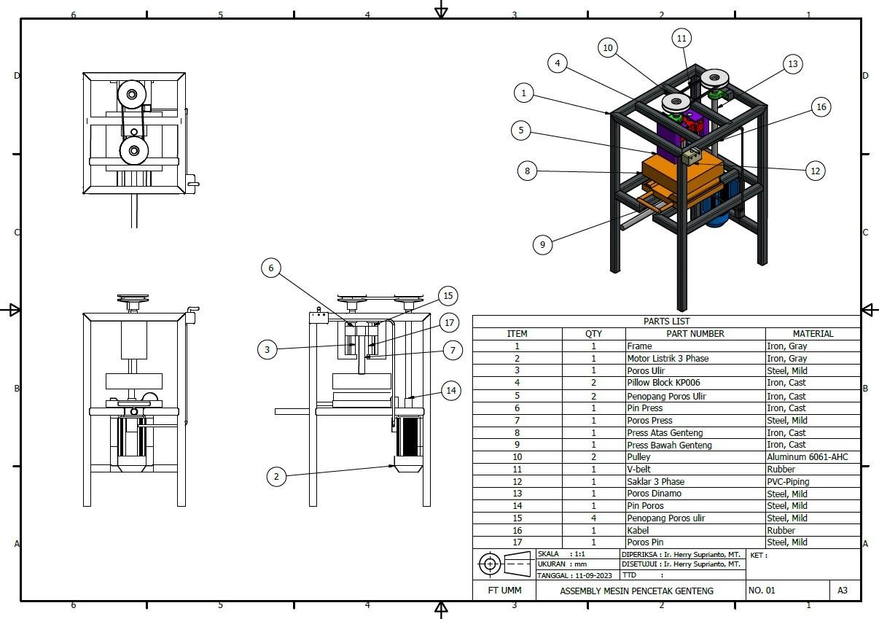
FIGURE 3. 3D Design from Semi-automatic Tile Making machine

CONCLUSIONS
In this paper, Pahl and Beitz method has been applied to design Semi-automatic Tile Making machine The result from this design is 22.5 cm x 27.5 cm x 1.5 cm for the cast dimension and 2.43 kg for the cast weight. It using single threaded shaft with outer diameter 24 mm and length 60 cm. for the pulley, it using iron with diameter 6 cm length from the belt is 85.84 cm, with belt number 1, as seen in FIGURE 3. It also using bearing number 6004, a 3 phase switch, and frame made from iron. For the future work, the author suggest to optimize this Semi-automatic Tile Making machine into full automatic Tile Making machine. Besides that’s, it is necessary to design automatic Tile Making machine that’s capable to making several roof tiles at once. Future research should focus on

Acknowledgments
We would like to express our sincere gratitude to all of the authors for their invaluable support and guidance throughout this research. Special thanks to University of Muhammadiyah Malang for providing the necessary resources and funding. We also appreciate the insightful feedback from the anonymous reviewers and the editorial team for their constructive comments, which significantly improved the quality of this manuscript.

References
1. Barry, W.D., Roof tiles and urban violence in the ancient world. Greek, Roman, and Byzantine Studies, 1996. 37(1): p. 55-74.
2. Perugino, F. and E. Vollaro, Roof Tiles, in The Chora of Metaponto 5: A Greek Farmhouse at Ponte Fabrizio. 2014, University of Texas Press. p. 353-360.
3. Berdahl, P., et al., Weathering of roofing materials–an overview. Construction and building materials, 2008. 22(4): p. 423-433.
4. Sánchez de Rojas, M.I., et al., Properties and performances of concrete tiles containing waste fired clay materials. Journal of the American Ceramic Society, 2007. 90(11): p. 3559-3565.
5. Moreno, A., Ceramic tiles: above and beyond traditional applications. Boletín de la Sociedad Española de Cerámica y Vidrio, 2006. 45(2): p. 59-64.
6. Borges, P.H.R., et al., Sustainable concrete roof tiles containing recycled glass. International Journal for Housing Science and Its Applications, 2011. 35(2): p. 69.
7. Simão, F.V., et al., Incorporation of sulphidic mining waste material in ceramic roof tiles and blocks. Journal of geochemical exploration, 2021. 225: p. 106741.
8. Sayyidah, N.H.M., S. Hasanah, and T. Yulianto. Determining The Types Of Tiles Based On Building Location And Building Elevation Using Fuzzy Weighted Product (WP) Methods. European Alliance for Innovation.
9. Mulyono, A., et al., PRODUCT DIVERSIFICATION AND WASTE RECYCLING FOR THE CLAY-BASED CRAFT INDUSTRY DEVELOPMENT.
10. Soares, A., C. Pimentel, and A. Moura, Production planning and scheduling with applications in the tile industry. International Journal of Operational Research, 2022. 44(1): p. 58-79.
11. Okoronkwo, C.A., et al., The Design, Construction and Computer–Aided Simulation of a Prototype Roofing Tile Machine. Int. Res. J. Eng. Technol, 2016. 3: p. 1-10.
12. Jensen, T.E. and M.M. Andreasen. Design Methods in Practice: Beyond the'systematic'approach of Pahl & Beitz. Designophy.
13. Malmqvist, J., R. Axelsson, and M. Johansson. A comparative analysis of the theory of inventive problem solving and the systematic approach of pahl and beitz. American Society of Mechanical Engineers.
14. Pahl, G., et al., Engineering design: a systematic approach. Vol. 3. 1996: Springer.
15. Jonassen, D.H., Instructional design models for well-structured and III-structured problem-solving learning outcomes. Educational technology research and development, 1997. 45(1): p. 65-94.

