Analysis of Shear Ram Reliability in Cutting Drill Pipe Using ANSYS Explicit Dynamic Simulation
Garibaldi Sadam Setyawan^{a)}, Yushuf Yanuar^{b)}, Achmad Fauzan Herry Sugiarto^{c)}, and Nur Hasanah^{d)}
Department of Mechanical Engineering, Universitas Muhammadiyah Malang, Malang, Indonesia

^{d)}Corresponding author: nurhasanah02@umm.ac.id
^{a)} saddamsatu9@gmail.com
^{b)} yushufyanuar40@gmail.com
^{c)} achmadfauzan@umm.ac.id
Abstract. This research aims to evaluate the reliability and performance of a Shear Ram Blowout Preventer (BOP) in cutting drill pipe using ANSYS Explicit Dynamic simulation, in order to prevent blowouts in the oil and gas drilling industry. The methods used include finite element analysis (FEA) and 3D design to analyze von Mises stress and stress distribution across various shear ram configurations. The simulation results show differences in von Mises stress values for each configuration, and identify critical points with the highest stresses on the upper ram, lower ram, and drill pipe. These findings provide important insights for design improvements and enhancing drilling operation safety. In conclusion, performance analysis of the BOP using this method is crucial to prevent failures in emergency situations, helping engineers design more reliable Shear Rams and improving efficiency and safety in the drilling industry.
Keywords: Shear ram, Blow out preventer, FEA

INTRODUCTION
This research focuses on the analysis of failures and optimization of oil and gas drilling equipment, specifically the role and reliability of shear rams in preventing blowouts. Shear rams are crucial components in drilling operations, yet failures frequently occur in the field. This study employs ANSYS Explicit Dynamic simulations and 3D design to understand material behavior and ensure a safe and efficient design. The objective is to investigate the reliability of shear ram blades in terms of cutting and sealing capabilities, as well as to evaluate the use of 40CrNiMo material to enhance the reliability and safety of drilling operations.
The research results indicate that the configuration with a specific shear ram blade angle of 20 degrees exhibits low von Mises stress values, which signifies improved reliability of the shear ram in drilling operations. These findings provide valuable new insights for the oil and gas industry in managing the risks associated with shear ram failures and enhancing operational safety.
This research also identifies gaps in the existing literature regarding the reliability of shear rams. Although many studies have been conducted to understand shear forces and material behavior under complex conditions, there is still a lack of in-depth analysis on the variations in shear ram blade angles and their impact on cutting capabilities. This study aims to fill that gap by utilizing ANSYS Explicit Dynamic simulations and superior materials.
By combining findings from previous studies and utilizing advanced simulation methods, this research makes a significant theoretical contribution and offers practical solutions to enhance the reliability of shear rams. The results not only provide new insights into shear ram reliability but also have substantial practical implications for the oil and gas industry in reducing blowout risks and improving safety in the field.
.
The limitations of this research include a focus on the reliability analysis of shear rams using ANSYS Explicit Dynamic simulations without considering other factors such as wellbore conditions and drilling fluids. The drill pipe material used in this simulation is S135 standard or AISI 4340, which means the findings may not be applicable to other drill pipe materials. With these limitations, the study aims to provide more specific and relevant results in the context of shear ram reliability.

METHODS
In this research, the Explicit Dynamic analysis method is utilized to understand the events occurring in the shear ram and drill pipe during the cutting process of a 3.5-inch drill pipe. The analysis stages include the creation of a 3D model using CAD software, input of technical data, mesh generation, boundary condition definition, and simulation execution. The ANSYS Explicit Dynamic method was selected for its capability to simulate rapid and complex dynamic conditions, such as when the shear ram cuts through the drill pipe. This method captures rapid changes in load and material response in real-time and models complex material behaviors, including plastic deformation and fracture. Furthermore, this method produces highly detailed and precise simulations, allowing for accurate analysis of stress and strain distributions in the shear ram and drill pipe. The use of specialized material models, such as Johnson-Cook, also aids in understanding material behavior under extreme operating conditions, providing in-depth and relevant analysis.

3D MODELING
The 3D design was created in Autodesk Inventor 2022. The design process serves as a means to visualize the research. It also acts as a reference for the researcher to determine the components that will experience maximum stress and deformation. FIGURE 1 below is the design of the shear ram that will be analyzed.

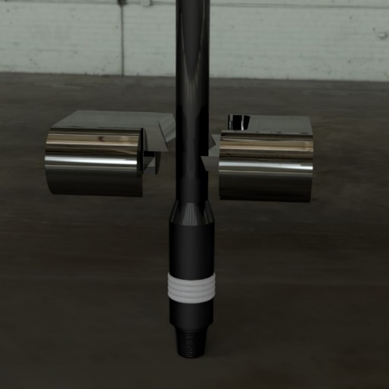
FIGURE 1. 3D Model Shear Ram Assembly

ENGINEERING DATA
40CrNiMo is an alloy steel known for its high strength, toughness, and wear resistance, with a chemical composition that includes carbon, silicon, manganese, phosphorus, sulfur, chromium, nickel, and molybdenum. This steel is ideal for applications that require strength and durability, such as machine components and other structural parts. As a material for shear rams, the superior properties of 40CrNiMo ensure that the tool can withstand high stress and impact during the cutting operation of the drill pipe, as well as providing good wear resistance, making it a suitable choice for the oil and gas drilling industry, as shown in TABLE 1 [1].
TABLE 1. Material Properties 40CrNiMo
40CrNiMo
No | Index | Symbol | Value | Unit
1 | Yield Strength | σy | 960 | MPa
2 | Tensile Strength | σ | 1050 | MPa
3 | Density | ρ | 7,85 | g/cm3
4 | Poisson's Ratio | ν | 0,3 | -
5 | Melting Temperature | T_{melt} | 1793 | K
6 | Initial Yield | A | 792 | MPa
7 | Hardening Constant | B | 510 | MPa
8 | Hardening Exponent | n | 0,26 | -
9 | Strain Rate | C | 0,014 | -
10 | Thermal Softening | m | 1,03 | -
 |  | D1 | 0,05 | -
 |  | D2 | 3,44 | -
 |  | D3 | -2,12 | -
 |  | D4 | 0,0002 | -
 |  | D5 | 0,61 | -

The material used in the manufacture of drill pipes must possess strength, corrosion resistance, and the ability to withstand high pressure. One commonly used material for drill pipe manufacturing is AISI 4340 shown in TABLE 2, which meets the API S-135 standards [2]. The table below will explain the material properties of AISI 4340 as the material for drill pipes.
TABLE 2. Material Properties AISI 4340
API S-135 / 36CrNiMo4 / AISI 4340
No | Index | Symbol | Value | Unit
1 | Density | ρ | 7,63 | g/cm³
2 | Elastic Modulus | E | 165 | Gpa
3 | Poisson's Ratio | ν | 0,25 | -
4 | Yield Stress | σy = A | 890 | MPa
5 | Microhardness | H | 35 | HRC
6 | Ultimate Tensile Stress | σu | 1050 | MPa
7 | Nominal Strain at Failure | εcr | 0,12 | -
8 | Friction Coefficient | f | 0,3 | -
9 | Damage at Failure | D_{cr} | 0,048 | -
10 | Energy Dissipation Parameter | $$\frac{G_{f}}{L}$$ | 12,5 | J/mm³
11 | J-C Plastic Parameter | B | 775 | MPa
12 |  | n | 0,43 | -
13 | J-C Failure Model Parameter | D₁ | 0 | -
14 |  | D₂ | 0,08 | -
15 |  | D₃ | -3,4 | -
16 | Initial Yield Stress | A | 1021,898 | MPa
17 | Hardening Constant | B | 744,192 | MPa
18 | Strain Rate Constant | C | 0,014
19 | Hardening Exponent | n | 0,55
20 | Thermal Softening Exponent | m | 1
21 | Fusing Temperature | T_{melt} | 1520 | ᵒC
22 | Acoustic Volume Velocity | D1 | 4578 | m/s
23 | Curve Slope Coefficienet | S1 | 1,33

CONNECTION
Connections are necessary to define the interaction between each contacting part. This aims to determine the events that will occur in each part during the simulation. The types of connections include several categories, such as bonded, frictionless, friction, and rough. In this simulation, the connection type used is frictionless. This type was selected because the contacting parts will experience friction on their surfaces. The following are the steps for defining connections in ANSYS 2021:
- In the connection menu, insert a manual contact region.
- Select the body to be designated as the contact dan the target.
- Choose the connection type as frictionless, see FIGURE 2.

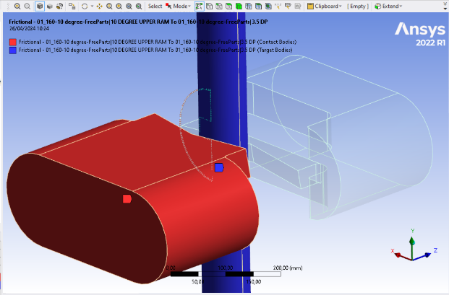
FIGURE 2. Connection

MESHING
At this stage, the model geometry is divided into small elements that form a mesh, which is crucial for the accuracy of the simulation results. The mesh must be fine enough to maintain accuracy, but not too fine to avoid excessive computational resource usage. In this simulation, a tetrahedral mesh is used to capture the entire geometry of the model, providing comprehensive coverage and preventing overlap [3]. The mesh for the ram has a size of 25 mm for the body and 5 mm for the blade, while the drill pipe has a mesh size of 15 mm for the body and 2 mm for the contact area with the ram, in order to capture fracture phenomena in detail as presented in FIGURE 3.

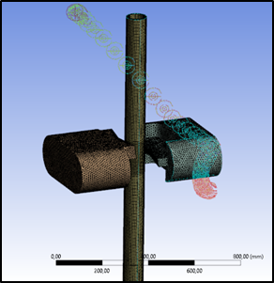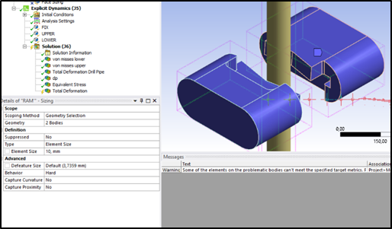
FIGURE 3. Meshing

BOUNDARY CONDITION
At this stage, the boundary conditions for the simulation are established, including the settings for forces, temperature, fixed constraints, and limited movement. This simulation employs several boundary conditions, such as fixed constraints and displacement . Further details on the setup of the boundary conditions will be explained in the following sections.
- Fixed Constraint Drill Pipe
The bottom surface of the drill pipe is defined as a fixed constraint.
- Displacement Upper Ram
The upper ram will experience a displacement of 1.8 inches along the Z-axis. Select the rear surface of the ram as the reference for the displacement.
- Displacement Lower Ram
The lower ram will experience a displacement of -1.8 inches along the Z-axis. Select the rear surface of the ram as the reference for the displacement.

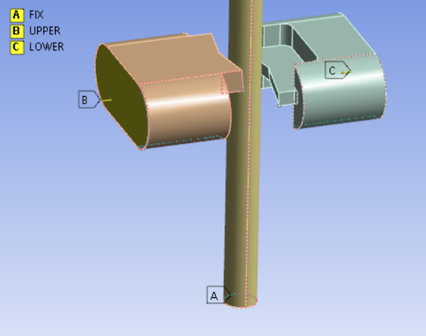
FIGURE 4. Boundary Condition
The boundary condition state is shown in FIGURE 4. The shear ram moves toward the drill pipe to cut it with a displacement of 1.8 inches toward the drill pipe within 5×10⁻⁴ seconds. This corresponds to field conditions, where the shear ram closes from a fully open position until it touches the drill pipe using a hydraulic pump. Once the shear ram touches the drill pipe, the operator bypasses the accumulator, causing a pressure of 30,000 psi to push the shear ram with significant force and at a very high speed [4, 5].

SOLVING
After completing all the above steps, the final step is to execute the solve by selecting the "Evaluate Results" option. In this simulation, a 12-core processor is used to run the numerical method, calculate the system's response to the given conditions, and present the results in an understandable form.

RESULTS AND DISCUSSION

MAXIMAL VON MISSES STRESS
From the analysis conducted using the explicit dynamic method on the shear ram during the drill pipe cutting process, the maximum von Mises stress values for both the upper and lower ram were obtained. The data from this analysis will be explained in detail in the following FIGURE 5 section.

FIGURE 5. Maximum Von Mises Stress Graph for Shear Ram

In the von Mises stress graph above, it can be observed that there is a general increase in the von Mises stress values as the cutting steps of the drill pipe progress. The x-axis represents the cutting steps of the drill pipe, while the y-axis displays the von Mises stress values for both the upper and lower ram at each step.
The maximum von Mises stress at a 20-degree angle was recorded as 1158.7 MPa for the upper ram and 1162 MPa for the lower ram during step 2. From the graph, it can be concluded that the von Mises stress values for both the upper and lower ram reach their maximum at step 2, which is attributed to the first contact between the ram and the drill pipe when the shear ram receives fluid pressure from the accumulator.

SHEAR STAGE
The FIGURE 6 demonstrates that during the initial cutting stage (shearing stage), the maximum stress occurs at the center of both the upper and lower rams.
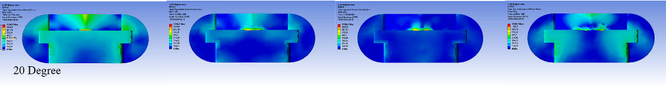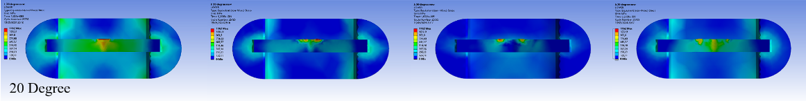
FIGURE 6. Shear Stages on Shear Ram

In the subsequent stages, although the stress decreases, the affected area expands due to the deformation of the drill pipe, resulting in a broader contact area with the surfaces of the upper and lower rams.

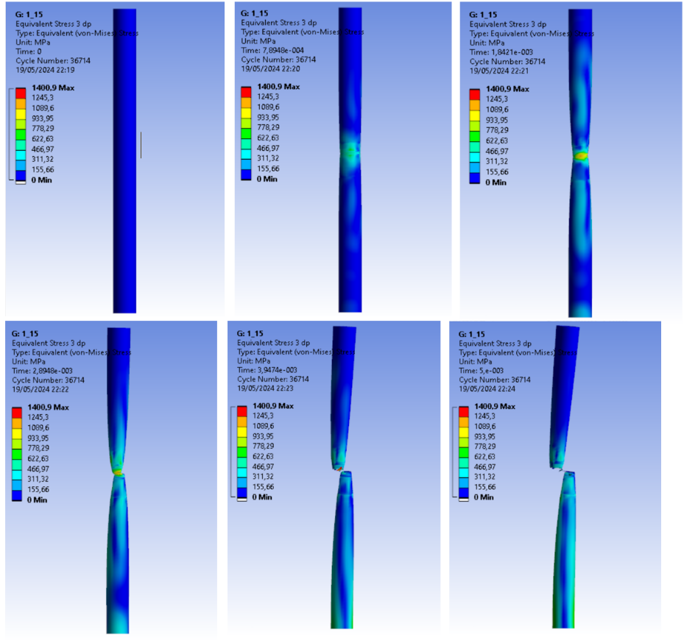
FIGURE 7. Von Mises Stress value of results

The maximum von Mises stress at a 20-degree angle is recorded at 1158.7 MPa for the upper ram and 1162 MPa for the lower ram during step 2. From the graph, it can be concluded that the von Mises stress values for both the upper and lower rams peak at step 2, which is attributed to the first contact between the rams and the drill pipe when the shear ram receives fluid pressure from the accumulator, as presented in FIGURE 7.

CONCLUSIONS
Based on the analysis using ANSYS Explicit Dynamic software on the BOP shear ram, the experimental results with a blade angle of 20 degrees are presented through graphs and von Mises stress contours. This analysis shows that the maximum von Mises stress on both rams is 1158.7 MPa for the upper ram and 1162 MPa for the lower ram.
Based on the analysis, it was found that after the cutting process, the conditions of the upper ram, lower ram, and drill pipe indicate that both the upper and lower rams did not experience plastic deformation after successfully cutting the drill pipe. The drill pipe was cut perfectly, as evidenced by:
- The wall thickness of the drill pipe that does not experience a drastic reduction
- A consistent cut of the drill pipe along horizontal direction
- No metal shavings present on the drill pipe
Based on this research, it is recommended to use materials with superior mechanical properties compared to 40CrNiMo to reduce stress on the shear ram. Additionally, expanding the variation of the blade angle could be pursued to achieve optimal results. Future studies are also expected to simulate various field condition parameters, such as fluid density, temperature, pressure, chemical properties of the fluid, and cutting speed. The use of equipment with higher technical specifications is also suggested to produce more valid analyses with smaller mesh sizes.

References
1. Wang, W., et al., Constitutive analysis and dynamic recrystallization behavior of as-cast 40CrNiMo alloy steel during isothermal compression. Journal of Materials Research and Technology, 2020. 9(2): p. 1929-1940.
2. Lukin, N., et al., Analysis of API S-135 steel drill pipe cutting process by blowout preventer. Journal of Petroleum Science and Engineering, 2020. 195: p. 107819.
3. Karma, V.K. and G. Maheshwari, Analysis of Effect of Pitch Error on Transmission Error and Mesh Stiffness in Spur Gear Using SciLab and Ansys Software, in Recent Trends in Materials: Select Proceedings of ICTMIM 2022. 2022, Springer. p. 245-260.
4. Zhang, F.-L., et al., BOP shear force evaluation under complex scenarios. Petroleum Science, 2023. 20(4): p. 2442-2451.
5. Tekin, A., et al., Estimation of shear force for blind shear ram blowout preventers. Res Eng Struct Mater, 2015. 1(1): p. 39-51.

