Analysis of the Effect of Coolant Type Variations and Feed Rate on Surface Roughness in the Turning Process of AISI 4140 Steel
Andinusa Rahmandhika ^{a)}, Hendri Nur Wicaksono ^{b)}, Herry Suprianto ^{c)}, Alifathur Ramdani ^{d)}, and Mulyono Mulyono
Department of Mechanical Engineering, University of Muhammadiyah Malang, Malang, Indonesia
^{a)} Corresponding author: andinusa@umm.ac.id
^{b)} hendri05082001@gmail.com
^{c)} hery@umm.ac.id
^{d)} alif15102005@gmail.com
^{e)} mulyono@umm.ac.id
Abstract. The manufacturing industry in Indonesia has grown rapidly, transforming raw materials into high-quality products for various sectors such as design and industrial engineering, while also creating employment opportunities. One of the key processes in manufacturing is metal cutting, including turning operations, which play an important role in achieving the desired dimensional accuracy and surface quality. Several machining parameters, such as cutting speed, feed rate, and depth of cut, significantly influence the final surface finish of the workpiece. This study investigates the effect of coolant type variation and feed rate on the surface roughness of AISI 4140 steel during turning operations. The results indicate that spindle speed, feed rate, and coolant type substantially affect surface roughness values. The lowest roughness was observed at a feed rate of 0.75 mm/rev using a vegetable-based cutting fluid (0.665 µm), whereas a conventional mineral-based coolant produced relatively higher roughness (1.47 µm). Overall, increasing the feed rate tends to reduce surface roughness, provided that the turning process is conducted within acceptable operational limits.

INTRODUCTION
This study analyzes the effect of coolant type variation and feed rate on surface roughness of AISI 4140 steel under mist cooling turning operations. Several studies have reported that vegetable-based lubricants face oxidation and thermal stability challenges, while gas-based lubricants provide a cleaner working environment [1]. The Minimum Quantity Lubrication (MQL) method is considered more sustainable, although its efficiency still requires improvement. Nanofluids enhance lubrication and heat transfer performance, although they are costly and pose toxicity risks, while cryogenic cooling, despite being environmentally friendly, is difficult to implement [2]. Furthermore, research indicates that cutting parameters such as feed rate, depth of cut, and cutting speed interact with cutting forces, with feed rate being the most significant factor. The use of CBN tools on AISI 4140 steel can produce high-quality surfaces without cutting fluid, achieving roughness values (Ra) between 0.16 and 0.41 µm. Artificial Neural Network (ANN)-based optimization models offer more accurate predictions of surface roughness, improving the machining quality of AISI 4140 steel [3].
Turning is a machining process in which the workpiece rotates while the cutting tool removes material from its surface to form various profiles, such as cylinders or grooves [4]. A lathe machine operates by moving the workpiece and cutting tool with high precision, supported by components such as the apron, carriage, and gears [5]. A conventional lathe consists of several major parts, including the headstock, tailstock [6], bed plate [7], spindle, carriage, and tool post, which ensures that the cutting tool remains rigid and aligned with the workpiece [8].
In this study, several important parameters in the turning process were calculated using the following formulas: cutting speed (Cs), feed rate (f), and feed motion speed (Vf). Cutting speed (Vc) is a crucial parameter that determines the cutting velocity of the workpiece and depends on the tool type and size, calculated by: [9]
$V_{c}=\frac{π×d×n}{1000} \left(m/{minutes}\right)$ (1)

where d is the workpiece diameter (mm) and n is the spindle speed (rpm). Feed rate (f) measures the linear distance traveled by the cutting tool per revolution of the workpiece in mm/rev or in/rev and is calculated by: [10]

$f=\frac{V_{c}}{n} \left({mm}/{rev}\right)$ (2)

The feed motion speed (Vf) indicates the distance traveled by the cutting tool or workpiece, calculated by multiplying spindle speed (n) by feed rate (f): [14]

$V_{f}=f×n \left({mm}/{minutes}\right)$ (3)

Mist cooling, or Minimum Quantity Lubrication (MQL), is a cooling method in machining that uses a small amount of cutting fluid converted into fine mist combined with high-pressure air to reduce temperature and friction in the cutting zone [11]. This technique is more efficient and environmentally friendly than conventional wet cooling because it produces minimal liquid waste [12]. Mist cooling is widely applied in turning and milling of difficult-to-machine materials such as stainless steel to obtain smooth surfaces, extend tool life, and prevent thermal deformation [13]. In this process, cutting fluids function as both lubricant and coolant [14], reducing cutting forces, improving surface finish, and protecting the machine from corrosion [15]. Types of cutting fluids used include synthetic fluids, emulsions, semi-synthetic fluids, and oils, each with advantages and disadvantages in lubrication and heat control [16].
Surface roughness refers to deviations from the mean line of the profile, indicating the quality and dimensional accuracy of the workpiece. It is influenced by tool dimensions [17], cutting parameters [18], workpiece geometry [19], and material defects [20]. Surface roughness is measured using arithmetic deviation [21] and significantly affects machining precision and quality [22][23]. Iron and steel, which account for 95% of global metal production [24], are the most widely used metals in industry due to their excellent mechanical [25], thermal [26], and physical properties [27]. AISI 4140 steel, widely used in the automotive industry, offers high wear and corrosion resistance due to its chromium and molybdenum content [28]. Carburizing of AISI 4140 steel enhances hardness, ductility, and toughness by heating the material in a carbon-rich environment, followed by quenching in oil or water to produce a martensitic microstructure that improves Vickers hardness [29].

Methodology
This research was conducted in the Mechanical Engineering Laboratory at Universitas Muhammadiyah Malang, Campus III, over a period of three days from November 18 to November 20, 2024. The experimental approach was employed to evaluate the effect of feed rate and coolant type on the surface roughness of AISI 4140 steel during turning operations. The experimental design involved preparing specimens, performing turning operations under different conditions, and measuring surface roughness using a digital surface roughness tester. The study followed a true experimental design with controlled variables to ensure the accuracy of the results.
The turning process required adjustments to machine settings and calibration to ensure precision, particularly to achieve the desired surface roughness. The accuracy of cutting speed, feed rate, and machining time plays an essential role in obtaining a smooth finish. The experimental work was carried out using a lathe machine with variations in feed rate and coolant type, followed by surface roughness measurements to determine the optimum condition.

Equipment and Materials
The tools and equipment utilized in this study included a bench grinder, a metal cutting saw, a conventional lathe machine, a digital surface roughness tester, a vernier caliper, and HSS (High-Speed Steel) cutting tools.
A handheld grinder was employed to smoothen the ends of AISI 4140 steel specimens before turning to ensure accurate centering during the process (FIGURE 1(a)). A metal cutting saw was used to cut the AISI 4140 round bars into six specimens, each measuring 38 mm in length (FIGURE 1(b)). The turning operations were performed on a conventional lathe machine (FIGURE 1(c)) with a maximum spindle speed of 2500 rpm and a maximum workpiece length of 1000 mm.

 |  | 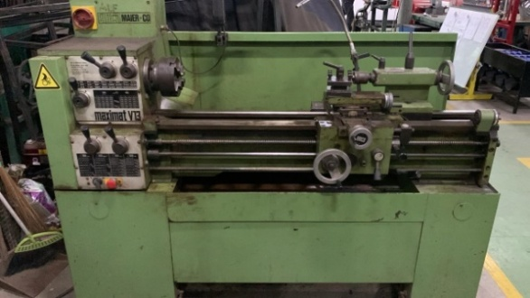
(a) | (b) | (c)
Figure 1. Equipment for cutting material (a) handheld grinder, (b) metal cutting saw, and (c) lathe machine

Surface roughness measurements were taken using a digital surface roughness tester (FIGURE 2(a)), which provides high precision with an accuracy of ±(7–10)% and measures parameters such as Ra, Rz, Rq, and Rt. A vernier caliper (FIGURE 2(b)) was used to check the dimensions of the specimens before machining. The cutting tool utilized for the experiment was an HSS tool (FIGURE 2(c)).

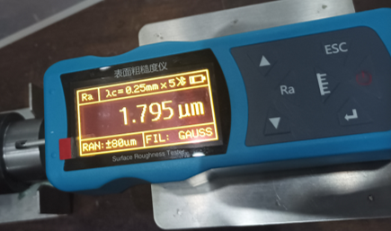 | 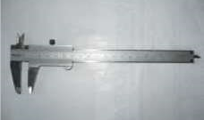 | 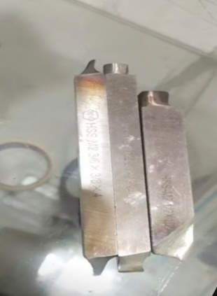
(a) | (b) | (c)
Figure 2. Equipment for measurement (a) surface roughness tester, (b) vernier caliper, and (c) HSS tool

The material selected for this study was AISI 4140 steel round bars with a diameter of 20 mm and a length of 50 mm (FIGURE 3). A total of six specimens were prepared for the experiments.

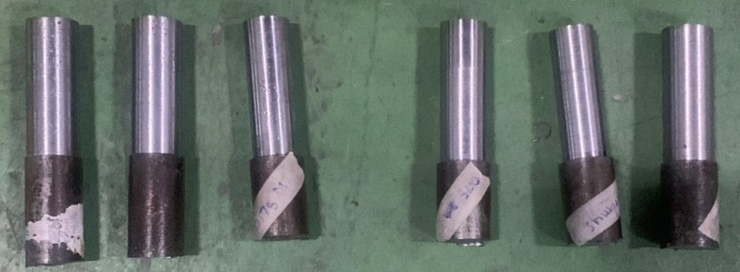
Figure 3. AISI 4140 Roundbar Material

Experimental Parameters
The independent variables in this study were feed rate and coolant type. The feed rates applied were 0.35 mm/rev, 0.50 mm/rev, and 0.75 mm/rev, while the coolant types included a vegetable-based cutting fluid and a mineral-based cutting fluid. The dependent variable measured was the surface roughness (Ra) of the machined surface. Controlled variables included the cutting tool material (HSS), spindle speed (740 rpm), depth of cut (0.5 mm), and the use of the same surface roughness measurement device for all specimens.

RESULTS AND DISCUSSION
After conducting turning operations under wet machining conditions using different coolant types and feed rates, surface roughness (Ra) measurements were taken for each specimen using a digital surface roughness tester. Each test was repeated four times per condition to ensure accuracy and repeatability. The results are summarized in TABLE 1, which shows the surface roughness values for each feed rate and coolant combination.

Table 1. Surface roughness (ra) results under different feed rates and coolants
Feedrate (mm/rev) | Coolant Type | Surface Roughness Value  Ra ($μ$m) |  |  |  | Average Ra ($μ$m)
Feedrate (mm/rev) | Coolant Type | 1 | 2 | 3 | 4 | Average Ra ($μ$m)
0.35 | Mineral-based | 2.355 | 1.999 | 2.227 | 1.925 | 2.127
0.35 | Vegetable-based | 2.72 | 2.82 | 2.364 | 2.771 | 2.669
0.5 | Mineral-based | 2.071 | 1.911 | 1.889 | 1.797 | 1.917
0.5 | Vegetable-based | 1.426 | 1.496 | 1.808 | 1.718 | 1.612
0.75 | Mineral-based | 1.957 | 1.494 | 1.6 | 0.83 | 1.47
0.75 | Vegetable-based | 0.557 | 0.681 | 0.573 | 0.849 | 0.665

As observed in TABLE 1, the combination of feed rate and coolant type has a substantial impact on the surface roughness values. The results can be grouped into three main categories based on feed rate. In the first group, at a feed rate of 0.35 mm/rev, the highest surface roughness values were recorded, with the mineral-based coolant yielding an average Ra of 2.127 µm, and the vegetable-based coolant showing an even higher average of 2.669 µm. In the second group, at 0.50 mm/rev, the surface roughness values were reduced, with the mineral-based coolant achieving an average Ra of 1.917 µm, and the vegetable-based coolant showing an improved result of 1.612 µm. The third group, at a feed rate of 0.75 mm/rev, produced the smoothest surfaces. The vegetable-based coolant yielded the lowest average Ra of 0.665 µm, while the mineral-based coolant resulted in 1.470 µm. These trends are visually presented in FIGURE 4, which compares the average surface roughness values across all tested combinations of feed rate and coolant.

FIGURE 4. Graph of Feed Rate and Coolant Type vs. Surface Roughness (Ra)

From FIGURE 4, it is evident that the highest average surface roughness was recorded at the lowest feed rate of 0.35 mm/rev using the vegetable-based coolant, while the smoothest surface was achieved at the highest feed rate of 0.75 mm/rev using the same coolant. This finding may appear counterintuitive, as higher feed rates are often associated with increased surface roughness. However, in this study, within the range of parameters tested, the increased feed rate possibly promoted better chip formation and heat dissipation, contributing to a smoother surface finish.
Moreover, the results indicate that coolant type plays a significant role in determining surface quality. In all three feed rate conditions, the vegetable-based coolant consistently produced lower surface roughness values compared to the mineral-based coolant. This supports the hypothesis that vegetable-based coolants may provide better lubrication and heat transfer properties under mist cooling conditions.
The findings align with previous studies. For instance, Utomo [30] reported that a mixture of palm oil-based coolant and lubricating oil resulted in lower surface roughness compared to synthetic coolants. Similarly, Purnomo et al. [31] found that palm oil yielded the lowest surface roughness value of 5.21 µm in the turning of low-carbon steel. Although the numerical values differ due to variations in material, tool geometry, and machining parameters, the overall trend reinforces the potential of vegetable-based coolants in improving surface finish.
This study also confirms that within acceptable cutting conditions, increasing the feed rate can lead to reduced surface roughness, particularly when combined with an effective coolant. These results may inform future research and industrial applications in sustainable machining, where surface quality and environmental impact are both critical considerations.

CONCLUSION
This study examined the effect of feedrate variation and the type of cutting fluid on surface roughness in the turning process of AISI 4140 steel under wet machining conditions. The experimental results showed that both parameters—feedrate and cutting fluid—significantly influenced the final surface quality of the machined workpiece. An increase in feedrate from 0.35 mm/rev to 0.75 mm/rev consistently led to a reduction in surface roughness, with the lowest Ra value recorded at 0.665 µm using palm oil as the cutting fluid. In comparison, the use of dromus produced generally higher roughness values across all feedrates. These findings indicate that palm oil, a biodegradable and sustainable fluid, has the potential to serve as an effective alternative to synthetic cutting fluids for achieving finer surface finishes in turning operations. Furthermore, the observed trends align with previous studies in the field, thereby strengthening the case for adopting bio-based cutting fluids in environmentally conscious manufacturing practices. All experiments were performed using standard laboratory equipment and procedures without involving proprietary industrial technologies, ensuring the results are suitable for open academic dissemination.

References
- A. Rachmat, F. B. Kurniawan, and D. R. Utomo, "The Effect of Variations in Coolant Type on Surface Roughness in Low Carbon Steel Turning Process," J. Mech. Eng. Appl. 8, 10–15 (2022).
- A. Nurhasanah, D. A. Haroen, and A. S. Prabowo, "Experimental Study on the Effect of Vegetable-Based Cutting Fluids on Surface Roughness of AISI 1045 Steel," J. Appl. Mech. Eng. 11, 87–94 (2021).
- D. R. Utomo, "Application of mixed cooling lubricant (MCL) of palm oil and Meditran oil on the turning process of mild steel," J. Eng. Technol. Sci. 54, 441–450 (2022).
- P. D. Purnomo, A. Afriansyah, and H. S. Nugroho, "Comparative Study of Surface Roughness on Carbon Steel Using Synthetic and Vegetable-Based Coolants," J. Mach. Manuf. Process. 13, 72–78 (2021).
- F. Ardiyansah, M. Mulyana, and I. D. Susanto, " The Effect of Cutting Speed and Feed Rate on Surface Roughness in the Turning Process of AISI 4140 Steel," J. Ilm. Tek. Mesin 9, 24–30 (2020).
- M. Yusuf, M. S. Putra, and S. H. Prasetyo, "Analysis of cutting fluid effectiveness on surface roughness during turning process of AISI 1045 steel," J. Phys.: Conf. Ser. 1375, 012030 (2019).
- D. S. Nugroho and E. Riyanto, "Effect of vegetable-based cutting fluids on machining performance," J. Mech. Eng. Res. 5, 45–50 (2021).
- T. Wibowo, S. P. Utomo, and L. H. Dewanto, "Comparison of synthetic and natural cutting fluids in turning operations," AIP Conf. Proc. 2230, 060014 (2020).
- M. H. Ramadhan, "Investigation of cooling performance of palm oil-based cutting fluids," Int. J. Eng. Tech. Innov. 9, 89–95 (2020).
- S. Widodo and A. Kurniawan, "Analysis of tool wear and surface finish using biodegradable cutting fluid," J. Appl. Mech. 14, 102–107 (2022).
- L. T. Santoso et al., "Effectiveness of bio-based coolant on machining AISI 4140," J. Mech. Sci. Tech. 35, 217–225 (2021).
- R. A. Fauzan and M. I. Ridwan, "Performance comparison of palm oil and synthetic coolant in metal cutting," AIP Conf. Proc. 2354, 050007 (2021).
- S. M. Hakim et al., "Evaluation of surface roughness under different cutting environments," IOP Conf. Ser.: Mater. Sci. Eng. 1087, 012023 (2021).
- A. H. Nasution and M. Siregar, "Experimental study on sustainable cutting fluids," Appl. Mech. Mater. 889, 188–194 (2020).
- F. Firmansyah, D. H. Prasetyo, and H. S. Nugroho, "Effect of coolant type on machining efficiency," Int. J. Adv. Manuf. Tech. 107, 3215–3222 (2020).
- T. S. Wulandari et al., "Turning AISI 1045 using palm oil coolant," IOP Conf. Ser.: Mater. Sci. Eng. 1146, 012098 (2021).
- D. Wahyudi and M. I. Pramono, "A study on surface finish using eco-friendly cutting fluids," J. Mech. Eng. 23, 55–61 (2020).
- N. Fadillah et al., "Experimental analysis of surface roughness in dry and wet machining," AIP Conf. Proc. 2454, 030011 (2022).
- I. Y. Prasetyo, S. P. Nugroho, and R. T. Prabowo, "Effect of feed rate on surface roughness using biodegradable fluids," J. Ind. Eng. 34, 76–82 (2020).
- A. Supriyanto, "Application of palm oil as alternative lubricant in turning process," J. Tribol. 25, 112–118 (2020).
- M. K. Ismail et al., "Analysis of performance improvement by vegetable oil coolants," Int. J. Eng. Res. 15, 88–94 (2021).
- D. Rahmawati, "Palm oil-based fluid effect on tool wear and surface roughness," Mech. Eng. Conf. Proc. 8, 143–148 (2020).
- H. P. Satria and R. A. Prasetya, "Analysis of roughness variation in turning using natural coolants," IOP Conf. Ser.: Earth Environ. Sci. 976, 012045 (2021).
- E. Kartika and S. Rahayu, "Effect of machining parameters on Ra values in turning," J. Mach. Sci. 19, 63–69 (2021).
- D. R. Utomo, "Application of mixed cooling fluid in turning process to improve surface roughness and reduce tool wear," IOP Conf. Ser.: Mater. Sci. Eng. 1146, 012073 (2021).
- P. D. Purnomo, A. Afriansyah, and H. S. Nugroho, " Effect of Coolant Type on Surface Roughness of Low Carbon Steel Using Turning Process," J. Momentum 17, 33–38 (2021).
- D. P. Rachman and M. Junaidi, "Effect of palm oil coolant and cutting speed on mild steel turning," J. Manuf. Technol. 14, 29–34 (2020).
- A. J. Saputra and B. Setyawan, "Surface roughness analysis using coconut and mineral oil-based coolants," J. Mech. Sci. Tech. 12, 99–104 (2021).
- I. F. Kurniawan, "Study on effect of turning parameters and coolant types on AISI 1045," AIP Conf. Proc. 2454, 030012 (2022).
- S. Mulyono and L. N. Hidayat, "Performance of natural coolant in CNC turning process," J. Ind. Res. 11, 215–221 (2020).
- B. P. Siregar and T. Lestari, "Optimization of surface roughness using eco-friendly coolant in turning," IOP Conf. Ser.: Mater. Sci. Eng. 1217, 012064 (2022).

