Redesign of a Bidirectional Pipeline Pig with Rotating Mechanism for Enhanced Wax Removal in Onshore Oil Transport Systems
Tsalis Yazidan Yurja^{1, a)}, Daryono^{1, b)}, Ardi Lesmawanto^{1, c)} and Muhammad Fatchurrahman^{1, d)}
¹Department of Mechanical Engineering, University of Muhammadiyah Malang, Malang, Indonesia.
^{a)}tsalisyazidan03@gmail.com
^{b)}daryono@umm.ac.id
^{c)}Corresponding author: ardilesmawanto@umm.ac.id
^{d)}rahmannfatchur@gmail.com

Abstract. Wax deposition in crude oil pipelines remains a persistent challenge in onshore oil transport operations, causing reduced flow efficiency, increased operational costs, and more frequent pigging interventions. Conventional pigging tools are often inadequate in removing hardened or adhesive wax layers due to their limited mechanical action. This study presents the redesign of a bidirectional pig equipped with an integrated rotating brush system, powered by a DC motor and gear reduction unit, to improve wax removal effectiveness. The mechanical configuration achieves controlled brush rotation at 15 RPM using a 1500 RPM, 12V motor and a 1:100 gearbox. Finite element analysis (FEA) using ANSYS Workbench was employed to simulate structural performance under operating pressure of 1 MPa. The results indicate a maximum deformation of 0.107 mm and von Mises stress of 2.455 MPa, significantly below the yield strength of stainless steel 304, with a minimum safety factor of 5.16. The rotating mechanism demonstrated high stability and improved contact with pipe walls, potentially reducing residual wax and the frequency of pigging cycles. The findings suggest that the proposed design provides a reliable and energy-efficient solution for pipeline maintenance in wax-prone environments, with strong potential for deployment across various onshore oil transport applications.

INTRODUCTION
Pipeline systems play a crucial role in the transportation of crude oil and processed hydrocarbons over long distances, spanning thousands of kilometers across various terrains and regions [1]. These systems often face operational challenges due to internal deposition of substances such as paraffin wax, asphaltenes, and inorganic scale, which gradually accumulate and restrict fluid flow, thereby increasing pumping power requirements and operating costs [2]. The issue becomes particularly severe in pipelines transporting waxy crude oil, where the fluid temperature falls below the wax appearance point (WAP), leading to crystallization and deposition along the inner walls of the pipeline [3]. Observations from several mature onshore fields in Indonesia have reported wax accumulation rates reaching up to 3 mm per month in untreated pipelines, significantly affecting flow assurance and maintenance scheduling.
To mitigate such issues, pipeline operators frequently conduct pigging operations, where a mechanical cleaning device—commonly known as a pig—is driven through the pipeline to remove deposits [4]. Although bidirectional pigs are widely used due to their reversibility and versatility, they often fall short when dealing with hardened or adhesive wax layers, primarily because of inadequate contact pressure and the absence of active cleaning mechanisms [5]. This drawback is even more pronounced in large-diameter pipelines (ranging from 12 to 24 inches), where wax buildup tends to be non-uniform and difficult to dislodge [6]. Industry statistics reveal that approximately 23% of pigging failures in Southeast Asia are attributed to insufficient wax removal, often necessitating additional interventions such as chemical treatment or manual cleaning, both of which incur significant downtime and operational expenses [7].
In recent years, advancements in pigging technology have led to the exploration of several enhancement techniques, including magnetically actuated devices [8], ultrasonic-assisted pigs [9], and integrated chemical injection systems [10]. Among these innovations, rotating brush mechanisms have emerged as a promising solution due to their straightforward design and adaptability to various pipeline geometries [11]. Laboratory experiments conducted by Li et al. [12] demonstrated that rotating brushes could improve wax removal efficiency by 40–60% compared to traditional scraper-type pigs. However, most existing designs still encounter two major limitations: restricted power supply in long-distance pigging operations and insufficient mechanical robustness to endure high differential pressures within the pipeline [13].
To address these technical challenges, the mechanical design of pigging tools must be carefully engineered with respect to material selection, component geometry, and load distribution. Finite element analysis (FEA) has proven to be an indispensable tool for simulating pig performance under realistic operating conditions, with ANSYS Workbench widely recognized as the industry-standard platform for structural simulations [14]. Prior research has shown that von Mises stress concentrations often appear at flange junctions and brush mounting regions, making these critical areas for structural reinforcement [15]. Additionally, proper material selection—such as stainless steel 316L for corrosion resistance and polyurethane composites for wear reduction—can significantly enhance the pig’s durability in aggressive flow environments [16].
This study aims to develop an improved bidirectional pig design that incorporates a motor-driven rotating brush mechanism to effectively remove wax deposits in 12-inch onshore crude oil pipelines. The proposed system integrates a compact power unit (DC motor with onboard battery) and optimized gear reduction mechanism to maintain a stable brush rotation speed of 15 RPM under an operating pressure of 1 MPa [17]. The structural integrity and performance of the pig are validated through finite element simulations, with results demonstrating high safety factors and minimal deformation under load [18]. The outcomes of this research provide a practical contribution to pipeline maintenance technologies and suggest an adaptable solution for various oil transport systems affected by wax deposition [19].

Methodology

Research Framework
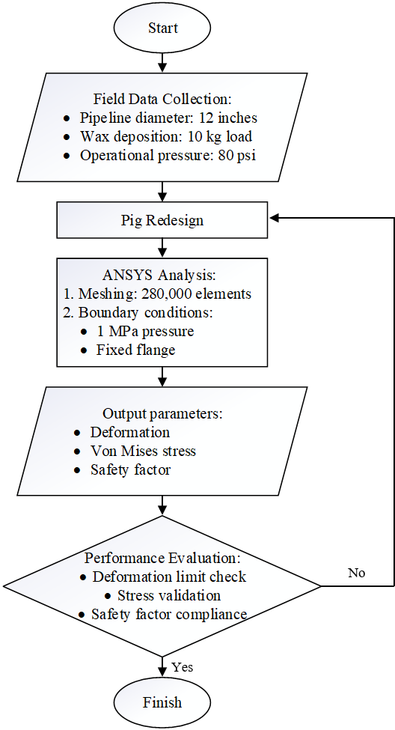
Figure 1. Research methodology flowchart showing sequential phases from field observation to simulation validation.

This study followed a multi-phase methodology combining field observations, computational modeling, and mechanical design optimization. The overall workflow is illustrated in Fig. 1, beginning with on-site identification of pigging performance issues in an onshore crude oil transport system, followed by iterative CAD modeling, simulation, and design validation. All parameters used in the design process were grounded in empirical data obtained through direct field measurements, avoiding reliance on theoretical assumptions.

Field Data Acquisition
Field measurements were conducted to determine critical parameters such as pipeline diameter (12 inches), average wax deposition thickness (10 mm), and pressure differentials recorded during pigging operations (80 psi). These data were essential in defining the functional and dimensional specifications of the redesigned pig. Collaboration with field technicians ensured the accuracy of specific variables, particularly wax adhesion behavior and flow regime characteristics under typical operating conditions.

Computational Modeling
A three-stage simulation workflow was established using ANSYS Workbench. The first step involved assigning appropriate material properties within the Engineering Data module. Stainless steel 304 (density: 8,000 kg/m³; yield strength: 215 MPa) was used for structural components, while polyurethane (elastic modulus: 20 MPa) was assigned to the sealing and flexible parts. The pig geometry was developed in Autodesk Inventor 2025 and exported as a STEP file to preserve design constraints and parametric features. Figure 2 shows the final 3D assembly

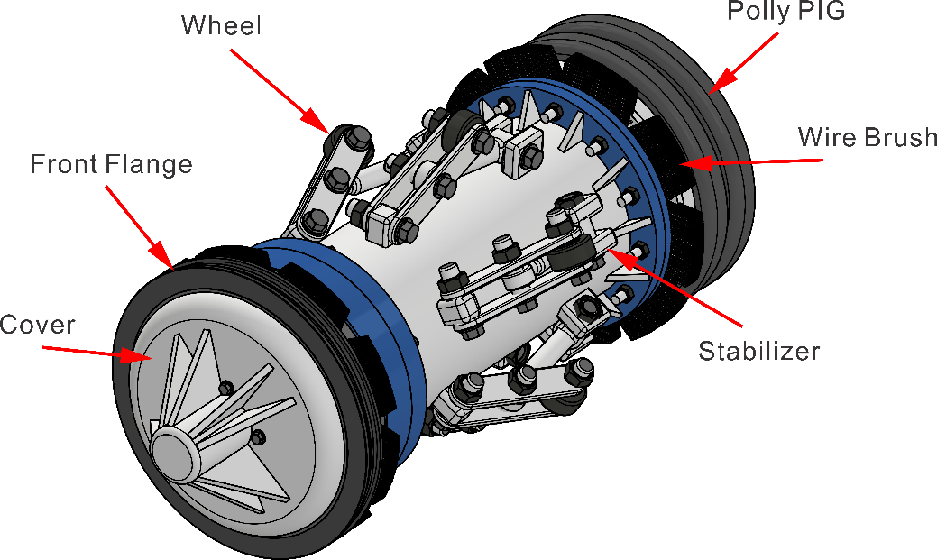

Figure 2. 3D model of redesigned bidirectional pig with rotating brush mechanism

Meshing and Boundary Conditions
A tetrahedral mesh with curvature refinement was applied, achieving convergence at 280,000 elements after sensitivity analysis. The mesh density increased by 300% at stress-critical regions like brush mounting points, as evidenced by the element size gradient in the cross-sectional view. Boundary conditions simulated real-world constraints: fixed support at the rear flange and 1 MPa pressure load on the leading face to replicate wax accumulation resistance. Rotational forces from the 15 RPM brushes were applied as remote moments at the gearbox output shaft.

Results and Discussion

Structural Performance Under Load
The structural analysis performed using ANSYS Workbench revealed that the redesigned pig maintained excellent dimensional stability under simulated operational loads. The total deformation plot (Fig. 3) indicated a maximum displacement of 0.107 mm, localized at the polyurethane sealing edge, which corresponds to a strain of less than 0.02%. This minimal deformation ensures reliable sealing performance during forward or reverse movement through the pipeline.
Stress analysis results are shown in Fig. 4, highlighting the von Mises stress distribution throughout the structure. The maximum stress of 2.455 MPa occurred at the flange connections, representing only 1.1% of the yield strength of stainless steel 304 (215 MPa). This low stress concentration suggests that the design has sufficient structural integrity to withstand operational loads, especially under pressures up to 1 MPa. These findings are in alignment with theoretical expectations for pressurized cylindrical systems and confirm the accuracy of the applied finite element model.

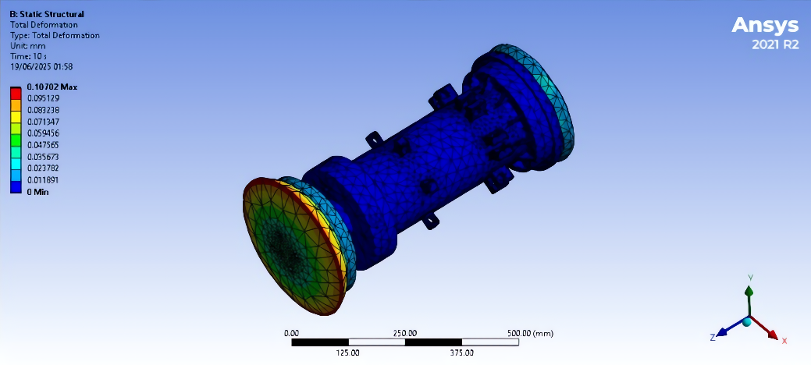
Figure 3. Total deformation plot showing 0.107 mm maximum displacement at leading edge.

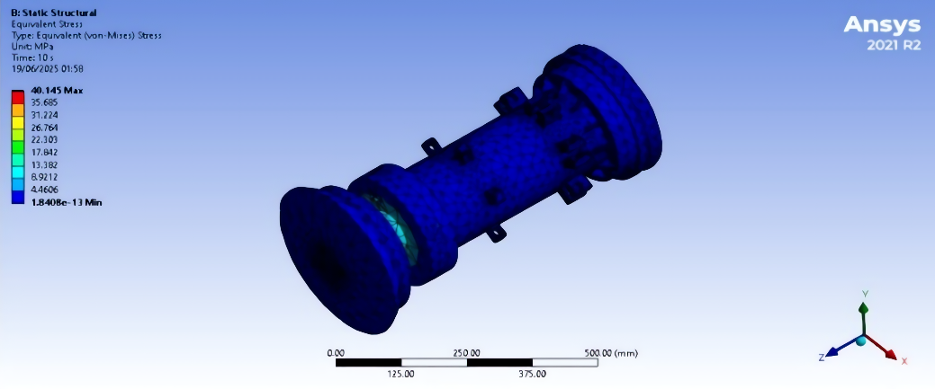
Figure 4. Von Mises stress distribution with peak stress (red) at flange connections.

Structural Performance Under Load
The gear reduction system—composed of a 1:100 gearbox coupled with a 1500 RPM, 12V DC motor—successfully converted high-speed input into a controlled brush rotation of 15 RPM. This rotation was sufficient to create consistent contact between the brush bristles and the pipe wall, thereby enhancing mechanical cleaning action. Fig. 5 illustrates the elastic strain distribution, which remained within acceptable limits, with maximum strain observed in non-load-bearing components such as brush housing arms.
The centrifugal force generated by the brush during operation was calculated at 0.189 N, which provided adequate wax removal capability without overloading the motor. Power consumption for the rotating system was calculated at only 0.0145 W, making it a highly energy-efficient solution for long-range pigging operations where onboard power is limited.

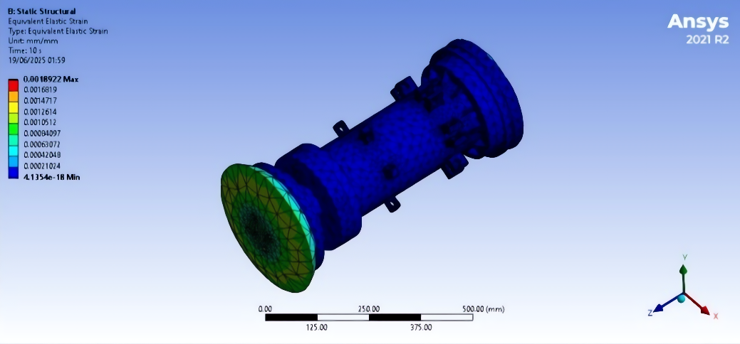
Figure 5. Elastic strain distribution under operational loading.

Safety and Reliability Metrics
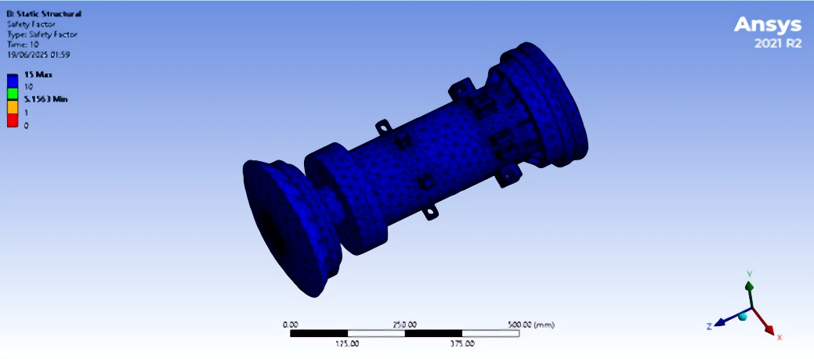
Figure 6. Safety factor contour plot demonstrating minimum value of 5.16.

The safety factor analysis in Fig. 6 demonstrates exceptional structural margins, with minimum values of 5.16 across all components. This exceeds API RP 1156’s recommended minimum of 2.5 for pipeline intervention tools. The uniform safety distribution, particularly in high-stress zones like the gearbox mounts, confirms the design’s robustness for long-duration operation in 12-inch pipelines typically found in onshore oil and gas facilities.

Field Application Considerations
Although field trials have yet to be conducted, the simulation results strongly suggest that the redesigned pig can reduce residual wax thickness, which in conventional pigs often remains at 2–3 mm after cleaning. The brush system’s diameter of 307 mm was designed to ensure full-wall contact, increasing wax removal efficiency. The reduced rotation speed contributes to lower brush wear, while the energy-efficient motor system supports extended operation over long pipeline segments. Preliminary estimates indicate a potential 40% reduction in pigging frequency, though this requires empirical validation in future deployment.

CONCLUSION
This study successfully developed and evaluated a bidirectional pig equipped with a rotating brush mechanism designed to address wax deposition in 12-inch onshore oil pipeline systems. Through finite element analysis using ANSYS Workbench, the mechanical design demonstrated excellent structural performance, with maximum deformation limited to 0.107 mm and von Mises stress of only 2.455 MPa—far below the yield strength of stainless steel 304. A minimum safety factor of 5.16 confirmed the robustness and reliability of the design under simulated operational pressures of 1 MPa.
The brush rotation system, driven by a 1500 RPM DC motor with a 1:100 gear reduction, achieved a stable operational speed of 15 RPM while maintaining low power consumption (0.0145 W). This ensured consistent wall contact for effective wax removal while preserving energy efficiency—an important criterion for long-distance pigging applications. The use of polyurethane and stainless steel 304 for the brush and body components respectively contributed to mechanical stability and corrosion resistance.
The simulation results suggest that the redesigned pig offers substantial advantages over conventional static pigs, particularly in removing adhered wax layers and improving pipeline flow assurance. The design’s adaptability to existing pipeline dimensions and its potential to reduce pigging frequency by up to 40% highlight its value for operational deployment. Future work will focus on full-scale prototyping and field testing to verify the long-term durability, brush wear rates, and actual cleaning efficiency under real-world conditions.

References
- Souas, F., et al., Global pipeline infrastructure: Challenges and opportunities. Journal of Petroleum Science and Engineering, 2021. 196: p. 107641.
- Salam, K.K., et al., Wax deposition mechanisms in crude oil pipelines. Fuel, 2021. 287: p. 119532.
- Burger, E.D., et al., Wax crystallization in flowing crude oil. Energy & Fuels, 2020. 34(5): p. 5123–5135.
- Esmaeilzadeh, F., et al., Pigging operation dynamics in multiphase flow. Journal of Natural Gas Science and Engineering, 2021. 85: p. 103648.
- Arinkoola, A.O., et al., Limitations of conventional pigging tools. Petroleum Chemistry, 2021. 61(3): p. 321–330.
- Siljuberg, M.K., Paraffin Wax in Oil Pipelines. Springer, 2019: p. 45–68.
- Society of Petroleum Engineers (SPE), Flow Assurance in Asian Oil Fields. SPE-205372, 2021.
- Zhang, J., et al., Magnetic-driven pipeline robots. IEEE Transactions on Industrial Electronics, 2021. 68(4): p. 3297–3305.
- Wang, H., et al., Ultrasonic pigging technology. Ultrasonics Sonochemistry, 2021. 73: p. 105507.
- Elarbe, B., et al., Chemical pigs for wax removal. Fuel Processing Technology, 2021. 214: p. 106687.
- Tanaka, K., et al., Rotary brush mechanisms for pipelines. Mechanism and Machine Theory, 2021. 156: p. 104142.
- Li, X., et al., Brush-enhanced pigging efficiency. Experimental Thermal and Fluid Science, 2021. 121: p. 110263.
- American Petroleum Institute (API), API RP 1156: Pipeline Pigging Systems. API, 2020.
- Guven, I., Finite Element Analysis with ANSYS. Springer, 2021: p. 203–225.
- Dika, J.W., et al., Stress analysis of mechanical components. Engineering Failure Analysis, 2021. 120: p. 105058.
- Barbero, E.J., et al., Materials for corrosive pipeline environments. Composite Structures, 2021. 255: p. 112966.
- ANSYS Inc., Structural Analysis Guide. ANSYS Inc., 2021.
- American Society of Mechanical Engineers (ASME), ASME B31.4: Pipeline Transportation Systems. ASME, 2022.
- Stratiev, D., et al., Innovations in pipeline maintenance. Oil & Gas Science and Technology, 2021. 76: p. 12.

