Aerodynamic Simulation of Bus Body using Leading Edge Variation
Elmi Iftachul Anam^{1, a)}, Ali Mokhtar^{1, b)}, and Mulyono^{1, c)}, Irsan Fahmi Almuhtarihan^{2, d)} and Nabiel Ilham Fahreza^{1, e)}
¹Department of Mechanical Engineering, University of Muhammadiyah Malang, Malang, Indonesia
²Department of Pharmacy, University of Muhammadiyah Malang, Malang, Indonesia
^{a)}elmianam220@gmail.com
^{b)}Corresponding author: mokhtar@umm.ac.id
^{c)}mulyono@umm.ac.id
^{d)}irsanfa@umm.ac.id
^{d)}nabielilham2005@gmail.com
Abstract. This study aims to analyze the effect of different leading edge angles on the aerodynamic performance of a bus body using Computational Fluid Dynamics (CFD). Two leading edge angles were investigated: 20 degrees and 25 degrees. The 3D geometry was modeled in SolidWorks 2022, and the simulation was carried out using ANSYS Fluent 2021 R1 with a steady-state flow setup at 80 km/h inlet velocity. The turbulence model applied was SST k-omega. The results indicate that the 25 degrees variation yields better aerodynamic performance, reducing the drag coefficient (Cd) to 0.7758 and drag force to 1,155.12 N, compared to 0.9742 and 1,450.43 N respectively for the 20 degrees variation. Both configurations produced negative lift coefficients, indicating downward force beneficial for vehicle stability. Additionally, the 25 degrees configuration demonstrates smoother airflow around the bus body, confirming its potential for improving fuel efficiency through aerodynamic optimization.

INTRODUCTION
In the current era of technological advancement, energy efficiency in transportation is critical. Buses, as a major mode of transport, require not only comfort and safety but also fuel efficiency to reduce carbon emissions and operational costs [1–3]. Carbon emissions also can cause significant impact on health. it is documented that poor air quality is responsible for approximately 3.7 million annual fatalities worldwide, primarily due to conditions such as ischemic heart disease, stroke, and respiratory diseases [19]. Furthermore, exposure to air pollutants, including traffic-related and industrial emissions, has been shown to exacerbate respiratory infections and lead to long-term health complications, particularly in vulnerable populations such as children and the elderly [20].
One of the primary factors affecting fuel efficiency is aerodynamic drag, which can account for up to 50% of fuel consumption at high speeds [1]. While most aerodynamic studies have focused on small vehicles, such as sedans and MPVs [4], the application to larger vehicles like buses is increasingly important. Buses typically operate over long distances, making aerodynamic improvements impactful [5]. The shape of the leading edge on a bus body significantly influences airflow behavior, drag force, and ultimately, fuel consumption.
Aerodynamics examines the interaction between solid bodies and surrounding air, particularly focusing on lift and drag forces [6–8]. CFD methods offer a powerful approach for analyzing these effects, combining physical principles, numerical modeling, and computational resources [9–13].
This study aims to investigate the impact of leading-edge angles (20° and 25°) on the aerodynamic performance of a simplified bus model. Lift and drag coefficients are used as performance indicators. This research seeks to identify the optimal geometry that improves aerodynamic efficiency without compromising vehicle stability.

Methodology

Research Equipment

SolidWorks 2022
SolidWorks is a CAD (Computer-Aided Design) software with capabilities for parametric 3D modeling and complex surface design. In this study, SolidWorks was used to model the geometric shape of a bus body with two variations of the leading edge, namely slopes of 20° and 25°, based on a basic sketch of a conventional bus design. Each model was constructed with scaled dimensions to represent the realistic proportions of a medium-sized vehicle.
The modeling process involved setting the dimensional units to millimeters and simplifying the geometry to reduce computational complexity during the simulation phase. Once the models were finalized, they were exported to STEP (.step) or IGES (.iges) formats to ensure compatibility with Ansys Fluent [14, 15]. SolidWorks’ ability to handle parametric geometry provided the flexibility to generate design variations efficiently and to accelerate iterative modifications of the geometry.

Ansys Fluent 2021 R1
Ansys Fluent is a CFD (Computational Fluid Dynamics) software based on the Finite Volume Method, used to analyze fluid behavior in both enclosed and open domains. In this study, the simulation was conducted under steady-state flow conditions, assuming incompressible and isothermal flow, in reference to typical conditions experienced by vehicles moving on highways [9], [11].
The bus model previously created was imported into Ansys Fluent, followed by mesh generation using the Meshing Tool. A tetrahedral mesh was selected due to its ability to accurately handle complex geometries. To obtain more stable and realistic results, inflation layers were applied around the vehicle surface to capture the viscous effects within the boundary layer region [12].
The simulation domain was configured to represent realistic aerodynamic conditions. At the inlet boundary, an air velocity of 80 km/h (22.22 m/s) was applied to simulate the vehicle's motion relative to surrounding airflow. The outlet boundary was set to atmospheric static pressure (0 Pa, relative) to allow the flow to exit freely. All vehicle surfaces were treated as no-slip walls, meaning that the velocity of the fluid at the surface was assumed to be zero relative to the surface. Additionally, a symmetry boundary condition was employed to model only half of the computational domain, thereby reducing computational time while preserving the physical accuracy of the simulation.
Turbulence modeling employed the k-ε Realizable Standard model, which is among the most commonly used turbulence models in vehicle simulations due to its stability and efficiency in predicting pressure and velocity distributions [13]. Iterations continued until convergence was achieved with residuals below 10⁻⁴, and simulation results were considered stable when the drag coefficient (Cd) and lift coefficient (Cl) values reached consistent outputs.

Research Workflow Diagram
The research steps are summarized in the flowchart presented in Fig. 1, which illustrates the sequence of activities starting from geometric modeling, importing the model into CFD software, mesh generation, boundary condition setup, and turbulence model selection. The process concludes with the analysis of simulation results, including pressure and velocity contour visualizations, as well as the calculation of drag (Cd) and lift (Cl) coefficients for each leading-edge variation. The entire procedure was conducted in a sequential and systematic manner to ensure the validity and reliability of the results.

Results and Discussion

3D Geometry
n this study, the 3D bus model was created using SolidWorks 2022, based on the general shape of commercial buses operating in Indonesia [14]. The overall dimensions of the model include a length of 12,000 mm, a width of 2,500 mm, and a height of 3,850 mm. The primary difference between the models lies in the variation of the leading-edge angle at the front part of the bus body. Two versions were developed with leading-edge inclinations of 20° and 25°, respectively. These variations were intended to evaluate the influence of front-end geometry on aerodynamic performance [16].
After the design process, the models were exported to ANSYS 2021 R1 for CFD-based aerodynamic simulation. Illustrations of the geometric models with different leading-edge angles are presented in Figs. 2 and 3.

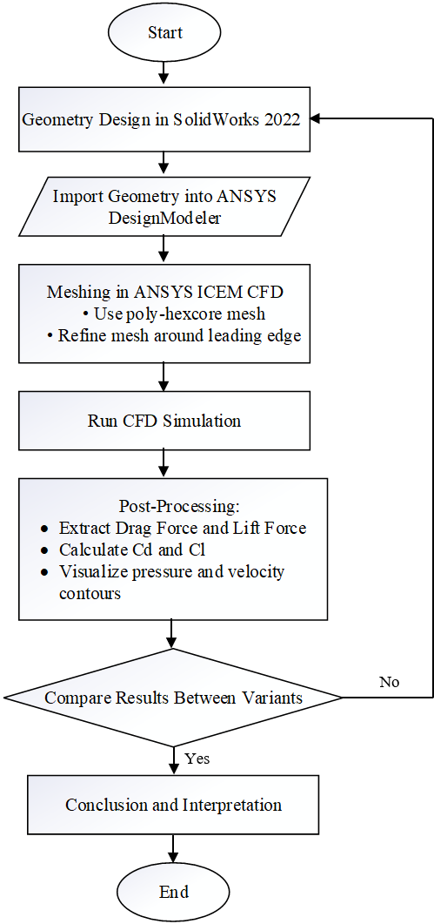
Figure 1. Flowchart of the Bus Body Aerodynamic Simulation

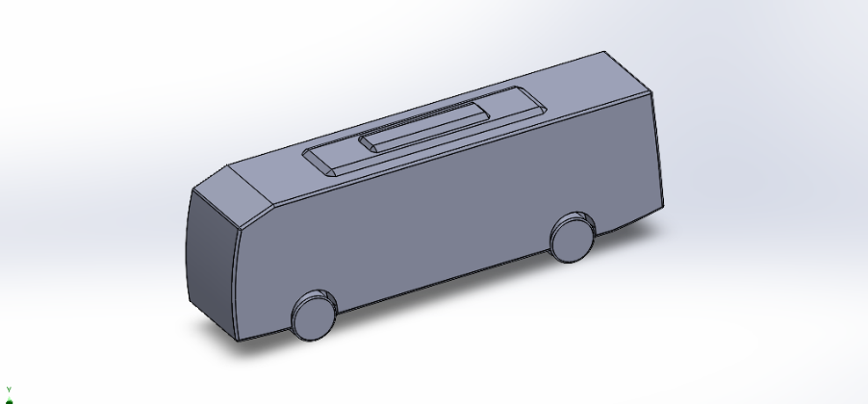
Figure 2. Bus Model with a 20° Leading Edge Angle.
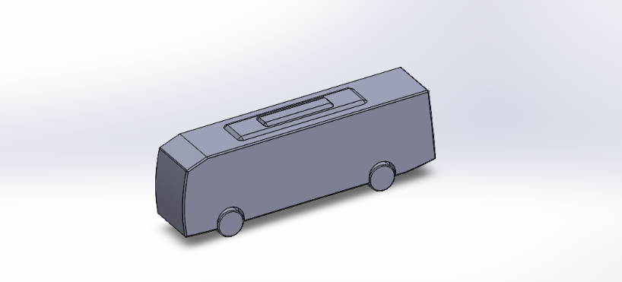
Figure 3. Bus Model with a 25° Leading Edge Angle

Simulation Domain Construction
The simulation domain was constructed using the Design Modeler module in ANSYS. The previously created bus geometry was imported into the working environment and positioned within a virtual wind tunnel. The dimensions of the wind tunnel were carefully designed to avoid wall effects on the simulation results, by ensuring sufficient clearance between the object and both the inlet and outlet boundaries [16]. The bus model was positioned with the airflow direction set from front (inlet) to rear (outlet), simulating real-world conditions of a vehicle moving against the wind. Figure 4 illustrates the domain construction process.

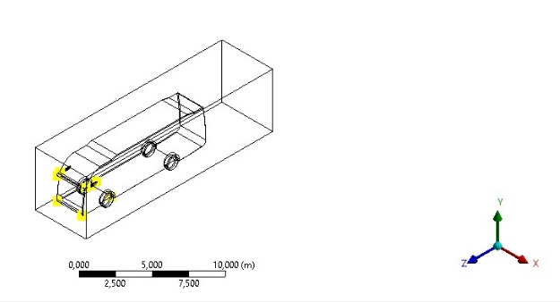
Figure 4. Domain Setup.

Mesh Generation
The meshing process was carried out using ANSYS ICEM CFD, employing a poly-hexcore mesh type, which combines hexahedral elements in the core flow region with polyhedral elements around complex surface geometries. This approach provides a more flexible and efficient mesh structure, particularly suited for capturing the curved and sharp contours of the bus body [17]. The poly-hexcore mesh visualization for the bus geometry is shown in Fig. 5.

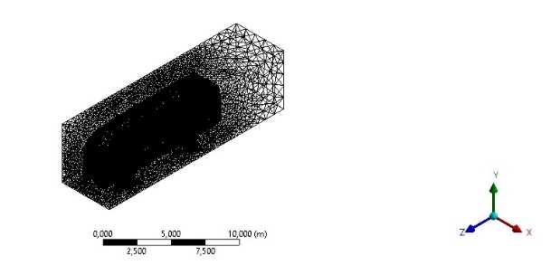
Figure 5. Poly-Hexcore Mesh Visualization on the Bus Geometry.

To improve solution accuracy, mesh density was increased around the vehicle walls by applying inflation layers. These layers are essential for capturing boundary layer phenomena and ensuring accurate turbulence modeling. Each model contained approximately 3 to 4 million mesh elements.

Aerodynamic Simulation
The aerodynamic simulations were performed under steady-state flow conditions with an inlet velocity of 80 km/h. The SST k-ω turbulence model was used, as it is known for its high accuracy in predicting flow separation and pressure gradient effects [18]. The CFD simulation results for the two leading-edge angle variations are presented in Table 1.

TABLE 1. CFD Simulation Results for Two Leading Edge Angle Variations.
Sudut Leading Edge | Gaya Angkat (N) | Koefisien Lift (Cl) | Gaya Hambat (N) | Koefisien Drag (Cd)
20° | -519,56 | -0,3514 | 1450,43 | 0,9742
25° | -503,49 | -0,3382 | 1155,12 | 0,7758

From the simulation results, it was observed that increasing the leading edge angle from 20° to 25° resulted in a reduction of drag force by 295.31 N. This indicates that the 25° model has a more streamlined shape, allowing air to flow more smoothly around the bus surface.
The drag coefficient (Cd) also showed a decreasing trend, from 0.9742 to 0.7758. This reduction of 0.1984 in Cd confirms that aerodynamic efficiency improves as the front-end inclination increases.
Meanwhile, the lift force for both variations yielded negative values, indicating the presence of downward force (downforce). This is beneficial as it increases the traction between the vehicle's tires and the road surface. The decrease in downforce from –519.56 N to –503.49 N in the 25° model is relatively minor and does not negatively impact vehicle stability.

Simulation Convergence
A simulation is considered converged when the residual values fall below the predefined thresholds—typically 10⁻³ for energy and 10⁻⁴ for velocity parameters. The residual curves shown in Fig. 6 indicate that the simulation successfully achieved convergence, particularly for the key output parameters such as drag and lift forces.

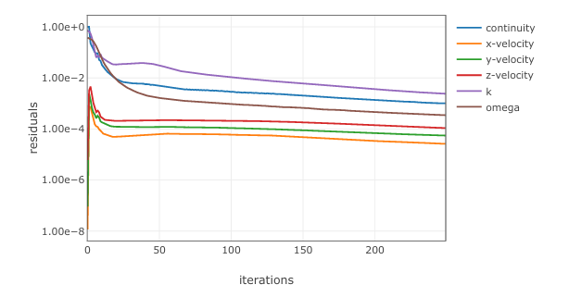
Figure 6. Residual Curve and Simulation Convergence.

CONCLUSION
Based on the Computational Fluid Dynamics (CFD) simulation results for two bus models with leading edge angles of 20° and 25°, it can be concluded that modifications to the front-end geometry significantly affect the vehicle’s aerodynamic characteristics. The model with a 25° leading edge demonstrated superior performance compared to the 20° model, as evidenced by a reduction in drag force from 1450.43 N to 1155.12 N, and a decrease in drag coefficient from 0.9742 to 0.7758. This indicates that airflow around the 25° model is more streamlined, resulting in improved aerodynamic efficiency.
In addition, both models produced negative lift forces, signifying the generation of downward force (downforce), which contributes to better vehicle stability during motion. The slight reduction in downforce observed in the 25° model was minor and did not compromise traction performance. Therefore, the 25° leading edge geometry can be recommended as a more aerodynamically efficient and stable design for bus-type vehicles.

References
- Hucho, W. H., & Sovran, G. (1993). Aerodynamics of road vehicles. Annual Review of Fluid Mechanics, 25(1), 485-537.
- Chen, G., Yang, J., & Wang, J. (2019). Analysis of drag reduction for bus by modification of shape. Results in Engineering, 3, 100091.
- Versteeg, H. K., & Malalasekera, W. (2007). An Introduction to Computational Fluid Dynamics: The Finite Volume Method. Pearson Education.
- Spalart, P. R., & Allmaras, S. R. (1992). A one-equation turbulence model for aerodynamic flows. AIAA Paper, 92-0439.
- Roshani, A., et al. (2021). Numerical and experimental study of aerodynamic performance of bus models. International Journal of Heat and Fluid Flow, 86, 108807.
- Patankar, S. V. (1980). Numerical Heat Transfer and Fluid Flow. Hemisphere Publishing Corporation.
- Menter, F. R. (1994). Two-equation eddy-viscosity turbulence models for engineering applications. AIAA Journal, 32(8), 1598-1605.
- Ferziger, J. H., & Perić, M. (2002). Computational Methods for Fluid Dynamics. Springer.
- Rahman, M. M., et al. (2015). CFD analysis of flow over bluff bodies with different shapes. Procedia Engineering, 105, 232–238.
- Sighard, F. H. (2017). Aerodynamics of buses and coaches: Reduction of fuel consumption. Natural Science, 9(10), 329-339.
- Saleh, P., et al. (2020). CFD study of drag reduction techniques on passenger buses. MATEC Web Conf, 225, 02012.
- Tallec, A., et al. (2019). Analysis of ground vehicle aerodynamic drag reduction. Journal of Wind Engineering and Industrial Aerodynamics, 188, 66-78.
- Raza, H., et al. (2021). CFD analysis using SolidWorks and Ansys. IOP Conf. Series: Materials Science and Engineering, 872(1), 012002.
- Fluent, A. N. S. Y. S. (2020). ANSYS Fluent Theory Guide. ANSYS Inc.
- ANSYS Inc. (2021). Ansys Fluent User’s Guide, Release 2021 R1.
- Wilcox, D. C. (2006). Turbulence Modeling for CFD. DCW Industries.
- Anderson, J. D. (1995). Computational Fluid Dynamics: The Basics with Applications. McGraw-Hill.
- Li, Z., et al. (2021). Aerodynamic design optimization of a coach. Transportation Engineering, 3, 100052.
- Eckelman M. and Sherman J.. Environmental impacts of the U.S. health care system and effects on public health. PLOS One 2016;11(6):e0157014
- Lelieveld J. , Haines A. , Burnett R. , Tonne C. , Klingmüller K. , Münzel T. et al.. Air pollution deaths attributable to fossil fuels: observational and modelling study. BMJ 2023:e077784.

