Mechanical Properties Analysis of a 125-Ton Class Excavator Attachment Using Autodesk Inventor Simulation
Yazid Fikri Fadholi^{a)}, Roro Heni Hendaryati^{b)}, Nur Hasanah^{c)}
and Dhimas Ari Widiyanto^{d)}
Department of Mechanical Engineering, University of Muhammadiyah Malang
Jl. Raya Tlogomas No. 246, Malang 65144, Indonesia.

^{a)}yazidfikrifadholi23@gmail.com
^{b)}Corresponding author: heni@umm.ac.id
^{c)}nurhasanah02@umm.ac.id
^{d)}dhimaswidiyanto6@gmail.com
Abstract. Attachments play a crucial role in excavator operations, particularly in mining environments where digging and material handling are intensive. This study aims to evaluate the mechanical strength of a 125-ton class excavator attachment—focusing on the boom and arm components—under increased bucket capacity conditions, from 6.7 m³ to 7.5 m³. Finite Element Analysis (FEA) simulations were performed using Autodesk Inventor to assess stress distribution, displacement, and safety factor under operational loading scenarios, including digging force and arm crowd force. The simulation results show that the arm experienced a maximum stress of 82.15 MPa, with a peak displacement of 2.449 mm and a minimum safety factor of 4.38. These results fall within safe limits when compared to the yield strength of SM490YA material, which is 365 MPa. Therefore, it can be concluded that the existing attachment structure remains safe and feasible for use with the increased bucket volume, without requiring significant structural modifications. The findings offer valuable insights into structural integrity assessment for heavy-duty excavators in the mining sector.

INTRODUCTION
Excavators are indispensable in mining and construction industries, with attachments such as booms, arms, and buckets subjected to direct operational loads [1]. In coal mining applications, these components endure high cyclic stresses, leading to localized deformations and material fatigue. Field observations frequently report premature failures, including cracks and deformations in arm and bucket structures, attributed to combined static and dynamic loads like digging and crowd forces [2, 3]. The growing demand for productivity has driven proposals to increase bucket capacity, yet such modifications often lack thorough structural assessments. Without proper mechanical evaluation, premature structural failures may occur, underscoring the need for rigorous stress and material strength analyses [4].
Prior studies have investigated excavator attachment performance. Sun and Xing (2025) emphasized the necessity of stress distribution evaluations when increasing operational capacity [5]. Research by MDPI Materials (2021) analyzed carbon-composite arm fatigue, highlighting the importance of fatigue life assessment [6]. Heliyon (2024) developed a fatigue life prediction system for rotary table excavators using multibody dynamics and FEA, identifying high-stress concentration areas under cyclic loading [7]. Rindone et al. (2020) proposed a fatigue model for excavator beams using real load data and modified S-N curves to estimate residual life [8]. However, none specifically address the structural feasibility of a 125-ton class excavator attachment when bucket capacity is increased from 6.7 m³ to 7.5 m³.
This study aims to evaluate the structural integrity of a 125-ton excavator attachment through FEA simulations in Autodesk Inventor, focusing on stress distribution, total deformation, and safety factors under standard and upgraded bucket capacities. The hypothesis posits that the increased bucket load will elevate stresses in critical regions but remain within elastic limits if the original design is sufficiently conservative [9]. The findings are expected to contribute to optimized attachment designs in mining operations.

Methodology
This study employed a quantitative simulation-based approach using the Finite Element Method (FEM) through Autodesk Inventor Professional 2019 [10]. The object of analysis is the attachment of a 125-ton class excavator, focusing on the boom and arm structures. The simulation stages include technical data acquisition, 3D modeling, material selection, boundary condition assignment, application of operational loads, meshing, and static analysis execution. The complete methodological workflow is illustrated in Fig. 1.

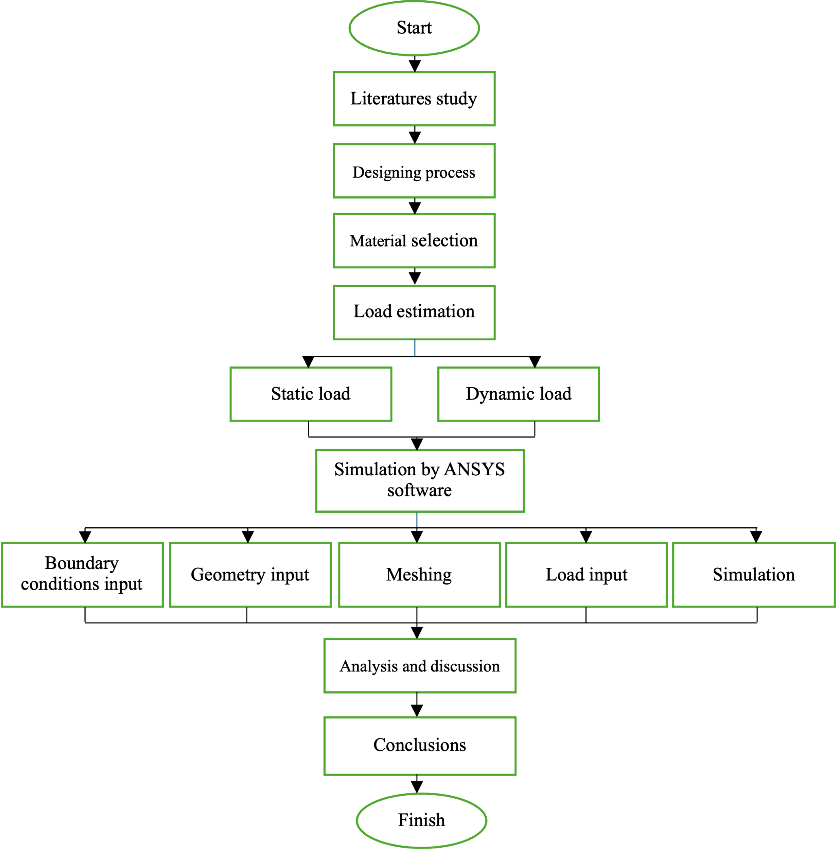

Figure 1. Simulation workflow for evaluating excavator attachment structure

The process began with constructing a precise 3D model of the excavator attachment. This modeling phase is essential to accurately capture the geometry and stress concentration areas that significantly affect simulation results [11, 12]. The SM490YA structural steel was selected due to its high strength and proven application in heavy mechanical structures.
Subsequently, boundary conditions were defined to simulate realistic constraints, such as mounting points and pin joints, as shown in Fig. 2. These constraints replicate the actual fixed points where the attachment connects to the excavator body [13]. Operational forces, including digging force and arm crowd force, were then applied to specific surfaces with realistic magnitudes and directions, representing field loading conditions [14], as shown in Fig. 3.
The meshing process followed, where the 3D model was discretized into finite elements. This conversion allows the solver to compute localized stress, strain, and displacement distributions across the structure [15]. Finally, a static simulation was conducted, integrating all setup parameters to evaluate structural responses under both standard and modified bucket capacities [16]. Simulation results were assessed in terms of Von Mises stress, total displacement, and safety factor, and compared to the material's yield strength to determine structural feasibility.

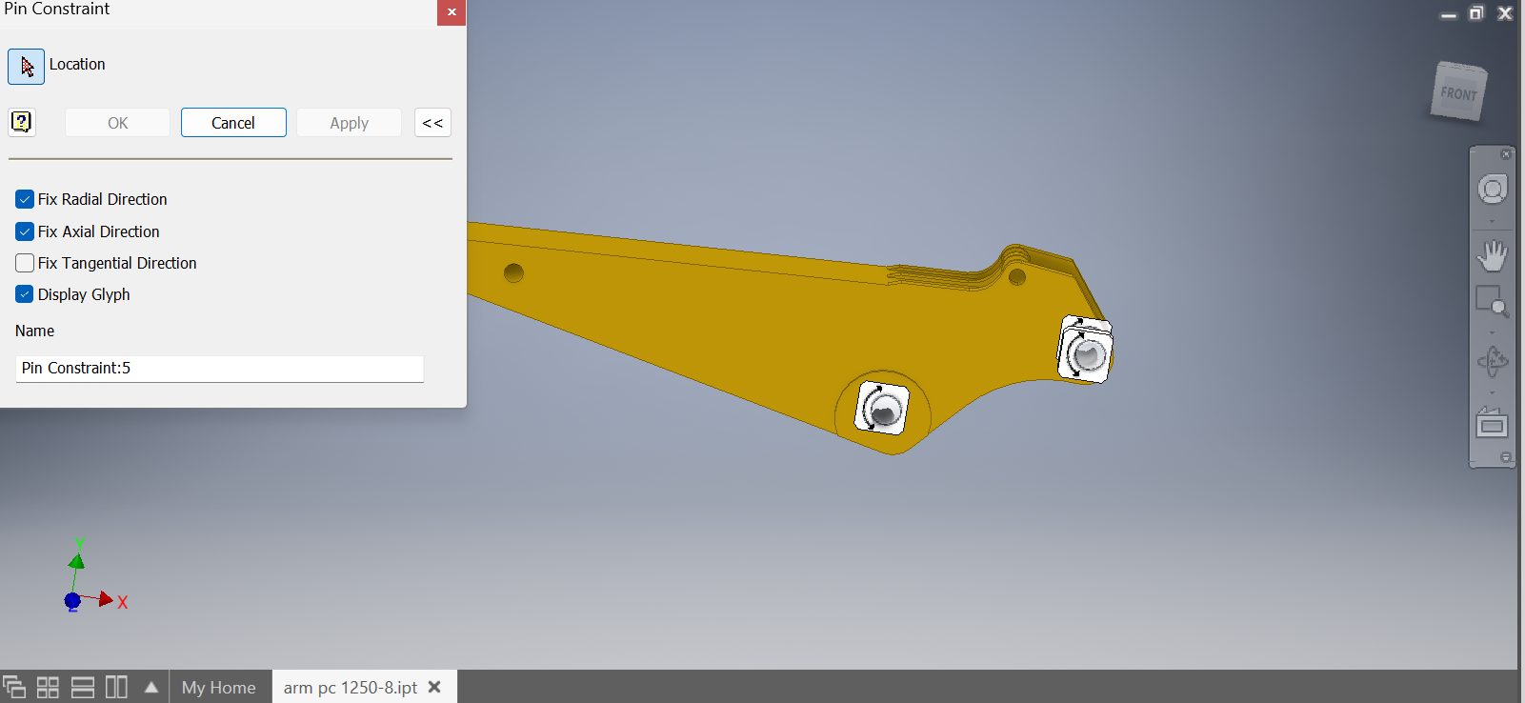
Figure 2. Defining Constraint Points.

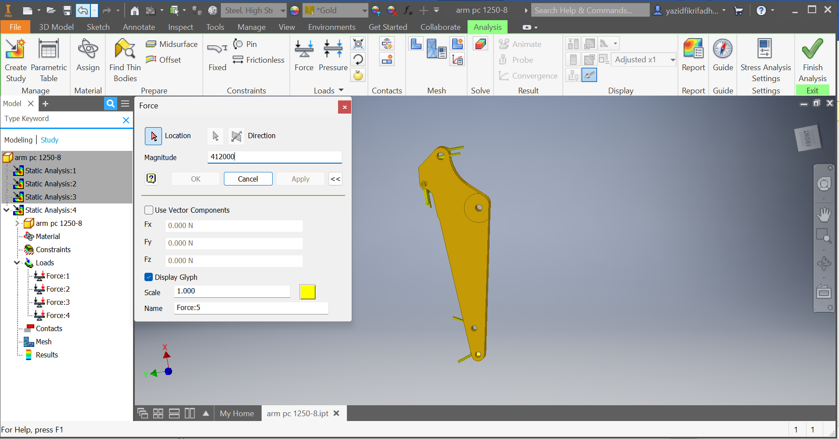
Figure 3. Load Application.

Results
Static simulation of the 125-ton excavator attachment was conducted using Autodesk Inventor Professional 2019, yielding stress distribution, displacement, and safety factor data under operational loads.

Arm Excavator Analysis

Stress Distribution (Von Mises)
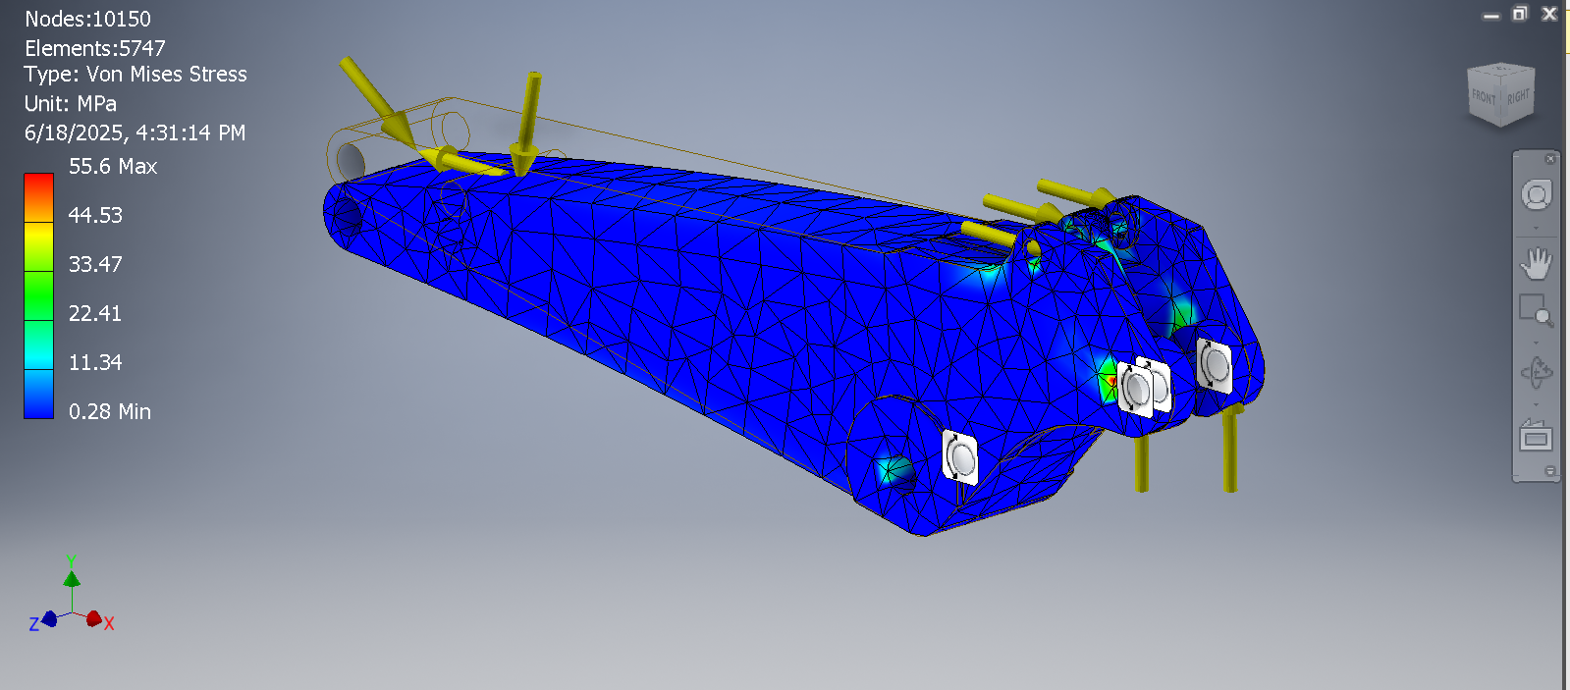
Figure 4. Von Mises stress distribution on the excavator arm.
As shown in Fig. 4, the maximum Von Mises stress on the arm was 55.6 MPa, localized near the pin hole connecting the arm cylinder—a critical stress concentration zone. The minimum stress recorded was 0.28 MPa. Notably, the peak stress remained well below the material’s yield strength (365 MPa), confirming elastic deformation behavior [17].

Displacement Analysis
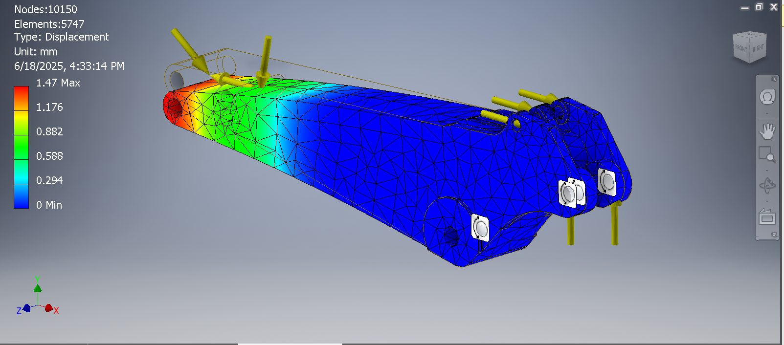
Figure 5. Total displacement simulation of the arm.

Figure 5 reveals a maximum displacement of 1.47 mm at the bucket-end of the arm, while the fixed supports showed 0 mm displacement. This minimal deflection (<1% of arm length) indicates sufficient rigidity to maintain functionality under load [17].

Safety Factor Evaluation
The safety factor ranged from 6.48 (near the bucket joint) to 15 (Fig. 6). Values >1.5 are considered safe; thus, the arm’s design exceeds requirements despite dynamic mining loads [18–20].

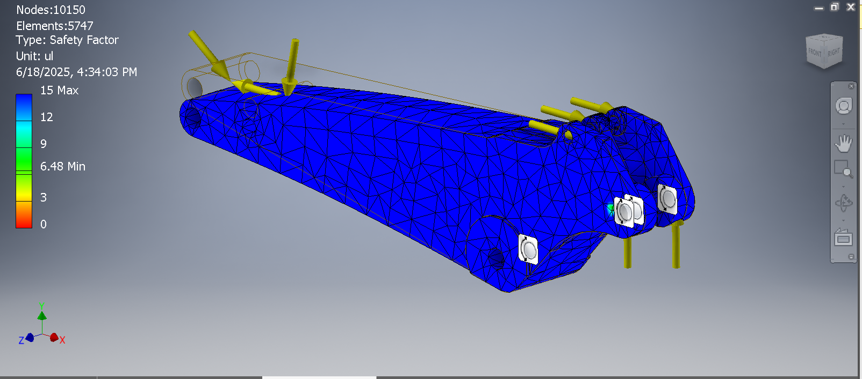
Figure 6. Total displacement simulation of the arm.

Boom Excavator Analysis

Stress Distribution (Von Mises)
The boom exhibited higher stress concentrations (82.15 MPa) at the bucket cylinder joint (Fig. 7), yet remained within elastic limits (365 MPa). The 0.15 MPa minimum stress occurred at low-load regions.

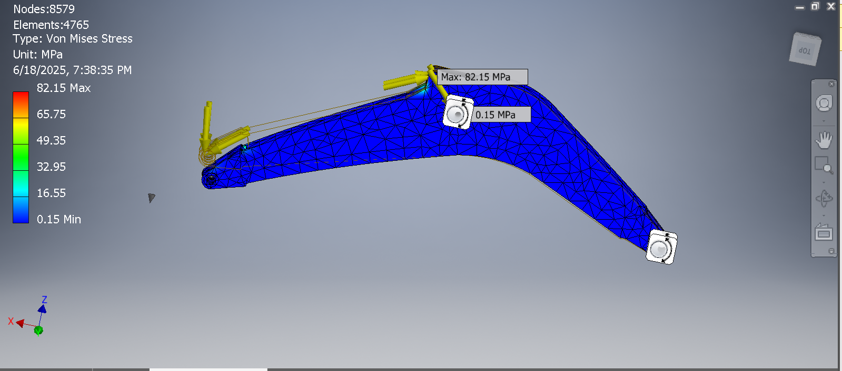
Figure 7. Von Mises stress simulation of the boom.

Displacement Analysis
Peak displacement reached 2.449 mm at the boom’s bucket-end (Fig. 8), while fixed points showed negligible movement (0.004 mm). This deformation (<2% of boom length) confirms structural stability [21].

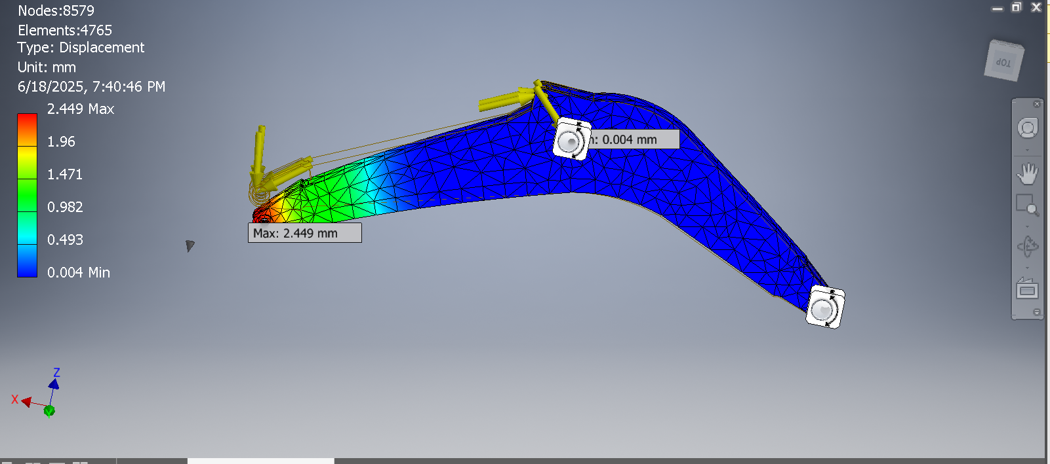
Figure 8. Displacement results of the boom.

Safety Factor
The minimum safety factor of 4.38 (Fig. 9) indicates the boom withstands 4× the operational load before yielding—exceeding the standard threshold of 3 for dynamic mining equipment.

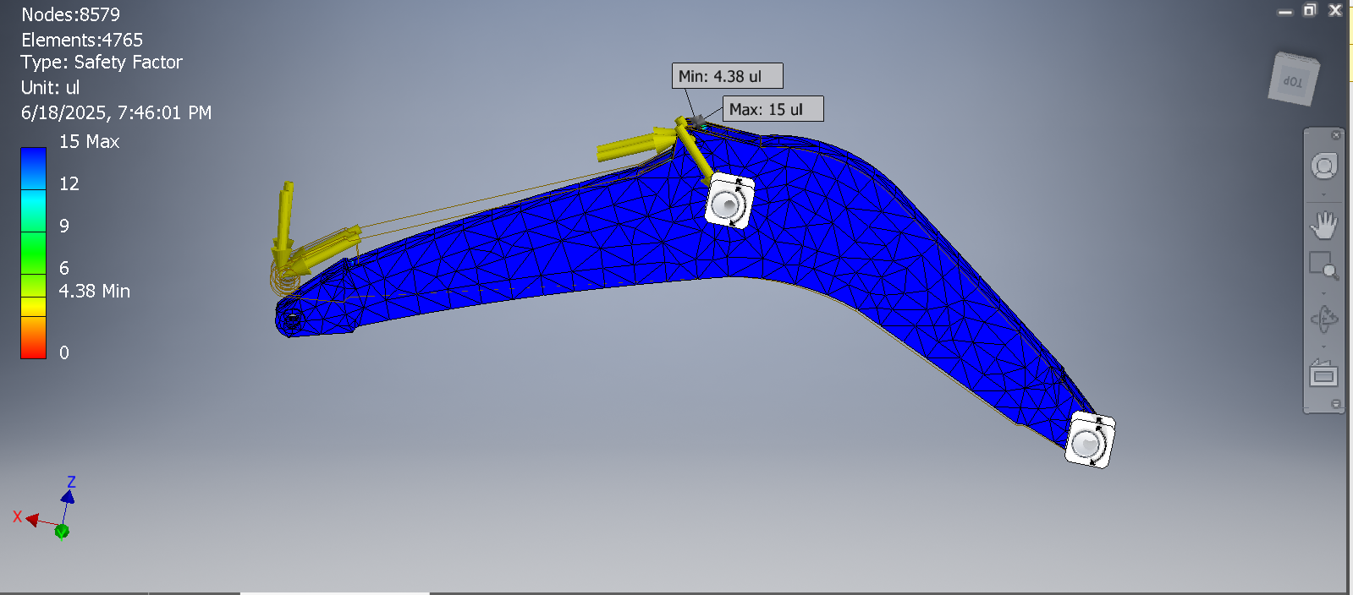
Figure 9. Safety factor analysis of the boom.

Comparative Summary
Table 1 consolidates key parameters for both components, validating their safety margins under upgraded bucket capacity (7.5 m³).

TABLE 1. Simulation results comparison for arm and boom.
Parameter | Arm Excavator | Boom Excavator | Safe Limit | Conclusion
Von Mises (MPa) | 0.28–55.6 | 0.15–82.15 | <365 | Safe
Displacement (mm) | 0–1.47 | 0.004–2.449 | <1–2% length | Safe
Safety Factor | 6.48–15 | 4.38–15 | >1.5 | Safe

CONCLUSION
The finite element analysis (FEM) of the 125-ton excavator’s attachment (boom and arm) using Autodesk Inventor yielded critical insights into its structural performance. The highest stress concentrations occurred near pin holes and hydraulic cylinder joints, with peak values of 55.6 MPa (arm) and 82.15 MPa (boom)—well below the SM490YA material’s yield strength (365 MPa), confirming elastic deformation limits were not exceeded. Displacement results further validated structural stability, with maximum deflections of 1.47 mm (arm) and 2.449 mm (boom), demonstrating negligible deformation relative to component dimensions under Digging Force loads. The Arm Crowd Force induced localized stresses at bucket joints, but safety factors remained robust (minimum 6.48 for arm, 4.38 for boom), ensuring reliability against plastic deformation or failure. Crucially, the evaluation of increased bucket capacity (6.7 m³ to 7.5 m³) confirmed the attachment’s feasibility for heavier loads, provided stress-prone areas are monitored. These findings collectively affirm that the 125-ton excavator attachment maintains sufficient safety margins for operational demands without requiring major redesigns.

References
- A. Assadzadeh, M. Arashpour, H. Li, R. Hosseini, F. Elghaish, and S. Baduge, “Excavator 3D Pose Estimation Using Deep Learning and Hybrid Datasets,” Adv. Eng. Inform., 55, 101827 (2023). https://doi.org/10.1016/j.aei.2023.101827
- Y. Sun et al., “Digging Performance and Stress Characteristic of the Excavator Bucket,” Appl. Sci., 13 (20), 11234 (2023). https://doi.org/10.3390/app132011234
- X. Wang, H. Sun, M. Feng, Z. Ren, and J. Liu, “Dynamic Analysis of Working Device of Excavator Under Limit Digging Force,” J. Inst. Eng. Ser. C, 102 (5), 1137–1144 (2021). https://doi.org/10.1007/s40032-021-00734-3
- H. Sun, Z. Ren, J. Li, G. Li, and W. Liu, “Bucket Structure Optimization of Backhoe Hydraulic Excavator Based on Compound Digging Trajectory and Limit Digging Force,” Adv. Mech. Eng., 14 (4), 1–8 (2022). https://doi.org/10.1177/16878140221097311
- B. Sun and B. Xing, “Research on Optimization Design of Excavator Boom Structure Based on Finite Element Analysis,” Eng. Struct., 45, 26–42 (2025).
- L. Solazzi, A. Buffoli, and F. Ceresoli, “Fatigue Evaluation for Innovative Excavator Arms Made of Composite Material,” Materials, 15 (21), 7642 (2022). https://doi.org/10.3390/ma15217642
- C. Xian, H. Zhang, Y. C. Kim, H. Zhang, and Y. Liu, “Programmed System for Fatigue Life Prediction of Excavator Turntables Based on Multi‑Body Dynamics and Finite Element Analysis,” Heliyon, 10 (12), e33126 (2024). https://doi.org/10.1016/j.heliyon.2024.e33126
- G. Zhao, J. Xiao, and Q. Zhou, “Fatigue Models Based on Real Load Spectra and Corrected S‑N Curve for Estimating the Residual Service Life of the Remanufactured Excavator Beam,” Metals, 11 (2), 321 (2021). https://doi.org/10.3390/met11020321
- Y. Wang et al., “Optimization of Excavator Bucket Structure by a Coupled Simulation Method,” Appl. Sci., 13 (20), 11245 (2023). https://doi.org/10.3390/app132011245
- M. Dom, “Analysis and Improvement of the Finite Element Simulation with Inventor of 3D‑Printed PLA Parts,” J. Comput. Des. Eng., 11, 56–64 (2024).
- S. Zhang and M. Mikulich, “Parametric CAD Modelling of Aircraft Wings for FEA Vibration Analysis,” J. Appl. Math. Phys., 9 (5), 889–900 (2021). https://doi.org/10.4236/jamp.2021.95060
- J. V. Sanjay, P. K. A. A, and S. S. Kathale, “Structural Analysis and Performance Optimization of Universal Bracket of Different Materials Used in Electric Four‑Wheeler Vehicles Using ANSYS Software,” Int. J. Eng. Res., 12 (4), 3190–3194 (2025).
- J. Lin et al., “Effects of Boundary Conditions on Stress Distribution of Hydraulic Support: A Simulation and Experimental Study,” Adv. Mech. Eng., 13 (3), 168781402110011 (2021). https://doi.org/10.1177/16878140211001194
- J. A. Martins and E. C. Romão, “The Importance of Accurate Boundary Condition in Obtaining Reliable Shearing Stresses on a Torsional Finite Element Simulation,” Eng. Technol. Appl. Sci. Res., 12 (3), 8482–8487 (2022). https://doi.org/10.48084/etasr.4809
- A. Ruggiero, R. D’Amato, and S. Affatato, “Comparison of Meshing Strategies in THR Finite Element Modelling,” Materials, 12 (14), 2332 (2019). https://doi.org/10.3390/ma12142332
- G. Cadet and M. Paredes, “Convergence Analysis and Mesh Optimization of Finite Element Analysis Related to Helical Springs,” Mech. Ind., 25, 4 (2024). https://doi.org/10.1051/meca/2024001
- A. Wijayanto, A. Akbar, and K. Nadliroh, “Strength Analysis of Dynotest Frame Using Autodesk Inventor,” J. Tek. Mesin, 7, 1301–1308 (2023).
- A. Wahab, M. Rohman, A. Saepuddin, and M. Sulaiman, “Design and Simulation of Strength Test for Prototype Sedan Car Chassis Using Aluminium Alloy 7075,” J. Tek. Mesin Indones., 17 (1), 78–85 (2022).
- L. A. N. Wibawa, “Effect of Material Selection on Frame Strength of Main Landing Gear for UAV Aircraft,” J. Teknol. Terap. Bisnis, 2 (1), 48–52 (2019).
- Y. S. Pramesti, “Design and Fabrication of Compost Processing Machine Frame with 5 kg/min Capacity,” J. Rekayasa Mesin, 8, 730–738 (2024).
- M. A. S. Alamin, “Design and Construction of Electric Car Prototype Chassis,” J. Tek. Otomotif, 7, 1166–1172 (2023).

