Structural Strength Analysis of a Ship Jig Saddle for Supporting a Frigate Hull Using ANSYS Simulation
Calvin Widyatama^{a)}, Daryono^{b)} and Heni Hendaryanti^{c)}
Department of Mechanical Engineering, University of Muhammadiyah Malang
Jl. Raya Tlogomas No. 246, Malang 65144, Indonesia.

^{a)}calvinwidyatama4@gmail.com
^{b)}Corresponding author: daryono@umm.ac.id
^{c)}heni@umm.ac.id
Abstract. The ship jig saddle is a structural support used to stabilize a frigate hull during production or maintenance. Its strength and stability are critical to ensure safety during handling processes. This study investigates the structural performance of a ship jig saddle under static loading using Finite Element Method (FEM) simulation. The model was developed using Autodesk Inventor and analyzed with ANSYS software employing the Tresca failure criterion. The material modeled corresponds to ASTM A36 structural steel, with geometric parameters adjusted based on typical industrial-scale applications. The static structural analysis revealed that the maximum shear stress experienced by the saddle was 3.65 MPa, which is significantly lower than the shear yield strength of the material (125 MPa). These findings confirm that the saddle design is structurally safe under the estimated static load conditions. The results of this study can serve as a design reference for similar structural supports in marine engineering applications.

INTRODUCTION
A ship jig saddle is a structural support used to maintain the stability of a vessel's hull during handling, transfer, or maintenance operations. In the case of a large frigate weighing several thousand tons, it typically requires multiple saddle supports to ensure uniform load distribution and prevent structural damage. ASTM A36 steel is commonly used for this application due to its high tensile strength, weldability, and resistance to heavy static loads [1]. Uneven load distribution or inadequate material strength may lead to deformation or structural failure. Therefore, careful attention must be given to the geometry and thickness of the saddle material to ensure structural safety and stability.
The Finite Element Analysis (FEA) method has become a key approach in evaluating stress and deformation in structural components, especially for complex support configurations such as saddles [2], [3]. Several studies have demonstrated that FEA-based simulations using software such as ANSYS can effectively optimize saddle design by minimizing stress concentrations and enhancing structural integrity [4], [5].
This research aims to analyze the structural strength of a ship jig saddle in supporting a frigate hull by applying simulation-based static stress analysis. The results are expected to provide a reliable design reference for safe and efficient jig saddle development in maritime engineering applications.
Previous works such as [3], [4], [6], and [7] have contributed significantly to the development of this study. Structural strength is a critical factor in mechanical design, as components must be able to withstand static loads while maintaining precision during operation. Tasdemir et al. [8] demonstrated how both analytical and numerical approaches can be applied to assess the strength of newly designed ship structures. Stress, defined as the internal force per unit area within a material, is a key parameter in evaluating the safety and reliability of mechanical components [9]. Similarly, strain, which describes the material’s deformation under load, is essential in modifying material properties and developing high-performance alloys [10]. Research on semiconductors [11] has also shown the relevance of strain engineering in improving material behavior, which can inform mechanical design decisions.
Tresca’s failure theory, which posits that material failure occurs when the maximum shear stress exceeds a critical limit, provides a useful framework for evaluating plastic deformation limits [12]. Deformation behavior—whether elastic or plastic—is strongly influenced by strain rate and the interaction between the material and external forces. Studies by [13] and [14] emphasize the role of viscosity and micropolar mechanisms in the material response to mechanical loading. Additionally, research on hyper-viscoelastic materials, such as non-porous polychloroprene, shows that deformation can be permanent or reversible depending on the material’s characteristics and applied forces [15].
Studies focused on saddle structures, such as those by [2], highlight the importance of precise design in distributing loads across support systems. ASTM A36 steel was selected in this research due to its favorable mechanical performance, especially post-welding, which enhances its load-bearing capacity [1]. Said and Fanb [16] noted that a trimaran frigate design provides better stability and maneuverability compared to conventional frigate designs. Wave-induced loading has a significant impact on structural design, particularly for long and slender hulls that are susceptible to bending moments, which must be accounted for in the saddle support design [17]. Static load analysis, as conducted by [18], offers insight into structural behavior under constant load conditions. Likewise, [19] analyzed both static and dynamic loads on industrial foundations to ensure structural durability under long-term service conditions.
The use of ANSYS in structural strength analysis is particularly relevant in ship jig saddle design, as it enables the simulation of multiple operational conditions, including dynamic and thermal loads, as well as environmental effects [20]–[21].

Methodology
This study applied a simulation-based approach to analyze the structural performance of a ship jig saddle under static loading conditions. The simulation workflow consisted of CAD-based design, load distribution calculation, Finite Element Method (FEM) simulation, and stress analysis using the Tresca/Guest failure criterion.

Tools and Materials
The 3D model of the saddle jig was created using Autodesk Inventor, based on technical drawings provided during the design phase. The model was then exported in Parasolid Binary format for further analysis in ANSYS. In ANSYS, the simulation was performed using the Static Structural module to calculate maximum, middle, and minimum principal stresses.
The material used was ASTM A36 steel, which was represented in ANSYS as Structural Steel, due to its closely matching mechanical properties. The jig geometry was meshed to ensure accurate stress calculations; incomplete meshing would prevent simulation execution.

Frigate Ship Specifications
The static load applied in the simulation was based on the mass of a frigate-class vessel, which was evenly distributed across the supporting jig saddles. The specifications of the ship are presented in Table 1.

TABLE 1. Frigate Ship Specifications
Specification | Value
Length | 140 m
Width | 19.75 m
Mass | 6,626 tons

Load Calculation
The load received by each jig saddle was calculated based on the proportional contact area. The mass applied to each jig was determined using:
(1)
where:
- M: Mass acting on a single jig (kg)
- A: Contact surface area of the individual jig
- A_{total}: Total contact area of all jigs
- M_{total}: Total mass of the frigate (6,626,000 kg)
The load was applied on the upper support area of the jig, while the lower face was constrained using fixed support in ANSYS.

Simulation Procedure
The simulation workflow is illustrated in Fig. 1. The design was created in CAD software, then exported and meshed in ANSYS. A static structural simulation was conducted to obtain stress distributions, followed by a safety evaluation using the Tresca failure criterion.

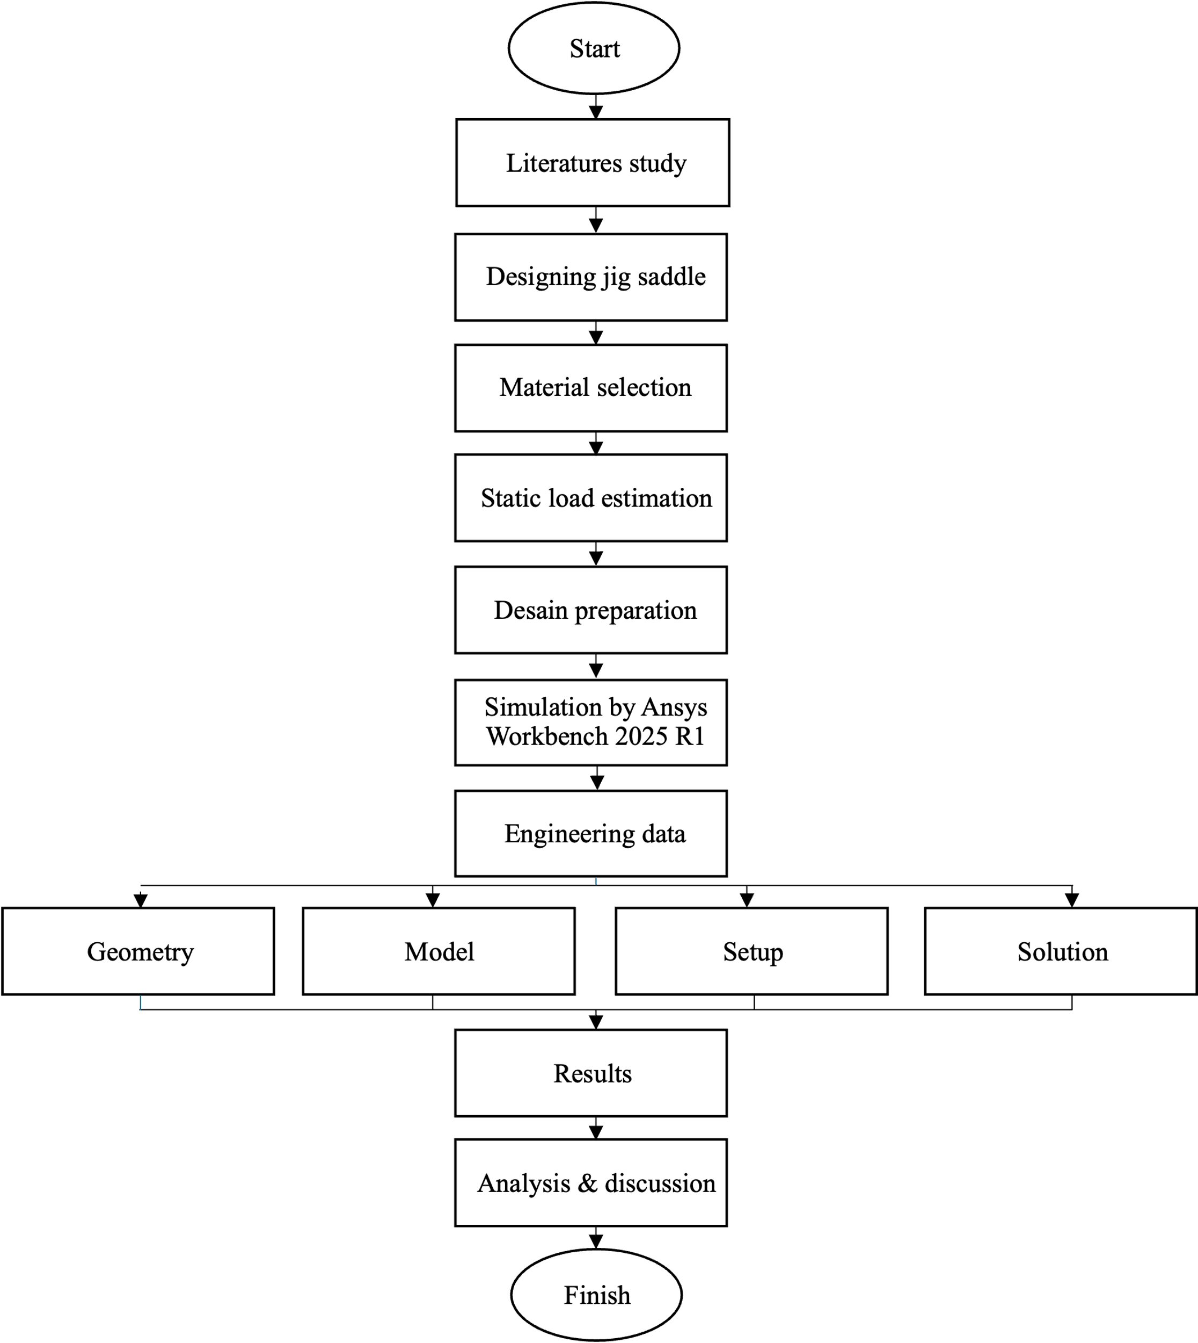
Figure 1. Simulation workflow of jig saddle structural analysis.

Results and Discussion

Load Distribution on the Ship Jig Saddle
To determine the load distributed on each saddle jig, the total mass of the frigate ship is divided by the number of saddle jigs used to support it. The ship has a total mass of 6,626,000 kg and is supported by 13 saddle jigs, resulting in a load of approximately 509,692.31 kg per jig.
Next, the distribution of this load is determined based on the area covered by each jig position. The surface area for each jig type is listed in Table 1.
TABLE 1. Load Distribution Area per Saddle Jig.
Saddle Jig Area | Surface Area (mm²)
Center Saddle Jig | 3,989,069.906
Right Side Saddle Jig | 1,742,854.904
Left Side Saddle Jig | 1,742,854.904
Total Area | 7,474,749.714

The weight received by each saddle jig area is calculated proportionally based on its surface area. The resulting distributed mass and weight for each jig type are as follows:
- Center Saddle Jig:
- Mass: 272,007.78 kg
- Weight: 2,668,396.33 N
- Right Side Saddle Jig:
- Mass: 118,842.26 kg
- Weight: 1,165,842.60 N
- Left Side Saddle Jig:
- Mass: 118,842.26 kg
- Weight: 1,165,842.60 N
The total load acting on the structure is the sum of the weights on all three jig types:
W_{total} = 5,000,081.53 N

Static Failure Analysis Using Tresca/Guest Theory
To evaluate the safety of the saddle jig structure under static loads, a failure prediction analysis was conducted using the Tresca (Guest) criterion. The principal stress values obtained from simulation results are summarized in Table 2.

TABLE 2. Principal Stress Summary
No | Type of Principal Stress | Max Stress (MPa) | Min Stress (MPa)
1 | Maximum Principal Stress | 9.7227 | -2.6244
2 | Middle Principal Stress | 4.0974 | -6.4782
3 | Minimum Principal Stress | 2.4297 | -12.756

Using the Tresca failure criterion, the maximum shear stress is defined as:

(2)

where
- σ1 = 9.7227 MPa
- σ2 = 4.0974 MPa
- σ3 = 2.4297 MPa

Calculations yield:
- = 5.6253 MPa
- = 1.6677 MPa
- = 7.293 MPa
Thus:

The shear yield strength (𝜏yield) for ASTM A36 material is given by:

Because , it indicates that the saddle jig does not experience static failure.

Normal Stress Calculation
Normal stress is determined by dividing the total acting force by the total surface area:

(3)

Static Failure Prediction and Structural Safety
Based on the calculated stresses and comparison with the yield limit, the saddle jig structure is proven to be safe. The maximum shear stress does not exceed the material limit, confirming that the ship jig saddle will not fail under the current static load.

Tresca/Guest Theory Plot
A visual representation of the Tresca/Guest theory is provided in Fig. 2, illustrating that the maximum shear stress line remains well below the shear yield strength boundary.

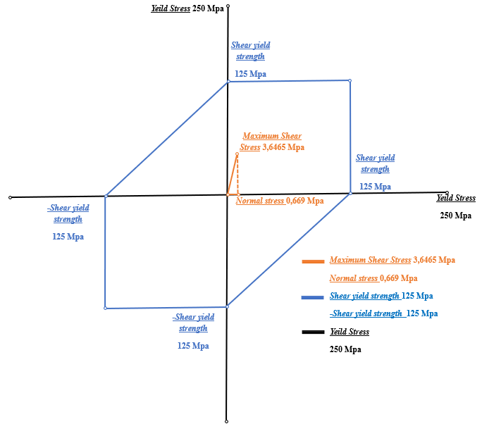
Figure 2. Tresca/Guest Theory Diagram.

From Fig. 2, it is evident that the maximum shear stress (3.6465 MPa) lies within the safe limit defined by the yield strength (125 MPa), validating the structural integrity of the saddle jig.

CONCLUSION
The structural analysis of the jig saddle under the static load of a frigate-class vessel confirmed that the design is safe and structurally sound. Simulation using ANSYS revealed a maximum deformation of only 0.01441 mm, indicating high rigidity. The observed maximum shear stress of 3.65 MPa and von Mises stress of 6.34 MPa were far below the yield strength of ASTM A36 steel (250 MPa), demonstrating that the jig remained well within its elastic region. The resulting safety factor of 39.42 further confirms the conservative and robust nature of the design. Additionally, the application of the Tresca/Guest failure theory verified that the saddle jig would not experience plastic deformation under the given load. These findings validate the jig saddle’s capability to reliably support large naval vessels during dockyard operations. Future studies may consider dynamic or fatigue loading scenarios and explore material or geometric optimization for improved efficiency.

References
- P. Preedawiphat, N. Mahayotsanun, K. Sa‑Ngoen, M. Noipitak, P. Tuengsook, S. Sucharitpwatskul, and K. Dohda, “Mechanical Investigations of ASTM A36 Welded Steels with Stainless Steel Cladding,” Coatings, 10 (9), Article 844 (2020).
- J. G. Patil et al., “Finite Element Analysis of Saddle Support for Stack Heat Exchanger,” Int. J. Eng. Appl. Sci. Technol., 5 (5), 78–85 (2020).
- A. M. et al., “Structural Analysis and Finite Element Methods: Modeling and Simulation in Mechanical Engineering,” J. Adv. Zool., 45 (1), 708–718 (2024).
- M. Chetan, M. Agale, and M. P. N. Awachat, “Finite Element Analysis of Horizontal Pressure Vessels Saddle,” Int. J. Innov. Eng. Sci., 2 (2), 2456–3463 (2017). [Online]. Available: www.ijies.net
- A. Sudhakar, “Numerical Analysis of Pressure Vessel Saddle Support Subjected to Various Loading Conditions,” Int. Res. J. Eng. Technol., 1186–1188 (2022). [Online]. Available: www.irjet.net
- J. Marcinkiewicz, M. Spadło, and Ż. Staszak, “Strength Analysis by the Finite Element Method (FEM) of a Modular Line,” Mater. Mech. Eng. Technol., 2024 (2), 44–52 (2024).
- V. Burra and V. Nallamothu, “Design and Structural Analysis of a Jig‑Fixture Assembly for a Tail Wing,” ISRN BTH‑AMT‑EX–2017/D17–SE Des., 69 (2017). [Online]. Available: https://www.diva-portal.org
- A. Taşdemir, S. Nohut, and M. Akman, “Analytical and Numerical Analysis of the Strength Performance of a Novel Ship Construction Profile,” J. Eta Marit. Sci., 9 (3), 200–209 (2021).
- S. S. Murugan, “Mechanical Properties of Materials: Definition, Testing and Application,” Int. J. Mod. Stud. Mech. Eng., 6 (2), 28–38 (2020).
- S. Singh et al., “Strain Engineering: A Sustainable Alternative to Avoid Using Strategic and Critical Raw Materials in Developing High‑Performance Alloys,” Mater. Today Adv., 24, 100538 (2024).
- R. Roldán et al., “Strain Engineering in Semiconducting Two‑Dimensional Crystals,” J. Phys. Condens. Matter, 27 (31), 1–23 (2015).
- M. Vinayagamoorthy and T. Shanthi, “Aspect of Cantilever Deflection of Bridge Deck Due to Material Nonlinearity,” Int. J. Eng. Res. Technol., 7 (11), 7–13 (2017).
- K. S. Surana, S. Sai, and C. Mathi, “Finite Deformation, Finite Strain Nonlinear Micropolar NCCT for Thermoviscoelastic Solids with Rheology,” Appl. Math., 16 (1), 143–168 (2025).
- A. H. Sakhaei, S. Erland, and T. J. Dodwell, “A Finite Deformation Cosserat Continuum Model for Uncured Carbon Fibre Composites,” Mech. Mater., 151, 103611 (2020).
- C. Salisbury, D. Cronin, and F. S. Lien, “Deformation Mechanics of a Non‑Linear Hyper‑Viscoelastic Porous Material, Part I: Testing and Constitutive Modeling of Non‑Porous Polychloroprene,” J. Dyn. Behav. Mater., 1 (3), 237–248 (2015).
- M. Said and B. Fanb, “Design Study of Trimaran Frigate DFT,” Int. J. Innov. Sci. Res. Technol., 6 (1), 959–968 (2021). [Online]. Available: https://ijisrt.com
- O. Mursid, E. Oterkus, and S. Oterkus, “Coupled Ship Simulation in Hydrodynamics and Structural Dynamics Induced by Wave Loads: A Systematic Literature Review,” J. Mar. Sci. Eng., 13 (3), 1–28 (2025).
- H. Singh, “Structural Analysis of a Chair Under Static Load Conditions,” Proc. Eng. Manag. Conf., 389–391 (2024)
- G. S. Khanday et al., “Analysis of Static and Dynamic Loads on Chimney Foundation in Modular Design of Cold Rolling Mill,” Int. J. Dyn. Syst. Differ. Equations, 5 (2), 99–111 (2015).
- B. V. H. S. Sai, “A Review Paper on Finite Element Methods Using ANSYS,” Int. Adv. Res. J. Sci. Eng. Technol., 8 (3), 200–208 (2021).
- M. Akash, “ANSYS Software for Mechanical Engineering,” Tech. Rep., 5 (2022).

