Effect of Cutting Depth Variation on the Surface Roughness of 6061 Aluminum Alloy
Mohamad Irkham Mamungkas^{a)}, Arif Filmansyah^{b)} and Murjito^{c)}
Department of Mechanical Engineering, University of Muhammadiyah Malang
Jl. Raya Tlogomas No. 246, Malang 65144, Indonesia.

^{a)} Corresponding author: irkham@umm.ac.id
^{b)} ariffilman01@gmail.com
^{c)}murjito@umm.ac.id

Abstract. This study investigates the influence of cutting depth variation on the surface roughness of 6061 aluminum alloy during turning operations. The 6061 aluminum alloy is widely applied in automotive and aerospace industries due to its favorable combination of high strength, good corrosion resistance, and excellent formability. In this work, turning experiments were conducted using three cutting depth levels, and the resulting surface roughness was measured with a digital roughness tester. The results indicate that surface roughness generally increases with greater cutting depth, primarily due to higher cutting forces and increased friction between the tool and workpiece. Additionally, changes in cutting depth were found to influence cutting temperature, which in turn affected the surface finish and microstructural characteristics. Based on these findings, selecting an optimal cutting depth is recommended to achieve improved surface quality and machining performance for 6061 aluminum alloy components.

INTRODUCTION
A lathe machine is commonly employed for various tasks such as drilling, deformation, facing, sanding, knurling, and cutting [1], by shaping the workpiece with a cutting tool [2]. During the turning process, the workpiece is rotated and positioned against a tool whose movement is parallel to the axis of rotation [3]. The main cutting angle and the feed rate are among the factors that can influence the quality of surface roughness [4]. Therefore, surface roughness serves as an indicator of both surface quality and product accuracy [5].
Turning process tests on different workpieces are conducted to gain a comprehensive understanding of how cutting speed and feed rate affect the surface roughness of machined parts [6]. Surface roughness is an important property in turning operations, as it is used to evaluate the performance of machine components [7]. Products with high-quality surface finishes face challenges in this industry, particularly in manufacturing [8]. Selecting the appropriate machining parameters is essential under such conditions [9]. The main cutting angle and feed rate are among the machining parameters that influence the quality of surface roughness [10]. Consequently, surface roughness is widely used as a measure of product surface quality and dimensional accuracy in the manufacturing industry [11].
In this study, the influence of cutting depth variation on the resulting surface roughness in the machining of 6061 aluminum alloy is analyzed [12]. This research aims to enhance understanding of the correlation between cutting depth and surface roughness [13], as well as to provide recommendations for the most effective machining parameters to achieve the desired results in the manufacturing of 6061 aluminum alloy components [14].

Methodology
This research refers to previous studies that have examined machining parameters and their influence on surface quality, which are relevant to the present work [15]. These earlier works served as important references for both designing the experimental procedure and evaluating the outcomes [16]. The workpiece material used in this study was 6061 aluminum alloy, known for its excellent heat treatability, good formability, weldability, and high corrosion resistance [17].
The chemical composition of the 6061 aluminum alloy employed in this research is presented in Table 1, where the primary alloying elements include magnesium and silicon. This composition is consistent with standard 6061 aluminum alloy specifications.

TABLE 1. Chemical composition of 6061 aluminum alloy.
Element | Composition (%)
Aluminium (Al) | Balance
Silicon (Si) | 0.4 – 0.8
Iron (Fe) | Max. 0.7
Copper (Cu) | 0.15 – 0.4
Manganese (Mn) | Max. 0.15
Magnesium (Mg) | 1.0 – 1.5
Chromium (Cr) | 0.04 – 0.35
Zinc (Zn) | Max. 0.25
Titanium (Ti) | Max. 0.15
Other elements | Max. 0.05 per element

The turning process was conducted using a conventional lathe machine operated at a cutting speed of 440 m/min with a feed rate of 0.112 rad/s. A high-speed steel (HSS) cutting tool was employed for material removal. The workpiece was prepared in cylindrical bar form with a diameter of 16 mm and a length of 150 mm. The bar was sectioned into nine specimens, corresponding to three cutting depth variations, with three repeated trials for each cutting depth level [19][20].
The independent variable in this study was the cutting depth, with three levels: 0.1 mm, 0.3 mm, and 0.5 mm. Other machining parameters were kept constant, including a main cutting edge angle of 55°, a cross-cutting edge angle between 12° and 15°, and a tool holder position angle of 80°.
Surface roughness measurements were performed using a JD-360 digital surface roughness tester, as illustrated in Fig. 1. Measurements were taken at three equally spaced points along each machined surface to ensure data representativeness [21].

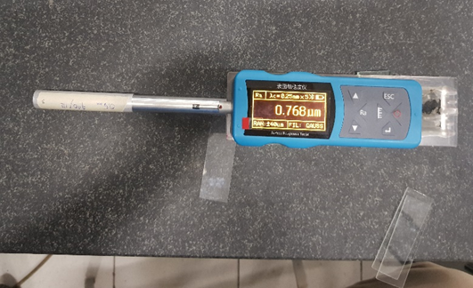
Figure 1. Measurement of surface roughness on 6061 aluminum alloy specimens.

From an empirical perspective, the surface roughness value (Ra) often shows a direct relationship with cutting depth (d). This means that deeper cuts typically produce rougher surfaces. This relationship can be expressed using the following empirical formula:

(1)

It should be noted that this relationship is material- and process-dependent, and factors such as cutting speed, tool material, and thermal effects also play a significant role in determining the final surface quality.

RESULTS AND DISCUSSION
In the turning process of Aluminum (Al 6061), surface roughness was measured at three parallel points on each of three specimens. Three cutting depths (0.1 mm, 0.3 mm, 0.5 mm) were tested, with the lathe running at a constant 440 RPM (0.112 rad/s). The surface roughness tester used was a JD-360 digital device. The results are presented as graphs in Figs. 2 to 4 and numerical values in Tables 2 to 4. The following subsections detail the results for each cutting depth.

Surface Roughness Test Results with a 0.1 mm Cutting Depth

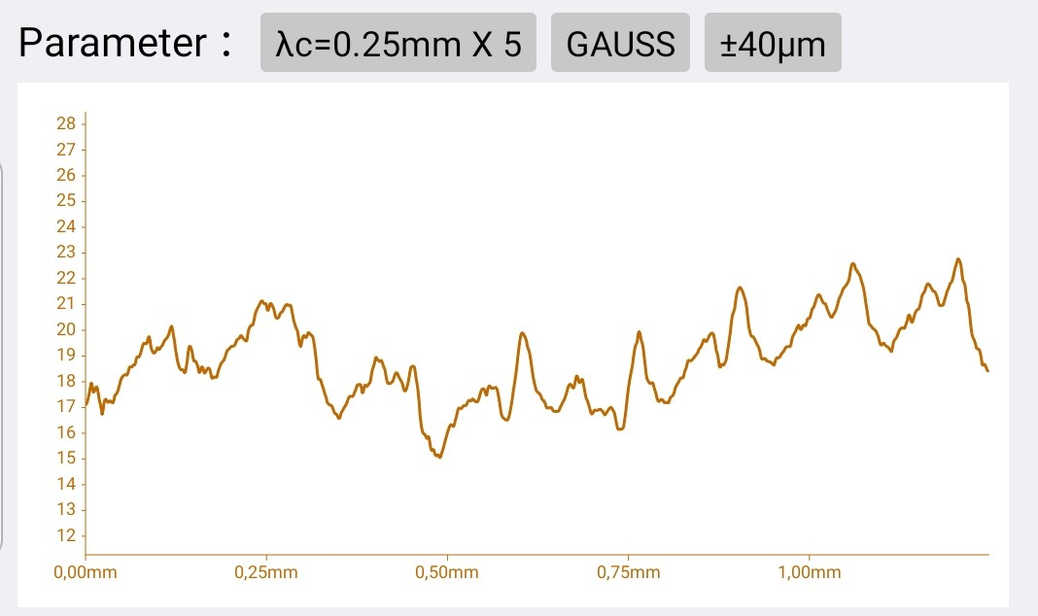
Figure 2. Surface Roughness Graph of the First Specimen for a Cutting Depth of 0.1 mm.

TABLE 2. Surface Roughness Test Results with a Cutting Depth of 0.1 mm
Specimen |  | Test Results
 |  | Ra µm | Rz µm | Rq µm
Spesiment 0,1 mm 440/112  1 | 1 | 0,598 | 2,726 | 0,696
Spesiment 0,1 mm 440/112  1 | 2 | 0,66 | 2,958 | 0,772
Spesiment 0,1 mm 440/112  1 | 3 | 0,779 | 3,601 | 0,933
Average |  | 0,679 | 3,095 | 0,800
Spesiment 0,1 mm 440/112  2 | 1 | 1,125 | 4,268 | 1,295
Spesiment 0,1 mm 440/112  2 | 2 | 1,138 | 4,517 | 1,314
Spesiment 0,1 mm 440/112  2 | 3 | 0,709 | 3,318 | 0,84
Average |  | 0,991 | 4,034 | 1,150
Spesiment 0,1 mm 440/112  3 | 1 | 0,935 | 4,371 | 1,156
Spesiment 0,1 mm 440/112  3 | 2 | 0,898 | 4,312 | 1,109
Spesiment 0,1 mm 440/112  3 | 3 | 0,791 | 3,762 | 0,962
Average |  | 0,875 | 4,148 | 1,076
Overall Average |  | 2,545 | 11,277 | 3,026

For the 0.1 mm cutting depth, Fig. 2 shows the surface roughness profile of the first specimen and Table 2 lists the measured Ra, Rz, and Rq values at three points on each of the three specimens. The overall average Ra at this depth was 2.545 μm (nine-point mean) under the 440 RPM turning conditions. These results correspond to the shallowest cut among those tested.

Surface Roughness Test Results with a 0.3 mm Cutting Depth
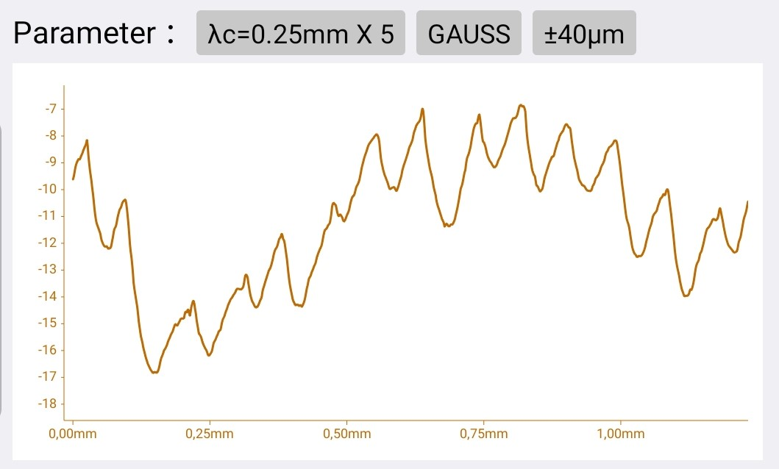
Figure 3. Surface Roughness Graph of the First Specimen for a Cutting Depth of 0.3 mm.

TABLE 3. Surface Roughness Test Results with a Cutting Depth of 0.3 mm
Specimen |  | Test Results
 |  | Ra µm | Rz µm | Rq µm
Spesiment 0,3 mm 440/112  1 | 1 | 0,686 | 2,714 | 0,778
Spesiment 0,3 mm 440/112  1 | 2 | 0,654 | 2,66 | 0,761
Spesiment 0,3 mm 440/112  1 | 3 | 0,717 | 2,753 | 0,82
Rata - rata |  | 0,686 | 2,709 | 0,786
Spesiment 0,3 mm 440/112  2 | 1 | 0,981 | 3,805 | 1,134
Spesiment 0,3 mm 440/112  2 | 2 | 0,847 | 3,552 | 0,997
Spesiment 0,3 mm 440/112  2 | 3 | 0,96 | 4,034 | 1,137
Rata - rata |  | 0,929 | 3,797 | 1,089
Spesiment 0,3 mm 440/112  3 | 1 | 0,769 | 3,157 | 0,894
Spesiment 0,3 mm 440/112  3 | 2 | 0,843 | 4,98 | 1,046
Spesiment 0,3 mm 440/112  3 | 3 | 0,976 | 4,122 | 1,152
Average |  | 0,863 | 4,086 | 1,031
Overall Average |  | 2,478 | 10,592 | 2,906

Figure 3 and Table 3 present the roughness test results for a 0.3 mm cutting depth. The measurements at three points on each of the three specimens yielded an overall average Ra of 2.478 μm under the same turning conditions (440 RPM). This average Ra value is slightly lower than that of the 0.1 mm depth, indicating a marginally smoother finish at 0.3 mm.

Surface Roughness Test Results with a 0.5 mm Cutting Depth
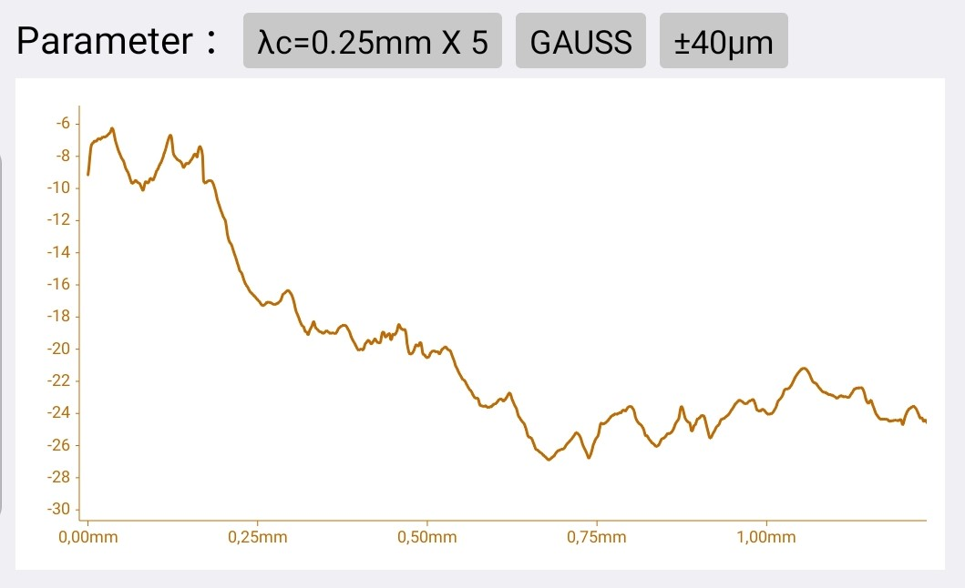
Figure 4. Surface Roughness Graph for a Cutting Depth of 0.5 mm.

TABLE 4. Surface Roughness Test Results for a Cutting Depth of 0.5 mm
Specimen |  | Test Results
 |  | Ra µm | Rz µm | Rq µm
Specimen 0,5 mm 440/112  1 | 1 | 0,967 | 4,049 | 1,132
Specimen 0,5 mm 440/112  1 | 2 | 0,747 | 3,381 | 0,898
Specimen 0,5 mm 440/112  1 | 3 | 0,695 | 3,333 | 0,827
Average |  | 0,803 | 3,588 | 0,952
Specimen 0,5 mm 440/112  2 | 1 | 0,974 | 4 | 1,125
Specimen 0,5 mm 440/112  2 | 2 | 0,783 | 3,61 | 0,936
Specimen 0,5 mm 440/112  2 | 3 | 0,996 | 4,307 | 1,174
Average |  | 0,918 | 3,972 | 1,078
Specimen 0,5 mm 440/112  3 | 1 | 1,067 | 4,249 | 1,234
Specimen 0,5 mm 440/112  3 | 2 | 0,712 | 3,338 | 0,838
Specimen 0,5 mm 440/112  3 | 3 | 0,768 | 3,162 | 0,895
Average |  | 0,849 | 3,583 | 0,989
Overall Average |  | 2,57 | 11,143 | 3,019

Figure 4 and Table 4 show the results for a 0.5 mm cutting depth. The average Ra calculated from the three measurements on each specimen was 2.570 μm at 440 RPM. This value is higher than that for the 0.3 mm cut, indicating a rougher surface compared to the medium-depth cut.

CONCLUSION
Surface roughness tests were performed on Aluminum (6061) during turning at cutting depths of 0.1 mm, 0.3 mm, and 0.5 mm (lathe speed 440 RPM). The results show that the 0.3 mm cutting depth produced the lowest average Ra value (2.478 μm), yielding the smoothest surface finish under the given conditions. In contrast, the 0.1 mm and 0.5 mm depths resulted in higher Ra values (2.545 μm and 2.570 μm, respectively). Therefore, a cutting depth of 0.3 mm is concluded to be optimal for minimizing surface roughness in this setup.

References
- M. S. Y. Lubis, A. Riza, and D. P. Agung, “Effect of machining parameters on the surface roughness of Aluminum 6061 and 7075 materials in the shaping process,” J. Muara Sains, Teknol., Kedokt. dan Ilmu Kesehat., 4(1), 145 (2020).
- B. Setyono, G. Setyono, and S. Pratama, “Effect of cutting speed and cutting depth on the surface roughness of ST60 steel, aluminum, and polyethylene in CNC Turning Fanuc Oi Mate TC VT15L Type PU 2A,” in Proceedings of the 8th National Seminar on Applied Science and Technology, 247–254 (2020).
- I. Pratama and M. A. Rizza, “Effect of milling process cutting parameters on the surface roughness of Aluminum 6061 material,” J. Tek. Ilmu dan Apl., 2(2), 49–56 (2022).
- A. Y. Aminy and A. A. Aji, “Optimization of Aluminum 6061 turning quality due to changes in HSS tool cutting angle,” J. Penelit. Enj., 25(2), 124–131 (2022).
- M. Rifaldi, “Performance of carburized leaf spring material cutting tools on the surface roughness in turning Aluminum 6061,” J. Ilmu Tek., 2(1), 47–56 (2024).
- B. Suroso and D. Prayogi, “Effect of spindle rotation speed and grinding depth on the surface roughness of St 37 steel using grinding lathe machine,” J. Rekayasa Mater. Manufaktur dan Energi, 2(1), 24–33 (2019).
- A. Pramanik, A. K. Basak, C. Prakash, S. Shankar, and S. Chattopadhyaya, “Sustainability in drilling of aluminum alloy,” Clean. Mater., 3, 100048 (2022).
- A. A. Nia and R. Amirifar, “Experimental study of the effects of pin geometry, advancing speed and D/d ratio on the mechanical and microstructural properties of 6061 aluminum alloy under friction stir processing,” J. Adv. Join. Process., 9, 100205 (2024).
- A. Akhavan Farid and M. A. Z. M. Yusoff, “Effect of cutting path strategy on the quality of convexly curved surface and its energy consumption,” Int. J. Light. Mater. Manuf., 3(4), 338–343 (2020).
- A. H. Mettanadi, A. R. Prabowo, T. Muttaqie, N. Muhayat, I. Istanto, and J. H. Cho, “Crashworthiness of cross-sectional hollow-tubes filled with concave hexagonal under compressive load using nonlinear FE analysis,” Procedia Struct. Integr., 47, 168–175 (2023).
- S. R. Zaidi, S. I. Butt, M. A. Khan, M. I. Faraz, S. H. I. Jaffery, and J. Petru, “Sustainability assessment of machining Al 6061-T6 using Taguchi-grey relation integrated approach,” Heliyon, 10(13), e33726 (2024).
- W. S. Yip, T. He, H. Wang, and S. To, “Facile fabrication of hierarchical micro/nano aluminum alloy surfaces with enhanced hydrophobicity and surface quality by single point diamond cutting under a magnetic field influence,” J. Mater. Res. Technol., 30, 7946–7957 (2024).
- F. Dong et al., “Improving the surface quality and its mechanism in ultraprecision machining of Al–Mg–Si alloy by multiple high energy shot peening pretreatment,” J. Mater. Res. Technol., 30, 7051–7064 (2024).
- J. Li, Z. Fan, J. Gao, Z. Yang, and Y. Tian, “Multi-pole magnetorheological shear thickening polishing on inner surface of aluminum alloy slender tubes,” J. Mater. Res. Technol., 27, 8258–8270 (2023).
- A. Yücel et al., “Influence of MoS₂ based nanofluid-MQL on tribological and machining characteristics in turning of AA 2024 T3 aluminum alloy,” J. Mater. Res. Technol., 15, 1688–1704 (2021).
- A. Madariaga, M. Cuesta, E. Dominguez, A. Garay, G. Ortiz-De-Zarate, and P. J. Arrazola, “Enhancing surface integrity of A7050-T7451 aluminium alloy by pneumatic machine hammer peening,” Procedia CIRP, 108, 317–322 (2022).
- T. Junge, T. Mehner, A. Nestler, A. Schubert, and T. Lampke, “Surface properties in turning of aluminum alloys applying different cooling strategies,” Procedia CIRP, 108, 246–251 (2022).
- G. Guerrero-Vacas, S. Fusco, M. Á. Rodríguez-Valverde, and O. Rodríguez-Alabanda, “Manufacturing hydrophobic surfaces on aluminium substrates by micro-milling with end-ball nose tools,” J. Manuf. Process., 124, 24–37 (2024).
- Z. Duan et al., “Performance evaluation of cold plasma and h-BN nano-lubricant multi-field coupling assisted micro-milling of aluminum alloy 6061-T651,” Alexandria Eng. J., 109, 610–625 (2024).
- A. E. Medvedev, T. Maconachie, M. Leary, M. Qian, and M. Brandt, “Perspectives on additive manufacturing for dynamic impact applications,” Mater. Des., 221, 110963 (2022).
- Z. Sun et al., “Influence of transversal vibration on cutting performance and surface integrity during ultrasonic peening drilling of Al-Li alloys,” Chin. J. Aeronaut., 37(10), 493–507 (2024).
- S. Sudarman, W. Guszolil, D. Daryono, and M. Lukman, “Feasibility study on a micro hydro power plant at Coban Jahe Waterfall, Jabung, Malang Regency,” J. Energy Mech. Mater. Manuf. Eng., 6(1), 41–52 (2021).
- A. Fauzan, H. Soegiharto, A. Mokhtar, and S. Adiwidodo, “The role of flue gas inhibitor on stabilizing heptane flame in mesoscale combustor,” 6(2), 111–118 (2021).
- W. Rowe John, “Vertical axis wind turbine,” US Patent 20040036297A1 (2004).

