The Effect of RPM Variation in Friction Welding on the Mechanical Properties and Microstructure of SS 304
Mohamad Irkham Mamungkas^{a)}, Taufik Hidayat^{b)}, Murjito^{c)} and Nur Subeki^{d)}
Department of Mechanical Engineering, University of Muhammadiyah Malang
Jl. Raya Tlogomas No. 246, Malang 65144, Indonesia.

^{a)} Corresponding author: irkham@umm.ac.id
^{b)} taufikhdyat1810@gmail.com
^{c)} murjito@umm.ac.id
^{d)} nursubeki@umm.ac.id

Abstract. This study aims to analyze the influence of pressure variation and current strength on the mechanical properties and microstructure of SS 304 stainless steel joints produced using the friction welding method. The welding process was carried out at rotational speeds of 1100 RPM and 1800 RPM. Tensile test results showed that joints welded at 1100 RPM achieved an average tensile strength of 2185.50 MPa, whereas those welded at 1800 RPM achieved an average tensile strength of 1926.42 MPa. Microstructural examination revealed that larger grain sizes at 1100 RPM produced more ductile joints, while finer grains at 1800 RPM resulted in harder but less tough joints. The findings indicate that higher rotational speeds tend to increase maximum tensile strength but may reduce plastic deformation, highlighting the necessity of selecting optimal parameters to achieve joint performance tailored to specific application requirements.

INTRODUCTION
Welding technology plays a crucial role in various industrial sectors, ranging from heavy construction manufacturing to high-precision metal-based products [1]. One of the challenges in welding is joining two different materials (dissimilar welding), particularly in applications involving stainless steel SS 304 [2]. This type of steel is widely used in the food, beverage, and chemical industries due to its corrosion resistance and ease of fabrication and welding [3].
Friction welding is a solid-state welding method that utilizes frictional heat and pressure to produce a joint [4][5]. This technique offers advantages in creating high-quality joints without fully melting the material, thereby reducing weld defects commonly found in fusion welding methods [6][7]. Furthermore, in the selective laser melting process, build direction and scanning speed, which are influenced by current, can affect the fatigue performance of SS 304L steel, with factors such as surface roughness, porosity, and residual stress playing a significant role [8][9].
This study aims to evaluate the effect of rotational speed variations on the mechanical properties and microstructure of SS 304 stainless steel joints [10][11]. Higher rotational speeds are expected to increase the generated frictional energy but may also induce thermal changes that influence the material structure [12][13]. The findings of this research are expected to provide valuable insights for improving joint quality and optimizing friction welding process parameters in broader industrial applications [14].
Various surface treatment methods, such as abrasive water jet peening and ultrasonic nanocrystal surface modification, have been applied to SS 304 stainless steel to enhance its mechanical properties [15]. These methods have successfully introduced a hardened layer that improves tensile strength and hardness, although with some trade-offs in corrosion resistance [16]. In addition, expansion deformation in SS 304 tubes has been shown to increase internal pressure strength and collapse strength, albeit with a slight reduction in corrosion resistance [17][18].
Although numerous studies have been conducted on the effect of process parameters on the mechanical properties and microstructure of SS 304 stainless steel, there remains a lack of understanding regarding the influence of the combination of pressure and current in the friction welding process for this material [19]. Most previous studies have tended to focus on the effect of a single parameter, such as rotational speed or pressure, without considering the interaction between these two factors in friction welding [20]. Moreover, although various surface treatment methods have been implemented to improve the mechanical properties of SS 304 stainless steel, no in-depth study has investigated how friction welding parameters such as pressure and current can directly affect joint strength [21]. Therefore, this study aims to fill this gap by further exploring the effect of the combination of pressure and current on the mechanical properties and microstructure of SS 304 stainless steel joints.

Methodology
This study employed an experimental approach to investigate the effect of rotational speed in friction welding on the mechanical properties and microstructure of SS 304 stainless steel. The experimental work was carried out at the Mechanical Engineering Laboratory of Universitas Muhammadiyah Malang from June to July 2024. The material used in this study was SS 304 stainless steel with a length of 100 mm and a diameter of 20 mm. The equipment employed included a friction welding machine, a tensile testing machine, microstructural testing instruments, and a thermal camera.
The welding procedure began with the preparation of test specimens according to the specified dimensions. The workpieces were mounted on the friction welding machine, ensuring proper alignment and secure clamping. The machine’s rotational speed was then set to 1100 RPM and 1800 RPM as the variables under investigation. The friction welding process was initiated to generate heat through friction until the surfaces of the workpieces bonded. Pressure was subsequently applied to complete the joint formation, while temperature and pressure data were recorded using a thermal camera and sensors. The welding process used in this study is shown in Figure 1.

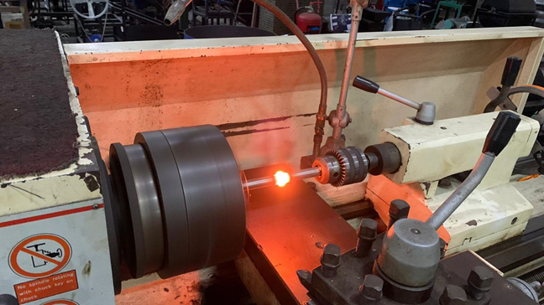
Figure 1. Friction welding process.

Two types of tests were conducted to evaluate the welded joints. The tensile test was performed to determine the tensile strength of the joints produced at different rotational speeds, while microstructural examination was carried out to analyze the grain structure and assess the influence of frictional parameters on the material’s properties. The resulting tensile and microstructural data were analyzed to evaluate the correlation between rotational speed, mechanical strength, and microstructural changes. Higher rotational speeds were anticipated to affect joint performance through variations in heat distribution and grain growth dynamics [22].

Results and Discussion

Tensile Test Results
The tensile test was conducted to evaluate the strength of friction-welded joints in SS 304 stainless steel at two different rotational speeds, 1100 RPM and 1800 RPM [23][24]. The results are summarized in Table 1.

TABLE 1. Tensile test results of SS 304 stainless steel friction-welded joints at 1100 RPM and 1800 RPM
Specimens (Based on Welding RPM) | Material Type | Specimen Number | Support Span (mm) | Diameter (mm) | Load (Kg) | Distance (mm) | Result (MPa) | Average (MPa)
1100 | Solid | 1 | 1 | 8 | 972,6 | 2,27 | 1850,99 | 2185,502
1100 | Solid | 2 | 2 | 8 | 706,2 | 1,78 | 2185,79 | 2185,502
1100 | Solid | 3 | 3 | 8 | 742,4 | 1,74 | 2404,7 | 2185,502
1100 | Solid | 4 | 4 | 8 | 1053,2 | 2,18 | 2173,29 | 2185,502
1100 | Solid | 5 | 5 | 8 | 1358,4 | 2,4 | 2312,74 | 2185,502
1800 | Solid | 1 | 1 | 8 | 1062,8 | 2.41 | 1794,48 | 1926,422
1800 | Solid | 2 | 2 | 8 | 158,2 | 1,2 | 1077,37 | 1926,422
1800 | Solid | 3 | 3 | 8 | 864,2 | 1,82 | 2558,54 | 1926,422
1800 | Solid | 4 | 4 | 8 | 1452,8 | 2,8 | 1817,23 | 1926,422
1800 | Solid | 5 | 5 | 8 | 436,6 | 1,34 | 2384,49 | 1926,422

At 1100 RPM, the tensile strength values ranged from 1850.99 MPa to 2404.70 MPa, with an average of 2185.50 MPa. The specimens, with a diameter of 8 mm, were able to withstand tensile loads between 706.2 kg and 1358.4 kg, and exhibited elongation between 1.74 mm and 2.4 mm. The load–time behavior during the tensile tests is illustrated in Fig. 2 for 1100 RPM and in Fig. 3 for 1800 RPM. These findings indicate that the welding process at 1100 RPM produced consistent joint quality, with minimal variation in tensile strength.
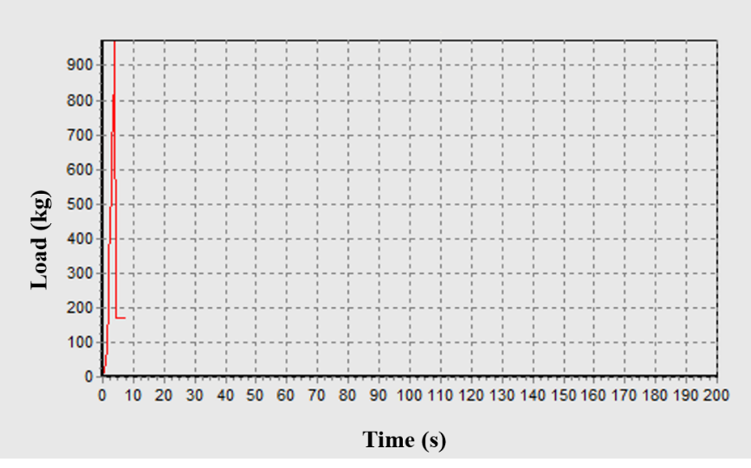
Figure 2. Tensile Test Load–Time Relationship at 1100 RPM
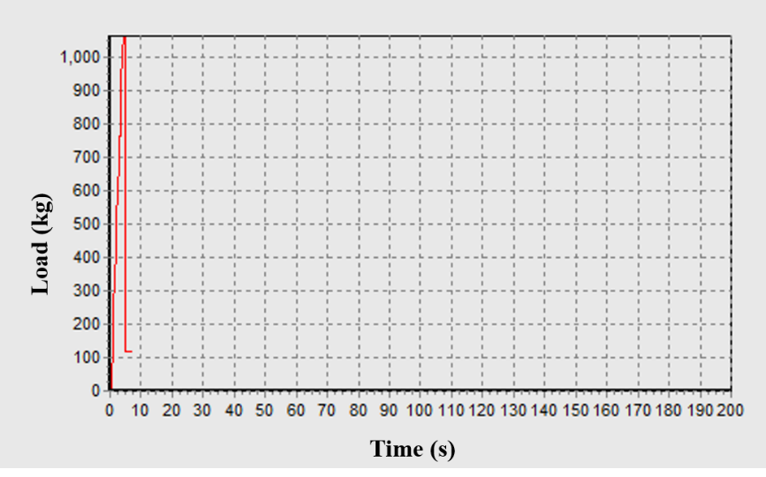
Figure 3. Tensile Test Load–Time Relationship at 1800 RPM

At 1800 RPM, the tensile strength values ranged from 1794.48 MPa to 2558.54 MPa, with an average of 1926.42 MPa. The tensile loads for these specimens ranged from 864.2 kg to 1452.8 kg, while elongation varied between 1.82 mm and 2.8 mm. Although several specimens at 1800 RPM achieved higher maximum tensile strength compared to those at 1100 RPM, the overall average was lower. This suggests that the higher rotational speed may have introduced excessive heat during welding, potentially causing unfavorable microstructural changes that reduced overall joint strength. The slightly greater elongation range at 1800 RPM also indicates increased deformation, which may contribute to the reduced mechanical performance compared to the 1100 RPM condition.
The tensile test results demonstrate that while both rotational speeds produced strong joints, the 1100 RPM setting provided more optimal and consistent mechanical performance.

Tensile Test Analysis
The tensile test analysis confirms that friction welding can be successfully applied to SS 304 stainless steel specimens at both 1100 RPM and 1800 RPM rotational speeds. The objective of this test was to determine the load-bearing capacity and overall joint performance under tensile loading conditions. For the 1100 RPM condition, all specimens with a diameter of 8 mm demonstrated a load-bearing capacity ranging from 706.2 kg to 1358.4 kg, with elongations between 1.74 mm and 2.4 mm before fracture. The corresponding tensile strength values ranged from 1850.99 MPa to 2404.70 MPa, yielding an average of 2185.50 MPa. These results indicate that the selected parameters for the 1100 RPM condition were effective in producing high-quality, consistent welds with minimal variability across specimens [26–29].
Similarly, specimens welded at 1800 RPM also had a diameter of 8 mm and produced tensile loads between 864.2 kg and 1452.8 kg, with elongations from 1.82 mm to 2.8 mm. The resulting tensile strength ranged from 1794.48 MPa to 2558.54 MPa, with an average value of 1926.42 MPa. Although some specimens at this speed achieved higher maximum tensile strength than those welded at 1100 RPM, the lower average suggests that the higher rotational speed may have generated excessive heat during welding. This heat could have caused thermal deformation or less favorable microstructural development, ultimately reducing the overall joint strength.
Furthermore, the slightly higher elongation values observed at 1800 RPM suggest increased deformation, which may be detrimental to tensile strength retention. While both rotational speeds produced strong joints, the 1100 RPM condition consistently yielded superior average tensile strength and structural stability. This indicates that the 1100 RPM parameter set is more suitable for welding SS 304 stainless steel components, particularly for applications requiring a balance between high strength and dimensional stability.

Microstructural Test Results
Microstructural examinations were conducted to evaluate the grain structure of friction-welded joints in SS 304 stainless steel at the two rotational speeds, 1100 RPM and 1800 RPM [30][31]. The results, presented in Figs. 4 to 5, reveal distinct differences in grain morphology between the two conditions.
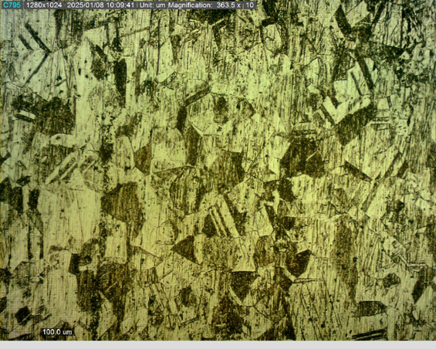
Figure 4. Microstructural Examination Results of Friction-Welded Joints at 1100 RPM


Figure 5. Structural Testing Results of Friction Welding at 1800 RPM

Welding at 1100 RPM produced relatively larger and coarser grains within the weld zone. This coarser grain structure is associated with improved ductility and greater plastic deformation capability, as the lower frictional energy and slower cooling rate provided more time for grain growth during the solid-state joining process [32].
In contrast, the specimens welded at 1800 RPM exhibited a finer and more uniform grain structure. This microstructural refinement can be attributed to the higher frictional energy and heat generation at elevated rotational speeds, which triggered dynamic recrystallization. This process produced new, fine grains that improved hardness and, in some cases, maximum tensile strength, but at the expense of reduced ductility [33].
From a performance perspective, the coarser grains observed in the 1100 RPM joints contributed to greater resistance to fracture under dynamic loading conditions, making them more suitable for applications where toughness is critical. Conversely, the finer grains in the 1800 RPM joints enhanced hardness and wear resistance but rendered the material more susceptible to brittle fracture, making them more appropriate for static load applications where minimal deformation is desired [34].
These findings confirm that rotational speed significantly influences the microstructural evolution in friction-welded SS 304 stainless steel, and the resulting grain morphology plays a decisive role in determining the balance between strength, ductility, and fracture resistance.

Microstructural Test Analysis
The analysis of the microstructural results highlights a clear influence of rotational speed on the thermal and mechanical processes occurring during friction welding of SS 304 stainless steel. At the lower rotational speed of 1100 RPM, heat generation occurred more gradually, causing the heat-affected zone (HAZ) to remain at elevated temperatures for a longer period. This prolonged thermal exposure allowed sufficient time for atomic diffusion and facilitated significant grain growth, resulting in a coarse-grained microstructure. Additionally, the slower heat dissipation in this condition increased the likelihood of grain overgrowth within the HAZ, which enhanced the joint’s ability to undergo plastic deformation before fracture.
In contrast, the higher rotational speed of 1800 RPM generated greater frictional energy and rapidly elevated the temperature within the weld zone. The extreme heat, combined with intense plastic deformation, promoted dynamic recrystallization, leading to the formation of finer, newly nucleated grains. The shorter high-temperature exposure time at this speed limited excessive grain growth, while relatively faster cooling preserved the fine-grained structure. This microstructural refinement improved hardness and, in some cases, maximum tensile strength; however, it reduced ductility and increased the susceptibility to brittle fracture under dynamic or impact loading.
Overall, the differences in microstructural development between the two welding speeds demonstrate that temperature magnitude, thermal exposure duration, and plastic deformation intensity work simultaneously to determine the final grain morphology and mechanical performance of the joint. The 1100 RPM condition is more suitable for applications requiring toughness and high fracture resistance, while the 1800 RPM condition may be advantageous for applications prioritizing hardness and wear resistance over ductility.

CONCLUSION
This study examined the influence of rotational speed variation in friction welding on the mechanical properties and microstructure of SS 304 stainless steel. The experimental findings revealed that joints welded at 1100 RPM exhibited higher and more consistent tensile strength, with an average value of 2185.50 MPa, compared to an average of 1926.42 MPa for joints welded at 1800 RPM. The 1100 RPM condition demonstrated superior load-bearing capability without excessive deformation, indicating better weld quality. Microstructural analysis showed that the 1100 RPM joints contained coarse grains, which enhanced plastic deformation and toughness under dynamic loading conditions. In contrast, the 1800 RPM joints exhibited a fine and uniform grain structure, which increased hardness and maximum tensile strength but reduced ductility, making them more suitable for static load applications. The higher rotational speed of 1800 RPM generated greater heat input, which promoted dynamic recrystallization and fine grain formation; however, excessive heat also introduced the risk of thermal deformation, potentially diminishing mechanical performance. From an application standpoint, 1100 RPM is recommended for components requiring high toughness and resistance to dynamic or impact loads, whereas 1800 RPM is better suited for applications that prioritize hardness and high static strength. Overall, the results emphasize the need to optimize friction welding parameters to achieve the desired balance between mechanical properties and microstructural characteristics, ensuring that welded joints meet the specific requirements of their intended industrial applications.

References
- Corrosion resistance of friction stir welded 304 stainless steel. Scripta Materialia 51, no. 2 (2004): 101–105.
- Microstructure and mechanical properties of friction stir welded AISI321 stainless steel. Journal of Materials Research and Technology 9, no. 3 (2020): 3967–3976.
- Friction welding of similar and dissimilar materials: A review. Materials Today: Proceedings 81 (2023): 208–211.
- The effects of transient temperature around welds on mechanical properties of A36 steel plate. Journal of Energy, Mechanical, Material, and Manufacturing Engineering 1, no. 1 (2017): 36–46.
- Prediction and optimization of friction welding parameters for joining aluminium alloy and stainless steel. Transactions of Nonferrous Metals Society of China 21, no. 7 (2011): 1480–1485.
- Thermal modeling of friction stir welding of stainless steel 304L. International Journal of Advanced Manufacturing Technology 75 (2014): 1299–1307.
- The effect of adding borax in the oxy-acetylene welding process on tensile strength. Journal of Energy, Mechanical, Material, and Manufacturing Engineering 9, no. 2 (2024): 13–16.
- Microstructure, surface quality, residual stress, fatigue behavior and damage mechanisms of selective laser melted 304L stainless steel considering building direction. Additive Manufacturing 46 (2021): 102147.
- Friction processing technologies. Welding in the World 47 (2003): 2–9.
- Rotary friction welding of Inconel 718–AISI 304 stainless steel dissimilar joint. Materials Science and Technology 39, no. 15 (2023): 1950–1960.
- Joining with friction welding of high-speed steel and medium-carbon steel. Journal of Materials Processing Technology 168, no. 2 (2005): 202–210.
- Characterization studies on weld strength of rotary friction welded austenitic stainless steel tubes. Materials Today: Proceedings 41 (2021): 1024–1029.
- Optimizing friction welding parameters in AISI 304 austenitic stainless steel and commercial copper dissimilar joints. Coatings 13, no. 2 (2023): 261.
- Mechanical and metallurgical properties of friction welded AISI 304 austenitic stainless steel. International Journal of Advanced Manufacturing Technology 26 (2005): 505–511.
- Optimization of spot welding for peel load on SPCC steel sheets. Journal of Energy, Mechanical, Material, and Manufacturing Engineering 5, no. 1 (2020): 53.
- Effect of different tool pin diameter on mechanical properties of friction stirred welded AISI 304 stainless steel plate. Materials Today: Proceedings 38 (2021): 2241–2248.
- Tensile strength prediction of empty palm oil bunch fiber composite with artificial neural network. Journal of Energy, Mechanical, Material, and Manufacturing Engineering 9, no. 2 (2024): 77–84.
- Effect of expansion deformation on the mechanical properties and corrosion resistance of an AISI 304 stainless steel tube in water from an oilfield. Coatings 12, no. 10 (2022): 1415.
- Effect of friction pressure and welding time on tensile strength of dissimilar joints between St 41 and stainless steel 304 using friction welding. Teknika 8, no. 1 (2023): 25–31.
- Effect of current on mechanical properties of SS304 welded joints with coolant media using MIG welding. (2016): 1–23.
- Effect of welding time and current strength in spot welding on tensile strength of stainless steel 304. Jurnal Teknik Industri Terintegrasi 6, no. 1 (2023): 272–278.
- High-strength titanium alloys for aerospace engineering applications: A review on melting-forging process. Materials Science and Engineering A 845 (2022): 143260.
- Microstructure evolution and mechanical properties of continuous drive friction welded dissimilar copper-stainless steel pipe joints. Materials Science and Engineering A 832 (2022): 142444.
- Non-monotonic evolution of microstructure and fatigue properties of round bar–plate rotary friction welding joints in 304 austenitic stainless steel. Materials & Design 224 (2022): 111400.
- Friction stir welding of austenitic stainless steel by PCBN tool and its joint analyses. Procedia Materials Science 6 (2014): 135–139.
- Evaluation of mechanical properties of friction stir welded commercially pure aluminium. MATEC Web of Conferences 172 (2018): 04003.
- Tensile strength and microstructure of rotary friction-welded carbon steel and stainless steel joints. Journal of Manufacturing and Materials Processing 7, no. 1 (2022): 7.
- Predicting the tensile strength of friction welded steel/ASS304L dissimilar joints. IOP Conference Series: Materials Science and Engineering 995, no. 1 (2020): 012042.
- Mechanical and microstructure properties of 304 stainless steel friction welded joint. International Research Journal of Engineering Science, Technology, and Innovation 2, no. 4 (2013): 65–74.
- Microstructures and mechanical properties of thin 304 stainless steel sheets by friction stir welding. Journal of Adhesion Science and Technology 32, no. 12 (2018): 1313–1323.
- Investigation of the mechanical properties of friction-welded joints between AISI 304L and AISI 4340 steel as a function rotational speed. Materials Letters 59, no. 19–20 (2005): 2504–2509.
- Flow rate effects on microstructure and mechanical properties for titanium weld joint. Journal of Energy, Mechanical, Material, and Manufacturing Engineering 6, no. 3 (2021).
- Transition of interfacial friction regime and its influence on thermal responses in rotary friction welding of SUS304 stainless steel: A fully coupled transient thermomechanical analysis. Journal of Manufacturing Processes 82 (2022): 403–414.
- Investigation on mechanical and metallurgical properties of rotary friction welded In718/SS410 dissimilar materials. Materials Today: Proceedings 45 (2021): 962–966.

